Emily Stockdale – BPMN’S and Use Cases
1906961
Computational Thinking
UWTSD

Use Case ID: | NO1
Use Case Name: | Draw 3 Rectangles
Created By: | Emily Stockdale
Date Created: | 08/01/2020

Actor(s): | Lego Mindstorms Robot
Description: | - The team will build a leggo robot, the robot will have to be able to hold a pen and draw three rectangles. Each one 10cm larger than the last one.
Preconditions: | - The code will be uploaded into the robot using the EV3 programming environment.
Postconditions: | - The robot needs to draw three rectangles  - For each rectangle drawn a 10cm increase is needed.
Normal Course: | - Robot draws rectangle and then goes back to the starting point  - second rectangle 10cm bigger than the previous rectangle and then goes back to the starting point  - Final rectangle 10cm bigger than the previous rectangle and then goes back to the starting point
Alternative Courses: | - If the robot comes across an obstruction and it is red then it will stop, raise a ‘sound alarm’, move the object and carry on  - If the obstruction is not red the robot stops and stops drawing
Initial Shape: | 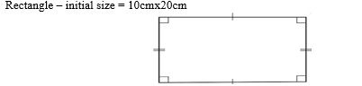

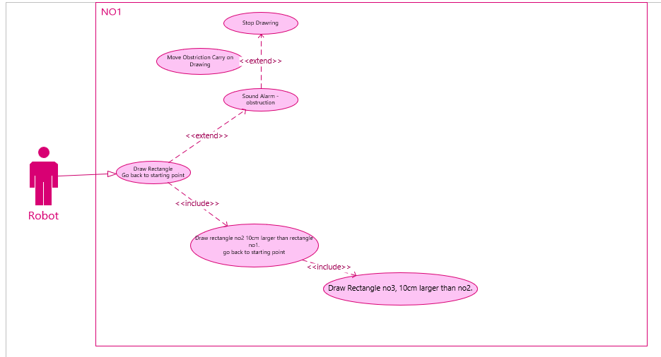
Rectangle UML

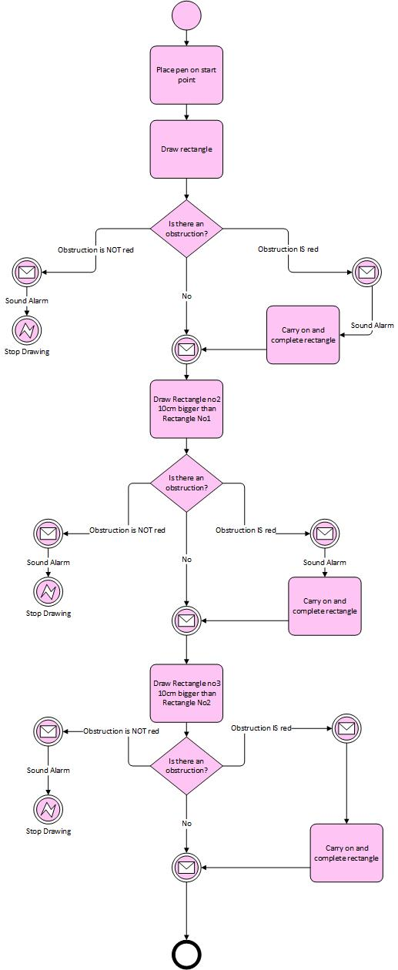
Rectangle BPMN
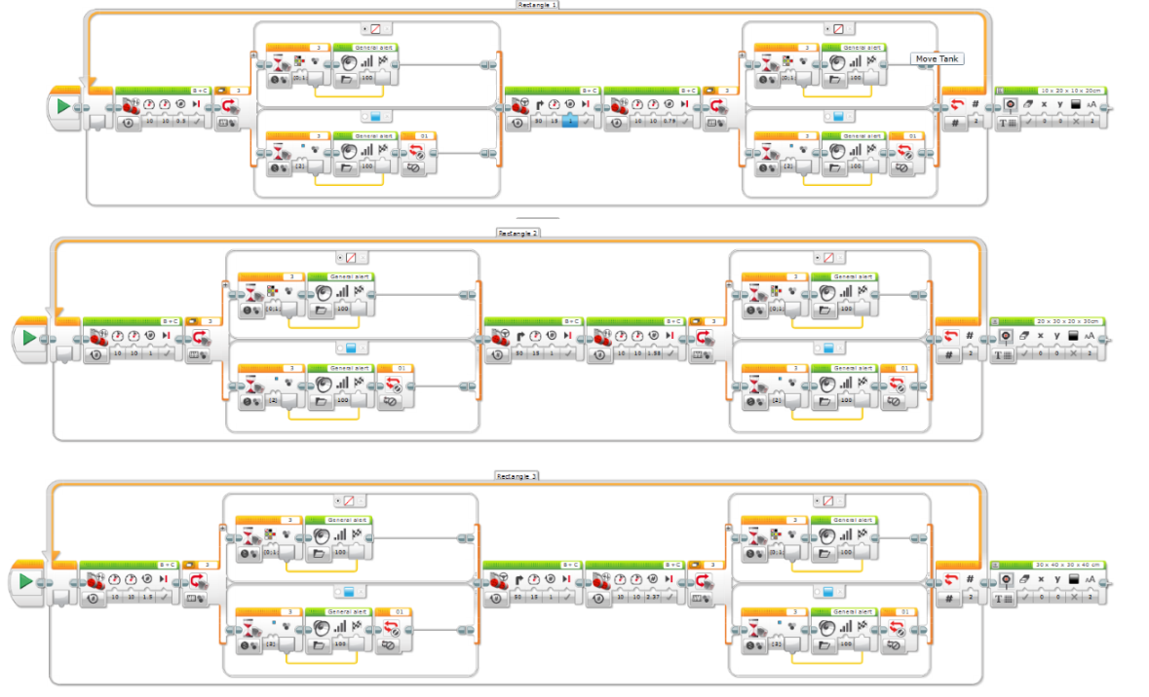
Code for Rectangle

Attempted rectangle

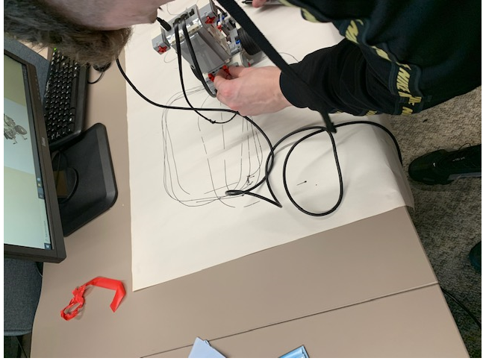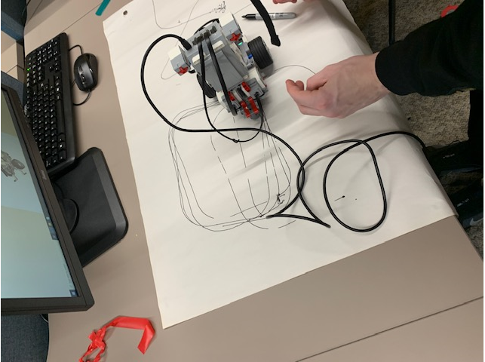

Although the attempt wasn’t successful for the three different shape sizes the group did achieve multiple one size rectangles. The cause of this may have been that the robot was too heavy which was causing the shape to be unsuccessful. If this was to be done again the building of the robot could potentially need to change the brick may possibly need to move to the middle to create a better weight ratio. Another attribute to success could be more time.

Use Case ID: | NO2
Use Case Name: | Draw 3 Right angled triangles
Created By: | Emily Stockdale
Date Created: | 08/01/2020

Actor(s): | Lego Mindstorms Robot
Description: | - The Leggo Robot will hold a pen and draw 3 right-angled triangles. Each triangle will have to be 10cm larger than the last one.
Preconditions: | - The code will be uploaded into the robot using the EV3 programming environment.
Postconditions: | - For each right-angle triangle drawn a 10cm increase is needed.  - Calculations of the area of each triangle are printed to the display
Normal Course: | - Robot draws triangle and then goes back to the starting point  - The second triangle needs to be 10cm bigger than the previous triangle and then goes back to starting point  - The final triangle 10cm bigger than the previous triangle and then goes back to the starting point
Alternative Courses: | - If the robot comes across an obstruction and it is red then it will stop, raise a ‘sound alarm’, move the object and carry on  - If the obstruction is not red the robot stops and stops drawing
Initial Shape: | 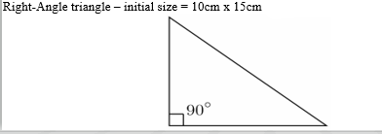

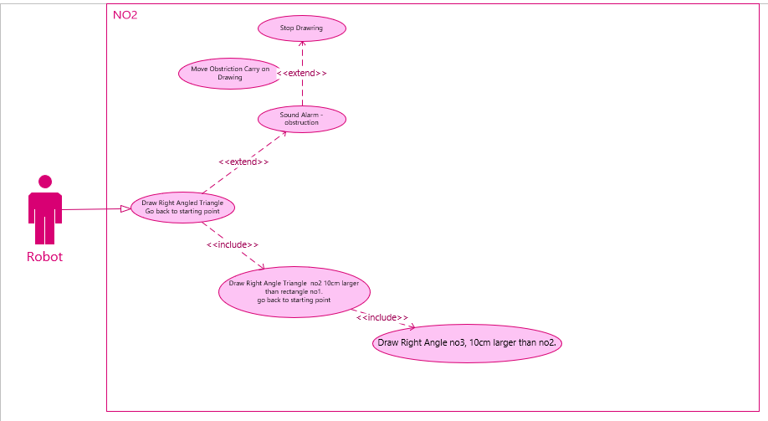
Right Angled Triangle UML

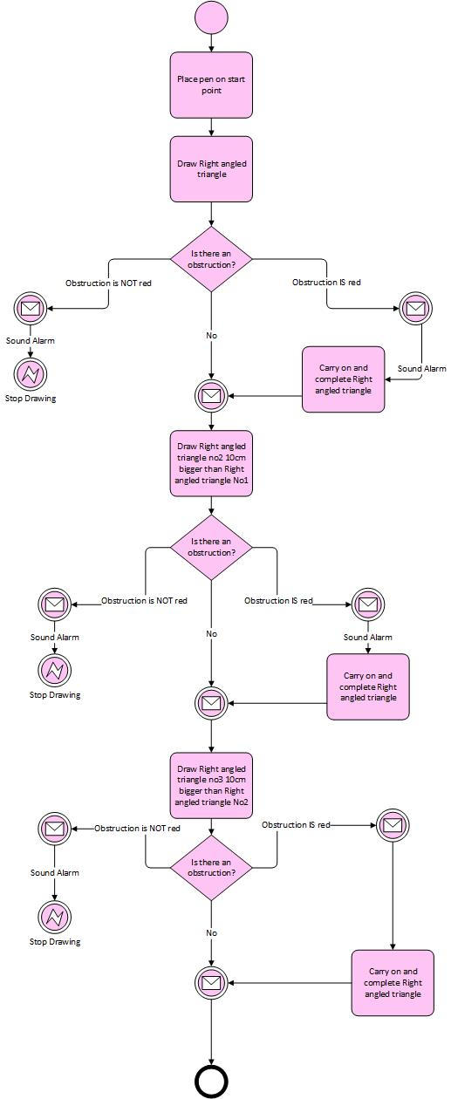
Right Angled Triangle BPMN
Right Angled Triangle

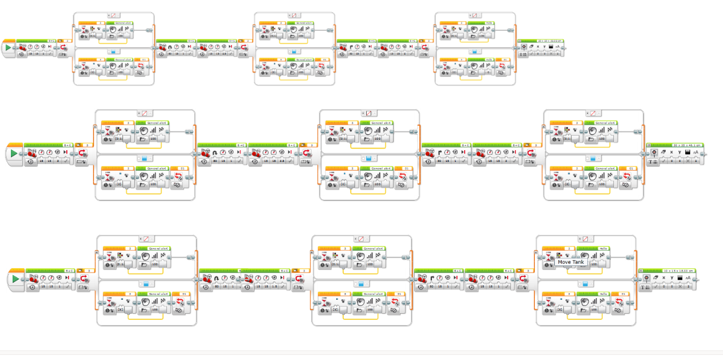

Right Angled Triangle Attempt

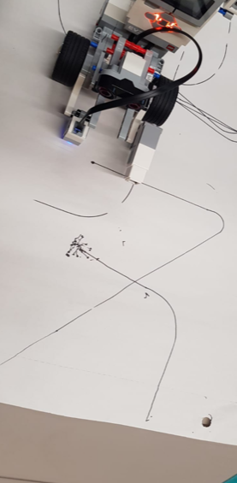
Although the right-angled triangle wasn’t successful this may have also been down to the weight of the robot which was heavy from the back. The time given for the building and testing of the code could have been longer to allow the group to make any changes if needed. The code is simple to change but the changes on the building of lego can take some time. There is a skill to creating a level robot with a space to allow for the pen.

Use Case ID: | NO3
Use Case Name: | Draw 3 Squares with a Circle in Each One
Created By: | Emily Stockdale
Date Created: | 08/01/2020

Actor(s): | Lego Mindstorms Robot
Description: | - The Robot will hold a pen and draw squares, each square will have a circle inside of it. Each shape will be 10cm larger than the last one.
Preconditions: | - The code will be uploaded into the robot using the EV3 programming environment.
Postconditions: | - The robot will need to drawer 3 squares with a circle in the middle  - Every shape will have a 10cm increase
Normal Course: | - Robot draws a square with a circle in and then goes back to the starting point  - Robot draws a second square with a circle in 10cm bigger than the previous shape and then goes back to the starting point  - Robot draws a final square with a circle in 10cm bigger than the previous shape and then goes back to the starting point
Alternative Courses: | - If the robot comes across an obstruction and it is red then it will stop, raise a ‘sound alarm’, move the object and carry on  - If the obstruction is not red the robot stops and stops drawing
Initial Shape: | 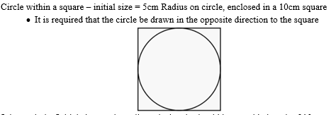

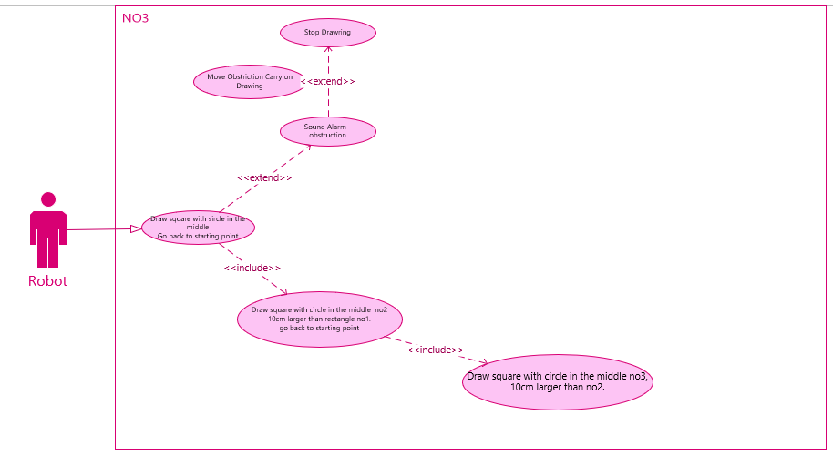
Square with a circle in the middle UML

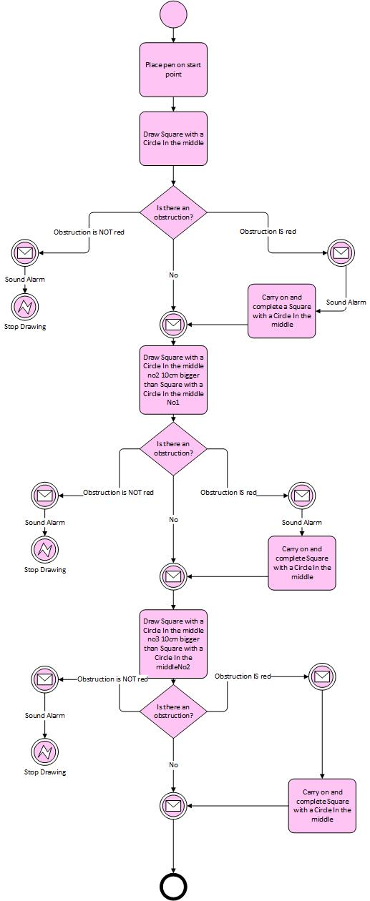
Square with a circle in the middle BPMN
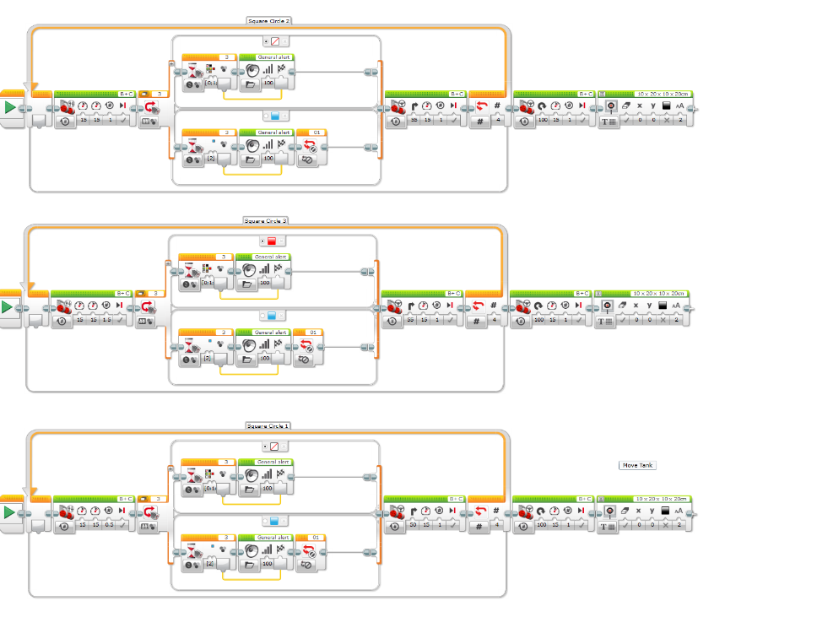
Square with a circle in the middle

Square with a Circle in the Middle

Although there is no photographic evidence the attempt for the square with a circle in the middle failed. The result of this could be best described as a ‘blob’ there is no explanation for this as it could have been a result of the paper being uneven and scrunching or again it could have been down to the building of the robot. Due to time there was no way of testing if the issue was the code or the robot and considering the battery needed charging every few attempts this was very difficult.

Use Case ID: | NO4
Use Case Name: | Draw 3 Join Symbols
Created By: | Emily Stockdale
Date Created: | 08/01/2020

Actor(s): | Lego Mindstorms Robot
Description: | - The Robot will draw 3 join symbols using a pen. Each shape needs to be 10cm bigger than the last one.
Preconditions: | - The code will be uploaded into the robot using the EV3 programming environment.
Postconditions: | - 3 join symbols need to be drawn  - Each shape needs to increase by 10cm
Normal Course: | - Robot draws a join symbol and then goes back to the starting point  - Robot draws a join symbol in 10cm bigger than the previous shape and then goes back to the starting point  - Robot finally draws a join symbol 10cm bigger than the previous shape and then goes back to the starting point
Alternative Courses: | - If obstruction appears along the drawing path and is red the robot halts, raises a sound alarm, removes object, and continues course  - If obstruction appears along the drawing path and is not red the robot halts, raises sound alarm, and stops drawing
Initial Shape: | 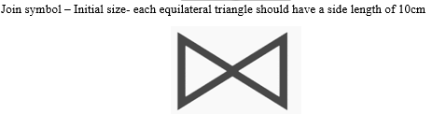

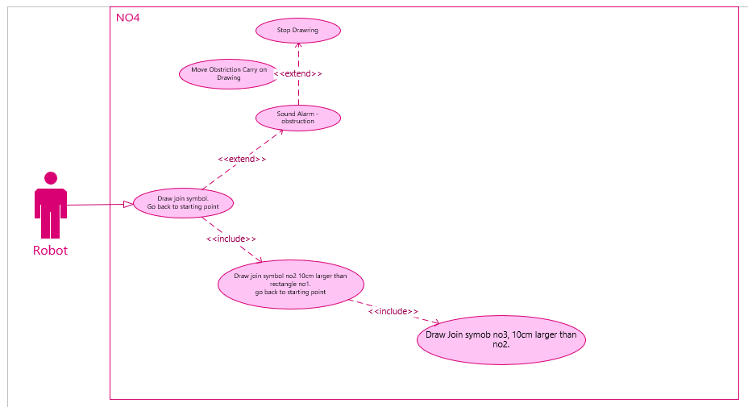
Join Symbol UML

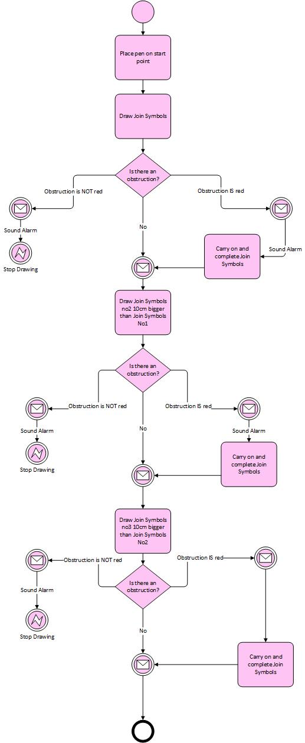
Join Symbols BPMN
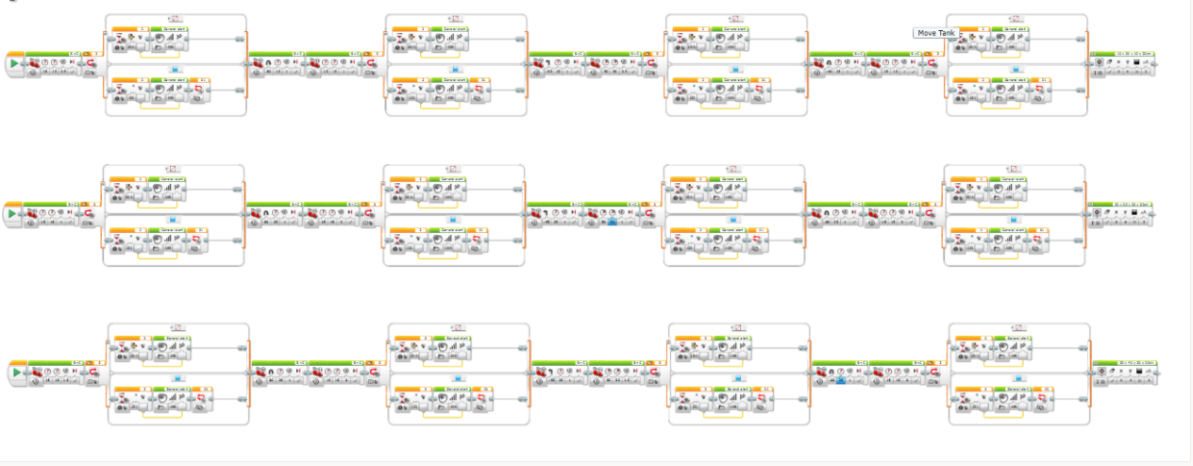
Join Symbols Code

Join Symbol Attempt

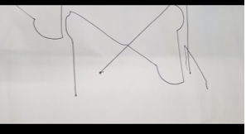

The join symbol was the most successful of the four diagrams, although there is only one example. The reason for the one example is the fact that the battery had died and there was not enough time to continue testing after the battery was charged. The group agreed that the test attempt was enough as it was as close to success as possible.

