Strategies for Resilience and Prosperity – Assignment 1

Report

Module Code: BMSP6006
Module Tutor: Glenn Behenna

Lauren Emily Price
Student Number: 1807244

CONTENTS
1.0 EXECUTIVE SUMMARY 2
2.0 INTRODUCTION 2
2.1 COMPANY BACKGROUND 3
2.2 OBJECTIVES OF THE REPORT 3
2.3 BUSINESS LEVEL STRATEGY/ COMPETITIVE STRATEGY 4
3.0 MAIN FINDINGS 5
3.1 GENERAL OVERVIEW OF THE LEGO GROUP’S STRATEGY 5
3.2 STRATEGY ANALYSIS OF THE LEGO GROUP 6
3.2.1 STAKEHOLDER ANALYSIS 7
3.2.2 SWOT ANALYSIS 9
3.2.3 BOWMANS STRATEGIC CLOCK 11
4.0 CONCLUSION 12
5.0 REFERENCES 13

EXECUTIVE SUMMARY
This report attempts to provide detailed strategic analysis in terms of current and future business strategy/strategies of The LEGO Group through the application of strategic management tools including that of a Stakeholder Power and Interest Analysis, a SWOT Analysis and a Bowmans Strategic Clock Analysis.
The findings highlight specific areas of intended strategy and emergent strategy within the organisation which is particularly relevant in terms of the internal and external environment in which the organisation actually exists. These internal and external factors play an extremely important role in strategic decision making.
LEGO’s strategy is a continuing work in progress that is constantly evolving to accommodate change therefore it is important that strategy is monitored and evaluated periodically to ensure a more flexible and agile strategic approach.

INTRODUCTION
Experts and theorists have studied the concept of strategy for years and have many conflicting thoughts and suggestions as to what strategy actually means.
Strategic Management theorists, Johnson et al define strategy as being the determinant force in terms of the direction and scope that a particular organisation takes over the long term. They believe that strategy should determine and identify how relevant resources should be allocated and utilised to meet the requirements of the market and the organisation’s stakeholders to achieve an advantage within an ever-changing environment in which the organisation exists. (Johnson et al., 2016). Strategy Expert, Michael Porter however, suggested that strategy can be described as more of a competitive position in terms of determining and allocating the utilisation of an organisation’s resources, skills, and competencies in the best possible way to create a competitive advantage over its rivals. Within his findings, Porter highlighted the importance of understanding the market in which the organisation exists as well as understanding its competitors. (Mindtools, 2020). The Mintzberg on Strategy YouTube video noted that Henry Mintzberg believed that due to the fast paced, ever changing environment in which organisations exist, being highly driven by technological advances, most strategies do not come from a formulated plan but tend to emerge through identifying a problem and then being able to adapt. He emphasized an “emergent strategy” approach. (Fasth, 2016).
An organisation’s strategy tends to be a combination of intended (planned) strategies which are often historic and emergent strategies (more agile) which result in realised strategies. An organisation’s strategy is a work in progress which must be able to evolve and adapt in relation to the environment in which it exists. (Mintzberg & Waters, 1985).
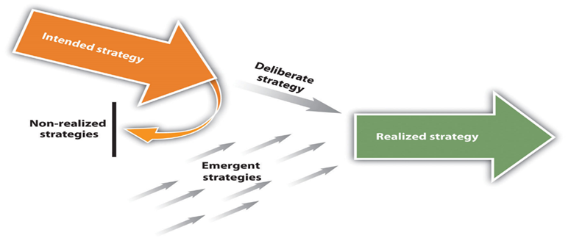(Ibid).

COMPANY BACKGROUND
LEGO, named after the Danish phrase “leg godt” (meaning ‘play well’), began its life circa 85 years ago in a small carpenter’s workshop located within the village of Billund, Denmark, making small wooden toys. Today, it is considered a global enterprise being one of the world’s leading toy manufacturers. The LEGO brick can be considered as the most important product of LEGO to date since its creation in 1958. Over the year’s LEGO’s products have seen significant development and innovation but the traditional LEGO brick remains the foundation of the entire organisation. (LEGO Group, 2020).
The simple and basic LEGO brick has stayed the same since the day it was patented, and its child-friendly design has paved the foundations of many childhoods throughout the world. (Augustyn, 2018). This simple, fully recognisable design has ensured the longevity of consumer loyalty, trust, and brand awareness.
LEGO has 50 companies all over the world and employs over 17.000 people. (LEGO Group, 2020). LEGO’s products are sold in more than 130 countries and its business focus is on manufacturing, marketing, development, and the distribution of LEGO toys worldwide.
The LEGO Group also co-owns a chain of six LEGO theme park resorts as part of Merlin Entertainments in Denmark, England, Germany, Malaysia, California and Florida. (Statista, 2020).
From Statista it is noted that in 2019, the LEGO Group recorded a revenue amounting to circa 5.16 billion euros. (Statista, 2020).

OBJECTIVES OF THE REPORT
This report will attempt to analyse the internal and external environment of The LEGO Group in terms of its current business strategy/strategies by drawing upon appropriate academic theories and models in the form of relevant strategic management tools including a Stakeholder Power and Interest Analysis, a SWOT Analysis and a Bowmans Strategic Clock Analysis. Through detailed analysis, the report will highlight aspects of sustainability and resilience through the application of these strategic management tools and will provide greater understanding of the current strategy/strategies of the organisation.
This report will provide a comprehensive and critically reflective analysis, providing relevant facts publicised about the organisation as well as being linked to appropriate academic literature.

BUSINESS LEVEL STRATEGY/ COMPETITIVE STRATEGY
To successfully analyse LEGO’s current business strategies, it must first be understood what is meant by Business Level Strategy and Competitive Strategy. Only then can the critical application of relevant strategic management tools be utilised.
Business level strategy can be described as the activities an organisation undertakes to achieve an advantage over its competitors and in terms of the decisions it has made. Long term performance of the organisation is linked to appropriate strategic decision making. (Seker, 2020). The main purpose of business level strategy is to identify and create differences between the position of the organisation and the position of its competitors and utilise this to the organisation’s advantage. In simple terms, business level strategy determines the decisions and actions that are taken within the organisation to position itself away from its competitors. (Ibid).
Management expert, Henry Mintzberg developed the ‘5 P’s of Strategy’ – Plan, Ploy, Pattern, Position and Perspective and these focused on five different approaches to developing strategy. He suggested that by fully understanding each particular ‘P’, it would be possible for an organisation to exploit their strengths and abilities and utilise them to their full advantage in order to develop a strong, successful and achievable business strategy. (Mind Tools, 2020).
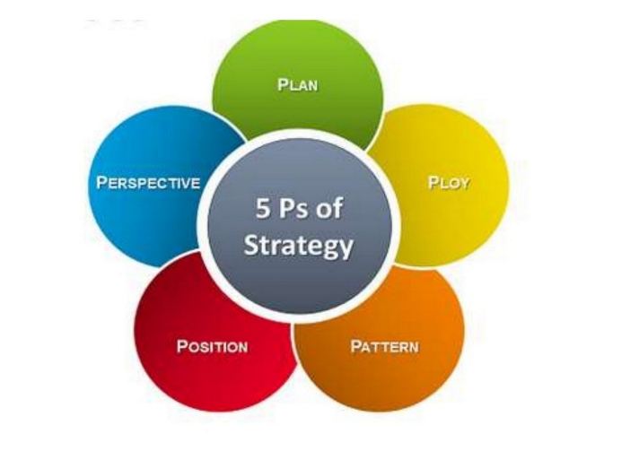
Mintzberg’s 5 P’s of Strategy: -

(Bhasin, 2018)

Competitive strategy is described as a long-term plan of action that is taken by organisations to obtain an advantage over competitors within the industry in which it sits.
Michael E Porter was quoted saying that “competitive strategy is about being different. It means deliberately choosing a different set of activities to deliver a unique mix of value”. (Johnson et al., 2016). In 1979, Porter developed the Porter’s Five Forces of Competitive Position Analysis which can be used to assess and evaluate an organisation’s competitive strength and position in the environment in which it exists. The concept is based on five specific competitive forces that determine the organisation’s position in term of its competitiveness within the market as well as determining the organisation’s strengths and weaknesses. The tool is useful for organisations to identify and comprehend factors that may affect profitability and aids decision making in terms of developing competitive strategies. (CGMA, 2013). It should be noted however, that the tool must be monitored and repeated continually over time to adjust in terms of the organisation’s strategy. (Chappelow, 2020).
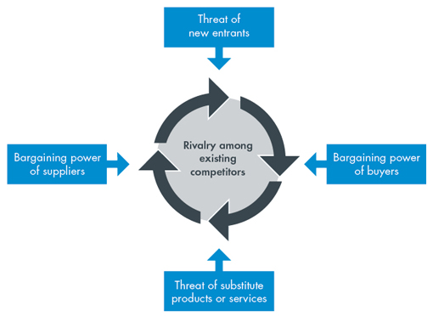
Porter’s Five Forces: -

(CGMA, 2013)

MAIN FINDINGS

GENERAL OVERVIEW OF THE LEGO GROUP’S STRATEGY
It is possible to understand LEGO’s strategies by extracting information from their beliefs, mission statement, vision, ideas, core values, promises and their spirit. By breaking down and piecing together the relevant information, this provides a clear picture of their current strategies.

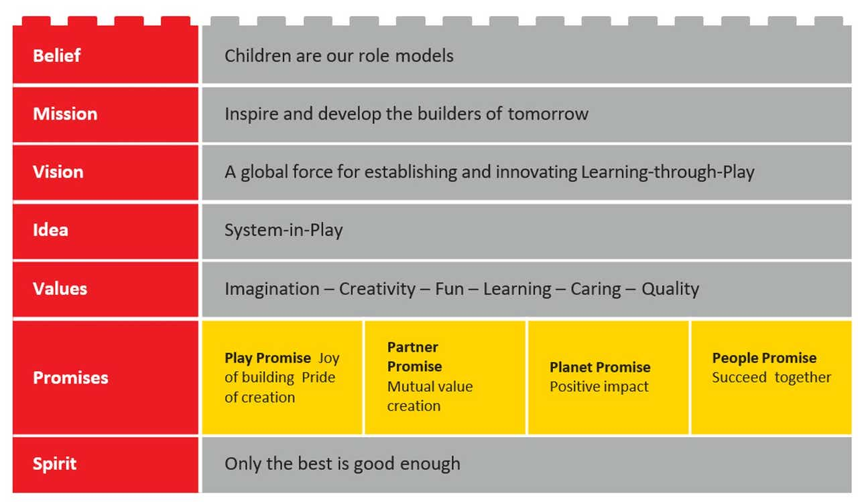

(LEGO Group, 2020)
LEGO focus their strategies around children and their mission statement to “inspire and develop the builders of tomorrow” encompasses this. Their strategies are formed from their six core values and are based around the innovation of high-quality toys while developing children’s creativity and imagination by learning through unstructured play.
LEGO have also developed four key promises which again form part of their organisational strategy and provides further insight into their goals and objectives for the future.
The People Promise ensures a safe, healthy, and respectful working environment for all at LEGO and ensures all human rights are upheld.
The Play Promise focuses on play and its importance to a child’s development. Play creates opportunities to develop learning through problem solving, to be creative and become resilient in a fast paced, challenging world.
The Planet Promise aims to build a sustainable future for all by making a positive impact to society and the planet. Its strategy focuses on minimising the environmental impact LEGO’s operations have on the planet with an aim for zero environmental impact in the future.
The Partner Promise pinpoints its strategy on the importance of creating strong partnerships with suppliers, customers, and stakeholders based on mutual respect and creating value while facing challenges seen in the marketplace.
(LEGO Group, 2020).
A further clear focal point of LEGO’s overall organisational strategy plan is their innovation strategy. LEGO concentrates much of its efforts into the development of new concepts through its products and aims for this every 2-3 years. (Ebrary, 2020).

STRATEGY ANALYSIS OF THE LEGO GROUP
Strategic management can be described as the management of an organisation’s resources in terms of allocation and utilisation to best achieve their set goals and objectives. The process of strategic management requires analysis of the internal and external environment in which the organisation exists to set achievable objectives and how to implement strategy that is best suited to the organisation itself. (Kenton, 2020).
Strategic management can also be defined as the process of identifying, selecting, and implementing an organisation’s goals and objectives over the long-term. (APM, 2020). Strategic management aims to achieve a competitive advantage by way of strategic analysis in terms of continuous strategy development including strategy implementation and control/monitoring. (Jurevicius, 2013).
In basic terms, strategic management is used by organisations to plan and prepare for the future in relation to its internal and external environment and how it will implement a strategic plan to achieve its goals/objectives and gain an advantage over its competitors.
Resilience plays an extremely important role in strategic management. Organisations develop their strategies as a way of forward planning to adapt to a multitude of different unforeseen operating difficulties within the environment in which it exists. (Coffaro, 2020). Many organisations today recognise that sustainability is a driving force in business and their Corporate Social Responsibility forms part of their strategic long-term plan. Sustainability is redefining organisations particularly in terms of product design to meet environmental standards which not only benefit their stakeholders including their employees, shareholders, suppliers etc. but also the planet and the wider environment in which it exists. (Ibid).
Below is a selection of strategic management tools that organisations may use to implement their strategic plan and identify their competitive position to achieve competitive advantage. These tools have been applied to The LEGO Group to provide detailed strategic analysis.

STAKEHOLDER ANALYSIS
Mendelow (1991), a well-known theorist, developed an extremely useful model used in strategic management, known as The Power Interest Matrix. The model aims to identify stakeholders, their level of power/interest in relation to an organisation and how best to manage them. (Oxford College of Marketing; 2020).
The diagram below shows the identification of LEGO’s stakeholders and their position on the grid refers to their level of interest and power in relation to the organisation. It is important to note that when identifying stakeholders in terms of interest, one must consider the stakeholder’s perspective and not the individual carrying out the analysis. (Smith, 2000). A stakeholder’s level of power can be derived from their level of hierarchy or their economic, political, or social position. (Ibid)

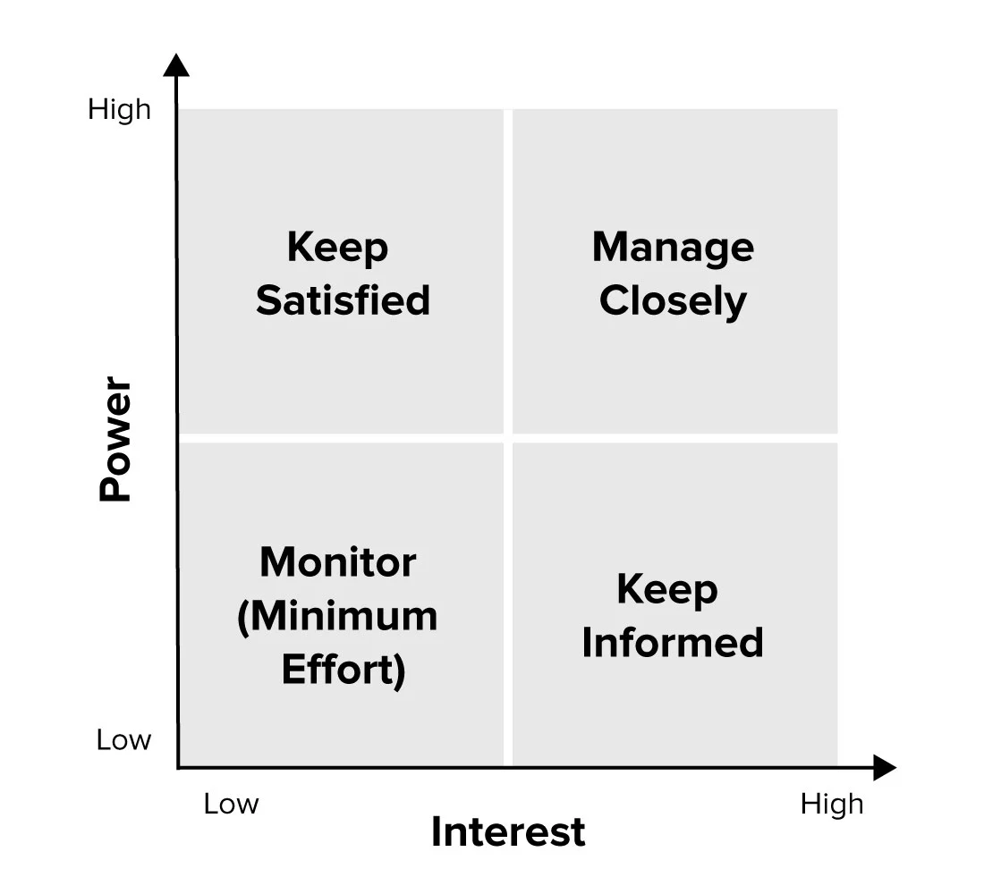
POWER INTEREST MATRIX FOR THE LEGO GROUP

Customers
Employees
Management
Government

Special Interest Groups

Suppliers

Communities

Competing Businesses
Advertisers

Interestingly, employees have been placed in the matrix within Manage Closely and as being of high interest/high power and the reasoning behind this derives from Peter Drucker’s quote, “culture eats strategy for breakfast”. (MC,2020). Drucker believed that people are fundamental to creating a strong, powerful culture which ultimately leads to success within an organisation. (MC, 2020). By keeping employees informed and involved with decision making and ensuring they are a part of the organisation’s strategic plans, ensures strong relationships between management and their employees. It is the quality of these relationships that determine the success of the organisation and ultimately, the successful implementation of the organisation’s intended strategies. (Drucker, 1977).
Competing businesses have been placed in the matrix within Monitor (Minimum Effort) and as being very low interest/low power since there is very little in the way of competition for The LEGO Group. LEGO is one of the worlds most respected toy companies which focuses on high quality, innovation, and investment of their staff. (Handley, 2020). This has ensured they maintain their good reputation with very little competition.
Special interest groups have been placed within Manage Closely on the grid showing they have relatively high power and medium interest. Greenpeace, for example had an extremely negative impact to the organisation back in 2014 when they highlighted LEGO’s close partnership with the oil company, Shell (one of the planet’s biggest polluters). (Ayech, 2014). Greenpeace accused LEGO of not choosing its suppliers responsibly or ethically, which made a mockery of LEGO’s actual core values and strategy plans in which they state they wish to make a better world for children and aim to have no environmental impact on the planet. (Ibid). Special interest groups, such as Greenpeace have the ability to negatively affect an organisation’s reputation.
The Power Interest Matrix is extremely useful to prioritise stakeholders in terms of determining how best to manage them. It should be noted however that the results garnished from using this tool are highly subjective and are dependent upon the individual applying the analysis. Also, interestingly, the tool doesn’t provide any analysis as to whether the interest of a stakeholder is positive or negative.

SWOT ANALYSIS
A SWOT Analysis is a strategic management tool which is used to identify Strengths, Weaknesses, Opportunities and Threats within an organisation in terms of its competitive position. A SWOT Analysis is used for organisational strategy planning and development and its analysis focuses on internal and external factors including current and future potential factors. (Grant, 2020).
The table below shows a SWOT Analysis for The LEGO Group and points are listed in order of priority.

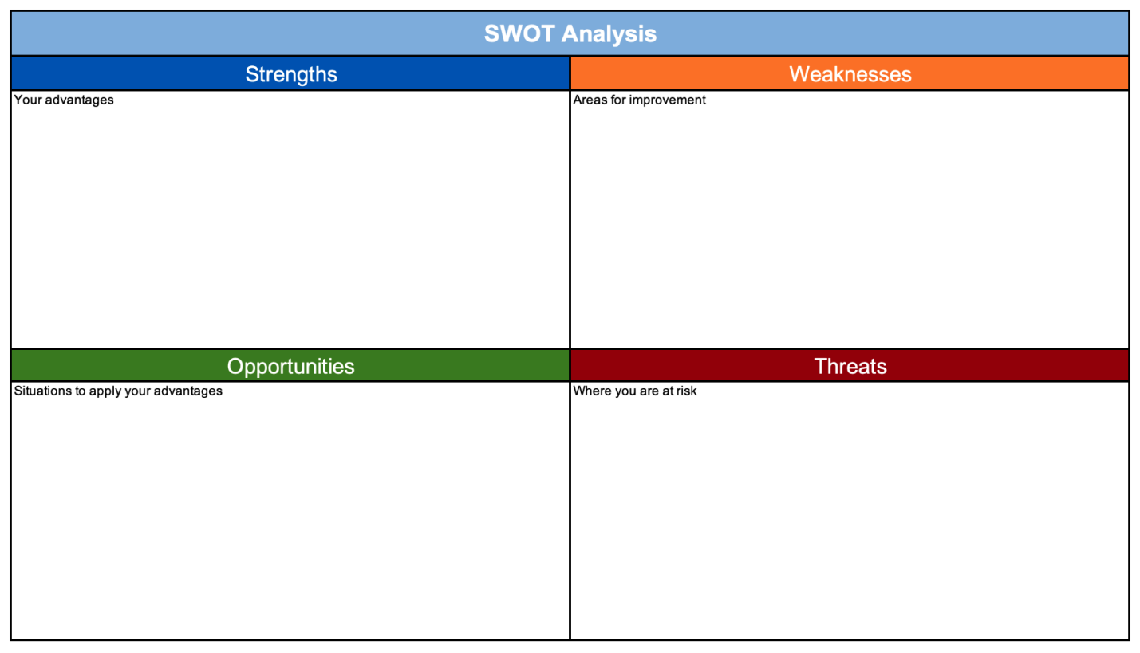
SWOT ANALYSIS FOR THE LEGO GROUP
- Expensive – LEGO is one of the more premium priced toys on the market.
- High grade plastic used to create LEGO bricks is expensive.
- Technological gaming advances seen today mean traditional toys are phasing out with children not understanding how to play.
- Potential to over innovate. (HISCOX, 2020).
- Global pandemic – COVID-19
- LEGO is expensive therefore consumers may look to purchase cheaper alternatives.
- Threat of imitation and counterfeit which may be bought as a cheaper alternative.
- To develop more sustainable materials in product development to adapt to consumer and environmental demands.
- Parents more likely to invest in toys that provide educational value via learning through play as they become more aware of the negative impact of technological devices.
- Educational settings to invest in LEGO as a learning tool.
- Highly reputable, trusted, and well-established company.
- Unlimited innovation potential – based on LEGO’s connection with movie franchises.
- Fully patented LEGO brick design with unlimited build possibilities making it a toy of longevity.
A SWOT Analysis provides clear definition between internal and external factors which is highly beneficial in terms of making strategic planning decisions. It is helpful to note however that a SWOT risks being extremely subjective based on the individual carrying out the analysis. A SWOT also focuses more on the factors at present rather than historical or future perspectives. (Grant, 2020).
What is interesting to note from the SWOT is that LEGO’s strengths and weaknesses are connected and interlink with each other in terms of innovation. In 2003 LEGO fell foul to over innovation and almost hit bankruptcy. The market at that time was already full of new and innovative technology and LEGO exhausted too many of its options. LEGO then focused on a strategy to monitor and manage the innovation of new products. (HISCOX, 2020).
As sustainability calls for change in business, LEGO should look to utilise sustainable resources in product manufacturing. Organisations are being pushed to do the right thing in terms of following their Corporate Social Responsibility and to do what is ethically right. In order to achieve resilience, LEGO’s strategic plan must contain a sustainability strategy in order to succeed. (Fisher, 2018).
Threats of the current COVID-19 global pandemic has affected most all organisations on a global scale and has caused change and uncertainty, requiring that organisations rethink the way in which they operate and to be resilient in terms of future planning.

BOWMANS STRATEGIC CLOCK
Bowman’s Strategic Clock is a useful strategic management tool used to illustrate its competitive position in the marketplace based on two particular focus points, namely, price and perception of value. Bowmans Strategic Clock depicts various market positions where an organisation’s customers may have alternative requirements in relation to value for money. (Johnson et al, 2011).
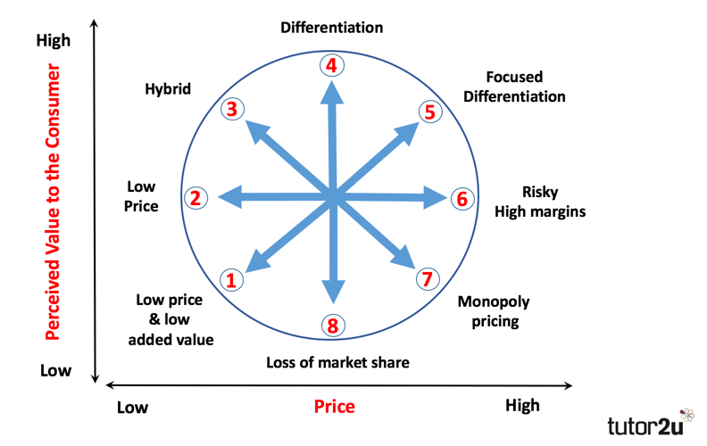
BOWMANS STRATEGIC CLOCK FOR THE LEGO GROUP



LEGO has been placed between position 4 and 5, Differentiation and Focused Differentiation with slightly more focus towards Differentiation.
Branding and high quality are the core focus points of a Differentiation Strategy and a Focused Differentiation Strategy aims to achieve premium prices for a product. The concept behind these strategies is to offer a high level of perceived added value. (tutor2u, 2018). LEGO is unique and offers extremely high-quality with a vast product line. There are very few who would be able to imitate and/or replicate their concept without a great deal of capital behind them. LEGO are well respected, trusted and have gained consumer loyalty which allows them to place premium prices on their products. LEGO is able to maintain its position and competitive advantage.
Bowmans Strategic Clock is particularly useful as a visual representation to aid decision making in terms of competitive advantage and positioning within the marketplace. (Johnson et al, 2011). It should be noted however that the tool is highly subjective to the individual carrying out the analysis and positions 6, 7, and 8 provide no validity within the competitive market whatsoever. By only choosing one position on the clock, an organisation risks losing focus elsewhere.

CONCLUSION
Strategic management tools are highly useful for an organisation such as The LEGO Group to identify their competitive position within the market to achieve a competitive advantage and implement their strategic plan however, much of the analysis is highly subjective and results from much interpretation from the individual carrying out the analysis. It is important to note that analysis and application of specific strategic management tools should be undertaken regularly, on a periodic basis to account for changes made to strategic decisions based on the ever evolving internal and external wider environment. Strategy can be described as an emergent process, constantly evolving because of fast paced change within the wider environment. Modifications and adaptions may be necessary periodically to react to changes within the environment to aid resilience in the marketplace and gain prosperity and it may be worth using a variety of tools at any one time to obtain a broader understanding. There is no one tool that is more superior that another although some may be better suited dependent upon the strategic decision-making process.
LEGO are a highly reputable, well-established organisation with an extremely loyal consumer base and their emergent strategies and resilient approach suggest they can remain a competitive leader within the marketplace for a long time to come.

REFERENCES
APM. (2020). What is Strategic Intent. Available at: https://www.apm.org.uk/resources/what-is-project-management/what-is-strategic-intent/ (Accessed: 12 October 2020).
Augustyn, A. (2018). LEGO. Available at: https://www.britannica.com/topic/LEGO (Accessed: 11 October 2020).
Ayech, S. (2014). LEGO: Everything is NOT awesome. Available at: https://www.greenpeace.org/international/story/7049/lego-everything-is-not-awesome/ (Accessed: 13 October 2013).
Bhasin, H. (2018). The 5 P’s of Strategy explained. Available at: https://www.marketing91.com/the-5-ps-of-strategy-explained/ (Accessed: 14 October 2020).
CGMA. (2013). Porter’s Five Forces. Available at: https://www.cgma.org/resources/tools/essential-tools/porters-five-forces.html (Accessed: 11 October 2020).
Chappelow, J. (2020). Porter’s 5 Forces. Available at: https://www.investopedia.com/terms/p/porter.asp (Accessed: 11 October 2020).
Coffaro, D. (2020). Strategic Resilience. Available at: https://leadchangegroup.com/strategic-resilience/#:~:text=Strategic%20Resilience%20is%20the%20practice,fluidity%20in%20the%20operating%20environment. (Accessed: 14 October 2020).
Drucker, P. (1977). People & Performance: The Brest of Peter Drucker on Management. Available at: https://books.google.co.uk/books?hl=en&lr=&id=fI0VYReBpI8C&oi=fnd&pg=PR1&dq=peter+drucker+relationship+in+an+organizational+culture&ots=5hSnKvLFiF&sig=0eAWMjn4xrUzDOZj6IdEsHVXlKE#v=onepage&q=relationship&f=false (Accessed: 13 October 2020).
Ebrary. (2020). The LEGO Group Strategy. Available at: https://ebrary.net/9823/management/lego_group#:~:text=The%20LEGO%20Group's%20mission%20is,strategy%20and%20an%20innovation%20strategy.&text=Growth%20strategy.,a%20number%20of%20growth%20drivers. (Accessed: 12 October 2020).
Fasth, J. (2016). Mintzberg on Strategy. Available at: https://www.youtube.com/watch?v=_vpvU5fIyOA (Accessed: 1 October 2020).
Fisher, D. (2018). The Millennial Consumer: A Driving Force For Corporate Sustainability. Available at: https://ecosphere.plus/2018/01/22/millennial-consumer-driving-force-corporate-sustainability/ (Accessed: 14 October 2011).
Grant, M. (2020). Strength, Weakness, Opportunity, and Threat (SWOT) Analysis. Available at: https://www.investopedia.com/terms/s/swot.asp (Accessed: 13 October 2020).
Handley, L. (2020). Lego is the world’s most reputable company as tech giants lag, survey says. Available at : https://www.cnbc.com/2020/03/03/lego-is-the-worlds-most-reputable-company-disney-follows.html#:~:text=Lego%20has%20topped%20a%20list,10%20every%20year%20since%202011. (Accessed: 13 October 2020).
HISCOX. (2020). Adapt or die: eight businesses that transformed their business models to survive. Available at: https://www.hiscox.co.uk/broker/about-hiscox/news/adapt-or-die-eight-businesses-transformed-their-business-models-survive (Accessed: 13 October 2020).
Johnson, G, Scholes, K and Whittington, R (2011) Exploring Corporate Strategy: Text and Cases, London: Prentice Hall.
Johnson, G., Whittington, R., Scholes, K., Angwin, D., Regner, P. (2016). Exploring Strategy (11th ed.). Pearson Education.
Jurevicius, O. (2013). Strategic Management and Strategic Planning. Available at: https://strategicmanagementinsight.com/topics/strategic-management-planning.html#:~:text=Strategic%20management%20is%20a%20continuous,and%20maintain%20a%20competitive%20advantage. (Accessed: 12 October 2020).
Kenton, W. (2020). Strategic Management. Available at: https://www.investopedia.com/terms/s/strategic-management.asp (Accessed: 12 October 2020).
LEGO Group. (2020). Careers. Available at: https://www.lego.com/en-gb/aboutus/careers/#:~:text=Today%20we%20are%20more%20than,' (Accessed: 11 October 2020).
LEGO Group. (2020). The LEGO Brand. Available at: https://www.lego.com/en-gb/aboutus/lego-group/the-lego-brand/ (Accessed: 11 October 2020).
LEGO Group. (2020). The LEGO Group History. Available at: https://www.lego.com/en-gb/aboutus/lego-group/the-lego-group-history/ (Accessed: 11 October 2020).
Mind Tools, (2020). Stakeholder Analysis. Available at: https://www.mindtools.com/pages/article/newPPM_07.htm (Accessed: 12 October 2020).
Mind Tools. (2020). Mintzberg's 5 Ps of Strategy. Available at: https://www.mindtools.com/pages/article/mintzberg-5ps.htm (Accessed: 11 October 2020).
Mind Tools. (2020). What is Strategy. Available at: https://www.mindtools.com/pages/article/what-is-strategy.htm (Accessed: 8 October 2020).
Mintzberg, H., & Waters, J. A. (1985). Of strategies, deliberate and emergent. Strategic Management Journal, 6, 257–272.
Oxford College of Marketing. (2020). What Is Mendelow’s Matrix And How Is It Useful? Available at: https://blog.oxfordcollegeofmarketing.com/2018/04/23/what-is-mendelows-matrix-and-how-is-it-useful/ (Accessed: 12 October 2020).
Seker, B. (2020). Business-Level Strategy. Available at : https://medium.com/@baturseker/business-level-strategy-7f065c5b904#:~:text=Business%2Dlevel%20strategy%20is%20an,compete%20in%20individual%20product%20markets. (Accessed: 11 October 2020).
Smith, L. W. (2000). Stakeholder analysis: a pivotal practice of successful projects. Paper presented at Project Management Institute Annual Seminars & Symposium, Houston, TX. Newtown Square, PA: Project Management Institute. Available at: https://www.pmi.org/learning/library/stakeholder-analysis-pivotal-practice-projects-8905 (Accessed: 13 October 2020).
Statista. (2020). Revenue of the LEGO Group from 2003 to 2019 (in billion euros). Available at: https://www.statista.com/statistics/282870/lego-group-revenue/ (Accessed: 11 October 2020).
The Management Centre. (2020). Culture Eats Strategy for Breakfast. Available at: https://www.managementcentre.co.uk/management-consultancy/culture-eats-strategy-for-breakfast/#:~:text=%E2%80%9CCulture%20eats%20strategy%20for%20breakfast,surer%20route%20to%20organisational%20success. (Accessed: 13 October 2020).
tutor2u. (2018). Bowman's Strategic Clock (Strategic Positioning). Available at: https://www.tutor2u.net/business/reference/strategic-positioning-bowmans-strategy-clock#:~:text=Bowman's%20Strategic%20Clock%20is%20a,competitive%20position%20in%20the%20market. (Accessed: 14 October 2020).

