2020
JENNIFER OSUNBOR

ID: 1808630
ASSIGNMENT 1
TUTOR: MAGDALENA WRONSKA

PRINCIPLES OF HEALTH AND SOCIAL CARE PRACTICE

Table of Contents

Introduction 2
Assessment and Intervention 2
Adopting a holistic approach 3
Policy and Practice 3
Common Core Principles 4
Developing the common core principles 5
Role of the Professional 7
Best Practice Implementation 8
Facing challenges and harnessing opportunities/ Conclusion 9

Introduction
The study about dementia has long been characterised by the highly "medical" concept of dementia: as a disease mainly associated with irreversible deterioration and defects, it is "no hope" Dementia is increasingly seen as a rights-based measure (Hung, et al., 2019). This has many benefits, including better legal protections, service privileges, and positive cultural changes in the ways of recognising and understanding dementia (including people with dementia themselves) (Oppert, et al., 2018). People with dementia at home surprised 70% of people with dementia in the UK, and they often choose to fall into people without dementia. The negative results of dementia patients are higher than other elderly people (Hunter, et al., 2016). Although even harmless falls can lead to psychosocial consequences, such as loss of self-confidence and fear of falling, the positive decline in the number of people who supported the injury may be greater than the number of people who did not continue to be injured. However, some studies have directly targeted trauma therapy for patients with dementia (Kadri, et al., 2018).
However, there is evidence that rehabilitation measures can improve the exercise inhibition ability of dementia patients, and physical exercise can improve the physical performance of dementia patients without increasing the risk of falls (Vernooij-Dassen & Moniz-Cook, 2016). The recently circulated rules recognise that multifactorial interventions may not be suitable for people with severe dementia, but they do not provide advice on the most ingenious way for Mrs.T.

Assessment and Intervention
Appropriate diagnosis, assessment and intervention services and various resources must be provided to solve individual problems and support healthy development, in an environment that restricts interference and inactivity at all levels, attention should be paid to flexible and personalised care programs (Hung, et al., 2019). Through interventions aimed at enhancing the abilities of people with dementia, their disease can progress, allowing them to live as neighbours most of the time. There may be problems with the "diagnostic vision" and the rationality of changes in behaviour, character or ability, and these problems will be widely accepted amongst the public (Swall, et al., 2020).
Cognitive assessment should be conducted directly with Mr. T in a perfect world, not based on the data of the caregiver, family or Mrs. T. There is no single cognitive test to diagnose dementia in people with Down syndrome/learning disability, and there is no consensus psychological motivation. Assess the intelligence used by the team in the UK (Vernooij-Dassen & Moniz-Cook, 2016).
Mr T, their caregivers, their family members and other people who support them should be informed, and participate in every stage of the evaluation, planning and service process as necessary (Oppert, et al., 2018). An individual approach is important, and it is important to remember to respect and provide all information, including rehabilitation, in a form that is important to the individual and his family/caregiver (Swall, et al., 2020).

Adopting a holistic approach
The general assessment of identifying and tracking Mrs. T's risk factors has become the main topic of discussion (Vernooij-Dassen & Moniz-Cook, 2016). This necrosis increases the risk of death during hospitalisation and hospitalisation of hip fractures in the elderly. Psychosocial factors such as depression and social isolation are also important for the health and recovery of patients with dementia after a fall (Swall, et al., 2020). General assessments such as the “Comprehensive Geriatric Assessment (CGA)” seem to improve the performance of people with developmental disabilities or delusions, Mr and Mrs. T caregivers understand the cause of the fall, and encourage early intervention for other health conditions that may undermine treatment (Berglund, et al., 2019).

Policy and Practice
There are some suggestions for studying dementia as a disability based on models, social rights and people’s response to dementia (Sjögren, et al., 2017). This article describes the social model of disability related to dementia, as well as the national and international laws that have been informed or related to it. It describes the tools that can be used to model online strategies, assesment, services, and improvements (Hung, et al., 2019). The social model of disability is use to advise and question the legal rights of patients with dementia, disability and public policy issues, and how dementia patients and their caregivers perceive and experience dementia and how to make it in a public place.
These devices have been developed to enhance the choice of rights-related methods and can be fully used in the formulation and implementation of dementia policies. However, the transition to the social model requires major changes at the micro and macro levels (individuals, institutions, and fundamentals). Many stakeholders are involved, their role in the model is completely changing, and the power factor must change (Kadri, et al., 2018).

Common Core Principles
This case study of Mr and Mrs T describes the general principles for supporting people with dementia. From the initial symptoms to the fully diagnosed condition, they can be used to improve the workforce of all health or social workers and individuals with dementia (Bateman, et al., 2016). They intend to win the trust of employees and arrange their activities and communications in a way that they respond correctly to Mr T at the end of the guide. (Berglund, et al., 2019). Although this guide is mainly written for health and social care, people who work in all situations where individuals interact with people with dementia should also pay attention to its principles and supporting information (Berglund, et al., 2019).
These principles can be applied to any customer service, which is equally important for people who work in the area (eg, shops and banks) and those who work in public places eg libraries, education, housing etc. The premise of writing these principles is that staff who support people in the later stages of dementia should receive professional training and support (Ballard, et al., 2018).

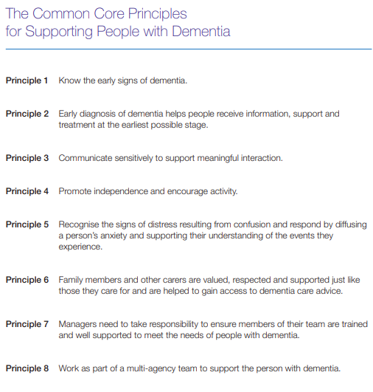

Developing the common core principles
Dementia refers to a series of symptoms characterised by a gradual loss of intellectual ability, which affects the ability to reason, match, and perform routine exercises related to daily life. This is an unpredictable condition that may be related to many clinical challenges and must be carefully identified (Bateman, et al., 2016). Over time, this situation may worsen and will have serious consequences for everyone involved. However, prudent motivation can provide a sense of security for the family and cause individuals to adapt their lifestyles to commit to the progress made and "live well with people with dementia." In patients with Alzheimer's disease over 80 years old, this disease is becoming more and more common. Knowing the first signs of dementia can be difficult and requires some investment (Kadri, et al., 2018).
The assessment requires appropriate information about Mr and Mrs T and careful consideration of physical factors to ensure that potential clinical changes are recognised. As individuals are affected and their families begin to understand the long-term consequences of this situation, sensitive support and compassion must be included in the identification process. Mr. T should be supported by those who are confident in adjusting their communication to reduce the stress and tension that may be caused by dementia (Ballard, et al., 2018). Support must be tailored to individuals and their personal interests and clear needs to encourage their autonomy and decision-making ability when making decisions (Cooney & O’Shea, 2019). The purpose of the principles outlined here is to enable health and social care institutions to become "demented" by actively supporting staff with dementia online, in medical centers or professional settings. We cited some resources that can be used informally or as part of a specific training program to implement agreements in the workplace (Berglund, et al., 2019).
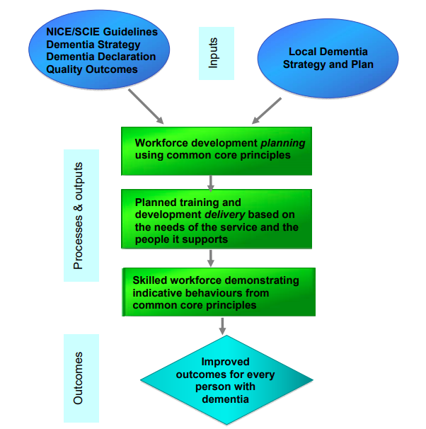

Role of the Professional
Support professionals to implement the wishes, requirements and expectations of the personal care plan. Professionals will continue to have direct and open discussions about the possible course of the disease in dementia (Bateman, et al., 2016). Professionals have created aspirations and networks to strengthen their regular investment in health, socialcare and independent services, and utilise multidisciplinary knowledge that different supervisors may have to maintain the well-being of dementia patients and their families (Cooney & O’Shea, 2019). When a person may have complex physical symptoms and complications, professionals must create information and desire perfect comfort, safety and prosperity. Professionals provide guidance and participate in conversations about keeping pace and improving a prosperous and healthy lifestyle where possible. Professionals are willing to distinguish between necessary, unnecessary or powerless interventions or treatments (Berglund, et al., 2019).
As the number of physical symptoms increases, more tests that meet the basic needs of individuals can be shown to identify and relieve physical pain and discomfort (Hunter, et al., 2016). When professionals accept that all progress that affects a person is related to dementia, it is easy to miss basic health need. In-depth bio psychological assessments starting from organic needs can help professionals develop research strategies to identify individual incentives (Bateman, et al., 2016). Evidence shows that visual and nonverbal skills are important tools that enable people with limited verbal communication to express, exercise, and participate to promote a protective, restorative and safe environment for dementia.
Experts understand that there are many non-pharmacological interventions that can increase personal satisfaction (Hunter, et al., 2016). Professionals understand how to use them in Alzheimer's patients. Professionals understand the importance of important exercises and their role in ensuring that people with total dementia can participate in exercises that are meaningful and enjoyable for them (Cooney & O’Shea, 2019). Professionals work with people with dementia and their families in a way to maintain and support personal character or self-confidence, and recognise how the most modern people with dementia experience the world. Professionals understand the support needs of family and friends, and know how to provide or sign appropriate interventions (Ballard, et al., 2018).
The support of continuing to participate in important sports helps people with dementia have the opportunity to continue to live their most perfect lives. There are indications that gently creating opportunities for coordinated communication (oral and non-verbal environments and communication) is a good consideration (Sjögren, et al., 2017). Knowing someone, including his/her wishes and expectations, different wishes, strengths and assets, and understanding his/her characteristics. Family/friend evidence shows that family and friends often want to continue to contribute to their lives and participate in the house (Kadri, et al., 2018).

Best Practice Implementation
The team sketched up a plan to redesign the corridors where the assessment phase and main residential areas and some physical therapy equipment are located (Bateman, et al., 2016). The focus of the redesign is to improve the social and nursing rooms by adding barrier-free spaces and creating a series of interconnected multi-purpose spaces that provide solutions for Mr T, soft colors are combined with different, flexible and dynamic lighting schemes to create a sense of light in this previously abandoned space (Sjögren, et al., 2017). Now, the T couple decided to sit down in the main public area, which is divided into oak and glass cabinets filled with souvenirs (Hunter, et al., 2016). Another part of the banquet offers more social nutrition options and has proven to be very popular, offering patients more freedom and supporting improved nutrition. The banquet space can also be used as a display space for patients and family members on topics such as fall prevention. It is also equipped with the equipment needed to execute treatment-related vocabulary before people return home (Quasdorf¸ et al., 2017).
The fully structured stairs allow patients to practice on the stairs at home, whilst introducing a physiotherapy trail at the end of the area (Sjögren, et al., 2017). The new arrangement seems to encourage more patients to receive treatment in time because they do not have to leave the ward at this time. The outline of the redesigned large toilet is also valuable for planning. A custom floor-to-ceiling glass screen separates the two core areas and provides a shocking center of improvement. The screen is operated by a local artist and is equipped with a cutting board from a nearby magazine, making patients and visitors more concerned (Quasdorf¸ et al., 2017). The tray can be retracted as needed to open the entire area also made a bridge slab in Maidenhead for use in a small treatment room outside the dining room. The agency underwent major changes during the project, but the team figured out how to talk to the neighborhood network and attracted a variety of agencies during the improvement plan, which, together with confidence, provided a great deal of funding for the region’s transformation. Mr and Mrs T spent more time in the living area, which was used more for visits and important exercises (Ballard, et al., 2018).

Facing challenges and harnessing opportunities/ Conclusion
Nursing teams face many challenges in developing and implementing plans. They must adapt to nearby service uniforms and organisational management changes, as well as the current organisational changes in the NHS (Cooney & O’Shea, 2019). They need a tireless, firm and strong shared vision to manage construction contractors who have disputes with artists, designers, and architects in bankruptcy proceedings. However, the artificial plan shows that they are committed to having a real and lasting impact on the care of people with dementia (Kadri, et al., 2018). Patients with dementia have a wide range of examinations. The EHE project shows that by using the project’s principles, which are based on an understanding of the possible impact of the physical environment on people with dementia, and working with caregivers, a more supportive environment can be created. In addition, the interview process involved in the EHE process raised the awareness of people in need of dementia and supported the implementation of the national plan (Quasdorf¸ et al., 2017).

REFERENCES

Ballard, C., Corbett, A., Orrell, M., Williams, G., Moniz-Cook, E., Romeo, R., ... & Wenborn, J. (2018). Impact of person-centred care training and person-centred activities on quality of life, agitation, and antipsychotic use in people with dementia living in nursing homes: A cluster-randomised controlled trial. PLoS medicine, 15(2), e1002500.
Bateman, C., Anderson, K., Bird, M., & Hungerford, C. (2016). Volunteers improving person-centred dementia and delirium care in a rural Australian hospital.
Berglund, M., Gillsjö, C., & Svanström, R. (2019). Keys to person-centred care to persons living with dementia–Experiences from an educational program in Sweden. Dementia, 18(7-8), 2695-2709.
Cooney, A., & O’Shea, E. (2019). The impact of life story work on person-centred care for people with dementia living in long-stay care settings in Ireland. Dementia, 18(7-8), 2731-2746.
Hung, L., Son, C., & Hung, R. (2019). The experience of hospital staff in applying the gentle persuasive approaches to dementia care. Journal of Psychiatric and Mental Health Nursing, 26(1-2), 19-28.
Hunter, P.V., Hadjistavropoulos, T., Thorpe, L., Lix, L.M. and Malloy, D.C., 2016. The influence of individual and organizational factors on person-centred dementia care. Aging & mental health, 20(7), pp.700-708.
Kadri, A., Rapaport, P., Livingston, G., Cooper, C., Robertson, S., & Higgs, P. (2018). Care workers, the unacknowledged persons in person-centred care: A secondary qualitative analysis of UK care home staff interviews. PLoS One, 13(7), e0200031.
Oppert, M. L., O'Keeffe, V. J., & Duong, D. (2018). Knowledge, facilitators and barriers to the practice of person-centred care in aged care workers: a qualitative study. Geriatric Nursing, 39(6), 683-688.
Quasdorf, T., Riesner, C., Dichter, M. N., Dortmann, O., Bartholomeyczik, S., & Halek, M. (2017). Implementing Dementia Care Mapping to develop person‐centred care: results of a process evaluation within the L eben‐QD II trial. Journal of Clinical Nursing, 26(5-6), 751-765.
Sjögren, K., Lindkvist, M., Sandman, P. O., Zingmark, K., & Edvardsson, D. (2017). Organisational and environmental characteristics of residential aged care units providing highly person-centred care: a cross sectional study. BMC nursing, 16(1), 44.
Swall, A., Hammar, L. M., & Gransjön Craftman, Å. (2020). Like a bridge over troubled water–a qualitative study of professional caregiver singing and music as a way to enable person-centred care for persons with dementia. International Journal of Qualitative Studies on Health and Well-being, 15(1), 1735092.
Vernooij-Dassen, M., & Moniz-Cook, E. (2016). Person-centred dementia care: Moving beyond caregiving. Aging & mental health, 20(7), 667-668.

