University of Wales Trinity Saint David
LEVEL 6 ASSESSMENT 2
Module: Usability Engineering
Module code: ACCB6017
Lecturer: Dr Fahad Ahmed
Submission deadline: 17th August 2026 14:00 (2 PM)
Student name: Anthony Ndubuisi Ekperechi
Student No. 2318045

Table of Contents
Introduction 3
2. Coloured Dashboard and Short Discussion 3
2.1 High fidelity 3
2.2 Game Interface 5
2.3 Game Area 5
3. Data Collection and Analysis 7
3.1 Summary of Positive and Negative Feedback 14
3.1.1 Summary of Positive Feedback 14
3.1.2 Summary of Negative Feedback 14
4. Data for Working Version 14
5. Reflective Summary 15
7. Summary 17
References 17
Appendices: 18

Title: Full Interface & Testing

Introduction
This introduction builds on the low-fidelity wireframe prototype developed in assignment 1 by upgrading it into a high-fidelity mobile interface app for the UWTSD adaptation of the Pandemic game. I adopted a user-centred design approach, gathering feedback through prototyping and usability testing to evaluate and improve the interface. [1]. The changes to the original wireframe were necessitated following peer evaluation, user comments and established usability principles, to create a more accessible, intuitive and engaging user experience. This report discusses the final full-colour storyboard, explains the rationale for choosing the colour scheme and graphics, evaluates feedback collected from representative users, and reflects on how usability theory and user involvement have shaped the final design [1].
Pandemic is a cooperative strategy board game designed by Matt Leacock in which players work together to prevent the spread of four deadly diseases across the world [1].
The objective is to work together to prevent the disease from spreading across the campus. All players share common objectives to collaborate by combining their unique skills, making strategic decisions to discover a cure before the pandemic becomes uncontrollable and managing limited resources. The emphasis of the game is on communication, teamwork, and careful planning as game participants bring in different ideas or abilities that are essential to the success of the cooperation. The combination of cooperative gameplay, strategic problem-solving, and increasing problem-solving has made Pandemic one of the most influential cooperative board games and provides its core mechanics to this university as a suitable base for a mobile game [1].

2. Coloured Dashboard and Short Discussion

2.1 High fidelity
The low-fidelity wireframes developed in assignment 1 were refined and transformed into a complete high-fidelity, full-colour storyboard that demonstrates the new and proposed user interface for the adaptation of the UWTSD Pandemic game, now titled Campus Pandemic Crisis. The storyboard illustrates the complete interface journey, including launching the application, navigating and selecting players' roles, the campus map, responding to campus outbreaks, collaborating with teammates and completing the game [2].
usability-versus-user-experience
Usability and user experience are linked to each other but are not the same. Usability is the ability of a user to easily and efficiently use a system without errors of use, while user experience is a holistic feeling of the user while interacting with the system. Our high-fidelity prototype is designed to give both feelings to the users [2].

High Fidelity Wireframe

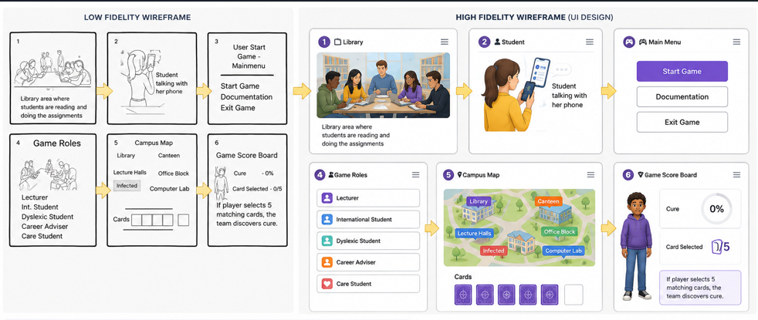
Figure 1 – High-fidelity storyboard.
If the storyboard had been designed purely from a usability perspective, the interface may have been more functional and minimal, concentrating mainly on efficiency, clarity, consistency and task completion. However, because the application is also a game, user experience was important. The use of characters, campus imagery, colour, achievements, a scoreboard and visual representations of missions was intended to make the interface engaging and enjoyable as well as usable [2].
This created a need to balance visual appeal with simplicity. For example, additional graphics could increase engagement but could also create visual clutter, so the graphics were kept simple and consistent. Similarly, colour was used to make the campus map and game activities more attractive and meaningful, while readable text, large buttons, white backgrounds and clear spacing were retained to support usability and accessibility. Therefore, the final design attempted to balance efficient interaction with an enjoyable and engaging user experience. [2].

2.2 Game Interface
Game Main Menu
The game main menu is the first area when you open the app. From the main menu, you can choose to start a new game, join a game, look at the tutorial or change or adjust your settings. Otherwise, you can click the exit button to exit the app [3].

Prototype Interface
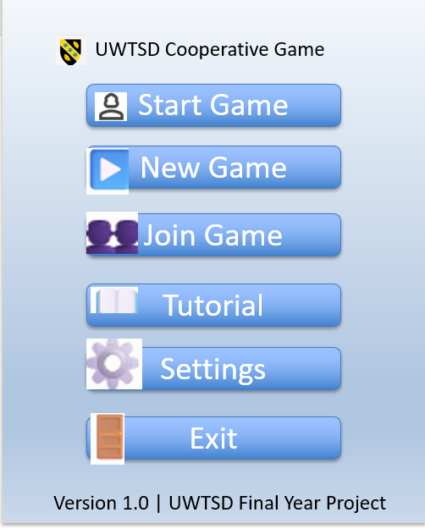
Figure 2 – Main menu
,

2.3 Game Area
The game area shows the gameplay process. When a participant clicks the Start Game button from the main menu of the app, the user will be directed to the “start a new game” page. From there, the user can select a role; after selecting the role, they can tour the campus map and see infected [3].
The player can move to level 4, where activities are taking place. Game activities and time remaining are displayed in minutes and seconds; points are also displayed. Number 5 is the scoreboard that displays scores, gains and achievements. At the end of each game, the player can choose to play again or return to home. No. 6 is documentation and a tutorial for any user looking to solve matters [3].
Number 7 is the setting that enables the user to reset the app to their specific needs, including the space, colour and accessibility. At the end is number 8, which is the exit. When you click the button, the system will ask the user to confirm the exit before it is allowed [3].

The Game

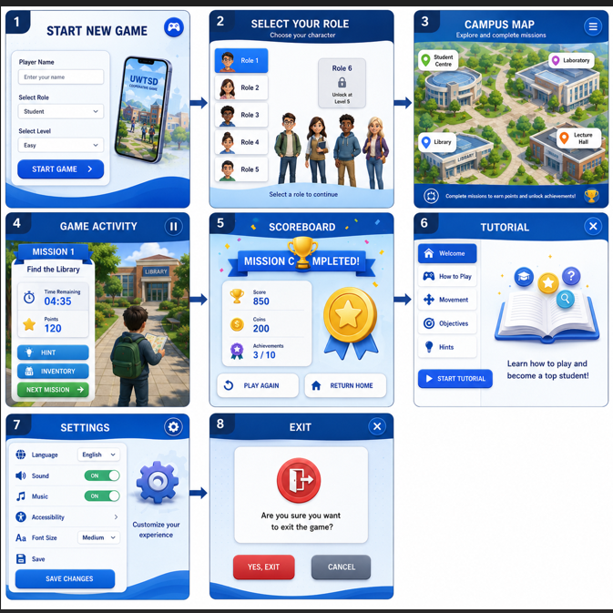
Figure 3 – Game area
Graphics and Colour Scheme
The graphics were deliberately kept simple and consistent to create an attractive interface without distracting users from gameplay [4].
A blue colour scheme was selected because blue is commonly associated with trust, concentration, and calmness. These characteristics are appropriate for an educational cooperative game where users are expected to collaborate and solve problems together [4].
The interface also uses:
- Rounded buttons to provide a modern appearance [4].
- White backgrounds to improve readability.
- Large buttons to support accessibility.
- Consistent typography throughout the application.
- Clear spacing between interface components to reduce visual clutter [4].
These design choices follow common Human–Computer Interaction (HCI) principles, including consistency, visibility, simplicity, and ease of navigation [4].

The final design is a product of an intuitive and interactive user-centred design process, with improved user and peer feedback collected during wireframe and prototype evaluations [4].

3. Data Collection and Analysis

The three participants were selected to provide different perspectives on the interface rather than relying on a single type of user. Their feedback reflected differences in confidence and technological experience, which was relevant to the personas considered during the earlier design stage. Although the small sample could not represent the complete potential user population, it provided contrasting perspectives that helped identify both common strengths and individual usability difficulties [5].

Peer Review 1

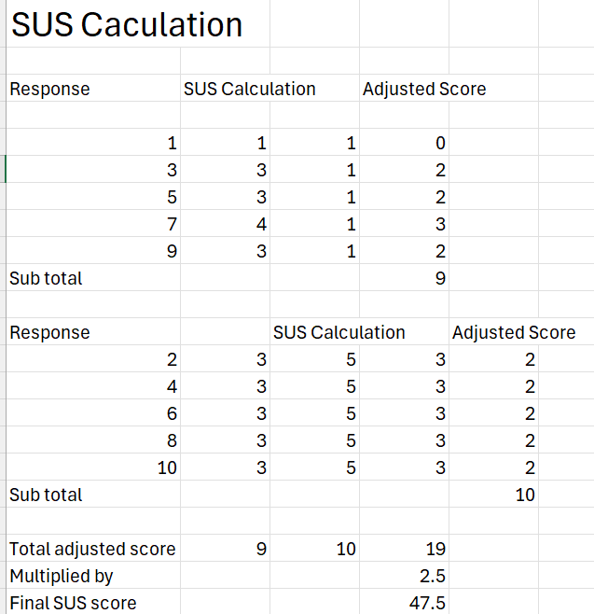
Figure 4. SUS Calculation – See Appendix 1.

Quantitative Evaluation
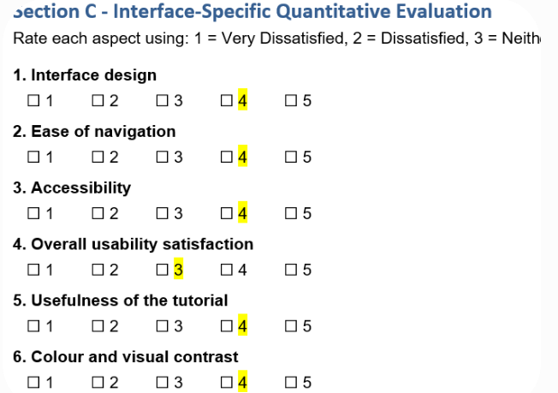
Figure 5 – Quantitative Evaluation – See Appendix 1.

Frequency Distribution
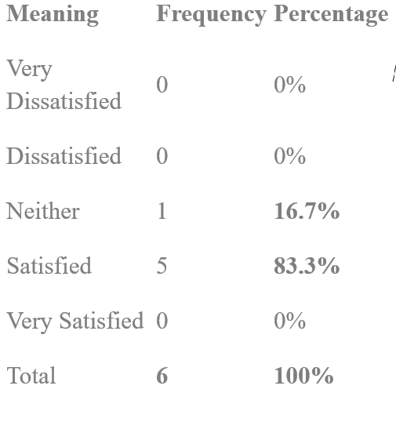
Therefore, the interface response was 83.3% satisfied, while 16.7% were neutral. There were no dissatisfied responses [5].
Mean interface calculation
(4+4+4+3+4+4)/6 = 23/6 = 3.83 (Mean).
Summary
Mean = 3.83/5
Satisfied responses: 83.3%
SUS: 47.5/100
Although the SUS score of 47.5/100 was lower than those of the other participants, the interface-specific ratings were generally positive, with 83.3% of responses indicating satisfaction and only 16.7% being neutral. The qualitative feedback suggests that the participant experienced some uncertainty regarding error handling and system feedback. Therefore, the lower SUS score should be considered alongside the participant's qualitative comments and the small sample size rather than interpreted in isolation as evidence of an unusable design [5].

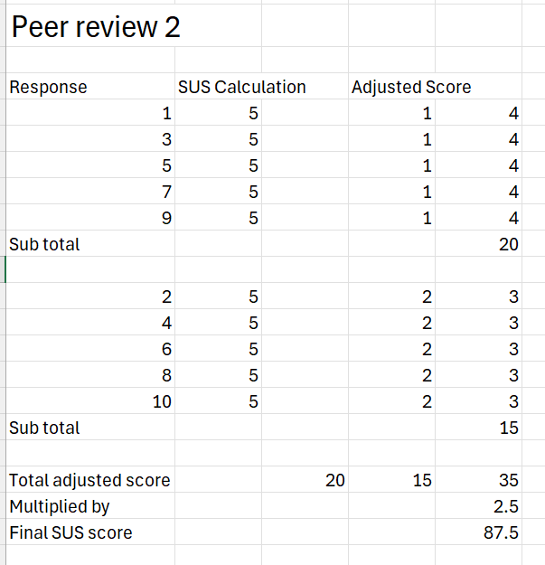
Figure 6. SUS Calculation – See Appendix 2.

Quantitative Evaluation

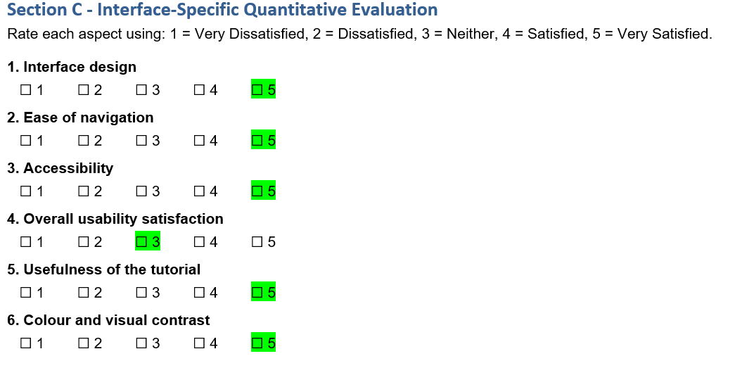 Figure 7 – Quantitative Evaluation – See Appendix 2.

Frequency Distribution
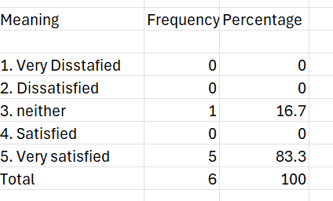
Therefore, the interface response was 83.3% very satisfied, while 16.7% were neutral. There were no dissatisfied responses [5].
Mean interface calculation
(5+5+5+3+5+5)/6 = 28/6 = 4.67/5
Summary
Mean = 4.67/5
Very satisfied responses: 83.3%
SUS: 87.5/100
This participant's results indicate a positive perception of the prototype's usability and accessibility. [5].

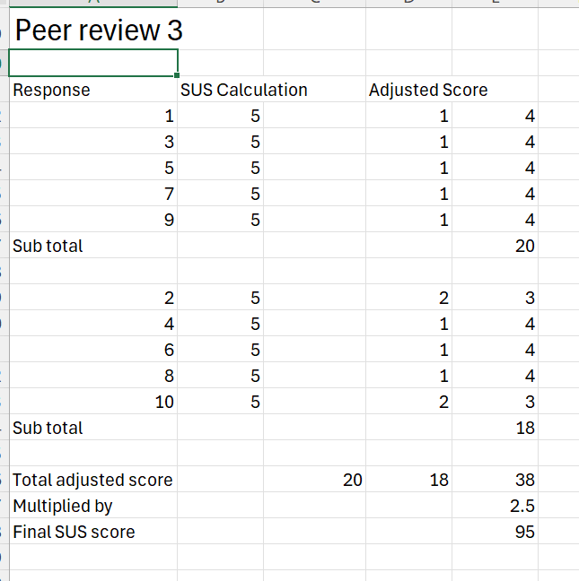
Figure 8. SUS Calculation – See Appendix 3.

Quantitative Evaluation

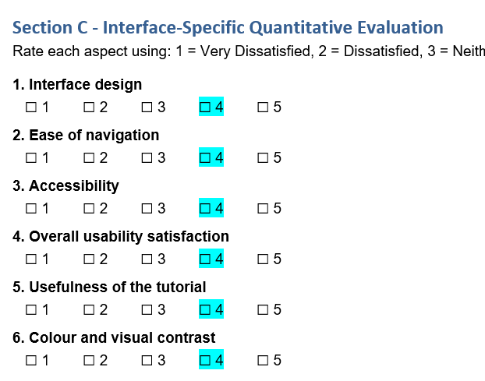
Figure 9 – Quantitative Evaluation – See Appendix 3.

Frequency Distribution
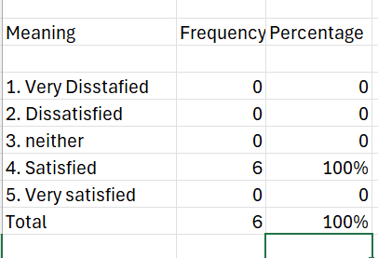
Therefore, the interface response was 100% satisfied. There were no dissatisfied responses [5].
Mean interface calculation
(4+4+4+4+4+4)/6 = 4/5
Summary
Mean = 4/5
Satisfied responses: 100%
SUS: 95/100
These results indicate a positive perception of the interface, with all six interface-specific items rated as satisfied. Frequency Distribution
Overall interface mean:
(3.83 + 4.67 + 4.00) / 3 = 4.17/5
Mean SUS score
(47.5 + 87.5 + 95) / 3 = 76.67/100
Summary:
Participant 1: Mean 3.83/5, SUS 47.5/100
Participant 2: Mean 4.67/5, SUS 87.5/100
Participant 3: Mean 4.00/5, SUS 95/100
Overall interface mean = (3.83+4.67+4)/3 = 4.17/5
Mean SUS score = (47.5+87.5+95)/3 =76.67/100

3.1 Summary of Positive and Negative Feedback
The feedback obtained from the usability evaluation is summarised below.
The feedback collected from the three reviews confirmed that the Must Have features identified through the MoSCoW prioritisation process, such as clear navigation, readable text, and accessible controls, were the most important to users. The usability evaluation therefore validated the design decisions made during the planning stage and highlighted additional improvements that can be incorporated into future versions of the application [5].

3.1.1 Summary of Positive Feedback
The interface was visible and easy to navigate, the colour coding clearly indicated outbreak and severity, buttons were appropriate for mobile devices, the cooperative gameplay was engaging, and the campus map was visual, organised and appealing [5].
- The navigation was simple and easy to understand.
- The buttons were clearly labelled.
- The colour scheme was attractive and professional.
- Users could identify the main functions without assistance [5].

3.1.2 Summary of Negative Feedback
Some of them were uncertainty about error handling/system feedback, outdoor colour visibility, and additional learning time for lower-technology users, [5].

4. Data for Working Version
If a working version of the cooperative game were built and released, both quantitative and qualitative data could be collected to evaluate how users interact with the application in practice. Quantitative data could include the number of users, frequency and duration of play sessions, time taken to complete missions, completion and abandonment rates, scores and achievements, use of hints and tutorials, navigation paths, errors encountered, and the screens or activities where users have trouble. Accessibility-related information could also be gathered, such as the use of accessibility settings and whether users repeatedly require assistance with controls [6].
The prototype evaluation demonstrated why these measures would be valuable. Although the three participants produced an overall interface mean of 4.17/5 and a mean SUS score of 76.67/100, individual experiences differed considerably. For example, one participant produced a lower SUS score and expressed uncertainty regarding error handling and system feedback, while other participants responded more positively to navigation and learnability. This suggests that aggregate scores alone may conceal individual usability difficulties [6].
A released application could therefore record anonymous interaction data to identify where these difficulties occur. For example, repeated use of the back button, frequent requests for hints, unusually long completion times, abandoned missions or repeated errors could indicate that particular screens or instructions require redesign. Tutorial completion and subsequent task performance could be compared to determine whether the tutorial genuinely helps users understand the game [6].
Qualitative data would remain important. Users could be invited to provide optional feedback through short post-game questionnaires, usability ratings and comments about navigation, accessibility, visual design and overall experience. This would help explain patterns identified in the quantitative usage data rather than relying on statistics alone [7].
The collected data could then influence the next iteration of the application. If users frequently make errors at a particular stage, instructions and feedback could be improved. If lower-technology-skilled users take longer to complete tasks, the tutorial could be expanded or additional guidance introduced. If users experience difficulty viewing the interface in different environments, colour contrast and display settings could be revised, reflecting the concern about outdoor visibility identified during the storyboard evaluation. If particular missions have high abandonment rates, their difficulty, instructions or time limits could also be adjusted [7].
Usage data could largely be collected automatically through anonymised application analytics, whereas emotional-response data would require direct user input through questionnaires, ratings, interviews or optional post-game feedback [7].
Data collection should be proportionate and privacy-conscious. Users should be informed about what information is collected and why, unnecessary personal information should not be gathered, and analytical data should be anonymised or aggregated where appropriate. The purpose would be to improve usability and accessibility rather than collect data without a clear design need [7].

5. Reflective Summary
Gibbs' Reflective Cycle
Description.
Developing the high-fidelity prototype from the initial low-fidelity prototype was a valuable but challenging experience. The process required research, asking questions and collecting feedback through questionnaires to determine how the design could be improved. I applied the System Usability Scale (SUS) to gather peer evaluations of the high-fidelity storyboard, alongside interface-specific quantitative questions and qualitative questions that could be analysed thematically. This provided both numerical and descriptive evidence about how users perceived the prototype [8].
The aim was to create an engaging and accessible cooperative game that users could enjoy while completing activities associated with responding to a pandemic. Usability principles, including Nielsen's heuristics and user-centred design principles, provided a structured framework for decisions concerning layout, navigation, accessibility and interaction [8].
Feelings.
Initially, I found the transition from a low-fidelity concept to a high-fidelity storyboard challenging because decisions that appeared straightforward at the conceptual stage required greater consideration when developing the detailed interface. I therefore recognised the importance of researching usability principles and obtaining feedback from other people rather than relying entirely on my own judgement. Receiving different responses from participants was particularly useful because it demonstrated that users may perceive the same interface differently [8].
Evaluation.
The evaluation produced generally positive results. Across the three participants, the overall interface mean was 4.17/5, while the mean SUS score was 76.67/100. Participants positively identified clear and consistent navigation, understandable instructions and visual design. However, the results were not uniform. One participant recorded a SUS score of 47.5/100 and expressed uncertainty regarding error handling and system feedback. Another participant recommended allowing additional learning time for users with lower technological skills and checking colour visibility for users viewing the interface outdoors. These findings provided useful constructive feedback rather than simply confirming the strengths of the design [8].
Analysis.
The generally positive scores suggest that the prototype was well received, while the variation between participants demonstrates the importance of usability testing. An interface that appears intuitive to the designer, or even to several users, may not be equally intuitive to everyone. The qualitative responses were therefore particularly valuable because they helped explain usability issues that numerical SUS scores alone could not identify. The evaluation highlighted areas that were difficult to recognise from the storyboard alone, particularly accessibility, error handling, system feedback and differences in users' technological abilities [9].
The experience also demonstrated the value of combining usability theory with user involvement. Nielsen's heuristics and user-centred design principles provided theoretical guidance, while participant feedback provided evidence of how aspects of the interface were perceived. Together, these approaches created a more balanced evaluation of the prototype [9].
6. Conclusion.
I learned that producing a high-fidelity interface is not simply a matter of improving the visual appearance of a low-fidelity design. It requires an iterative process of designing, evaluating, receiving feedback and reconsidering design decisions. The evaluation demonstrated that positive overall results should not cause individual difficulties to be ignored. In particular, the lower SUS result and comments concerning error handling, accessibility and visibility identified opportunities to make future versions more inclusive and understandable [9].
Action Plan.
If a working version were developed and released, I would collect actual usage data in addition to further user feedback. This could include task-completion times, errors, abandoned missions, navigation paths, tutorial and hint usage, and mission-completion rates. These data could reveal where users encounter difficulties during real interaction rather than relying solely on their perceptions of a storyboard [10]. The findings could then influence subsequent iterations by improving error messages and feedback, adjusting time limits, strengthening tutorials and improving colour and contrast for different environments. Further usability testing with a larger and more diverse group of participants would also provide stronger evidence about the accessibility and usability of the application [10].
Together, usability theory and user involvement created an informed and iterative design process in which theoretical principles guided good practice while participant feedback grounded design decisions in user experience. This process has shown me that effective user-centred design depends not only on creating an interface that appears usable, but also on continually evaluating, learning from users and applying those findings to future iterations [10].

7. Summary
Overall, this project demonstrates the value of an evidence-based, user-centred approach to interface design, involving potential users throughout the design process and applying good usability principles, resulting in a more effective and engaging mobile game design, providing a strong foundation for future design and implementation [11].

References

[1] | L. Y. L. J. B. R. Liu C, “Search Interface Design and Evaluation,” Foundations and Trends in Information Retrieval, vol. 243–416, no. 3, pp. 3-4, 2021.
[2] | e. a. Chuhuai Yue, “UIOrchestra: Generating High-Fidelity Code from UI Designs with a,” Association for Computational Linguistics, vol. 4, no. 9, p. 2769–2782, 2025.
[3] | F. Staiano, Designing and Prototyping Interfaces with Figma: Elevate your design craft with UX/UI principles and create interactive prototypes, Packt Publishing Ltd,, 2023.
[4] | P. T. Chavez OJF, “UI/UX prototype design for a personalized learning mobile app to boost comprehension: a design thinking model,” The TQM Journal, , vol. 38, no. 3, pp. 558-579, 2026.
[5] | S. A. Z. H. a. C. B. H. Liang, “Understanding User and Developer Perceptions of and Responses to Dark Patterns in Online UIs,,” in IEEE Symposium on Visual Languages and Human-Centric Computing (VL/HCC), , Raleigh, NC, USA, , 2025.
[6] | Rocky Heckman, "Strategies for Ongoing Improvement," in Designing Platform Independent Mobile Apps and Services, Wiley-IEEE Press, 2016.
[7] | A. Ashcraft, Learn WinUI 3.0: Leverage the power of WinUI, the future of native Windows application development, Packt Publishing, 2021.
[8] | T. W. H. E. B. T. K. Seyed Parsa Neshaei, “MindMate: Exploring the Effect of Conversational Agents on Reflective Writing,” in ACM Conferences, Yokohama, Japan, 2025.
[9] | E. Ekarina1, “Exploring Reflective Learning for A Design Thinking Class,” Journal of English Language Teaching and Linguistics, , vol. 10, no. 1, pp. 61-78, 2025.
[10] | e. a. Abigail Juras, ““No co-design process can ever truly cater to every single person”: Perspectives of young people in Australia on co-design for the prevention of mental health challenges,” Mental Health & Prevention, vol. 38, 2025.
[11] | M. G. B. N. Thomas Byers, “From Quarters Per Minute to Daily Quests and Seasons: Developer Perspectives on Temporal Design in Video Games,” CHI '26: Proceedings of the 2026 CHI Conference on Human Factors in Computing Systems, pp. 1 - 15, 2026.

Appendices:
Appendix 1.
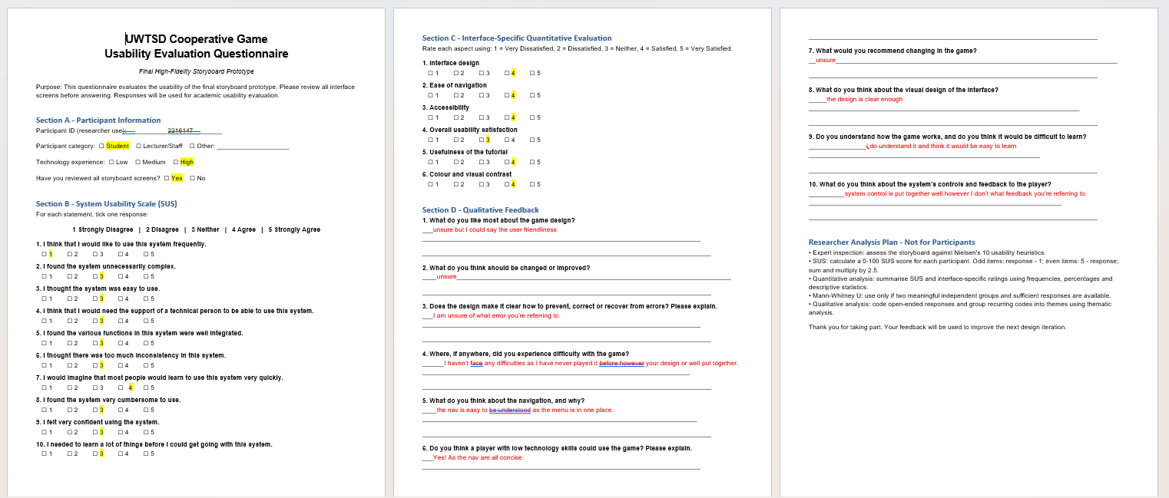
Appendix 2.
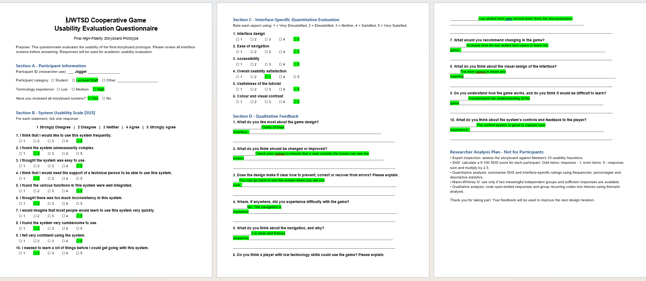
Appendix 3.



