STUDENT NAME: ADRIANA TRIFU
STUDENT NUMER: 1812538
MODULE CODE: BMSW5106
LECTURER: MD KALAM

Knowledge and Information Management Skills for the Workplace
ACADEMIC REPORT

EXECUTIVE SUMMARY
Wagamama is restaurant related to the private sector. It is a Japanese restaurant and noodle bar, and its Watford branch is situated on King Street. It is an Asian inspired branch in the UK, providing Japanese food to its customers. First, Wagamama was opened in 1992 in Bloomsbury. Founder of this branch was Alan Yau. This main branch has its more than 150 sub-branches all over the globe. The main owner of these branches is The Restaurant Group. In January 2014 Wagamama succeeded in opening 190 branches all over the world including 130 branches in UK itself. Wagamama is the Japanese's word which means self-indulgent.
This brand also follows the procedure of Kaizen. Kaizen means good change, and it talks about the taste and the dishes which can change everyone's mind to have it. It can be said that it provides fast food facilities to the people in UK. This restaurant also follows the cleanliness rule so that people can know that the restaurant environment is perfectly safe. They provide organic food to the people so that each person can trust their quality.

TABLE OF CONTENTS
INTRODUCTION 1
MAIN BODY 3
PART 1 3
Explain the relationship between data, information and knowledge 3
Explain the relationship between individual knowledge and organisational knowledge 5
The Nonaka and Takeuchi Model of Knowledge Management 6
The Von Krogh and Roos Model of organizational epistemology (1955) 6
Apply analysis and modelling techniques to identify knowledge assets. 9
Evaluate actual and potential knowledge assets 11
PART 2 13
Explain what is required to create, store, apply, and integrate knowledge. 13
Consider the importance of intellectual property rights. 14
PART 3 17
Explain the contribution knowledge assets have on an organisation. 17
Evaluate the knowledge requirements for the organisation 18
Evaluate the organisation’s framework for enabling knowledge sharing 20
Recommend improvements to the current framework 22
CONCLUSION 24
REFERENCES 25

INTRODUCTION
Wagamama restaurant, Watford branch, as described in the executive summary, it is restaurant serving Asian and Japanese cuisine. This branch is Asian inspired, serves Japanese food, and it is also known as a noodle bar in UK. This branch is situated on King Street in Watford, and it is the most famous branch of Japanese food in this area. Wagamama consists in more than 190 branches serving Japanese food all over the world.
More than 150 branches are working in UK itself. This report has discussed the relationship between knowledge and data as well as information in context to the Watford branch. This report will discuss the organisational as well as individual knowledge concerning Wagamama and its Watford branch. Various modelling techniques and analysis will be applied to identify knowledge assets. This report will explain what is required in order to create, sore, apply and integrate knowledge, and the importance of intellectual property rights will be considered as well.
This report will discuss the knowledge of assets at Wagamama Watford branch. In this report, the knowledge required to lead a Japanese food restaurant it is also discussed in detail. The present work will include an evaluation of the organisation’s framework for enabling knowledge sharing, and lastly, a recommendation will also be provided in the context of Wagamama's Watford branch so that changes can be adopted in order to improve their serving food facility and its whole framework. The whole report will discuss all important factors related to increasing the productivity and profitability of the company
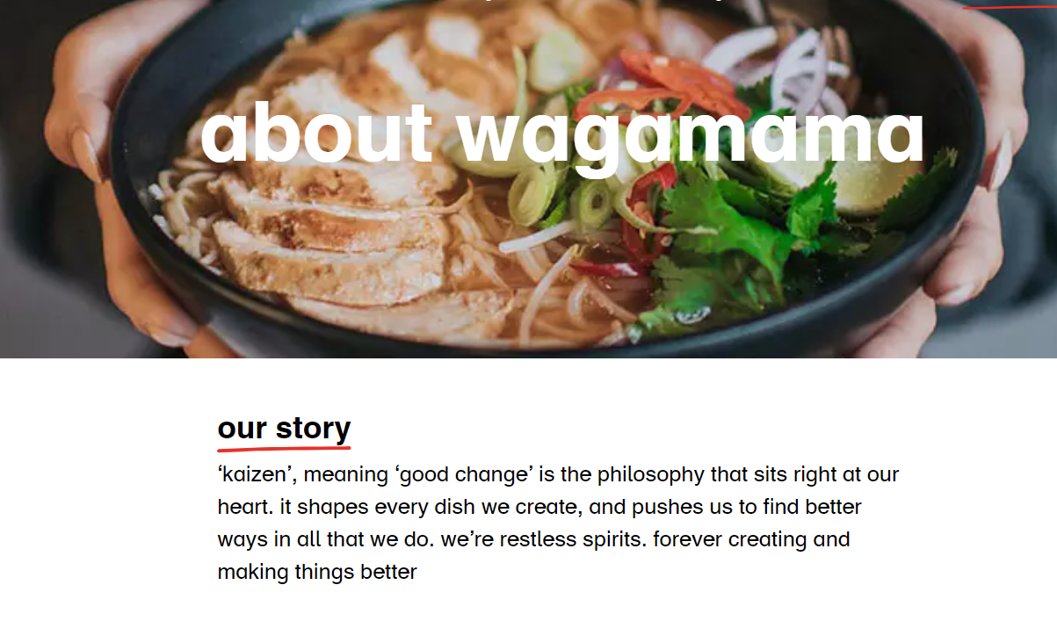

Figure 1.
(Source:Wagamama-about-us,2020)

MAIN BODY

PART 1

Explain the relationship between data, information and knowledge
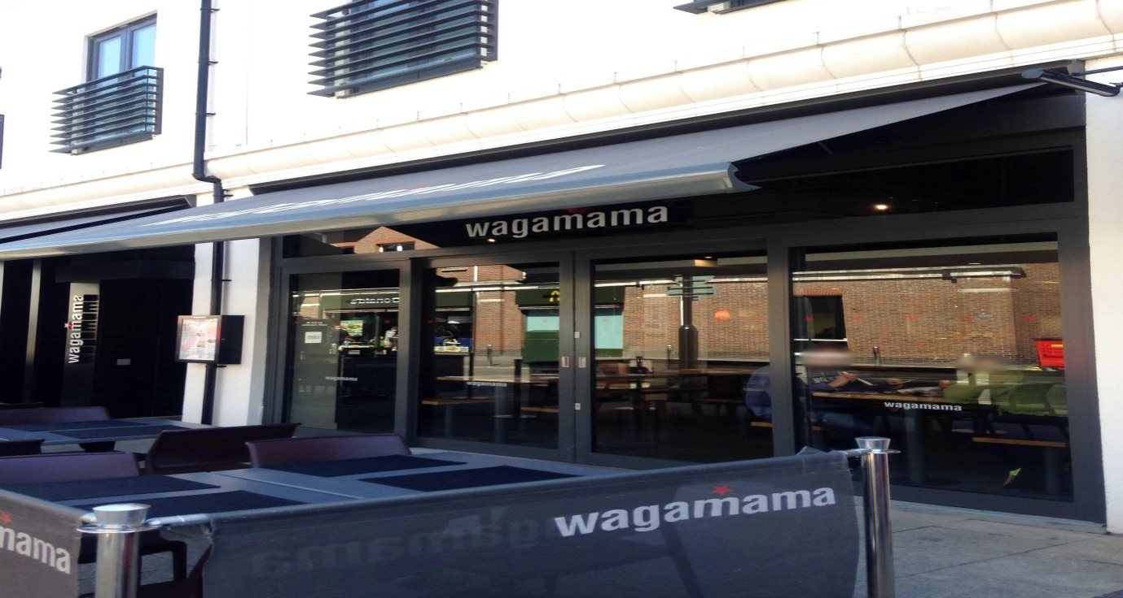
Figure 2: Wagamama’s Watford Branch, London
(Source: Zomato, 2019)
Data
Data refers to a very small but crucial part of the information. Mainly it is collected in numerical form. These data are collected by observing the actual situations and actions, and set the values of information in quantitative as well as in qualitative variables. This data can be about a person or object. Collectively, all raw information collected it is called data, and a single unit of that data or singular information is termed as Datum (Sánchez and Sideris, 2017).
Data, knowledge, wisdom and information are somehow much close to each other in the context of their concepts. But each term has its different role as well as its meaning in concluding a correct result. Basically, it can be said that data is collected to make it suitable information by analysing it. After the data is being analysed, it is meaningfully arranged, so that it comes in a format which can be easily understood by seeing it. When collected data is arranged in a specific manner and streamed in a suitable way, then it can be characterised as Shannon entropy.
Information
Information can be resolved as uncertainty. Information is the data that can be changed and updated. It changes its meaning in different ways and concepts. Its concept can be related to different notions like communication, knowledge, control, form, meaning, mental stimuli, perception, understanding, entropy, presentation, constraints and data. Information is related to the data which is collected with observations and different interviews and feedbacks. When data is arranged in a particular format, and gives an effective meaning, then can be termed as information. Information is also related to knowledge. Information can be transmitted to other people or persons in various ways like through communication. (DeLone, and McLean, 2016).
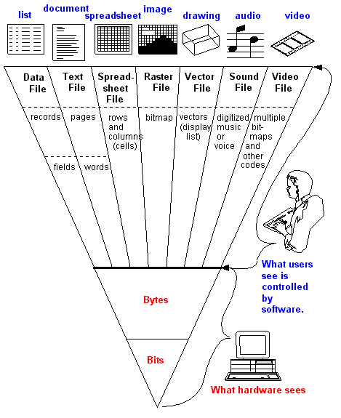
Figure 3: Computer definition of information
(Source: Your Dictionary, 2019)
As in computer language, it can be defined as data can be inputted in the computer in different ways: in the form of a list, documents, spreadsheet, video, audio, image, or drawing, all these being inserted inside the computer. If the data file is inserted, then it will be recorded in different fields. Spreadsheets are found in different rows and columns, images include raster files as its bitmaps, and that is also inserted in the information form. Drawing is changed in the form of vector files which has its display list in the form of information. Audios in the computers have sound files in the form of digitised music or voice and video files have multiple numbers of bitmaps and other codes. All these are coded and decoded in the computer to display it as information. All these different types of information are calculated to bytes and bits. The computer sees the bytes and bits as information and users see that information as it was inserted. It is termed as information in the computer's language (Han et. al, 2020).
Wagamama’s Watford branch also keeps all their records in the updated technology using computers and accessories. Wagamama keeps their all records like their customer contacts, their feedbacks, their requirements, their experiences regarding this place as well as they also keep their pictures of their restaurants and dishes. All this, collectively, shows the information regarding the Watford branch of Japanese food in the UK.
Knowledge
Knowledge can be understood as an awareness of anything or familiarity with any information or content, action, or incident. Knowledge is the most important factor by which skills and the techniques of a person can be improved in the most effective way. Knowledge can be generated anywhere and in any form.
For example, an employee of Wagamama prepares a dish like noodles and serves it to a customer. That specific customer suggests them to make it spicier using ginger in their dish. The knowledge has been taken by the employee of the restaurant, and from next time, they start using ginger for some spicy taste in their dish. It made their dish tastier.

Explain the relationship between individual knowledge and organisational knowledge
Within an organisation, individual knowledge must be shared with others, so it can have effect on the organizational knowledge base. Management is required to facilitate the process of communication and interaction between their employees, in order to amplify their individual knowledge and internalize it for contributing to the organizational knowledge (Nonaka, 1994).
Knowledge refers to the process of learning from actions and incidents, and it can be implicit as well as explicit, formal or informal.
Although it is hard to define knowledge, it is agreed that it refers to ideas, procedures, rules and information all combined. Organizational knowledge can be seen as a metaphor, because it is not the organisation responsible of creating knowledge, but the employees of the organisation who create it.
Nonaka (1994) defines knowledge as valid belief, where belief is used to justify self-interest. Many theories are given regarding knowledge.

The Nonaka and Takeuchi Model of Knowledge Management

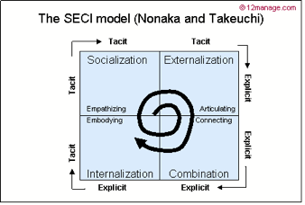
Figure 4. The SECI model (Nonaka and Takeuchi)
(Source: The Impact of Firm Knowledge Strategy on its Competitive Knowledge: A System Dynamics Approach, 2020)

According to Nonaka and Takeuchi (Nonaka and Takeuchi, 1995), the creation of knowledge can be defined as the capability of the business as a whole to be able to create knowledge, spread it throughout the organization, and present it in its systems, products and services. It refers to the connection between tacit and explicit knowledge, which leads to the creation of new knowledge.
The Von Krogh and Roos Model of organizational epistemology (1955), refers to the difference between individual knowledge and the social one. According to this model, knowledge inhabits both the mind of the individuals within the company, and, at social level, the links between them.

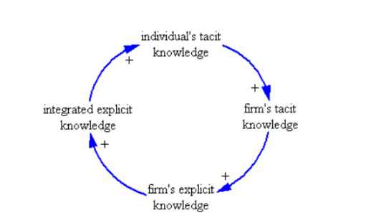
Figure 5: Knowledge creation cycle in organizations
(Source: The Impact of Firm Knowledge Strategy on its Competitive Knowledge: A System Dynamics Approach, 2020)

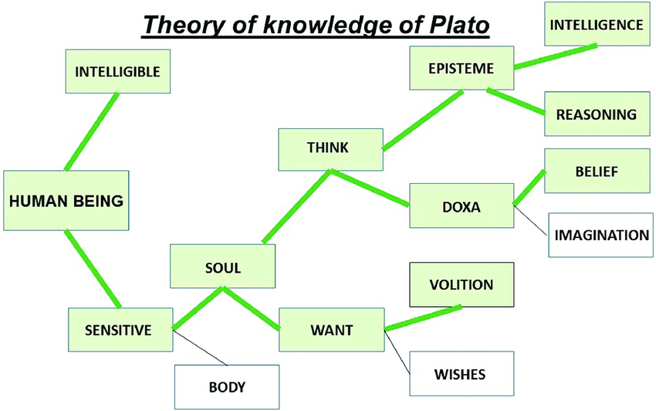
Figure 6: Theory of Knowledge of Plato
(Source: Wikipedia, 2019)
The study of knowledge has given the term known as epistemology. Different philosophies are given regarding knowledge. One of them was given by Plato. It is also known as Plato's epistemology. Plato's study regarding knowledge is related to idealism as well as realism. Plata has described different forms of knowledge, and according to that, they have prescribed in the form of soul and reality. This theory contains transcendental, third-person arguments, Euthyphro dilemma, five regimes, unwritten doctrines of Plato and political philosophy.
In this, it is prescribed that the human body and wishes are much correlated in human's life. Without wishes and desires, a human cannot put any effort into doing anything. This philosophy is also generalised by Wagamama Watford branch, as they wish for the successful business all over the world, and for this, they have to do research on their customers, regarding what people think about their restaurants. Due to wants, the Watford branch will remain ready to accept all beneficial suggestion in their restaurant, in order to increase their productivity as well as growth in the UK.
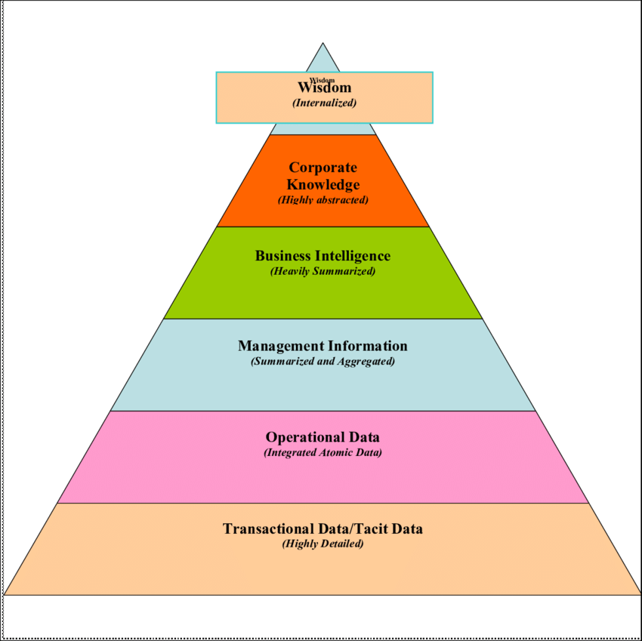
Figure 7: Organisational information
(Source: Sudhir warier, 2018)
Transactional Data is the main information which has to be transferred to another level of the restaurant, like top-level managements. Medium level of the organisation plays an important role in transferring crucial messages between the top level and the lower level and vice-versa.

Apply analysis and modelling techniques to identify knowledge assets.
A knowledge audit can be created in order to mark the knowledge requirements and its use within an organisation. It helps in outlining the gaps and flows and the way they contribute to the company’s goals.

GAP Analysis
It can be used as a tool to address the following:
- The difference between the actual knowledge management state and the desired one of the company
- Raise barriers to the knowledge management implementation process.
- Helps at identifying new opportuniteis for future collaboration and combined knowledge
- Minimizes redundancies within the company.
Collecting data can be calculated as a primary source as it is raw information. It only can be understandable only to the person who has collected it. It is raw information collected by observing the activities of a person or any object. Analysing data, includes the procedure known as data triangulation as well as data percolation. Wagamama's Watford brand is also deciding to collect the data on how they are working and what should be their approaches if they decide to change and expand the business. Therefore, they are collecting the data on how much customers they receive according to their dishes, to what people like the most of their restaurant and according to that they will decide if they should open a new branch in the area. That decision will be taken according to this data collection and its final outcome (Speidel et. al, 2018).
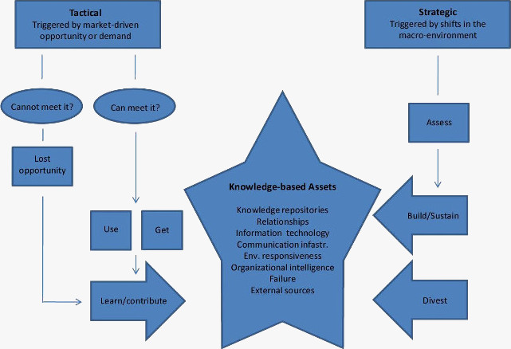
Figure 8: KM model
(Source: Bukowitz and Williams, 2019)
Under the knowledge management model, all the factors that affect the environment and the growth of the Wagamama restaurant are highlighted, so that knowledge repositories can take place. It helps in improving the relationship among the workers of the restaurants. It increases the workers power of understanding according to their customer's requirements. It also helps in improving the communication skills of the workers of the restaurants, and it helps in developing a polite personality towards their customers, so that customers also feel comfortable when visiting the restaurant. Every staff member has responsibilities. They feel that they are working for their own growth. It makes environmental responsiveness so that they perform according to the requirements of the customers and restaurants because they are responsible for their work.
Knowledge management is a procedure in which data is collected through observing or by taking feedbacks, interviews or opinions of the public regarding the restaurant. It helps in adopting implements according to the huge number of feedbacks received. It helps in improving their serving facilities, by understanding the data. Two methods are adopted: qualitative and quantitative method. It helps in concluding an effective result. Lastly, the data is percolated with the help of predetermination technique, and this helps in extracting relevant data in the form of useful information (Nan and Sansavini, 2017).

Evaluate actual and potential knowledge assets
The actual knowledge procedure takes place as long as the person is alive, as people learn from their past. It gives them experiences. It helps in reducing their mistakes in their future actions. It also improves their decision making technique. Wagamama’s success is also based on their knowledge assets. They overcame that phase where they made mistakes, and they learnt from them. Those mistakes made them stronger and helped them improve their skills, their dishes, and their connection to their customers. It also taught them how they can grow effectively in the competitive market, as so many restaurants are present in the local area.

Communication is the best way to transmit information to different levels. Through communication, formal as well as informal data, analysed, can be expressed to the different people. It helps in knowing about any result and also helps in sharing different views regarding the company. Information can be transmitted as a message. It does not require any particular procedure. It can be transmitted with the help of indirect or direct observation.
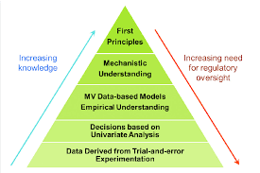
Figure 9: Knowledge Pyramid
(Source: Mo Jiang, 2018)
Knowledge pyramids help strong decision making process, individually as well as organisationally. It involves various experiments in making data into useful information. After that, variables are analysed and based on that; decisions are made. It helps in the MV model to empirical understanding. After that, understandings are mechanised. It results in making strict rules or principles. All these steps in the knowledge pyramid help the Wagamama’s Watford restaurant in UK to increase their knowledge as well as in increasing their needs for regulating oversights (Graban, and Lathan, 2018).

PART 2

Explain what is required to create, store, apply, and integrate knowledge.
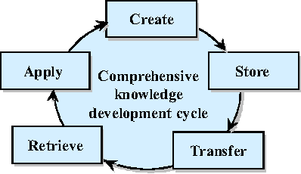
Figure 10: Integration into Knowledge Management
(Source: Xuwei Pan, 2016)
Knowledge management process makes it easy to create, store, transfer, retrieve and apply the information in beneficial ways. It is also known as the integration process of knowledge management. Raw data is collected and after analysis, it becomes meaningful information which helps the company gather effective information. After this creating procedure, that information is stored in the records of the restaurant. These records can be kept in books or templates of the restaurants. This information is transferred to another department by using different external mediums like media; news, online portals, or even websites of this particular restaurant on social media. There are various different mediums by which transfer of the information takes place to all different sources. It helps in increasing the popularity of Wagamama's Watford restaurant in Watford (Brunel, 2016).
When the transfer of information is completed, the retrieving process of the information takes place. Storing, capturing and sharing the data are highly affected by the knowledge management procedure. It starts with recognising the important knowledge related to the Japanese Restaurant in UK named as Watford. It is the restaurant basically needs the information which helps the company to grow effectively, generating high profitability from the market. In this knowledge, management procedure helps in identifying important data for the restaurant and also recognises what decisions exactly will benefit the company. This whole procedure is known as a knowledge map (Zhu et. al, 2018).
Preparing a knowledge map, it helps in creating a working environment as well as it also regulates the workflow among the workers. It also helps in making effective decisions with reference to the new implementations which should be applied in the organisation, in order to improve their performances. It helps in identifying the key knowledge regarding its workers who are performing their particular activities in the restaurant, by offering their best services to grow their profits and number of customers. Knowledge is the main part of a professional organisation. In organisations, knowledge is required to maintain and to lead the business activities in the most particular way.
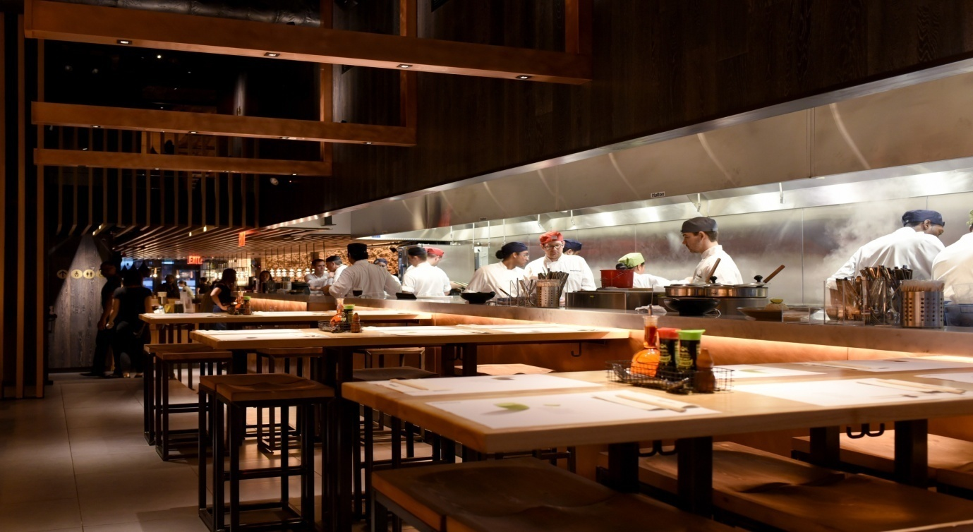
When knowledge is retrieved, then it can be easier to think that whether it is useful for restaurants or not. According to that, information is applied in their working environment, so that effective working from the workers can be achieved. It helps in increasing the number of customers in the company (Kinh, 2018).

Consider the importance of intellectual property rights.
Intellectual Property can also be defined as privilege. It can be defined as individual rights related to the organisation or restaurants which they are leading, for this government and organisational standards are prepared for the entrepreneurs as well as for partners of the organisation who are leading that organisation. In this report, Wagamama's Watford's branch is taken, which is leading its business of providing Japanese food. This Restaurant is highly inspired by Asian culture, and due to this, it provides dishes related to that culture. In the UK people do not get food which is Asian inspired. Therefore, this restaurant is very famous in the area.
Intellectual properties help in providing exclusive rights to the inventors of this restaurant as well as it helps in protecting the rights of the creators of these restaurants. Due to their legal rights, it allows the owners of these restaurants to share their information so that this can be shared to the public, and due to its better results, public also comes to the restaurant. It helps in knowing that no one is using their restaurant's copyrights and patent for their business purpose. It increases the confidentiality of the restaurant in order to increase their productivity. It allows the restaurant to share their information by using different mediums like online portals, and websites.
It helps in increasing their power in resisting in the firm. It helps in providing legal defence and widely increases the incentives of the creators so that new implements can be done to renovate different tastes and dishes, and allows them to make any other changes they want to. It also helps in developing socially as well as financially. Socially, provides different culture food in another culture. It helps in knowing about a different culture. It also increases employment opportunities in Watford. Many Japanese people also reside in the UK. They know their culture, and due to that, they can be useful for this Japanese restaurant in preparing different types of dishes. It also helps in protecting patents of the firm as no one can copy their brand value and image for their benefit purpose (AA Thornton 2019).

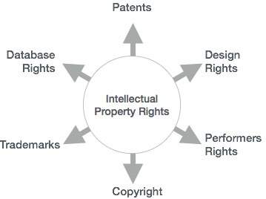
Figure 11: Intellectual Property Rights
(Source: Tutorialspoint, 2016)
WIPO has discovered various intellectual property rights as by giving the format for industrial designs. They also included scientific discoveries. They have given rights to the restaurants and organisation so that they can fight for their legal rights.
They also can do scientific work in their organisation, so their work its profitable for the world economy. It also includes literary as well as artistic work which is invented if the firm. They have their own patent and copyright. No one can copy that idea. Otherwise, restaurants have their right to file a case against that particular person or firm which has copied that idea and thoughts. When any invention takes place, then it should be registered in the standards under the World Intellectual Property Organisation (WIPO, 2017).

PART 3

Explain the contribution knowledge assets have on an organisation.
Within an organisation, knowledge assets can be seen as a triangle of processes, people and technology interacting with the purpose of achieving the same goal.
Systemized Knowledge assets help in packaging knowledge. It helps in keeping all the records related to their restaurant as well as their customers. It helps in preparing documents, manuals and specifications. It uses database information to show their profit and losses. It helps in preparing their final balances sheet, which is prepared at the end of the financial year. It also requires their licenses and patents to show their legal existence in the markets of providing Japanese food and Asian culture.
Routine knowledge assets are another main factor that helps the restaurant to give a beneficial routine from which tactic knowledge is embedded in different types of practices as well as actions. It helps the company in deciding to know-how about daily operations, and they lead it effectively that more burden does not come on a single worker. It also provides the work to their staff according to their skills and convenience. It provides organisational routines so that daily functions can be completed in time. It also helps in maintaining the organisational culture. It shows their different identity (Handan et. al, 2019).
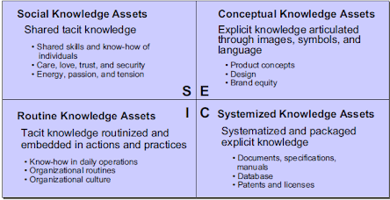
Figure 12: Knowledge Assets
(Source: Chuck Carey, 2016)
Conceptual knowledge assets help in explicating knowledge in various forms like an image, different languages, or symbols. It helps in generating different product concepts. It also helps in manufacturing different designs and its brand equity in the market so that it has its different Goodwill on the name of its functioning and well-maintained image in the competitive market of providing noodles and Japanese food (Lin et. al, 2018).
Knowledge is the most important and strong asset, which can be found in any organisation. Knowledge assets can be defined in various perspectives. Social knowledge assets help in sharing tactic knowledge regarding the internal functioning of the restaurants. It shows the way workers treat their customers in their restaurant. As well as it shows the care, love, trust, security in these social knowledge assets. In this context, energy of the workers in performing the tasks which are required by the customers in the restaurant, also make an impression in front of their customers. It also provides opportunities to know the choices of their customers. It also helps in improving the relationship between customers and employees. (Natalicchio et. al, 2017)

Evaluate the knowledge requirements for the organisation
Knowledge management is a strategy adopted in organisation to create, identify, represent, distribute and enabling knowledge for that content, document, insight or experience. Well-designed knowledge management programs provide many benefits in the company, so that they can manage their objectives according to knowledge management. Knowledge management is a very important asset in preparing knowledge strategies. It helps in reducing risks and costs; therefore, the extra expenses can be reduced, and the loss of costs can also be diminished. This small reduction helps in preventing high loss in the restaurant (Fredriksson and Rappestad, 2016)
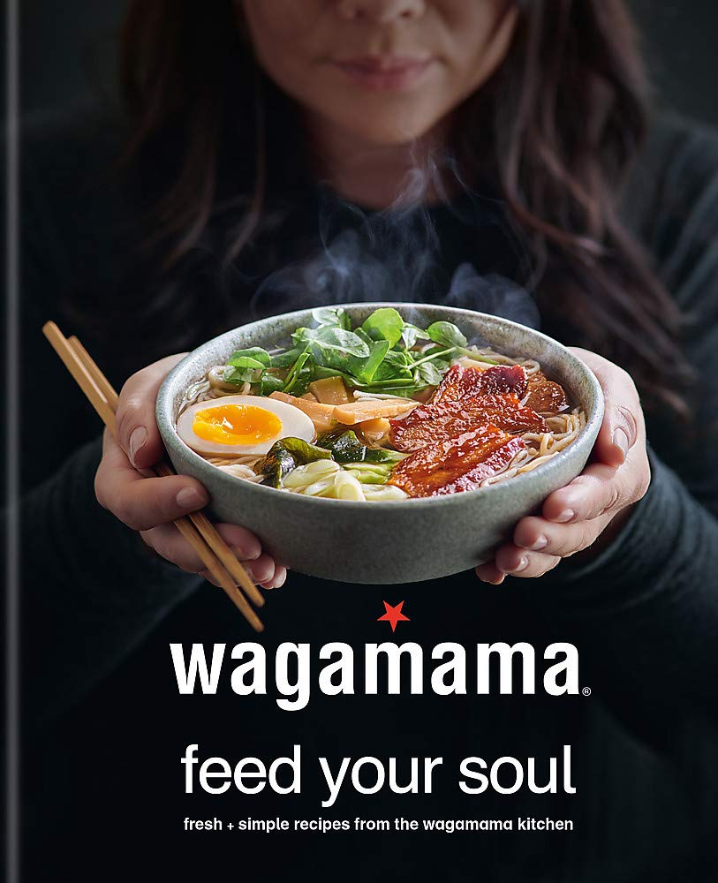
Improving productivity and performance, is Wagamama’s every day’s goal. Leveraging existing assets to reduce cost, risk and cycle time helps in completing the tasks or orders in less time so that customers who visit the restaurant do not have to wait for a long time. People come to restaurants to fulfil their craving requirements. At that time, they order whatever they want to have. It helps in increasing their customer number as well as they can also attract more people towards their restaurants to get more profits.
Improved decision-making strategy also helps in making beneficial and strong decisions for the growth of their restaurant. Good decision making helps in improving the best presentation of the restaurants in from of their customers.
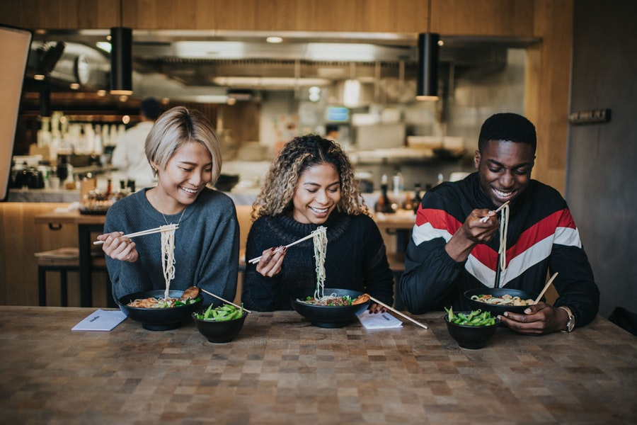
Improved strategic planning helps preparing their ordered dishes on time, providing their customer's delicious taste, availability of all the dishes which they have mentioned in their menu cards. It helps in making a good reputation of the restaurant in the market (Malekpour et. al, 2020).
Faster development of new technical approaches helps in developing the restaurants functioning. Many restaurants use many hygienic strategies and this helps in managing their routine work as well as the customer's order in the time. It uses more technical things and uses updated technologies and services for serving the people in the restaurants of Wagamama.
Faster more reboots problem solving as if any problem occurs in functioning or completing the orders, then there should be more alternatives so that they can fulfil customer's requirements. It also can be done by making a humble request from customers, and this also requires that polite nature behaviour should be maintained in the company (Van Aken and Berends, 2018).
When people work in the restaurant, training is provided to the workers in the restaurants, so they can be able to perform at Wagamamas’s high standards. They also provide shifts with trained people so that they can learn from observing them; this helps in reducing work cost and training expenses in the restaurants. For this purpose, the company has created a new job role, known in the restaurant as ‘black belt’, whose job is to train new staff.
Increased versatility of the workforce, helps in increasing the performances of the workers as well as it also helps in increasing the versatility of the whole workforce in the Wagamama’s branches (Stijepic, 2018).

Evaluate the organisation’s framework for enabling knowledge sharing
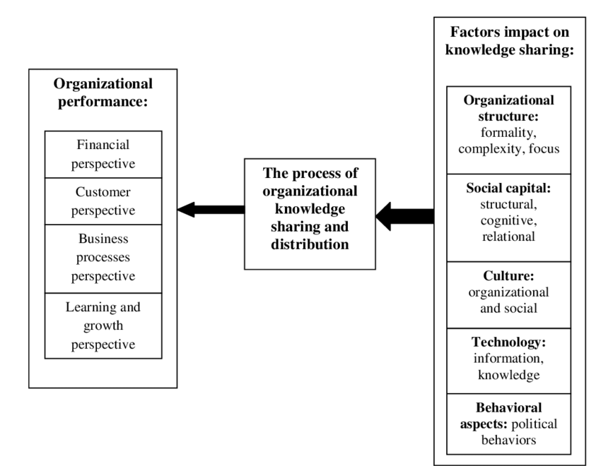
Figure 13: Enabling knowledge sharing capabilities
(Source: Gholamreza Jandaghi, 2018)
Knowledge sharing represents exchanging information, and it has many benefits for an organisation, such as: reusable problem-solving experience, faster decision making process, innovation and growth, reduces the loss of know-how, and also improves delivery to the company’s customers. Many factors that help in sharing the knowledge have beneficial aspect for the restaurant. Knowledge sharing can be achieved through many mediums. It increases the effectiveness of the restaurant in the market. Watford restaurant focuses on the complexity and formality of the business. Wagamama restaurant branch is also focusing on structuring all the activities so that all workers of the restaurants can have equal tasks to do. All have to perform equally so that partialities and misbehave do not take place in the restaurant. Due to good knowledge management, the firm can complete their work in the most effective way. Better knowledge management helps in calculating work in the most effective way. It also maintains the internal environment of the Watford restaurant. It increases the understanding of the power of the worker towards each other and toward the restaurant. If workers feel comfortable at their job, then they will perform by thinking that they are performing for themselves. If a worker has an issue within the company, then they will only perform to earn money, and they will not be satisfied. If they are not satisfied, then they will become the reasons for conflicts and issues in the restaurants (Charband and Navimipour, 2018).
The culture and the practices which are adopted by the Wagamama's Watford restaurant are highly inspired by Asian culture, being famous as a noodle bar in the area (Nyman, 2017).
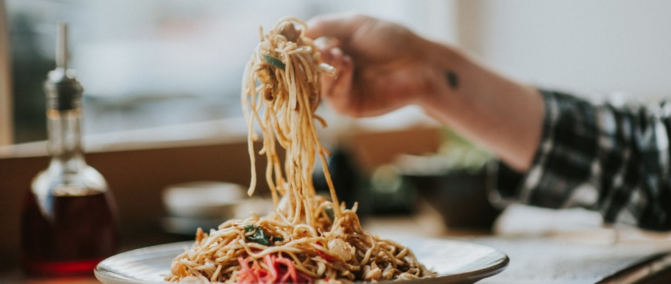
This Restaurant is leading its business all over the world with more than 190 branches. Wagamama is not only serving food but also it is doing its business of cloths, bath accessories, perfumes, and cosmetics. This brand name has achieved goodwill that people will trust it's all product without any questions. This trust can be achieved only when a brand uses its name in the market without breaking the trust of its customers. This brand is providing quality products as well as quality and quantity in their restaurants. All this information is highly affecting positively the growth of the restaurant.
Information is shared by using technologies. Political behaviour also affects the functioning of the restaurants. Political behaviours also affect the pricing strategies of the restaurant, and due to external factors, many internal factors of the company are affected through various activities and because of that, many times the company is struggling to grow. But due to better strategies applied in the organisation, these circumstances can be fulfilled by effective planning which help in maintaining the growth of the restaurants constantly. It helps in better consistency in the market so that it can exist in this tough competition. All these processes combined perform for better functioning of the organisation. It is the process that helps in sharing the knowledge and enabling the knowledge in the most beneficial way to increase the productivity of the firm. It helps in generating high Goodwill and market value (Chan et. al, 2016).

Recommend improvements to the current framework
This recent public-health crisis, the hard period of quarantine, and physical distancing it has been the restaurant industry’s greatest challenge to date. Wagamama should adopt strategies to maintain a good hygiene in their restaurant in the first place, and also strategies to ensure the physical distancing rules, so that their customers feel safe. People are now mostly noticing the hygiene adaptability in restaurants. They can make themselves sure that they are in the right place. They need to see a clean environment, safety procedures and also to feel again the taste of fresh vegetables and their beloved dishes.
Also, the company should arrange the tables of the restaurants in a suitable way that people do not feel awkward while having food. The table should be directed in a good manner and should have some view so that people can enjoy their food, and the time spend in the restaurant. Many people who come to the Watford branch restaurant also sees if the restaurant is clean or not, if the food is fresh and served on time, if the staff is polite and if their requirements are being fulfilled. As it can be said that first impression can be also the last impression. New customers also should get attracted towards the restaurant by its cleanliness and hygiene adaptability of the workers, together with the taste and the freshness of their products (Nizame et. al, 2019).
The menu should be aligned and reinvented to new consumer preferences; Dishes should be repriced according to the new market conditions and the company should concentrate more on the value of its products than upselling them.
A very important factor that needs improvement is their delivery business who needs optimization, and the company should rethink their restaurant design as well.

CONCLUSION

In this report, knowledge and information management has been discussed and deeply explained in the context of Wagamama's restaurant, Watford Branch. In this report, different terms like knowledge, information, data, knowledge management, assets have been provided in detail. The relation between information, data, and knowledge has been discussed together with definitions. The definition of individual knowledge and organisational knowledge is also provided. The modelling technique of identifying knowledge has been discussed and explained, as well as requirements of storing the information, creating, applying and integrating the knowledge.
In this report, the actual potential of the knowledge in leading the restaurant is critically discussed. Knowledge management and the requirements of knowledge management has been explained, in order to show how it affects the profitability and productivity of the company. Another important subject discussed in the present work is related to the importance of intellectual property rights. All the requirements and the benefits from all intellectual property rights have been mentioned. This report has also discussed the contributions of the knowledge assets in increasing the productivity of the restaurant. This report has also evaluated the framework of the organisation for enabling the knowledge in the restaurants so that it can help in improving the functions of the restaurant. Lastly, recommendations are also given in the context of Wagamama Watford restaurant.

REFERENCES
Brunel, N. (2016). Is cortical connectivity optimised for storing information?. Nature Neuroscience, 19(5), pp.749-755.
Chan, G.S.H., Hsiao, A.C.H. and Lee, A.L.Y., (2016). Exploration of customer compliant behaviour toward asain full-service restaurants. International Journal of Marketing Studies, 8(2), p.46.
Charband, Y. and Navimipour, N.J., (2018). Knowledge sharing mechanisms in education. Kybernetes.
DeLone, W.H. and McLean, E.R., (2016). Information systems success measurement. Foundations and Trends® in Information Systems, 2(1), pp.1-116.
Fredriksson, E. and Rappestad, N., 2016. REDUCING RISKS AND COSTS WHEN WORKING WITH INCOTERMS IN PURCHASING WITHIN THE ASIA-PACIFIC REGION. E–Proceeding, 2016, p.158.
Graban, TS and Lathan, R.E., (2018). African Pyramids of Knowledge: Kemet, Afrocentricity and Africology, Molefi Kete Asante. African Journal of Rhetoric, 10(1), pp.213-220.
Han, X., Song, E., Zhou, Y., Hu, T., Xia, Z. and Zhang, Q., (2020). Photon upconversion afterglow materials toward visualised information coding/decoding. Journal of Materials Chemistry C, 8(11), pp.3678-3687.
Handa, P., Pagani, J. and Bedford, D. (2019). Assigning Value to Knowledge Assets. Knowledge Assets and Knowledge Audits (Working Methods for Knowledge Management), pp.201-217.
Kinh, KT (2018). APPLING INFORMATION COMMUNICATION TECHNOLOGY (ICT) AND EXPERIENTIAL LEARNING IN CLIMATE CHANGE EDUCATION AT HIGHER EDUCATION: A CASE STUDY. USD Journal of Social Sciences, Humanities and Education, 8(5), pp.57-64.
Lin, C., Li, B. and Wu, Y.J., (2018). Existing knowledge assets and disruptive innovation: The role of knowledge embeddedness and specificity. Sustainability, 10(2), p.342.
Malekpour, S., Walker, W.E., de Haan, F.J., Frantzeskaki, N. and Marchau, V.A., (2020). Bridging Decision Making under Deep Uncertainty (DMDU) and Transition Management (TM) to improve strategic planning for sustainable development. Environmental Science & Policy, 107, pp.158-167.
Nan, C. and Sansavini, G. (2017). A quantitative method for assessing the resilience of interdependent infrastructures. Reliability Engineering & System Safety, 157, pp.35-53.
Natalicchio, A., Ardito, L., Savino, T. and Albino, V. (2017). Managing knowledge assets for open innovation: a systematic literature review—Journal of Knowledge Management.
Nizame, F.A., Alam, M.U., Masud, A.A., Shoab, A.K., Opel, A., Islam, M.K., Luby, S.P. and Unicomb, L., (2019). Hygiene in restaurants and among street food vendors in Bangladesh. The American Journal of Tropical Medicine and Hygiene, 101(3), pp.566-575.
Nonaka, I. (1994), ``A dynamic theory of organizationalknowledge creation’’, Organization Scienc e, Vol. 5No. 1, pp. 14-37.
Nonaka, I. and Takeuchi, H. (1995), The KnowledgeCreating Company ± How Japanes e CompaniesCreate th e Dynamics of Innovation, OxfordUniversity Press, Oxford
Nyman, J. (2017). Cross-cultural Kitchen: Britishness, Globalization, and New Migrants in Monica Ali's in the Kitchen. In Displacement, Memory, and Travel in Contemporary Migrant Writing (pp. 210-229). Brill Rodopi.
Sánchez, L. and Sideris, M.G., (2017). Vertical datum unification for the international height reference system (IHRS). Geophysical journal international, 209(2), pp.570-586.
Speidel, L., Harrington, H.A., Chapman, S.J. and Porter, M.A., (2018). Topological data analysis of continuum percolation with disks. Physical Review E, 98(1), p.012318.
Stijepic, D. (2018). Workplace Heterogeneity and the Returns to Versatility. Available at SSRN 2635542.
Van Aken, J.E. and Berends, H., (2018). Problem-solving in organisations. Cambridge university press.
WIPO, CI (2017). The global innovation index 2017: innovation feeding the world.
Zhu, H., Tian, F., Wu, K., Shah, N., Chen, Y., Ni, Y., Zhang, X., Chao, K.M. and Zheng, Q., (2018). A multi-constraint learning path recommendation algorithm based on the knowledge map. Knowledge-Based Systems, 143, pp.102-114.
Online
AA Thornton (2019) (Online) [Accessed Through]
<https://www.lexology.com/library/detail.aspx?g=0b676aa6-7a3b-4bcb-8570-ccb90699eeef>, [Accessed on 12th Aug, 2020]
Bukowitz and Williams, (2019) (Online) [Accessed Through] <http://www.knowledge-management-tools.net/three-km-models.html>, [Accessed on 12th Aug, 2020]
Chuck Carey, (2016) (Online) [Accessed Through]
<http://www.compendian.com/2015/01/corporate-knowledge-is-a-corporate-asset>, [Accessed on 12th Aug, 2020]
Gholamreza Jandaghi, (2018) (Online) [Accessed Through]
<https://www.researchgate.net/figure/Conceptual-model-of-enabling-knowledge-sharing-capabilities_fig3_236845888>, [Accessed on 13th Aug, 2020]
Mo Jiang, (2018) (Online) [Accessed Through]
<https://www.researchgate.net/figure/Knowledge-pyramid-for-model-based-decision-making-Higher-layers-in-the-pyramid_fig1_310615291>, [Accessed on 12th Aug, 2020]
Sudhir warier, (2018) (Online) [Accessed Through]
<https://www.researchgate.net/figure/Organizational-Knowledge-Hierarchy_fig2_265379876>, [Accessed on 12th Aug, 2020]
Tutorialspoint, (2016) (Online) [Accessed Through]
<https://www.tutorialspoint.com/information_security_cyber_law/intellectual_property_right.htm>, [Accessed on 12th Aug, 2020]
Xuwei Pan, (2016) (Online) [Accessed Through]
<https://www.semanticscholar.org/paper/Integrate-Context-into-Knowledge-Management-Pan-Zhu/29fedc210253d365fc54ee8e952eb243cbd61729>, [Accessed on 12th Aug, 2020]
Your Dictionary, (2019) (Online) [Accessed Through] <
https://www.yourdictionary.com/information>, [Accessed on 12th Aug, 2020]
Zomato, (2019) (Online) [Accessed Through] <https://www.zomato.com/london/wagamama-watford>, [Accessed on 13th Aug, 2020]
Wagamama-about-us, (2020) (Online) [Accessed Through] <
https://www.wagamama.com/about-us>, [Accessed on 01st Sept, 2020]

