

A study on the impact of entrepreneurial motivation, drive and environment on Chinese female entrepreneurial performance
Qinqin Lou (2109268)

Module: LCDB7011

Module Lead: Dr Abdullah Promise Opute

University of Wales Trinity Saint David

15th September, 2022

Table of Contents
1 Introduction………………………………………………………..…1
2 Literature review…………………………………………………..…3
3 Research hypothesis………………………………………….….….14
4 Methodology………………………………………………………..20
5 Data analysis…………………………………………………….….29
6 Findings and Conclusions……………………………………….….33
7 Bibliography……………………………………………….………..35
Appendix………………………………………………………………4

1 Introduction
The globalization of the economy and the development of the new economy over the last few decades have provided excellent opportunities for women to start their own businesses. However, given the dual role of women and business operators as well as traditional gender perceptions in society, female entrepreneurs face many problems and constraints from both themselves and the outside world, what exactly makes them decide to start their own business?
According to the Global Entrepreneurship Monitor (2018) study, the rate of female entrepreneurship rose by 6.6% in the countries participating in the survey, compared to a 0.7% increase for men, with the growth rate of female entrepreneurship being much higher than that of men. Female entrepreneurship is seen as an effective means of addressing women's employment difficulties, eradicating female poverty, improving women's own social status, promoting rapid economic development and fostering social progress (Jiu, Lingyun and Mei, Qiang, 2014). However, compared to other entrepreneurial groups, female entrepreneurship is more likely to be limited by many aspects, such as traditional attitudes, entrepreneurial climate, and entrepreneurial capital, and coupled with differences in local culture, infrastructure, and regional policies, women become a disadvantaged group in the entrepreneurial workforce and generally have lower performance in the entrepreneurial process (Huo, Hongmei 2013; Song, Yang 2019).
Entrepreneurial performance is a commonly used indicator to measure entrepreneurial outcomes. Both the external environment faced by entrepreneurs and the intrinsic elements of individual entrepreneurs influence their entrepreneurial behaviour (Wang Jieqiong and Sun Zehou 2018). Scholars have shown that the entrepreneurial environment significantly and positively affects entrepreneurial performance (Zhang Yingliang and Tang Li 2013), and that entrepreneurship, as an intrinsic element of the individual entrepreneur, can contribute to entrepreneurial performance (Xie Xueyan et al. 2018).
The purpose of this study: 1) to construct a model of the mechanisms of entrepreneurial motivation, entrepreneurial spirit, entrepreneurial environment and women's entrepreneurial performance, and to reveal the extent and paths of entrepreneurial motivation, entrepreneurial spirit and entrepreneurial environment on women's entrepreneurial performance; 2) to explore the deep-seated problems affecting women's entrepreneurial performance based on the results of the empirical study, and to provide corresponding countermeasure suggestions for improving women's entrepreneurial performance.
Significance of the study: 1) The triple perspective of the external entrepreneurial environment and the entrepreneurs' internal entrepreneurial motivation and entrepreneurial spirit explains the paths and extent of their influence on women's entrepreneurial performance, which not only enriches the research perspective and content of women's entrepreneurship, but also provides theoretical support for better interpretation of women's entrepreneurial performance. 2) In addition, it focuses on women's employment and entrepreneurship, comprehensively analyses the real-life scenarios of their entrepreneurship, helps them break through the entrepreneurial dilemma, and helps form a situation where women's entrepreneurship drives employment, which has certain practical value in promoting social and economic development.

2 Literature review
2.1 Female entrepreneurship
Although theoretical descriptions and realistic portraits of entrepreneurs, especially successful ones, tend to be more "masculine" (Schumpeter, 1934), women have always been an important group for entrepreneurial activity. (Schumpeter, 1934), women have always been an important group for entrepreneurial activity, and the Global Entrepreneurship Monitor (GEM) The 2018/2019 Women's Entrepreneurship Report published by the Global Entrepreneurship Monitor (GEM) states that approximately 231 million women in the 59 economies surveyed are starting or running new businesses, a fact that has recently begun to attract the active attention of entrepreneurship scholars, particularly in the last five years (Brush et al., 2014; Hechavarria et al. 2019), the research literature on female entrepreneurship has grown rapidly, while this research literature is no longer bound to explaining the characteristics of the female entrepreneurial process and the causes of success and failure, but is instead dedicated to exploring the fundamental issues in entrepreneurship research using female entrepreneurship as a context, a change that is very noteworthy. It may even be judged that the trend in women's entrepreneurship research in the near future is no longer towards explanatory studies of women's entrepreneurship groups, but rather towards contextually embedded research designs that respond to fundamental questions that have long been of interest in the field of entrepreneurship but have not been well theoretically explained (Zahra, 2007), with significant research value.
Research on women's entrepreneurship has gone through two broad phases. Early research followed the basic assumptions of the field of sociology, exploring the particular problems women may encounter in entrepreneurship in the context of differences in social expectations of gender roles, particularly the 'stereotype effect', and thus crystallizing management responses for women entrepreneurs (Jennings and Brush, 2013). Such studies tend to consider female entrepreneurs as a specific group, and the basic premise is to incorporate a multidimensional framework of 'female-male' gender comparisons into the analytical process, exploring gender differences in entrepreneurial activity and the key barriers faced by women (Alsos et al., 2006). DeTienne and Chandler, 2007; Jennings and Brush, 2013), which is later summarized as female entrepreneurship research based on the homogeneity hypothesis. The homogeneity hypothesis plays an important role in characterizing groups of female entrepreneurs, but cannot explain the fact that there are differences between female entrepreneurs (Gundry and Welsch, 2001).
Recent research has further refined and explored the unique yet universal research questions that women may encounter in entrepreneurship, based on the recognition of differences in social expectations of gender roles, which will later be summarized as female entrepreneurship research based on the heterogeneity hypothesis. This research trend has emerged thanks to the theoretical challenges induced by new entrepreneurial practices driven by the Internet and information technology: authoritative reports and academic studies have found that female entrepreneurs have increasingly strong growth expectations and are founding or managing an increasing number of high-growth businesses (Devine et al., 2019; Elam et al., 2019), a fact that largely challenges the homogeneity-based assumptions of the basic premise of female entrepreneurship research. Specifically, at least two interrelated and challenging research questions have been induced: first, why do a few female entrepreneurs overcome gender barriers and thus achieve superior entrepreneurial performance when gender differences still exist; and second, does the rapid increase in female entrepreneurial performance and even the level of performance of large firms led by women mean that gender becomes an important context for exploring general questions in entrepreneurship research? The literature has begun to focus on these issues, moving from gender differences to comparisons between female entrepreneurs and discussing the underlying reasons why some women can start high-growth entrepreneurial ventures while others cannot (Morris et al., 2006). Although there have been a number of literature reviews on female entrepreneurship (de Bruin et al. 2006; Ahl and Marlow 2012; Cai Li et al. 2019), most of these studies have examined the progress, contributions and future trends of female entrepreneurship research based on a homogeneous hypothesis research stance, and recent studies based on a heterogeneous hypothesis have not received sufficient attention to be sorted out and summarized.
2.2 Entrepreneurial motivation
As the starting point of entrepreneurial activity and a central tenet of the entrepreneurial process, the GEM report (2001) classifies entrepreneurship from the perspective of entrepreneurial motivation into two types of entrepreneurship: opportunity-based entrepreneurship, which refers to individuals' preferences being attracted to opportunities and active entrepreneurship, and survival-based entrepreneurship, which refers to passive entrepreneurship due to the lack of better employment options. Furthermore, the GEM report shows that the rate of survival entrepreneurship among Chinese women remains higher than the global average (Chen & Zhang, 2016). Although survival entrepreneurship is at a slightly lower level than opportunity entrepreneurship and is slightly less effective in supplying jobs, upgrading industrial structures, and innovating technologies and products (Liu Pengcheng et al, 2013), the contribution it brings positively drives economic growth and sustained social development.
2.3 Entrepreneurial drive (entrepreneurship/ the spirits)
The development of entrepreneurship is influenced by internal and external factors. Macro aspects such as social culture and social relations will influence entrepreneurship. Management skills, knowledge management, business environment, self-management, and government policies are predictors that influence the development and change of quick-impact entrepreneurship (Rezaei-Moghaddam & Izadi, 2019). The function of entrepreneurial market agents is mainly determined by entrepreneurship, but the generation and promotion of entrepreneurship mainly depends on the construction and operation of the innovation ecosystem (Guo, Yanqing, 2018).
In recent years, domestic and foreign scholars have also expressed their views on the dimensional structure of entrepreneurship.
Lüthje et al. (Lüthje et al., 2010) argue that entrepreneurship in terms of individual entrepreneurs includes three dimensions: innovation, control, and risk-taking. Entrepreneurship reflects the innovative and risk-taking spirit of entrepreneurs (Li Wei and Ding Chao, 2016). Entrepreneurship promotes openness and innovation and influences openness to innovation in four dimensions: innovation, cooperation, risk-taking, and competitiveness (Chen, Honghua, and Zang, Shuwei, 2017; Wang, Jingyi, 2018).
In terms of measuring entrepreneurship, Sobel (2008) first tested Baumol's theory by selecting variables including the rate of start-up creation to measure productive entrepreneurship. Measuring the content dimensions of entrepreneurship is a central issue in quantitative research on entrepreneurship. The main views of academic scholars on the multidimensional division of entrepreneurship are: 1) Zahra(1993): renewal strategies, new business, new ventures; 2) Miller (1983): innovation, pioneering, and risk-taking; 3) Covin & Slevin (1991): pioneering, risk-taking, innovation; 4) Jeffrey & Morgan (1999): continuity, exploring new markets, strategy, renewal; 5) Lumpkin & Dess (1996): autonomy, risk-taking, competition, innovation, pre-emptiveness
The results of the structural dimensions of entrepreneurship by national and international scholars reveal the emphasis placed by each scholar. Regardless of the number of dimensions, both domestic and international scholars emphasise innovation as well as risk-taking, and it is the behavioural activities of entrepreneurs in entrepreneurial settings that characterise entrepreneurship. Therefore, based on the findings of most domestic and international scholars, the majority of scholars have adopted Covin & Slevin's (1989) research perspective. Combining the previous perspectives with the content of this study, this study follows the perspectives of the previous studies to measure the entrepreneurship variables of start-up entrepreneurs.
2.4 Entrepreneurial environment
In the study of the entrepreneurial environment, most of the research by Chinese scholars has been based on situational modifications or applications of foreign entrepreneurial environment evaluation models based on specific regions or entrepreneurial subjects. The most classic models for evaluating the entrepreneurial environment are the following three.
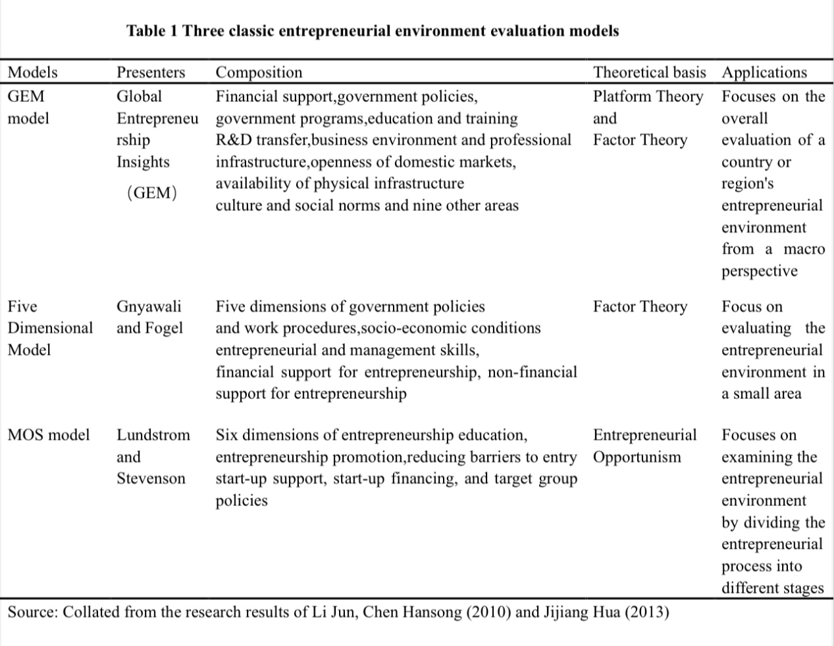
This study focuses on the regional macro-supportive environment for women's entrepreneurship. Therefore, based on Gnyawali and Fogel's (1991) five-dimensional model and the connotation of entrepreneurial environment, the article defines the rural female entrepreneurial environment as a geographically specific entrepreneurial environment with unique social and economic characteristics, which refers to the entrepreneurial environment as perceived by female entrepreneurs, measured in four dimensions: financing environment, government support, level of economic development, and entrepreneurial climate.
2.5 Entrepreneurial performance
Mainstream research on entrepreneurial performance has generally chosen to follow the theoretical perspectives of organisational performance research and has produced numerous well-established research findings (Neill, York, 2012). Current entrepreneurial performance research has been conducted from three main perspectives: resource-based theory, process theory and goal theory. Shaozhong Yu (2013) proposed four theoretical perspectives on entrepreneurial performance research, namely natural determinism, social cognitive theory, resource-based theory and strategic adaptation theory. A growing number of scholars believe that entrepreneurial performance is influenced by the interaction of multiple factors, rather than simply by one factor alone. The relevant influences can be broadly classified into five categories: environmental factors, resource support, strategic factors, entrepreneurs and their teams, and other factors. The internal and external environment is an important resource for entrepreneurship. Changes in the environment can also create a variety of opportunities for entrepreneurship and are an important factor influencing entrepreneurial performance. Resources are one of the key factors affecting entrepreneurial performance, and resource acquisition, integration and utilisation can greatly contribute to entrepreneurial performance (Cai, Li and Liu, 2007). Chen Zhongwei and Lei Hongsheng (2008) analysed the role of entrepreneurial characteristics such as autonomy, innovativeness and intrinsic traits, as well as team factors such as leadership patterns, member competencies, interpersonal relationships and interactions, in enhancing entrepreneurial performance.
Chrisman (1998) suggests that entrepreneurial performance is generally measured along two dimensions: the survival dimension and the success dimension. As an economic entity, survival is the first issue that must be considered by the entrepreneurial enterprise, and reflects the ability of the enterprise to operate autonomously and sustainably on its own, therefore survival is the absolute indicator of entrepreneurial performance; based on the survival of the enterprise, achieving success is the fundamental goal of the entrepreneurial enterprise. Among these financial indicators are measured mainly in terms of sales revenue, profitability, return on assets, and debt ratio (Robinson, 1998). Non-financial indicators are mainly measured in terms of market (share, penetration, etc.), product (new product development, qualification rate, quality and quantity, etc.), employees (productivity, turnover rate, satisfaction, etc.) and customers (satisfaction, loyalty, etc.). As research progresses, scholars have also included entrepreneurial spiritual rewards and happiness in the entrepreneurial performance measurement system, in parallel with economic performance measures. Entrepreneurs who seek to maximise non-wealthy returns are more inclined to achieve high entrepreneurial performance with parallel economic rewards and psychological rewards (Su, Xiaohua, Chen, Jiayin, Zhang, Shujun and Peng, 2018). Entrepreneurship not only brings economic rewards to entrepreneurs, but the success of entrepreneurship also enables entrepreneurs to feel self-worth, gain a sense of entrepreneurial happiness, and facilitate employees' entrepreneurial motivation. Therefore. this study incorporates emotional performance into the entrepreneurial performance index system.
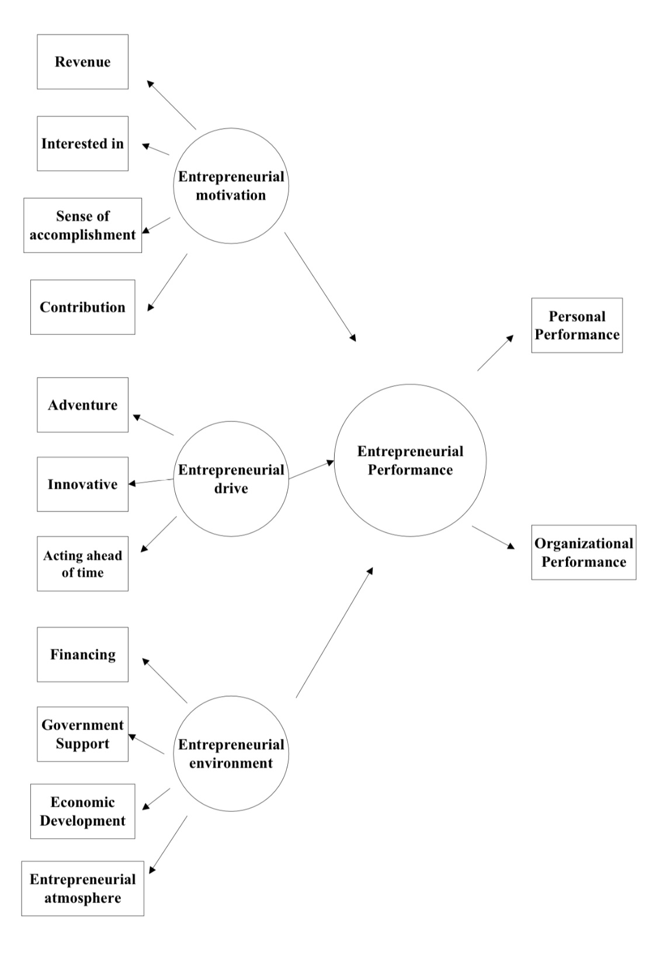
Fig. 1 Conceptual framework

3 Research hypothesis
3.1 Research hypothesis on the impact of entrepreneurial motivation on entrepreneurial performance
Luo Mingzhong (2014) found that when entrepreneurs are driven by entrepreneurial motivation, they will spontaneously seek, learn, and practice knowledge and skills related to entrepreneurship. According to Mike Liu (2018), entrepreneurs, driven by entrepreneurial motivation, will actively acquire knowledge and information related to entrepreneurship through various learning pathways in order to achieve the goal of performance improvement and entrepreneurial success.
As one of the key outcome variables of entrepreneurial motivation, entrepreneurial performance often directly reflects the outcome of entrepreneurial activities. Christopher (2004) studied the achievement motivation and entrepreneurial behavior of entrepreneurs and confirmed that achievement motivation can have a significant impact on the entrepreneurial career and entrepreneurial performance of entrepreneurs. Wang Yingzhao (2018) argues that driving entrepreneurial performance with entrepreneurial motivation, and thus increasing the sense of achievement in the entrepreneurial process, is an important development in the field of entrepreneurial motivation research. Entrepreneurial motivation is strongly linked to entrepreneurial performance, and the stronger the level of motivation, the more likely it is to promote entrepreneurial growth and have a stronger impact on business performance (Yang daojian, 2019). A number of studies have pointed out that the type of entrepreneurial motivation makes a difference in the impact on entrepreneurial performance. Wang Huafeng (2014) verified the significant positive effect of entrepreneurial motivation on entrepreneurial performance and also demonstrated that the mechanism of the difference in the type of entrepreneurial motivation on entrepreneurial performance is different. Therefore, the following hypothesis is proposed in this study.
H1a: Entrepreneurial motivation as a whole has a significant positive effect on personal female entrepreneurial performance
H1b: Entrepreneurial motivation as a whole has a significant positive effect on organizational female entrepreneurial performance

3.2 Research hypothesis on the impact of entrepreneurial drive on entrepreneurial performance
※Here, the entrepreneurship indicates the entrepreneurial drive, represents the spirit, the qualities as an entrepreneur should behave. “entrepreneurial drive” is not a good keyword to do the literature review.
The richness of entrepreneurship has given rise to a multidimensional concept (Bula, 2012). Entrepreneurship is initially expressed as a series of economic resource optimisation lines arising from the realisation of the economic value of innovation (Schumpeter, 1934). Characterised by processes, practices, fundamental leadership arrangements at the firm level, and a critical introduction to entrepreneurial behaviour (Covin et al., 2006), entrepreneurship is concerned with growth and innovation in firms, seizing market opportunities and taking risks. Most of the existing research on the concept of entrepreneurship is related to organisational culture (Khedhaouria et al., 2020), entrepreneurship education (Ndofirepi, 2020), entrepreneurial performance (Pei et al., 2020), firm performance (Kaya, 2015; Presutti & Odorici, 2019; Demneri- Kruja, 2020), business R&D investment, business performance and regional economic growth (Ebru & Ayşe Sevencan, 2018) are linked. Entrepreneurship is generally considered to be a driver of value creation, but there appears to be little empirical research on the relationship between entrepreneurship and entrepreneurial performance of start-ups (Theriou & Chatzoudes, 2015). Therefore, studying the relationship between entrepreneurship and business start-up performance is a valuable topic. Researchers have argued that this link is positive (Hu et al., 2010).
Since Covin and Slevin (1989, 1991), scholars have largely argued that entrepreneurship can have an impact on firm performance, and that this impact is generally direct and strong in the entrepreneurial process. Entrepreneurship reflects the pioneering, innovative and risk-taking nature of the firm and is concerned with the strategic posture of the organisation (Covin & Slevin, 1989). Entrepreneurship is a strategic orientation characterised by innovation, risk-taking and forward deterrence (Covin & Slevin, 1991). Entrepreneurship is reflected in the search for market opportunities and the identification of market risks, the development of market resources, the promotion of organisational change, the willingness to take risks and the courage to innovate (Oviatt & Mcdougall, 2005). Companies with a high level of entrepreneurship integrate knowledge, create new insights about market opportunities, and recognise innovative changes in related industries, which affects entrepreneurial performance (Messersmith & Wales, 2013). Entrepreneurial performance can help entrepreneurs to assess their own capabilities and monitor the performance of their firms. Based on the above analysis, the following hypotheses are proposed.
H2a：Entrepreneurial drive as a whole has a significant positive effect on personal female entrepreneurial performance
H2b: Entrepreneurial drive as a whole has a significant positive effect on organizational female entrepreneurial performance

3.3 Research hypothesis on the impact of entrepreneurial environment on entrepreneurial performance
Scholars have different views on the impact of the entrepreneurial environment on entrepreneurial performance. Some scholars argue that there is an 'inverted U-shaped' relationship between some dimensions of the entrepreneurial environment and entrepreneurial performance (Chen, Jingxin and Dai, 2018). Zhu Honggen et al. (2015) show that financial services, socio-economic and infrastructure directly and positively influence entrepreneurial performance; Wang Qingjin et al. (2019) show that cultural and social norms, education and training, research and transfer development in the entrepreneurial environment can improve the performance of start-ups; Xu Wenfei (2019) argues that the performance of e-commerce entrepreneurship is less influenced by the entrepreneur's own characteristics, while entrepreneurial policy, entrepreneurial atmosphere, financial services, entrepreneurial foundation and other entrepreneurial environment factors are its key influencing factors; Liu Chang et al. (2015) found that there are differences in the paths of influence of different components of entrepreneurial environment on different types of performance, among which policy support, financial support and cultural atmosphere significantly and positively influence survival performance in entrepreneurial performance, infrastructure has the most significant influence on growth performance, and market environment has the most significant effect of the market environment is on innovation performance.
A good entrepreneurial environment is the key for women entrepreneurs to break through their entrepreneurial difficulties and promote the success of their businesses. The environment for female entrepreneurship in China is a little bit complex, and female entrepreneurship is a special type of entrepreneurship, due to social expectations of women's roles in wealth creation on the one hand, and the stereotype of traditional Chinese thinking that 'man is in the marketplace while woman is in the home' on the other, especially as women may be treated unequally when accessing entrepreneurial resources. This phenomenon can occur in many countries around the world, for example, Iwu & Opute (2021), who study gender differences in economic participation in the Republic of Congo. Hao Hongyan (2019), Ghouse et al. (2017) and others suggest the positive effects of a good financing environment, policy support, location conditions, economic development status and entrepreneurial climate on female entrepreneurship. It is thus clear that women can only truly enhance their entrepreneurial performance in the entrepreneurial process if they can adequately obtain support from the external environment to compensate for the lack of their own resource endowment. Therefore, the following hypothesis is proposed：
H3a: Entrepreneurial environment as a whole has a significant positive effect on female personal entrepreneurial performance
H3b: Entrepreneurial environment as a whole has a significant positive effect on female organizational entrepreneurial performance
Above all, through the discussion, this study proposes a total of 6 The hypotheses are summarised in Table 2 shows.
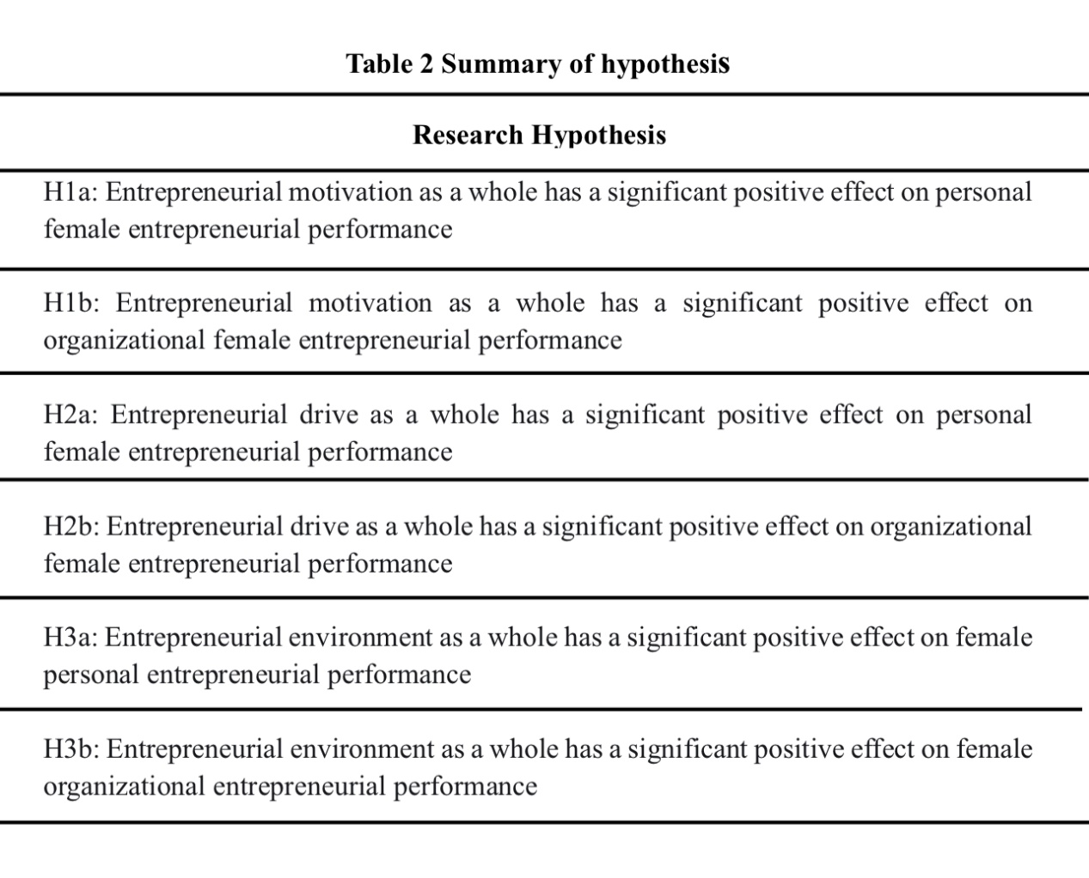

4 Research Methodology
4.1 Questionnaire design
The survey for this study was divided into two parts: basic information and variable measures. The questionnaire was administered to a group of key Chinese new business leaders, all of whom were women. The variable scales were drawn from well-established scales by Chinese and international scholars. All research variables were measured using a pre-validated multi-item scale using a five-point Likert scale where 1 = strongly disagree and 5 = strongly agree. The questionnaire was divided into four sections - Entrepreneurial Motivation Measure Scale, Entrepreneurial Drive Measure Scale, Entrepreneurial Performance Measure Scale, and Basic Information.

4.2 Measure Scales
The Entrepreneurial Motivation Scale is referenced from the scale developed by Taormina (2007).
The Entrepreneurship Scale refers to Miller's (1983) and Morris' (1994) research, which classifies entrepreneurship into three dimensions: risk-taking, innovation, and forward action.
The Entrepreneurial Environment scale refers to the study of Zhu Honggen et al. (2015) and measures four dimensions: financing environment, government support, level of economic development and entrepreneurial atmosphere.
The entrepreneurial performance scale was mainly referred to the scales of Liu Xiandi (2018), Xie Yaping et al. (2016), which were all borrowed from the comprehensive scale of Covin & Slevin, Greenhaus (2006).
In summary, the items were also adapted and improved according to the research content of this topic, and the specific measurement items of the scale are shown in Table 3.
Table 3 Measurement items
S/Nr | Contructs | Measurement items | Sources
A  Independent  variables | Entrepreneurial motivation | - I think running a business will improve my financial situation  - I like to take the initiative in organising my own work  - I enjoy having power in my work  - I think I would have a good future if I started a business | Taormina&Lao(2007)
B  Independent  variables | Entrepreneurial drive |  | Miller(1983)  Morris(1994)
B  Independent  variables | Innovative spirit | - I place great emphasis on product/service innovation  - I can proactively adopt new methods and technologies to reduce costs or increase output | Miller(1983)  Morris(1994)
B  Independent  variables | adventurous spirit | - I always take a bold and positive approach in order to increase the likelihood of getting potential bids  - When faced with uncertainty, I take bold and swift action to achieve my goals | Miller(1983)  Morris(1994)
B  Independent  variables | Spirit of forward action | - I have a great ability to spot market opportunities | Miller(1983)  Morris(1994)
C  Independent  variables | Entrepreneurial environment |  | Zhu Honggen(2015)
C  Independent  variables | Atmosphere | - Local culture encourages innovation  and creativity, with a strong entrepreneurial climate | Zhu Honggen(2015)
C  Independent  variables | Governmental | - Local government provides good policy support for entrepreneurship | Zhu Honggen(2015)
C  Independent  variables | Economic | - High level of local economic development | Zhu Honggen(2015)
C  Independent  variables | Financing | - Local loan amounts can meet actual funding needs | Zhu Honggen(2015)
D  Dependent variables | Entrepreneurial performance |  | Xie Yaping et al (2016)  Covin&Slevin, Greenhaus（2006）
D  Dependent variables | Personal Performance | - My personal income is much higher than before I started my business  - I am very satisfied with my current competence  - I am very satisfied with my current state of personal development and progress | Xie Yaping et al (2016)  Covin&Slevin, Greenhaus（2006）
D  Dependent variables | Organizational Performance | - Our main business has a growing market share  - Our company's profitability is very good | Xie Yaping et al (2016)  Covin&Slevin, Greenhaus（2006）
E  Control variables | Demographic factors | Age, Education, Marital status, Industry, Sources of initial funding

4.3 Data collection
The research scale is based on the proven scales of international scholars, and based on this, this study is a survey of mainly female entrepreneurs within China, or female principals working in entrepreneurial enterprises. In the early stages of the research, a number of female entrepreneurs were interviewed and the questionnaire was designed by combining all the factors at the end of the interviews. The research was conducted with the consent of the subjects concerned, and a small sample was tested. A total of 50 start-up companies were interviewed and the total number of questionnaires was 120, of which 102 were actually returned. After discarding the irregular questionnaires that did not meet the requirements, the final number of valid questionnaires was 100, so this sample had an 83.3% validity rate.
As can be seen from the table, the distribution of “Industry type” shows that the majority of the samples are "Service", with 72%. Over 50% of the Age sample chose "18-34". The proportion of the 35-44 sample is 34.00%. 62.00% of the sample would choose "postgraduate". Length of funding the business distribution shows that the majority of the sample is '2.0' (2-5 years), with 50 samples (50.00%). The frequency is shown in Table 3.
Table 4 Frequency

Items | Categories | N | Percent (%)
Industry type | service | 72 | 72
Industry type | wholesale | 10 | 10
Industry type | e-business | 18 | 18
Age | 18-34 | 50 | 50
Age | 35-44 | 34 | 34
Age | 45-60 | 16 | 16
Qualifications | undergraduate | 20 | 20
Qualifications | postgraduate | 62 | 62
Qualifications | doctoral | 18 | 18
Marriage | married | 78 | 78
Marriage | unmarried | 22 | 22
length of funding the business | 1 | 30 | 30
length of funding the business | 2 | 50 | 50
length of funding the business | 3 | 20 | 20
Total |  | 100 | 100

Descriptive statistical analysis generally measures the level of an indicator for each variable through the mean and standard deviation. A higher mean indicates a higher average level of the sample for this indicator, and a discrete trend is used to describe the degree of dispersion of data in the data distribution, e.g. the standard deviation indicates the magnitude of differences between different samples on the same indicator. This questionnaire takes a five-point Likert scale for dimensional observations, the higher the score, the higher the agreement, i.e. the later the option, the higher the score, the stronger the agreement. With a mean value above 3 indicating that most of the respondents were more inclined to agree. As can be seen from the below table, the high scores in all areas indicate that the subjects are more likely to agree with this.
Table 5 Descriptive statistical analysis
 | Mean | Std. Deviation
PEP | 3.937 | 1.113
OEP | 3.960 | 1.096
Motivation | 3.982 | 1.106
Drive | 3.990 | 1.099
Environment | 3.958 | 1.115

  - Reliability analysis
In order to ensure the reliability and validity of the scale, this study drew on the proven scales used by previous authors, and at the same time, in order to enhance the scientific and validity of this study, the reliability was tested through pre-research data collection and analysis to ensure the reliability of the survey scales in this study. For the reliability test, the Cronbach's alpha test was used. Cronbach's Alpha (the α) coefficient to measure the alpha coefficient is between 0 to 1 between 0 and 1, the closer it is to 1 the higher the internal consistency of the scale, the better the reliability. the higher the internal consistency of the scale and the better the reliability. If α coefficient is less than 0.6 the degree of internal consistency is generally considered to be low; between 0.7 to 0.8 indicates that the scale has a fair degree of reliability; A scale between 0.8 and 0.9 is considered to have very good reliability. As can be seen from the table 6, the reliability coefficients for the scale questions are high, so the survey data are considered to be relatively reliable.
Table 6 Reliability Statistics
scale | Cronbach's Alpha | N of Items
Motivation | 0.992 | 4
Drive | 0.992 | 5
Environment | 0.994 | 4
PEP | 0.995 | 3
OEP | 0.992 | 2

  - Exploratory Factor Analysis
Validity analysis tests the accuracy of questionnaire design. Among them, structural validity can judge the accuracy and validity of the questionnaire's items; content validity can judge the suitability of potential variables. In this study, the research scale is a well-established scale and has been suggested by relevant scholars and women entrepreneurs for reference. The analysis of the research sample data revealed that the Bartlett spherical test for each variable had a p-value is less than 0.001, the KMO value for motivation is 0.869, the KMO value for entrepreneurial drive is 0.873, and the KMO value for environment is 0.856, the KMO value for PEP is 0.784, until so far, the KMO values for the study sample are all greater than 0.7. However, the KMO value for OEP is 0.500, means the validity is not good.
Table 7 Validity
scale | KMO | Bartlett Test
Motivation | .869 | 0.000
Drive | .873 | 0.000
Environment | .856 | 0.000
PEP | .784 | 0.000
OEP | .500 | 0.000

Further exploratory factor analysis was carried out, following the extraction principle of the default eigenvalue greater than 1 in the principal component method of factor extraction. The table 7 shows that factor extraction was carried out on the data with the criterion of the default eigen root greater than 1. A total of one common factor was extracted, with a cumulative variance contribution of 97.702% (greater than 60%) and a good degree of explanation for the extraction, indicating that the extracted factors were effective.
Table 8 Total Variance Explained
Component | Initial Eigenvalues |  |  | Extraction Sums of Squared Loadings
Component | Total | % of Variance | Cumulative % | Total | % of Variance | Cumulative %
1 | 17.586 | 97.702 | 97.702 | 17.586 | 97.702 | 97.702
2 | 0.189 | 1.051 | 98.754
3 | 0.094 | 0.524 | 99.277
4 | 0.056 | 0.312 | 99.589
5 | 0.031 | 0.175 | 99.763
6 | 0.017 | 0.095 | 99.859
7 | 0.010 | 0.056 | 99.915
8 | 0.008 | 0.046 | 99.960
9 | 0.005 | 0.030 | 99.991
10 | 0.002 | 0.009 | 100.000
11 | 2.320E-16 | 1.289E-15 | 100.000
12 | 2.199E-16 | 1.222E-15 | 100.000
13 | 1.119E-16 | 6.215E-16 | 100.000
14 | 1.112E-16 | 6.178E-16 | 100.000
15 | 4.135E-18 | 2.297E-17 | 100.000
16 | -2.543E-19 | -1.413E-18 | 100.000
17 | -2.120E-16 | -1.178E-15 | 100.000
18 | -3.000E-15 | -1.667E-14 | 100.000
Extraction Method: Principal Component Analysis.

The factor loading matrix reflects the degree of correlation between the original variables and the factors. In order to more accurately interpret the naming of individual principal factors, the maximum variance method was used to implement an orthogonal rotation of the factor loading matrix. When selecting items for measurement, the magnitude of the factor loading values was used as a criterion for retention and exclusion to build the factor loading matrix, and factor loadings less than 0.5 were excluded, with questions in the same column in the final factor ranking being classified as the same category. In summary, the questionnaire was divided into 1 area for each of the measurement questions, with each factor loading greater than 0.5.
Table 9 Component Matrixª
 | Component
 | 1
running a business will improve my financial situation | 0.992
take the initiative in organising my own work | 0.992
enjoy having power in my work | 0.995
have a good future if I started a business | 0.971
great emphasis on product/service innovation | 0.986
proactively adopt new methods and technologies | 0.979
take a bold and positive approach | 0.971
take bold and swift action to achieve goals | 0.993
great ability to spot market opportunities | 0.995
a strong entrepreneurial atmosphere | 0.992
good policy support | 0.995
High level of local economic development | 0.992
Local loan amounts can meet actual funding needs | 0.979
higher income | 0.991
satisfied with my current competence | 0.992
satisfied with my current state of personal development and progress | 0.995
main business has a growing market share | 0.992
company's profitability is very good | 0.989
Extraction Method: Principal Component Analysis.
a. 1 components extracted.

5 Data analysis
5.1 Correlation analysis
Correlation analysis is a statistical analysis method to determine the degree of association between two or more variables of equal status in academic research, in which the closeness of the relationship between variables is expressed in the form of statistical indicators. Based on the existing literature, this study mainly adopts Pearson coefficient for correlation analysis of variables, and the judgment criteria are 0.7~1 for strong correlation, 0.3~0.7 for moderate correlation and 0~0.3 for weak correlation. The specific results of the correlation analysis are shown in the table 10.
Table 10 Pearson Correlation
 | PEP | OEP | Motivation | Drive | Environment
PEP | 1
OEP | 0.992*** | 1
Motivation | 0.995*** | 0.991*** | 1
Drive | 0.994*** | 0.992*** | 0.999*** | 1
Environment | 0.998*** | 0.991*** | 0.995*** | 0.997*** | 1
* p<0.05 ** p<0.01 *** p<0.001

The correlation coefficients were 0.992, 0.995, 0.994, 0.998 and were all greater than 0, implying a positive relationship between PEP and OEP, Motivation, Drive, Environment, Environment.The correlation coefficients were 0.991, 0.992, and 0.991, respectively, and were all greater than 0. This means that there is a positive correlation between OEP and Motivation, Drive, and Environment.
  - Regression analysis
Correlation analysis can only explain the closeness of the variables and not how the variables exert their influence on each other. In order to further verify the effect of the variable’s entrepreneurial motivation, entrepreneurship, entrepreneurial environment and entrepreneurial performance, the exact magnitude of the effect between the variables will be verified through regression analysis.
Table 11 Parameter Estimates (n=100)
 | Unstandardized Coefficients |  | Standardized Coefficients | t | p | R 2 | Adj R 2 | F
 | B | Std. Error | Beta
Constant | 0.036 | 0.023 | - | 1.58 | 0.117 | 0.997 | 0.997 | F (3,96)=11980.541,p=0.000
Motivation | 0.893 | 0.101 | 0.888 | 8.872 | 0.000*** | 0.997 | 0.997 | F (3,96)=11980.541,p=0.000
Drive | -1.041 | 0.127 | -1.028 | -8.168 | 0.000*** | 0.997 | 0.997 | F (3,96)=11980.541,p=0.000
Environment | 1.136 | 0.068 | 1.139 | 16.802 | 0.000*** | 0.997 | 0.997 | F (3,96)=11980.541,p=0.000
Dependent Variable: PEP
* p<0.05 ** p<0.01 *** p<0.001
The model R-squared value of 0.997 implies that Motivation, Drive, Environment can explain 99.7% of the variation in PEP. An F-test of the model revealed that the model passed the F-test (F=11980.541,
p=0.000<0.05), which means that at least one of Motivation, Drive, Environment would have an influential relationship on PEP.
The regression coefficient value of Motivation was 0.893 (t=8.872, p=0.000<0.01), implying that Motivation would have a significant positive influence relationship on PEP. Hypothesis H1a is verified.
The regression coefficient value for Drive was -1.041 (t=-8.168, p=0.000<0.01), implying that Drive has a significant negative effect on PEP. Hypothesis H2a is not verified.
The regression coefficient value for Environment was 1.136 (t=16.802, p=0.000<0.01), implying that Environment would have a significant positive influence relationship on PEP. Hypothesis H3a is verified.

Table 12 Parameter Estimates (n=100)
 | Unstandardized Coefficients |  | Standardized Coefficients | t | p | R 2 | Adj R 2 | F
 | B | Std. Error | Beta
Constant | 0.037 | 0.054 | - | 0.693 | 0.49 | 0.985 | 0.984 | F (3,96)=2075.033,p=0.000
Motivation | 0.165 | 0.237 | 0.167 | 0.698 | 0.487 | 0.985 | 0.984 | F (3,96)=2075.033,p=0.000
Drive | 0.573 | 0.3 | 0.575 | 1.913 | 0.059 | 0.985 | 0.984 | F (3,96)=2075.033,p=0.000
Environment | 0.247 | 0.159 | 0.252 | 1.554 | 0.123 | 0.985 | 0.984 | F (3,96)=2075.033,p=0.000
Dependent Variable: OEP
* p<0.05 ** p<0.01 *** p<0.001

The model R-squared value of 0.985 implies that Motivation, Drive, Environment explains 98.5% of the variation in OEP. An F-test of the model revealed that the model passed the F-test (F=2075.033, p=0.000<0.05), which means that at least one of Motivation, Drive, Environment would have an influential relationship on OEP.
Further regression using stepwise gave the following results: indicating that the effect of Drive on OEP is significant and the hypothesis is valid

Table 13 Coefficientsª
Model |  | Unstandardized Coefficients |  | Standardized Coefficients | t | Sig.
 |  | B | Std. Error | Beta | t | Sig.
1 | (Constant) | .013 | .052 |  | .251 | .803
1 | Drive | .989 | .013 | .992 | 78.592 | .000
a. Dependent Variable: OEP

Above all, the regression coefficient value for Motivation was 0.165 (t=0.698, p=0.487>0.05), implying that Motivation does not have an influential relationship on OEP. Hypothesis H1b is not verified.
The regression coefficient value for Drive was 0.989 (t=78.592, p=.000＜0.01), implying that Drive have an effect on OEP. Hypothesis H2b verified.
The regression coefficient value for Environment was 0.247 (t=1.554, p=0.123>0.05), implying that Environment does not have an influential relationship on OEP. Hypothesis H3b is not verified.

6 Findings and Conclusion
- Women's entrepreneurial motivation is measured in four
dimensions: income, interest, sense of achievement and contribution; women's entrepreneurial spirit is measured in three dimensions: spirit of adventure, spirit of innovation and spirit of forward action; women's entrepreneurial environment is measured in four dimensions: financing environment, government support, level of economic development and entrepreneurial atmosphere; women's entrepreneurial performance is measured in two dimensions: individual performance and organizational performance. Good reliability and validity of the variables and measures are achieved.
2) A regression analysis of the relationship between entrepreneurial motivation, entrepreneurial drive, entrepreneurial environment and entrepreneurial performance was conducted. It was found that the effects of entrepreneurial motivation and entrepreneurial environment on personal entrepreneurial performance (PEP) were significant and positively correlated, and the hypothesis test was valid. The effect of entrepreneurial drive on individual performance is not significant and the hypothesis test is not valid. The effect of entrepreneurial motivation and entrepreneurial environment on organizational performance (OEP) was also found to be insignificant and the hypothesis test did not valid. However, the effect of entrepreneurial drive on organizational entrepreneurial performance was significant and the hypothesis valid.
3) Why are some of the hypothesis results not significant. I think there are three possibilities.
a. The results of the correlation analysis show that the correlation between the variables is too high, could the strong correlation lead to "multicollinearity"? I think it is possible, but I don't know how to do this step.
b. The sample size is not large enough. There are 23 variables in this study, but the sample is only 100. Usually a sample size of 5 times the standard basic size is better. This may also lead to the hypothesis not being valid.
c. Does the data match my research question? It is possible that the values of the variables were not set appropriately for my research question, resulting in unsatisfactory results.

In the end, although the results of this study were not ideal, it was the first real step towards trying to do quantitative work and was a very important attempt for my personal academic career. I think I will keep this assignment forever, so that no matter what problems I encounter in the future, I will take it out and look at it, and I will definitely be re-energised to challenge anything that I think is "impossible". Thank you to our dear teacher, Dr. Promise, for helping us so much. Thank you to my dear classmates, it has been such a privilege to study with you all. Finally, thank you to myself for completing this assignment.

7 Bibliography

Appendix 1 Dataset
Instructions: Please, use a 5-point likert-scale as described below:
1 - Strongly Disagree
2 – Slightly Disagree
3 – Neutral
4 – Slightly Agree
5 – Strongly Agree

Construct A: Entrepreneurial motivation

No. | Statements | Scale

 |  | 1 | 2 | 3 | 4 | 5
A1 | I think running a business will improve my financial situation | 6 | 6 | 8 | 45 | 35
A2 | I like to take the initiative in organising my own work | 5 | 8 | 8 | 46 | 33
A3 | I enjoy having power in my work | 6 | 8 | 6 | 45 | 35
A4 | I think I would have a good future if I started a business | 6 | 6 | 8 | 35 | 45
r
Construct B: Entrepreneurial Drive

No. | Statements | Scale

 |  | 1 | 2 | 3 | 4 | 5
B1 | I place great emphasis on product/service innovation | 4 | 8 | 9 | 46 | 33
B2 | I can proactively adopt new methods and technologies to reduce costs or increase output | 6 | 8 | 4 | 42 | 40
B3 | I always take a bold and positive approach in order to increase the likelihood of getting potential bids | 6 | 6 | 8 | 35 | 45
B4 | When faced with uncertainty, I take bold and swift action to achieve my goals | 5 | 8 | 8 | 46 | 33
B5 | I have a great ability to spot market opportunities | 6 | 8 | 6 | 45 | 35

Construct C: Entrepreneurial environment 环境

No. | Statements | Scale

 |  | 1 | 2 | 3 | 4 | 5
C1 | Local culture encourages innovation and creativity, with a strong entrepreneurial atmosphere | 5 | 8 | 8 | 46 | 33
C2 | Local government provides good policy support for entrepreneurship | 6 | 8 | 6 | 45 | 35
C3 | High level of local economic development | 6 | 9 | 5 | 47 | 33
C4 | Local loan amounts can meet actual funding needs | 6 | 8 | 4 | 42 | 40

Construct D: Entrepreneurial performance

No. | Statements | Scale

 |  | 1 | 2 | 3 |  | 4 | 5
D1 | My personal income is much higher than before I started my business | 6 | 9 | 5 |  | 47 | 33
D2 | I am very satisfied with my current competence | 5 | 8 | 8 |  | 46 | 33
D3 | I am very satisfied with my current state of personal development and progress | 6 | 8 | 6 |  | 45 | 35
D4 | Our main business has a growing market share | 5 | 8 | 8 | 46 |  | 33
D5 | Our company's profitability is very good | 5 | 8 | 8 | 42 |  | 37

Part E: Demographics
Gender Age

Male Female 100 Between 18 and 34 50

Between 35 and 44 34
Industry Type
Between 45 and 60 16
Service 72

Wholesale 10 Qualifications
Undergraduate Degree 20
E-business 18
Postgraduate Degree 62

Doctoral Degree 18
Marriage status
Married 78 

Unmarried 22

How long have you been founding this business?

1 – 12months 30

2 – 5years 50

6years and above 20

Appendix 2 Questionnaire
Questionnaire

PART ONE: Demographics

- What is your age?
- Between 18 and 34
- Between 35 and 44
- Between 45 and 60
- What is the industry in which you started your business?
- Service
- Wholesale
- E-business
- What is your highest degree?
- Undergraduate Degree
- Postgraduate Degree
- Doctoral Degree
- What is your current marital status?
- Married
- Unmarried
- How long have you been founding this business?
- 1 – 23months
- 2 – 5years
- 6years and above

PART TWO: Entrepreneurial Motivation

- What is your motivation for starting your own business?

 |  | Strongly Disagree | Slightly Disagree | Neutral | Slightly Agree | Strongly Agree
 |  | 1 | 2 | 3 | 4 | 5
A | I think running a business will improve my financial situation
B | I like to take the initiative in organising my own work
C | I enjoy having power in my work
D | I think I would have a good future if I started a business

PART THREE: Entrepreneurial Drive

- What drove you to start your own business?

 |  | Strongly Disagree | Slightly Disagree | Neutral | Slightly Agree | Strongly Agree
 |  | 1 | 2 | 3 | 4 | 5
A | I place great emphasis on product/service innovation
B | I can proactively adopt new methods and technologies to reduce costs or increase output
C | I always take a bold and positive approach in order to increase the likelihood of getting potential bids
D | When faced with uncertainty, I take bold and swift action to achieve my goals
E | I have a great ability to spot market opportunities

PART FOUR: Entrepreneurial Environment

- How is your current business environment?

 |  | Strongly Disagree | Slightly Disagree | Neutral | Slightly Agree | Strongly Agree
 |  | 1 | 2 | 3 | 4 | 5
A | Local culture encourages innovation and creativity, with a strong entrepreneurial atmosphere
B | Local government provides good policy support for entrepreneurship
C | High level of local economic development
D | Local loan amounts can meet actual funding needs

PART FIVE: Entrepreneurial Performance

- What is your current outstanding entrepreneurial performance?

 |  | Strongly Disagree | Slightly Disagree | Neutral | Slightly Agree | Strongly Agree
 |  | 1 | 2 | 3 | 4 | 5
A | My personal income is much higher than before I started my business
B | I am very satisfied with my current competence
C | I am very satisfied with my current state of personal development and progress
D | Our main business has a growing market share
E | Our company's profitability is very good

