MANAGEMENT ECONOMICS
LCBB5003
Valentin Daniel Susanu
2019937

Table of Contents
1. Overview of company and chosen product 3
2. Identifying Demand and market equilibrium 4
2.1. “Price of Substitutes” 4
2.2. “Price of Complements” 5
2.3. Consumer Income 6
2.4. “Consumer tastes and Preferences” 7
3. Indicating the elasticity of Demand 9
3.1. Substitution Effects: 9
3.2 Income Effects 9
3.3 Price Policy Analysis 12
References: 13

1. Overview of company and chosen product
Apple is a multinational technology company that is headquartered in the US and serves its customers with consumer electronics, online services and software. The company was formerly an Apple Computer Company till 1977, and after that, it became Apple Computer Inc. The founders of the company, Steve Jobs, Ronald Wayne and Steve Wozniak operate the company and decide strategies for the growth and success as well as competitive advantage of the company. The company has over 520 retail stores and over 154000 employees globally. The company serves its customers with products and services from consumer electronics, online services and software services. The digital gadgets sold by Apple are according to the preferences and demands of the customers that serve them with speed and security as the features in the digital gadgets of Apple are strong and secure for their customer range. Technological changes and advancements along with the product range in the company for gaining competitive advantage are productive.
The handset of Apple has been chosen as the major business and its main product to customers. The handset of Apple is smartphones that have the iOS mobile operating system and provide the customer base with great benefits that are demanded by the customer base. The handset of Apple has strong battery life, a fast and powerful chip, a mobile design that is flat-edged and flawless, durable and bright as well as enhancing the OLED display. Apple's iPhone is preferred by most customers globally even if the price range of the smartphone from Apple is high. It has been observed that the company sold more than 300 million iPhones in the financial year 2022 (Screenrant, 2022).
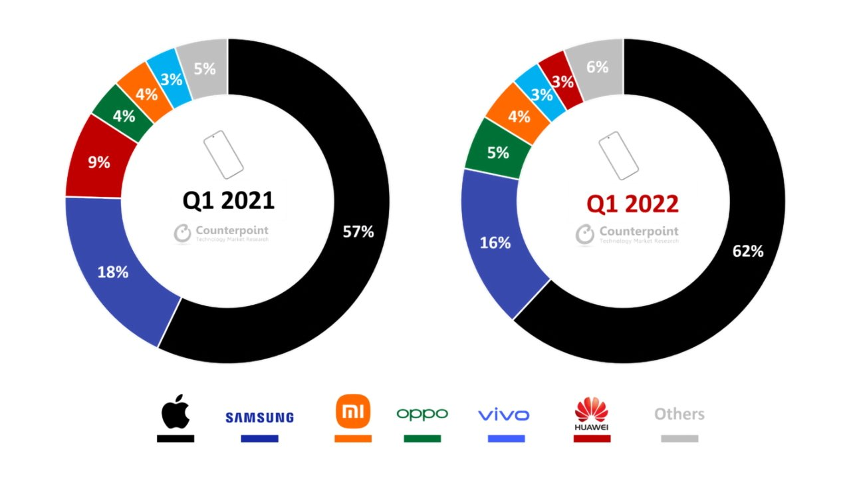
Figure 1: iPhone dominates the premium smartphone market
(Source: Appleinsider, 2022)
The above image indicates the demand for the iPhone in comparison to other smartphones. This justifies the reason for researching how Apple products are contributing to or impacting the economic factors globally.

2. Identifying Demand and market equilibrium

2.1. “Price of Substitutes”
The best substitute for Apple is Microsoft which also produces advanced products and has been serving customers for a decade. Apple sells Mac, iPad, iPhones, Airpods, watches, smart TVs, and some accessories of these electronic gadgets (Apple, 2022). On the other hand, Microsoft is a huge brand that manufactures mobile phones, laptops, desktops, watches, hardware of desktops, laptops, and mobiles along with antivirus protection (Microsoft, 2022). Therefore, this organization is the biggest competitor of Apple because of its substitute products.
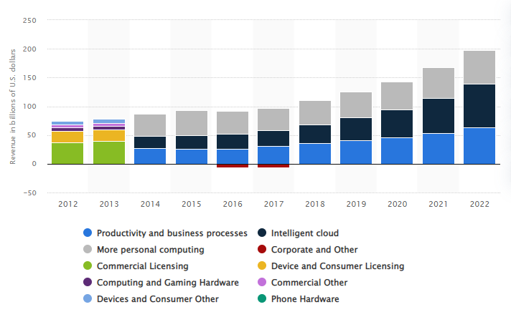
Figure 2: Revenue of Microsoft from 2012-2022
(Source: Statista, 2022)
Presently, the prices of Microsoft products are getting lower, and that is why it is rising as a huge brand. However, the revenue is lower in comparison to Apple, but the sustainability of Microsoft products is the biggest threat to Apple's business (Statista, 2022). The substitute products can affect the business income of Apple because whenever people will get a better substitute at a lower price, they will switch to another brand. As per the research findings obtained from Statista (2022), the revenue of Microsoft is "63.4 Billion US Dollars" which is an increasing trend and can create difficulties for the organization in the future.

2.2. “Price of Complements”
Complements are generally the reviews, and feedback from the customers in a positive way which means praising the product, and its qualities. The best complementary product of Apple is the Apple watch whose sales are increasing day by day (Statista, 2022). Compliments for a product motivate the creator to innovate more additional, and advanced features in that product. Not only that, the creator gets inspired to create more innovative, and different types of products to make the business more advanced, and improved. The price of Apple watches is not increasing at a huge rate, but it is increasing based on the demand of customers worldwide. As per the research findings obtained from Statista (2022), the usage of wearable accessories, and home accessories Apple is increasing day by day increasing the sales percentage (51.99%).
The increasing compliments for the product, is increasing the sales of the other products of this company because the quality of that product has been rated great, and that is the reason, people are trusting this brand in terms of other products. The sales percentage of the organization has increased in comparison to earlier times. As per the research findings extracted from Statista (2022), the present revenue of the organization is approximately “365.82 Billion US Dollars” in the last year.

2.3. Consumer Income
Presently, the income of the consumers is increasing because the country’s economic condition is quite stable now as per the GDP. As per the report of Statista (2022), the present GDP rate of the country is 5.98%. GDP measures an overall output of an entire economy by adding up total investment, consumption, Government expenditure, and net exports. Therefore, the economic condition of the country is shown in this data that is indicating the economic stability, and growth of the nation. As per the analysis of Statista (2022), the increasing revenue of the company proves that demand is increasing for the products because of their efficient marketing which indicates that demand is inelastic, and keeps changing continuously.
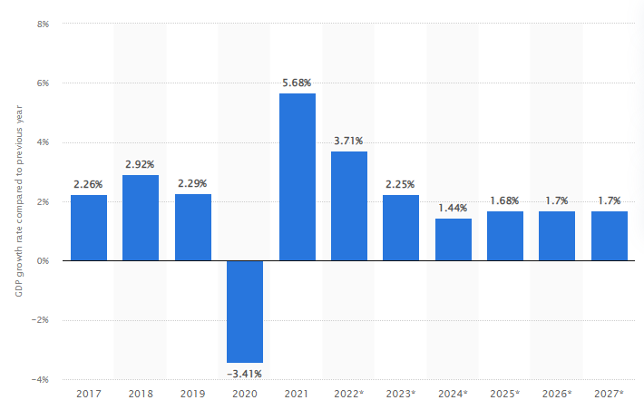
Figure 3: GDP of United States from (2017-2027)
(Source: Statista, 2022)
Increasing the income of customers will enhance their buying capacity, and they will buy more products as there will be no financial issues. This is why the sales of the company are increasing day by day because of the higher demand for products, and the high income of the consumers.

2.4. “Consumer tastes and Preferences”
The preferences, and buying behavior of customers are not constant because they always try to find better options, and sometimes depending on situations, the purchase behavior of customers, and their preferences change (Tyagi et al. 2018). A major factor in changing preferences, and tastes of customers is the sudden outbreak of the pandemic. After Covid, customers' preferences changed, and the sellers struggled to sell their products to the customers because there was a sense of insecurity while buying products at the time of Covid (Mehta et al. 2020). For example, if a customer’s buying behavior, and preferences change constantly, it can create huge difficulties in terms of selling because a seller will not be able to understand how to satisfy the customer, and what is the actual gap in the business. As a consequence, the sales growth of the organization will be decreased because of not fulfilling the objectives of a customer.
2.5. “Consumer expectations of price (of your product or service)”
The price expectation from the consumers alters the price behavior as well as the demand for the product. Price expectations from customers drive the demand and the purchasing decisions from the customers. Consumers develop a price expectation in their mind for the product they want to buy. The findings have revealed that the consumers as well as the inflation rate have not impacted the demand for Apple handsets, and iPhones for the customers (Businessofapps, 2022). The customers of Apple handsets are not sensitive to price and do not change their purchasing decision. This is understood by the fact that customers still buy iPhones and the demand for iPhones is good in comparison to the other premium smartphones. The customers of Apple have low or no sensitivity to the prices of the products from Apple. This is due to the fact that Apple has a lack of competition in the iOS system and the demand for Apple handsets is high which allows Apple to charge premium pricing for its handset.
Consumers expect the price of handsets from the iPhone to increase as the smartphones from Apple are effective and enticing to the customer base (Appleinsider, 2022). The demand for iPhone is still rising as the company is focusing on making the handset unique and enticing to the customer base. Power over the pricing of the handsets from Apple has been observed.
2.6. “Demographics”
The possible sales of Apple handsets are decreasing with the rise of the inflation rate. This is not due to the increasing costs of Apple products, but the inflation along with other macroeconomic factors may end up hurting the demand for the handsets of Apple. Due to rising inflation and other macroeconomic factors, the existing iPhone users may not want to upgrade to new models for the time period. Hence, iPhone customers who are loyal to the products may not want to upgrade now and may decide to postpone the upgrade of their handset. The demand for the iPhone is not lowered due to macroeconomic factors, but the customers may want to postpone their buying of Apple's newest model till the economic conditions are getting better. This is due to the fact that the proposition of Apple is strong and the customers are loyal to the services and products Apple. However, the sales of Apple products, especially the handset from Apple are slowing down due to the rising global inflation. The price of the handsets from Apple has been increased by the company several times in the last 5 years. This may impact consumer demand in some ways eventually (Cnbc, 2022).

3. Indicating the elasticity of Demand

3.1. Substitution Effects:
From the point of view of a customer, luxury is not always necessary, but in maintaining a high-profile lifestyle, luxury is required along with fulfilling the necessary needs of a person. In this scenario, the substitution effects of buying a handset are considered more a luxury than a necessity because there are brands like Samsung, Microsoft, and others who also sell the substitute products of Apple at comparatively reasonable prices (Microsoft, 2022). In most cases, buying Apple products is a fascination for the consumers rather than fulfilling the necessity of their daily lives. As found in the research of Apple (2022), 1 iPhone 13 Pro costs approximately $999 which is a huge amount, and no one will buy such a costly product to fulfill the basic objectives of daily life.
Luxury means to increase the status of personal living by upgrading the way of living in comparison to others. On the other hand, necessity means fulfilling the basic requirements of daily life which means completing the fundamental requirements which indicate a decent way of living in a moderate standard refers to necessity (Luque, 2022). Therefore, from a customer's point of view, the product is necessary for them because they want to stay connected with the brand, and want to get upgraded by using this phone that defines luxury by fulfilling all the necessities. This factor indicates demand is inelastic because Apple generates different ranges of iPhones every year, and customers' demand also keeps changing as per the upgradation of the models.

3.2 Income Effects
Income is one of the factors that influence the purchasing behavior of a person and it is obvious that higher income provides high buying power to consumers. Apple is a luxurious brand, which people in the medium to the low-income range cannot afford. When a consumer has a higher throwaway income, it provides more opportunity for the customers to spend on luxurious products or brands but most people in the medium to low-income range find it an unnecessary waste of money. According to Statista, (2022), total pay in the UK grew 5.1% approximately and the regular pay grew by about 4.7% in the three months to June 2022.
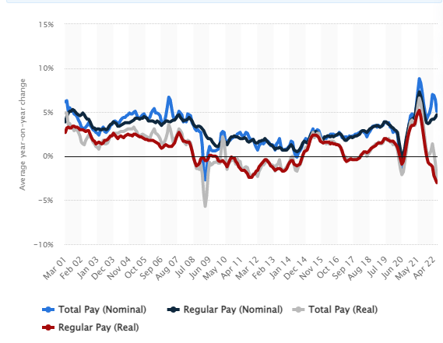
Figure 4: Growth of Regular Pay in the UK
(Source: Statista, 2022)
Therefore, it has been analyzed that the average income of people in the UK is growing, which indicates that people of the United Kingdom possess the ability to spend money on luxurious brands and the GDP of the UK was approximately 568.7 Billion British pounds, which is increasing by 2.9% in an approximate way (Statista, 2022). This designates that people of the UK hold the ability to spend on luxurious brands. Apple is a brand that provides quality products at a premium price and the range of iPhones has various models and pricing. The most popular iPhone is the “iPhone 13 Pro max” worldwide and its price is approximately $1049.00, which is a huge amount. The total market share of Apple iOS in the UK reached approximately 46.85% in the year 2022 (Statista, 2022).
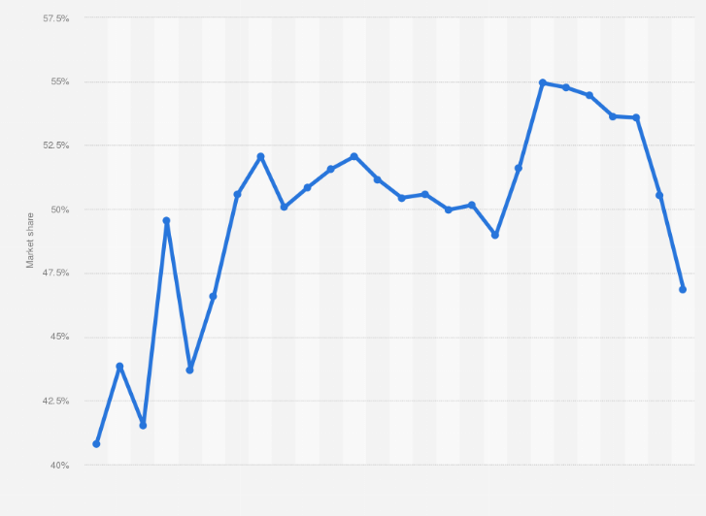
Figure 5: Market share of Apple iOS
(Source: Statista, 2022)
Therefore, it has been analyzed that the purchase of the iPhone represents a large amount of the consumer's income and it has been found statistically that the demand for iPhone is decreasing as the market share of Apple is decreasing with time.
Demand elasticity is a measure of changes in demand when the firm changes its price. Price elasticity equals the quantity of the demanded goods divided by the price of the demanded products (Labandeira et al., 2017). Therefore, the demand for the Apple iPhone is elastic because due to premium pricing the demand for the iPhone is decreasing. As the price of the iPhone is huge and people buy it in a high-income range only, therefore, the demand is reducing among people and the market share of Apple indicates that the growth is condensing day by day in the UK. However, according to Lusk and Tonsor (2016), it is simple to understand that if the price of a specific product goes up, the demand goes down automatically and on another hand, the demand for a product increases when the price falls. Conversely, it also has to be mentioned that Apple is a luxurious brand and the demand for the iPhone is huge worldwide but the demand automatically goes down as the high-income people tend to purchase iPhone but the middle or low-income range people do not think about purchasing iPhone, as its pricing is huge.

3.3 Price Policy Analysis
Apple uses a Premium Pricing Strategy for iPhones and the brand has a good, better and best lineup. The iPhone is superior to competitor offerings according to the company’s point of view because customers prefer to buy Apple iPhones. Therefore, customers will pay a premium for the Apple iPhone but the customer base is limited to iPhones as there are many people in the medium to low-income range and some of them do not like to spend too much money on iPhones. One of the reasons that people do not want to buy Apple is because not only the pricing is premium but the service cost of the iPhone is high. According to a survey most youngsters have stated that they can spend a premium amount for the Apple platform and design but those people who cannot afford to pay for the iPhones can make trade-offs in the features because there are substitute handsets that provide the same features in a low price range such as Samsung, XIAOMI, and OPPO. Therefore, Apple should offer iPhones with a minimum price range to attract customers because the goodwill of Apple is huge and it provides premium quality handsets with providing value to the customers. Apple should apply Economy Pricing to target those customers, who are looking for a “no frills” product. Apple can minimize the cost of packaging, marketing and production without compromising the quality and features to keep the price down to attract more customers. However, it would be easy for Apple to apply this strategy because it has large sales volumes and can generate more profit from low prices.

References:
Appleinsider, 2022. Phone dominates premium smartphone market with 62% of sales in Q1 2022. Available from: https://appleinsider.com/articles/22/06/23/iphone-dominates-premium-smartphone-market-with-62-of-sales-in-q1-2022 [Accessed: 28 August 2022]
Businessofapps, 2022. Apple Statistics (2022). Available from: https://www.businessofapps.com/data/apple-statistics/ [Accessed: 27 August 2022]
Cnbc, 2022. How inflation will affect Apple. Available from: https://www.cnbc.com/2022/07/01/wealthy-customers-will-help-apple-resist-the-effects-of-inflation.html [Accessed: 28 August 2022]
Labandeira, X., Labeaga, J.M. and López-Otero, X., 2017. A meta-analysis on the price elasticity of energy demand. Energy policy, 102, pp.549-568.
Luque, A., 2022. Analysis of the concept of informal economy through 102 definitions: legality or necessity. Open Research Europe, 1(134), p.134.
Lusk, J.L. and Tonsor, G.T., 2016. How meat demand elasticities vary with price, income, and product category. Applied Economic Perspectives and Policy, 38(4), pp.673-711.
Mehta, S., Saxena, T. and Purohit, N., 2020. The new consumer behaviour paradigm amid COVID-19: permanent or transient?. Journal of health management, 22(2), pp.291-301.
Microsoft. 2022. Support for Microsoft products and apps. Available at. https://support.microsoft.com/en-us/all-products. [Accessed: 29 August 2022]
Screenrant, 2022. Here's How Many iPhones Apple Reportedly Plans To Sell In 2022. Available from: https://screenrant.com/apple-iphone-sales-expectation-2022-report/ [Accessed: 26 August 2022]
Statista, 2022. Average year-on-year growth of weekly earnings (3 month average) in the United Kingdom from March 2001 to June 2022. [online] Available from: <https://www.statista.com/statistics/933075/wage-growth-in-the-uk/> [Accessed on 30 August 2022].
Statista, 2022. Market share of Apple iOS in the United Kingdom (UK) from December 2011 to April 2022. [online] Avaiable From: <https://www.statista.com/statistics/271195/apple-ios-market-share-in-the-united-kingdom-uk/#:~:text=Apple%20iOS%20mobile%20market%20share,Kingdom%20(UK)%202011%2D2022&text=In%20April%202022%2C%20the%20total,percent%20in%20the%20previous%20year> [accessed on 30 August 2022].
Statista, 2022. Quarterly gross domestic product in the United Kingdom from 1st quarter 1955 to 2nd quarter 2022. [online] Available From: <https://www.statista.com/statistics/785546/gross-domestic-product-per-quarter-united-kingdom/> [accessed on 30 august, 2022].
Statista. 2022. Global revenue of Apple from 2004 to 2021(in billion U.S. dollars). Available at. https://www.statista.com/statistics/265125/total-net-sales-of-apple-since-2004/. [Accessed: 28 August 2022]
Statista. 2022. Microsoft's revenue from 2012 to 2022 financial years, by segment (in billion U.S. dollars). Available at. https://www.statista.com/statistics/273482/segment-revenue-of-microsoft/. [Accessed: 28 August 2022]
Statista. 2022. Real gross domestic product (GDP) growth rate in the United States from 2017 to 2027(compared to the previous year). Available at. https://www.statista.com/statistics/263614/gross-domestic-product-gdp-growth-rate-in-the-united-states/. [Accessed: 28 August 2022]
Statista. 2022. Share of Apple's revenue by product category from the 1st quarter of 2012 to the 2nd quarter of 2022. Available at. https://www.statista.com/statistics/382260/segments-share-revenue-of-apple/. [Accessed: 28 August 2022]
Tyagi, A., 2018. A Study on Factors Affecting Consumer Buying Behaviour. International Journal of Business & Engineering Research, 11.

