Samuel Miles (BAE Systems OME Apprentice)
2112603@student.uwtsd.ac.uk

DYnamic investigation
Analysis of effects of mesh density in impact simulations
Contents

Abstract 2

Introduction 2

Simulation Setups 2

Simulation Results
First Simulation 13
Second Simulation 18

Conclusion 22

Recommendations 22

References 23

Abstract
To complete this report the student created two simulations using Abaqus 2018 full edition so the results could be complex compared to those possible in the student edition. The first simulation was completed with less nodes therefore a lower mesh density. The second simulation was then created increasing the number of nodes therefore increasing the mesh density. This drastically changed the simulation results and the steel projectile went through the titanium plate with ease.
Introduction
This report is a detailed analysis of a high-speed projectile hitting a block of another material. Within this report will be a comparison of two simulations showing the differences when the mesh density has been changed. This report uses simulations created in Abaqus software. Within Abaqus the student used Johnson-Cook damage model so the simulations could be realistic. The Johnson-Cook damage model uses the following information

Density | ρ (kg/m³)
Shear modulus | G (GPa)
Poisson's ratio | ν
J–C yield strength | A (MPa)
J–C hardening coefficient | B (MPa)
J–C strain hardening exponent | N
J–C strain rate constant | C
J–C softening exponent | M
Melting temperature | T_{m} (K)
J–C damage constant | d₁
J–C damage constant | d₂
J–C damage constant | d₃
J–C damage constant | d₄
J–C damage constant | d₅
Table 1 - List of information used during Johnson-Cook damage model [1]
Simulation Setup
The student created the simulation from scratch within the software. The projectile was loosely based off the tip of a 30mm RARDEN to make it as realistic as possible. The plate of material is a simple block of 10mm thickness.
The first thing the student was required to do was create the parts that were going to be used in the simulations. The figure below is the sketch created by the student for the projectile. The length of the projectile was 100 m and top was 15 mm so when it was revolved it became a 30 mm round.
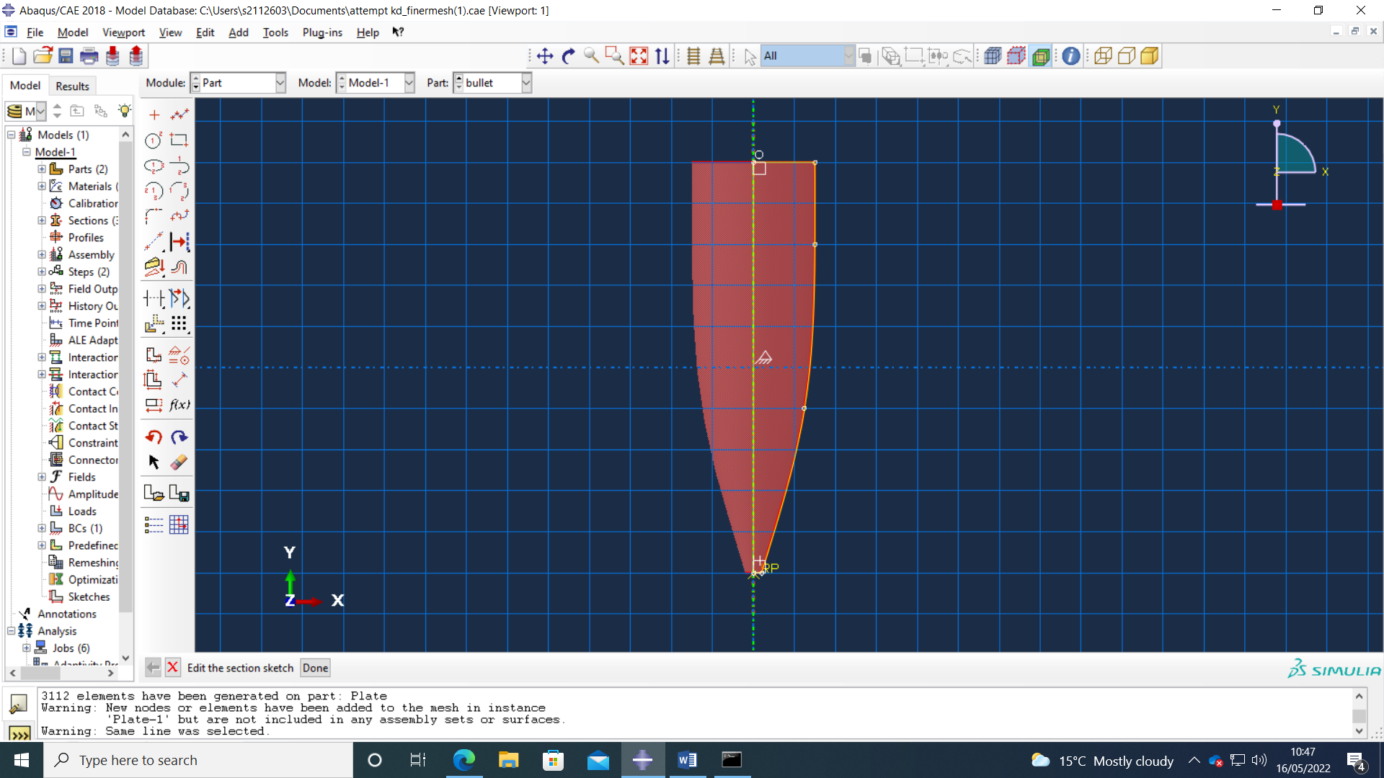
Figure 1 - Sketch created in Abaqus for the projectile
In figure 2 you can see that sketch created for the plate of material the projectile would be fired at. It was 190 mm x 210 mm and then extruded 10mm thick.
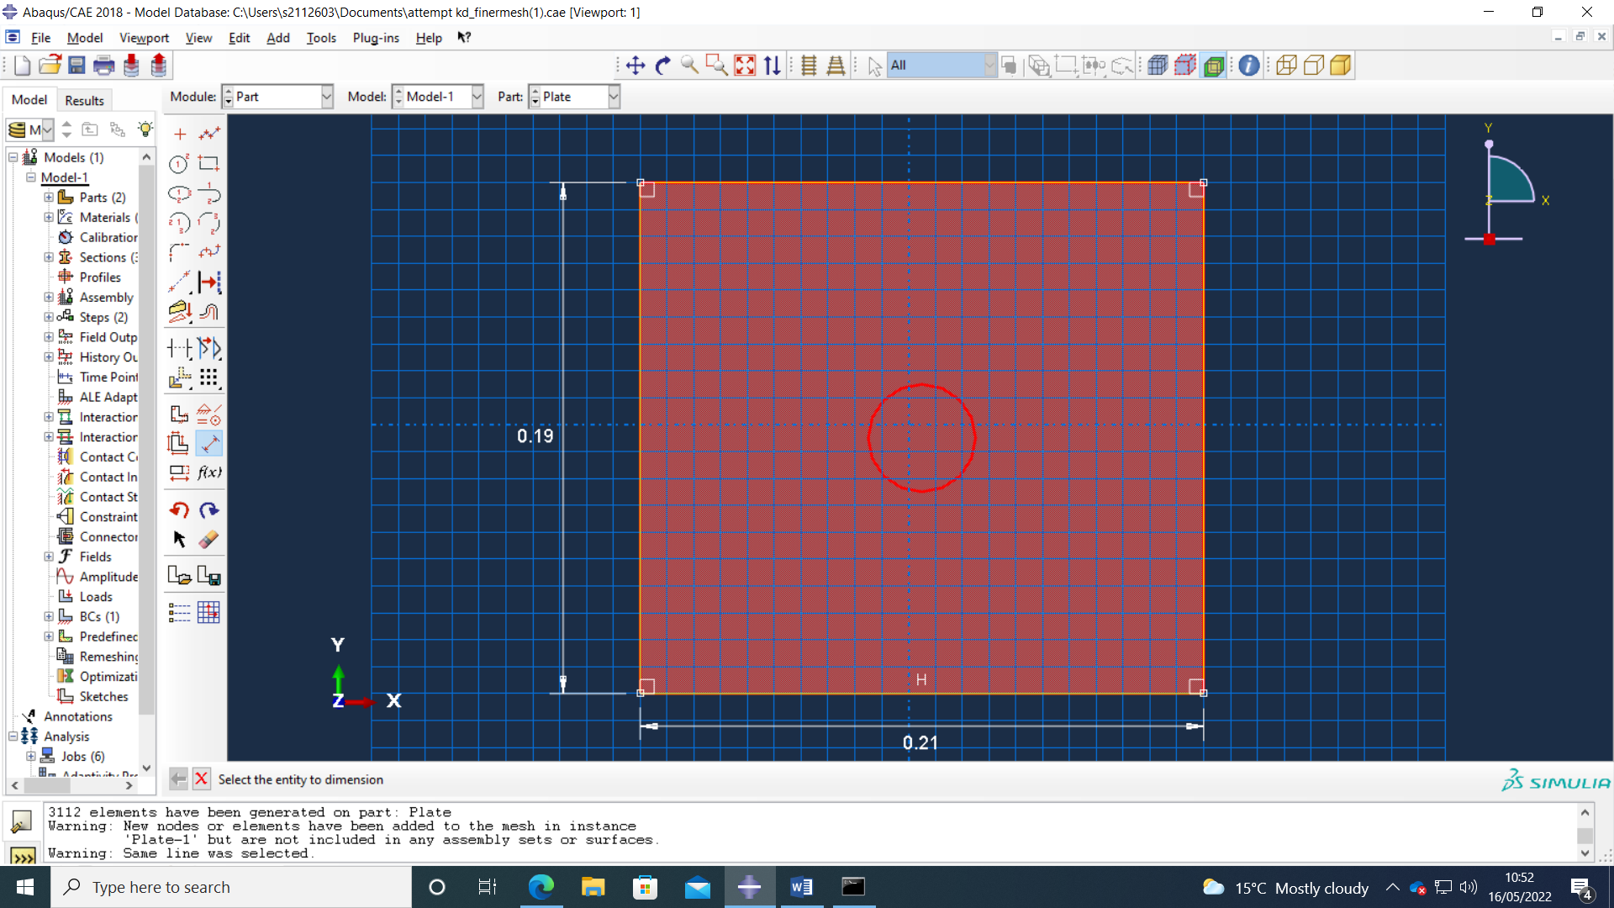
Figure 2 - Sketch created in Abaqus for the plate
For the projectile 4340 Steel was used and below in figures 3, 4 and 5 you can see the figures that were entered into Abaqus to be used in the simulations. Along with the information visible in the figures below, this steel also had a fracture energy of 12500 and a density of 7830. All of the information was taken from references found online in reliable documents. [2] [3]
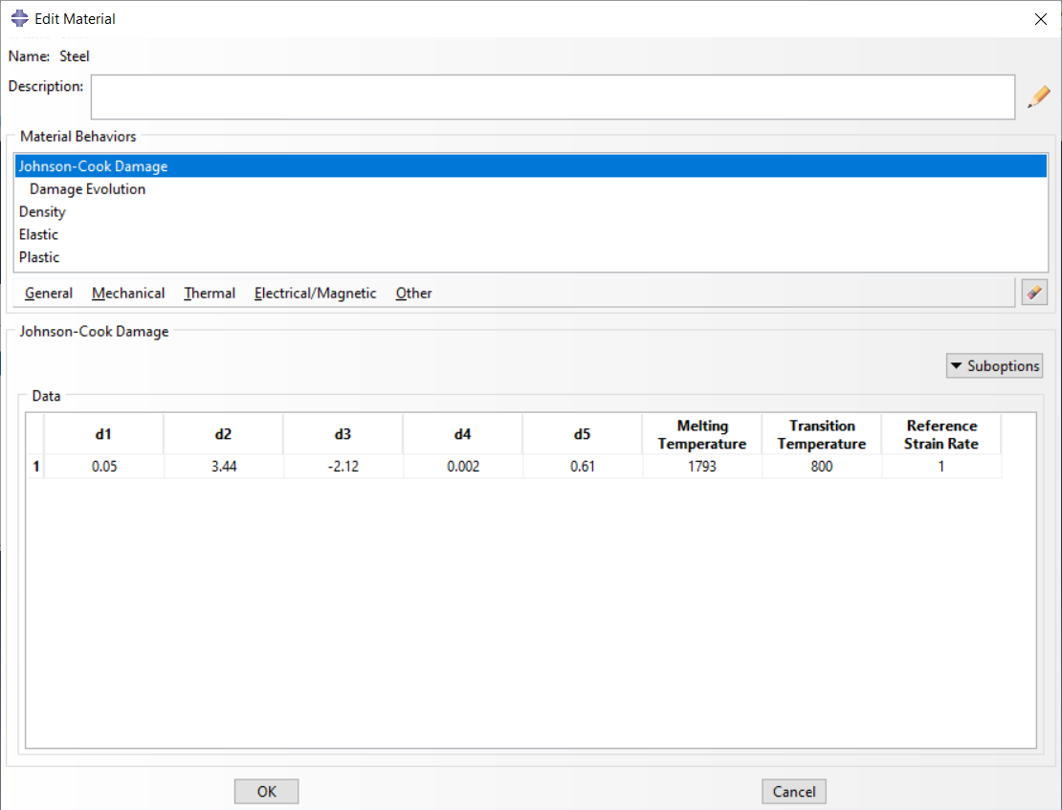
Figure 3 - Johnson-Cook damage figures for Steel
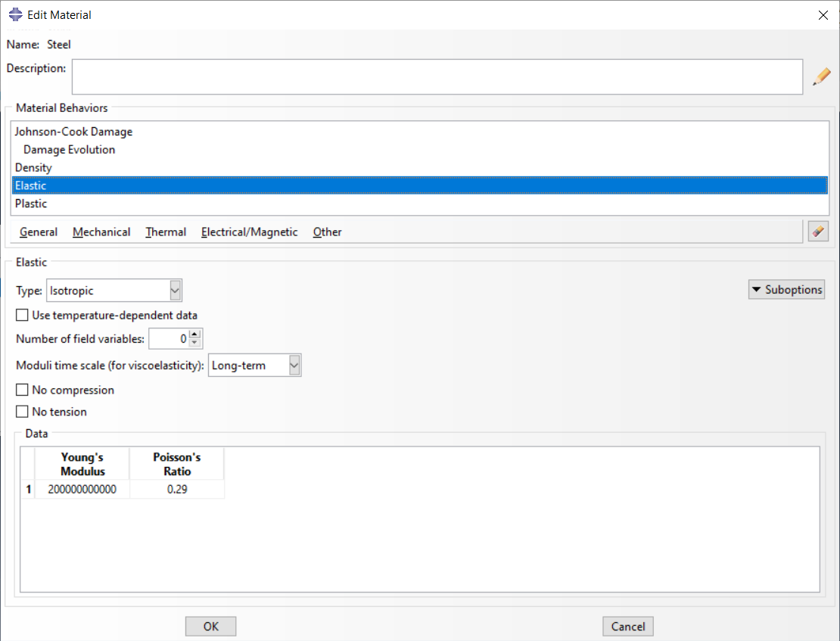
Figure 4 - Elastic numbers used for Steel
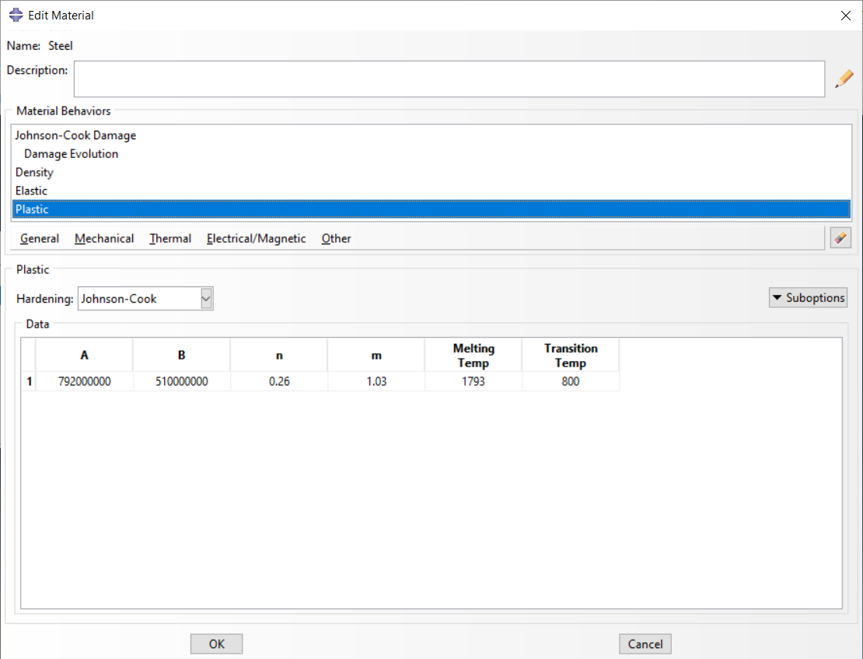
Figure 5 - Plastic figures used for Steel
For the plate of material used in the simulation, the chosen material was a Titanium alloy (ti-6al-4v). The Johnson-Cook damage figures [4] can be seen in figure 6 along with the melting temperature and transition temperature [5]. In the suboption part of Johnson-Cook damage is a fracture energy of 33670 [6] and its density is 4430. Figures 7 and 8 show the elastic and plastic figures used for Titanium in the simulations [4].
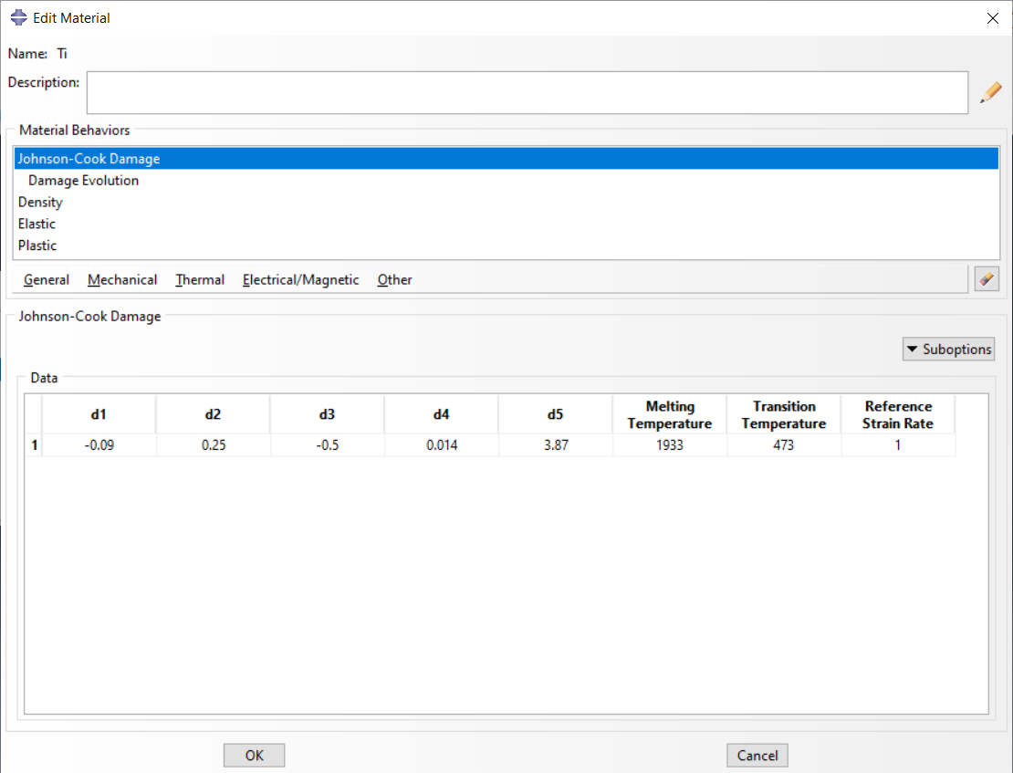
Figure 6 - Johnson-Cook damage figures for Titanium
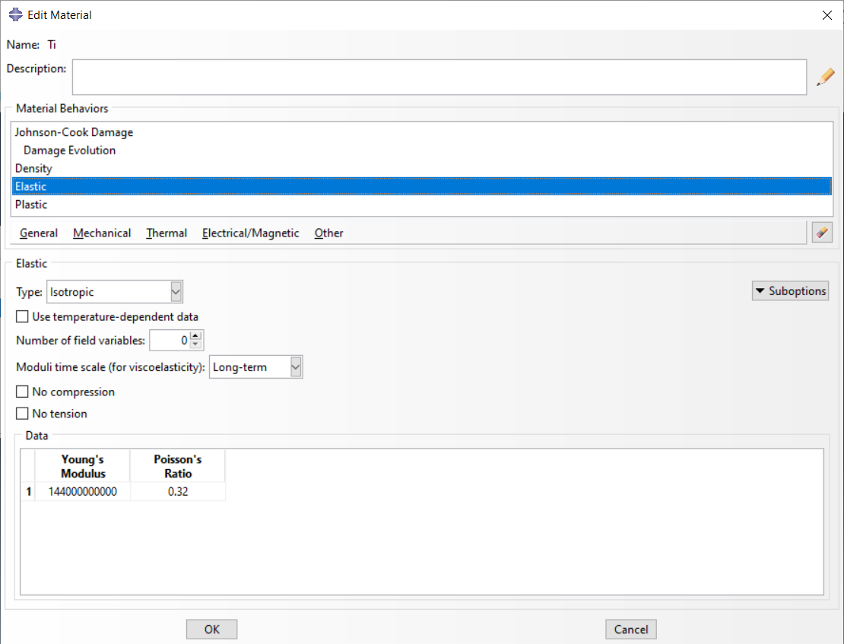
Figure 7 - Elastic figures for Titanium
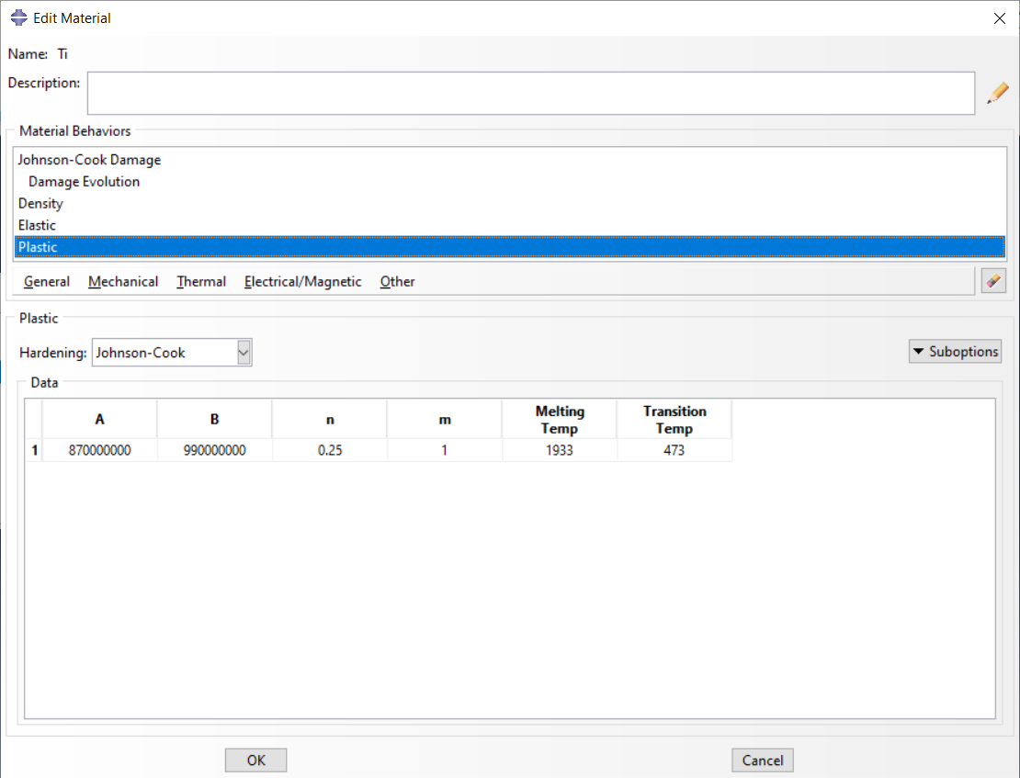
Figure 8 - Plastic details for Titanium
Once the materials were created the student then had to create sections which is shown below in figure 9. After clicking the ‘Create Section’ command the box on the left will come up and the type of section must be chosen. In this case the two sections used in this was solid, homogeneous. After that the user must select what material that section will be made of and they will then appear in the ‘Section Manager’ as seen on the right of figure 9.
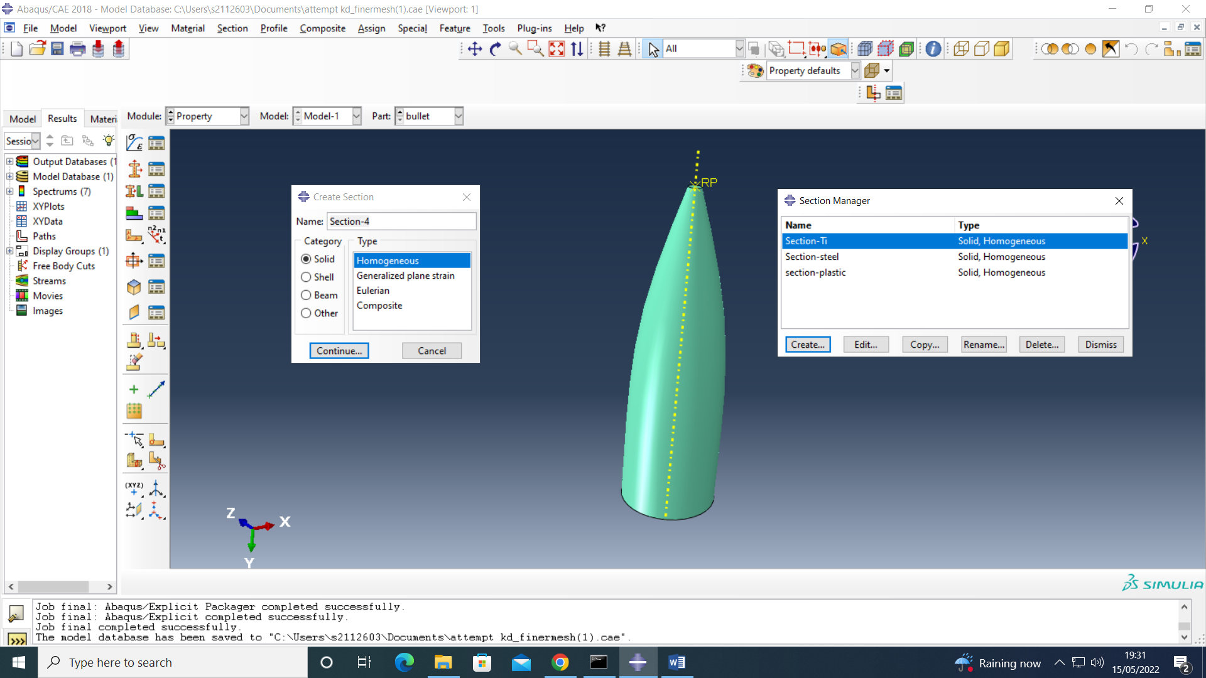
Figure 9 - Display when creating sections in Abaqus
The next step the student had to complete was creating the assembly. Below, in figure 10, is the assembly used in the simulations to complete this analysis.
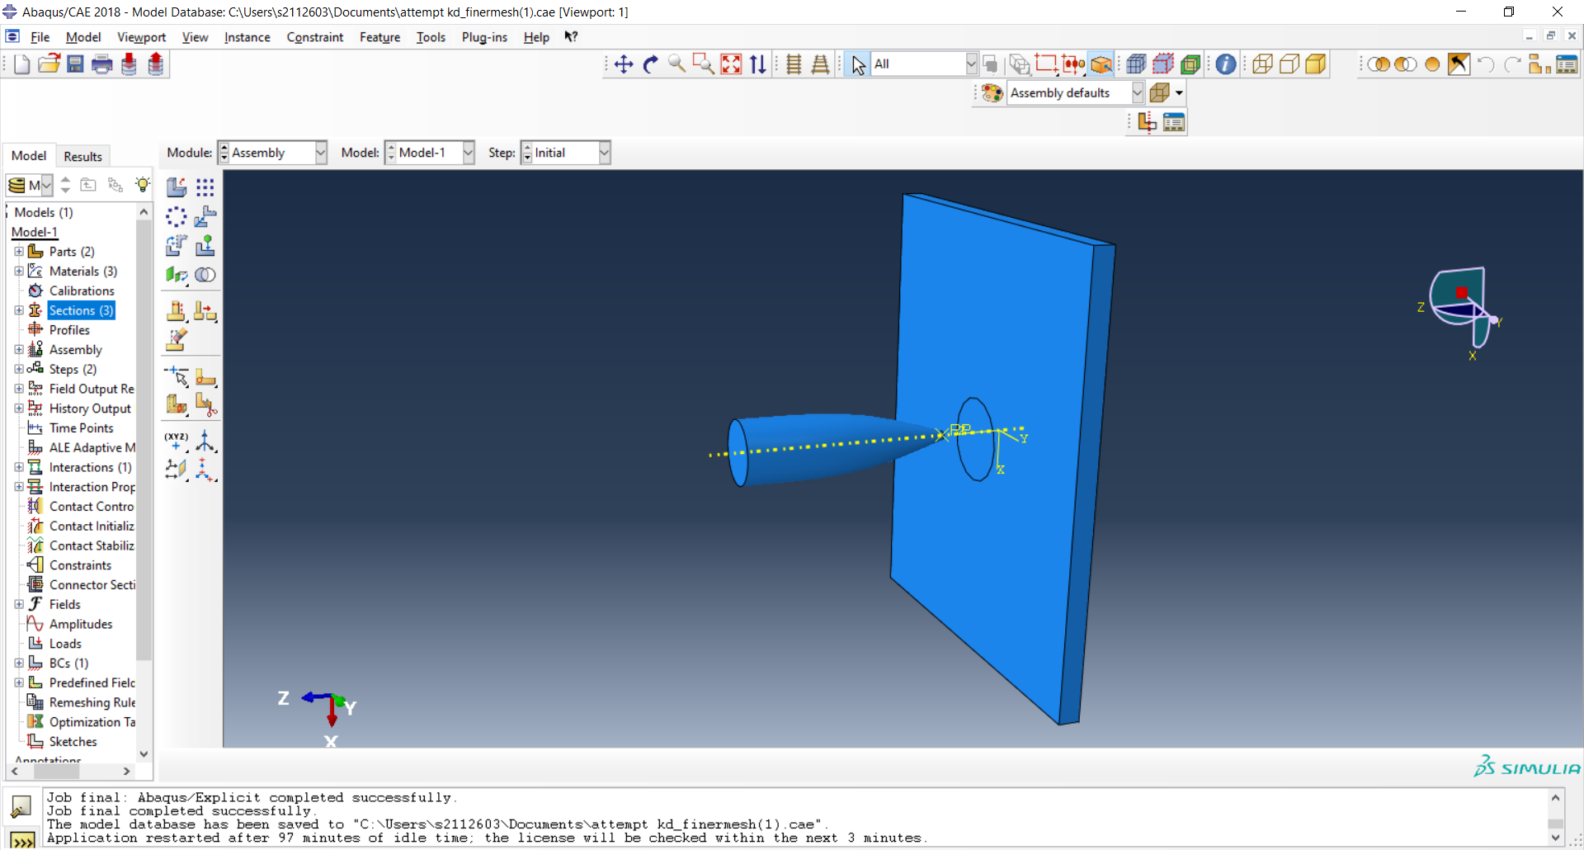
Figure 10 - Assembly used for the simulations
The first box in figure 11, in the top left, shows the steps created for the simulation and their details. The box to the right is used when editing field outputs and from that you can set the output variables wanted from the simulations and how many intervals for the them to be broken down into. For this the student chose 1500 so they could view exact moments wanted.
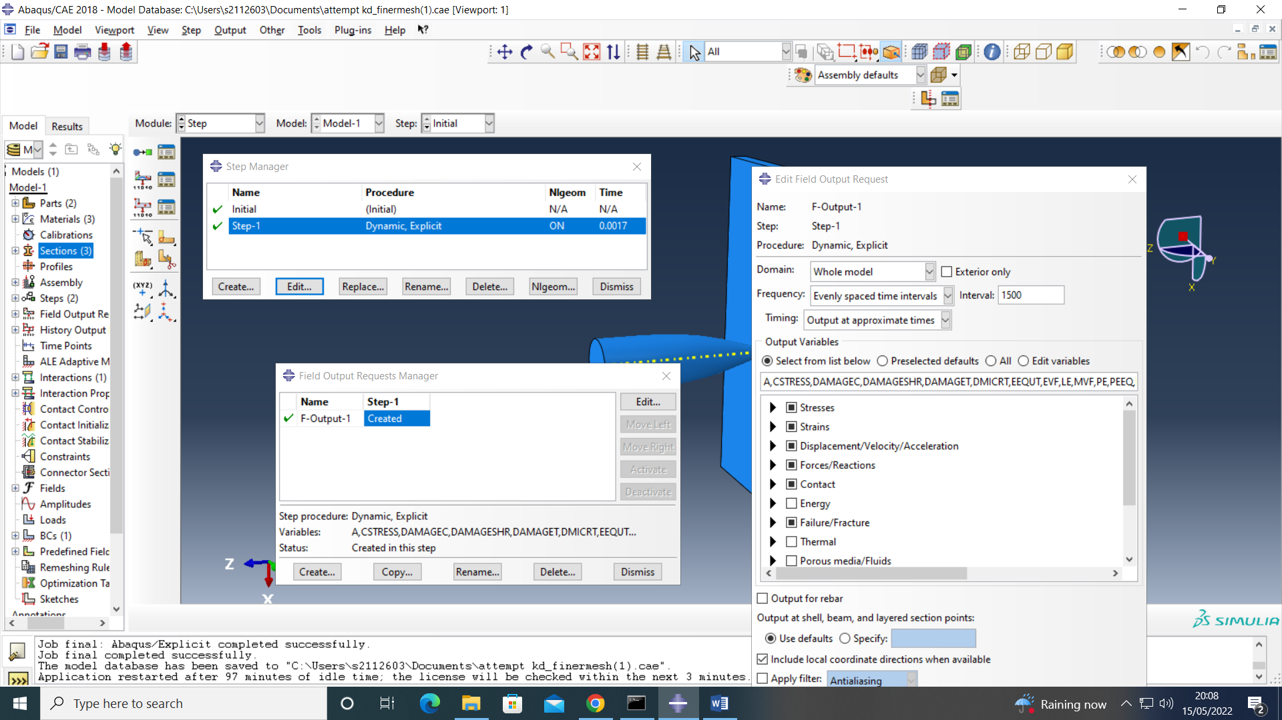
Figure 11 - Step menu display in Abaqus
After creating and applying the steps the next thing that must be done is create the interaction. Visible in figure 12 below, is the interaction created by the student. The ‘Second surface’ which the student has called nodes is on the plate that would interact with the projectile during the simulation. This is an important thing to do so the projectile hits as many nodes as possible which makes it more realistic.
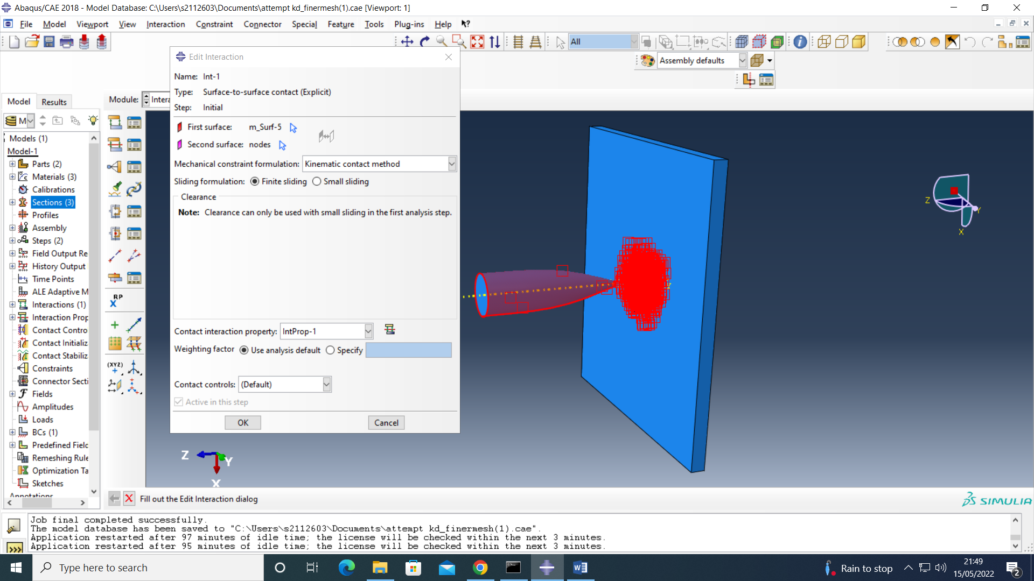
Figure 12 -Interaction section of Abaqus
Below is the load interface in Abaqus where the student set the velocity of the projectile to 500 metres per second as seen in the box in figure 13. Also visible in figure 13 is the boundary condition around the edge of the plate. This was done so the plate remains in its place for the duration of the simulation.
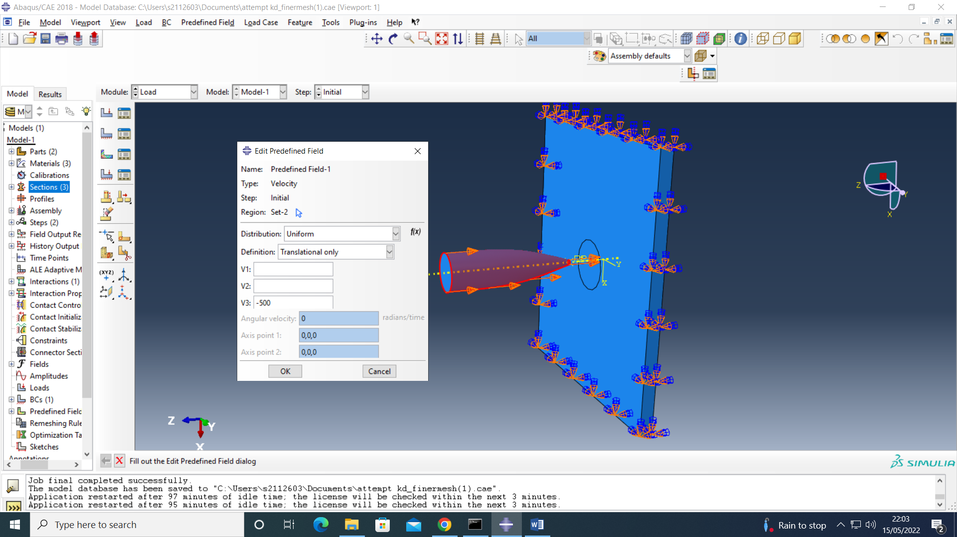
Figure 13 – Load interface in Abaqus
The next step in creating the simulation would have been to mesh the parts. This mesh for the projectile was very simple and the student did not need to change anything about it. The mesh for the projectile can be seen in figure 14.
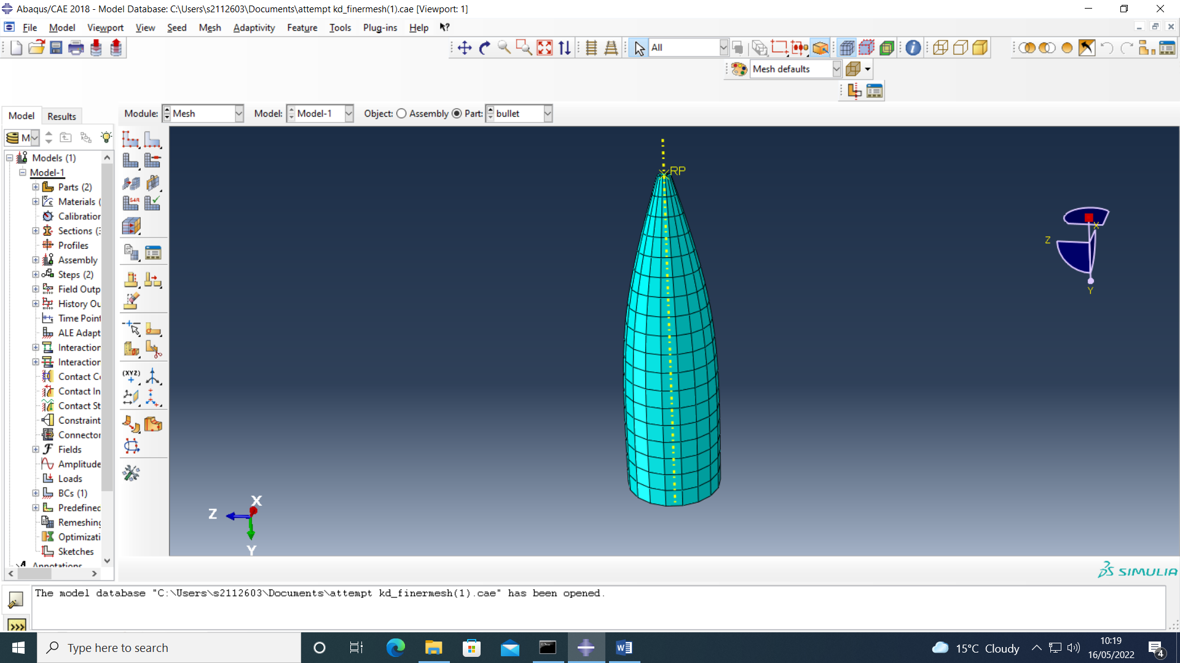
Figure 14 - Mesh of projectile in Abaqus
The mesh for the projectile however was edited by the student. To make the mesh more realistic during the simulations they created a partition when creating the part so the mesh density would be greater in the middle (where the projectile is hitting). The mesh for the plate for the first simulation can be seen in figure 15 below.
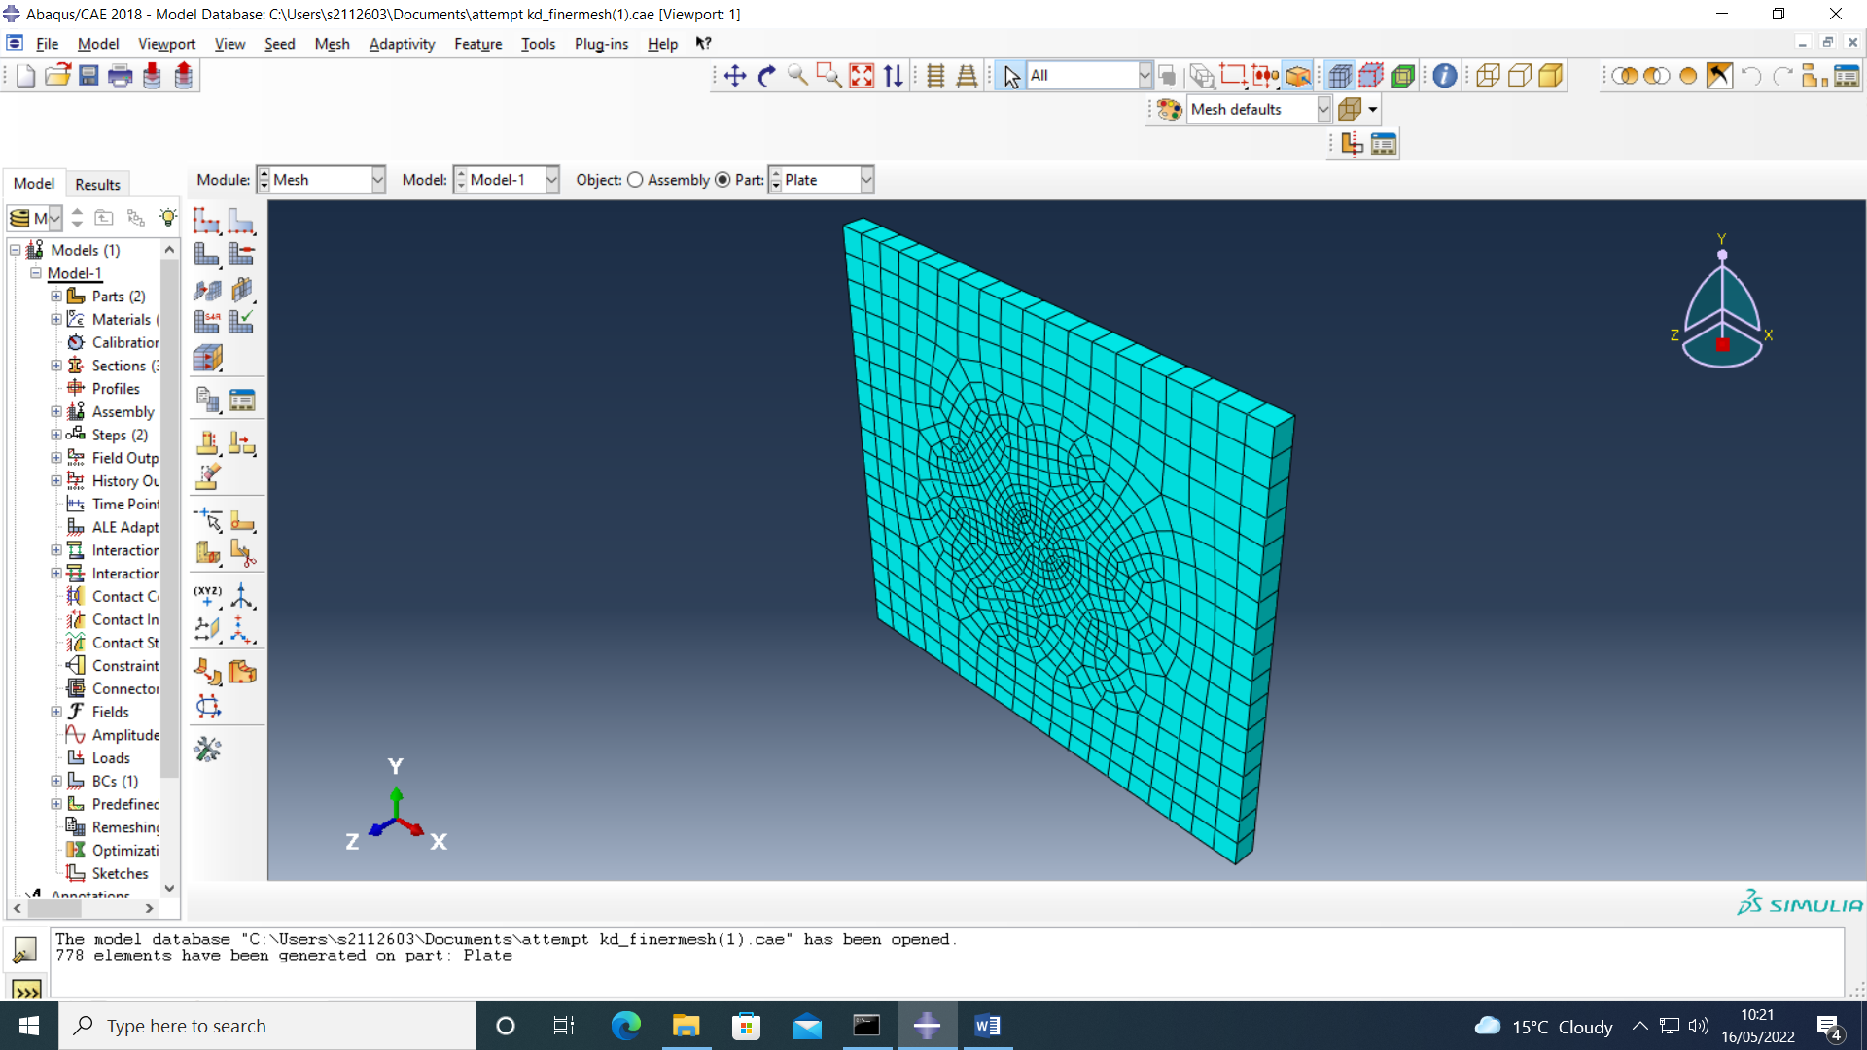
Figure 15 - Plate mesh for first simulation
Figure 16 is a screenshot of the plate mesh for the second simulation completed by the student. The difference from the other mesh is the mesh density on the sides of the plate. In figure 15 the plate only has one element on the sides and in figure 16 there is four elements. Mesh density can cause huge differences in the results of simulations so it is important to get it right.
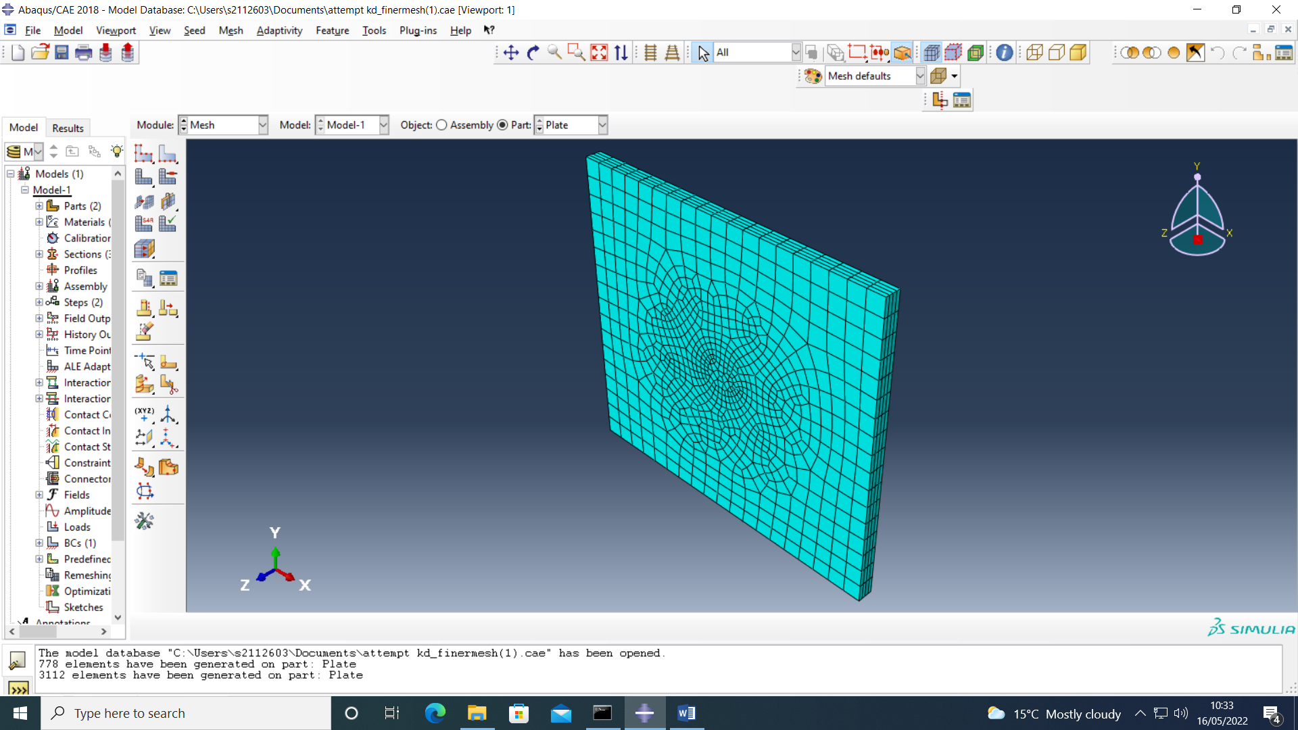
Figure 16 - Plate mesh for the second simulation
Simulation Results
Simulation 1
The first simulation ran by the student was with the lower mesh density. Figure 17 below is the initial contact between the projectile and the plate and figure 18 and 19 are the steps just after that.
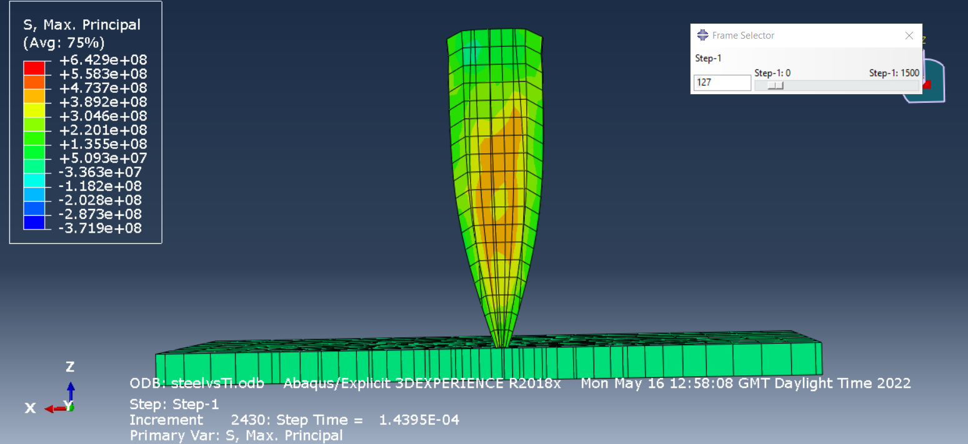
Figure 17 - Initial contact first simulation (Step 127)
Comparing figures 17 and 18 it is clearly visible that there is tensile stress building up inside the projectile by the red. Figure 18 also shows the compression stress building up in the plate signified in the blue colour.
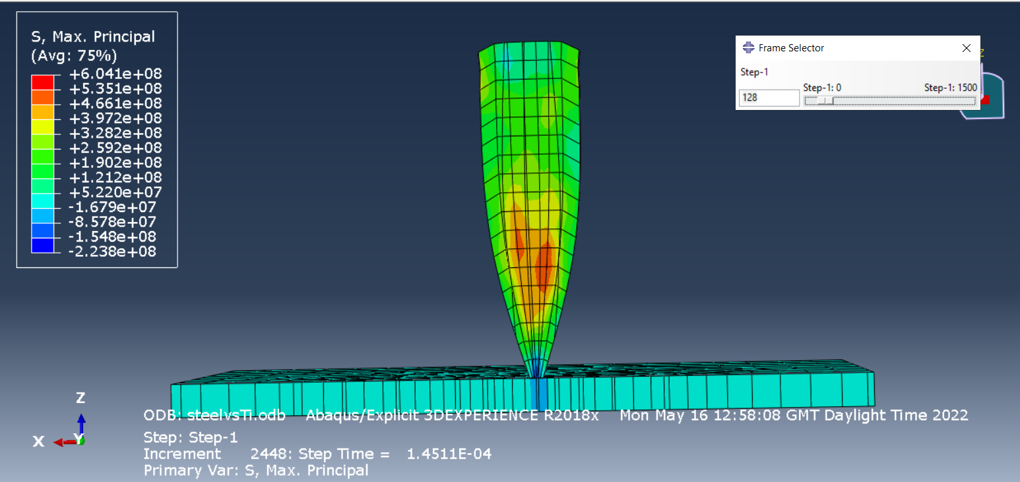
Figure 18 - Step 128 of first simulation
Continuing one step further, figure 19 shows further tensile stress building in the projectile with the stress waves heading towards the nose. The same compression stress remained in step 129 as 128 but some tensile stress has appeared in the plate looking at the green.
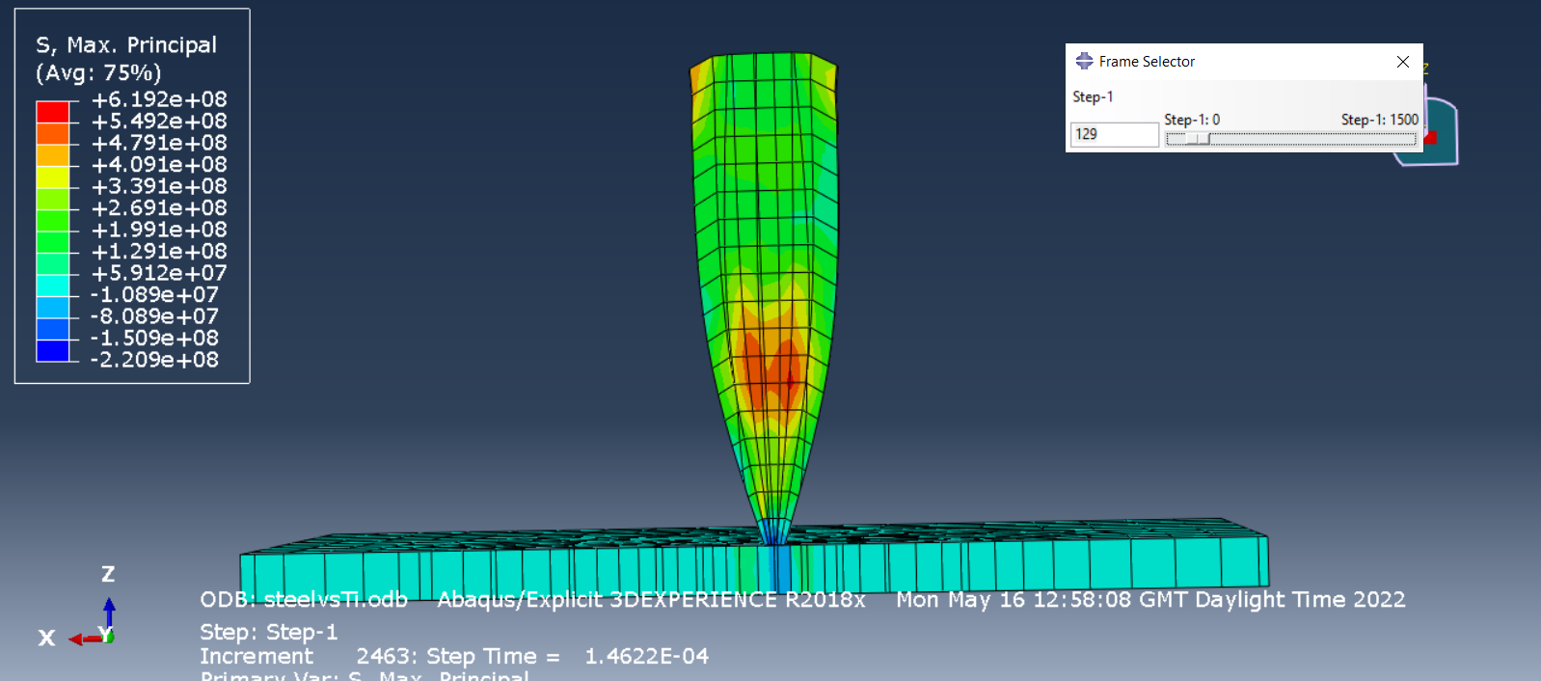
Figure 19 - Step 129 of the first simulation
Figures 20, 21 and 22 show a good example of stress waves making their way through the plate. Figure 20 shows a small amount tensile stress around the tip of the projectile.
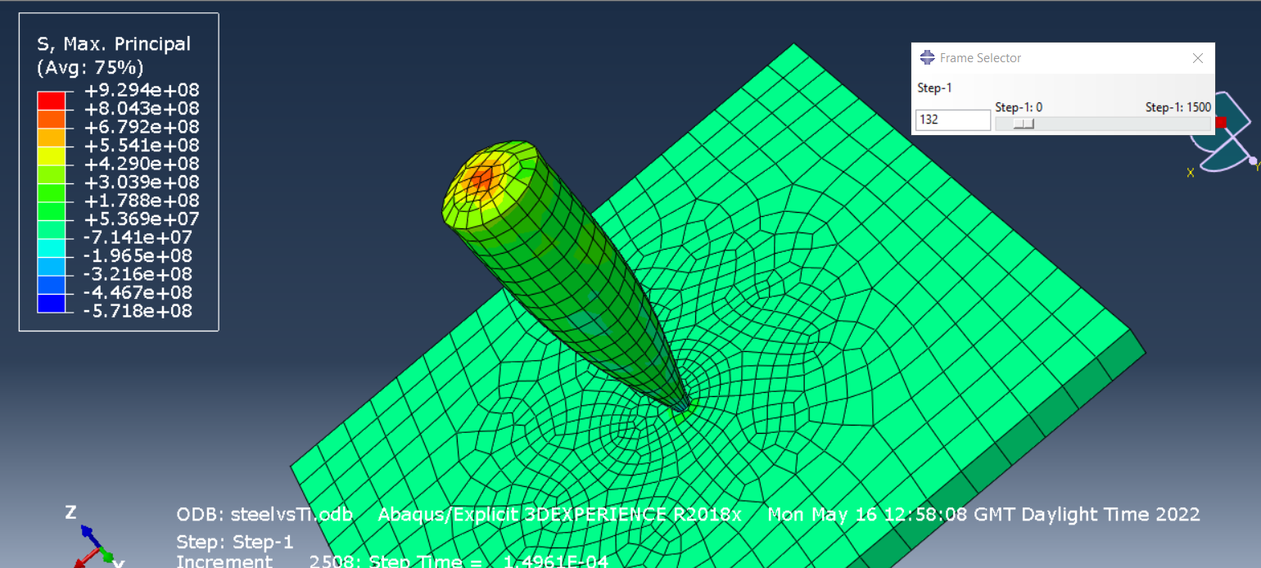
Figure 20 - Step 132 of first simulation
Moving onto figure 21 it is apparent that the area of tensile stress has gotten larger and increased. Figure 21 also shows tensile stress making its way up to the base of the projectile (circled in figure 21)
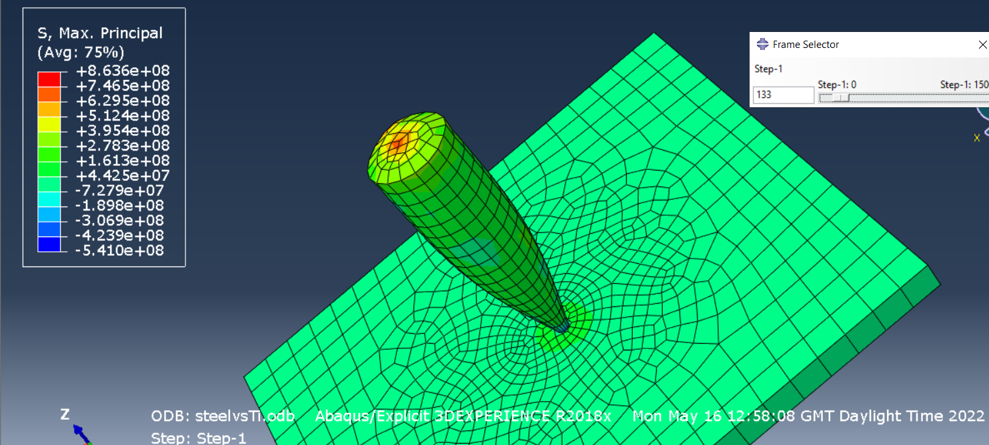
Figure 21 - Step 133 of first simulation
Figure 22 clearly shows a difference in colour for the majority of the plate compared to figure 21. This is caused by the tensile stress wave mentioned in figure 20 and 21. That same stress wave can still be seen also by the nose of the projectile.
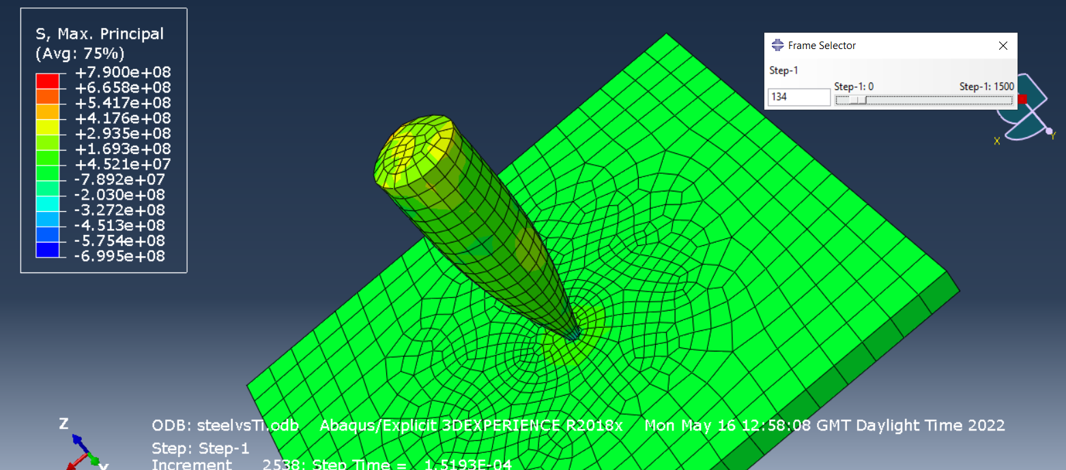
Figure 22 - Step 134 of first simulation
From figure 23 it is clear that there is a large amount of tensile stress in the bullet from the large amount of red colouring. Comparing figure 23 to the steps earlier on in the simulation it is also visible that the nose of the projectile was beginning to compress and become closer to failure. Looking at the plate in figure 23 also shows a slight warp caused from the impact of the projectile.
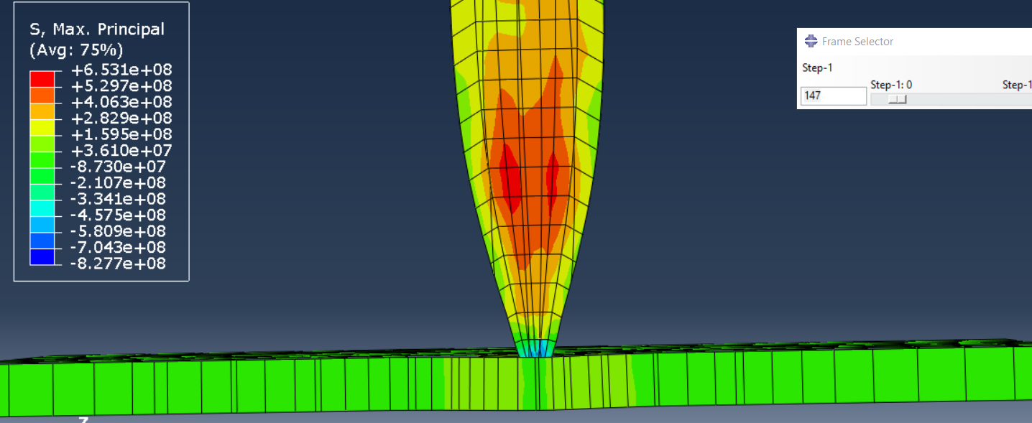
Figure 23 - Step 147 of the first simulation
At step 152 the nose of the projectile fractured under to the stress it was experiencing. Figure 24 shows the projectile after the fracture and the curve in the plate is still visible.
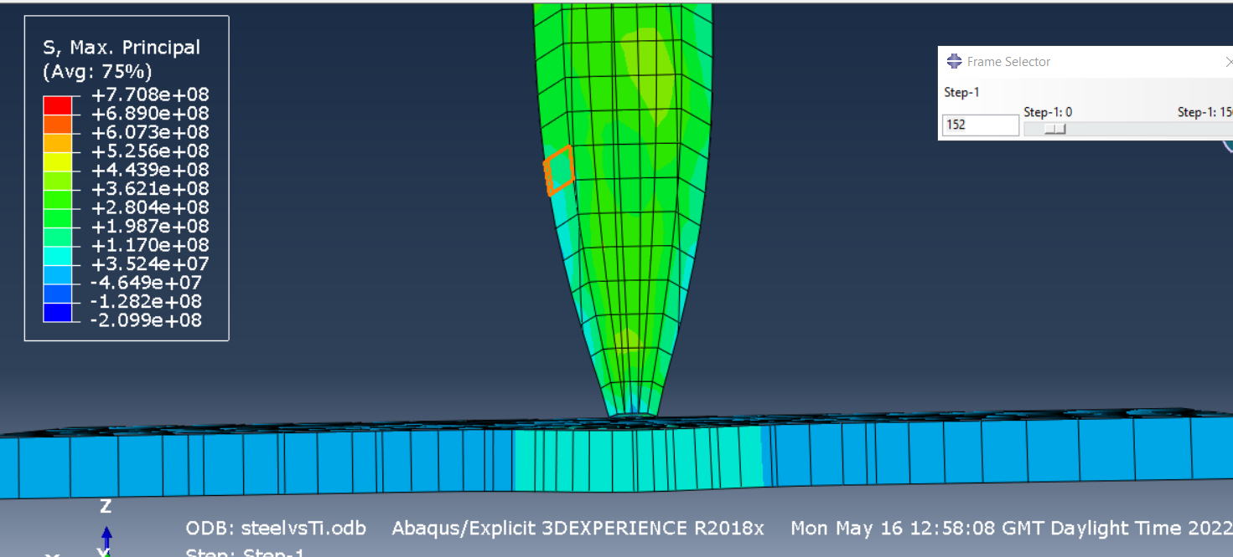
Figure 24 - Step 152 in first simulation
Going further into the simulation, figure 25 shows the impact and compression of the second row of element in the projectile. It also shows further curving of the plate and tensile stress within the plate.
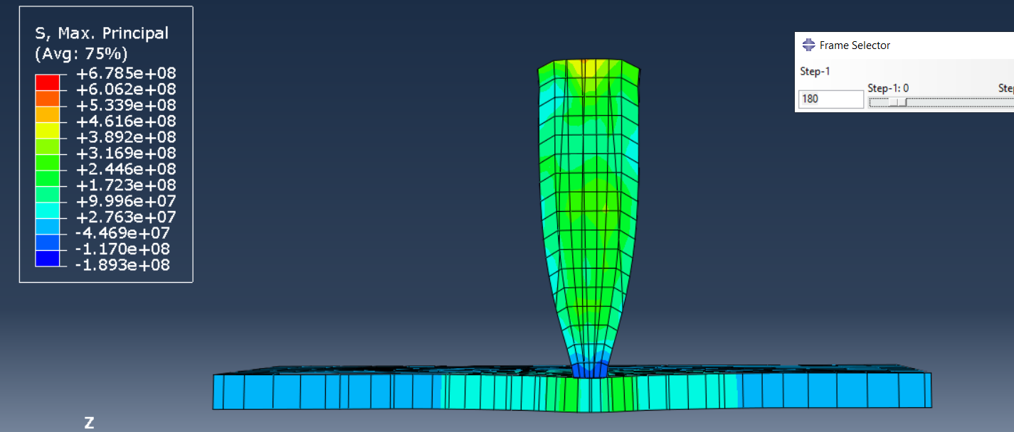
Figure 25 - Step 180 of first simulation
Just like the elements at the nose of the projectile the second row also fractures but at step 235. Figure 26 shows the projectile after the element fracture. It is also clear that the forces from the projectile made the plate curve even more. The red elements in the plate show how much tensile stress is acting on that element. Using the key in the top left the stress should be around 1 x 10⁹ which should really be fracturing the element in the plate.
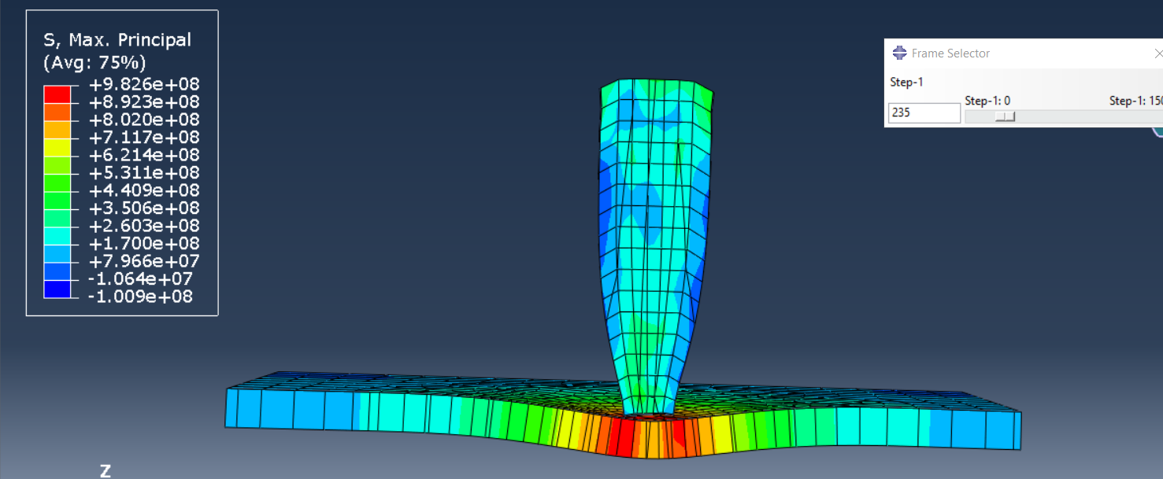
Figure 26 - Step 235 of first simulation
At the end of the first simulation the projectile got ricocheted back off the material plate as shown in figure 27. Figure 27 also shows how much the projectile has been compressed and fractured. It is visible that the plate remained curved but did not fracture under any stress throughout the duration of the simulation.
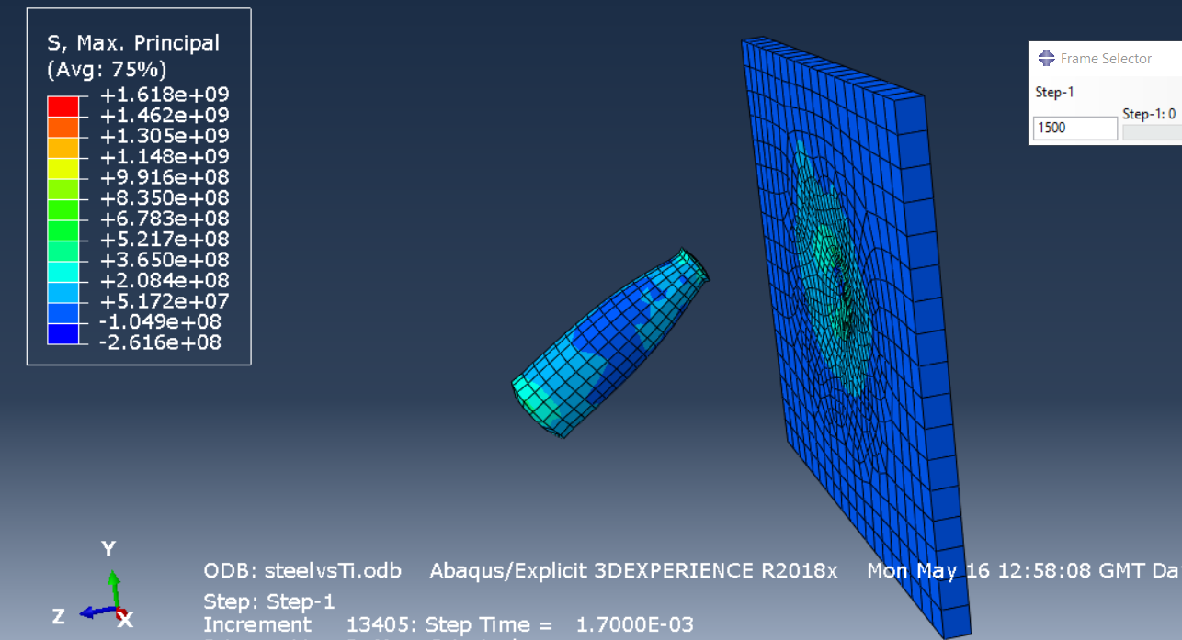
Figure 27 - End of first simulation
Simulation 2
As no elements fractured in the plate during the first simulation even under the massive tensile stress there was clearly some problem. The student decided to increase the mesh density on the sides to give the elements a greater chance of breaking. Figure 28 shows tensile stress in the bullet and a small wave appearing at the nose of the projectile.
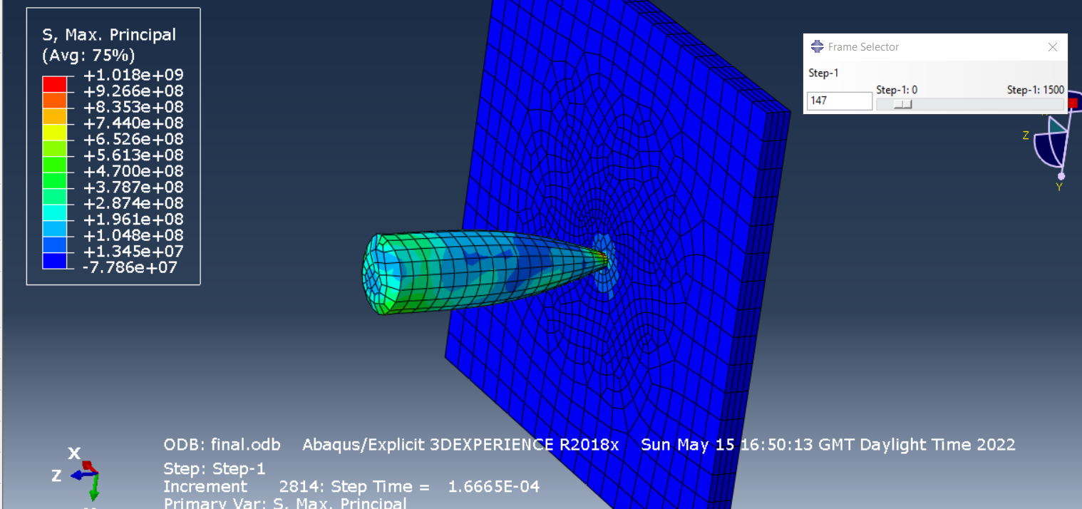
Figure 28 - Initial contact for second simulation
Figure 29 gives a better view of the nose of the projectile and it shows a large tensile stress in one of the elements.
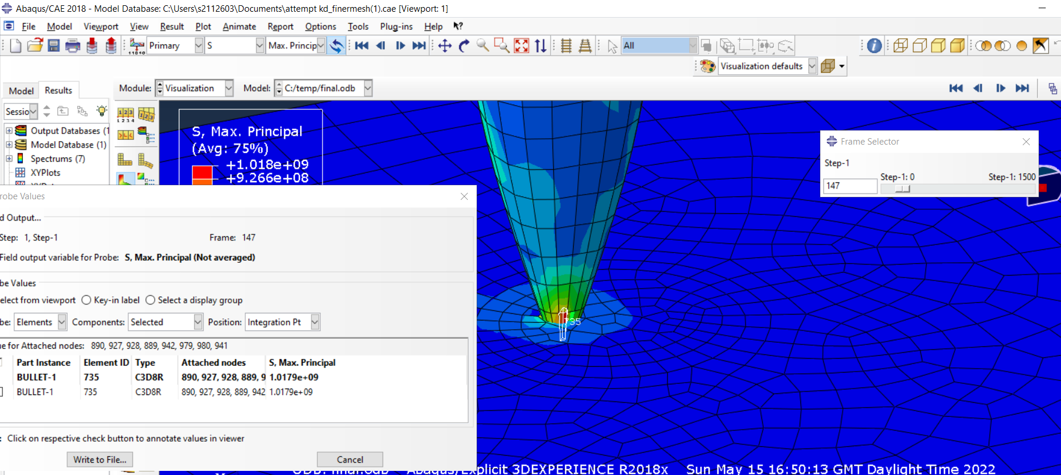
Figure 29 - Close up of initial contact for second simulation
The step after figure 29 the stress wave at the nose of the projectile increased in size as shown in figure 30.
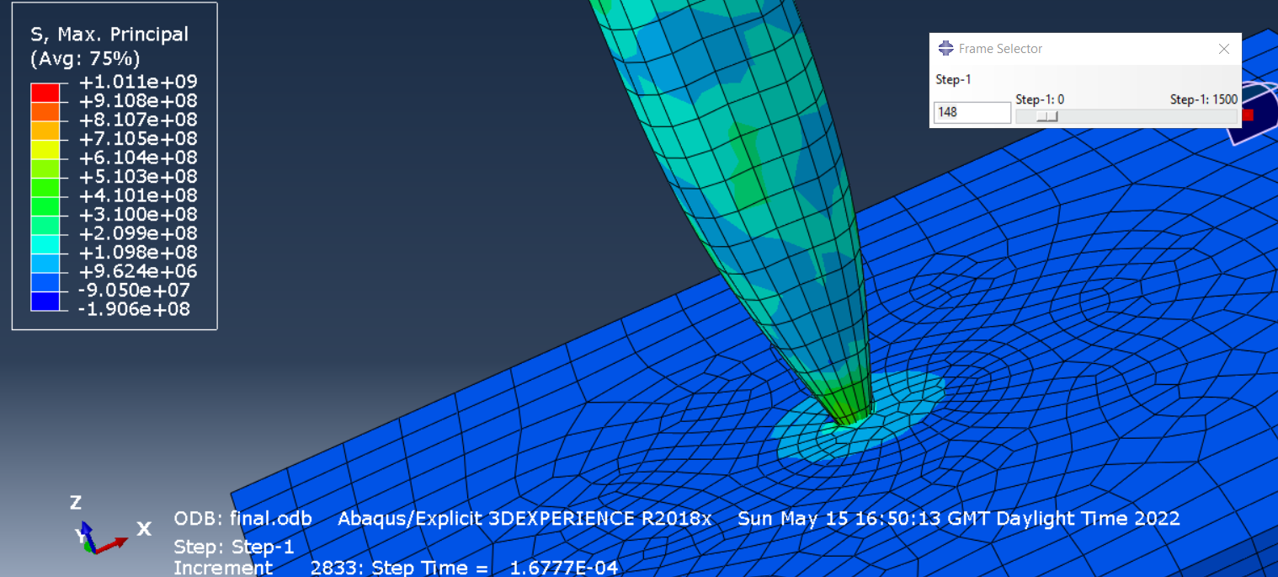
Figure 30 - Step 148 of the second simulation
Figure 31 below shows the projectile when it is partly through the plae of material. This figure shows that elements were being deleted from the stress they were expierencing and that increasing the mesh density worked for the student.
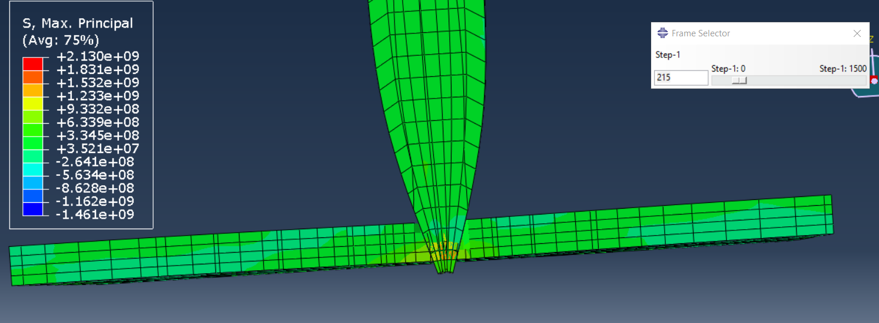
Figure 31 - Step 215 of second simulation
Figure 32 is of the same step but from a different perspective. This image shows the tensile stress waves making its way across the plate in the darker shade of green. By the hole forming in the plate there is also another stress wave beginning its way across the plate.
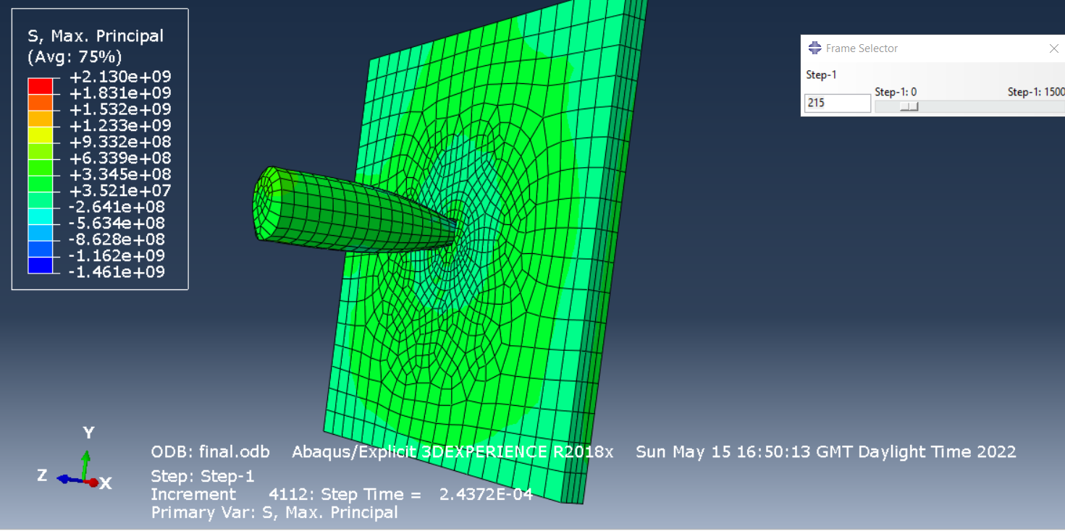
Figure 32 - Step 215 of the second simulation (Alternative angle)
Another 100 steps into the simulation the projectile begins to come out of the back of the plate. This is shown in figure 33. In this figure there is clearly a large amount of tensile stress on the back of the plate. It starts with red surrounding the projectile and then makes its way down to green which is a good example of a stress wave.
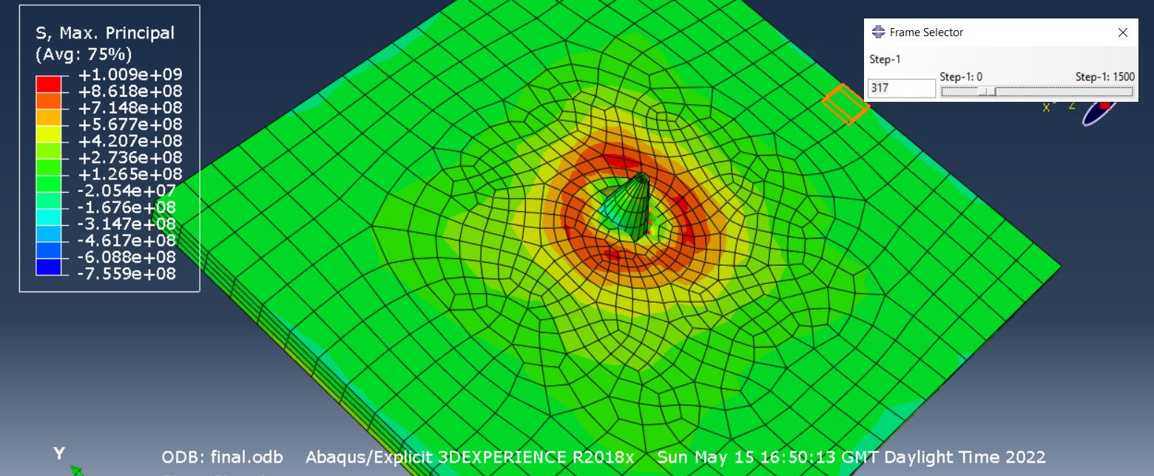
Figure 33 - Step 317 of the second simulation
For the duration of the simulation after figure 33 the projectile made its way through the plate of material causing tensile stress waves towards the lower end of the spectrum.
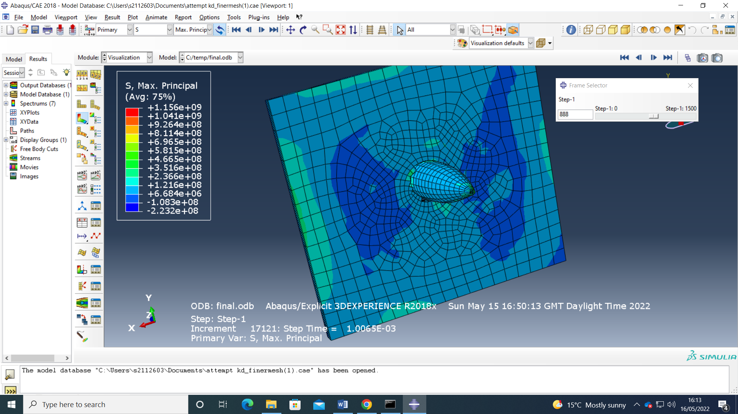
Figure 34 - Step 888 in the second simulation
Figure 35 is an image taken at the end of the second simulation and from looking at the element that fractured the projectile didn’t go perfectly straight through the material. It shows the projectile did go slightly off path due to the material it was trying to go through.
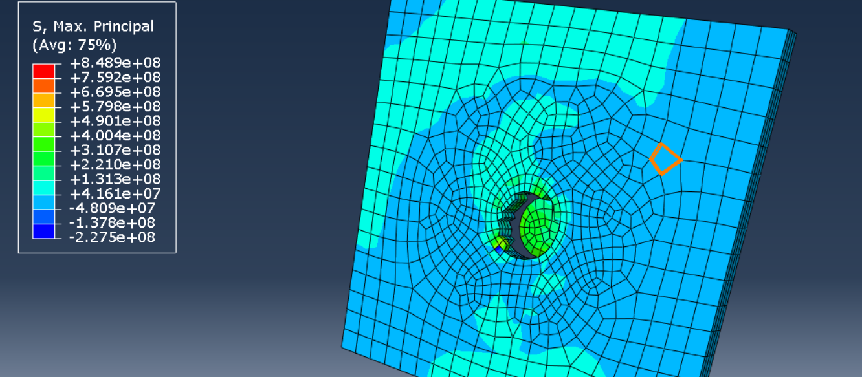
Figure 35 - End of second simulation
Conclusion
From these simulations the main thing that can be concluded is that mesh density makes a huge difference when completing simulations like the ones required for this report. The first simulation failed to live up to the student expectations and the titanium plate didn’t fracture at all despite being hit by a 30 mm steel projectile at 500 metres per second. After increasing the mesh density however, the projectile went through the plate as the student wanted. From the simulations a conclusion can also be created for steel projectile vs titanium plate in which the steel projectile will come out on top in the real world.
Recommendations
In the second simulation there was a point at the start where some of the projectile’s elements weren’t registering hitting the plate. This problem would be caused by the interaction settings. If this test or another test would be conducted by the student again the interaction nodes should be changed accordingly to create an all-round better simulation. To consolidate the findings of this report further these simulations could be repeated with multiple different materials to see if they come out with the same results.
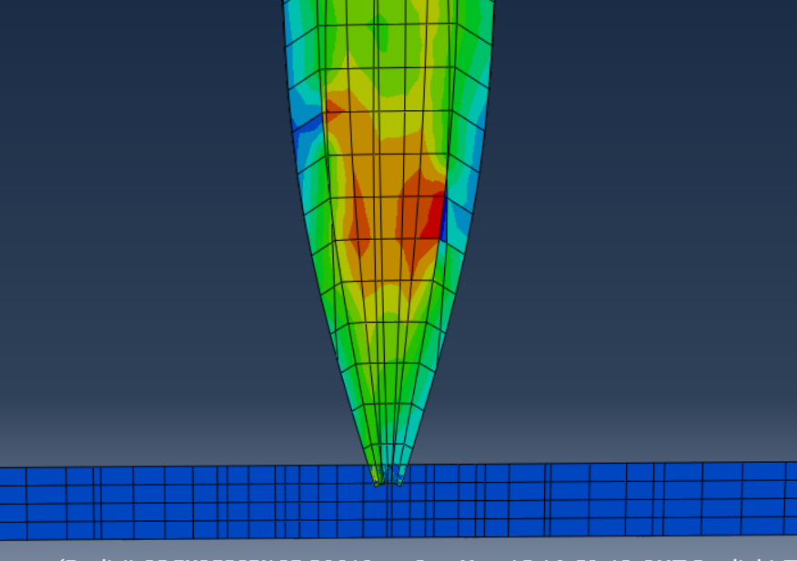
Figure 36 - Elements not registering hitting the plate

References

[1] | W. Xuemei, "Validation of Johnson-Cook plasticity and damage model using impact experiment," International Journal of Impact Engineering, vol. 60, pp. 67-75, 2013.
[2] | L. B.-V. X. C. Haim Waisman, "Explicit and implicit methods for shear band modeling at high strain rates," Columbia University , 2018.
[3] | J. R. T. Mabrouki, "A contribution to a qualitative understanding of thermo-mechanicaleffects during chip formation in hard turning," Materials Processing Technology, 2006.
[4] | A. G. R. B. H. B. S. B. Manel Sbayti, "Finite Element Analysis of hot Single Point Incremental forming of hip prostheses," MATEC Web of Conferences, 2016.
[5] | W. L. H. Z. S. L. T. Z. L. L. Hui Yu, "Study on Non-Isothermal Transformation of Ti-6Al-4V in Solution Heating Stage," MDPI, 2019.
[6] | T. A. D. S. F. J. T. V. S. M.-B. &. L. S. H. Carolina Bermudo Gamboa, "Modeling of the fracture energy on the finite element simulation in Ti6Al4V alloy machining," 2021.

