

University of Wales Trinity Saint David
School of Engineering

Vehicle to Grid

Oscar Pollitt 1900412

BEng Motorsport Engineering

ACHA6012
Table of Contents
Introduction 3
Literature Review 4
Energy Supply 4
Energy Storage 5
National Grid 5
Smart Charging (V1G) 6
Vehicle to Grid (V2G) 6
EVs in the UK 8
Ethics 8
Conclusions 9
References 10
Appendices 12

Introduction
In 2021 the world is much more aware of the environmental challenges that the world is facing. The Paris agreement is a legally binding international treaty on climate change where the main goal is to limit global warming to an increases 1.5 degrees Celsius since the beginning of the industrial era . This means that the 196 countries in this treaty all aim to limit global warming. (The Paris Agreement, 2021)
The main driver of global warming is the greenhouse effect where an increase in greenhouse gases in the air trap the suns heat and don’t let it reflect back into space. Many of the gases about to be mentioned exist naturally but human activity has increased the concentration of them In the atmosphere. In particular the gases that are focused on the most is CO2, methane, nitrous oxide and fluorinated gases. CO2 is largest contributor with levels in the atmosphere 48% more then they were before the industrial revolution in 1750. The main causes for a rise in greenhouses gases is burning fossils fuels that release CO2, cutting down forests that store vast amounts of CO2 (deforestation) increased livestock farming that produces methane and using fertilizes that contain nitrogen. Currently the rate of global warming is 0.2 degrees Celsius per decade with the average global temperature 1.1 degrees Celsius above preindustrial levels. (The Paris Agreement, 2021)
When focusing on the topics in this report the greenhouse gas that is key is CO2, carbon dioxide. This is because for the last century, to produce electricity we have been burning fossil fuels which release carbon into the atmosphere. The UK over the last couple decades has tried to introduce more and more renewable and non-carbon energy supply in order to cut its own carbon emissions. For example in April 2021 the UK has set a new target to cut emissions by 78% by 2035 from 1990 with the overall goal to have net zero carbon emissions. (UK enshrines new target in law to slash emissions by 78% by 2035, 2021)
When looking at the automotive sector the largest and most obvious change is the introduction and implementation of electric vehicles (EV) to replace petrol and diesel vehicles . The UK government has banned petrol and diesel cars by 2030 and hybrids by 2035. (Government takes historic step towards net-zero with end of sale of new petrol and diesel cars by 2030, 2021). On top of this the UK has pledged to make all energy sources in the UK clean by 2035. (All UK's electricity will come from clean sources by 2035, says PM, 2021). One of the solutions in order for the grid to meet these demands set out by the government is smart charging and vehicle to grid technology.

Literature Review
Energy Supply
There are multiple methods of generating electricity both using fossil fuels and renewable energy. As you can see as of November 2021 that 50.1% of power came from natural gas, 5.6% from coal, 1.4% hydroelectric, 7.3 % biomass, 13.6% nuclear and 16.1% Wind. (UK Electricity Production, 2021)

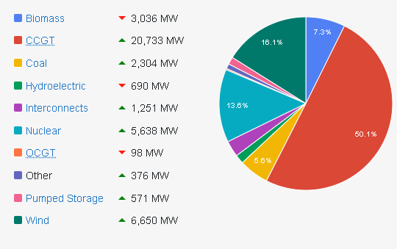

When looking at the trend in electricity generation the percentage of power that is renewable has increased significantly since 2000 with the use of fossil fuels decreasing significantly. The plan for the UK government is to make this distribution have no fossil fuels by 2035 (Department for Business, Energy & Industrial Strategy, 2021) The details of how various power sources work is in the appendix
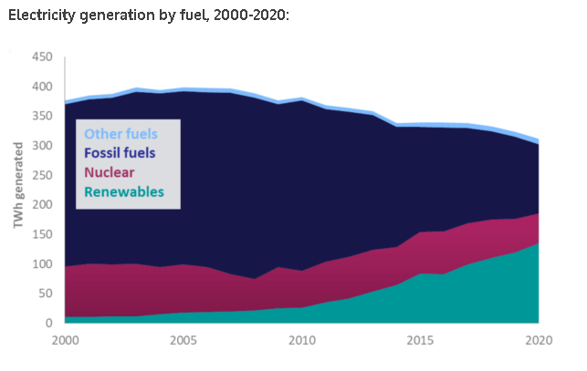

Energy Storage
Batteries used to store large amounts of electricity for multiple applications including EVs are usually large versions of common rechargeable batteries. These batteries are mainly lithium ion, lead acid, and lithium iron as well as other battery technologies. As mentioned below an EV battery is a good way to store energy as they are high capacity, high power batteries. The efficiency of a lithium Ion Battery according to The World Energy Council is 85-95%. One of the most efficient storage methods compared to other storage methods. (Electricity Storage | US EPA, 2021) As of 2021 the UK holds 1.1GW of battery storage capacity storage. See appendix for how other types of energy storage works. (UK's energy storage pipeline passes 16GW, 2021)
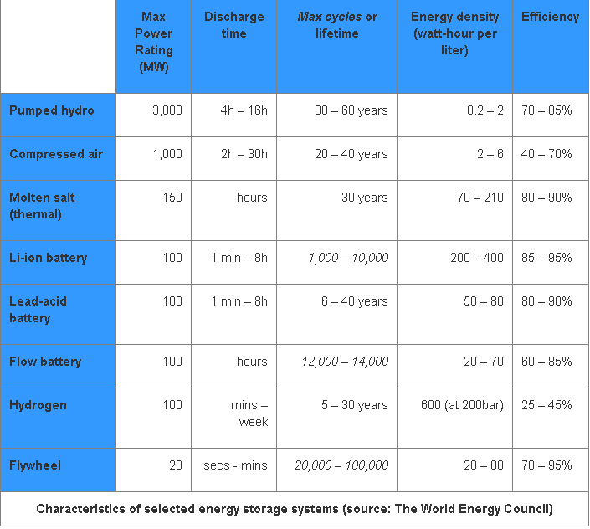

(EESI), 2021)

National Grid
The national grid is the company that controls the transmission and distribution of electricity and gas throughout the UK. The grid refers to the high voltage powerlines, gas pipelines, interconnectors and storage facilities for the purpose of distributing electricity. The grid also manages the energy transferred from and to Ireland, the Netherlands, France, Norway and Belgium. (What is the national grid? - Drax, 2021) Within the UK network there are 14 distribution network operators (DNOs) that manage the distribution to consumers in different regions around the UK. (DNO/IDNO – Nationwide Utilities, 2021)
The infrastructure of the grid works by connecting power station to sub stations to DNOs. To be able to make this system work, voltage and frequency of electricity must be balanced and kept stable at all times. The National Grid Electricity System operator (ESO) regulates and ensures the correct voltage, frequency and reserve power levels are met at all times. ESO does this by ensuring the whole system operates at a frequency of 50 Hz. 50 Hz referring to the number of directional changes alternating current (AC) electricity makes every second. It is vital to keep this value constant across the UK. Even a 1% deviation could damage equipment and infrastructure. Flexible generators are used to exactly match the demand to the grid. This requires quick frequency response where generators are setup to automatically respond to demand requests correcting frequency deviation in seconds. (The power system’s super subs - Drax, 2021)
The national grid is easily able to predict demand throughout the day easily due to common habits like coming home from work and using kitchen appliances. However when a power station breaks down or there is a cold snap in weather. The system needs reserve power to keep the grid stable. Reserve power currently relies on thermal power stations such as biomass, gas turbines and if enough of an issue, coal. (The great balancing act, 2021) On top of this the large scale introduction of renewable sources in the recent years provides a challenge to the grid. This is due to many of these sources being weather dependent meaning it the electricity is more volatile and is harder to be balanced. This means that the electricity produced by these sources will be completely uncorrelated with electricity demand. This therefore requires energy storage
One method to overcome this challenge, where energy storage is vital, is smart appliances and smart charging. The basic of smart technology is to spread the electrical demand across the day reducing the size of peaks and troughs in grid demand This is known as grid balancing. This is where Vehicle to Grid technology comes in.

Smart Charging (V1G)
Smart charging is the system where an appliance or EV and charging device share a data connection, and the charging device shares a data connection with the charging operator .i.e. the grid . In terms of electric vehicles (EV). Smart charging systems allows charging stations to monitor and manage the energy consumption in order to optimise it to be as efficient as possible and put less pressure on the grid. This technology is relatively simple to introduce into existing traditional charging stations and is important to ensure that the mass introduction of EVs isn’t a burden on the grid. Smart charging is advertised to EV drivers as a money saving and environmentally greener way of charging their car.
Smart charging ensures that the load of power is distributed evenly across vehicles at a charging station and that when nationwide electricity usage is in peak demand it reduces the consumption until power becomes available again. The consumer also has the ability to inform the charging operators how long they plan to charge the car and how much charge they need in the vehicle so that people can still travel at short notice. (Smart Charging of Electric Vehicles: the ultimate guide, 2021)

Vehicle to Grid (V2G)
What is V2G
Vehicle to grid is a step further from smart charging with technology that gives everyday EV vehicles the opportunity to store and supply power back into the grid to ensure electricity is available across the UK during peak usage hours. Having the ability to store energy on a large scale and for no extra cost allows the grid to be more reliant on renewable energies. This is because renewable energy’s main downside is that it is reliant on weather and therefore cannot control when its producing energy. This means during peak hours vehicles can supply energy back to the grid that was produced sustainably rather than relying on fossil fuel burning power stations to keep up with the demand. (Vehicle-to-Grid (V2G): Everything you need to know, 2021)

How it Works
V2G refers to the two way flow of electricity to the grid. This works through a specifically built charger that has the potential to charge from the grid or return stored energy back to the grid, a bidirectional charger. A good incentive for the consumer to use this technology is the potential to make money off the charging system where the EV can be charged during off of peak hours for a cheaper price, then that energy can be sold back to the grid when premiums are high during peak demand hours. EV batteries storing energy is an extremely cost effective method on energy storage as these batteries require no additional investments in hardware. Just like smart charging the owners have the ability via an app or other control method to control how much charge they need and when they need it. (Vehicle-to-Grid (V2G): Everything you need to know, 2021)
Currently in the EV market there are 4 different types of connections. Two AC and two DC plugs. AC charging allows for up to 43 kW and DC allows for up 350kW. DC charging is faster because EVs need DC current and therefore can go straight in and bypass the converter, which is there to convert AC current which the grid runs off. There are speeds of charging. slow, fast and rapid. A 3kW charger will give you a slow charge of around 6-12 hours. A 7-22kW charger will give you a fast charge of around 3 to 4 hours. A 50-210kW charger will give a rapid charge of around an hour. (What are the different types of plugs available to charge my electric car? | Wallbox, 2021)
Limitations
Currently V2G technology is there and works well on a small scale. However further development is needed to introduce this technology into the mainstream market. For example, vehicles need bi- direction charging plugs to work with vehicle to grid and currently that is only the CHAdeMO DC Connector which currently is compatible with Honda, Mazda, Mitsubishi and Tesla. However the only vehicles with V2G capability are the Nissan Leaf and the Nissan e-NV200. It should be noted that other manufactures are working on developing V2G compatibility with their vehicles. This means going forward vehicle manufactures, and regulatory bodies will have to improve standardisation of EV charging systems so that vehicle to grid can be implemented on a wide scale.
One other challenge with V2G is the theory that constantly cycling the battery could harm battery performance. Research shows that there is opposition on this subject and that there isn’t a conclusive answer. One study by (K Uddina et al, 2017)states that if done right V2G technology can actually prolong the life of the battery by reducing capacity fade 6% and power fade by 3% over a three month period. Another study by (M Dubarry et al, 2017) however challenges this by stating that by constantly cycling the battery is detrimental to the battery shortening its lifespan in the vehicle to less than five years. They concluded that a V2G step twice a day increased capacity loss by 75% and resistance by 10%. Interestingly this study refers to smart charging stating that the impact of delaying the charge in order to reduce impact on the grid is found to be negligible. A note to make about these two studies is that the second study tested a battery in a laboratory and the first study conducted a simulation model test.
Going Forward
Going forward the need for standardisation in charging technology in vehicle to grid is essential in order for vehicle to grid technology to develop and grow unhindered. Currently the UK doesn’t have any proposals for standardisation so that all EVs can use bi-directional charging systems. However the government is interested in V2G technology with £30 million invested into V2G technologies. (£30 million investment in revolutionary V2G technologies, 2021)

EVs in the UK
In the UK there are around 400,000 EVs on the road. In the UK there are 32 million cars. This means that EVs makeup 1% of the UK car population. With the government’s aim to have all vehicles on the road electric by 2050 the UK needs to achieve 23.2 million EVs by 2032 or 55% of all vehicles. (ECCC,2021) Assuming battery technology doesn’t change. According to (Worldwide battery capacity in electric vehicles 2025 | Statista, 2021) average battery capacity will be 45KWh in 2025. And according to (The Electric Range of an EV, 2021) the average EV range is 181 miles. According (Erin Yurday, 2021) the average daily distance is 19 miles. These figures show that the average EV gets 4 miles for every 1 KWh. That means for the average day an EV needs 4.75KWh of charge. Currently that means EVs in the UK over a day need 1.9 GWh. When applied to 23.2 million cars this means that over a day the grid will need to supply EVs 109.25 GWh over a day. Currently the UK has an average demand of 30.4GW. Over a day that’s 729.6GW. If the authors calculations are correct currently EVs would take around 0.2 % of the grids energy. When applied to 23 million cars that’s 14.97% of the grids current power production. (National Grid: Live Status, 2021) Another note to make is that if the average EV has 45KWh of capacity and assuming every EV car had V2G capability by 2032 that would mean the grid could have 1035GW of energy storage at hand.

Ethics
One ethical issue comes from lithium ion batteries where the mining of lithium and cobalt is not environmentally friendly as it requires high energy and water consumption, often in arid areas deprived of water. (College of Engineering, 2021) The mining isn’t necessarily ethical when the resourced mined for these batteries are located in developing countries. For example 90% of cobalt comes for the Democratic Republic of the Congo where the average income is $1200. In some countries children as young as seven work these mines in often unsafe conditions. Lithium is also a relatively rare element with as little as 30 to 95 million tons left of the resource on earth (Willuhn, 2021)

Conclusions
In conclusion renewable energy is almost certainly on its way to dominating the UK electricity production with the UK aiming for 100% clean energy by 2035, but due to the nature of many of these technologies they are weather dependent and therefore inconsistent. More electricity storage sites and solutions will be needed to keep renewable energy viable otherwise replacing energy production with greener solutions but then using more fossil fuels to support the grid when they aren’t available negates the benefit of using green energy sources.
Vehicle to grid offers a viable technology to do this on top of the other methods of energy storage seen in the appendix. Vehicle to grid allows for vast amounts of energy storage with some organisations pushing for over 20 million EVs on the road by 2032 with no extra investment in energy storage hardware. The consumer can also be incentivised to utilise this technology as it can earn them money by storing energy for the grid. The downside to this however is that vehicle to grid technology isn’t quite there yet with only two compatible vehicles on the market right now and only a select few manufactures using vehicle to grid capable chargers, One thing that the EV market could benefit from is greater incentive for manufactures to use the same connections allowing for smoother technological advancement in V2G. Investment is being made into vehicle to grid, so the UK government is displaying confidence in the technology and its future.
Another downside of implementing vehicle to grid is the possibility that it reduces the lifespan of batteries with one source claiming it could reduce a vehicle’s battery life to less then five years. It should be noted other studies do claim the opposite, however if this is to be true, it will be a point of contention for V2G implementation not only creating doubts for the average consumer but inviting environmental concerns from creating a long term effect of increasing battery production. Battery production where the rare resource lithium and cobalt is mined has not only environmental impacts but ethical issues and therefore if vehicle to grid is to be implemented there should be a drive for both better battery technology and mining these resources more ethically.
Whilst technology for Vehicle to grid is developing the more simple V1G smart charging is an effective system with little to no effect on EV batteries. It reduces the load on the grid by monitoring and regulating power to EV vehicles ensuring that reserve power stations which are usually fossil fuelled don’t need to be switched on during peak hours. If vehicle to grid is not introduced smart charging not just in the automotive sector but industry wide is a key step forward in tackling carbon emissions and reducing the load on the grid.
The mass introduction of EVs has benefits and drawbacks. A benefit being a large scale introduction of available large capacity batteries that can store energy and don’t burn fossil fuels. A drawback however is that the load on the grid for EVs could go from 0.2% to 14.97%. If this report was to be improved it would be ideal to research into whether the grid could handle this.

References
Unfccc.int. 2021. The Paris Agreement. [online] Available at: <https://unfccc.int/process-and-meetings/the-paris-agreement/the-paris-agreement> [Accessed 22 November 2021].
GOV.UK. 2021. UK enshrines new target in law to slash emissions by 78% by 2035. [online] Available at: <https://www.gov.uk/government/news/uk-enshrines-new-target-in-law-to-slash-emissions-by-78-by-2035> [Accessed 22 November 2021].
GOV.UK. 2021. Government takes historic step towards net-zero with end of sale of new petrol and diesel cars by 2030. [online] Available at: <https://www.gov.uk/government/news/government-takes-historic-step-towards-net-zero-with-end-of-sale-of-new-petrol-and-diesel-cars-by-2030> [Accessed 22 November 2021].
UK Electricity Production. 2021. UK Electricity Production. [online] Available at: <https://electricityproduction.uk> [Accessed 22 November 2021].
Department for Business, Energy & Industrial Strategy, 2021. DIGEST OF UNITED KINGDOM ENERGY STATISTICS 2020. [online] Available at: <https://www.gov.uk/government/statistics/electricity-chapter-5-digest-of-united-kingdom-energy-statistics-dukes> [Accessed 22 November 2021].
US EPA. 2021. Electricity Storage | US EPA. [online] Available at: <https://www.epa.gov/energy/electricity-storage> [Accessed 22 November 2021].
(EESI), E., 2021. Fact Sheet | Energy Storage (2019) | White Papers | EESI. [online] Eesi.org. Available at: <https://www.eesi.org/papers/view/energy-storage-2019> [Accessed 22 November 2021].
Drax. 2021. What is the national grid? - Drax. [online] Available at: <https://www.drax.com/power-generation/what-is-the-national-grid/> [Accessed 22 November 2021].
Drax. 2021. The power system’s super subs - Drax. [online] Available at: <https://www.drax.com/power-generation/power-systems-super-subs/> [Accessed 22 November 2021].
Grid.iamkate.com. 2021. National Grid: Live Status. [online] Available at: <https://grid.iamkate.com> [Accessed 22 November 2021].
Drax. 2021. The great balancing act: what it takes to keep the power grid stable - Drax. [online] Available at: <https://www.drax.com/power-generation/great-balancing-act-takes-keep-power-grid-stable/> [Accessed 22 November 2021].
Virta.global. 2021. Smart Charging of Electric Vehicles: the ultimate guide ⚡️. [online] Available at: <https://www.virta.global/smart-charging?hsLang=en> [Accessed 22 November 2021].
Virta.global. 2021. Vehicle-to-Grid (V2G): Everything you need to know. [online] Available at: <https://www.virta.global/vehicle-to-grid-v2g> [Accessed 22 November 2021].
Wallbox.com. 2021. What are the different types of plugs available to charge my electric car? | Wallbox. [online] Available at: <https://wallbox.com/en_us/faqs-plug-types> [Accessed 22 November 2021].
K Uddina T Jackson Widanalage D. Widanagea Gael Chouchelamaneb PA.Jennings J Marcoa, 2017. On the possibility of extending the lifetime of lithium-ion batteries through optimal V2G facilitated by an integrated vehicle and smart-grid system. [online] Coventry: The University of Warwick. Available at: <https://www.sciencedirect.com/science/article/pii/S0360544217306825?via%3Dihu> [Accessed 22 November 2021].
M Dubarry, A Devie, K McKenzie, 2017. Durability and reliability of electric vehicle batteries under electric utility grid operations: Bidirectional charging impact analysis. Journal of Power Sources. [online] pp.39-49. Available at: <https://www.sciencedirect.com/science/article/pii/S0378775317306365> [Accessed 22 November 2021].
GOV.UK. 2021. £30 million investment in revolutionary V2G technologies. [online] Available at: <https://www.gov.uk/government/news/30-million-investment-in-revolutionary-v2g-technologies> [Accessed 22 November 2021].
Theccc.org.uk. 2021. [online] Available at: <https://www.theccc.org.uk/wp-content/uploads/2020/12/The-UKs-transition-to-electric-vehicles.pdf> [Accessed 22 November 2021].
Statista. 2021. Worldwide battery capacity in electric vehicles 2025 | Statista. [online] Available at: <https://www.statista.com/statistics/309584/battery-capacity-estimates-for-electric-vehicles-worldwide/> [Accessed 22 November 2021].
NewMotion. 2021. The Electric Range of an EV. [online] Available at: <https://newmotion.com/en/knowledge-center/news-and-updates/the-electric-range-of-an-ev> [Accessed 22 November 2021].
Erin Yurday, C., 2021. Average Car Mileage UK 2022. [online] Nimblefins.co.uk. Available at: <https://www.nimblefins.co.uk/cheap-car-insurance/average-car-mileage-uk> [Accessed 22 November 2021].
College of Engineering, 2021. Lithium-ion batteries need to be greener and more ethical. [online] Nature.com. Available at: <https://www.nature.com/articles/d41586-021-01735-z> [Accessed 22 November 2021].
Willuhn, M., 2021. How long will the lithium supply last?. [online] pv magazine International. Available at: <https://www.pv-magazine.com/2020/09/15/how-long-will-the-lithium-supply-last/> [Accessed 22 November 2021].

Appendices

Types of Power Production
Hydropower uses the flow of water propelled by either gravity from a reservoir or by flow of a river. This rotates a turbine to generate electricity. Hydro power is also linked to a form of storage using reservoirs mentioned below. This is considered a renewable electricity source. As of November 2021 Hydroelectric makes up 1.8% of UK electricity production
Nuclear Power uses nuclear fission to generate heat that creates steam that rotates the turbines that generate electricity. Nuclear fission usually uses the element uranium. The amount of energy released from this is enormous compared to fossil fuel electrical sources. According to electricity.ca up to 1 million times more energy per atom compared to fossil fuels is released. Even though nuclear energy releases zero greenhouse emissions the major problem is the radioactive waste that can be harmful to humans for thousands of years and has to be stored deep underground. As of November 2021 Nuclear makes up 14.4% of UK electricity production
Coal, Natural Gas and Biomass are burned to heat water, which creates steam to spin a turbine and generate electricity. Coal and natural gas are sourced from deep underground where coal is mined, and natural gas is sourced from drilling wells and can be used for other applications like heating. Coal and natural gas are considered fossil fuels. Biomass refers to the organic material that can be burned to produce electricity. Biomass can also be converted into synthetic gas and oil using various methods such as pyrolysis. As of November 2021 Biomass produces 7.6%, Coal produces 5.4% and lastly combined cycle gas turbines make up 50.5% of electricity production in the UK
Wind power is a source of electricity where turbines capture kinetic energy from the wind and convert it into energy. Wind power is reliant on the weather and is known as intermittent energy supply. Therefore wind turbines do not match the grid demands so successful storage systems and methods need to be developed to keep this technology viable. This is considered a renewable energy source. As of November 2021 wind produces 16% of UK electricity production
Solar energy is either collected photovoltaically where the sunlight is converted to direct current using semiconductors, or it can collect thermally where it uses the suns heat. This is considered a renewable energy source.
Tidal power is generated by the change is tide that create currents that rotate submerged turbines. The electricity can be generated by either tidal barrages, fences or turbines. Tidal systems are more efficient then wind/air systems because the ocean is much denser then air and therefore creates a greater force on turbines that are connected to generators. This is considered a renewable energy source.
Geothermal uses the heat of the earth’s crust to produce electricity. Hot water from underground water reservoirs creates steam that rotates a turbine. Because the heat from inside the earth is constant. Geothermal electricity generation is a stable and consistent method of generating power. However If this is done carelessly can have negative impacts on the environment. This is considered a renewable energy source.

Types of Energy Storage
Hydroelectric storage uses the same turbines that produce hydropower, but the flow of water is switched so that the higher reservoir is filled from the lower reservoir. When energy demand is high this system releases the stored water back down to the lower reservoir to produce electricity again when it is needed. The efficiency of this system according to The World Energy Council is 70-85%
Compressed Air is where electricity is used to compressed air up to 1,000 PSI and then is stored away, usually underground. When electricity demand is needed the compressed air released through an expansion turbine generator. The efficiency of this system according to The World Energy Council is 40-70%
Flywheels is where electricity is used to accelerate a flywheel, usually with technology to minimise resistance and drag. For example some flywheels have magnetic bearings and in are in a vacuum. This is to conserve as much kinetic energy as possible. These flywheels can reach speeds up to 60,000 RPM. When the electricity is needed the rotational force of the flywheel is used to turn a generator. The efficiency of this system according to The World Energy Council is 70-95%

