University of Wales Trinity Saint David
School of Engineering



L5 Control and Automation
Application of Automation in Wastewater Treatment
ACMA5001

Matthew Frey
1302960
06/04/2025

Abstract
This report explores the critical role of Instrumentation, Control, and Automation (ICA) in enhancing the performance, efficiency, and sustainability of wastewater treatment processes. With increasing environmental regulations, urbanisation, and the need for resource-efficient operations, ICA has become central to the design and management of modern treatment facilities. The report traces the historical development of ICA from basic feedback control to integrating advanced digital technologies, including programmable logic controllers (PLCs), SCADA systems, sensors, and actuators. It examines how these components interact to deliver real-time monitoring, control, and optimise complex treatment processes. The influence of emerging technologies, such as artificial intelligence (AI), the Internet of Things (IoT), remote monitoring, predictive maintenance, and edge–cloud computing, is also analysed, highlighting their potential to transform wastewater operations through enhanced automation and data-driven decision-making. Despite the benefits, the report acknowledges several key challenges, including high capital costs, limitations of legacy systems, cybersecurity risks, and skills shortages. It concludes that ICA is essential for achieving environmental compliance, operational resilience, and long-term sustainability in wastewater treatment. Investing in secure, interoperable, intelligent automation solutions is critical to future progress.

List of Abbreviations
ICA – Instrumentation, Control, and Automation
AI – Artificial Intelligence
ML – Machine Learning
IoT – Internet of Things
PLCs – Programmable Logic Controllers
PID – Proportional-Integral-Derivative (controller)
SCADA – Supervisory Control and Data Acquisition
PROFIBUS – Process Fieldbus
RTUs – Remote Terminal Units
HMI – Human-Machine Interface
IT – Information Technology
EEC – European Economic Community (in reference to Directive 91/271/EEC)

Table of Contents
Abstract 2
List of Abbreviations 3
1 Introduction 5
2 ICA in Wastewater Treatment 6
2.1 Historical Context of ICA in Wastewater Treatment 6
2.2 Core Components and System Architecture 7
2.2.1 Sensors 7
2.2.2 Controllers 8
2.2.3 Programmable Logic Controllers (PLCs) 9
2.2.4 Actuators 10
2.2.5 Supervisory Control and Data Acquisition Systems (SCADA) 11
2.3 Communication Protocols and Integration Platforms 12
2.4 Emerging Trends: Smart Monitoring and Predictive Analytics 13
2.4.1 AI in Automation 13
2.4.2 IoT (Internet of Things) 13
2.4.3 Remote Monitoring 14
2.4.4 Predictive Maintenance 14
2.4.5 Edge Computing and Cloud Solutions 14
2.5 Challenges and Limitations 15
3 Conclusion 16
4 References 17

Figure 1: Example P&ID of Typical Wastewater Treatment Facility (Jiménez-Benítez et al., 2022) 5
Figure 2: Timeline evolution of control methods on wastewater treatment processes (Iratni & Chang, 2019) 6
Figure 3:Basic Block Diagram of a Sensor and Signal Conditioning System (Bhattarai, 2019) 7
Figure 4: Example of Cascade Control Structure (Iratni & Chang, 2019) 8
Figure 5: Basic Block Diagram of a PLC System 9
Figure 6: Example of typical WWTP SCADA Display (Anderson, 2020) 11
Figure 7: Token Passing in a Master-Slave Network Architecture (igus Engineer's Toolbox, n.d.) 12

Introduction
Wastewater treatment is essential for modern infrastructure, ensuring that discharged effluent complies with regulatory standards while minimising ecological damage (Olsson & Newell, 1999). As urban populations and industrial activities grow, the demand for efficient and cost-effective treatment solutions has increased. ICA technologies are crucial for enhancing efficiency, reducing human intervention, and ensuring compliance with environmental regulations (Henze et al., 2008).
This report examines the role of ICA in wastewater treatment facilities, tracing the historical development and implementation of these technologies. It discusses the integration of sensors, controllers, actuators, and supervisory systems to achieve optimal performance and evaluates how regulatory standards have driven technological advancements.
Additionally, the report analyses contemporary developments in ICA, focusing on the impact of digital technologies like AI, ML, and IoT. These innovations have enhanced automation capabilities in treatment plants, providing predictive insights and optimised process control (Vanrolleghem & Lee, 2003). Through this analysis, the report highlights the importance of ICA in wastewater treatment and its influence on the future of sustainable water management.
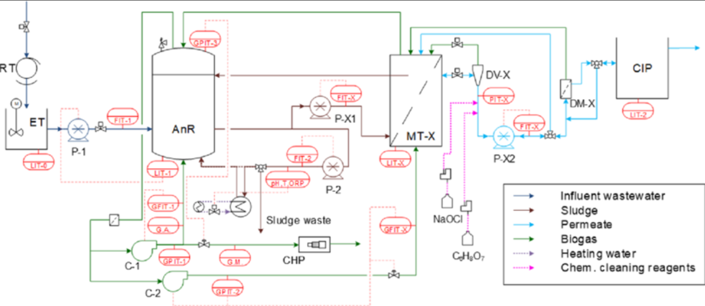
Figure 1: Example P&ID of Typical Wastewater Treatment Facility (Jiménez-Benítez et al., 2022)

ICA in Wastewater Treatment

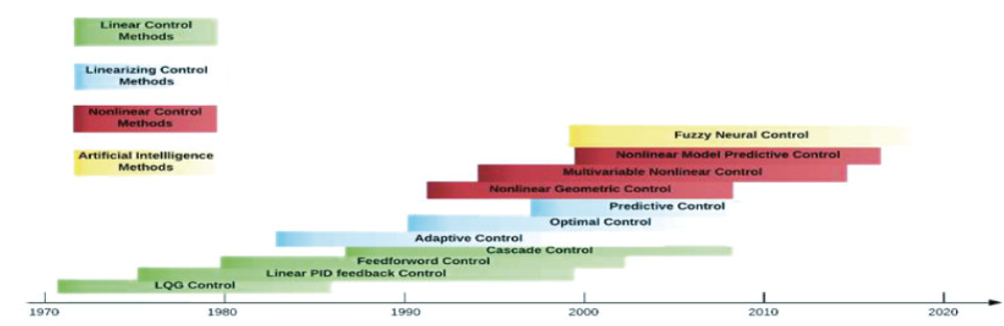
Historical Context of ICA in Wastewater Treatment
Figure 2: Timeline evolution of control methods on wastewater treatment processes (Iratni & Chang, 2019)

The application of ICA in wastewater treatment has evolved significantly over recent decades, enhancing treatment efficiency and regulatory compliance and highlighting the importance of automation in modern wastewater management (Tchobanoglous et al., 2013).
Early facilities relied on manual monitoring and control, resulting in inefficiencies and inconsistent treatment quality (Metcalf & Eddy, 2014). The introduction of ICA in the early 1970s was driven by the recognition that treatment plants often operated under highly variable load conditions despite being designed for average flows (Olsson, 2012). Initial efforts concentrated on feedback control and analogue systems to stabilise process conditions. The first international conference on ICA in 1973 initiated structured knowledge sharing, although scepticism persisted due to limitations in plant design and operator training (Olsson, 2012).
In the 1980s, digital technologies like PLCs and early SCADA systems began replacing manual operations, enabling real time control of key processes such as aeration. However, sensor reliability issues and a lack of staff expertise hindered wider adoption (Jeppsson et al., 2002). Nonetheless, this period laid the groundwork for more complex control architectures.
The 1990s saw ICA gaining traction due to growing regulatory demands, particularly in Europe, after adopting the Urban Waste Water Treatment Directive (91/271/EEC). Utilities upgraded plants to meet nutrient discharge limits, leading to increased use of automated controls for nutrient removal and sludge handling (Jeppsson et al., 2002). SCADA systems became more common, and sensor quality improved, reducing implementation barriers.
In the 2000s, the emphasis shifted from technology availability to integration and optimisation, focusing on coordinated plant-wide automation to enhance performance, cut costs, and adhere to stricter environmental regulations. Jeppsson et al. (2002) noted that sensor technology was no longer the main bottleneck; inflexible plant designs and management culture constrained ICA effectiveness.
The 2010s brought intelligent systems incorporating predictive analytics, model-based control, and subsystem integration. These advancements enabled utilities to maximise the performance of ageing infrastructure (Yuan et al., 2019). The emergence of IoT, ML, and digital twins further strengthened ICA's role in fostering adaptive, efficient, and resilient wastewater systems.
The evolution of ICA from basic control loops to integrated, smart systems reflects technological progress and external drivers such as regulation, urbanisation, and sustainability goals. Today, ICA is essential for delivering reliable, cost-effective, and environmentally compliant wastewater services (Yuan et al., 2019; Olsson, 2012).

Core Components and System Architecture

Sensors
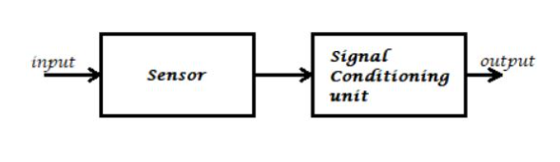

Figure 3:Basic Block Diagram of a Sensor and Signal Conditioning System (Bhattarai, 2019)

Sensors are essential in control systems, providing real time data on wastewater treatment processes. Treatment plants use various sensors to monitor water quality, including level sensors, flow meters, pressure sensors, and temperature sensors (Niazi, 2021).
Chemical and analytical sensors closely track water quality: pH sensors measure acidity, dissolved oxygen probes monitor oxygen levels for biological treatment, turbidity sensors assess clarity, and conductivity sensors detect dissolved salts or ions (Niazi, 2021; Sharma, 2024). Some facilities utilise specialised sensors for specific contaminants (e.g., ammonia or nitrate) or online analysers for chemical oxygen demand.
This continuous insight enables operators and automated systems to maintain optimal plant performance while adhering to regulatory discharge limits. Reliable sensors detect early issues, such as pH imbalances or oxygen depletion, enabling timely corrective actions to maintain effluent quality (Sharma, 2024).

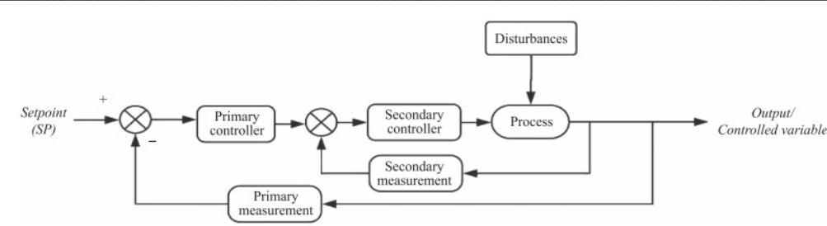
Controllers
Figure 4: Example of Cascade Control Structure (Iratni & Chang, 2019)

In wastewater treatment, controllers are vital for maintaining process variables at set points by adjusting equipment based on sensor feedback. Most control loops use feedback controllers, primarily proportional-integral-derivative (PID) control, to maintain parameters like flow, level, or chemical concentration (Dewesoft, 2023). These can be implemented within PLCs or as dedicated units. For example, a controller modulates a valve or pump speed to stabilise a tank's liquid level despite inflow fluctuations. A typical case is the dissolved oxygen control in aeration tanks, where the controller adjusts airflow to meet the oxygen demand for microbes, ensuring effective treatment (Sharma, 2024). Such automated adjustments stabilise processes against disturbances and optimise performance.
Advanced strategies, such as cascading controllers, manage interdependent variables. Larger plants may use model-based or adaptive controls to address complex wastewater characteristics. Regardless of sophistication, controllers enhance efficiency and consistency. Control systems maintain effluent quality better than manual operations by processing real-time sensor data and issuing rapid actuator corrections. Studies show that instrumentation and automated control can reduce energy consumption and increase treatment capacity by 10–30% (Olsson et al., 2005). Well-tuned controllers also minimise chemical usage and equipment wear by preventing over-correction and oscillations typical of manual control.

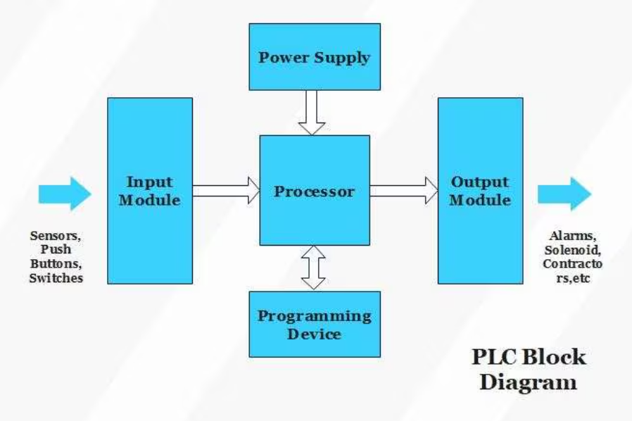
Programmable Logic Controllers (PLCs)
Figure 5: Basic Block Diagram of a PLC System
A PLC is an industrial computer that executes real-time control logic, directly interfacing with sensors and actuators, particularly in harsh environments typical of treatment plants where moisture, corrosion, and electrical noise are common (Sharma, 2024). PLCs continuously gather input signals from sensors, like level, flow, and pressure, and apply programmed strategies to determine appropriate output actions. For example, PLCs can monitor liquid levels at a pump station, automatically manage pumps to maintain desired levels and adjust aeration blower speeds based on dissolved oxygen readings (Sharma, 2024).
Networked PLCs form distributed control systems, efficiently managing multiple processes within modern treatment plants. Their flexibility, ease of reprogramming, scalability, and compatibility with SCADA systems enhance operational reliability across wastewater treatment processes, ensuring seamless coordination from screening to disinfection (PLC Technician, 2023).

Actuators
Actuators act as the "muscles" of automated systems, executing actions based on control signals and converting commands into mechanical movement. In treatment plants, valve actuators are crucial for managing water and airflow. Electric motor-driven actuators control various valves, including gate, butterfly, and ball valves (Sully, 2008). Pumps and blowers also rely on actuation, utilising motors powered by variable-frequency drives or starters following PLC commands.
These actuators enable prompt adjustments according to controller outputs. For instance, an automated system may throttle a valve to reduce flow into a clarifier nearing overload or increase a chemical dosing pump rate when pH levels drop. Actuators operate on/off (discrete positioning) and modulate control modes. In on/off service, an actuator fully opens or closes a valve, such as shutting off a sludge discharge valve when a tank is full. In modulating control, the actuator adjusts the position of a valve to regulate flow rate or pressure.
Modern electric actuators often include digital controls that provide real-time feedback to the SCADA system, increasing visibility and enabling proactive maintenance (Sully, 2008). Some use pneumatic or hydraulic principles, particularly in older systems. Regardless of type, actuators are designed for reliability and robustness, operating efficiently in harsh conditions and capable of handling numerous manoeuvres annually. By automating valves, gates, dampers, and other devices, actuators enable treatment processes to adapt dynamically to changing conditions.

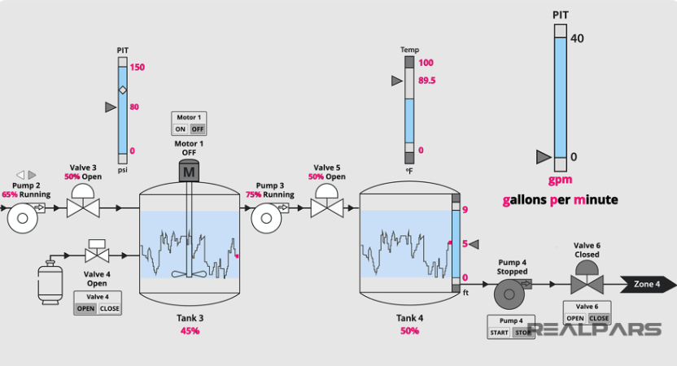
Supervisory Control and Data Acquisition Systems (SCADA)
Figure 6: Example of a typical WWTP SCADA Display (Anderson, 2020)
A SCADA system integrates monitoring and control in wastewater treatment facilities, presenting information coherently to operators. It is a computerised oversight layer that collects data from field controllers, stores and displays it, and allows operators to manage processes from a central or remote location (Tuser, 2021). SCADA systems are essential for monitoring and controlling treatment plants and associated infrastructure like pumping stations (Tuser, 2021).
A typical SCADA architecture in a wastewater plant includes supervisory computers (servers or workstations running SCADA software), human-machine interface (HMI) displays for operators, remote terminal units (RTUs) or PLCs, and communication links connecting these devices (Tuser, 2021). The field PLCs/RTUs collect sensor data and send control signals to actuators, while SCADA software polls these controllers for real-time readings and status updates (Sharma, 2024). This data is visualised on HMIs, often through intuitive graphics, enabling quick assessment of system conditions. SCADA also logs historical data for trend analysis, reporting, and optimisation.
Alarm functionality is crucial; if any sensor or equipment status indicates an issue (e.g., pump failure or high effluent turbidity), SCADA raises the alarm for operator intervention. It can execute automated responses, such as shutting down a pump if a downstream valve is closed, preventing potential issues. SCADA serves as the intelligence hub of the plant's automation, enabling a small team to manage extensive facilities efficiently (Sharma, 2024). Given increased connectivity, cybersecurity and system redundancies are essential for safeguarding critical infrastructure. Overall, SCADA is vital in municipal and industrial wastewater management, enhancing decision-making, regulatory compliance, and proactive maintenance.

Communication Protocols and Integration Platforms
Robust communication protocols are essential for integrating ICA components, ensuring reliable data exchange among sensors, controllers, actuators, and supervisory systems. They dictate how information is transmitted and responded to within the control network, vital in achieving real-time responsiveness, interoperability, and fault diagnostics.
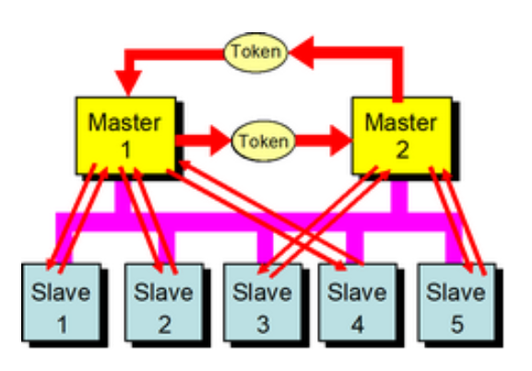
Rinaldi (2018) highlights that Modbus is widely used in industrial applications due to its simplicity, cost-effectiveness, and legacy support. Developed in the late 1970s, Modbus enables a master device (like a PLC or computer) to communicate with multiple slave devices (such as sensors or actuators) through a straightforward request-and-response model, which facilitates reading data (e.g., temperature) or executing commands (like turning a valve). This ease of implementation contributes to its continued use, particularly in older systems.

Figure 7: Token Passing in a Master-Slave Network Architecture (igus Engineer's Toolbox, n.d.)

Conversely, advanced protocols like PROFIBUS and its Ethernet-based successor, PROFINET, offer enhanced functionality for modern automation. PROFIBUS connects field devices directly to controllers using a token-passing system, preventing message collisions and ensuring reliable data delivery, making it suitable for real-time control in complex environments. Rotork (2018) noted that PROFIBUS is favoured in German-engineered control systems for its performance and diagnostic capabilities.
PROFINET builds on PROFIBUS, utilising standard Ethernet for faster data transmission and greater flexibility. It allows industrial devices to communicate over an IT-friendly network while prioritising time-critical data. PROFINET supports real-time and ultra-fast isochronous communication, which is vital for high-speed processes such as robotics or packaging. Additionally, it facilitates integration with enterprise systems, enhancing the efficiency and accuracy of smart factories.
These protocols are foundational to digitalised industrial control systems. They enable seamless integration of diverse ICA components and enhance performance, diagnostics, and scalability across various applications.

Emerging Trends: Smart Monitoring and Predictive Analytics

AI in Automation
Artificial intelligence (AI) is revolutionising wastewater treatment automation through data-driven process control. Machine learning models optimise aeration, chemical dosing, and other processes to enhance treatment efficiency and energy usage. AI-based predictive controllers maintain effluent quality while reducing energy consumption, resulting in cost savings (Wang et al., 2023). Additionally, AI systems improve operational safety by detecting real-time anomalies and equipment faults (Nagpal et al., 2024). Numerous global pilot projects show that AI-driven automation enhances plant performance and reliability across various contexts (Nagpal et al., 2024).

IoT (Internet of Things)
IoT technologies are deployed in wastewater instrumentation for continuous, real-time monitoring and control. Intelligent sensor networks transmit data on flow, pH, and pollutant levels, enabling operators to respond quickly to changing conditions (Pandey et al., 2022). IoT-SCADA integration allows remote adjustment of valves and pumps, facilitating rapid intervention and standardised treatment management. These connected systems enhance efficiency by reducing manual inspections and optimising resource use, thus lowering energy and labour costs (Pandey et al., 2022). IoT-driven automation has also expedited incident response and improved process stability in wastewater facilities (Pandey et al., 2022).

Remote Monitoring
Advances in remote monitoring allow wastewater treatment plants to be supervised and controlled off-site via secure networks. Modern supervisory control and data acquisition (SCADA) systems and IoT sensors provide operators with live dashboards and alarms from dispersed locations. This improves safety by reducing the need for staff to enter hazardous sites while ensuring quick identification of irregularities. One study developed a cloud-based system to aggregate data from decentralised wastewater plants, showcasing effective remote performance oversight (O'Donovan et al., 2015). This infrastructure enables utilities to maintain treatment quality and compliance with fewer onsite personnel, contributing to cost reductions through streamlined operations (O'Donovan et al., 2015).

Predictive Maintenance
Data analytics in instrumentation and control are shifting maintenance from reactive to predictive strategies. By continuously monitoring equipment vibrations, flow patterns, and other indicators, algorithms can forecast pump failures, sensor drift, or membrane fouling before they escalate. This foresight allows for proactive maintenance, avoiding unplanned downtime and enhancing operational efficiency. Studies confirm that AI-enabled systems facilitate predictive maintenance in wastewater facilities, reducing sudden breakdown risks and lowering lifecycle costs (Wang et al., 2023; Nagpal et al., 2024). In the UK, a cloud-based AI solution using IoT sensors achieved over 88% accuracy in predicting sewer blockages, prompting preventative cleaning that averted pollution incidents (Shepherd et al., 2023). Such examples highlight how predictive maintenance improves reliability and safety while reducing maintenance expenses.

Edge Computing and Cloud Solutions
The wastewater sector uses edge computing and cloud platforms for enhanced data management. Cloud computing offers scalable storage and powerful analytics for the vast data from treatment plants, enabling advanced process optimisation and long-term performance analysis (Pandey et al., 2022). This model reduces onsite IT infrastructure needs and costs by allocating resources on demand. Meanwhile, edge computing processes data at or near the source, supporting real-time automation. By performing onsite analytics, edge devices lower latency and maintain critical control functions despite limited connectivity (Shahra et al., 2024). Research indicates that edge processing significantly enhances response times and reliability for water quality monitoring, while a hybrid edge-cloud approach combines low-latency control with high-level analysis. Together, these solutions improve operational efficiency and resilience in wastewater treatment, leading to safer operations and reduced costs through optimised resource use.

Challenges and Limitations
Modern wastewater treatment relies on ICA technologies, but persistent global barriers affect legacy and emerging systems. Many utilities still operate legacy SCADA and PLC systems, which were not designed with modern cybersecurity in mind and can struggle to interface with today's digital tools (Bello et al., 2023; Bhandari et al., 2023). These older systems lack robust security features, making critical infrastructure vulnerable to cyber-attacks, and cannot easily integrate with new sensor networks or analytics platforms.
Emerging ICA technologies promise improved efficiency and decision support but have high implementation costs and added complexity (Cairone et al., 2024). Water utilities globally face constraints of limited funding and high sunk costs in existing infrastructure, complicating the justification for expensive automation upgrades (Ahmed et al., 2023).
A significant barrier is the skills gap; many wastewater utilities have a limited workforce with the expertise to manage advanced automation, data analytics, and cybersecurity (Ahmed et al., 2023). New technologies require new skills, but utilities struggle to upskill staff or attract specialists, hindering technology uptake (Ahmed et al., 2023; Bhandari et al., 2023). Additionally, integrating cutting-edge ICA solutions with decades-old equipment poses technical challenges, often requiring retrofitting or middleware to accommodate modern interfaces (Bhandari et al., 2023). This makes digital transformation in the wastewater sector slow. Finally, security remains a concern as increased connectivity in modern ICA expands the cyber-attack surface and outdated legacy IT amplifies incident risks (Bello et al., 2023; Bhandari et al., 2023).

Conclusion
Integrating Instrumentation, Control, and Automation (ICA) has transformed wastewater treatment, enabling more efficient and sustainable operations. From analogue feedback loops to intelligent, AI-enhanced systems, ICA has evolved alongside environmental demands and technological advancements. Core components like sensors, PLCs, controllers, actuators, and SCADA systems now work together to monitor and optimise real-time processes. Emerging technologies, such as IoT, edge computing, and predictive analytics, further enhance performance and resilience. However, challenges like legacy infrastructure, high costs, and skill gaps hinder adoption in some areas. Despite these obstacles, ICA is essential for regulatory compliance, resource efficiency, and sustainability in wastewater treatment. Investing in smart and interoperable ICA solutions will be crucial for modern wastewater management as digital transformation accelerates.

References
Ahmed, F., Johnson, D., Hashaikeh, R. & Hilal, N. (2023). 'Barriers to innovation in water treatment', Water, 15(4), p. 773. Available at: https://doi.org/10.3390/w15040773
Anderson, M. (2020). 'SCADA Applications in Water Treatment', RealPars, 2 November. Available at: https://www.realpars.com/blog/scada-applications
Angelakis, A.N. and Snyder, S.A. (2015). 'Wastewater Treatment and Reuse: Past, Present, and Future', Water, 7(9), pp. 4887–4895
Bello, A., Jahan, S., Farid, F. & Ahamed, F. (2023). 'A systemic review of the cybersecurity challenges in Australian water infrastructure management', Water, 15(1), p. 168. Available at: https://doi.org/10.3390/w15010168
Bhandari, P., Creighton, D., Gong, J., Boyle, C. & Law, K.M.Y. (2023). 'Evolution of cyber-physical-human water systems: challenges and gaps', Technological Forecasting and Social Change, 191, 122540. Available at: https://doi.org/10.1016/j.techfore.2022.122540
Bhattarai, U. (2019). 'What are Sensors? Definition, block diagram and different types', Upendra Blogs, 30 June. Available at: https://upendrablogs.wordpress.com/2019/06/30/what-are-sensors-definitionblock-diagram-and-different-types/ (Accessed: 6 March 2025)
Cairone, S. et al. (2024). 'Revolutionising wastewater treatment toward circular economy and carbon neutrality goals: pioneering sustainable and efficient solutions for automation and advanced process control with smart and cutting-edge technologies', Journal of Water Process Engineering, 63, 105486. Available at: https://doi.org/10.1016/j.jwpe.2023.105486
Cheremisinoff, N.P. (2002). Handbook of Water and Wastewater Treatment Technologies. Boston: Butterworth-Heinemann
Dewesoft (2023) 'What is a PID Controller?' Dewesoft Blog. Available at: https://dewesoft.com/blog/what-is-pid-controller
EMQX Team (2024). 'Smart Water Operation and Management with EMQX MQTT Platform', EMQ Blog, 15 February. Available at: https://www.emqx.com/blog/smart-water-operation-and-management
European Commission (1991). 'Council Directive 91/271/EEC concerning urban wastewater treatment', Official Journal of the European Communities. Available at: https://doi.org/10.1039/ec9110
Henze, M., van Loosdrecht, M.C.M., Ekama, G.A. and Brdjanovic, D. (2008). Biological Wastewater Treatment: Principles, Modelling and Design. London: IWA Publishing. ISBN: 9781843391883
Igus Engineer's Toolbox (n.d.) 'What is PROFIBUS and how does it work?'. Available at: https://toolbox.igus.com/4410/what-is-profibus-and-how-does-it-work
Ingildsen, P. and Olsson, G. (2016). Smart Water Utilities: Complexity Made Simple. London: IWA Publishing
Iratni, A. and Chang, N.-B. (2019) 'Advances in Control Technologies for Wastewater Treatment Processes: Status, Challenges, and Perspectives', IEEE/CAA Journal of Automatica Sinica, 6(2), pp. 337–363. Available at: https://www.ieee-jas.net/article/doi/10.1109/JAS.2019.1911372 (Accessed: 5 March 2025)
Jeppsson, U. et al. (2002). 'Status and future trends of ICA in wastewater treatment – A European perspective', Water Science and Technology, 45(4–5), pp. 485–494. Available at: https://doi.org/10.2166/wst.2002.0653
Jiménez-Benítez, A., Robles, Á., Giménez, J.B., Ferrer, J. and Seco, A. (2022). 'Process and Instrumentation Diagram (P&ID)', in A semi-industrial scale AnMBR for municipal wastewater treatment at ambient temperature: performance of the biological process. Available at: https://www.researchgate.net/figure/Process-and-Instrumentation-Diagram-P-ID_fig1_359009940 (Accessed: 20 February 2025)
Metcalf & Eddy (2014). Wastewater Engineering: Treatment and Resource Recovery. New York: McGraw-Hill Education. ISBN: 9780073401188
Nagpal, M. et al. (2024). 'Optimising wastewater treatment through artificial intelligence: recent advances and future prospects', Water Science and Technology, 90(3), pp. 731–757
Niazi, M.A. (2021). 'Types of Instrumentation Used in Wastewater Treatment Facilities', Control.com, 16 December. Available at: https://control.com/technical-articles/types-of-instrumentation-used-in-wastewater-treatment-facilities/
O'Donovan, P. et al. (2015). 'A cloud-based distributed data collection system for decentralised wastewater treatment plants', Procedia Engineering, 119, pp. 464–469
Olsson, G. (2012). 'ICA and me – A subjective review', Water Research, 46(6), pp. 1585–1624. Available at: https://doi.org/10.1016/j.watres.2011.12.054
Olsson, G. and Newell, B. (1999). Wastewater Treatment Systems: Modelling, Diagnosis and Control. London: IWA Publishing. ISBN: 9781900222079
Olsson, G. et al. (2005). Instrumentation, Control and Automation in Wastewater Systems. London: IWA Publishing. Available at: https://doi.org/10.2166/9781780402680
Pandey, S. et al. (2022). 'Wastewater Treatment with Technical Intervention Inclination towards Smart Cities', Sustainability, 14(18), p. 11563
PLC Technician (2023). 'PLCs and Water Treatment Facilities', PLC Technician (News Blog), 24 October. Available at: https://www.plctechnician.com/news-blog/plcs-and-water-treatment-facilities
Rieger, L. et al. (2012). Guidelines for Using Activated Sludge Models. London: IWA Publishing. ISBN: 9781780401164
Rinaldi, J.S. (2018). 'Modbus WINS in Water and Waste Water', Real Time Automation Blog, 12 June. Available at: https://www.rtautomation.com/blog/modbus-wins-in-water-and-waste-water/
Rotork (2018) ‘Wastewater treatment plant in Portugal using Profibus-enabled actuators’, Case Study, 30 March. Available at: https://www.rotork.com/en/media/latest-news/2018/03/30/profibus-wastewater-portugal
Shahra, E.Q. et al. (2024). 'Intelligent Edge-Cloud Framework for Water Quality Monitoring in Water Distribution System', Water, 16(2), p. 196
Sharma, S. (2024). 'PLC and SCADA: Understanding the Differences in Industrial Automation Systems', Wevolver, 20 March. Available at: https://www.wevolver.com/article/plc-and-scada
Shepherd, W. et al. (2023). 'Cloud-Based Artificial Intelligence Analytics to Assess Combined Sewer Overflow Performance', Journal of Water Resources Planning and Management, 149(7), p. 04023041
Sully, I. (2008). 'Actuators' Essential Role in the Water Industry', WaterWorld, 1 September. Available at: https://www.waterworld.com/wastewater-treatment/article/16202394/actuators-essential-role-in-the-water-industry
Tchobanoglous, G., Stensel, H.D., Tsuchihashi, R. and Burton, F. (2013). Wastewater Engineering: Treatment and Resource Recovery. New York: McGraw-Hill Education. ISBN: 9780073401188
Tuser, C. (2021). 'What is Supervisory Control & Data Acquisition (SCADA)?', Water & Wastes Digest, 17 June. Available at: https://www.wwdmag.com/utility-management/article/10939241/what-is-scada-supervisory-control-data-acquisition
UK Environment Agency (2020). 'Urban Waste Water Treatment Directive Compliance Report', Environment Agency. Available at: https://www.gov.uk/government/publications
Vanrolleghem, P.A. and Lee, D.S. (2003). 'Online monitoring equipment for wastewater treatment processes: State of the art', Water Science and Technology. Available at: https://doi.org/10.2166/wst.2003.0151
Water UK (2021). A Guide to Wastewater Treatment in the UK. London: Water UK. Available at: https://www.water.org.uk
Wang, Y. et al. (2023). 'A Review on Applications of Artificial Intelligence in Wastewater Treatment', Sustainability, 15(18), p. 13557
Yuan, Z. et al. (2019). 'Sweating the assets – The role of instrumentation, control and automation in urban water systems', Water Research, 155, pp. 381–402. Available at: https://doi.org/10.1016/j.watres.2019.02.034

