

Certificate of Higher Education in Skills for the Workplace

Task 1
Effective Team Working and Communication

Student name: Alexandra Florica
Student ID: 2029869

Module name: Effective Team Working and Communication
Module code: (BMSW4002_LON)
Lecturer name: Ejiro Esohwode
Submission date: 08/05/2022

Communication is giving, receiving or exchanging ideas, information, signals or messages through appropriate media, enabling individuals or groups to persuade, to seek information, to give information or to express emotions. This broad definition includes body-language, skills of speaking and writing. It outlines the objectives of communication. It emphasizes listening as an important aspect of communication.

Models of Communication
- Shannon and Weaver (1948/49).
In 1948, Shannon was an American mathematician, electronic engineer and Weaver was an American scientist both of them join together to write an article in “Bell System Technical Journal” called “A Mathematical Theory of Communication” and also called as “Shannon-Weaver model of communication”. This model is specially designed to develop the effective communication between sender and receiver. Also, they find factors which affecting the communication process called “Noise”. At first the model was developed to improve the technical communication. Later it’s widely applied in the field of Communication.


Sender or Source (S)---The message (M)---The channel (C)---The receiver ( R)
This SMCR model was the basis of subsequent models such as SCHRAMM`s (1954) and BERLO`s (1960).
This is demonstrated by the Case Study, Maria and Pedro, where Pedro, working on a building site, received a phone call from his wife Maria but because of the noise he misunderstood `chicken` for `kitchen`.
- Schramm (1954)
Schramm's Communication Model, based on the Shannon-Weaver model, was initially proposed in 1954. It was first proposed by Charles Osgood. He first claimed that communication is more of a circular model than a linear one. The Schramm model of communication is a cyclical model of communication in which a message or information, as well as its feedback or acknowledgement, move between a sender and a recipient. Because the views of another theorist, Osgood, impacted the Schramm model, it is also known as the Osgood and Schramm Model of Communication or the Encode-Decode Model of Communication.
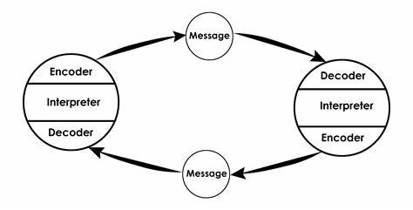
Example:
“Will you join me for a movie?” ABC asks XYZ.
Because XYZ remained silent and did not answer, the communication between ABC and XYZ was incomplete. If XYZ had been uninterested in the film, he might have reacted or informed ABC of his disinterest.
According to Schramm’s model, when the information reaches the recipient, the receiver must provide feedback and let him know if XYZ has strictly received the message that the speaker intended. If he is unclear about anything or has any doubts, he should consult the speaker.
- Berlo (1964)
Berlo`s SMCR model is similar to the others but, like Shannon and Weaver, it is one of the earliest such frameworks and is a little less refined as a result. For one, the model does not consider the impact of noise on communication effectiveness. Nor does it consider feedback, which means the sender and receiver do not receive important information regarding how their messages are perceived and conveyed.
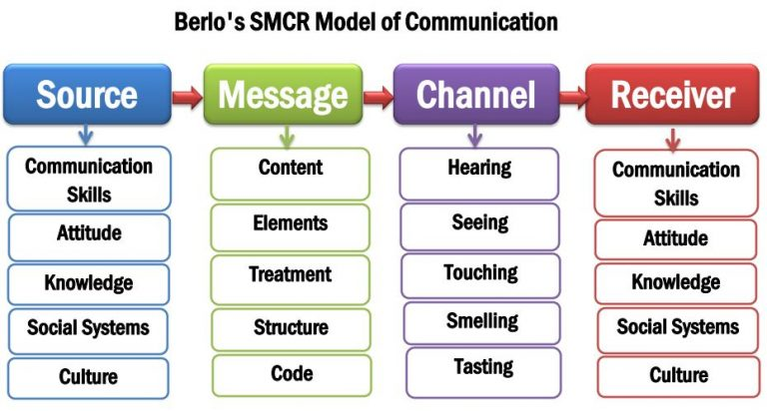

Communication skills:
- Verbal
Verbal Communication is indeed crucial to learn that good oral communication cannot be fully ignored from non-oral communication in the form of our body language, tone of the sound, and expressions of the face.
- Oral communication: which includes what we speak to others in the form of words.
- Written communication: which includes what we write in the form of words.
- Listening skills: This includes how we listen to others.
- Mediated communication: which includes the world wide web for searching data.
- Non-verbal communication: which includes body language, confidence, etc.

- Non-verbal
- Nonverbal communication encompasses all aspects of communication that do not include the use of words. Nonverbal communication aids in the formation of our identities and the negotiation of relationships. Gestures: Movements of our hands, arms, and head tell a lot about how we feel about an issue, what we are passionate or sad about, and even when we are angry. If we are excited, our gestures may increase in frequency and speed. If we are sad, our gestures might stop altogether.
- Body Language: This is how our bodies express our inner feelings or thoughts. If we're sad, we may close our eyes and sit with our arms crossed and our heads bowed. However, if we are confident, we will most likely stand tall with our shoulders back and communicate by looking them in the eyes.
- • The way we say things reveals a lot about what's going on inside of us. Stuttering and stumbling through our speech patterns can signal that we are apprehensive or uncomfortable addressing a topic. It could also imply that we are not being truthful in our conversation and are lying or inventing a story.
- Features of our environment: The way we decorate our environment reveals a lot about what we value, what we're interested in, and how we want to be perceived to the outside world.
- Objects that affect our personal image & interaction patterns: These are objects we own or decorate ourselves with (including bodily alterations such as tattooing/piercing(s)), and they show what matters to us, what groups we belong to, and even our personal perspective on modesty and sexuality.
- Active listening
Active listening is the practice of getting ready to listen, observing what verbal and nonverbal messages are being sent, and then providing appropriate feedback to demonstrate attention to the message being presented.
- Empathetic listening
Empathic listening is the act of paying close attention to and responding to the input of others during a conversation. Making an emotional connection with the other person and discovering similarities between their experience and your own to deliver a more heartfelt response is what empathetic listening includes.

To summarise, communication is an active activity that occurs on a daily basis. A purposeful, intentional, and continuing interchange of ideas and gestures is required for effective communication. To improve patient experiences, health care workers must identify barriers to effective communication and seek to eliminate the negative. Communication is a constantly evolving art form. It takes work, empathy, active listening, and a good mindset to be successful.

