Harvard Referencing – Practice Activity 1
This activity is designed to help you practice your referencing skills.
On the pages that follow there are 20 reputable sources from either books, journals, or websites.

You must first decide if the source you are looking at is a book, journal article, or a web site in order to look for the correct information.
Using your new knowledge of referencing, along with your ‘Grab Sheet’ and your ‘Referencing Diagrams’ (both available on the Harvard Referencing tile), please provide the 2 citation for each source, and the full correctly formatted reference for each source in the spaces provided.
The images of the webpages all contain hyperlinks – this means you can click on the link and look around the webpage to search for the information you need (You may need to right click and select ‘open link’ – also accept any blocked pop-ups).
When referencing journal articles, keep in mind that they sometimes do not include a page number – or in some instances a volume – or in some cases an issue!
When referencing webpages – Keep in mind - your accessed on dates will not be the same as mine!
When you are finished, ensure you check your answers against the ones provided.
The first question has been done for you as an example…

Good luck!
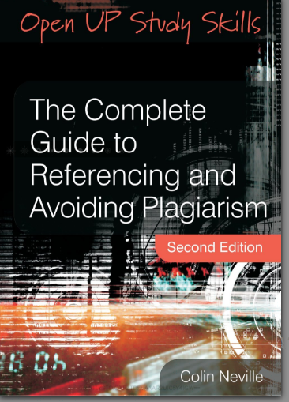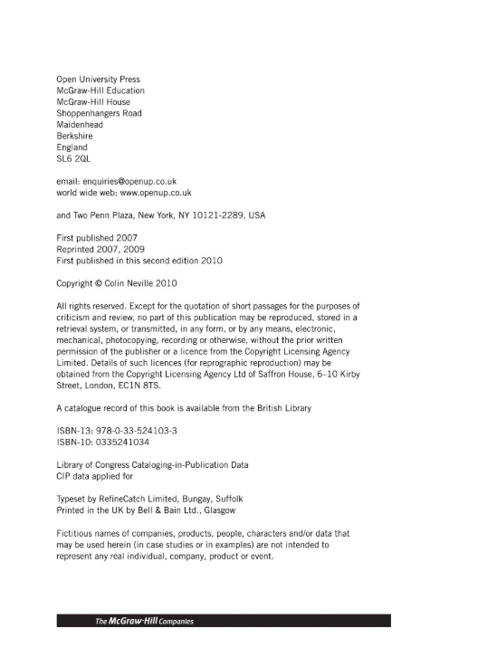

Citation : (Neville, 2010) or Neville (2010)
Reference : Neville, C. (2010) The Complete Guide to Referencing and Avoiding Plagiarism. 2nd edn. Maidenhead: Open University Press.
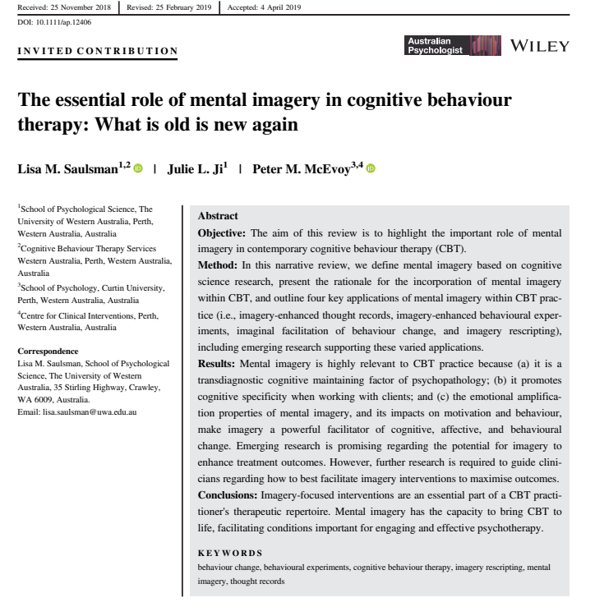
Citation :
Reference :
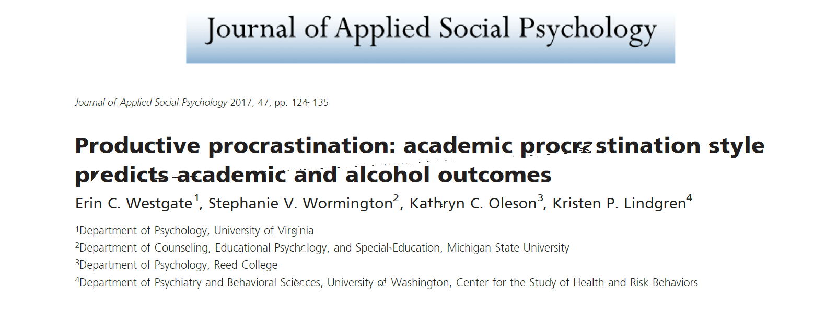
Citation :
Reference :

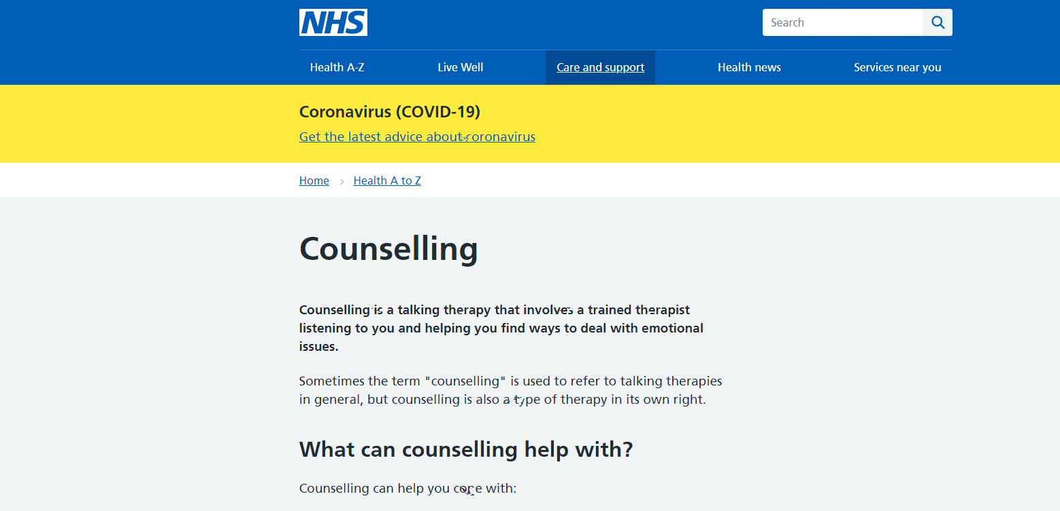

Citation :
Reference :
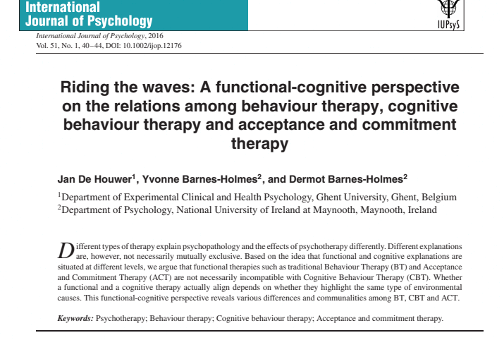

Citation :
Reference :
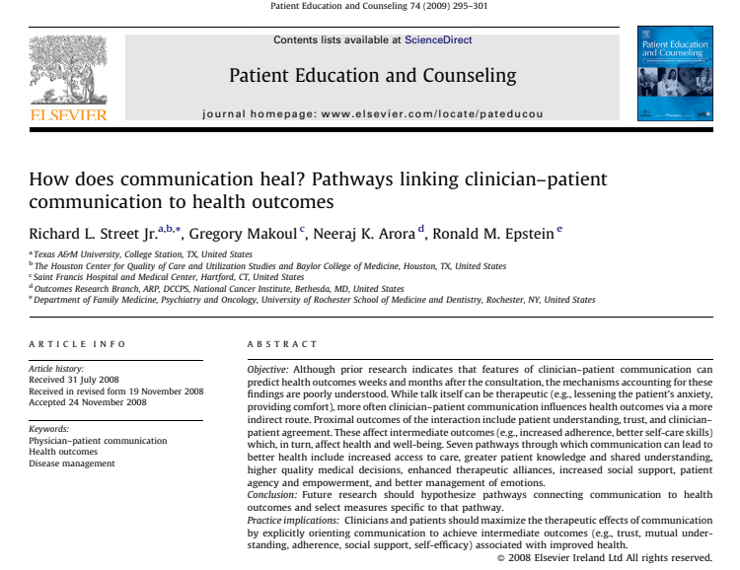

Citation :

Reference :

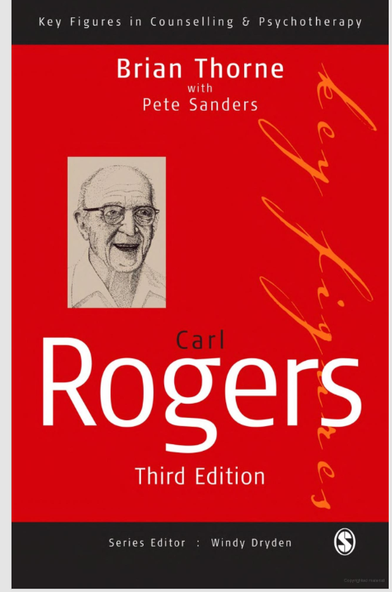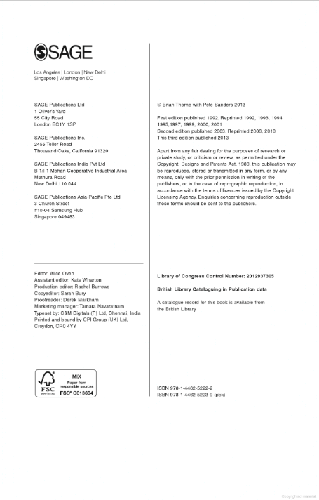

Citation :
Reference :
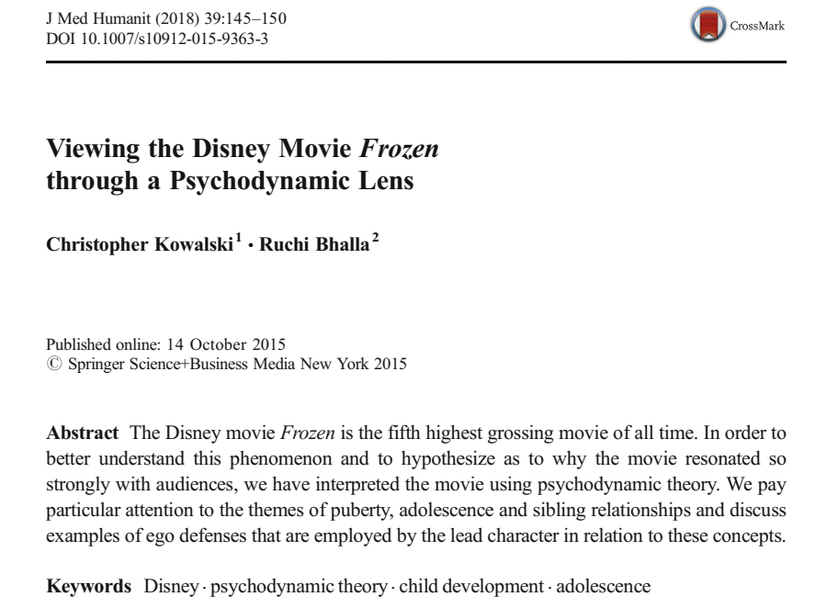

Citation :
Reference :

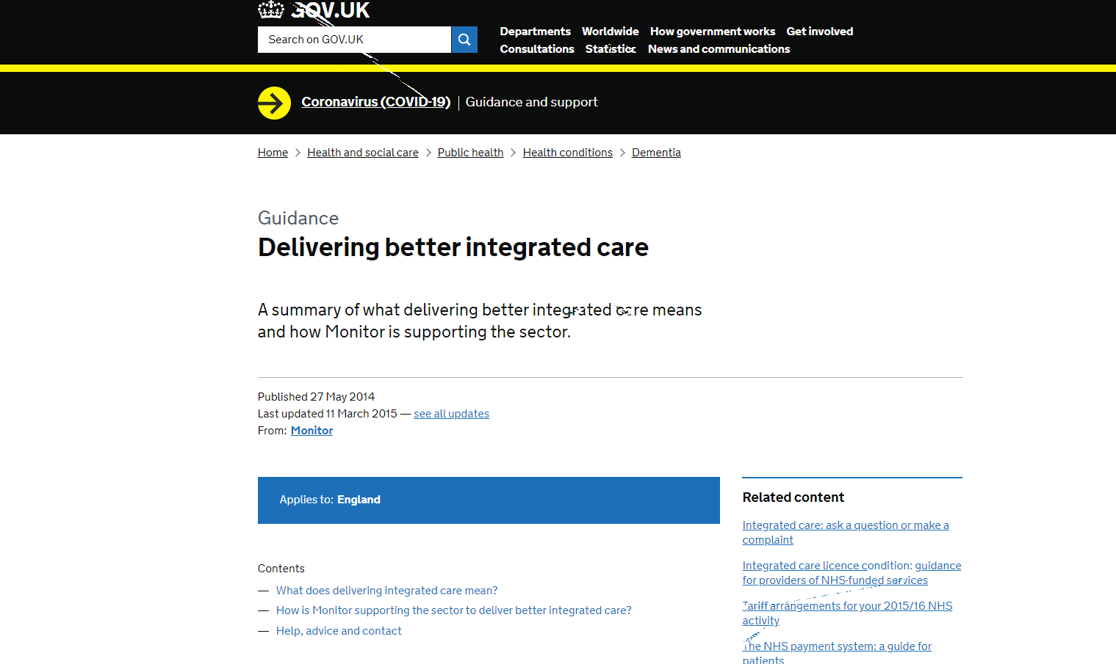

Citation :
Reference :
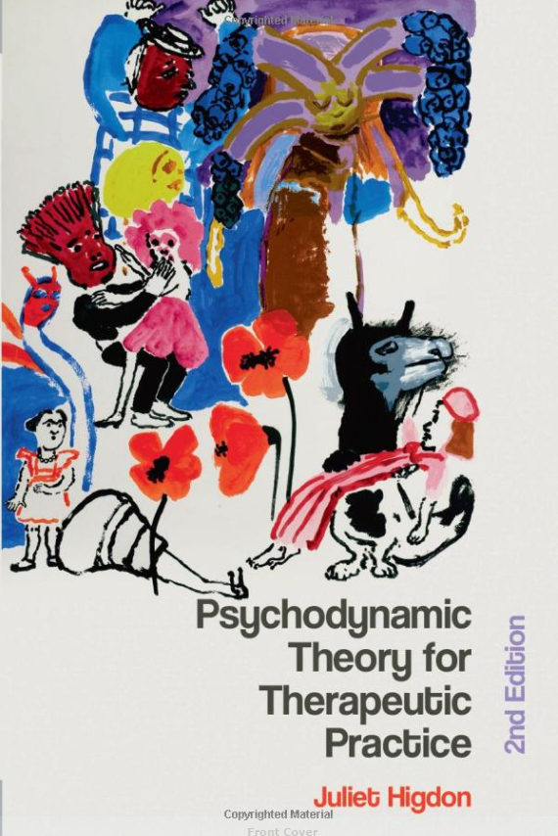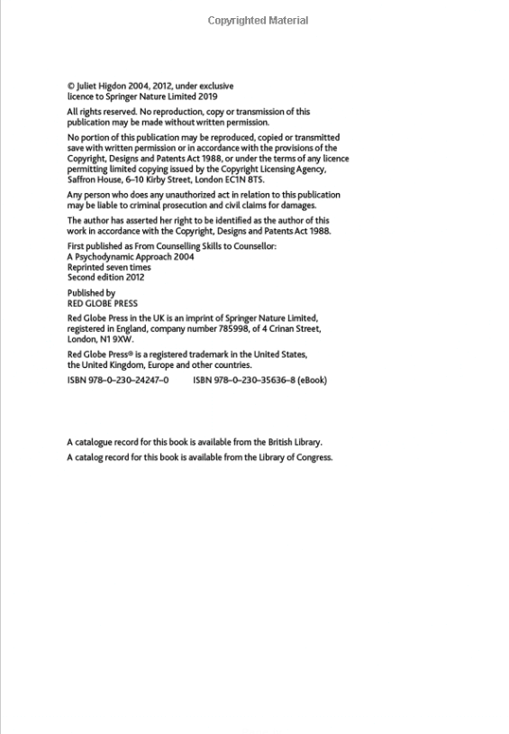

Citation :
Reference :
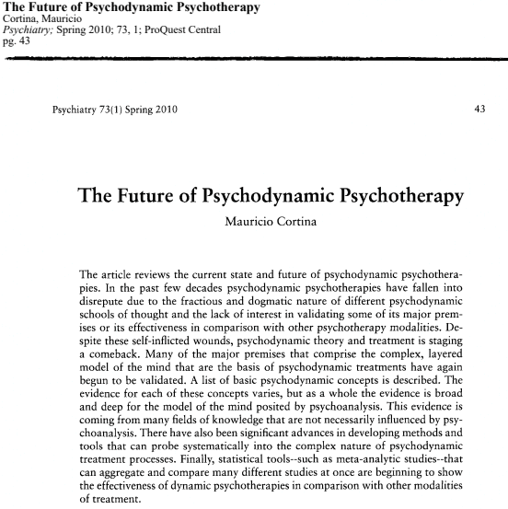

Citation :
Reference :

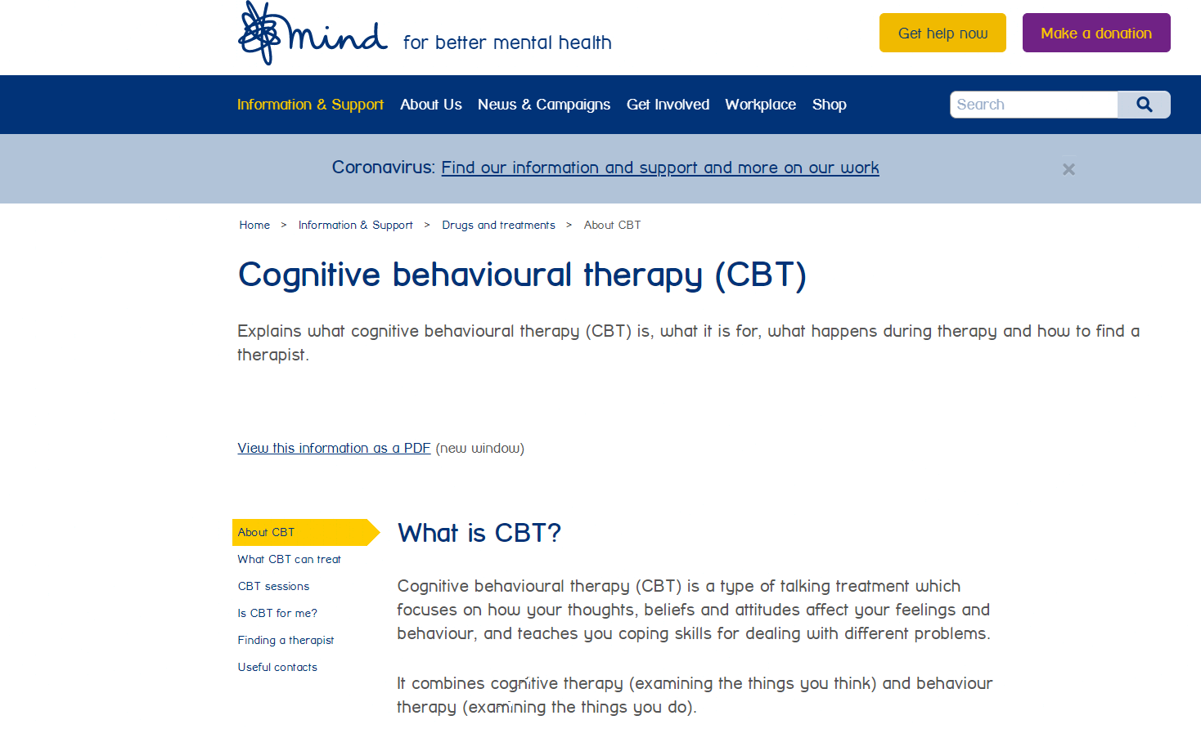
Citation :
Reference :
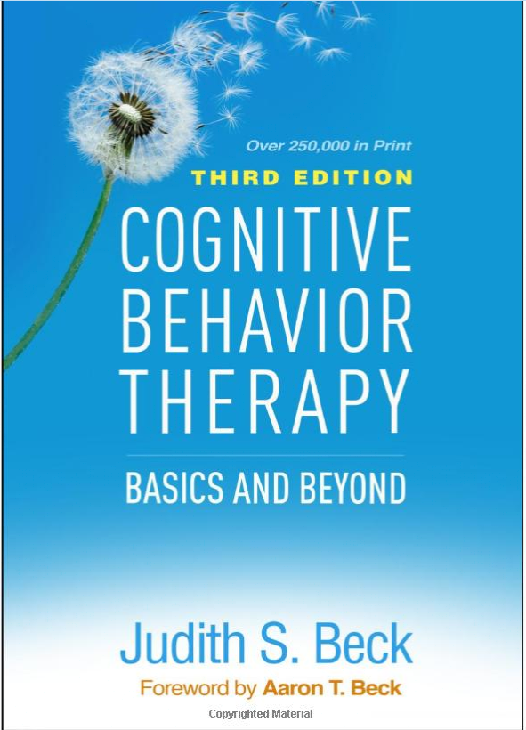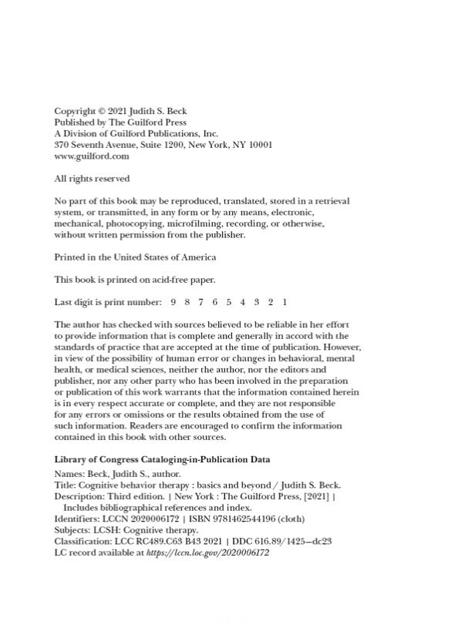
Citation :
Reference :
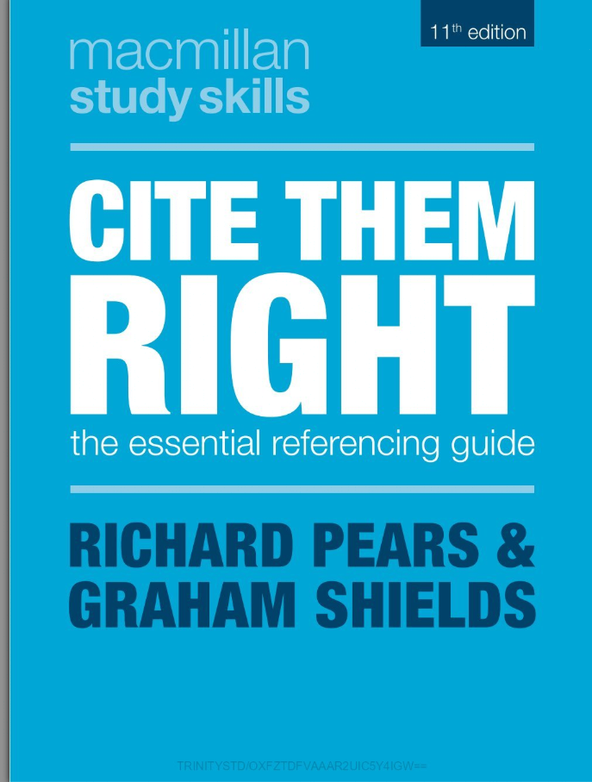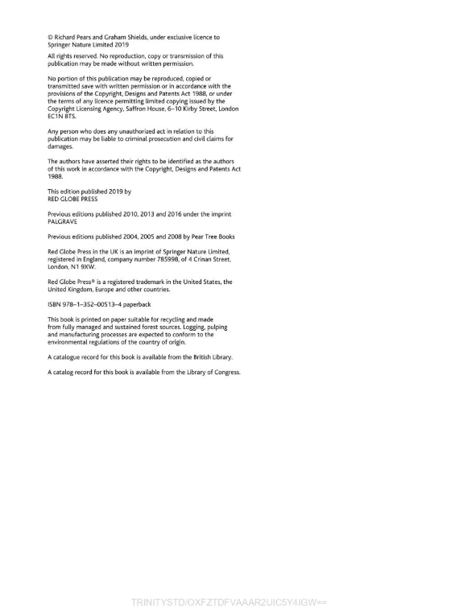
Citation :
Reference :

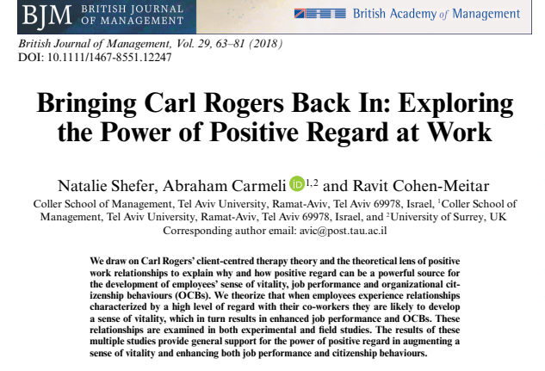

Citation :
Reference :
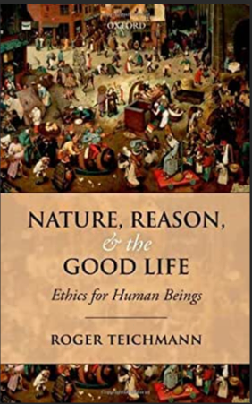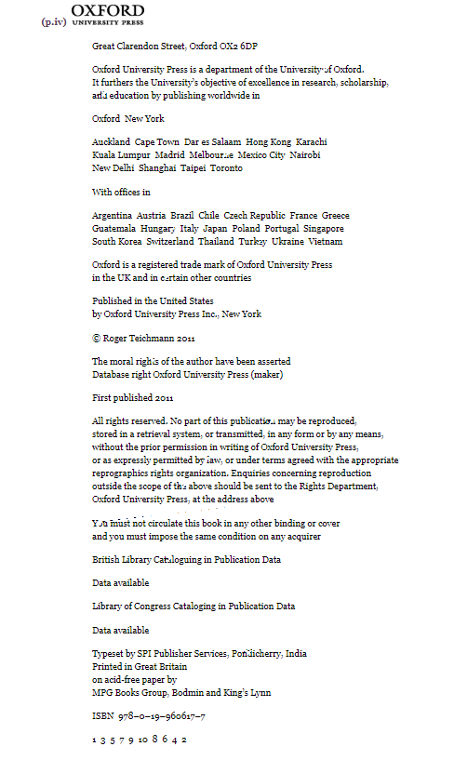
Citation :
Reference :

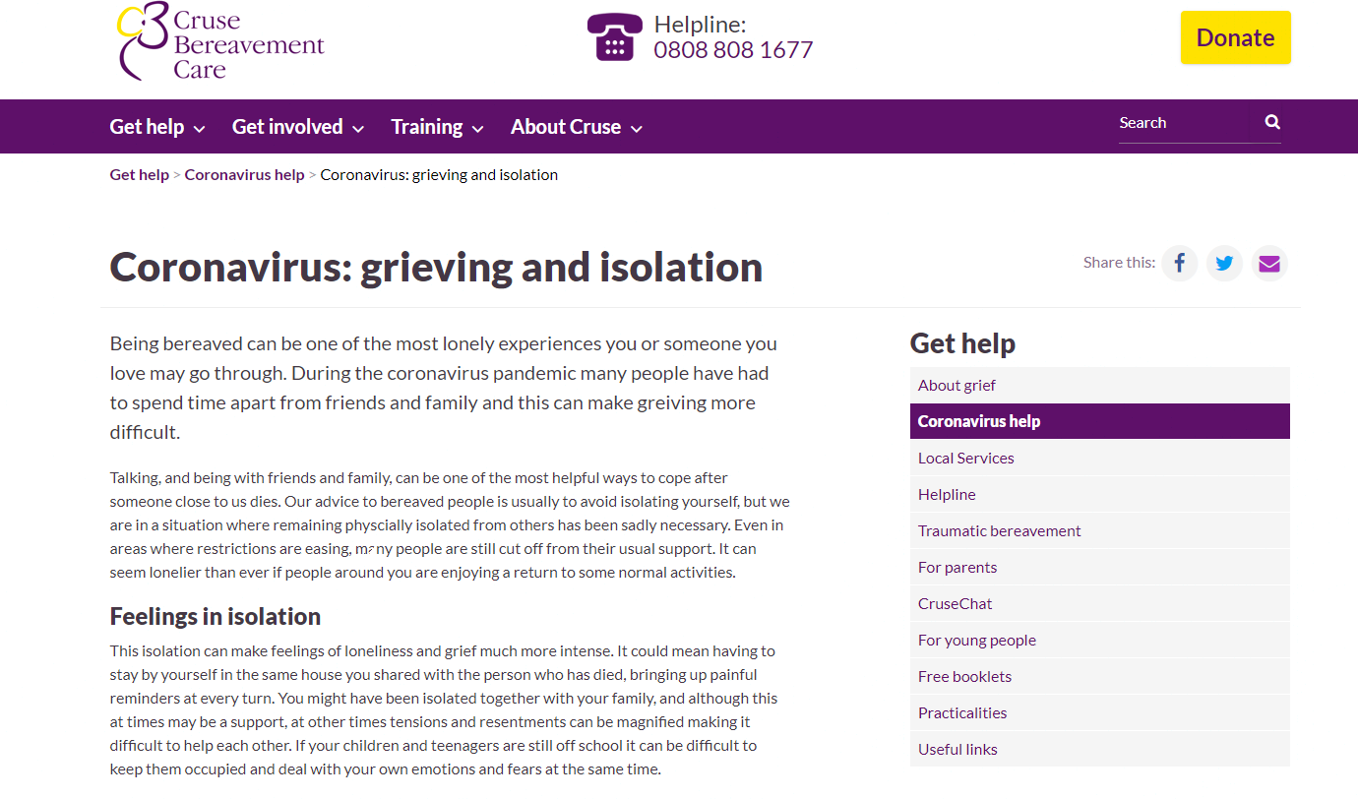

Citation :
Reference :
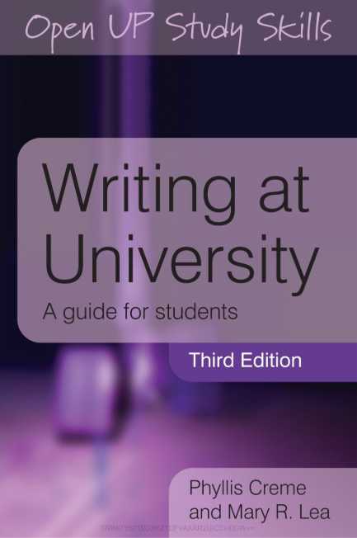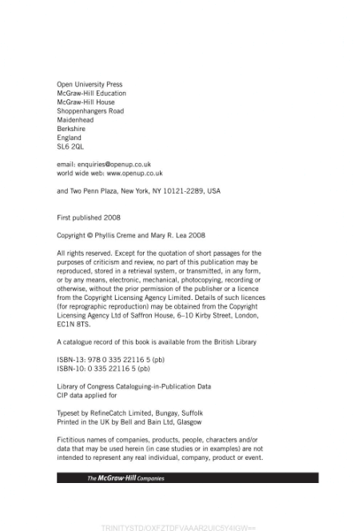

Citation :
Reference :

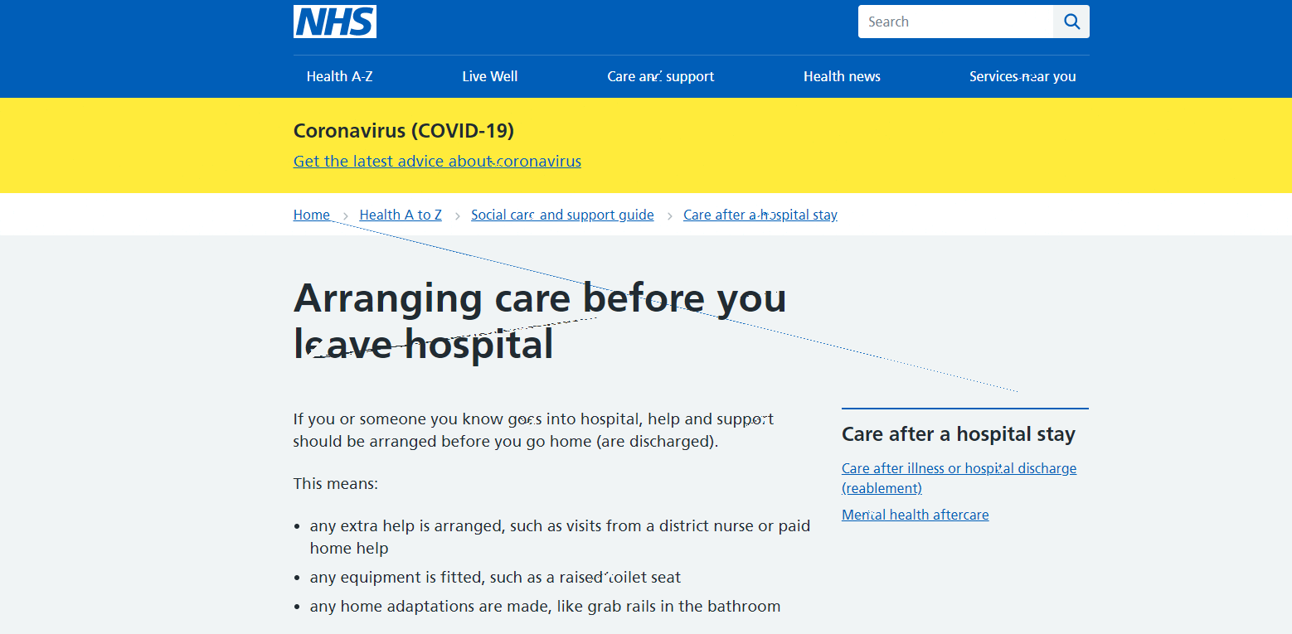

Citation :
Reference :
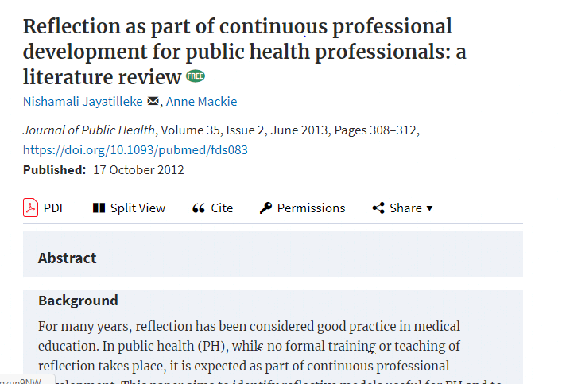

Citation :
Reference :

