ASSIGNMENT

Student Name : Erum Shehzadi

Student ID Number: 2319030

Module : Introduction to Health and

Social Care

Module Code : LCHS4003

Submitted to : Dr Raheela Sheikh

Submission Date : 19 Oct 2025

Table of Contents
Task 1: Poster related Health Care Services
Task 2: National health service current functioning
Introduction 3
National Health Service (NHS) 3
Strong Suits 4
Challenges 4
Conclusion 6
References 7

TASK 1 : Poster

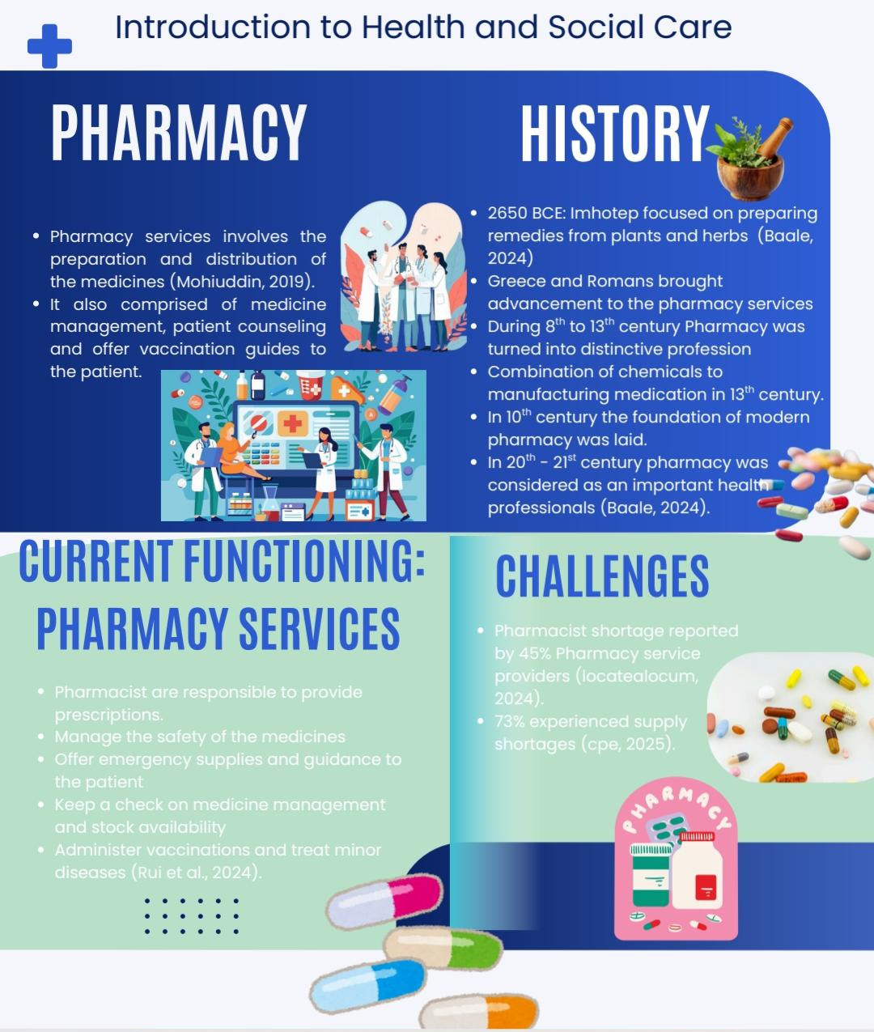

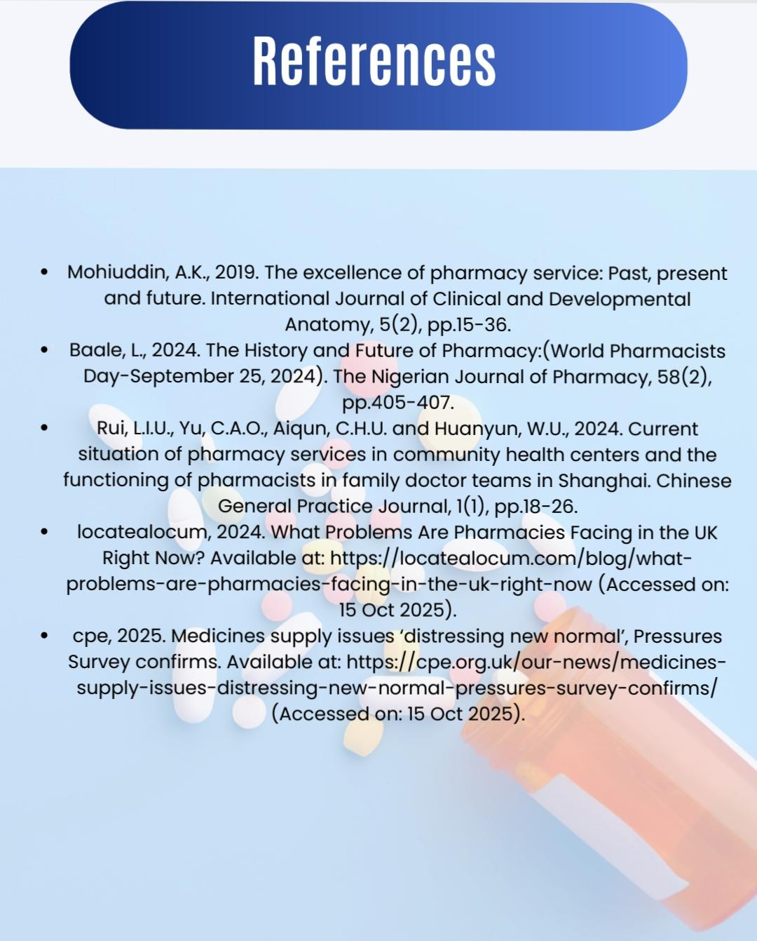

Introduction
The health care services serve as the foundation for boosting the health and well-being of the public. The quality and universal standards fulfilled by the healthcare service providers ensure that the individuals are getting access to high-quality care, accessibility to curative services and treatments. The essay pinpointed the origins of the National Health Service (NHS) by elaborating on its history and key principles of its establishment. The current structure of the NHS and its prime functions are also part of the discussion.

National Health Service (NHS)
The National Health Service, also known as NHS, is the public health care system operating in the United Kingdom. The foundation of the NHS was laid in 1948, having experience of almost 75 years in human care and healthcare services. The organisation has successfully developed trust (Mould et al., 2023). During post-World War II, the health care organisation was established. The purpose was to offer care services and treatments to the injured and unhealthy individuals. Moreover, the core belief of establishing the NHS was to make health facilities easy to access and remove the financial burden from the patient.
The National Health Service Act of 1946 acted as the key legislation for universal and free medical care services by the NHS (Powell and Williams, 2024). The foundational principles of the NHS are to offer universal health services without discriminating against individuals for their national identities, financial situations or the seriousness of their health conditions. Moreover, the belief of the NHS is that patients and their immediate family members have the right to be involved in the treatment cycle (Crisp et al., 2024). The principle of free at the point of need ensures that the service providers do not charge the individual at the time of use of medicines.
The health care system has a professional team of 742,792 healthcare professionals (NHS, 2025). This employee pool comprises doctors, nurses and other paramedical staff. The number of community health staff is 1,278,470. Furthermore, the current NHS has successfully expanded its services across the United Kingdom. NHS England is responsible for monitoring budgets and making decisions to manage present and future operations, and managing digital health care services (England, NHS, 2024). The Department of Health and Social Care (DHSC) is accountable for forming policies and building a network with the government to ensure funds (Crawford and Simpson, 2018). In addition to it, the National Institute for Health and Care Excellence is operating to offer instructions to manage health care services at the national level.
The NHS has established its strengths in health care and services; however, there are some challenges that are hindering its operations.

Strong Suits
- The core belief of the NHS is its biggest strength, which is to consider the clinical needs of the person for providing services, not their financial position and ability to pay for the services.
- The universal availability of healthcare services has resulted in 1.6 million global patient interactions (NHS Confederation, 2023).
- The NHS offer a wide variety of health and well-being care and management facilities, from treating minor injuries to chronic diseases, with the help of a diverse and professional workforce.

Challenges
In working for the delivery of prime functions, the NHS experiences a variety of pressures.
- The NHS is experiencing a rapid reduction in the talented workforce. The medical professionals are leaving their jobs due to the high workload.
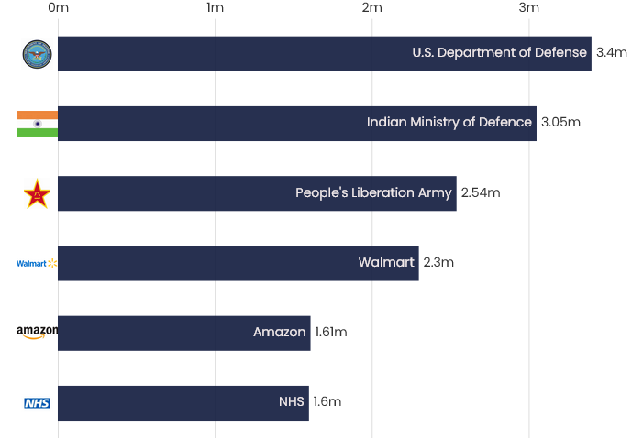
Figure 1: Workforce shortage in the NHS
Source: nhsconfed, 2024.
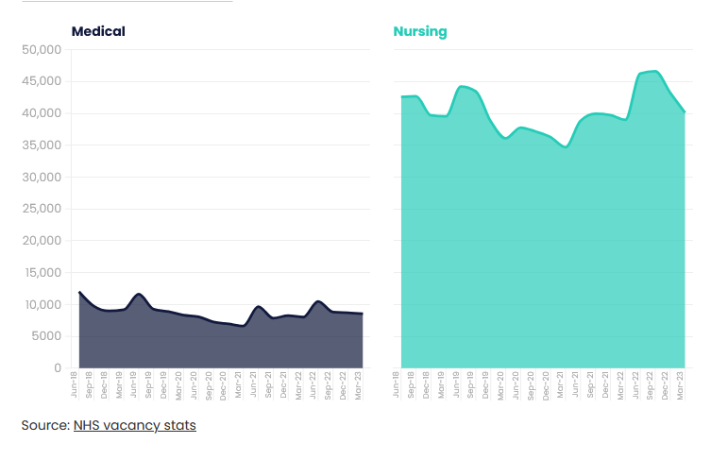
Figure 2:Medical and nursing vacancies
Source: nhsconfed, 2024.
- The inadequate funds and supply chain issues are another challenge that hampers the NHS in bringing innovation and meet supplies demand.
- The patients are constantly complaining about the huge waiting time. The data shows that almost 7.47 million people are waiting for planned and non-emergency medical care and treatments (NHS Confederation, 2024).
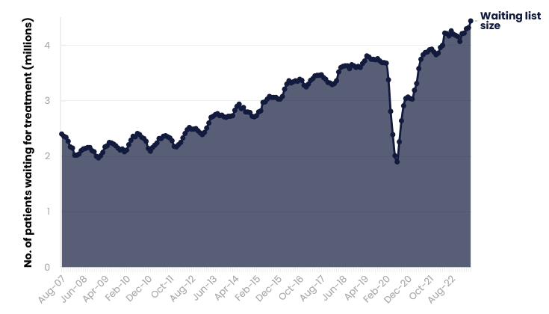
Figure 3: Elective treatment waiting list
Source: nhsconfed, 2024.

Conclusion
The NHS is the prime healthcare service organisation of the United Kingdom. It offers high-quality care services to the global population. The strengths of the organisation are its strong principles and the quality of its functions. However, the NHS is undergoing challenges due to rapid leaving of the workforce, economic challenges and delayed elective treatments.

References
Crawford, R. and Simpson, P., 2018. A review of the Department of Health and Social Care's Funding Reform Model. https://doi.org/10.1920/re.ifs.2018.0151
Crisp, N., Bamrah, J.S., Morley, J., Augst, C. and Patel, K., 2024. The NHS founding principles are still appropriate today and provide a strong foundation for the future. bmj, 384. doi: https://doi.org/10.1136/bmj-2023-078903
England.nhs, 2024. What we do. Available at: https://www.england.nhs.uk/about/what-we-do/ (Accessed on: 15 Oct 2025).
Mold, A., Berridge, V., Gorsky, M., Crook, T., Sheard, S. and Seaton, A., 2023. Lessons from the history of British health policy. Lessons from the History of British Health Policy. DOI: 10.5871/bapolhist/9780856726859.001
NHS, 2025. NHS Workforce Statistics - March 2025 (Including selected preliminary statistics for April 2025). Available at: https://digital.nhs.uk/data-and-information/publications/statistical/nhs-workforce-statistics/march-2025 (Accessed on: 15 Oct 2025).
nhsconfed, 2023. Key statistics on the NHS. Available at: https://www.nhsconfed.org/articles/key-statistics-nhs (Accessed on: 15 Oct 2025).
Powell, M. and Williams, I., 2024. What is a ‘National’‘Health’‘Service’? A keyword analysis of policy documents leading to the formation of the UK NHS. Health Economics, Policy and Law, 19(3), pp.323-336. Doi: 10.1017/S1744133124000057

