A technical report on the performance of the longbow against plate armour at the Battle of Agincourt

By Stuart Atkins
Student number 1809912

Abstract

This report aims to determine whether the longbow was the major contributing factor towards the English victory at the Battle of Agincourt. By researching various studies and tests and utilising armour penetration formulas, it can be said that longbow arrows were capable of penetrating poor quality armour and chain mail, but were unlikely to penetrate higher quality armour, such as that found in the centre of a breastplate. The longbow was truly a destructive weapon in the hands of English archers and was certainly a factor contributing to the victory, however, it is the author’s opinion that it is not solely responsible. In addition to the longbow capability, many other factors played their part in the victory, with the defensive position chosen by the English one of the major factors.

Contents

Title………………………………………………………………………………………………………………………………………2
- Introduction..............................................................................................................................2
  - Aim……………………………………………………………………………………………………………..…………..2

- The Battle of Agincourt……………………………………………………………………………………………….……….2

- Was the longbow really that effective?...................................................................................3

- Other factors affecting the battle…………………………………………………………………………………………3
  - Troop Composition………………………………………………………………………………………………….3
  - Defensive Position…………………………………………………………………………………………………..3
  - Leadership……………………………………………………………………………………………………………….3
  - Ground Conditions……………………………………………………………………………………………..……4

- Longbow vs Armour Debate…………………………………………………………………………………………….…..4
  - English Longbow Testing against various armour circa 1400…………………………………..4
  - A report of the findings of the Defence Academy war bow trials Part 1 – 2005……..5
  - Arrows Vs Armour – Agincourt Myth Busting………………………………………………………….6

- Penetration Calculations………………………………………………………………………………………………………8
  - Patel-Gillingham Formula………………………………………………………………………………………..8
  - German Demarre Equation………………………………………………………………………………………9
  - Angle of Obliquity……………………………………………………………………………………………….…10

- Discussion…………………………………………………………………………………………………………………………..11

- Conclusion…………………………………………………………………………………………………..……………………..11

- Reference List……………………………………………………………………………………………………………………..12

Appendix A…………………………………………………………………………………………………………………………13

A technical report on the performance of the longbow against plate armour at the Battle of Agincourt

- Introduction

The Battle of Agincourt was a battle in the Hundred Years’ War that resulted in a victory for the English over the French on 25th October 1415. The English army, led by King Henry V, famously achieved victory despite being heavily outnumbered.
The penetrative power of the longbow, in particular its use with the ‘needle bodkin arrow’, has been referred to by many historical authors as the major contributing factor to the defeat of the French Army at the Battle of Agincourt on 25th October 1415 [1].

  - Aim
By conducting research and using the author’s knowledge of scientific principles of OME, this report aims to determine whether the longbow was indeed the major contributing factor towards the English victory at Agincourt.

2.0 The Battle of Agincourt

Most would agree that the French army was significantly larger than the English, although the exact number is disputed. It is commonly estimated that the English army contained approx. 6,000 men, whereas the French army probably consisted of 20,000 men.
On the morning of the battle, King Henry positioned his army for battle on a recently ploughed field flanked by woods. He positioned his men-at-arms in the centre, flanked by longbow archers. The terrain gave the English an advantage as it reduced the numerical advantage of the French army by narrowing the front.
The French army battled through poor ground conditions and a barrage of arrows before finally reaching the English front line. The French cavalry were unable to overwhelm the archers, who had driven sharpened stakes into the ground. This was an innovative technique that the English had not previously used in the Battles of Crécy and Poitiers.
At some point in the battle the English archers abandoned their longbows and began fighting hand-to-hand alongside the men-at-arms. The next line of French knights that joined the fighting found themselves so tightly packed that they were unable to use their weapons effectively, and the tide of the battle began to turn toward the English.
While the precise number of casualties is unknown, it’s estimated that English losses amounted to approx. 400 and French losses to about 6,000, many of which were noblemen [2].

3.0 Was the longbow really that effective?

Since the 16th Century, many historians have believed that the longbow weapon alone determined many victories for England, including the battle of Agincourt. It has been claimed that arrows fired from a longbow were capable of piercing chain armour at 200 metres. This claim was further supported by the recovery of longbows from the Mary Rose in 1979, due to the amount of ‘pull’ these longbows had (100-180 lb) [3].
Whether or not the longbow alone was the decisive reason for victory it is evident to many historians that at the very least the longbow altered English warfare tactics. This is due to the many English victories in the 14th and 15th century.

4.0 Other Factors affecting the battle

While the effectiveness of the longbow was certainly a factor that contributed to victory, there are a number of other factors that also contributed to the victory that are worth mentioning.

4.1 Composition of troops
The French were superior in number; but it is difficult to know the exact number of French soldiers who actually took part in the battle. Up to 60% of the French army consisted of heavily armed cavalry, knights and nobility. The rest of the army consisted foot soldiers, consisting mainly of poorly trained commoners. The French infantry did have archers, but preferred to use a crossbow.
The English army consisted of a large number of professional soldiers. Most of the English infantrymen were armed with longbows, proven to be effective in battles. There was a comparatively small number of heavy cavalry.
4.2 Defensive Position
The French made the mistake of allowing the English to choose their own defensive position. King Henry positioned his army in a natural depression sided by woodland (which provides protection from flanking). The field narrowed in width between the French and English positions, which undermined the French superiority of numbers. The English positioned its archers on both flanks and at the front, and protected them with 6 ft wooden stakes.
4.3 Leadership
Henry was a clear and decisive leader compared to the French army’s chain of command which lacked coordination. He had also proved himself on the battlefield with victories prior to the Battle of Agincourt.
4.4 Ground Conditions
The condition of the ground was not suitable for horses. The fields had been recently ploughed and it had also rained heavily prior to the battle, which caused the ground to be wet and muddy. Enduring a barrage of English arrows, the heavily armoured French knights had to cover a distance of approx. 300 metres, which would have been very difficult in the mud. Once they reached the English and engaged in hand to hand combat the French knights were physically exhausted. Lightly armed English archers, who were also armed with swords and axes then had an advantage over the tired French knights.

5.0 Longbow vs Armour Debate

The question as to whether longbow arrows were capable of penetrating armour has been debated over the years by many historians. Numerous studies and tests have been conducted to try to establish the answer to this question. Three different experiments are shown below.

5.1 English Longbow Testing against various armour circa 1400 [4]
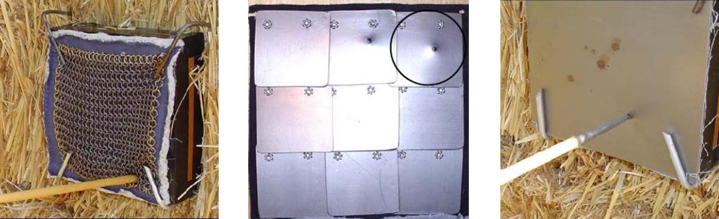
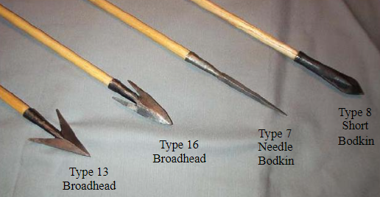
This is a thesis written by Matheus Bane in 2006 which looked at the effects of different longbow arrow head types (Figure 1) against different types of armour (Figure 2).
Figure 2 - Showing three different types of armour. Riveted chain mail, overlapping thin plate, 1.2 mm steel plate armour (left to right)
Figure 1 - Arrow head types

The results of this test showed that most armour types, aside from plate armour, failed to prevent the arrows from perforating. The needle bodkin arrow was very effective against all types of armour tested, and did manage to perforate the 1.2 mm steel plate, albeit not by much. The author’s conclusion was that most soldiers on the battlefield would have been at risk from the longbow, as the joints and gaps between plates would all still be vulnerable, being mostly of chain mail until the 16th century.
This test had a number of unknown variables and it is difficult to establish how representative it is (it doesn’t specify the material properties of the armour or arrows and a light bow was used at a short range). Although unlikely to be representative, this test does show how effective arrows can be against lower quality armour, such as chain mail.

5.2 A report of the findings of the Defence Academy War bow trials Part 1 – 2005
In 1992, Peter Jones (RARDE) established a scientific benchmark for the discussion about the effectiveness of the medieval longbow. Since then it has often been employed as the basis for those seeking to demonstrate, compare or contrast or re-evaluate the historical role played by this weapon system.
Following on from the work by Jones, a study [5] was conducted in 2005 which thoroughly investigates whether bodkin arrows can penetrate plate armour and conducts both practical and laboratory experiments. This study aimed to achieve a standard that is satisfactory to traditional archery experts, historians, blacksmiths and academics.
The conclusions of this study were that against thinner plate armour (~1 mm) which was likely to be found in many areas of a suit of armour, any of the arrow head types were capable of penetrating up to 80 mm into flesh. Against thicker plate (~2 mm) which was likely to be found on the front of the breastplate, in some cases there was some penetration of the plate, but it is unlikely to be fatal. Although this is the opinion of the author and further testing regarding how the impact affects the body would need to be conducted to confirm this. Against the thick plate (~3 mm) which was likely to be found only on the thickest parts of the breastplate and helmet, penetrations are unlikely.
Based on these conclusions, it suggests that the longbow certainly had the capability to kill. And if used at the correct range, firing a barrage of arrows at armed troops would inflict death and disruption. Based on this, you could then argue that it may indeed be the major contributing factor to victory at Agincourt.
However, not all would agree. Kelly DeVries is a Medieval Warfare historian from the Department of History, Baltimore, US. This report has his feedback and critique. Much of DeVries’ criticism seems to be aimed at the assumption that heavier bows were the norm, and he feels that the bow used in this study was too powerful. The author’s counter argument was that professional archers in the late middle ages would be capable of pulling a heavy bow of around 150 lb. This is supported by the Tudor period bows recovered from the Mary Rose which had estimated pull weights of 100–180 lb [3].
It’s worth noting that in this study the arrow heads were hardened to a greater hardness than any bodkin arrow heads recovered to date. For example, the lozenge arrow head was hardened to nearly 500 Hv, which is unlikely to be representative. They also chose to shoot at a flat sheet of armour, rather than a worked breastplate, because they argue that it would produce more consistent results. This is true but it ignores the fact that armour was fluted and curved in key areas to reduce the likelihood of penetration.

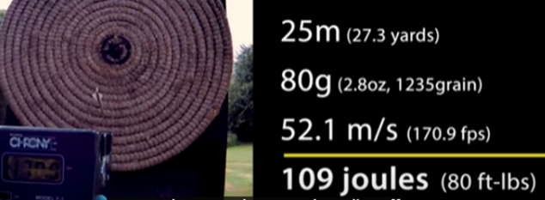
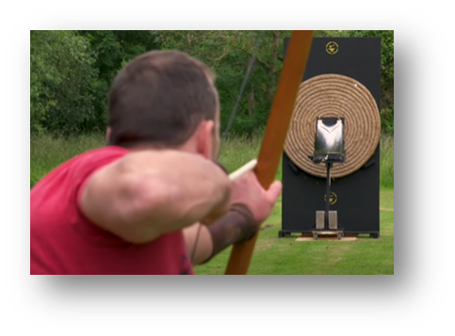
5.3 Arrows Vs Armour – Agincourt Myth Busting
Figure 3 - Arrow Velocity and Energy
Figure 4 - Archer flat shooting at 25 m

Another interesting experiment [6] was conducted by Tod’s Workshop in 2019. They aimed to answer the question ‘What did the longbows at Agincourt do to the French Knights?’ by using accurately made equipment and set up in a representative manner.

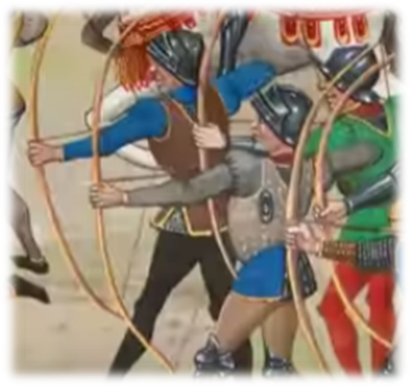
The bow was a copy of a Mary Rose bow. Its pull was 160 lb at 30inches draw weight which was deemed an average draw weight for medieval longbows. Any more and they would be difficult to use repetitively.
Figure 5 - Cartoon depiction of Longbows in use

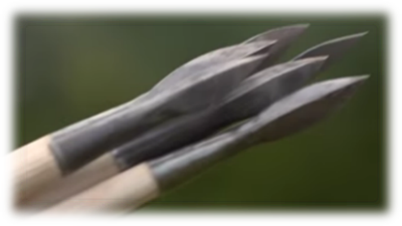
The arrows were also based on the Mary Rose arrows. The head replicates a recovered arrow head from 1403 made from wrought iron. In this experiment both case hardened heads and non-case hardened heads were compared.
Figure 6 – Image of arrows tested

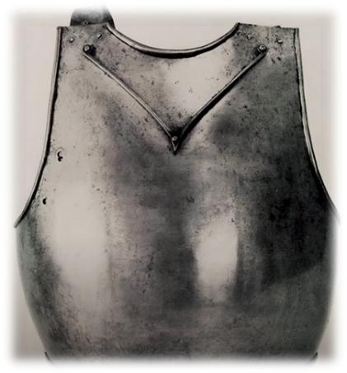
The armour was based on the Churburg 14 breastplate (Figure 7) which is dated 1390. It was manufactured to replicate the carbon content (0.5% carbon steel), weight, thickness and dimensions. It was 2.5 mm thick in centre and 1.5 mm thick on the sides and underwent the same process of normalising the steel. A big difference to other tests and studies researched was that in this case the armour was not fixed to allow for inertia.
Figure 7 - Churburg 14 breastplate

In this experiment, the arrows didn’t penetrate the armour. They either dented it slightly or ricocheted, with the hardened arrows appearing to do more damage. Figure 8 shows a snap shot of the arrow impact and ricochet. This is a case-hardened arrow.

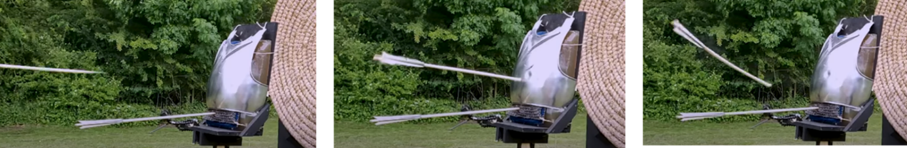
Figure 8 - Images showing arrow impacting breastplate

It’s worth saying that although those investigating this did attempt to be as representative as possible, they have chosen to shoot arrows at the centre of the breastplate, which is the strongest part of the armour.

6.0 Penetration Calculations

There are numerous penetration calculations and equations that have been developed over the years to estimate the penetrative effects of projectiles. Predominantly these equations are designed for use with large calibre munitions impacting targets at high velocities.

The following calculations use the figures for projectile weight and diameter, impact velocity and armour strength, which were given in the assignment tasking (Appendix A).

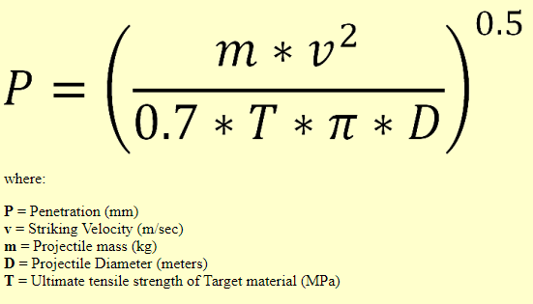
6.1 Patel-Gillingham Formula [7]

Calculate penetration against a target with an ultimate tensile strength of 500 MPa (approximate based on given yield stress of armour of 350 MPa) at a 90 deg angle:
$P=(\frac{mv2}{0.7*T*п*D})$^{0.5}
$P=(\frac{0.116*53.34*53.34}{0.7*500*п*0.1111})$^{0.5}
= 1.644 mm

Calculate penetration against a target with an ultimate tensile strength of 800 MPa (approximate based on given yield stress of armour of 600 MPa) at a 90 deg angle:
$P=(\frac{mv2}{0.7*T*п*D})$^{0.5}
$P=(\frac{0.116*53.34*53.34}{0.7*800*п*0.1111})$^{0.5}
^{= 1.299 mm}
These calculations suggest that an arrow impact against lower quality armour at 100 m range, would penetrate 1.644 mm. In this instance, only the thickest parts of armour would withstand full penetration.
Against better quality armour, such as worn by noblemen and knights, the calculation shows penetration to be 1.299 mm. This would not be enough to penetrate against the thicker armour, such as the centre of the breastplate or helmet, but the majority of the body, which is protected by thinner armour would still be at risk from injury.

6.2 German Demarre Equation [7]
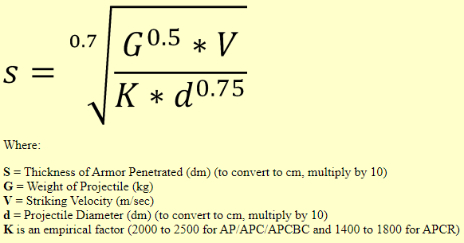

This equation can be simplified and rewritten as:
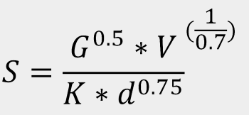

Using this formula to calculate penetration against a target with a K value of 2000 (K is a resistance constant, which represents the quality of the armour):

S = G^{0.5} * V ^{(1/0.7)}
K * d^{0.75}

S = 0.116^{0.5} * 53.34 ^{(1/0.7)}
2000 * 0.1111^{0.75}

= 1.275 mm penetration

This calculation suggests that an arrow impact at 100 m against armour would penetrate 1.275 mm. This would not be enough to penetrate against the thickest parts of armour, such as the centre of the breastplate or helmet, but the majority of the body which is protected by thinner armour would still be at risk from injury. The result of this calculation is related to the resistance constant, which in this case was chosen as 2000, but it is difficult to know what constant value would be representative due to the differences and uncertainty in both arrow and armour quality from the 15th Century.

6.3 Angle of Obliquity

The angle of impact also has a significant effect on the longbows ability to penetrate. Most studies, and the calculations found in this report assume a perpendicular strike angle. It’s worth mentioning that when the impact angle increases the ballistic limit velocity, i.e. the required velocity for penetration, also increases. As the obliquity of the arrow exceeds a critical value, less of the conical part of the arrow head impacts the target and ricochet occurs. The increase in penetration resistance as obliquity increases is also due to the increase in armour material it needs to get through. As the obliquity increases, the thickness of steel plate encountered by the arrow increases and causes an increase in total work, and therefore, the armour becomes more resistant to perforation [8].

7.0 Discussion

Based on the studies and trials looking at the penetrative power of the English longbow, it could be said that a bodkin arrow fired from a longbow would be capable of penetrating chain mail, low quality and thin plate armour, but unlikely to penetrate thicker and better quality plate armour. Having said that, there are many factors that could affect the penetrative effects.
For example, variations in bow draw weight, arrow type and arrowhead type (material, hardness, shape) will affect penetration. Some arrowheads were designed to puncture armour, while others were designed to maximize damage to the flesh but had poor armour penetration.
Variations in armour plate thickness, carbon levels, tempering and hardening and layers (mail, textile etc.) would also affect penetration.
Another factor is the angle of impact and range. Most tests assume a direct perpendicular strike. Clearly, if an arrow impacts at an angle it will decrease the amount of penetration and arrows fired over larger distances will lose their penetrative capability.
How deep is the penetration? For arrows that manage to perforate plate armour it is difficult to know how deep into flesh they go. If the arrows only manage to penetrate into flesh a couple of centimetres then vital organs may survive and the result might not be fatal (although this would still likely hamper or disable a person).
Economic and social factors are also a factor. Armour that defended very well against arrows were likely to be very expensive and worn by the minority.
Although the penetration calculations shown in this report are not designed for low velocity arrows against medieval armour, the results do reflect that which is shown in the trials and studies conducted, which is that penetration of thin plate armour is possible.

8.0 Conclusion

It is the author’s view that the English victory at Agincourt was a result of a combination of factors, some of which have been discussed. The tests and studies have shown that well-made breastplates, as worn by French knights and heavy cavalry, are difficult to penetrate, however, the author has confidence that against chain mail and poor quality armour bodkin arrows would be very effective at killing or disabling. In the right circumstances depending on angle of obliquity, range, arrow head hardness, armour thickness etc., bodkin arrows fired from a longbow can perforate plate armour.
Therefore, it is the author’s opinion that the longbow was the decisive weapon at the Battle of Agincourt, when used with the correct strategy and fired in sufficient quantities, but that it was not the major contributing factor to victory.
It’s difficult to imagine the English being able to win the battle if they didn’t have the longbow capability. Having said that, if it were not for the defensive position and terrain advantage, the English would likely have been flanked or surrounded by the larger French force and the outcome possibly very different.
It’s not possible to pin point the victory to a single reason and that must mean that multiple factors led to the French defeat.

9.0 Reference List

[1] Technical Authoring. Level 6 Assessment Specification. Task Description. APPENDIX GA36c
[2] Battle of Agincourt. https://www.worldhistory.org/Battle_of_Agincourt/
[3] Hardy. Longbow: A Social and Military History. 1 Oct. 1986. P209–217
[4] Matheus Bane. English Longbow Testing against various armor circa 1400. June 2006. https://docslib.org/doc/3991911/english-longbow-testing-against-various-armor-circa-1400
[5] Paul Bourke & David Whetham (2007) A report of the findings of the Defence Academy war bow trials Part 1 Summer 2005, Arms & Armour, 4:1, 53-81, DOI: 10.1179/174962607X177436. https://doi.org/10.1179/174962607X177436
[6] ARROWS VS ARMOUR – AGINCOURT MYTH BUSTING. August 30, 2019. https://todsworkshop.com/blogs/blog/arrows-v-s-armour-agincourt-myth-busting
[7] Armor Penetration Formulas. Created 9 July 2018. Updated 27 January 2022. https://www.alternatewars.com/BBOW/Ballistics/Term/AP/AP_Pen_Formula.htm
[8] Liaghat, Gholamhossein & Naeini, H. & Felli, S.. (2005). The mechanics of normal and oblique penetration of conical projectiles into multi layer metallic targets. Iranian journal of science and technology. transaction B, Engineering. 29. 241-251. (PDF) The mechanics of normal and oblique penetration of conical projectiles into multi layer metallic targets (researchgate.net)

Appendix A

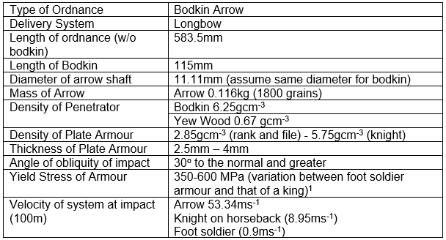

Ordnance, Munition & Explosives
Royal Armaments Research & Development Establishment
Vickers hardness number

