Equality, Diversity and Inclusion within Industry – Presentation

Student: Begum Rujina Khatun
Student ID: 2234581
Module: International Meetings Management for the Hotel Industry (BMIH6007)
Module Tutor: Christopher Wilkin
Presentation Date: 5th February 2025
Submission Date: 7th February 2025

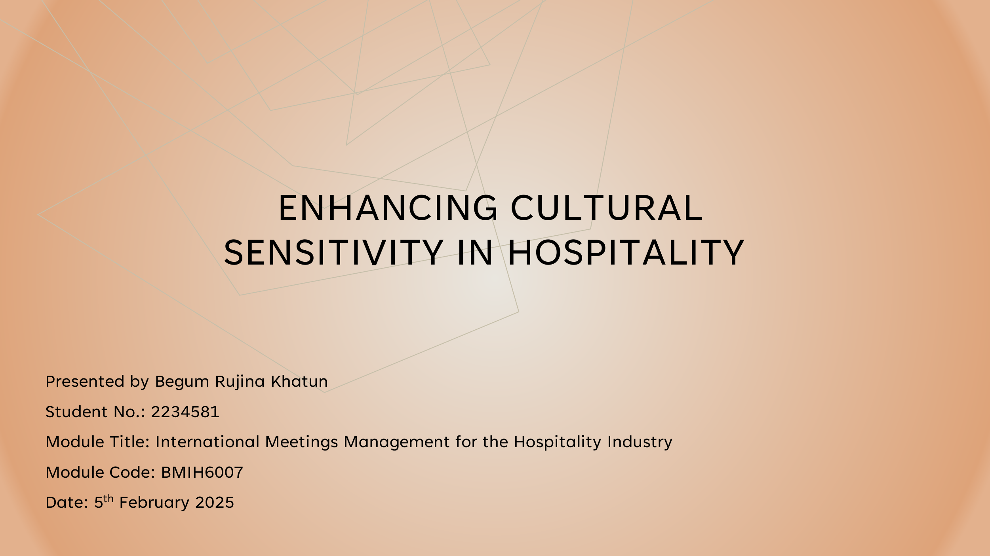

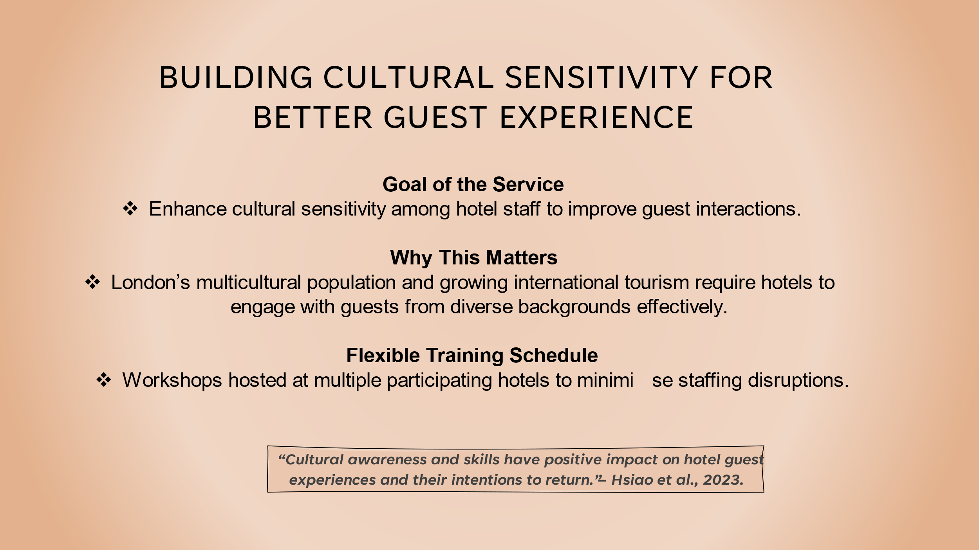

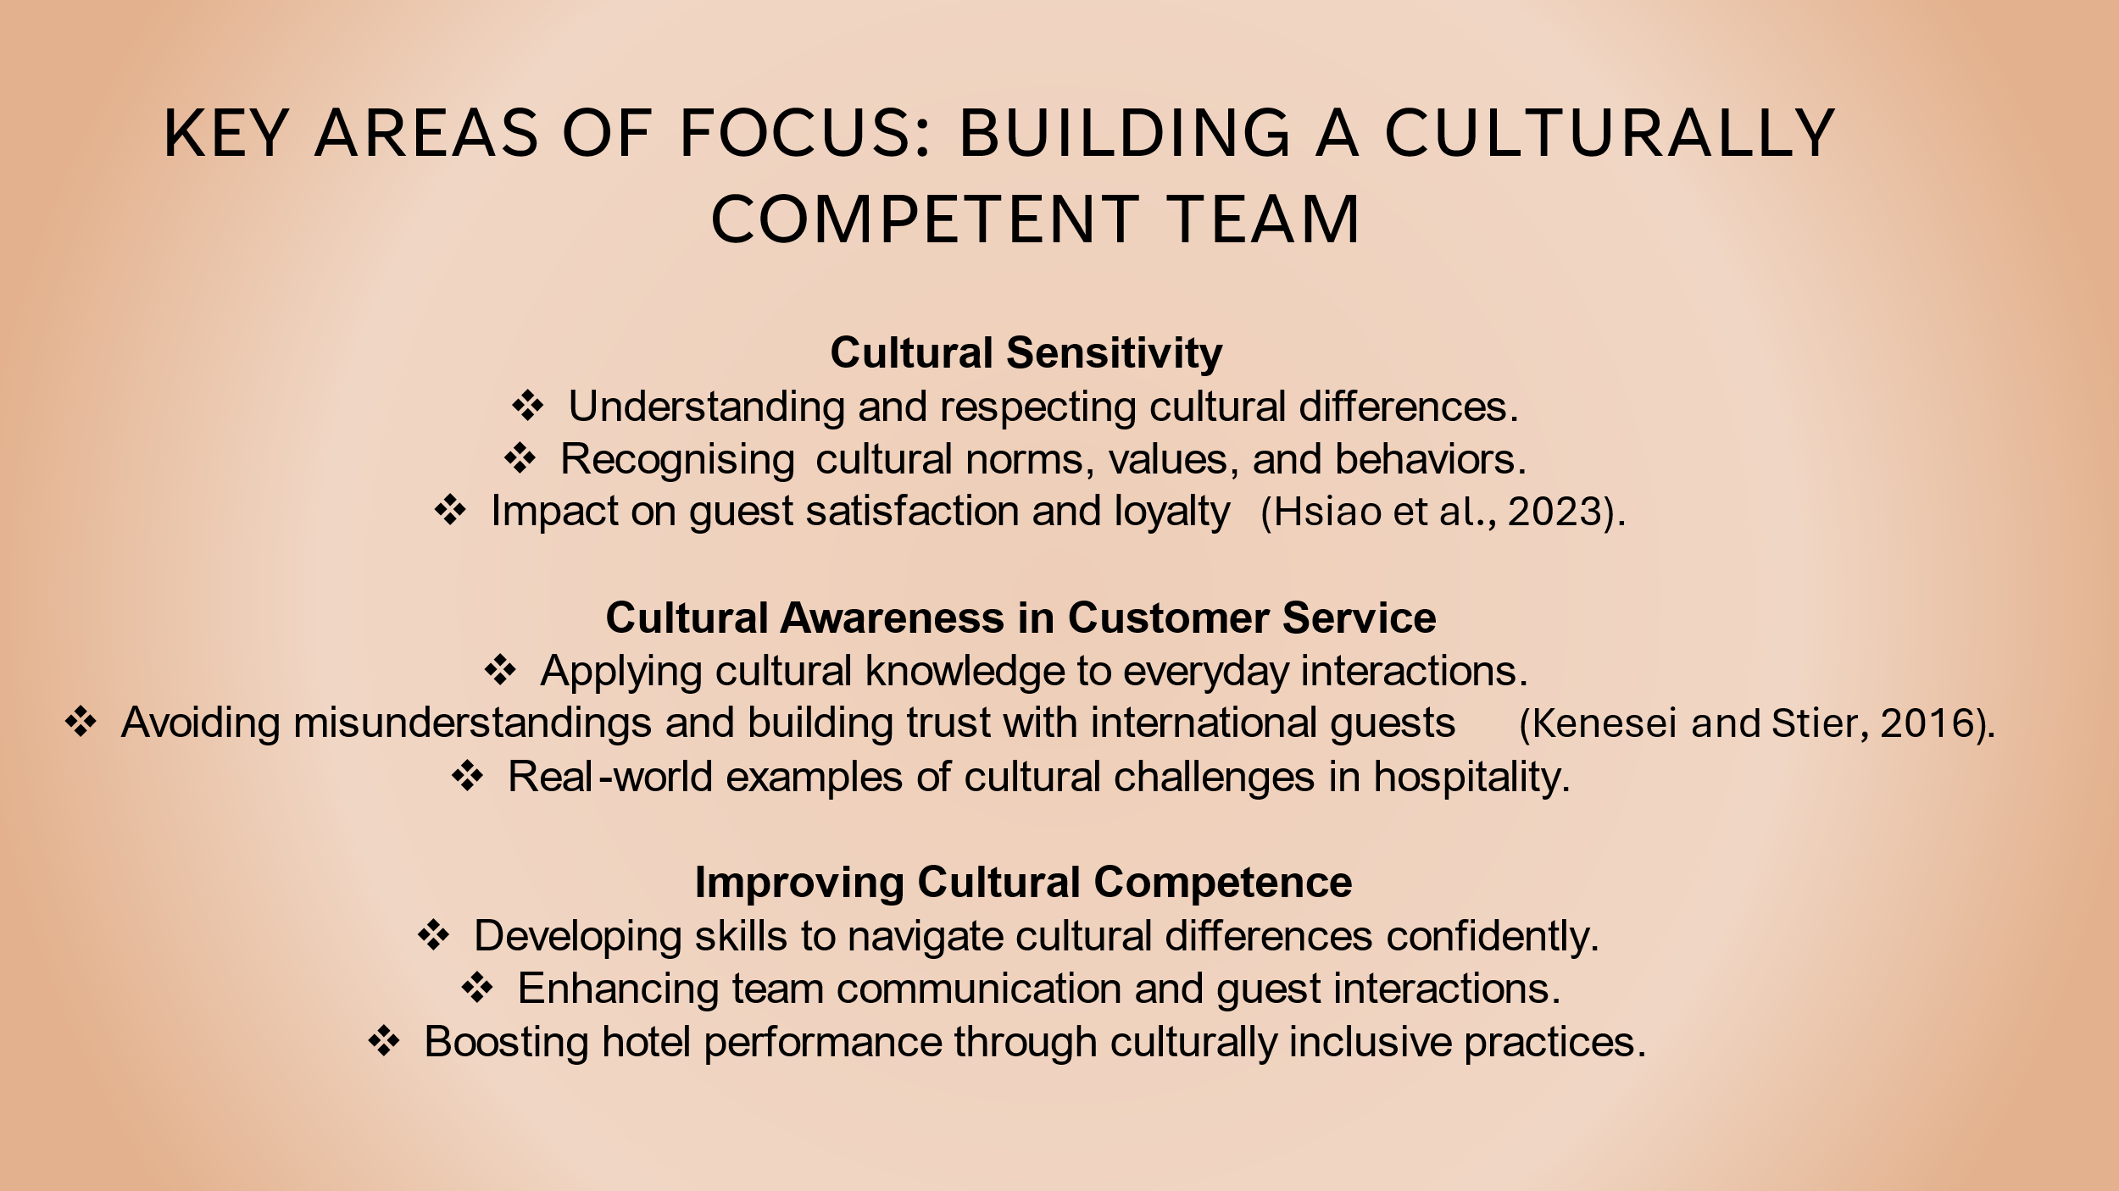

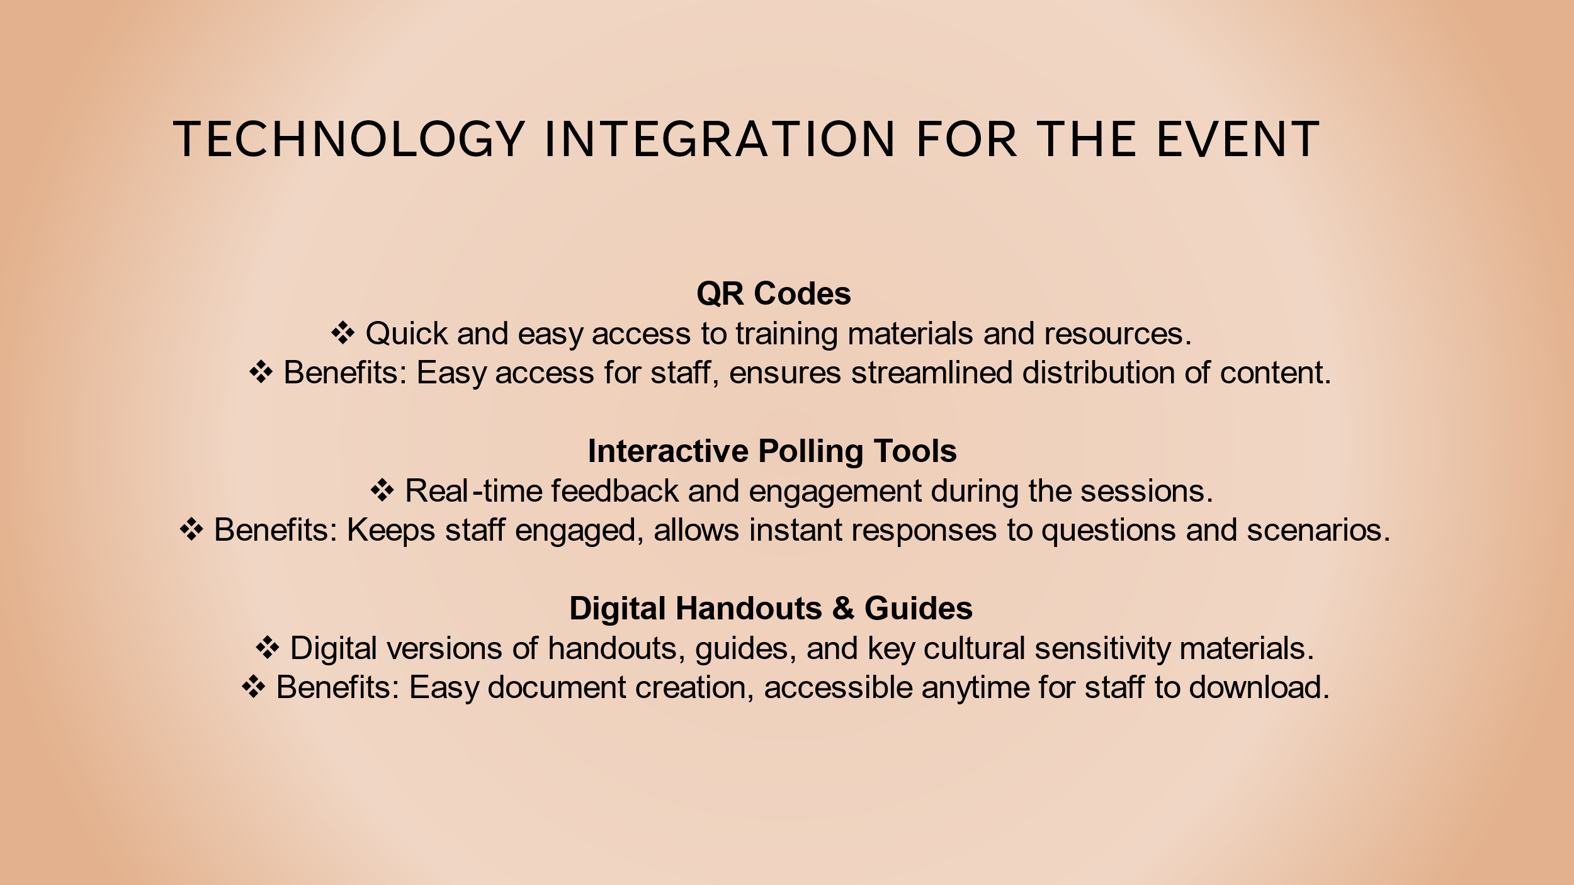

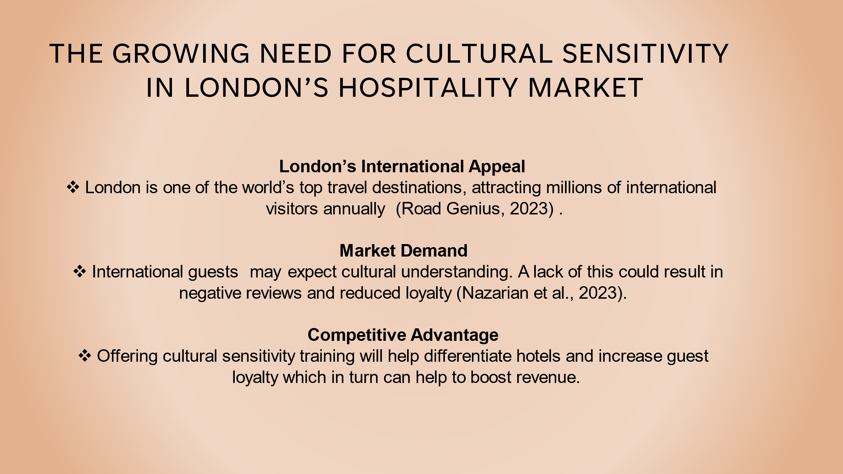

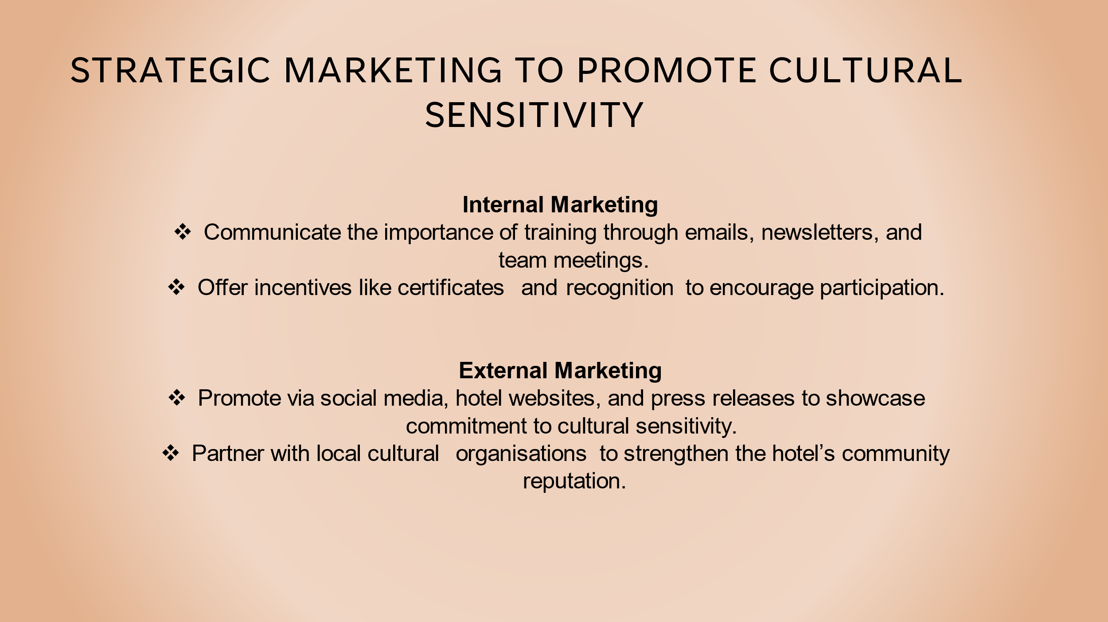

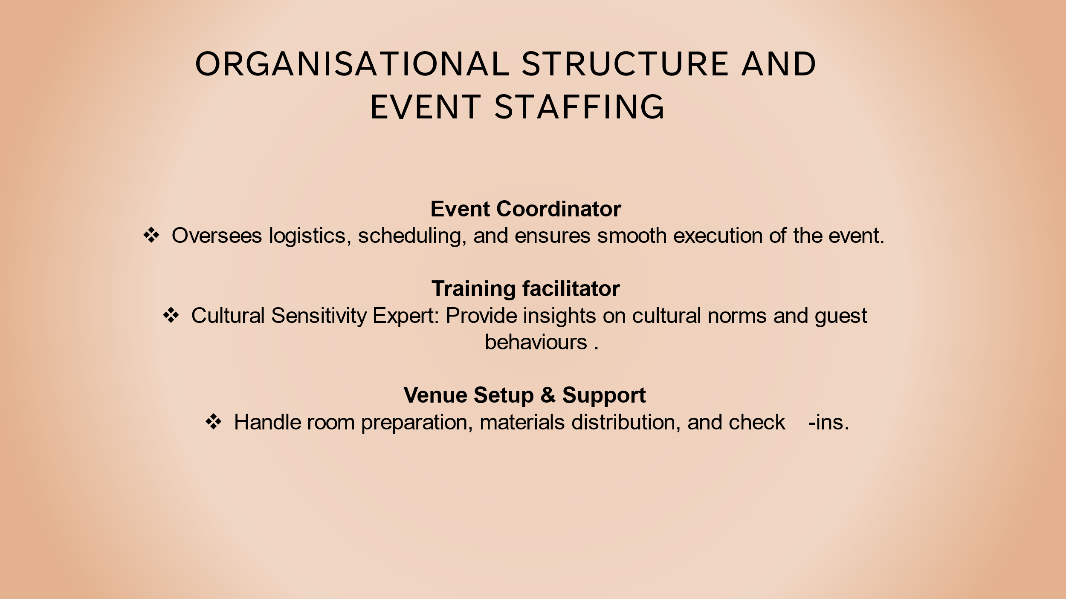

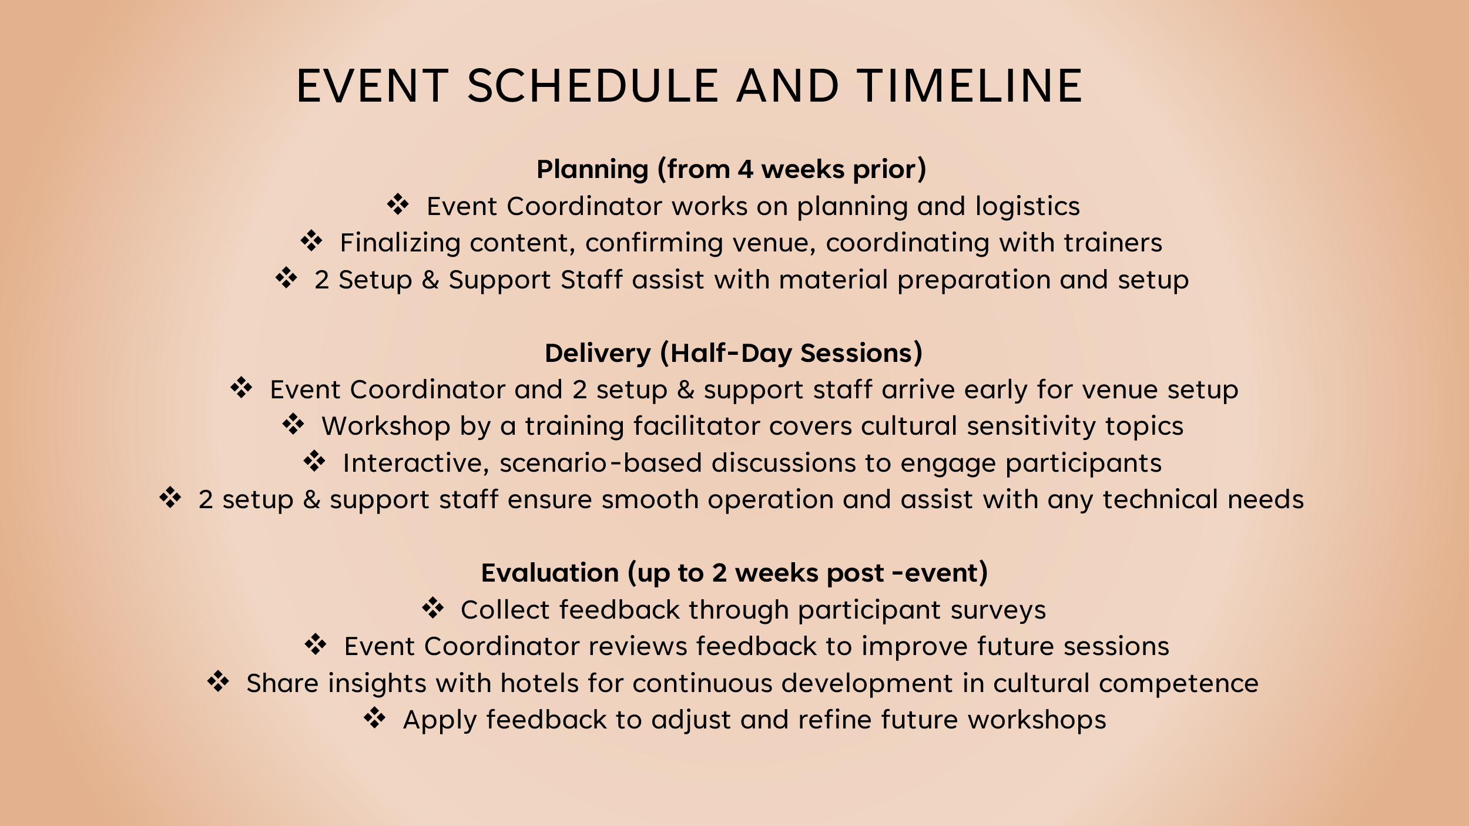

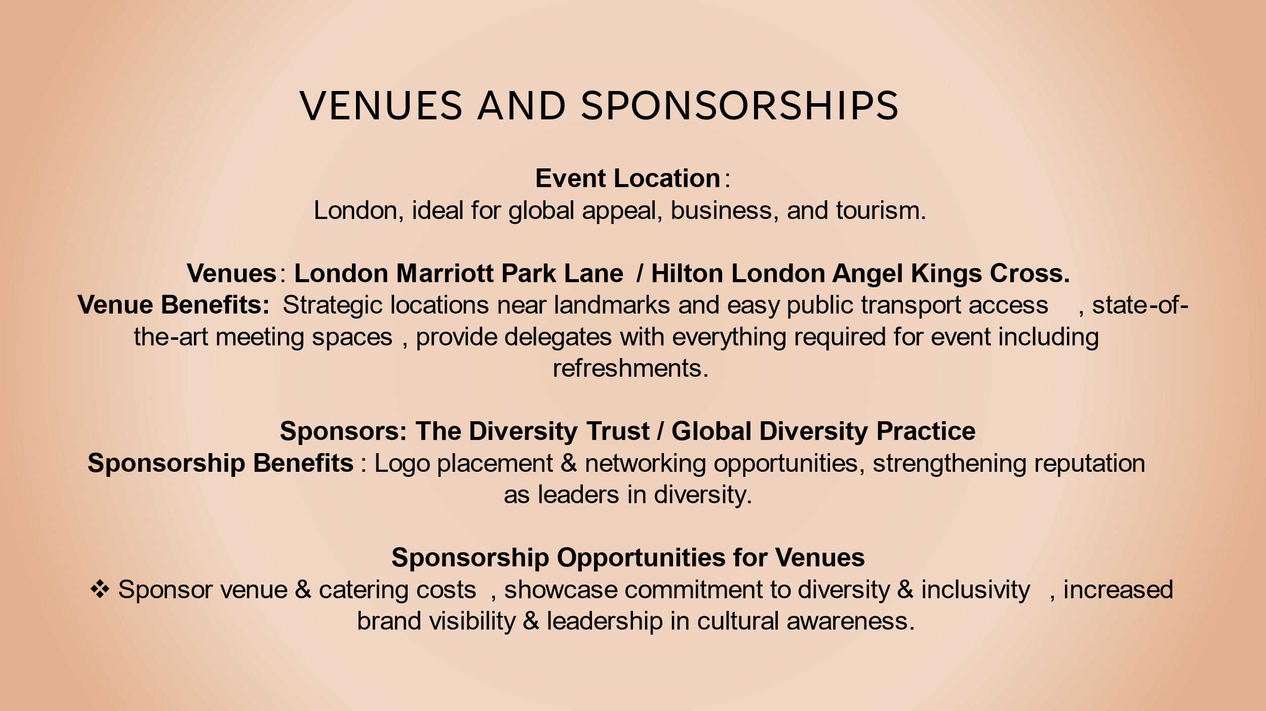

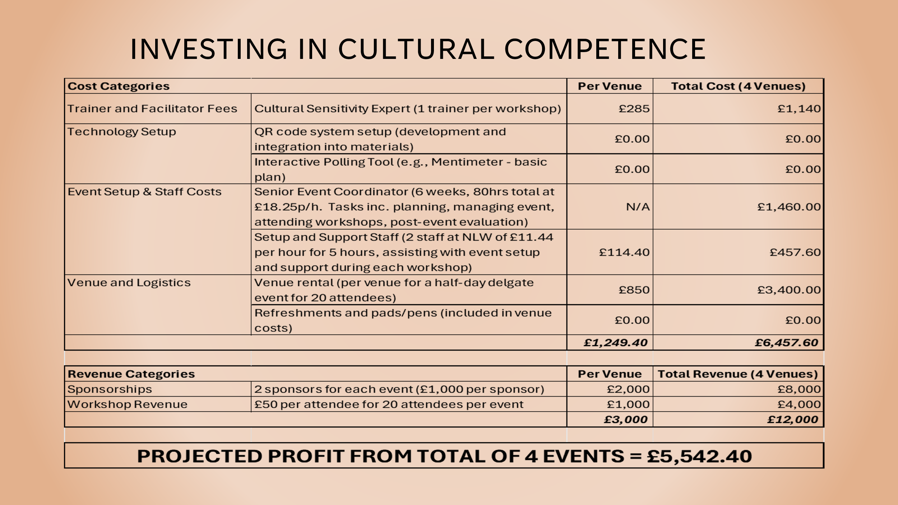
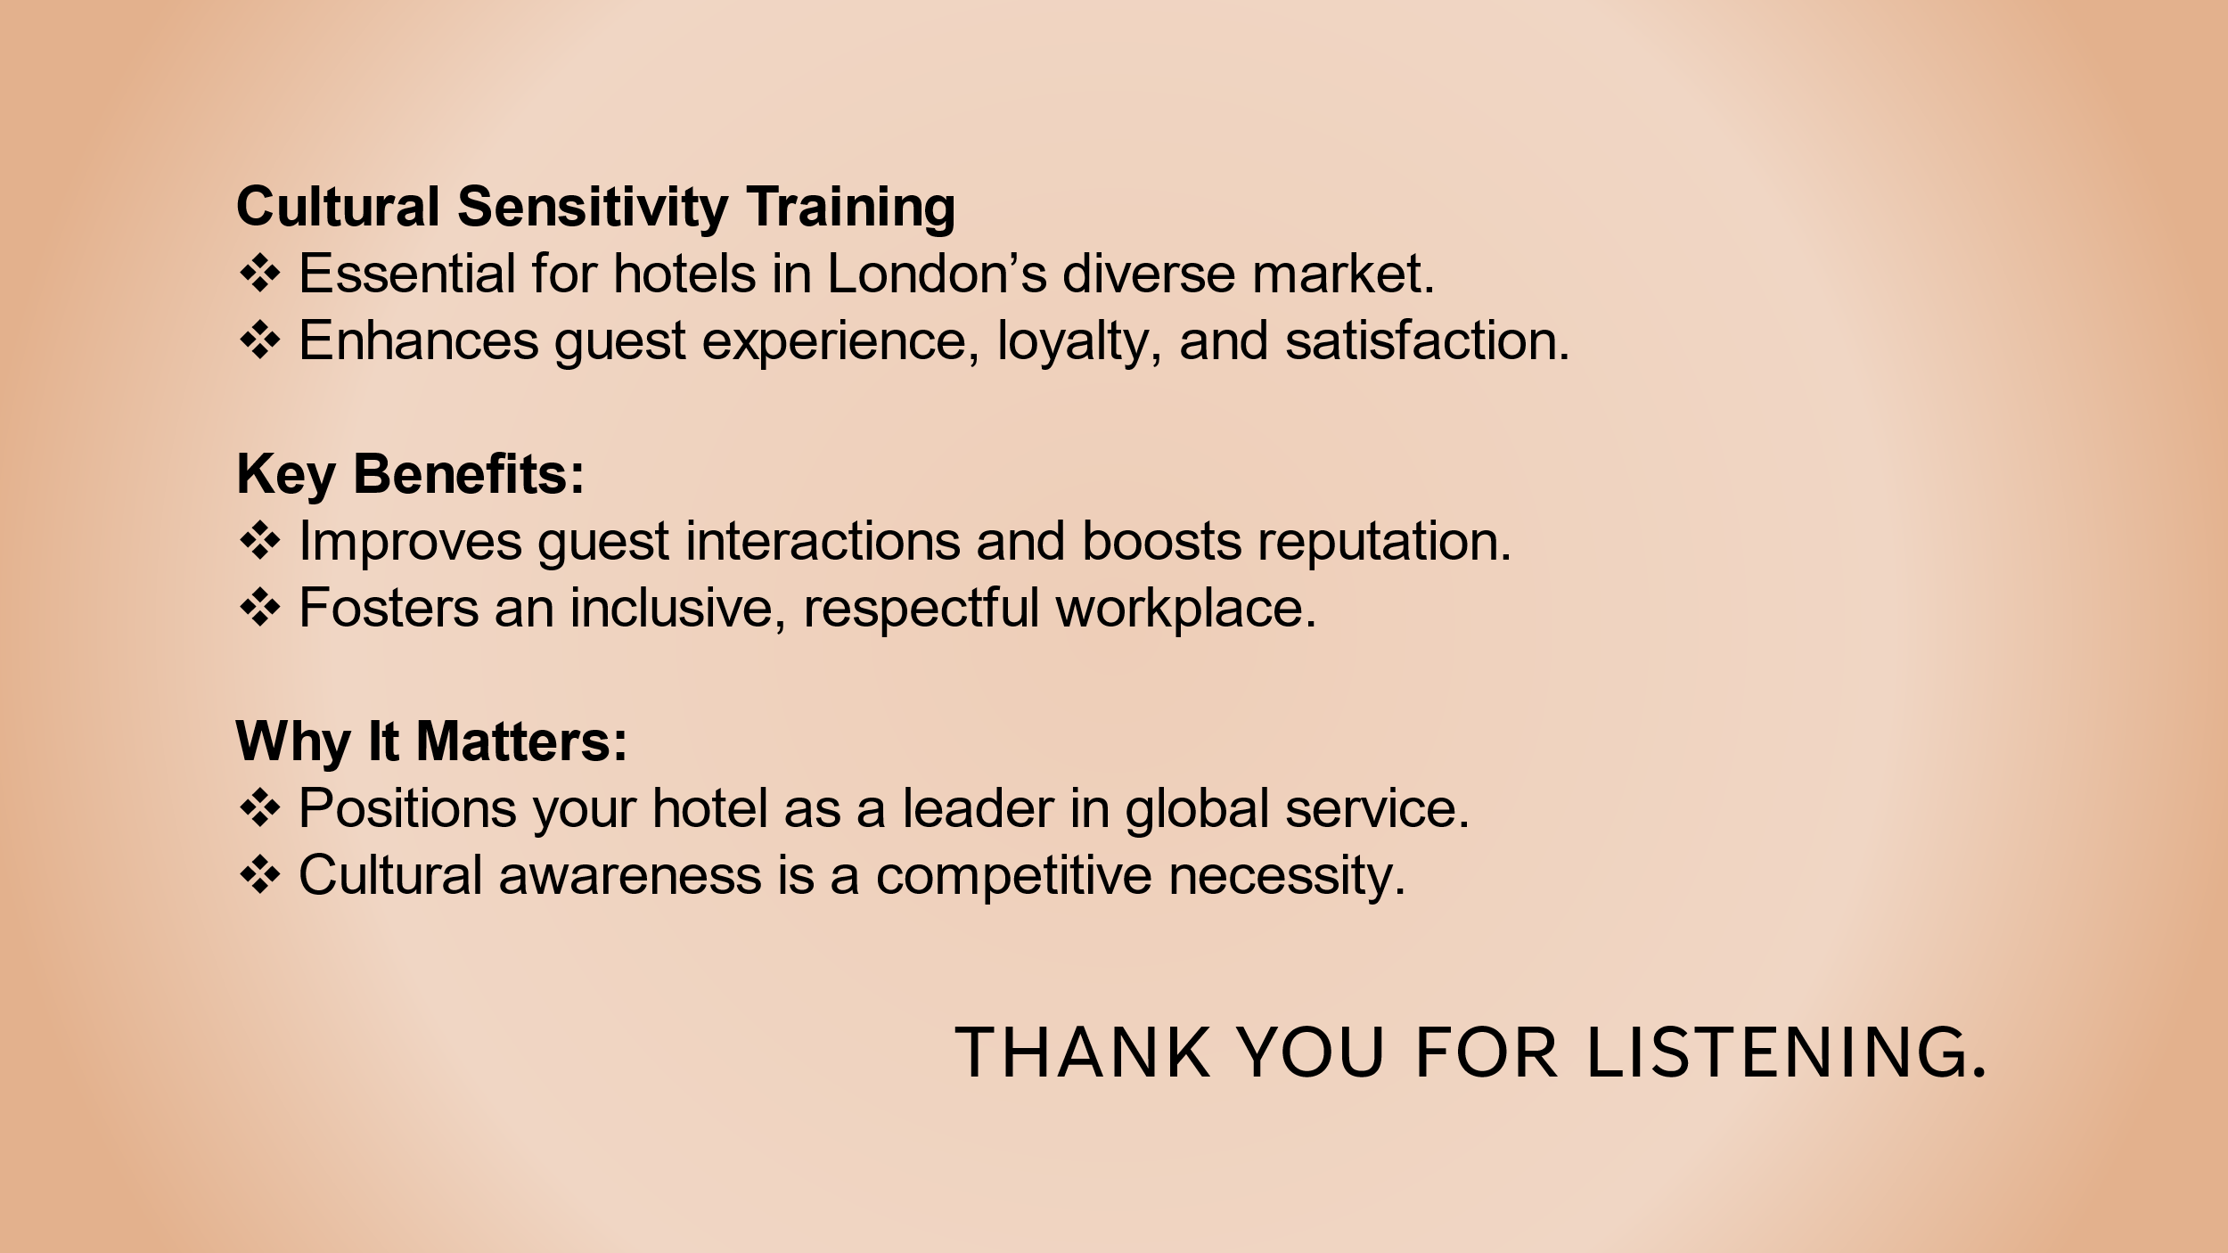

References:
Almeida, A. (2024). A Guide to Inclusive and Culturally Significant Events with InEvent. [online] InEvent Blog. Available at: https://inevent.com/blog/others/guide-inclusive-culturally-events-with-inevent.html [Accessed 27 Jan. 2025].
Ambardar, A. (2013). Cross-Cultural Training for Hotel Frontline Employees . International Journal of Hospitality and Tourism Systems, vol. 6, no. 1, pp. 66-74.
Aspire Leadership (2012). Best Equality, Diversity & Inclusion (EDI) Training Courses | Aspire Leadership, London, UK | A One (1) Day CPD Accredited EDI Training Course UK. [online] Aspire Leadership. Available at: https://www.aspire-leadership.co.uk/leadership-skills/equality-diversity-inclusion-training/?gad_source=1&gclid=EAIaIQobChMIi9SkhPyiiwMVrpFQBh3w5Rn1EAAYAyAAEgKdTfD_BwE [Accessed 1 Feb. 2025].
Battaglia, S. (2024). Diversity in hospitality: how cultural inclusivity defines the industry. [online] Glion. Available at: https://www.glion.edu/magazine/diversity-in-hospitality-how-cultural-inclusivity-defines-the-industry/ [Accessed 27 Jan. 2025].
Canva. (2021). How to generate a QR code. [online] Available at: https://www.canva.com/qr-code-generator/ [Accessed 27 Jan. 2025].
Global Diversity Practice. (2019). About Us. [online] Available at: https://globaldiversitypractice.com/about-us/ [Accessed 28 Jan. 2025].
Grobelna, A. (2015). Intercultural Challenges Facing the Hospitality Industry. Implications for Education and Hospitality Management. Journal of Intercultural Management, [online] 7(3), pp.101–117. doi:https://doi.org/10.1515/joim-2015-0023.
Hirespace.com. (2025a). DoubleTree by Hilton London Angel Kings Cross. [online] Available at: https://hirespace.com/Spaces/London/178123/DoubleTree-By-Hilton-London-Angel-Kings-Cross/Claremont-Suite/Business?position=8 [Accessed 1 Feb. 2025].
Hirespace.com. (2025b). London Marriott Park Lane. [online] Available at: https://hirespace.com/Spaces/London/135348/London-Marriott-Park-Lane/Oxford-Suite/Business?position=10 [Accessed 1 Feb. 2025].
Hou, T., Fu, S., Cao, Y., Zheng, X. and Yu, J. (Jordan) (2022). Construing travelers’ choice on peer-to-peer accommodation-sharing platform: an investigation into cultural identity and accommodation type. Journal of Electronic Business & Digital Economics. doi:https://doi.org/10.1108/jebde-09-2022-0027.
Hsiao, A., Ma, E., Manfreda, A., Baker, M. and Xu, J. (2023). A social exchange perspective on boosting customer loyalty through culturally competent servers. Journal of Hospitality Marketing & Management, [online] 32(4), pp.1–23. doi:https://doi.org/10.1080/19368623.2023.2184439.
Indeed.com. (2025). Senior event coordinator salary in London. [online] Available at: https://uk.indeed.com/career/senior-event-coordinator/salaries/London [Accessed 29 Jan. 2025].
Kenesei, Z. and Stier, Z. (2016). Managing communication and cultural barriers in intercultural service encounters. Journal of Vacation Marketing, [online] 23(4), pp.307–321. doi:https://doi.org/10.1177/1356766716676299.
Mariani, M. and Predvoditeleva, M. (2019). How do online reviewers’ cultural traits and perceived experience influence hotel online ratings? International Journal of Contemporary Hospitality Management, [online] 31(12), pp.4543–4573. doi:https://doi.org/10.1108/ijchm-11-2018-0927.
Nazarian, A., Shabankareh, M., Ranjbaran, A., Sadeghilar, N. and Atkinson, P. (2023). Determinants of Intention to Revisit in Hospitality Industry: A Cross-Cultural Study Based on Globe Project. Journal of International Consumer Marketing, [online] 36(1), pp.1–18. doi:https://doi.org/10.1080/08961530.2023.2192537.
Raghav (2024). The Nuances Of Cultural Sensitivity In Event Planning. [online] Premier Staff. Available at: https://premierstaff.com/blog/cultural-sensitivity-in-event-planning/ [Accessed 27 Jan. 2025].
Road Genius (2023). London Tourism Statistics - How Many Tourists Visit? (2023). [online] Road Genius. Available at: https://roadgenius.com/statistics/tourism/uk/london/ [Accessed 26 Jan. 2025].
Sizoo, S., Iskat, W., Plank, R. and Serrie, H. (2004). Cross-Cultural Service Encounters in the Hospitality Industry and the Effect of Intercultural Sensitivity on Employee Performance. International Journal of Hospitality & Tourism Administration, 4(2), pp.61–77. doi:https://doi.org/10.1300/j149v04n02_04.
Synergita (2023). Cultural Sensitivity Training: The Bridge Between Employee Development and Inclusive Productivity. [online] Blogs | Resources. Available at: https://www.synergita.com/blog/okr-management-software/cultural-sensitivity-training/ [Accessed 27 Jan. 2025].
Teimouri, H., Chegini, M.G., Jenab, K., Khoury, S. and LaFevor, K. (2016). Study of the relationship between employee engagement and organisational effectiveness. International Journal of Business Excellence, 10(1), p.37. doi:https://doi.org/10.1504/ijbex.2016.077617.
The Diversity Trust. (2025). Clients & Partners Archive - The Diversity Trust. [online] Available at: https://www.diversitytrust.org.uk/clients-partners/ [Accessed 29 Jan. 2025].

