Josh Jones
2501946
ASSIGNMENT 1: Html & css web development
Introduction to Web & Database Concepts (ACCA4023)
18th November 2025
Table of Contents
Introduction 2
Requirements 3
Implementation 4
Site Structure and General Design 4
Home Page 4
Schedule Page 5
Contact Page 5
Tickets (Booking) Page 5
Booking Confirmation Page 5
Validation Summary 6
HTML Validation 6
CSS Validation 6
Evaluation 8
Usability, Accessibility and SEO in Web Development 8
Evaluation of the Beats & Lights Festival Website 8
Comparison with Two Live Festival Websites 9
Usability 9
Accessibility 9
SEO 9
Mobile Friendliness 10
Conclusion 10
References 11
Appendices 12
HTML 12
CSS 23

Introduction
This report will document all the processes I’ve gone through which are design, implementation and evaluation of my website. It is a website for my fictional music festival ‘Beats & Lights Festival’ that showcases event information, schedules, contact details and simple ticket booking functionality. This first outlines the purpose, target audience and subject matter of the website and then describes the implementation of each page using HTML and CSS (Home, Schedule, Contact, Tickets booking and the ticket booking confirmation page after you complete the form) highlighting features like an embedded video player, event schedule table, contact form with an embedded Google map and a ticket booking form. The report also includes validation results from W3C tools, highlighting any errors identified, if any, and how these were corrected. Also, the website is assessed in terms of usability, accessibility and SEO, supported by academic research and there is also a comparison made with two live websites to determine strengths and areas for improvement. The report then concludes with recommendations and includes full HTML + CSS code listings in the appendices.

Requirements
The website serves as both an information source and an interactive space for the multi-genre Beats & Lights Festival. Its main goal is to share important festival details, including dates, schedule, location, and contact information; users can also book tickets online through an easy and straightforward form.
The site targets music fans who want to attend the festival, people looking up performance times and searching for venue details and those who wish to buy tickets. Organizers, partners and local community members may also use the site to check information about the event.
The website focuses on the festival theme and introduces the event with a welcoming tone that shows its slogan which is “made by you, for you.” It shows the festival dates, an overview and a friendly message that encourages visitors to look at all the differents performances that will be happening. The content is made to be clear, engaging and suitable for a big audience.
To achieve this goal, the site must:
- Provide clear and current festival information like what is it, when is it, where is it, etc.
- Allow easy navigation between main sections like Home, Schedule, Contact and Tickets.
- Allow people to be able to contact organizers and book tickets.
- Show all information in a visually appealing and professional manner that matches the style and energy of this particular music festival.

Implementation

Site Structure and General Design
The Beats & Lights Festival website is a multi-page HTML/CSS site containing a Home page, Schedule, Contact, Tickets (Booking) and Booking Confirmation page. Each page uses the same layout structure: a header with the festival logo, a navigation bar, and a footer. This consistency helps users move between pages easily.
The website uses simple and readable typography and a dark blue / light blue / black colour scheme creating a modern and vibrant festival style. The site also includes a meta viewport tag and several percentage-based widths which means it can scale reasonably well on smaller screens (although there is no dedicated mobile menu).
A glassmorphic effect is applied to the booking form using CSS backdrop filters which gives it that glass look like the brand-new ‘Liquid Glass’ iOS look. The form also has a fade-in animation for a more polished user experience.
Below is a simplified description of each page.

Home Page
The Home page introduces the festival with a large heading, short welcome text and the festival dates. The festival logo and navigation bar appear at the top. A key feature is the embedded MP4 video, displayed using an <iframe>.
The embedded video make the page visually engaging while still staying simple and quick to load.

Schedule Page
This page shows the timetable of artists and performance times using a structured HTML table. It includes a title (“B&L Festival Schedule”) and a clear three-column layout: Date, Time, Performer.
The table includes styling such as a navy header row, alternating row colours, and a hover effect to improve readability.

Contact Page
The Contact page provides ways for users to reach the organisers. It includes:
- Social media links (Instagram, Twitter, Facebook)
- A mailto email link
- A Google Maps embed showing the festival location
- The full address written underneath the map
The page uses clear headings and sectioning tags (<section>, <main>) which help the structure and accessibility.

Tickets (Booking) Page
This page contains an interactive HTML form where users can:
- Enter their name and email
- Select a festival day
- Choose number of tickets
- Choose type of ticket (Standard, VIP, Backstage)
All fields use HTML5 validation (e.g., required fields, email format check, number limits). When submitted, the form sends the user to the confirmation page which doesn’t use a database as this website only needed HTML + CSS.
The page features the glass-style transparent form created with CSS filters.

Booking Confirmation Page
This page thanks the user for their booking and shows a booking reference number. It also tells the user that a confirmation email has been sent and directs them to the Contact page if they need support. The page is simple and completes the user journey from browsing → booking → confirmation.

Validation Summary

HTML Validation
Using the W3C HTML validator, the following issues were found:
- Incorrect tag nesting in the navigation section
(a <div> was closed outside the <nav>).
- Missing lang="en" attribute on <html> tag.
- Obsolete frameborder attribute on the video <iframe>.
All of these were corrected by moving/verifying closing tags and adding a language attribute.
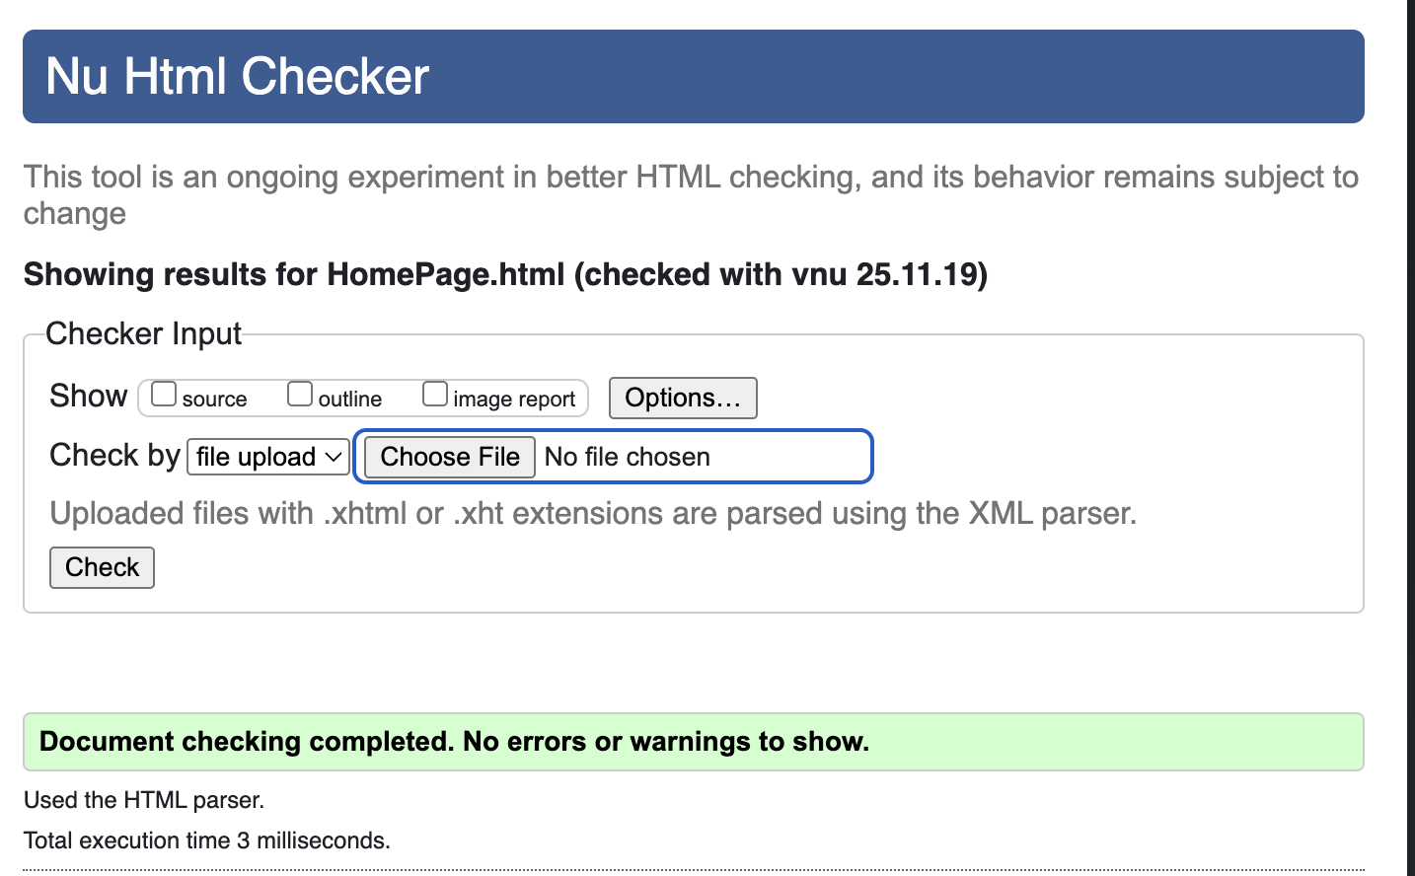

CSS Validation
The CSS validated correctly with no errors or warnings.
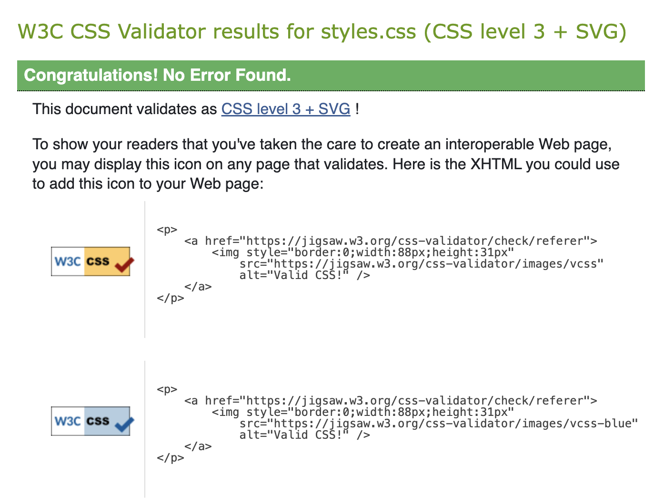

Rewrite – no HMIZE but needs changing etc etc
Validation needs to only include home page and main css

Evaluation

Usability, Accessibility and SEO in Web Development
Usability, accessibility, and SEO are the three key factors to get effective web development. Usability looks at how easily people can reach their goals on a website as it relies on clear navigation, reasonable structure and of course readable content. A study in the UK of 66 university websites found that the most common problems were “contrast errors and the need to increase the computability of webpages with future technologies and tools.” This shows that good usability depends on clear and well-structured information and not just technical performance. [3]
Accessibility makes sure that people with visual, motor, hearing, or cognitive impairments can use websites. WCAG 2.1 organizes its guidance into four principles: perceivable, operable, understandable, and robust. A UK Government accessibility monitoring report from 2022 to 2024 revealed that almost all public sector websites tested had accessibility issues, although “55.3% were fixed by the public sector organisations during the monitoring.” [1] so this highlights the need for regular checks. Another UK study focusing on health websites for elderly beginners found “most of the participants rated font size, and low contrast between background and font colour, as the most significant accessibility issue.” [2]
SEO helps websites show up in search results. Key techniques include unique titles, headings, meta descriptions, alt text and semantic HTML. These techniques also support accessibility because descriptive markup helps both screen readers and search engines understand content.
Together, these principles make sure a site is easy to find, easy to use, and inclusive.

Evaluation of the Beats & Lights Festival Website
The Beats & Lights Festival website has five pages with a consistent header, navigation bar and footer. Usability is strong due to clear page structure, readable text and simple navigation. People can easily find festival dates, view the schedule, access contact details and even book tickets. The glass-style booking form is visually appealing yet readable and HTML5 validation boosts form reliability.
The site covers all important tasks, but it could be better by adding a homepage link to the logo, explaining VIP/Backstage ticket options, and including an FAQ section.
SEO is somewhat handled through meaningful headings and festival-related keywords. However, all pages use the same <title> tag and lack meta descriptions so adding unique titles, descriptive meta tags and improved alt text would help increase visibility on search engines.
Accessibility is mostly good with there being semantic HTML, labelled form fields and text alternatives for key content. Improvements could include adding lang="en", checking colour contrast on hover, providing more descriptive alt text, and adding a “skip to content” link. These changes directly tackle issues commonly found in UK studies [2].

Comparison with Two Live Festival Websites
I looked at two well-known festival sites which are Glastonbury Festival and Reading Festival to compare how they work.

Usability
Glastonbury’s homepage is packed with news, historical content and lots of menus. While this complexity will work with dedicated fans, first-time visitors will feel overwhelmed. Reading Festival has a cleaner layout with fewer content blocks and a streamlined navigation bar (Line up, Tickets, Essentials), leading to a more focused user journey. Beats & Lights aligns more closely with Reading’s approach: simple, task-oriented, and easy to navigate.

Accessibility
Testing with WAVE shows that both sites have minor errors like Glastonbury lacks alt text and repeats link labels where Reading comes up with less issues because of their simpler pages and higher contrast on pages that help lower these barriers. In comparison, Beats & Lights already meets many accessibility basics like semantic structure and labelled forms but like Reading, it could improve by adding skip links and refining alt text. These work with the report that “font size, and low contrast between background and font colour” as the most important issue within accessibility where Reading has followed this closely. [2]

SEO
Both Glastonbury and Reading have rock-solid SEO but Reading benefits from cleaner URLs and concise meta descriptions. With Glastonbury having lots of content and a good link ecosystem that give it a strong reputation online but smaller festivals like Beats & Lights can follow Reading’s clear titles and headings to get better search visibility.

Mobile Friendliness
Reading Festival offers a single-column mobile layout with large buttons and not a lot of banners where Glastonbury’s heavier pages need more scrolling and bandwidth. Beats & Lights with its lightweight pages and responsive design works similarly to Reading by adapting well to smaller screens.

Conclusion
Reading Festival serves as a closer benchmark for the Beats & Lights site because it shows that a small task-focused festival website can stay functional for everyone including those with additional needs and SEO-friendly without overwhelming people. Where Glastonbury shows the compromise between detailed content and simplicity and even though large festivals might need more information, clarity should not be sacrificed for maximum simplicity for people.

References
[1]
UK Government Digital Service, “Accessibility monitoring of public sector websites and mobile apps from 2022 to 2024.” Dec. 17, 2024. [Online]. Available: https://www.gov.uk/government/publications/accessibility-monitoring-of-public-sector-websites-and-mobile-apps-from-2022-to-2024/accessibility-monitoring-of-public-sector-websites-and-mobile-apps-from-2022-to-2024
[2]
A. Good, S. Stokes, and J. Jerrams-Smith, “An investigation into the usability & accessibility of UK health information Web sites,” vol. 21, no. 3, pp. 72–79, 2007, [Online]. Available: https://researchportal.port.ac.uk/en/publications/an-investigation-into-the-usability-amp-accessibility-of-uk-healt/
[3]
A. Sophia, “Web Accessibility of the Top Research-Intensive Universities in the UK,” vol. 11, no. 4, 2021, doi: 10.1177/21582440211056614.

Appendices

HTML

<!DOCTYPE html>
<html lang="en">
<head>
<meta charset="UTF-8">
<meta name="viewport" content="width=device-width, initial-scale=1.0">
<title>Beats & Lights Festival</title>
<link rel="stylesheet" href="styles.css">
<link rel="icon" type="image/x-icon" href="assets/logo.png">

</head>
<body>

<header id="main-header">
<div class="container">
<img src="assets/logo.png" width="100" height="100" alt="Logo">
</div>
</header>
<nav id="navbar">
<ul>
<li><a href="HomePage.html">Home</a></li>
<li><a href="Schedule.html">Schedule</a></li>
<li><a href="contacts.html">Contact</a></li>
<li><a href="book.html">Tickets</a></li>
</ul>
</nav>
<div class="bg-container">
<div class="bg"></div>
<div class="bg"></div>
</div>

<h1>Welcome to the Beats & Lights Festival 2025</h1>
<p>We are a music festival made by you, for you. We have a range of different genres that will be playing throughout the event.</p>
<p>The festival goes from 16th October 2026 to the 18th October 2026. </p>
<p>A festival here to celebrate the community, music, arts and culture. We hope to see you enjoying all the different acts here.</p>
<iframe width="560" height="315" src="assets/festivalvid.mp4" title="video player"></iframe>

<footer id="main-footer">
<p> Copyright &copy; 2025 Beats & Lights Festival </p>
</footer>

</body>
</html>

<!DOCTYPE html>
<html lang="en">
<head>
<meta charset="UTF-8">
<meta name="viewport" content="width=device-width, initial-scale=1.0">
<title>Beats & Lights Festival</title>
<link rel="stylesheet" href="styles.css">
</head>

<header>
<div class="logo">
<img src="assets/logo.png" width="100" height="100" alt="Logo">
</div>
</header>
<nav id="navbar">
<div class="container"> <ul>
<li><a href="HomePage.html">Home</a></li>
<li><a href="Schedule.html">Schedule</a></li>
<li><a href="contacts.html">Contact</a></li>
<li><a href="book.html">Tickets</a></li>
</ul>
</nav>
</div>
<body>
<h1 style="color: black; text-align: left;">B&L Festival Schedule</h1>
<table border="1">
<!-- Table header -->
<thead>
<tr>
<th>Date</th>
<th>Time</th>
<th>Performer</th>
</tr>
<!-- Table body -->
<tbody>
<tr>
<td>Friday 10th</td>
<td>10:20 am</td>
<td>Becky Hill</td>
</tr>
<tr>
<td>Friday 10th</td>
<td>4:50 pm</td>
<td>Olivia Dean</td>
</tr>
<tr>
<td>Friday 10th</td>
<td>8:10 pm</td>
<td>Fred again..</td>
</tr>
<tr>
<td>Saturday 11th</td>
<td>11:40 am</td>
<td>Myles Smith</td>
</tr>
<tr>
<td>Saturday 11th</td>
<td>6:35 pm</td>
<td>Tate McRae</td>
</tr>
<tr>
<td>Saturday 11th</td>
<td>10:10 pm</td>
<td>Jamie xx</td>
</tr>
</tbody>
</thead>
</table>
</body>

<footer id="main-footer">
<p> Copyright &copy; 2025 Beats & Lights Festival </p>
</footer>

</body>
</html>

<!DOCTYPE html>
<html lang="en">
<head>
<meta charset="UTF-8">
<meta name="viewport" content="width=device-width, initial-scale=1.0">
<title>Beats & Lights Festival</title>
<link rel="stylesheet" href="styles.css">
</head>
<body>

<header id="main-header">
<div class="container">
<img src="assets/logo.png" width="100" height="100" alt="Logo">
</div>
</header>
<nav id="navbar">
<div class="container"> <ul>
<li><a href="HomePage.html">Home</a></li> |
<li><a href="Schedule.html">Schedule</a></li> |
<li><a href="contacts.html">Contact</a></li> |
<li><a href="book.html">Tickets</a></li>
</ul>
</nav>
</div>

<h1>Contact Beats & Lights</h1>
<section>
<p>We are a music festival made by you, for you.</p>
<p>If you would like to contact us please use the following options: </p>
<a href="https://www.instagram.com/inittogetherfestival" target="_blank">Instagram</a> |
<a href="https://www.instagram.com/inittogetherfestival" target="_blank">Twitter</a> |
<a href="https://www.facebook.com/inittogetherfestival">Facebook</a>
<p>Or email us at
<a href="mailto:hi@beatslightsfestival.com">hi@beatslightsfestival.com</a>
</p>
</section>

<section>
<h1>Where are we located?</h1>
<iframe src="https://www.google.com/maps/embed?pb=!1m18!1m12!1m3!1d9923.310068759907!2d-3.7302299712935434!3d51.553061728144556!2m3!1f0!2f0!3f0!3m2!1i1024!2i768!4f13.1!3m3!1m2!1s0x486e66103fc170ff%3A0xc960a6ab6e191771!2sOld%20Park%20Rd%2C%20Port%20Talbot!5e0!3m2!1sen!2suk!4v1759999000971!5m2!1sen!2suk" width="600" height="450" style="border:0;" allowfullscreen="" loading="lazy" referrerpolicy="no-referrer-when-downgrade"></iframe>
<p>We are located at</p>
<p>Old Park Road, <br>
Margam <br>
Port Talbot <br>
SA13 2TG </p>
</section>

<footer id="main-footer">
<p> Copyright &copy; 2025 Beats & Lights Festival </p>
</footer>

</body>
</html>

<!DOCTYPE html>
<html lang=”en”>
<head>
<meta charset="UTF-8">
<meta name="viewport" content="width=device-width, initial-scale=1.0">
<title>Beats & Lights Festival</title>
<link rel="stylesheet" href="styles.css">
<link rel="icon" type="image/x-icon" href="assets/logo.png">

</head>
<body>

<header id="main-header">
<div class="container">
<img src="assets/logo.png" width="100" height="100" alt="Logo">
</div>
</header>
<nav id="navbar">
<div class="links"> <ul>
<li><a href="HomePage.html">Home</a></li>
<li><a href="Schedule.html">Schedule</a></li>
<li><a href="contacts.html">Contact</a></li>
<li><a href="book.html">Tickets</a></li>
</ul>
</nav>
</div>
<div class="bg-container">
<div class="bg"></div>
<div class="bg"></div>
</div>

<h1>Thanks for booking your tickets!</h1>
<p> Your booking reference is #BL732473</p>
<p>Confirmation of your booking will be sent to your email.</p>
<p>If you need support with your tickets or anything else, please contact us by using our contact page.</p>

<footer id="main-footer">
<p> Copyright &copy; 2025 Beats & Lights Festival </p>
</footer>

</body>
</html>

<!DOCTYPE html>
<html lang=”en”>
<head>
<meta charset="UTF-8">
<meta name="viewport" content="width=device-width, initial-scale=1.0">
<title>Beats & Lights Festival</title>
<link rel="stylesheet" href="styles.css">
<link rel="icon" type="image/x-icon" href="assets/logo.png">

</head>
<body>

<header id="main-header">
<div class="container">
<img src="assets/logo.png" width="100" height="100" alt="Logo">
</div>
</header>
<nav id="navbar">
<div class="container"> <ul>
<li><a href="HomePage.html">Home</a></li>
<li><a href="Schedule.html">Schedule</a></li>
<li><a href="contacts.html">Contact</a></li>
<li><a href="book.html">Tickets</a></li>
</ul>
</nav>
</div>
<div class="bg-container">
<div class="bg"></div>
<div class="bg"></div>
</div>

<!-- Form code -->
<div class="container">
<h1>Book Tickets</h1>
<form action="completebooking.html" method="POST">
<label for="name">Full Name</label>
<input type="text" id="name" name="name" placeholder="Enter your full name" required />

<label for="email">Email</label>
<input type="email" id="email" name="email" placeholder="Enter your email" required />

<label for="date">Select Festival Day</label>
<select id="date" name="date" required>
<option value="">-- Choose a Day --</option>
<option value="day1">Day 1 - Friday, October 16</option>
<option value="day2">Day 2 - Saturday, October 17</option>
<option value="day3">Day 3 - Sunday, October 18</option>
</select>

<label for="tickets">Number of Tickets</label>
<input type="number" id="tickets" name="tickets" min="1" max="10" required />

<label for="type">Ticket Type</label>
<select id="type" name="type" required>
<option value="standard">Standard - £60</option>
<option value="vip">VIP - £120</option>
<option value="backstage">Backstage - £250</option>
</select>

<button type="submit">Book Tickets</button>
</form>

<footer id="main-footer">
<p> Copyright &copy; 2025 Beats & Lights Festival </p>
</footer>

</div>
</body>
</html>

CSS
@import url('https://fonts.googleapis.com/css2?family=Montserrat:ital,wght@0,100..900;1,100..900&display=swap');

p {
font-size: 18px;
font-family: "Montserrat";
}

h1 {
font-weight: 600;
}
body {
margin: 0;
height: 100%;
display: flex;
flex-direction: column;
background-color: #6E8CFB;
background-size: auto 100%; /* maintain natural width */
font-family: sans-serif;
}
header {
background-color: #50589C;
padding: 0;
text-align: center;
}

#navbar{
color: #000;
text-align: center;

}

#navbar ul{
padding: 10px;
list-style:none;
}
#navbar li{
display:inline;
}
#navbar a{
font-size:18px;
padding-right:25px;
color: black;
}
#navbar a:hover{
color:white;
}

table {
width: 80%;
margin: 20px auto;
border-collapse: collapse;
font-family: Arial, sans-serif;
text-align: left;
color: black;
background-color:#6E8CFB;
}

th, td {
padding: 10px 15px;
border-bottom: 1px solid #ddd;
}

thead {
background-color: navy;
color: white;
}

tr:nth-child(even) {
background-color: lightblue;
}

tr:hover {
background-color: #eaf3ff;
}

strong {
font-weight: 800;
}

/* Contact Form – Apple Liquid Glass style */
form {
background: rgba(255, 255, 255, 0.08); /* a more softer and subtle transparency */
backdrop-filter: blur(25px) saturate(180%) brightness(0.9);
-webkit-backdrop-filter: blur(25px) saturate(180%) brightness(0.9);
border-radius: 20px;
padding: 40px;
max-width: 1000px;
width: 100%;
border: 1px solid rgba(255, 255, 255, 0.25);
box-shadow:
0 8px 30px rgba(0, 0, 0, 0.25),
inset 0 0 0.5px rgba(255, 255, 255, 0.4);
color: #fff;
animation: fadeIn 0.8s ease;

}

/* Labels */
label {
display: block;
font-weight: 500;
margin-bottom: 6px;
margin-top: 15px;
font-size: 0.9em;
color: rgba(0, 0, 0, 0.9);
font-family: 'Montserrat';
font-weight: 700;

}

/* Inputs + selects + textarea */
input,
select,
textarea {
width: 100%;
padding: 12px;
border-radius: 12px;
border: 1px solid rgba(255, 255, 255, 0.25);
font-size: 15px;
background: rgba(255, 255, 255, 0.08);
color: black;
transition: all 0.3s ease;
outline: none;
resize: vertical;
}

input::placeholder,
textarea::placeholder {
color: rgb(0, 0, 0);
}

input:focus,
select:focus,
textarea:focus {
background: rgb(255, 255, 255);
border-color: rgb(255, 255, 255);
box-shadow: 0 0 15px rgb(255, 255, 255);
transform: translateY(-1px);
}

/* Button */
button {
width: 100%;
margin-top: 25px;
padding: 14px;
font-size: 1em;
border: 1px solid rgba(255, 255, 255, 0.25);
border-radius: 999px;
background: linear-gradient(135deg, rgba(255,255,255,0.25), rgba(255,255,255,0.15));
color: #fff;
font-weight: 600;
cursor: pointer;
transition: all 0.3s ease;
backdrop-filter: blur(12px);
-webkit-backdrop-filter: blur(12px);
box-shadow:
0 6px 20px rgba(0, 0, 0, 0.25),
inset 0 0 0.5px rgba(255, 255, 255, 0.4);
}

button:hover {
background: linear-gradient(135deg, rgba(255,255,255,0.35), rgba(255,255,255,0.2));
box-shadow:
0 8px 25px rgba(0, 0, 0, 0.3),
inset 0 0 1px rgba(255, 255, 255, 0.6);
transform: translateY(-2px);
}

button:active {
transform: translateY(0);
box-shadow: 0 3px 10px rgba(0, 0, 0, 0.3);
}

main {
padding: 20px;
}
footer {
background-color: #50589C;
color: rgb(0, 0, 0);
text-align: center;
padding: 20px;
margin-top: 100px;
}

