

University of Wales Trinity Saint David
ACNA6002: Environmental Planning and Policy (2025/2026)
Coursework 1 – Written Critique

Environmental Impact Assessment of the Bryn Henllys Extension Solar Farm:
A Critical Review

Name | Nikhil rai
Student Number | 2511003
Lecturer | Alisdair Cunningham
Module Code | ACNA6002

Word count: 4,000 words (excluding tables, references, and title page).

1. Introduction and Background
This assignment is a critical review of the Environmental Statement (ES) prepared by Wardell Armstrong for the Bryn Henllys Extension Solar Farm, a 9.9 MW solar photovoltaic project proposed by Lightsource BP at Waun Llwyd Farm, Upper Cwmtwrch, Powys (SA9 2UX). The ES was published in June 2019 and submitted alongside the planning application to Powys County Council. The aim of this critique is to assess how well the developer and its consultants carried out the Environmental Impact Assessment (EIA) process, whether the ES meets best-practice standards, and whether it gives the decision-maker enough information to reach an informed planning decision.
Environmental Impact Assessment matters because it is the main tool for identifying, predicting, and evaluating environmental harm from development before a decision is made (Glasson et al., 2012). Without it, planning decisions would rely on limited understanding of environmental outcomes, and communities affected by development would have no formal way to understand or influence proposals. In Wales, EIA carries additional weight. The Well-being of Future Generations (Wales) Act 2015 requires public bodies to make decisions that balance social, economic, cultural, and environmental well-being over the long term. When a competent authority approves a development based on a poor Environmental Statement, that long-term balance is put at risk. The Town and Country Planning (Environmental Impact Assessment) (Wales) Regulations 2017 set out the legal requirements for screening, scoping, and the content of the ES, bringing the EU EIA Directive into Welsh law. The ES is the primary means by which the EIA communicates with regulators, statutory consultees, and the public; its quality directly shapes the quality of the resulting decision (Lee and Colley, 1992; IEMA, 2016).
This review uses the Lee and Colley (1992) Environmental Statement Review Package as its analytical framework. This is the most widely used quality-assessment tool for Environmental Statements internationally (Sandham and Pretorius, 2008; Peterson, 2010; Momtaz and Kabir, 2013). The Package divides an ES into four Review Areas, which break down further into seventeen review categories and multiple sub-criteria, each rated on an A–F scale (Table 1). Overall grades are reached through professional judgement about the relative importance of each sub-criterion, not through simple mathematical averaging (Lee and Colley, 1992, p. 14). This assignment is structured as follows: Section 2 describes the project and its policy context; Section 3 sets out the critique methodology; Section 4 applies the Lee and Colley sub-criteria across all four Review Areas using evidence from the ES text and appendices; Section 5 brings the findings together; and Section 6 presents conclusions and recommendations.
Table 1: Lee and Colley (1992) grading symbols (compiled by the author from Lee and Colley, 1992).
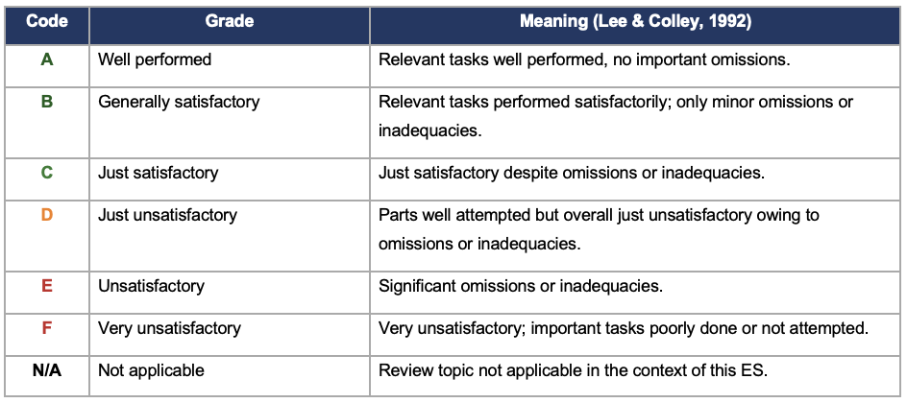

2. Project Context

2.1 The Proposed Development
The Bryn Henllys Extension is a ground-mounted solar photovoltaic installation with a generation capacity of 9.9 MW. It covers roughly 22 hectares at Waun Llwyd Farm, near Upper Cwmtwrch, within the area of Powys County Council, in the former Swansea Valley coalfield. The land was previously used for opencast coal mining, and historical maps and environmental records confirm that the site and its surroundings have contained mine shafts, brickmaking works, waste tips, a railway, and ponds that were later filled with refuse (Lightsource BP, 2019).
The project is not a standalone development. It was designed as an extension to an already approved 20 MW solar farm that Powys County Council granted permission for in June 2018 under planning reference P/2015/0176. Although the original scheme was never built, Lightsource BP later proposed this 9.9 MW addition on neighbouring land. The design sets out a 40-year operational life, with panel heights ranging from 1.0 to 2.9 metres, and infrastructure including inverter stations, a substation, perimeter fencing, and internal access tracks. The ES comprises a main text volume and supporting appendices, including a Phase 1 Desk Study (Appendix 10.2), a Conceptual Site Model (Appendix 10.3), assessment methodology (Appendix 10.5), and an Unexploded Ordnance (UXO) Risk Screening (Appendix 10.7). The ES was prepared by Wardell Armstrong, a multidisciplinary environmental consultancy.

2.2 How Planning Policy Shaped the EIA
Several policy instruments directly influenced the scope, content, and focus of the ES, and it is important to understand how they affected the assessment rather than simply listing them. The Powys Local Development Plan 2011–2026, adopted on 17 April 2018 (Powys County Council, 2018), identifies Local Search Areas (LSAs) where solar farms between 5 and 50 MW are considered acceptable in principle, provided they meet criteria covering landscape, biodiversity, residential amenity, and cumulative impact. Policy RE1 of the LDP specifically permits renewable energy developments in designated areas, subject to compliance with environmental safeguards. Because the Bryn Henllys site falls within an LSA, the ES does not need to argue the case for solar energy at this location in general terms. Instead, it focuses on demonstrating compliance with the LDP criteria. This is appropriate and keeps the assessment proportionate; however, it narrows the discussion of alternatives, since the ES treats co-location with the approved 20 MW scheme as essentially the only option rather than one of several possibilities. The implications of this narrowing are examined in Review Area 3.
At the national level, Planning Policy Wales Edition 10 (Welsh Government, 2018) sets out a planning framework centred on sustainable development and placemaking, with a strong presumption in favour of renewable energy. The Climate Change Act 2008, updated by the 2050 Target Amendment Order 2019, commits the United Kingdom to achieving net-zero greenhouse gas emissions by 2050. The Well-being of Future Generations (Wales) Act 2015 requires public bodies in Wales to apply the sustainable development principle, meaning they must meet present needs without undermining the ability of future generations to meet their own. Together, these measures create a policy environment that supports solar development. The ES consistently weighs the climate benefits of the scheme against local adverse effects, which is valid; however, it tends to frame negative impacts as secondary to the overall renewable-energy case. Review Area 4 addresses this imbalance in emphasis.
The ES follows CLR11 (Environment Agency, 2004) for its assessment of ground conditions and contamination. CLR11 sets out a tiered approach: the Phase 1 desk study identifies potential hazards, and where plausible pollutant linkages are found, the guidance recommends progressing to a Phase 2 intrusive investigation involving soil sampling, groundwater monitoring, and gas monitoring. Wardell Armstrong completed the desk study and produced the Conceptual Site Model but did not carry out a Phase 2 investigation, despite the site’s lengthy industrial history. The implications of this gap are examined in Review Area 2.

3. Critique Methodology
The Lee and Colley (1992) Review Package was chosen as the main analytical framework for this critique because of its transparency, structured layout, and wide use in EIA research and practice (Momtaz and Kabir, 2013; Sandham et al., 2013). The Package organises an ES into four Review Areas: (1) Description of the Development, Local Environment, and Baseline; (2) Identification, Analysis, and Assessment of Impacts; (3) Alternatives and Mitigation; and (4) Communication of Results. Each Review Area contains several review categories, which are further broken down into sub-criteria. Each sub-criterion is rated using the A–F scale shown in Table 1. The overall grade for each Review Area, and for the ES as a whole, is reached through expert judgement about the relative importance of each sub-criterion, not through arithmetic averaging.
Evidence for this review is drawn from the Bryn Henllys Extension Environmental Statement, including the main chapters, the Non-Technical Summary, and Appendices 10.1 (Legislation, Policy and Guidance), 10.2 (Phase 1 Desk Study), 10.3 (Conceptual Site Model), 10.5 (Assessment Methodologies), and 10.7 (Explosive Ordnance Assessment). To put the findings in context, the critique also draws on published comparative studies of ES quality. Sandham and Pretorius (2008) and Peterson (2010) consistently identify data adequacy and cumulative assessment as recurring weaknesses in ESs internationally, while Steinemann (2001) and Anifowose et al. (2016) highlight alternatives and monitoring as the aspects of EIA practice that most frequently fall short. These comparative perspectives help to assess whether the weaknesses found in the Bryn Henllys ES are specific to this project or reflect wider patterns across EIA practice.
One limitation of the Lee and Colley Package is that it assesses the document rather than the process. An ES can score well on paper even if the underlying consultation or baseline data collection was inadequate, and the reverse is also true. This critique therefore supplements the document-based review with analysis of procedural evidence, including the timing of consultation correspondence and the absence of field investigation data.

4. Application of the Lee and Colley Review Package

4.1 Review Area 1: Description of Development, Local Environment and Baseline
The description of the site and baseline conditions is one of the stronger parts of this ES. Wardell Armstrong makes thorough use of existing data sources. The Phase 1 Desk Study (Appendix 10.2) draws on records from the British Geological Survey, Groundsure Enviro Insight, the Coal Authority, Natural Resources Wales, Cadw, and the Clwyd-Powys Archaeological Trust. The breadth of this data-gathering effort is reflected in sub-criterion 1.5.2, which receives an A grade. The Conceptual Site Model (Appendix 10.3) systematically sets out potential contamination sources linked to the site’s mining history, along with pathways and receptors covering human health, groundwater, surface water, and ground gas.
The inclusion of a UXO Risk Screening (Appendix 10.7) is appropriate for a former opencast mining site and is consistent with CIRIA C552 guidance, which states that site-specific risks, including possible ordnance from blasting operations, should be considered during the desk study phase.
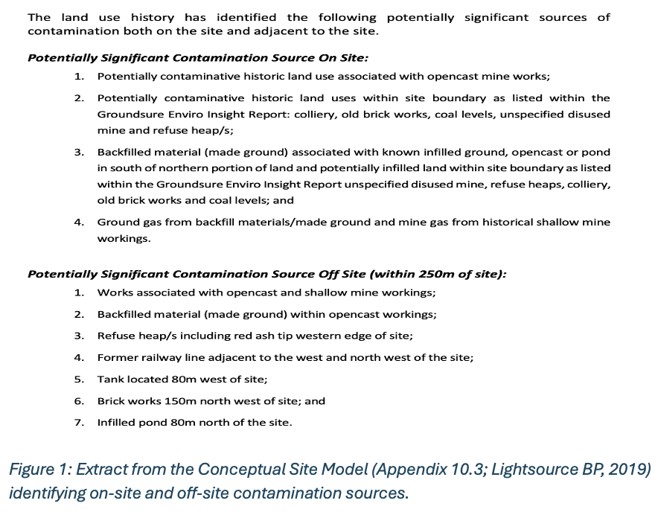
However, there are notable gaps. The description of construction materials, workforce numbers, and waste volumes is descriptive rather than quantified. IEMA (2016) argues that an ES should provide enough information for the reader to independently check the consultant’s conclusions; the lack of materials tables, embodied carbon estimates, and workforce projections makes independent verification difficult. Sub-criteria 1.1.6 and 1.1.7 are therefore rated D and E respectively. Furthermore, the cumulative assessment of the neighbouring approved 20 MW project is very limited. Both projects share the same receiving environment and, if built, would operate together as a single 29.9 MW installation. IEMA (2016) recommends that when linked developments share a receiving environment, their combined impacts should be assessed within a single cumulative framework. The ES does not include a combined-footprint matrix, meaning the decision-maker was not given a full environmental picture. The detailed sub-criterion ratings for Review Area 1 are set out in Appendix 1. Overall Review Area 1 grade: B (Generally satisfactory).

4.2 Review Area 2: Identification, Analysis and Assessment of Impacts
The Bryn Henllys ES uses a systematic risk matrix (Tables 10.1 to 10.6 of the Bryn Henllys ES (Chapter 10)) to produce significance scores. This matrix combines receptor sensitivity with the magnitude and probability of each effect, producing a risk rating for each pollutant linkage in the Conceptual Site Model. The matrix approach is methodical and broadly consistent with CLR11 and CIRIA C552 guidance (sub-criterion 2.2.3, grade B). The approach anchors significance to deviations from baseline conditions (Table 10.3 of the ES), which is methodologically sound.
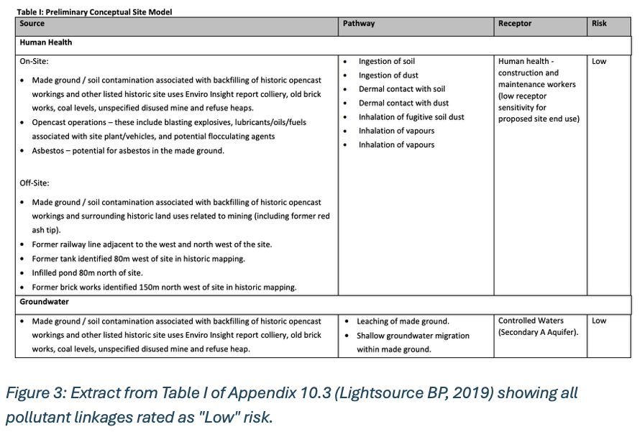
Three weaknesses limit the quality of this Review Area. First, every pollutant linkage in the Conceptual Site Model (Appendix 10.3) is rated as ‘Low’ risk — covering human health, groundwater, surface water, and ground gas uniformly. CLR11 sets out a tiered approach: the Phase 1 desk study is designed to identify potential hazards, not to confirm or rule them out. Where plausible linkages are found, CLR11 recommends progressing to a Phase 2 intrusive investigation involving soil sampling, groundwater monitoring, and gas monitoring. Rating every linkage as ‘Low’ for a site with recorded mining operations, waste tips, and backfilled ponds — without any field verification — goes beyond what that tier of investigation can defensibly support. Sub-criterion 2.2.5 therefore receives a D grade.
The absence of a Phase 2 investigation means that the planning authority approved construction on land with a recorded pollution history without having access to any soil or water quality data. This represents a gap in material information (sub-criterion 2.2.2, grade D). The ES methodology section (Appendix 10.5) describes a risk-based approach that factors in receptor sensitivity and effect magnitude, adjusted for probability (Tables 10.1 and 10.2 of the ES). This framework is fundamentally sound; however, its outputs are only as reliable as the input data. When the inputs consist entirely of desk-based assumptions rather than measured observations, the resulting risk ratings carry a level of uncertainty that the ES does not adequately acknowledge. This matters because Table 10.3 of the ES defines the thresholds at which effects are considered ‘significant’ in EIA terms, and without field data, those thresholds have not been tested against actual site conditions.
Third, the ES does not include a formal air-quality assessment, and no documented reason is given for leaving it out. Construction on potentially contaminated soils can generate dust containing harmful particles, and excluding air quality without justification is a notable omission (sub-criterion 2.1.1, grade D). Sandham and Pretorius (2008) and Peterson (2010) recognise data adequacy as a persistent weakness in ESs worldwide, and the Bryn Henllys ES fits this pattern. A further weakness in this Review Area is the lack of any attempt to put a monetary value on environmental costs and benefits. No social cost of carbon benchmarking is provided, which would have allowed a quantitative comparison of the climate benefits of solar generation against the residual impacts on landscape and biodiversity (sub-criterion 2.3.4, grade E). The detailed sub-criterion ratings for Review Area 2 are set out in Appendix 2.
Overall Review Area 2 grade: C (Just satisfactory).

4.3 Review Area 3: Alternatives and Mitigation
This Review Area is the weakest, which is consistent with international research showing that alternatives and mitigation are the most poorly addressed aspects of EIA practice globally (Steinemann, 2001; Sandham et al., 2013). The Bryn Henllys ES does not include a site-selection matrix comparing the merits of different locations. The justification rests entirely on co-location with the approved 20 MW scheme, while the ‘do-nothing’ alternative is covered in a single paragraph. Steinemann (2001, p. 6) argues that alternatives are the only stage in the EIA process where environmental harm can be entirely avoided, rather than just reduced. If alternatives are not properly tested, mitigation becomes the only tool available — and mitigation can only lessen harm, not remove it. The absence of a systematic alternatives analysis meant the decision-maker had to approve the only option put forward, with no evidence that better options had been explored. Sub-criterion 3.1.1 therefore receives an E grade.
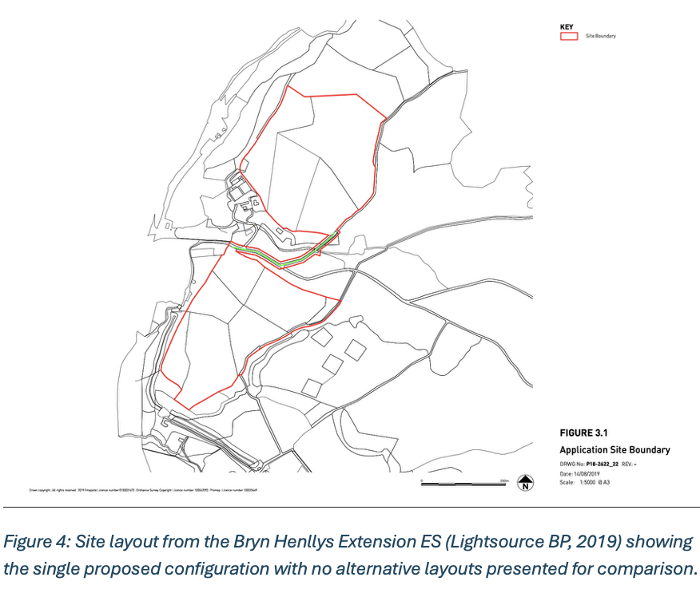
This weakness also has implications under the Well-being of Future Generations (Wales) Act 2015, which requires that decisions balance competing long-term needs. Showing that balance has been achieved is difficult when only one option has been assessed. The Act’s ‘involvement’ principle requires that the views of affected communities shape development outcomes, which further strengthens the case for genuine assessment of alternatives. The ES gives little attention to alternative construction methods (sub-criterion 3.1.2, grade D). For a site with identified contamination risks, considering trenchless versus open-trench cabling, or whether pile-driven versus ballasted foundations would reduce soil disturbance, would have been a useful addition. The absence of such analysis limits the reader’s ability to judge whether the chosen construction approach minimises environmental risk.
The mitigation measures set out in the ES are individually reasonable: a Construction Environmental Management Plan (CEMP), breeding-bird timing restrictions, grassland seeding, and sensitive lighting. These are standard practices for solar farm developments and follow established guidance. However, IEMA (2016) recommends that mitigation commitments should be accompanied by a monitoring plan that sets out performance indicators, trigger thresholds, and the parties responsible for enforcement. The ES references a preliminary CEMP but does not include a full Environmental Monitoring and Management Plan. Without such a plan, there is no way to confirm whether the proposed mitigation measures are carried out, or whether they achieve their intended purpose after planning consent is granted. Sub-criterion 3.2.5 receives an E grade. The detailed sub-criterion ratings for Review Area 3 are set out in Appendix 3.
Overall Review Area 3 grade: D (Just unsatisfactory).

4.4 Review Area 4: Communication of Results
The ES is well organised and follows the structure set out in Schedule 4 of the EIA Regulations 2017. The table of contents is detailed, cross-referencing between the main text and appendices generally works well, and the Non-Technical Summary is accessible and avoids unnecessary jargon. Sub-criterion 4.2.2 receives an A grade for its clear and logical structure.
The main concern in this Review Area is the consultation process. Welsh planning law requires applicants for major development to carry out statutory pre-application consultation before submitting a planning application. The purpose is to ensure that community and expert views can shape the proposal before it is submitted. In this case, Lightsource BP set up a consultation webpage, which meets the procedural requirement. However, Freedom of Information correspondence between Wardell Armstrong and Powys County Council was sent in June 2019 — the same month the ES was published. If the council’s response to that request was received after the ES was finalised, it could not have fed into the assessment. Therefore, these reasonably questions whether there was sufficient opportunity for members of the public to provide their input to influence the assessment.
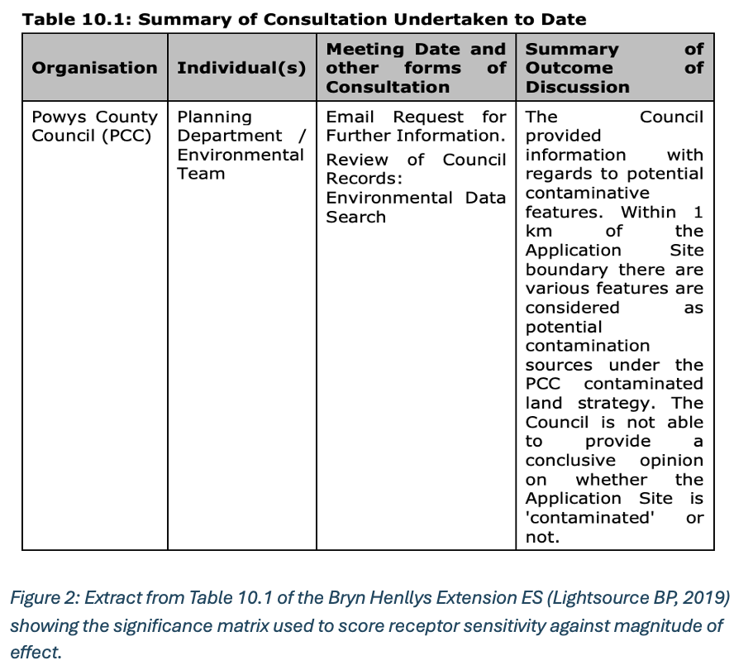
Consultation is more than just a source of practical information. Communities may hold local knowledge that surveys miss, such as historical land use, informal access routes, or wildlife sightings not recorded in official databases. Beyond its practical value, consultation also serves a democratic purpose: if the people affected by a development do not have a genuine opportunity to influence it, the legitimacy of the resulting planning decision is weakened, regardless of how technically sound the ES may be. IEMA (2016) recommends that ESs include a clear record of how consultation feedback was considered, often referred to as a ‘you said / we did’ table. The Bryn Henllys ES does not include such a record.
In addition, parts of the ES adopt a slightly promotional tone, emphasising the benefits of renewable energy while framing negative impacts as consistently ‘Low’. This is not unusual in ESs prepared on behalf of applicants (Glasson et al., 2012), but it does create an imbalance in emphasis that readers should be aware of. The detailed sub-criterion ratings for Review Area 4 are set out in Appendix 4.
Overall Review Area 4 grade: B (Generally satisfactory).

5. Overall Findings
Table 6 (compiled by the author) presents the overall grades. Taking the four Review Areas together, the Bryn Henllys Extension ES receives an overall grade of C (‘Just satisfactory’). The baseline description and communication are the strongest Review Areas, both scoring B, while alternatives and mitigation is the weakest at D, and impact identification and analysis is just satisfactory at C.
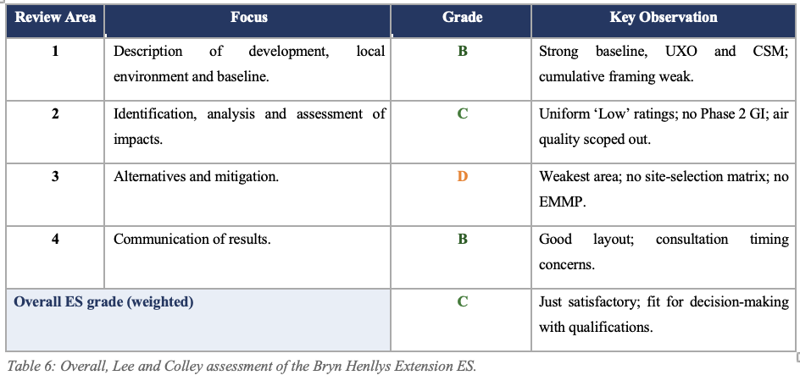

Several of the weaknesses identified in this ES are not unique to this project. Anifowose et al. (2016), reviewing oil and gas ESs, and Sandham and Pretorius (2008), examining South African ESs, both found that monitoring and alternatives are the parts of EIA that consistently underperform. The Bryn Henllys ES fits this pattern. Similar weaknesses have been observed in other Welsh renewable energy ESs; the Y Bryn Wind Farm ES (Y Bryn, 2023) also lacks a systematic site-selection matrix. This suggests that the problems identified here are not simply the failings of one consultant or one project, but point to deeper structural issues within EIA practice — where the system rewards procedural compliance over genuine environmental protection.
The absence of a Phase 2 intrusive investigation is particularly concerning given the site’s documented contamination history. The planning authority granted consent for construction on former opencast mining land without any field data on soil or water quality. While planning conditions may require investigations before work begins, the purpose of the ES is to inform the decision itself, not to defer critical information to a later stage. This approach runs counter to the precautionary principle that underpins EIA theory (Wood, 2003).
The consultation timing is also significant. If correspondence with key consultees was still being sent in the same month the ES was published, the statutory pre-application consultation may have been met in form but not in substance. The Well-being of Future Generations (Wales) Act 2015 specifically requires the involvement of stakeholders in achieving well-being goals, and a consultation process that does not actually feed into the ES undermines that aim.
The public were included through pre-application consultation, but the compressed timing limits the evidence that their input materially influenced the ES; the developer carried out most advisory steps (scoping, Statement of Community Involvement) as well as the mandatory ones; statutory consultees including NRW, Cadw, CPAT and Powys County Council were engaged; however, alternatives and a meaningful do-nothing comparison received the least attention; air quality appears to have been scoped out without an explicit justification accessible to the reader; and the documentation is sufficient to allow the competent authority to reach a reasoned decision, which is consistent with the subsequent grant of planning permission. These findings track closely with published reviews of other solar and wind-farm ESs, which identify alternatives, cumulative effects and post-consent monitoring as persistent weak points (Sandham and Pretorius, 2008; Anifowose et al., 2016).
The critique reveals several clear gaps between EIA theory and practice. In theory, alternatives analysis should be the stage where environmental harm can be entirely avoided (Steinemann, 2001); in practice, the Bryn Henllys ES treats co-location as a given. In theory, CLR11 sets out a tiered investigation process where desk study findings should be verified by field data; in practice, the ES stops at the desk study tier despite identifying plausible pollutant linkages on a former opencast site. In theory, consultation should shape the assessment before it is finalised; in practice, FOI correspondence was still being sent in the month the ES was published. In theory, mitigation commitments should be monitored and enforced through a management plan; in practice, no such plan is provided. These gaps are not unique to this project but reflect a wider pattern where procedural compliance has become a substitute for genuine environmental protection.

6. Conclusion and Recommendations
The Bryn Henllys Extension ES receives an overall grade of C (‘Just satisfactory’) following a sub-criterion-by-sub-criterion analysis using the Lee and Colley (1992) Review Package. It performs weakest in alternatives and mitigation (grade D) and strongest in baseline description and communication (both grade B). The ES shows competent use of existing data sources, a carefully structured Conceptual Site Model following CLR11, and the appropriate inclusion of UXO risk screening for a former opencast mining site. The weaknesses are significant and reveal recurring gaps between what EIA theory requires and what practice delivers: uniform ‘Low’ contamination risk ratings without a Phase 2 intrusive investigation; the unexplained omission of a formal air-quality assessment; a brief alternatives analysis; the absence of a dedicated Environmental Monitoring and Management Plan; and a consultation timeline that limits the opportunity for feedback to shape the ES.
Three recommendations follow from this analysis. First, future ESs for sites with documented contamination histories should include a Phase 2 intrusive investigation, or at minimum provide a clear and defensible reason for not conducting one at the ES stage. Second, Steinemann (2001, p. 6) argues that alternatives offer the greatest potential for reducing adverse effects; ESs should therefore include a systematic site-selection matrix and a proper do-nothing comparison, rather than treating co-location as the only viable option. Third, every ES should include a full Environmental Monitoring and Management Plan setting out performance indicators, trigger thresholds, and responsible parties, in line with IEMA (2016) guidance. The consultation process should be transparently documented through a ‘you said / we did’ record showing how comments influenced the final assessment.
This case study shows that procedural compliance alone is not enough. An EIA system that repeatedly underperforms on monitoring and alternatives risks legitimising decisions rather than improving them. If developers continue to meet only the minimum procedural requirements, the EIA process becomes a documentation exercise rather than a genuine tool for environmental protection. The question that whether the documentation helps the competent authority make an informed decision. The answer is qualified: the ES provides enough information for a decision to be made, but it does not provide the depth needed for the decision-maker to be confident that all reasonable options and risks have been fully explored. Strengthening these areas would bring practice closer to the goals of the Well-being of Future Generations (Wales) Act 2015: ensuring that today’s decisions do not compromise the well-being of future generations.

7. References
- Anifowose, B., Lawler, D.M., van der Horst, D. and Chapman, L. (2016) ‘A systematic quality assessment of Environmental Impact Statements in the oil and gas industry’, Science of the Total Environment, 572(1–3), pp. 570–585. Click to Open
- Environment Agency (2004) Model Procedures for the Management of Land Contamination (CLR11). Bristol: Environment Agency. Click to Open
- Glasson, J., Therivel, R. and Chadwick, A. (2012) Introduction to Environmental Impact Assessment. 4th edn. London: Routledge. Click to Open
- Institute of Environmental Management and Assessment (IEMA) (2016) Delivering Proportionate EIA: A Collaborative Strategy for Enhancing UK Environmental Impact Assessment Practice. Lincoln: IEMA. Click to Open
- Lee, N. and Colley, R. (1992) Reviewing the Quality of Environmental Statements. Occasional Paper No. 24. 2nd edn. Manchester: EIA Centre, University of Manchester. Click to Open
- Lightsource BP (2019) Bryn Henllys Extension Environmental Statement (prepared by Wardell Armstrong, Ref. CA11620/001). Click to Open
- Momtaz, S. and Kabir, S.M.Z. (2013) Evaluating Environmental and Social Impact Assessment in Developing Countries. Amsterdam: Elsevier. Click to Open
- Peterson, K. (2010) ‘Quality of Environmental Impact Statements and variability of scrutiny by reviewers’, Environmental Impact Assessment Review, 30(3), pp. 169–176. Click to Open
- Powys County Council (2018) Powys Local Development Plan 2011–2026. Adopted April 2018. Llandrindod Wells: Powys County Council. Click to Open
- Sandham, L.A. and Pretorius, H.M. (2008) ‘A review of EIA report quality in the North West Province of South Africa’, Environmental Impact Assessment Review, 28(4–5), pp. 229–240. Click to Open
- Sandham, L.A., Van Heerden, A.J., Jones, C.E., Retief, F.P. and Morrison-Saunders, A.N. (2013) ‘Does enhanced regulation improve EIA report quality? Lessons from South Africa’, Environmental Impact Assessment Review, 38, pp. 155–162. Click to Open
- Steinemann, A.C. (2001) ‘Improving alternatives for environmental impact assessment’, Environmental Impact Assessment Review, 21(1), pp. 3–21. Click to Open
- UK Parliament (1990) Town and Country Planning Act 1990, c. 8. London: HMSO. Click to Open
- UK Parliament (2008) Climate Change Act 2008, c. 27. London: The Stationery Office. Click to Open
- UK Parliament (2019) The Climate Change Act 2008 (2050 Target Amendment) Order 2019, SI 2019/1056. Click to Open
- Welsh Government (2015a) Planning (Wales) Act 2015, anaw 4. Cardiff: Welsh Government. Click to Open
- Welsh Government (2015b) Well-being of Future Generations (Wales) Act 2015, anaw 2. Cardiff: Welsh Government. Click to Open
- Welsh Government (2017) The Town and Country Planning (Environmental Impact Assessment) (Wales) Regulations 2017, SI 2017/567 (W. 136). Click to Open
- Welsh Government (2018) Planning Policy Wales (Edition 10). Cardiff: Welsh Government. Click to Open
- Wood, C. (2003) Environmental Impact Assessment: A Comparative Review. 2nd edn. Harlow: Pearson Education. Click to Open
- Y Bryn Wind Farm (2023) Y Bryn Wind Farm Chapter 3: Approach to EIA. Click to Open

Appendix 1: Review Area 1 — Sub-Criterion Ratings
Table 2 (compiled by the author): Review Area 1 – sub-category assessment.
Ref | Review Criterion (Lee & Colley, 1992) | Rating | Justification / Evidence from ES
1.1 Description of the development
1.1.1 | Purposes and objectives of the development adequately explained. | C | Net-zero rationale given but project-specific need not fully justified beyond proximity to the consented 20 MW scheme.
1.1.2 | Design, size, scale, construction and operation duration described; use of diagrams, plans, charts, maps. | B | Layout figures (1.1–3.2), panel heights (1.0–2.9 m) and 40-year operational life stated clearly.
1.1.3 | Environmental planning that shaped the design described. | D | Some design iteration referenced (hedgerow buffers, panel height for glare) but rationale and alternatives tested are not documented.
1.1.4 | Important design features for environmental and socio-economic management highlighted. | C | Conservation grazing and grassland seeding identified but not prominently signposted.
1.1.5 | Physical presence/appearance within the receiving environment indicated. | B | Photomontages and ZTV analysis in the LVIA chapter.
1.1.6 | Nature and quantities of construction and operational materials described. | D | Descriptive, not quantitative; no embodied-carbon or materials tabulation.
1.1.7 | Number of workers involved in construction and operation estimated. | E | Construction traffic referenced but workforce numbers and maintenance visit frequency not clearly estimated.
1.2 Site description
1.2.1 | Land area well defined; location clearly shown on a map. | A | Clear red-line boundary at grid reference 275917/212511 with multiple scale figures.
1.2.2 | Land uses described; different land-use areas demarcated. | B | Current improved grassland on former opencast and post-development layout clearly shown.
1.2.3 | Alternative plans/designs/sites discussed. | D | Alternative layouts mentioned but no systematic site-selection matrix.
1.3 Residuals (waste matter/energy)
1.3.1 | Types/quantities of waste and residuals estimated with uncertainty ranges. | D | Construction arisings acknowledged qualitatively; end-of-life PV panel waste not quantified despite 40-year horizon.
1.3.2 | Handling, treatment and disposal routes indicated. | C | Commitment to a CEMP is given; no detailed waste-hierarchy or disposal-route table.
1.4 Bounding the study
1.4.1 | Study area delimited with appropriate scale map(s). | B | Topic-specific study areas (3 km visual, 1 km ecology, 250 m contamination) defined and justified.
1.4.2 | Affected environment broad enough to include significant off-site effects. | D | Off-site contamination sources considered; but cumulative framing with the adjacent 20 MW farm is weak.
1.4.3 | Time horizon long enough to account for delayed effects. | C | 40-year horizon used; decommissioning/soil restoration treatment is brief.
1.5 Baseline conditions
1.5.1 | Important components identified; methods, fieldwork and uncertainties disclosed. | B | Strong Phase 1 desk study (Appendix 10.2); thorough site walkover (June 2019); UXO risk assessment included. Ecology survey effort more limited.
1.5.2 | Existing data sources searched and used. | A | Use of BGS, Groundsure, Coal Authority, NRW, Cadw and CPAT data is exemplary.
1.5.3 | Local plans consulted; probable future state described. | B | Powys LDP and emerging RLDP consulted; do-nothing baseline outlined for most topics.

Appendix 2: Review Area 2 — Sub-Criterion Ratings
Table 3 (compiled by the author): Review Area 2 – sub-category assessment.
Ref | Review Criterion (Lee & Colley, 1992) | Rating | Justification / Evidence from ES
2.1 Identification of impacts
2.1.1 | All important issues in the EIA terms of reference included; exclusions accounted for. | D | Scoping undertaken, but air-quality assessment appears scoped out without published justification.
2.1.2 | Direct and indirect impacts identified using a systematic methodology. | B | Matrix methodology (Tables 10.1–10.6) and source-pathway-receptor framework applied systematically.
2.1.3 | Due attention to sensitive areas, off-site, delayed, cumulative and synergistic effects. | D | Cumulative assessment with the adjacent 20 MW scheme acknowledged but not quantified.
2.1.4 | Non-standard/accident effects considered. | D | Accident scenarios (e.g. transformer oil spill to the underlying Secondary A aquifer) not explicitly modelled.
2.1.5 | All project phases considered. | B | Construction, operation and decommissioning addressed, though decommissioning is less detailed.
2.1.6 | Key impacts identified for more intense investigation; scoping methods justified. | B | Key impacts flagged per chapter; scoping outcomes reported.
2.2 Analysis of impact severity
2.2.1 | Impacts analysed as deviation from baseline. | B | Framework (Table 10.3) explicitly anchors significance to baseline change.
2.2.2 | Data sufficient; gaps indicated. | D | Reliance on desk study; absence of Phase 2 intrusive ground investigation is a material data gap.
2.2.3 | Prediction methods described and appropriate; assumptions discussed. | B | Methods grounded in CLR11, CIRIA C552 and IEMA guidance.
2.2.4 | Impact severity encompasses appropriate characteristics. | B | Magnitude, probability, duration addressed via Tables 10.1–10.6.
2.2.5 | Quantitative estimates where possible; qualitative descriptions well defined. | D | Contamination risks rated uniformly ‘Low’ with limited quantitative evidence.
2.3 Assessment of impact significance
2.3.1 | Significance of residual impacts distinguished from severity. | B | Distinction between significance and severity is clear.
2.3.2 | Significance assessed using national/international standards. | B | CLR11, CIRIA C552, IEMA guidance and WFD thresholds used.
2.3.3 | Choice of standards, assumptions and value systems justified. | C | Standards cited, but limited engagement with community objections.
2.3.4 | Economic values attributed to environmental costs/benefits where possible. | E | No monetisation; no social cost of carbon benchmarking.
2.3.5 | Affected stakeholders identified. | B | Statutory consultees (NRW, Cadw, CPAT) and local community identified.

Appendix 3: Review Area 3 — Sub-Criterion Ratings
Table 4 (compiled by the author): Review Area 3 – sub-category assessment.
Ref | Review Criterion (Lee & Colley, 1992) | Rating | Justification / Evidence from ES
3.1 Alternatives
3.1.1 | Alternative sites, processes, designs, operating conditions considered. | E | No systematic alternative-site matrix; co-location with the consented scheme taken as given; do-nothing addressed only briefly.
3.1.2 | Alternative construction strategies considered. | D | Limited discussion of construction options; no trenchless vs trenched cabling comparison.
3.1.3 | For public sector proposals: alternative means of achieving project goals. | N/A | Privately promoted development; criterion not directly applicable.
3.2 Scope and effectiveness of mitigation measures
3.2.1 | Stakeholders consulted; their views accounted for in mitigation. | C | Pre-application consultation undertaken; but no ‘you said / we did’ matrix.
3.2.2 | Mitigation of all significant adverse impacts considered; measures defined. | B | CEMP, biodiversity enhancement, breeding-bird timing constraints, sensitive lighting specified.
3.2.3 | Residual/unmitigated impacts discussed. | C | Residual effects labelled ‘not significant’; justification occasionally thin.
3.2.4 | Effectiveness of mitigation clear; uncertainty addressed. | D | Mitigation specified but not benchmarked against performance indicators.
3.2.5 | Environmental monitoring and management plan presented. | E | Outline CEMP referenced; no full Environmental Monitoring and Management Plan appended.
3.3 Commitment to mitigation
3.3 | Proponent expresses commitment to, and capability of, carrying out mitigation. | C | Mitigation described in declarative terms; enforcement via planning conditions and responsible parties not fully defined.

Appendix 4: Review Area 4 — Sub-Criterion Ratings
Table 5 (compiled by the author): Review Area 4 – sub-category assessment.
Ref | Review Criterion (Lee & Colley, 1992) | Rating | Justification / Evidence from ES
4.1 Project involvement (consultation)
4.1 | Genuine and adequate stakeholder consultation shaping the EIA. | D | Pre-application consultation technically met; however, FOI correspondence with Powys CC sent in the same month as ES publication.
4.2 Layout
4.2.1 | Introduction describing project, aims of EA, how achieved. | B | Clear chapter introductions and methodologies; volume 1 introduction is comprehensive.
4.2.2 | Information logically arranged; clear TOC. | A | Structure aligns with Schedule 4 of the 2017 EIA Regulations; full contents list provided.
4.2.3 | External data sources acknowledged; full references provided. | B | In-chapter referencing is satisfactory; occasional reliance on grey-web sources could be tightened.
4.3 Presentation
4.3.1 | Comprehensible to non-specialist; appropriate graphics. | B | Clear tables and figures; acronyms generally defined.
4.3.2 | Integrated whole; appendix data discussed in main text. | B | Good cross-referencing, e.g. Appendix 10.3 CSM referenced in Chapter 10.
4.4 Emphasis
4.4.1 | Appropriate emphasis for adverse and beneficial effects. | C | Beneficial effects prominently emphasised; adverse effects uniformly framed as ‘Low’.
4.4.2 | Unbiased; not lobbying for a particular point of view. | C | Promotional tone in places, typical of applicant-commissioned ES (Glasson et al., 2012).
4.5 Non-technical summary
4.5.1 | Adequate NTS; jargon avoided. | B | NTS is readable and avoids technical jargon.
4.5.2 | NTS comprehensive; covers project, environment, impacts, mitigation, residual effects. | B | Main chapters summarised; some residual effects arguably understated.

