Task 1 (a) Report on Essential Academic and Employment Skills for the Future Career Path
In this modern era, we can see the contribution of computing and software solutions in the workplace. A certificate in this sector is beneficial for students but also crucial to get success in technology-driven industries. Nowadays employers search for those who have qualities like problem-solving, teamwork, and analytical thinking to real-world business challenges.
Essential Academic Skills
Students can go ahead for their career development and lifelong learning through academic skills. For students, research and analytical abilities are essential for academic purposes, as these are helpful to evaluate business software, identify solutions, and keep them updated with emerging technologies [1].
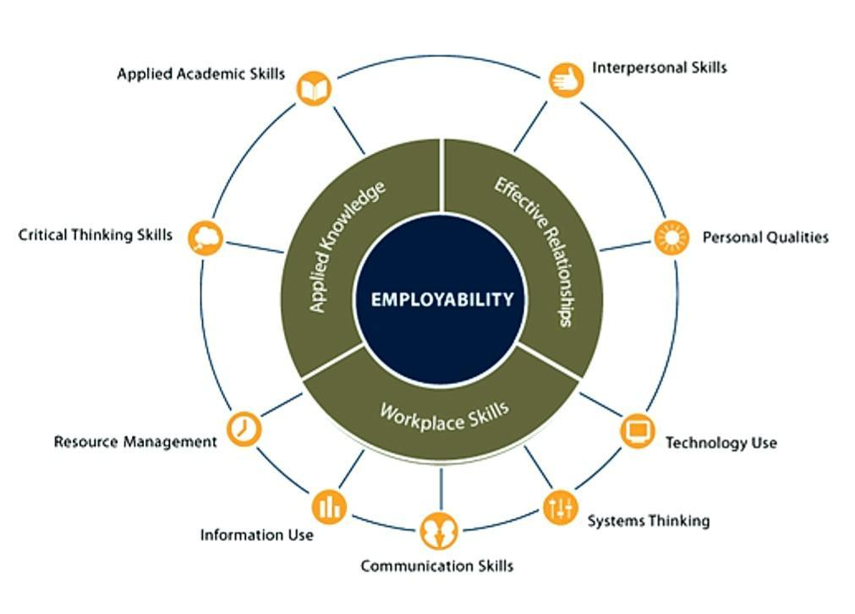
Figure: Employability Skills Framework [2].
Communication and writing skills are also equally important through which students can help students document technical processes and present findings clearly. Time management and independent learning enhance the ability to complete projects efficiently, such as coding assignments, group tasks, or technical documentation [3].
Essential Employment Skills
Technical competence, like having the knowledge of applications like Microsoft Excel, databases, and cloud-based business tools (e.g., Google Workspace, ERP systems), is the key to success in the field of computing and business software [4].
However, the employers who have the zeal to learn new software solutions can survive in the competitive world of the IT industry [5].

In end, it can be said that the combination of academic and employment skills prepares students for dynamic careers in computing and business environments.

References:

[1] | S. F. a. C. Steven, Integrating Key Skills in Higher Education: Employability, Transferable Skills and Learning for Life, London,U.K.: Routledge, 2013.
[2] | C. f. O. R. a. Development, “Employability Skills,” Necessary Skills Now Network, 2025. [Online]. Available: https://www.necessaryskillsnow.org/emploability-skills.php.
[3] | J. A. a. H. Higson, “"Graduate Employability,'Soft Skills' Versus 'hard' Business Knowledge: A European Study",” Higher Education In Europe, vol. 33, no. 4, pp. 411-422, 2008.
[4] | World Economic Forum, “The Future of Jobs Report 2023,” World Economic Forum(WEF), Geneva, Switzerand, April 2023.
[5] | UK Government, “Information Technology(IT) Skills,” april 2024. [Online]. Available: https://nationalcareers.service.gov.uk. [Accessed 7th november 2025].

