Individual Business Model Canvas with entrepreneurial reflection using appropriate academic models

Module Title: Entrepreneurship

Module Code: BMIH5001

Student Name: Catalin Alexandru Cocos

Student ID: 2214591

Lecturer’s Name: Chris Wilkin

Table of Contents
Part 1 3
Introduction 3
Discussion 4
Conclusion 8
Part 2 9
Reflection 9
References 11
Appendices 13

Part 1

Introduction
The following essay will be based on the business model canvas and value propositions for a newly-ideated hospitality firm that has not been opened as of yet. It is compulsory for business plans to be formed before companies are opened. The name of the proposed company is Nutrition Niche Kitchen.

Discussion
The name for the new business idea has been chosen, and it is Nutrition Niche Kitchen. The business has been developed for a cafe which would specialise in selling organic food products, in order to be able to appeal to the target customer segment whose members are conscious regards their health. That would be inclusive of tourists who visit the United Kingdom and aim to search for healthy food and beverage items which also taste good at the same time. In addition to that, teenagers prefer to spend time at cafes which sell cheap commodities for sustenance (Ebert and Griffin, 2020). That is also yet another reason for which this cafe has to be opened, in order to be able to fulfil the purpose of providing healthy alternatives which can improve their lifestyles.
The business is expected to be opened within the tourism sector. That is owed to the fact that it includes the hospitality industry, which is composed of different fields such as hotels and food and beverage companies (Bresciani et al., 2021). Due to the grounds that any idea for a business consists of an extensive plan before it is begun, a business plan has been created based on a Business Model Canvas. A company has to receive raw materials in the form of supplies for the reason of being able to begin the process of offering its services, commodities, or goods (Blank and Dorf, 2020). In the case of Nutrition Niche Kitchen, the suppliers who will be chosen have to do with Ecotone. That company would help provide the new business with organic raw materials, which will be used as ingredients for cooking healthy food and brewing the beverages that the company has the aim of providing. Added to that is one more key partner who will be included in the supplier groups for Nutrition Niche Kitchen. That is expected to appear in the form of Ashwood Designs, and this business organisation is going to be able to complete the task of providing the new firm with chairs, booths, couches, and tables, without which the buyers will not be able to be seated.
The supply chain management process that will be expected to be used is the Just-in-Time (JIT) inventory management method. JIT helps enterprising entities to receive their manufacturing goods only at the time when they are required (Figueroa-Domecq et al., 2020). The usage of this will be capable of letting Nutrition Niche Kitchen provide food cooked with fresh items as opposed to those stored in warehouses, as this can spoil the ingredients, lowering the quality of the products. As a result of this, the company is going to be able to live up to its name truly by refraining from performing any actions that may hamper the health of its target consumer market. In spite of the fact that this can potentially create challenges like unprecedented barriers in the transportation route of the supply chain, it would help Nutrition Niche Kitchen to make sure that it is not giving out harmful items to its clients. That matter will be improved even further due to the ground that short local supply chains would be utilised (Williams, 2021). Products which are sourced locally tend to travel short distances, thereby ensuring that not too much transport fuel is used, making the procedure more eco-friendly in comparison to those chains which have the tendency of being longer owing to them being based internationally (Barringer and Ireland, 2018). Daylesford Organic is one of the potential competitive rivals of the newly-ideated business, however, since it utilises the aid of long and overseas supply chains, this emits a high amount of pollutants. It does that as it focuses on global resources, while the element that makes Nutrition Niche Kitchen unique is the factor that it emphasises more on the quality of the final product, rather than where it is sourced from [Refer to Appendix 1].
A short supply chain was elected not only due to the company wanting to stress healthy and environment-friendly items, it was simultaneously chosen to ensure that good-quality supplies are received at low prices. Companies which use domestic suppliers do not have to spend their capital on import taxes and can also refrain from needing to work in correspondence with the laws of other nations (Page and Connell, 2020). In the future, after the business has been set up and has succeeded to a high degree, even other suppliers will be included. For the time-being, due to the small amount of the initial costs, only two main ones are going to be involved. Along with this, the new company wishes to give many alternatives to regular plant-based meals, and these have the objective of taking care of the needs of purchasers who may be allergic to gluten and also do not enjoy consuming animal products. Keeping them in mind, vegan meals, snacks, and beverages have been included in the menu [Refer to Appendix 2]. It will allow Nutrition Niche Kitchen to appeal to larger numbers of demographics owed to the growing number of vegans in the country, and the fewer numbers of eateries which completely cater to their requirements. Around 4% of the UK’s residents follow vegan diets now (Statista, 2024). That has made it more difficult for the food industry of the nation-state to carry on its usual business of selling meat products (Mmbaga et al., 2020). Alongside that, it can be considered to be a new tourism business as it aims to attract environmentally-aware inbound travellers, too. Individuals who visit the UK, in addition to the residents of the nation itself, have begun to become more socially ethical-minded, and do not prefer it when animals are killed for the consumption of their meat or other products (Awan and Sroufe, 2022). Being mindful of them, too, will help the new and unopened business to thrive in its industry of choice through the provision of vegan items.
The vegan goods will consist of artificial meat as well, and since this is going to taste how most consumers will want them to, Nutrition Niche Kitchen can appeal to this demographic of tourists and citizens, too. The location of the cafe, which will start out with only one building, is slated to be in the Western section of the city of London, England. It is a metropolitan town in which many people dwell, and it is one of the most popular tourist destinations in all of Britain. Urban dwellers are more likely than people of other demographics to visit cafes most often (Osterwalder et al., 2020). That is the reason due to which it will be opened in London. The major resources for this business will involve human resources in the form of a creative chef who can come up with innovative ideas for just plant-based dishes, besides servers from all walks of life, for providing jobs to less privileged demographics of persons [Refer to Appendix 3].
The other source includes financial resources, and a starting capital of 3000 Great British Pounds has been received from bank loans. From that, 1600 GBP will be used for paying fixed costs like electricity bills, rent of the building, and the pay roles of the employees. Out of it, 1400 British Pounds are going to be utilised to pay the variable costs, such as marketing, advertisements, promotions, and supplies. Maintaining customer relationships is vital for any given business as it allows it to figure out the opinions of its buyers, based on which it can modify its operations if needed (Yuliantini et al., 2023). A department comprising a customer service manager and representatives will be formed, who will be responsible for resolving clients' queries. The company will create its own social media accounts through which it can send offers, vouchers, and news regarding discounts to loyal customers, and even answer potential consumers' questions, or use their feedback to develop its products. Customers feel more satisfied when they see that businesses are actively interacting with them, as it shows them that the company genuinely cares with regard to their demands (Fabeil et al., 2020). After the brand has received more loyal customers, it can try to retain them through loyalty cards, thus maximising its business prospects. It will also know their basic interests through their regular orders and social networking algorithms, letting Nutrition Niche Kitchen create personalised items and gift baskets [Refer to Appendix 4].
The corporate entity will use distribution channels in the form of delivery services like Uber Eats. Distribution channels are those used by firms to help their items reach the final consumers (Mansoori and Lackeus, 2020). Moreover, its official online website can help potential buyers browse which goods they would want, and that can be sent to their homes. It will help the company grow as people prefer convenience in the form of food being delivered to their houses. Instagram would be used for advertisements since teenagers and young adults frequently use it. YouTube is utilised by most people worldwide, and this is why it will let Nutrition Niche Kitchen promote its services and items to wide audiences. Profits will be generated through the main services of catering and the provision of meals [Refer to Appendix 5].

Conclusion
The critical analysis of the business plan of Nutrition Niche Kitchen has been given above. In it, its value proposition was included, and it will begin its functions with 3000 Pounds. JIT will be used by it, in addition to social media sites as customer service platforms and marketing channels.

Part 2

Reflection
I was asked to create a business plan for a tourism company of my choice, and I decided that I wanted to build a nutrition-based cafe in London. I could form the business model canvas, plan, and value proposition since my teachers taught me in relation to these concepts. My peers helped me, too, and that is why I was able to understand the difficult topics. I performed research on the tourism, hospitality, and food industries of the UK, and this helped me to justify my choices. The Goal-setting Theory has been used for it. It states that knowing one’s aims lets them perform actions, helping them achieve desired results (Brown, 2022). Hence, I took an entrepreneurial and managerial test to examine my leadership abilities. I found that I have moderate to high entrepreneurial capabilities.
The second stage of the Gibbs Reflective Cycle is Feelings. I saw that I can switch off from duties entirely, am either naturally proficient or do not try, have unusual ideas, am competitive and hardworking, and enjoy challenges. ‘Feelings’ is used for understanding the positive and negative thoughts regarding the experience (Williams et al., 2020). I was pleased to see that I have unique ideas, nevertheless, I do not approve of the fact that I am stubborn regarding endeavours I cannot immediately succeed in.
I disagree with the notion that pleasing people is less important than performing tasks well, which might have contributed to my moderate entrepreneurial score as I think of individuals’ needs, which is why I wish to open a health-conscious cafe, and this is a negative element. The third phase, Evaluation, lets people critically interpret events (Pieper et al., 2021). That is why my managerial score was high since I like looking after people’s needs, which is a positive aspect. Another reason is that I am accepting and do not want to generally change courses of occurrences. One more unfavourable characteristic is that I am short-tempered when it comes to deadlines, which may intimidate employees in future.
I saw that I am moderately enterprising as I am willing to perform less challenging tasks if the pay is high. The fourth stage is Analysis, letting individuals understand the wider implications of their actions (Adeani et al., 2020). I am more managerial than entrepreneurial, which I realised when I figured that I do not like performing tasks others have not done before. It can make it difficult for me to open the company in future.
I understood that I am independent and future-oriented. ‘Conclusion’ helps persons analyse what they should improve. Factors which make me entrepreneurial include the idea that I believe luck as a phenomenon does not exist and people contribute to their own fortunes (Nolden et al., 2020). I even enjoy speaking to individuals with different mindsets as this lets me come across new perspectives. I can be a good leader as I enjoy teamwork. As I feel pressured at times, I should improve self-management and my entrepreneurial capacities.
I can manage myself, and therefore others, better by prioritising the order of my tasks and creating routines for my daily activities. Action Plan is the last stage, helping people formulate plans for enhancing themselves in future (Vedula et al., 2022). I should read relevant books on how to become adaptable. I will be more entrepreneurial after studying regarding the lives and behaviour of successful business leaders, understanding financial management, and attending relevant workshops.

References
Adeani, I.S., Febriani, R.B. and Syafryadin, S., 2020. Using GIBBS’reflective cycle in making reflections of literary analysis. Indonesian EFL Journal, 6(2), pp.139-148.
Awan, U. and Sroufe, R., 2022. Sustainability in the circular economy: insights and dynamics of designing circular business models. Applied Sciences, 12(3), p.1521.
Barringer, B.R. and Ireland, R.D., 2018. Entrepreneurship: Successfully Launching New Ventures, 4th Ed., Prentice Hall: New Jersey.
Blank, S. and Dorf, B., 2020. The startup owner's manual: The step-by-step guide for building a great company. John Wiley & Sons.
Bresciani, S., Ferraris, A., Romano, M. and Santoro, G., 2021. Building a digital transformation strategy. In Digital transformation management for agile organizations: A compass to sail the digital world (pp. 5-27). Emerald Publishing Limited.
Brown, N., 2022, March. Teaching reflective practice in teams: In-person and virtual activities. In 2022 IEEE Global Engineering Education Conference (EDUCON) (pp. 419-422). IEEE.
Ebert, R.J. and Griffin, R.W., 2020. Business essentials. Pearson.
Fabeil, N.F., Pazim, K.H. and Langgat, J., 2020. The impact of Covid-19 pandemic crisis on micro-enterprises: Entrepreneurs’ perspective on business continuity and recovery strategy. Journal of Economics and Business, 3(2).
Figueroa-Domecq, C., De Jong, A. and Williams, A.M., 2020. Gender, tourism & entrepreneurship: A critical review. Annals of tourism research, 84, p.102980.
Mansoori, Y. and Lackeus, M., 2020. Comparing effectuation to discovery-driven planning, prescriptive entrepreneurship, business planning, lean startup, and design thinking. Small Business Economics, 54, pp.791-818.
Mmbaga, N.A., Mathias, B.D., Williams, D.W. and Cardon, M.S., 2020. A review of and future agenda for research on identity in entrepreneurship. Journal of Business Venturing, 35(6), p.106049.
Nolden, C., Barnes, J. and Nicholls, J., 2020. Community energy business model evolution: A review of solar photovoltaic developments in England. Renewable and Sustainable Energy Reviews, 122, p.109722.
Osterwalder, A., Pigneur, Y., Smith, A. and Etiemble, F., 2020. The invincible company: how to constantly reinvent your organization with inspiration from the world's best business models (Vol. 4). John Wiley & Sons.
Page, S.J. and Connell, J., 2020. Tourism and entrepreneurship. In Tourism (pp. 262-279). Routledge.
Pieper, M., Roelle, J., vom Hofe, R., Salle, A. and Berthold, K., 2021. Feedback in reflective journals fosters reflection skills of student teachers. Psychology Learning & Teaching, 20(1), pp.107-127.
Statista, 2024. Topic: Veganism and vegetarianism in the UK. [Online] Available at: <https://www.statista.com/topics/7297/veganism-in-the-united-kingdom/#topicOverview> [Accessed on: 31 January 2024].
Vedula, S., Doblinger, C., Pacheco, D., York, J.G., Bacq, S., Russo, M.V. and Dean, T.J., 2022. Entrepreneurship for the public good: A review, critique, and path forward for social and environmental entrepreneurship research. Academy of Management Annals, 16(1), pp.391-425.
Williams, K., Woolliams, M. and Spiro, J., 2020. Reflective writing. Bloomsbury Publishing.
Williams, S., 2021. FT Guide to Business Start Up: The most comprehensive guide for entrepreneurs, 32nd Ed., Financial Times Press: Harlow.
Yuliantini, T., Marlapa, E., Daru, A.S.I.H., Srihadi, T.F., Rohman, A. and Soelton, M., 2023, November. Business Planning Based On Green Management, Should Be Sustainable?. In ICCD (Vol. 5, No. 1, pp. 135-140).

Appendices
Appendix 1
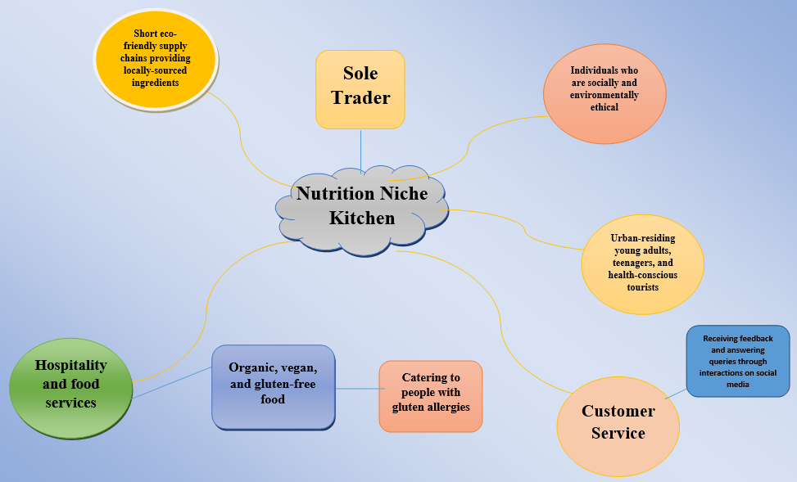
Figure 1: Mind Map
(Source: self-developed)
Appendix 2
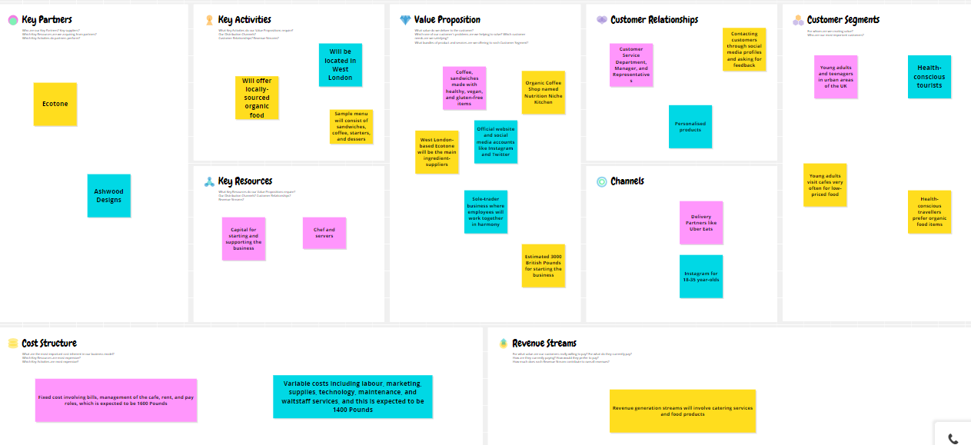
Figure 2: Business Model Canvas
(Source: self-developed)
Appendix 3
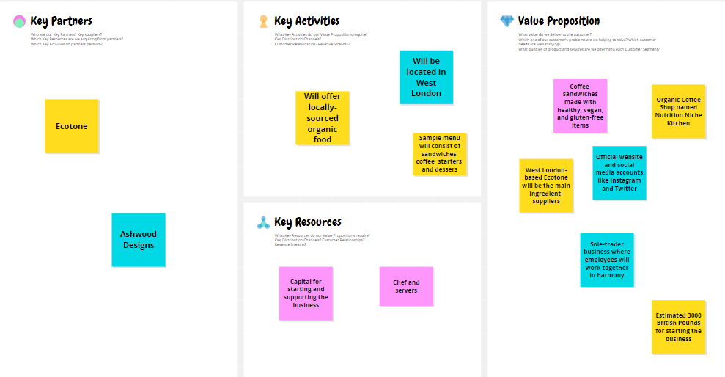
Figure 3: Business Model Canvas
(Source: self-developed)
Appendix 4
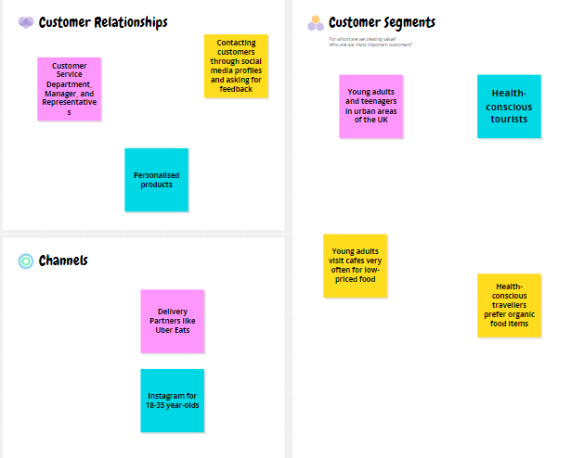
Figure 4: Business Model Canvas
(Source: self-developed)
Appendix 5
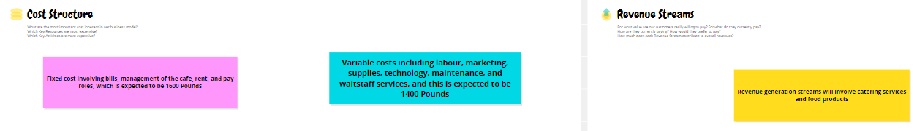
Figure 5: Business Model Canvas
(Source: self-developed)

