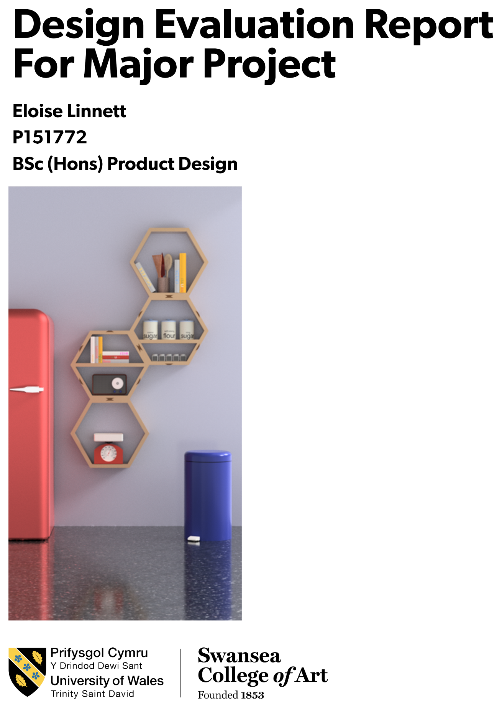
Table of Contents

Initial Design 4
Developing the Design 6
Hinge System 7
Assembly 8
Quality and Testing 9
Manufacturing, Audience, and Use Cases. 11
Design Philosophy 14
References 15

Honey is a shelving solution that allows the user to have a personal set up, adapted to meet their own personal requirements. Consisting of four hexagonal units; two primary and two secondary. The two primary units are fixed to the wall and to one another. The secondary unit extend off of the primaries using sliding hinges. The design of Honey can be adapted, with the secondary units able to be fitted in any which manner the user desires. Its legion of design possibilities enables the product to suit a wide range of within a home or even the work place. The design holds a multitude of character from the solid wood grain and the joinery method, giving the piece a more individual physique. Honey invokes a design philosophy depicting that everything is a prototype, ready to be developed and improved on. Your situations requirements may change, and so Honey will adapt to work best for you.

Initial Design
The Initial design steps for Honey began by way of sketch explorations, with a primary focus on shape iterations and a secondary consideration of multi-sized shapes for a shelving system. The main focus on shape exploration was its potential for singular-shape usage. The benefit of this system is that it has no dependence on more than one shape in order to keep contact and not leave gaps between units making up the shelving system. Inspiration came from the honeycomb; a matrix of hexagons joining at the boundary… achieving constant contact. An iteration of a regular pentagon, for example, depends on a secondary shape –a triangle- either in gaps pending between individual shapes or as a secondary filler. This resulted with a choice of triangle, square and hexagonal units as they were self-dependent in their possibility of repetition.
As well as sketches, I made 3D mock-ups of a singular unit in cardboard to get a better sense of the shape and its volume possibilities. I particularly enjoyed the triangular option and its possibilities in regards to orientation and formation, but felt that its acute negative margin would leave the user short changed for space. In other words, the acute angles of the corners would pose a less user-friendly option for filling of the shelves than that of the hexagonal or the square shapes.
This left me to decide between the two remaining shapes, and still the possibility of ranged sizes. In order to make this decision, I looked into the current market to see what was on trend, what has been a success, and where there was a hole in the market. Square unit shelves are a common object, with IKEA having one of their more successful pieces being Kallax: A storage unit consisting of square spaces ranging in quantity from 4 up to 16 per whole unit. This design is simple and greatly successful. From this design I particularly liked its simplicity and clear silhouette. Another of IKEAs square set shelving systems is the EKET which consists of a range of quantities of smaller squares in a bustling cluster ranging in depths. Seeing this piece first hand, in particular, helped me in designing my own product. As a range of depth was something I was exploring personally, to see it in an existing product gave me the change to have a first-hand review. I found this style displeasing and felt that the overlapping sides and edges caused by the change in depth between the individual boxes gave the products a muddled appearance. I wanted my design to have crisp line work and a clear silhouette and so this helped me progress with my design. Although finding square shelves was easy, with it being a common shape for unit shelving, finding on-the-market examples for hexagonal shapes was scarcer. Whilst hexagonal shelving does exists, I believed it was a design that could be bettered.
A staple feature of my design was for it to have potential for individuality. I went forward with a hexagonal shelving system as this was by far less common and so speaks more for the consumer than a square set up would. However, an additional feature was to be developed in order to spark that individuality to set it and the user aside from any other.
A permanent feature for a non-committal shape was key in my design. In theory, I wanted the user to be able to feel as though they had a one-off piece, and if in a few months grew tired could re-jig their own system to have another unique piece of furniture.
Discussing this option, having alternative situ of design, was received with great interest. After the explanation of the design, I found that many people instantly had an idea of how they would format it themselves, in what they believed to be the best way. This was a great response as it encouraged this aspect of the design, the ability for it to be personal to each user.

Developing the Design
The design of Honey started with a singular unit fixed, with then three supported units extending as secondary. With this structure there was a concern for an uneven weight- being the primary unit placed with the remaining three secondary’s docked all coming off to one side. This was considered the worst case scenario, considering Archimedes’ Law of the Lever. This situation was tested using a simplified example using a single beam and far sided fixing. The amount of movement made me reconsider the design of my product to produce a more stable setting and shared weight distribution.
The redesign of the structure for my product saw a pair of anchored primaries instead of just the sole one, where two secondary’s would connect from, encouraging a more even spread of weight distribution for stability. With this change, different set-ups were explored. I would encourage placements with visual symmetry but the user could place the two secondary units in any which way they wanted (see figure 1).

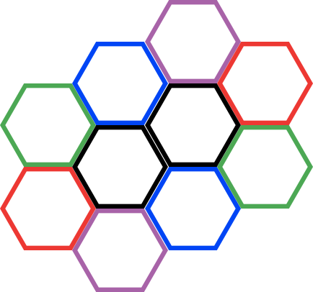
Figure 1(The black hexagons represent the primary units, fixed in place to the wall. The paired coloured hexagons represent recommended set ups for the secondary units)

In order to limit the overbearing weight distribution of two secondary’s stemming from a singular primary unit, I designed the secondary units to have only one access point. The primary unit’s each have access points on each side of the hexagonal perimeter, allowing the user to input in any direction. The secondary’s one access point is where they link to the primary. This disallows a secondary building from another secondary.

Hinge System
Through sketching exploration, I researched different ways for which my design could be formed. From magnetic strips to whole system brackets, I explored a range of styles for how to link the units. The key features this system needed to have was that it was simple enough for the user to use with ease but not overbearing within the design. A linear track was the front runner in my design proposal but I felt that this took away from the design simplicity and the clean silhouettes of the hexagonal units (as the hexagonal units would not be able to sit flush against one another). From here I made the step to an embedded sliding system where a dovetail style wedge fits between units. By making the male part of the sliding system embedded in the units, rather than an addition part, this kept the design simple and clean cut. This was important for my design style as I want the silhouette to be crisp and each part to sit flush to one another. The male parts act as the wedge keeping the paired units together. When a female part is not in use there are half wedges to be put in, in order to avoid gaping hole (see figure 2).
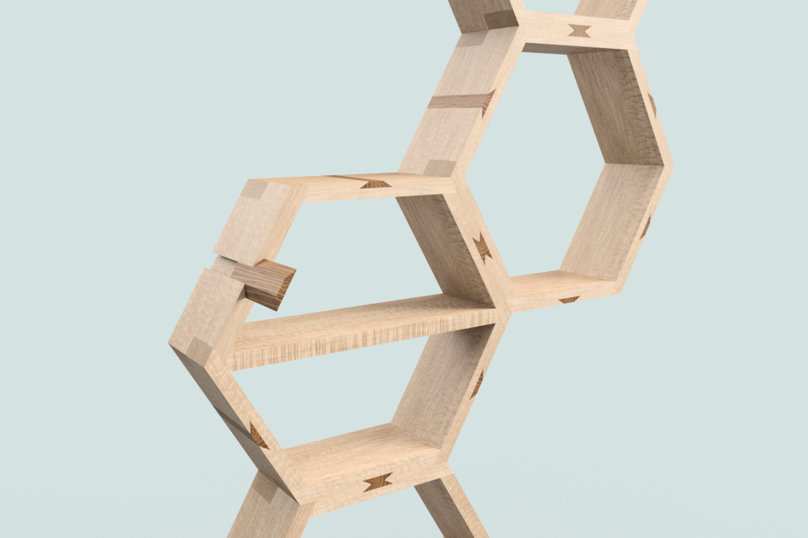
Figure 2 demonstration of half wedge being inserted to fill gap

Through discussion with a medley of people in respect to this hinge system there was a common response of worry about it being weak. Although tested to success I took this note on board and revisited my design. Exploring alternative styles to reassure the consumer, I looked to double the hinges and increase their size. I chose the extension of size as I felt this was better aesthetically and also kept the method simple.

Assembly
Honey takes place in the form of four units- separated into a pair of primaries and a pair of secondary’s- three wedges, eight half wedges and a pair of wall inserts (as showcased in the Figure 3). To set up my product, a design is decided using a list of recommended formations. Once a system order is decided the user uses the template included in the packet to decipher where on the wall the unit will be placed (paying close attention to its degree orientation making sure its level). This template will show the user where they need to drill into the wall to anchor the product. Once marked up, and double checked, the user can then make the step of installing the wall inserts. After these are in the wall, the two primary units are placed upon them securely, with no screws required. With the primary units placed, a wedge piece can be placed between the two to bind them together and fill female wedge-less part leaves. To then apply the secondary units, the user puts the remaining full wedges into the female anchor points where they wish to build from, and then follow this up with the units themselves. The remaining gaping parts are filled with the half wedges, as explained before. When the user feels inclined to change the systems shape they remove the secondary units by just pulling them towards themselves square on, decide where it is to go and from there swap out the holding half wedge for the full wedge and replace it with the half wedge, and then push on the secondary unit. This change can happen as and when the user wants to.
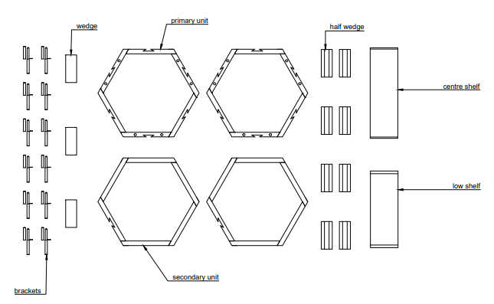
Figure 3 Items list

Quality and Testing

In order to achieve a higher end product, I needed the piece to have greater quality in regards to its style, than those of existing products. In order to achieve this, I focused on the joints within each individual unit and its material. I also wanted to have the joints visible, to give a more character to the units. To achieve this, I looked into different joint systems and material choices. For the joints, I focused on finger joints as these are a staple piece in woodworking, and are a simple way to show more care and intricacy in its manufacturing.
Whilst exploring different styles of finger joint quantities, I found a pairing of three fingers was visually pleasing and so began testing with this. Considering the hexagonal shape to be used, the 60 degree angle was something to cause concern as it gave an easier slip potential than that of a 90 degree turn. However when made, it tested to hold 25kgs with no sign of breaking or slipping, with the joint glued together with PVA. This weight was to be considered a success, by using the weight of a 4 year old –which is at an average 18.14 kg. This was the baseline weight. After considering ‘worst case scenarios, I concluded that a child trying to hang off the shelves could cause the most harm, and past 4 I would assume the child should have the sense to not do so. By knowing that one joint can hold past this weight I can then assume that as a unit it would be stronger in whole by it then having the next face to push off from and not slip.
Through personal production of this joint I concluded that the cost benefit was not productive enough for the mass market I would want me product to endure. And so from here I went back to looking at the joinery methods. I revisited a lower quantity finger joint of a simple singular finger per end. This still gave the piece an exposed end of joint and so the detailing was still there and thus the character of the piece was still integral, however the efficiency of the making was more primal. This refined joint choice was then tested in the same set up as before, with a table like set up put on top of the joint with weights put upon it. This is how I tested the joint as it was the weakest direction of the joint in regards to the chance of it slipping. This test however was completed with Gorilla Heavy Duty Gab Adhesive instead of PVA glue as this gave a stronger grip. The test was again a success, being tested up to 31.25kg with no signs of slipping or breaking.
To achieve the character and individuality in the piece through the material I explored different types of wood -synthetic and natural- and those with different finishes such as a lamination or varnishes. I knew I wanted to make the product with wood as this was a material that I felt held an abundance of character through the detail of the grain. From the exploration of testers I decided to use beech wood. The grain was visible, and this feature of individuality was key, but was not overbearing. I felt that this was the right choice in material as a high define grain would limit its suitability within the owners home/space. The strength of Beech was a major factor as it had to be strong enough to withstand potentially heavy items. Beech hosts a tensile strength of between 106 and 130 MPa. I completed testing of the joints and hinge system using MDF which had a considerably lower tensile strength range of 10.2 to 25.2 MPa. My testing proved successful, to previously mentioned minimal limitations of a child’s weight, and so I can conclude that the beech will be even more successful. Choosing wood as my material choice was not only due to the character embarked on wood through its grain but also for its sustainability aspects. In the throwaway society we live in now, using a material that can repurposed or recycled, and that is renewable is advantageous as it doesn’t contribute to the growing wasteland that so many products feed into.

Manufacturing, Audience, and Use Cases.
The production purpose for Honey would be for that of mass production. Angled plane CNCing would be used to achieve the singular finger joinery at the appropriate angle of 60° across the end faces of sides to a depth of 3inches. To achieve the recess of the female part of the hinge the side pieces will again be CNC cut, by either two strokes- a forward cut using a standard cutter at 1inch to then be followed through with a dovetail cutter of 30° to achieve the angled sides- or by using a specialist made tool bit tool to achieve the cut in a singular stroke. The anchor holes on part A on the primary units would be achieved by using pillar drills with a 12.5 mm tool bit to a depth of 80mm. To machine the wedges a specialist tool would be required, in a diamond shape with a centred 60°, this then cuts the side profile of pre-cut 2.4 x 6 x 0.8 inch bit of beech, in order to get the required shape. The half wedges are made with 30° dovetail tool bits on the CNC machine cutting into pre-cut 2.4 x 6 x0.4 in bits of wood. Assembly of units would be by hand with the prior mentioned gorilla grab adhesive coasted on overlapping sections, and then clamped together.
Mass production is necessary as I believe Honey suites shops such as Next Home. Next Home operate around 500 stores in the united kingdom and so feature within this brand a high quantity would be required, of a minimum of 5000 required at start of sales to then increase depending of interest, and thus meaning mass production is required.
Next have a targeted consumer age range of between 20 and 46 years, with a primary focus on that of the ages 25-35. A reason why this is a suitable audience for my design is that with Honey’s ability to be changed and personalised without marking the user’s walls it will appeal to those in renting situation. This is a key point in regards to my audience awareness for my design, as renting has not only gone on the rise, where in 2011 there were 11% of the adult population living in private renting, but in 2018 this soared to 28%. As well as this, the ages of those renting take hold primary within the ages below 35 for private renting and with social renting under 35’s still hold a collective almost 40% (see figure 4).
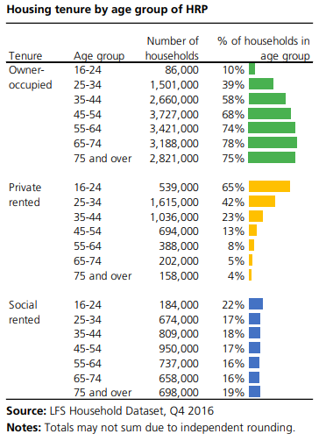
Figure 4

Not only is Honey appropriate for the renting market, be that by the owner not wanting to spoil their property repeatedly, but also by the tenant by its ability to allow them to achieve their own personal touch in a space they may not otherwise be allowed to. Honey is also appropriate to any home situation. Due to its changeable style the function can be formatted to suit best the user in any which environment they need. It’s not limited to a singular room such as that of the living room, but can reach maximum potential in other scenarios such as that of the home office, kitchen or child’s room (see Figure 5, 6 & 7). The size of each unit in particular allows for a whole range of items to be stored, and with the drop in sub shelves allowing multi-layer filling.
I have based the retail price of Honey at £400. This price took into consideration the cost of material labour and reward. This price is far more than other hexagonal shelving’s however no other system is similar. The uniqueness of Honey encourages the high price, it’s not like that of anything on the market right now, and can give the user a sense of individuality. It mimics the nature of a one off piece but is accessible to the many. This price correlates to the desired market- Next- who retail their solid wood large shelving systems as high as £1,299.

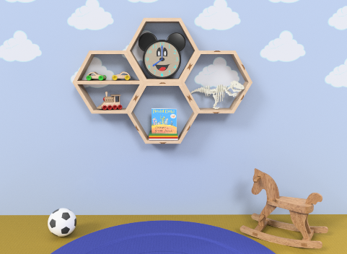
Figure 5
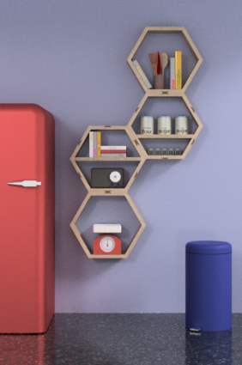
Figure 6
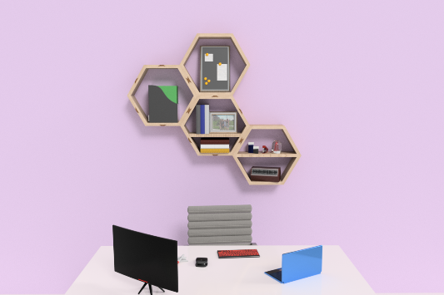
Figure 7

Design Philosophy
This design is a physical manifestation of my own design philosophy; ‘The Future is the Past Repeating Itself’.

‘The future is the past repeating itself; this is what I believe to be true. New things are mere regurgitations of things before and that is something that cannot be ignored. Every new though you have come from each turn of your life until that point, that has been installed, digested and brought back out in a newly reformed manner.’
One of the primary function of Honey is its ability to be formatted in a medley of ways, depending on the user. A change of mood, requirements or a development of understanding can see the piece be reorganised. The core pieces are the same; a changed system of Honey is a by-product forged from a conglomerate of factors that are simply regurgitated to become a new product. The user learns from its possibilities, to an extent of ranged directions.

‘There is almost no such thing as a new thought’
Just in the same as the above quote, honey has a limited number of possible orientations. And so, what may be a new and fresh set up to the user will have almost certainly been completed already by another. However this is not something to deter the user, the sense of the individuality is the key aspect. As is with a new thought, a new rendition of formation of Honey had to have come from somewhere. Be it, a frustration with a prior set-up, an inclination to a new style or any other means, the user learns and evolves; in a manner of speaking, every [orientation] will always be a prototype, ready for another rendition of what they might believe to be better.

References
Linnett, E. 2018 The Future Is The Past Repeating Itself. Personal Manifesto: UWTSD
Websites:
Harding, A. (2019). The 15 Most Popular Ikea Products of All Time. [online] The Cheat Sheet. Available at:
https://www.cheatsheet.com/culture/the-15-most-popular-ikea-products-of-all-time.html/
Next (2019). Sideboard Shelving Homeware from the Next UK online shop. [online] Next.co.uk. Available at:
https://www.next.co.uk/shop/department-homeware-productaffiliation-sideboardsshelving/isort-price%20rev#1_0
Reference For Business. (2019). Next plc - Company Profile, Information, Business Description, History, Background Information on Next plc. [online] Available at: https://www.referenceforbusiness.com/history2/0/Next-plc.html
Statista. (2019). Next store numbers 2012-2019 | UK Statistic. [online] Available at: https://www.statista.com/statistics/462421/next-store-numbers/?fbclid=IwAR0zMXFk8d8-m9kX1NbwNVtBXw7FV2tjuNJFqwtKzeBSwZ0wrrj1MvPZp-o
Swedish Wood. (2019). Wood is a sustainable construction material - Swedish Wood. [online] Available at:
https://www.swedishwood.com/about_wood/choosing-wood/wood-and-the-environment/wood-is-a-sustainable-construction material/?fbclid=IwAR346MnwLLtwklikCiFU_oGle0ZdCmZJFIulBBSSrVqIqQeXMvySarv2YYc

Word count: 3286

