Network and cyber security essentials
Lab 4

Table of Contents
IP addressing table 2
Pinging 3
Pinging Server 3
Pinging PC1 3
Ping PC2 4
Ping PC3 4
Ping PC4 4
Ping Laptop 5

IP addressing table

Device name | Interface | IP Address | Subnet Mask | Default Gateway
Server-PT | NIC | 192.168.1.14 | 255.255.255.0 | 192.168.1.15
PC-PT PC1 | NIC | 192.168.1.10 | 255.255.255.0 | 192.168.1.15
PC-PT PC2 | NIC | 192.169.1.11 | 255.255.255.0 | 192.168.1.15
PC-PT PC3 | NIC | 192.168.1.12 | 255.255.255.0 | 192.168.1.15
PC-PT PC4 | NIC | 192.168.1.13 | 255.255.255.0 | 192.168.1.15
S960-24TT Switch | NIC | N/A | 255.255.255.0 | N/A
1941 Router | NIC | 192.168.1.15 | 255.255.255.0 | N/A
2901 Router | NIC | 192.168.3.1 | 255.255.255.0 | N/A
AccessPoint-PT | NIC | N/A | 255.255.255.0 | N/A
Laptop-PT | NIC | 192.168.3.2 | 255.255.255.0 | 192.168.3.1

The table that has been presented above is my devices that I used in my simple network.

Pinging

Pinging Server

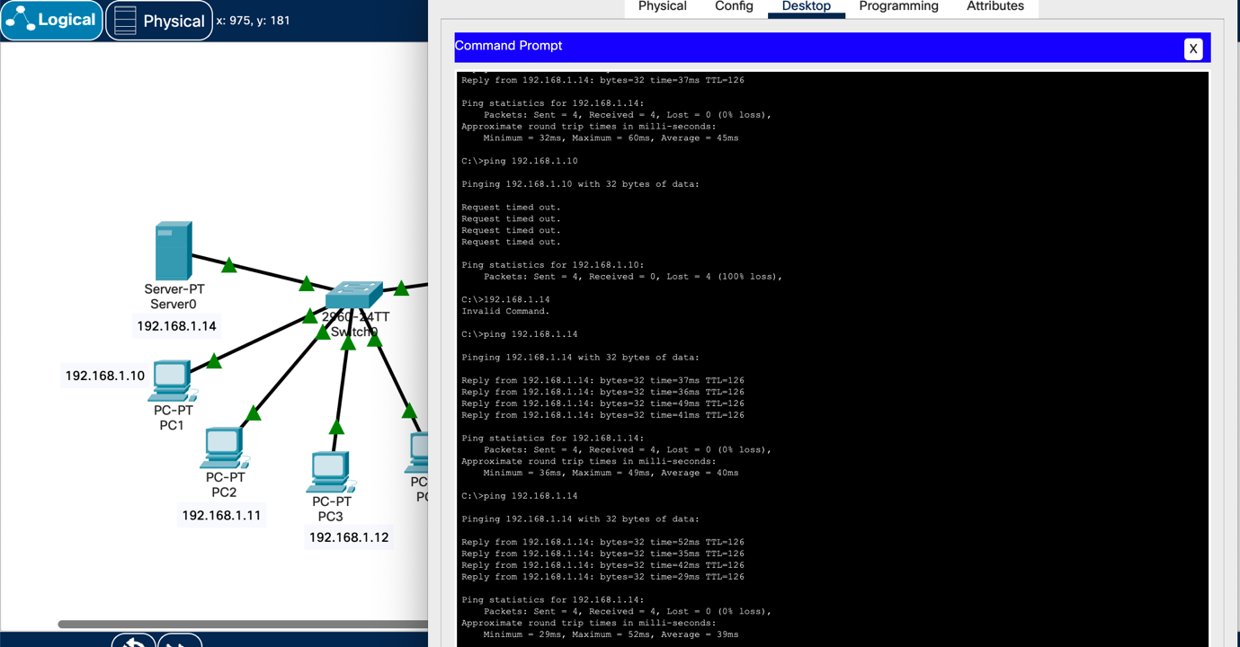
This screengrab is from when I used the laptop to pining the server, and as you can see the ping was successful.

Pinging PC1

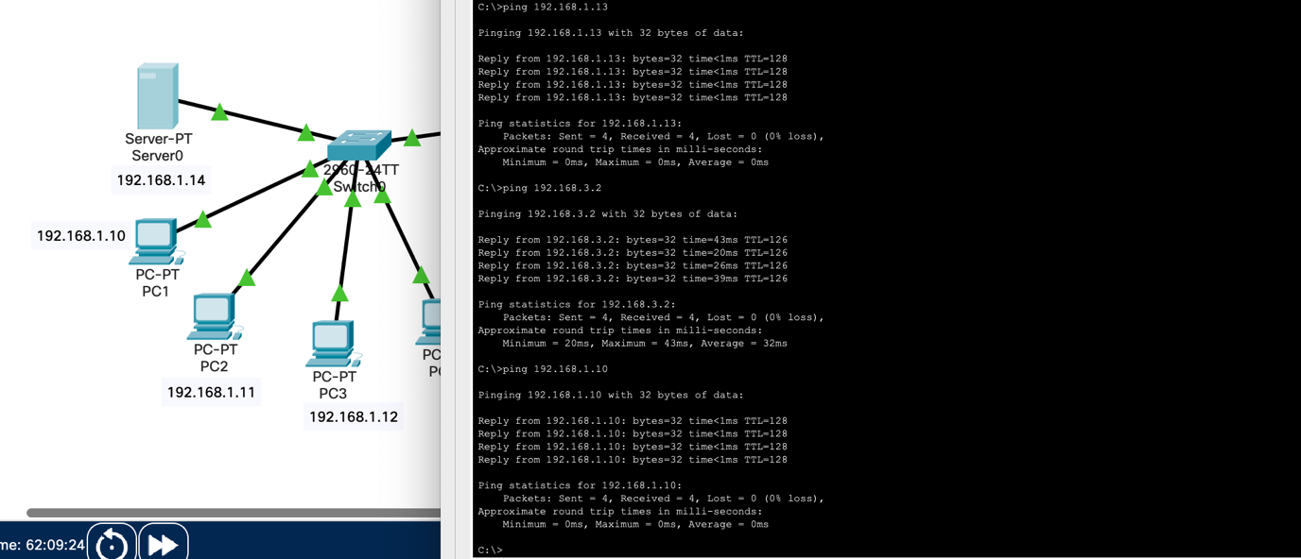
This screengrab shows the successful ping from the server to PC1.

Ping PC2

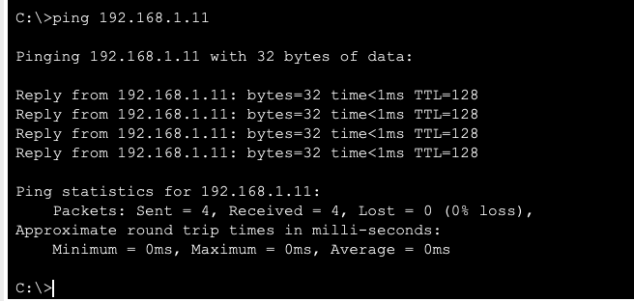
This is a screenshot of me pinging PC2 from the server.

Ping PC3

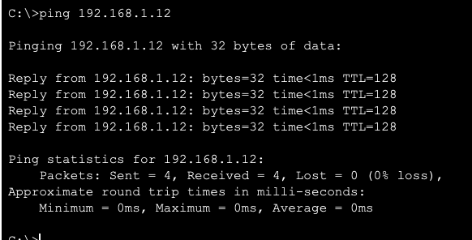
This is a screenshot of me pinging PC3 from the server.

Ping PC4

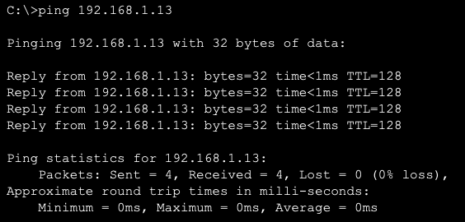
This is a screenshot of a ping from PC4 from the server.

Ping Laptop

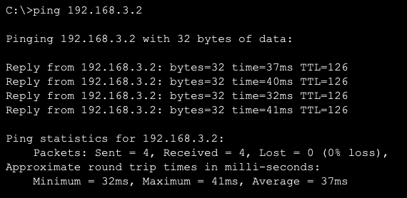
This is a ping from the server to the laptop.

Logical and physical topology

Logical

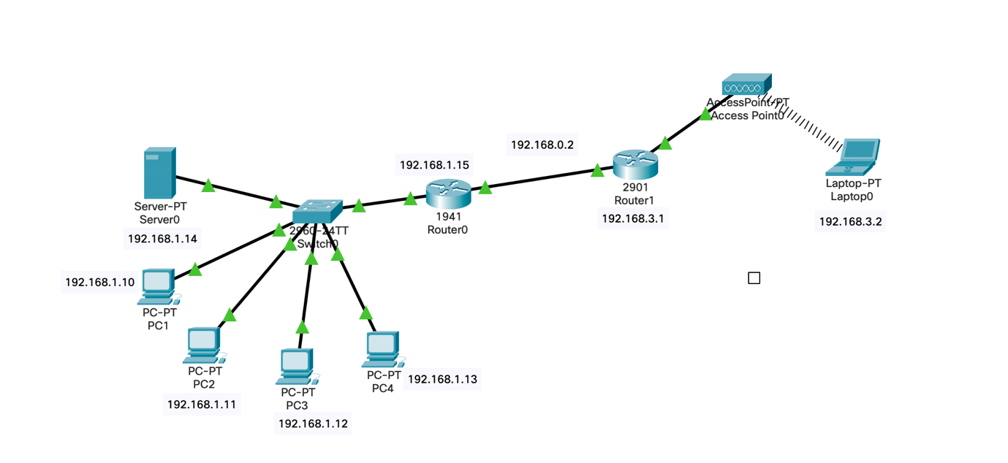

This is my logical topology.

Physical


This is my physical topology.

