
The challenge faced by the enegy sector


December 5, 2022
Tudor ioan plescan
2127270

University of Wales
Trinity Saint David

Contents
1.0 Introduction 2
2.0 Main Findings 3
2.1 Nature, Scope and Impact 3
2.2 SWOT Analysis 3
2.3 PESTLE Analysis 4
3.0 Conclusion 5
4.0 Recommendations 6
5.0 Planning, Monitoring and Reviewing the Solution 6
6.0 Appendices 7
7.0 Reference List 9

Introduction

At this very moment the energy sector in UK is the middle of a crisis. The energy crisis is unprecedented and is driving the cost of living crisis. Last October, 4.5 milion UK households were in fuel poverty. (National Energy Action, 2022)
It is very hard for people who are living in the UK right now because some of the people will have to choose between a warm house or a warm meal witch it’s not acceptable in 2022.
Looking at the nature of the problem and at all internal and external stakeholders everybody it is suffering due to the crisis in the energy sector.

Main Findings

Nature, Scope and Impact
As presented couple of weeks ago, the nature of the problem in the energy sector is the unpredictable actions from Russia. Due to the conflict between Russia and Ukraine, the energy sector in Europe suffered a lot. The scope of the problem is affecting internal and external stakeholders. People are suffering from the crisis because the price of gas and electricity which mean average prices have been increased by 27% in October 2022 and they will increase again in April 202 with another 20%. (Bolton and Steward, 2022). The impact on internal and external stakeholders it is big. The low and middle classes are struggling with paying the increased bills and sometimes people have to make drastic choices to be able to afford to live. Internal stakeholders will suffer because of the demand for their staff and resources. The government is trying to find reasonable options and solutions but in the meantime, the population has to face big gas and electric bills.
External stakeholders are affected the most by this crisis. A lot of people because of the price rises are going into debt and they are finding it hard to get back on their feet.
Looking more into the depth of the problem, using the 5Why’s theory the nature, scope, and impact can be worked out easier.

SWOT Analysis
SWOT ( strengths, weaknesses, opportunities, and threats) analysis is a framework used to evaluate a company’s competitive position and to develop strategic planning. SWOT analysis assesses internal and external factors, as well as current and future potential. (Kenton, 2022)
Working with SWOT analysis, the business can look into their problems find their weaknesses and strengths, and also can look into opportunities how to build a better business. Using SWOT businesses can also look at threats from competitors and find suitable solutions for the future so the business can develop more in the coming years.
As identified in the SWOT analysis a war or pandemic cannot be something someone can think of, but, there should always be a worst-case scenario and how to react when something like this happens. Having multiple solutions for different problems and unexpected events could help businesses stay open for a long time.
If the UK didn’t rely on different countries for their gas and electricity and had already options for self-sustainable resources, not even the war would’ve affected the UK economy.
As a business, the owners should always be aware of conversion strategies because they can help to fix different problems and that would make the business more independent (self-sustainable resources > rely on other countries for resources)
Geothermal energy it’s a self-sustainable resource. Once at the surface, fluids of various temperatures can be used to generate electricity. The technology for electricity generation from hydrothermal reservoirs is mature and reliable, and has been operation for more than 100 years. (United Nations, 2022)

Using SWOT Analysis on the energy sector, the internal stakeholders can find where the business is not doing well but also find solutions for the existing problems.

PESTLE Analysis
A PESTEL analysis is a strategic framework commonly used to evaluate the business environment in which a firm operates. Traditionally, the framework was referred to as a PEST analysis; The framework was extended to include Environmental and Legal factors as well. (peterdy, 2022)
It’s very important for a company to follow this analysis because it can help the business grow and develop into a healthier business.
PESTEL analysis it’s formatted from Political Factors, Economic Factors, Social Factors, Technical Factors, Environmental Factors, and Legal Factor
Specifically, the PEST or PESTLE analysis is a useful tool for understanding risks associated with market growth or decline and as such the position, potential, and direction of a business or organization.
Looking at business sometimes it looks like they are doing fine and the business is running as it should but deep down they may have different problems which could be of legal nature where they might not have the right legal team which could get the business in a major situation where a lawsuit will be created so the business could be affected economically and in the worst case scenario the business will have to close. It’s very important for a business owner to choose your employees carefully because in the future they could damage your business and that can make the owner bankrupt.

Looking at the PESTEL analysis in this report, the energy sector could look and find reasonable solution for the crisis the UK is facing right now. It is very important to take into consideration every little aspect because sometimes the little things can make a difference. As it’s been stated before, nobody can predict a war or a pandemic but if the government had in place the right technology and resources, the working class wouldn’t feel the crisis they feel now these days. Owners of businesses should always look for new ways to make their business run properly and how to improve their services. Looking for new methods and technology will help the business to be up-to-date with the evolution.

3.0 Conclusion

As it’s been stated before, looking for the right way to manage a business a lot of the existed issues won’t exist anymore. Having the right people working in the right position will help the business to grow and not face problems in the future.
The energy sector at this very moment is facing a major crisis. Because nobody looked at how to create a solution before the problem existed and nothing is been prevented now the whole country has to suffer. From the low class to the high class, everybody is facing very expensive bills for their gas and electricity which will lead people to go into debt because they won’t be able to afford their bills.
If everything was looked into it, these problems wouldn’t exist now and everybody could live their life a bit easier because people sometimes are struggling when it comes to money.
Due to the crisis, a lot of businesses will go bankrupt because sometimes the profit won’t cover the cost of gas and electricity (for example: a bakery ) and they will have to shut their doors. The communities will suffer as well because when a small business will have to shut its doors, people will have to go to big supermarkets or shops, and sometimes small communities will have to commute to the next village or town to get the essentials for day-to-day life.
Having the right technology and the right attitude toward the unknown could have the country go thru this crisis easier. Self-suitable resources would make the country more independent and that would help because the UK won’t have to rely on other countries for their resources.

4.0 Recommendations
As looking for recommendations, the owners should always look for ways to improve because that’s the only way to move forward.
As discussed, the energy sector it is big. When talking about the energy sector people need to think that it’s not only the companies who are responsible for this crisis but the government as well.
The county has relied on different countries for their resources when they could’ve find different solution to make the county self-sustainable.
Looking for solution, wind energy could be one of them. UK could have plenty of wind turbines due to the weather of UK.
Wind is a plentiful source of clean energy. Wind farms are an increasingly familiar sight in UK. To harness electricity from wind energy, turbines are used to drive generators which then feed electricity into the National Grid. (Davies, 2017)
As a normal person, the residence location can play a major role in energy-efficiency. Windy places can be easily used to have installed a wind turbine. Wind turbines can produce a lot of extra energy, which people can sell it back to the grid. (Keen’s Buildings, 2021)
Solar panels could be a good idea because it’s self-suitable and cuts your carbon footprint.
Solar electricity is a low-carbon, renewable energy. A Typical home solar PV system could save around one tonne of carbon per year, depending on where you live in the UK(Energy Saving Trust, 2021)
Water it’s another way to produce electricity using hydropower and hydrokinetics. Hydropower or hydroelectric power is one of the oldest and largest sources of renewable energy, which uses the natural flow of moving water to generate electricity. (US Department Of Energy, 2014)
Biomass is organic, meaning it is made of material that comes from living organisms, such as plants and animals. The most common biomass materials used for energy are plants, wood and waste. Biomass Energy can also be a non-renewable energy source. (Turgeon and Morse, 2022)

There are out there different recommendations and solutions but the right people need to look at them more often. In the end of the day, a crisis like the population is facing right now could have a really bad effect on the population in the short run but in the long run as well. Internal and external stakeholders will feel the effects of the crisis every day. From not having enough money to pay the bills to finding the right resources to meet the demand.

5.0 Planning, Monitoring and Reviewing the Solution

Planning, Monitoring and Reviewing the Solutions is a very important step for any kind of business, no matter if it is a small business or a big business. It’s very important that you have a backup plan which will help to keep the business running. Businesses should never have just one solution and they should always have another one at least in case the first one won’t work.
Keeping up with the legislation and policies will help the owners with monitoring the business and they can see if the solutions they have it’s suitable for future problems.
Shortage of self-sustainable resources and solutions for the energy sector crisis
CRITERIA | WEIGHTING | SOLUTIONS
 |  | Solar panels | Wind turbines | Hydroelectric | Biomass
INTERNAL IMPACTS | 1 | 1 | 2 | 1 | 5
RESOURCES REQUIRED | 4 | 3 | 3 | 2 | 6
STAKEHOLDER INVOLVEMENT | 3 | 4 | 1 | 3 | 4
COST TO IMPLEMENT | 5 | 2 | 4 | 4 | 1
TIME TO IMPLEMENT | 2 | 5 | 5 | 5 | 2
LONG-TERM BENEFITS | 7 | 6 | 6 | 7 | 3
SHORT-TERM BENEFITS | 6 | 7 | 7 | 6 | 7
TOTALS |  | 129 | 131 | 133 | 113

6.0 Appendices
5Why’s theory
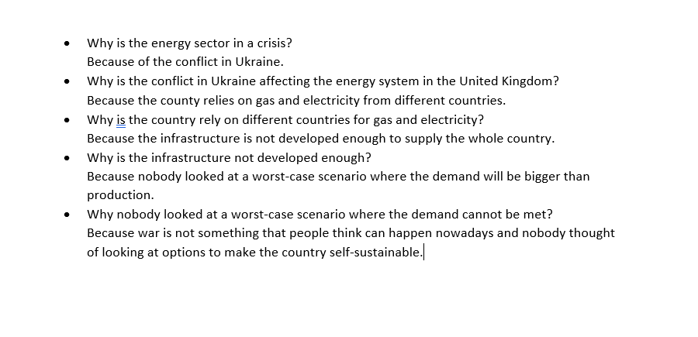
SWOT analysis :
Strengths | SWOT ON THE ENERGY SECTOR | Weakness
Established infrastructure |  | Growing Demand
Energy Efficiency |  | High Turnover
Opportunities |  | Threats
Tax Incentive |  | War in supplying countries
Seasonal increase in the number of days of sunlight |  | Rising costs
Investing in wind turbines |  | Compliance and regulatory risks

PESTEL Analysis :
P  POLITICAL | E  ECONOMIC | S  SOCIAL | T  TECHNOLOGY | E  ENVIRONMENTAL | L  LEGAL
Pandemic  No renewable energy source  Tax increase | Inflation rate  Industry growth demand  Unemployment rate | Culture related  Buying habits | Electric cars  Green Energy  Training in development | Renewable energy  Impact of a future pandemic  Recycling  Climate Change | Health and Safety  Employment Law  Data Protection

7.0 Reference list
Bolton, P. and Steward, I. (2022). Domestic energy prices. [online] House of Commons Library. Available at: https://commonslibrary.parliament.uk/research-briefings/cbp-9491/.
Davies, L. (2017). Types and alternative sources of renewable energy. [online] EDF Energy. Available at: https://www.edfenergy.com/for-home/energywise/renewable-energy-sources.
Energy Saving Trust (2021). Solar panels. [online] Energy Saving Trust. Available at: https://energysavingtrust.org.uk/advice/solar-panels/.
Keen’s Buildings. (2021). Importance of Self-Sustainable Living | Keen’s Buildings. [online] Available at: https://keensbuildings.com/what-is-self-sustainability-and-why-is-it-so-important/.
Kenton, W. (2022). SWOT Analysis: How To With Table and Example. [online] Investopedia. Available at: https://www.investopedia.com/terms/s/swot.asp.
National Energy Action (2022). Energy crisis. [online] National Energy Action (NEA). Available at: https://www.nea.org.uk/energy-crisis/.
peterdy (2022). PESTEL Analysis. [online] Corporate Finance Institute. Available at: https://corporatefinanceinstitute.com/resources/management/pestel-analysis/.
Turgeon, A. and Morse, E. (2022). biomass energy | National Geographic Society. [online] education.nationalgeographic.org. Available at: https://education.nationalgeographic.org/resource/biomass-energy.
United Nations (2022). What Is Renewable energy? [online] United Nations. Available at: https://www.un.org/en/climatechange/what-is-renewable-energy.
US Department Of Energy (2014). Hydropower Basics. [online] Energy.gov. Available at: https://www.energy.gov/eere/water/hydropower-basics.

