
BMHP5015
Changemakers: Building your Personal Brand for Sustainable Employment
LECTURER: Wafa Nasir
Student: Mihaela Rodica Bob
Student Number:2419507

Task 1 – Personal Brand

A personal brand stands for the distinct combination of skills, values, and reputation and individual projects to employers to prove their professional value (Rampersad, 2015). Building an authentic personal brand is essential for standing out in today's job market and successfully navigating career transitions.
​Currently, my brand combines twelve years of UK hospitality experience-including five years as a housekeeping supervisor-with formal education in health and social care. Having completed Level 4 qualification, I am currently in the first year of my bachelor’s degree in health and social care. My professional background has developed my emotional intelligence, crisis management, and cross-departmental communication, strengths that my colleagues and supervisors consistently recognize.
​My ultimate ambition is to become a Behavior Therapist working with adolescents. To bridge my current role with this goal, I must proactively reframe and enhance my professional identity (Peters, 2020). Alongside my degree, I plan to undertake specialized training to become a Registered Behavior Technician (RBT) and gain practical experience in special educational needs (SEN) settings. Furthermore, I intend to leverage my academic journey to build a professional network on LinkedIn and connect with youth mental health practitioners. Engaging with professional bodies such as the UK Society for Behavior Analysis will further establish my credibility (Gorbatov, Khapova and Lysova, 2018).
​Ultimately, aligning my social care degree, leadership background, and specialized behavioral training will allow me to build a strong personal brand, securing my dream job supporting young people.

Task 2 - Network Map and Rationale

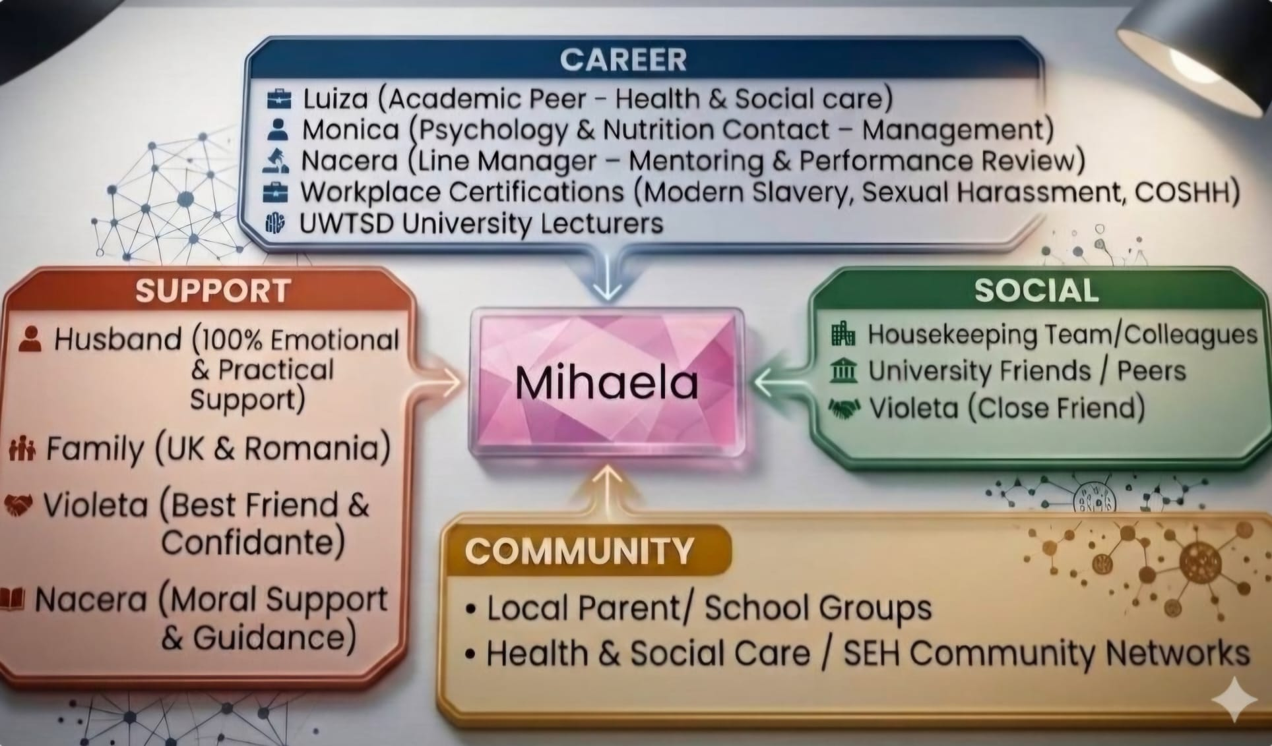

Currently, my personal and professional network can be classified as a hybrid network, combining strong closed elements with selective open connections (Bourdieu, 1986). Having worked in the UK hospitality sector for twelve years as a supervisor while currently studying for a BSc in Health and Social Care, my network is naturally divided across different environments.
​Analyzing my social capital reveals an important level of bonding social capital. I have strong, high-trust connections with my husband-who is in his final year of university studying management and provides complete emotional and practical support-alongside my family, close friends, and current hospitality team (Putnam, 2000). However, as I aim to transition into a career as an adolescent Behavior Therapist, this tight-knit network presents clear limitations.
​My primary area of weakness lies in bridging and linking social capital within the pediatric and behavioral therapy sectors. While my current university peers, management-focused contacts, and workplace training in safeguarding offer emerging bridging connections, I lack direct "linking" relationships-specifically connections with clinical supervisors, SEN coordinators, and established youth mental health practitioners (Granovetter, 1973).
​To address these gaps and support my career progression, I must strategically expand my network. I plan to join professional organizations such as the UK Society for Behavior Analysis and attend relevant developmental psychology conferences. Additionally, securing entry-level experience or volunteering in special educational needs (SEN) settings will allow me to build meaningful connections with senior decisionmakers, thereby strengthening my linking social capital and advancing my long-term career goals.

Task 3- Blog

Embracing the Digital Shift: How Technology is Transforming UK Social Care
Target Audience: Social care professionals, and care workers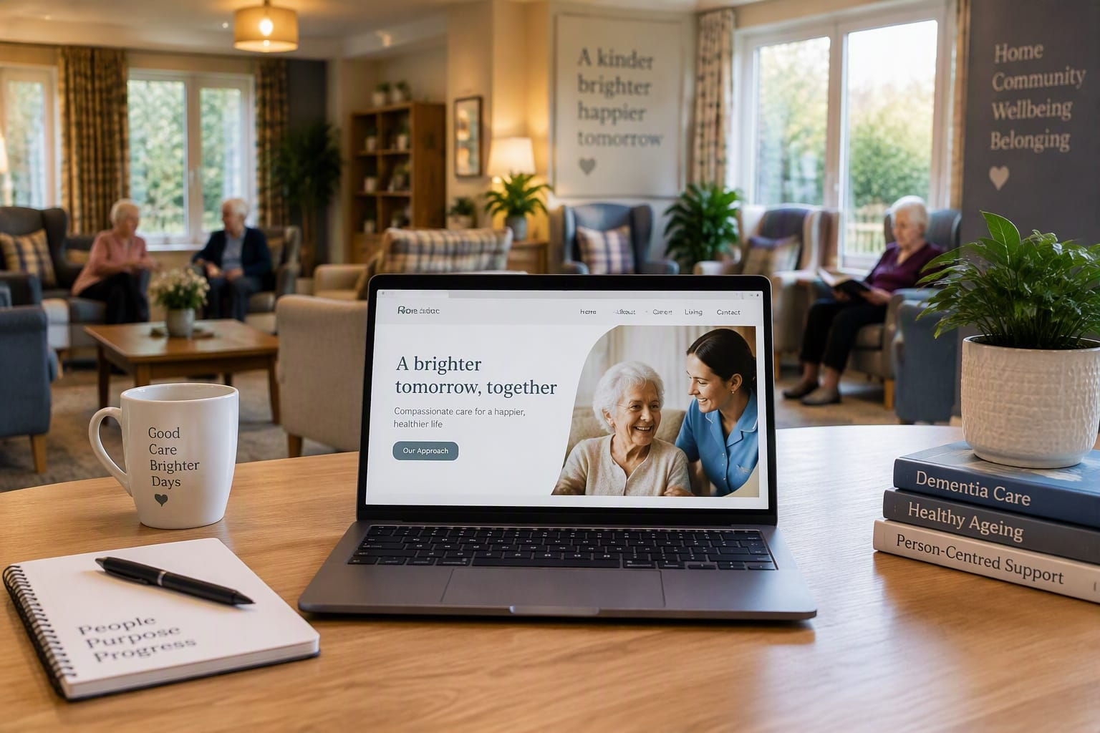

Introduction
The UK health and social care sector faces growing demand and staffing shortages. Digital innovation, from electronic care records to Artificial Intelligence (AI), is essential to modernising care delivery.
​The Rise of Digital Records
Digital Social Care Records (DSCRs) are replacing paper-based documentation, enabling real-time information sharing across care homes, community teams, and the NHS. This reduces administrative burden, minimises human error, and ensures care remains seamless and person-centred.
​Smart AI and Initiative-taking Care
AI and smart devices—such as wearable health monitors and fall-detection sensors—enable proactive intervention before crises occur. By detecting early signs of deterioration, these tools support independent living for vulnerable individuals while promoting dignity.
​Overcoming Implementation Challenges
Transitioning to digital care presents challenges regarding data privacy, cybersecurity, and staff digital literacy. Organizations must invest in comprehensive training to build workforce confidence. Crucially, technology should enable rather than replace human empathy.
​Conclusion
Digital transformation is actively reshaping UK care. By adopting innovative solutions and prioritizing person-centred values, providers can build a sustainable, efficient, and compassionate system.

Task 4- NHS Equality, Diversity and Inclusion Quiz What is the primary goal of the NHS Equality, Diversity, and Inclusion Improvement Plan?
The core objective is to dismantle structural inequities and discrimination across the NHS workforce, promoting a fair and supportive environment. This initiative seeks to boost staff retention, enhance work experience, and deliver superior care to service users.

- How does the NHS EDI Improvement Plan propose to tackle the gender pay gap?
To address pay disparities between genders, the strategy focuses on increasing female leadership through targeted career advancement channels. Furthermore, it advocates for transparent recruitment standards and adaptable work options to retain female staff across all seniority levels.

- What is meant by the term ‘intersectionality’ as used in the NHS EDI Improvement Plan?
Intersectionality describes how multiple protected characteristics, including race, gender identity, disability, and sexual orientation, overlap to generate distinct forms of advantage or marginalization. The plan adopts this perspective to ensure EDI strategies target these combined experiences rather than examining traits in isolation.

- Why is it important for the NHS to create a psychologically safe work environment?
Proving a psychologically safe workplace allows employees to voice concerns, report errors, and offer feedback without fearing negative repercussions. This culture of transparency alleviates workplace stress and directly safeguards patient outcomes.
- How does the NHS EDI Improvement Plan suggest improving the experience of internationally recruited staff?
The strategy outlines structured orientation, tailored cultural integration, and continuous pastoral guidance to help international recruits settle smoothly. It also guarantees equal access to mentorship programs and career progression pathways right from the start.

- What role does leadership play in advancing EDI objectives according to the NHS Improvement Plan?
Leaders are expected to embed inclusive principles into daily operational practice and take responsibility for EDI outcomes. Senior staff must champion equality values, define actionable goals, and actively cut workplace barriers for their teams.

- Identify one way the NHS EDI Improvement Plan aims to reduce health inequalities within the workforce.
One key measure involves offering targeted occupational health and mental wellbeing resources designed to meet the specific requirements of underrepresented employee groups.

- Why does the NHS EDI Improvement Plan emphasize the importance of collecting and analyzing data on protected characteristics?
Systematic data collection and evaluation help the NHS pinpoint representation gaps, track disparities in career progression, and assess the true impact of EDI policies. This evidence-based approach ensures interventions are precise and result-driven.

- Explain how flexible working policies can contribute to equality and inclusion in the NHS workforce.
Flexible working models accommodate staff members with caregiving duties, long-term health conditions, or disabilities, helping them remain in employment. This approach builds a more diverse workforce while offering equal prospects for professional growth.

- What is one strategy mentioned in the NHS EDI Improvement Plan to combat bullying and harassment in the workplace?
One central measure is creating transparent, accessible reporting channels alongside mandatory training in civility and anti-racism for managers to address microaggressions promptly.

Task 5- A Letter to Yourself

​Dear Younger, Me,
​I am writing this letter to you during those early, daunting days of moving to the UK. I know how overwhelmed you feel right now. You are in a new country without extended family, struggling with a language barrier, and starting a new job in housekeeping with no prior experience. On top of that, your heart aches with worry over whether your young son will integrate at school, while you and your husband barely cross paths because of his exhausting double shifts.
​I want to reassure you that you are far stronger than you realize. Back then, you were relying heavily on resilience, the quiet strength that allowed you to keep pushing forward despite constant uncertainty and fear. Every difficult shift and every quiet moment of worry was secretly building your capacity to adapt, learn, and persevere.
​If I could give you one perspective during that time, it would be a deeper understanding of emotional intelligence, particularly self-compassion and emotional regulation. You carried an immense emotional load, often feeling isolated and anxious. Developing emotional intelligence at that stage would have helped you acknowledge your fear without letting it overwhelm you. It would have reminded you to be kinder to yourself, recognizing that adapting to a new culture and learning a new language takes time.
​Looking back, those hardship-filled months were not in vain. They laid the foundation for the empathy, adaptability, and emotional maturity you draw upon today in your health and social care career. Your son will adapt and thrive, your English will improve, and your hard work will open doors you cannot yet imagine.
​Be proud of your courage. You are building a brighter future, one resilient step at a time.
​With love and admiration,
Your Future Self

Task 6

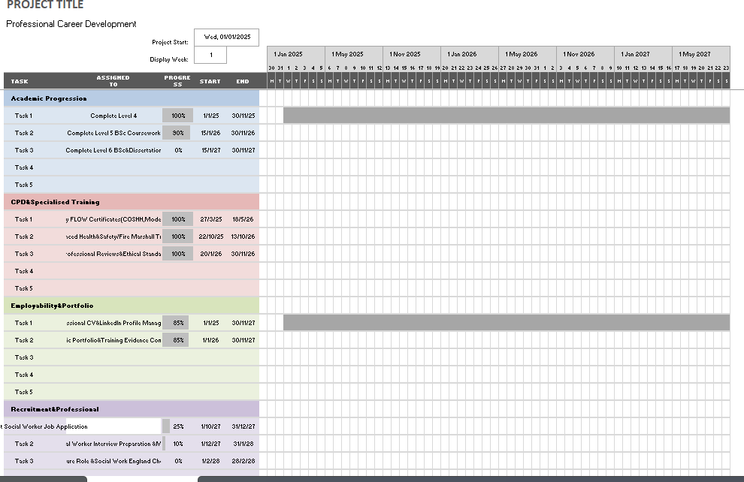

Task 7- Making Changes- Report

Setting: Residential Care Home for the Elderly

Proposed Change: Transitioning from Paper-Based Documentation to Digital Social Care Records (DSCRs)
​1. Introduction
​As the manager of a residential care home, I aim to implement Digital Social Care Records (DSCRs) to replace paper-based care plans. This transition aligns directly with NHS England’s strategic vision to digitize social care, enhancing service quality, inter-agency communication, and person-centered care delivery across the sector (NHS England, 2022). Transitioning to digital platforms minimizes administrative errors and ensures real-time access to crucial resident health data (Care Quality Commission, 2023).
​2. Planning the Change
​The implementation plan is guided by Lewin’s Three-Step Change Model: Unfreeze, Change, and Refreeze (Lewin, 1951; Burnes, 2020).
​Unfreeze Phase: I will communicate the urgent need for digital record-keeping to staff, addressing underlying anxieties regarding technical literacy and organizational change (Cummings, Bridgman and Brown, 2016).
​Change Phase: This phase involves rolling out accessible tablet devices, delivering structured software training sessions, and introducing peer mentors to support daily navigation (Kotter, 2012).
​Refreeze Phase: Finally, the refreeze phase will embed digital records into standard operating procedures through continuous monitoring, feedback loops, and celebrating early operational milestones to lock in habit changes (Hayes, 2022).
​3. Skills Required
​Executing this organizational transition requires strong transformational leadership and high emotional intelligence (EI) (Goleman, 2006; Bass and Avolio, 1994). Empathy, active listening, and clear communication are essential skills to address staff resistance with patience and transparency (Yukl, 2013). Additionally, strategic project management and digital literacy are required to coordinate IT infrastructure setup, maintain regulatory compliance, and ensure ongoing data protection under the General Data Protection Regulation (GDPR) and the Data Protection Act 2018 (Information Commissioner's Office, 2021).
​4. Barriers and Solutions
​Key barriers include staff resistance due to fear of technology, potential language barriers among diverse frontline workers, and a temporary loss of productivity during training (Skills for Care, 2023). To overcome these challenges, I will establish a supportive learning environment using multi-lingual visual guides, peer champion mentoring, and paid protected training time (Department of Health and Social Care, 2023). Drawing on principles of personal resilience and emotional intelligence, I will foster psychological safety (Edmondson, 2019), reassuring staff that mistakes during the initial learning curve are natural and fully supported.
​5. Conclusion
​In conclusion, adopting Digital Social Care Records is a transformative step that modernizes care delivery, minimizes administrative burdens, and improves resident safety (CQC, 2023). By combining structured change management with empathetic leadership and resilient problem-solving, this strategy ensures a smooth transition toward a sustainable, digital-first care environment (NHS England, 2022).

Reference List

Bass, B.M. and Avolio, B.J. (1994) Improving organizational effectiveness through transformational leadership. Thousand Oaks: Sage Publications.
​Behavior Analyst Certification Board (2022) BCaBA task list and certification standards. Littleton: BACB.
​Burnes, B. (2020) 'The origins of Lewin’s three-step model of change', Journal of Applied Behavioral Science, 56(1), pp. 32–59.
​Care Quality Commission (2023) Digital record transformation in adult social care. London: CQC.
​Chartered Institute of Personnel and Development (2023) Continuing professional development (CPD) guide. London: CIPD.
​Cummings, S., Bridgman, T. and Brown, K.G. (2016) 'Unfreezing change as three steps: Rethinking Kurt Lewin’s legacy for change management', Human Relations, 69(1), pp. 33–60.
​Department of Health and Social Care (2021) Building the right support: Delivery plan. London: HMSO.
​Department of Health and Social Care (2023) A complex workforce: Digital skills in adult social care. London: DHSC.
​Edmondson, A.C. (2019) The fearless organization: Creating psychological safety in the workplace for learning, innovation, and growth. Hoboken: John Wiley & Sons.
​Gibbs, G. (1988) Learning by doing: A guide to teaching and learning methods. Oxford: Further Education Unit.
​Goleman, D. (2006) Working with emotional intelligence. London: Bloomsbury Publishing.
​Gore, N.J., McGill, P., Toogood, S., Allen, D., Hughes, J.C., Baker, P., Austin, D. and Denne, L.D. (2013) 'Definition and scope for positive behavioral support', International Journal of Positive Behavioral Support, 3(2), pp. 14–23.
​Hayes, J. (2022) The theory and practice of change management. 6th edn. London: Palgrave Macmillan.
​Health and Care Professions Council (2023) Standards of continuing professional development. London: HCPC.
​Information Commissioner's Office (2021) Guide to the General Data Protection Regulation (GDPR). Wilmslow: ICO.
​Jasper, M. (2013) Beginning reflective practice. 2nd edn. Andover: Cengage Learning.
​Kotter, J.P. (2012) Leading change. Boston: Harvard Business Review Press.
​Lewin, K. (1951) Field theory in social science: Selected theoretical papers. New York: Harper & Row.
​NHS England (2022) Digitizing social care: Transforming records across care settings. London: NHS England.
​Skills for Care (2022) Supervision guide for health and social care employers. Leeds: Skills for Care.
​Skills for Care (2023) The state of the adult social care sector and workforce in England. Leeds: Skills for Care.
​Yukl, G. (2013) Leadership in organizations. 8th edn. Boston: Pearson

