Jayden Brewer (2403712)

Surveying and re design of existing road layout within the UWTSD SA1 campus
Engineering and construction surveying

Practical – Site survey

We carried out a survey of the existing area that a new section of road has been proposed to be added due to the current layout not being suitable. The existing road directs traffic into the wasteland area and makes the turn towards the IQ building tight and unsafe.
We created points of significance using our equipment. We created points on areas such as corners of manhole covers, trees, lampposts, aco drains and the edge of kerbs. With all the data collected we were able to pin all of the data into AutoCAD as we gathered coordinates for each point. I then adjusted the drawing created with the existing data to what the university wants to do with the road.
The below CAD drawing shows the points that we gathered in our group from our practical GNSS survey exercise. Different layers have been used to identify each significant object or structure in the area.
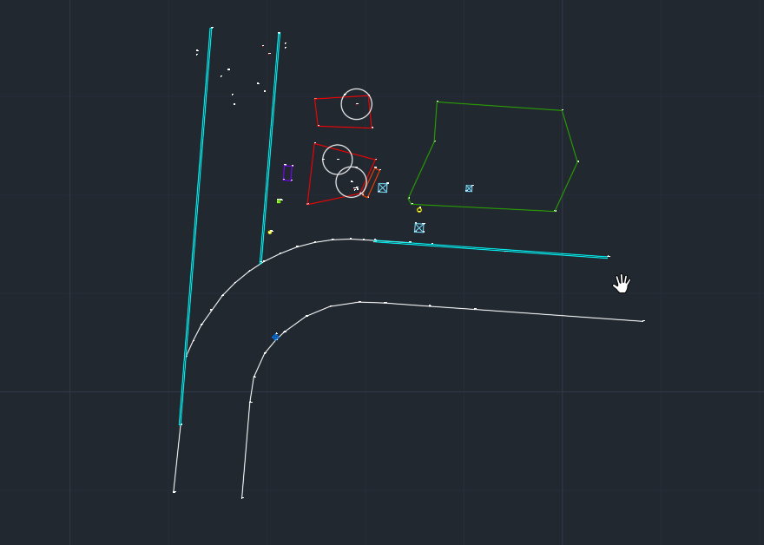

However, redirecting the road will mean that we will need to remove the existing area. As shown on the existing drawing on AutoCAD there is two lampposts that will need to be removed and dealt with. The surrounding area will need to be removed to allow for the redirection of the road.

When constructing the new curve of the road we will need to meet building requirements. We will have to account for a lot of work
-Removal of old road surface
- Making good of ground conditions
-Prepare the base and allow for sloping to avoid flooding
- Consider the need for drainage
- Lay base and lay new surface
This will require us to get a contractor in to complete the removal of the existing toad surface and any areas we require soil to be removed in preparation to complete these works.
A specialist electrical contractor will also be required for the removal of the lampposts and wiring below.
With the way the current road is set, there is a raise in elevation when traveling from the Fforwm building toward the IQ building. We will use this to our advantage and fit a drain on the bend to allow running water to direct into it. The road naturally runs downwards before reaching the bend when driving next to the Fforwm building, this will help in directing rainwater towards the drainage I have proposed.

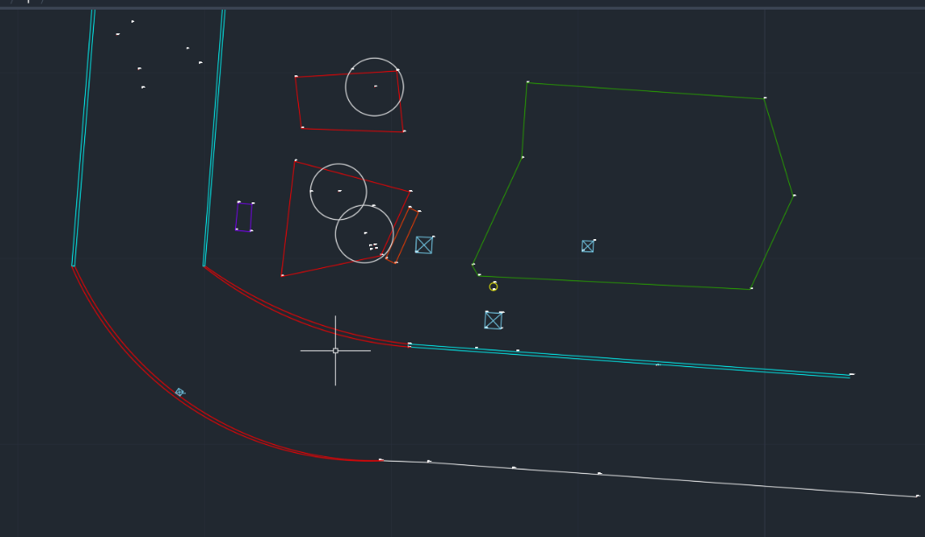

Construction of new road

The new diversion of the road must meet regulations and be structurally sound. This road must take the load of constant traffic from pedestrians to heavy vehicles such as lorry’s carrying a heavy load. “HGVs and other vehicles are permitted to weigh up to a maximum of 44 tonnes in the UK.” However due to the university’s purpose it is highly unlikely we will ever have a vehicle weigh over 44 tonnes come to site. The road will structurally be designed and built to withstand the 44 tonne weight limit due to the potential for future works to be carried out on the wasteland behind the Fforwm building. (gov.uk, 2010)

Pavements are required to be a certain depth to account for the load they will be taking.

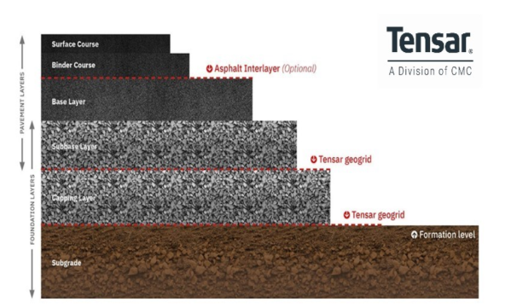

(Tensar.co.uk, n.d.)

The above image demonstrates the different layers aggregate, soil and asphalt that are used when building pavements. The usage of multiple layers of material is to create a structurally strong and long lasting surface. The use of asphalt is beneficial due to its long lasting properties. However, in the case of this project we will use blocks instead of asphalt in order to match with eh existing pavements surrounding the area. Kerb depths are typically required to be set 150mm below the road surface height and will raise 150mm above road surface height.

