
APPENDIX GA36a

LEVEL 4 ASSESSMENT SPECIFICATION

Student name: |  | Student ID number:
Programme: | DA-BSC in Engineering Management
Module: | Finance Management
Module code: | ACMA 4017 | Contribution to Overall Module Assessment (%): | 100%
Lecturer: | Dr Moutushi Tanha | Internal Verifier: | Dr Irina Neaga
Assignment Title: | Writing a report on Financial Management for Projects | Word count (or equivalent): | 2500 words
Submission deadline: | To be confirmed | Return date of provisional marks & written feedback: | Within 20 working days of the submission date
Submission method: | All written assessments, where practical and possible, must be submitted via Turnitin unless otherwise instructed by the Lecturer. (Please DO NOT put this assessment specification into Turnitin or it will match many similarities with other students’ submissions.)  Alternative submission method (if applicable):  Late submission of the assessment will result in a late penalty mark. Penalties for late submission: Up to one week late, maximum mark of 40%. Over one week late, 0%. Only the Extenuating Circumstances Panel may approve a change to submission dates.
Academic honesty / referencing: | Academic honesty is required. In the main body of your submission, you must give credit to authors on whose research and ideas your work is based. Append to your submission a reference list that indicates the books, articles, etc. that you have used, cited or quoted in order to complete this assessment.

Module Learning Outcomes (from module syllabus)
Upon the successful completion of this module, the student should be able to:
- critically assess the development and strategic importance of supply chain operations;
- evaluate logistics operations techniques and practices for innovation in SCM.

TASK DESCRIPTION

Use of Generative AI in Assessment

RESEARCH | For this assessment, you can use Generative AI to support you in research, including searching for bibliography, using tools to summarise, compare and interrogate materials. | Yes ​☒​  No ​☐​
STRUCTURE | For this assessment, you can use Generative AI to support you in structuring your submission, including creating a draft argument structure, identifying parts and headings, etc. | Yes ​☒​  No ​☐​
PROOFREADING | For this assessment, you can use Generative AI to check your own text/creation for grammatical and syntactical mistakes, including rephrasing of your own work within specific standards. | Yes ​☒​  No ​☐​
WRITING | For this assessment, you can use Generative AI to create text for submission. | Yes ​☐​  No ​☒​
CREATIVE | For this assessment, you can use Generative AI to create creative materials, such as images. | Yes ​☐​  No ​☒​
PROGRAMING | For this assessment, you can use Generative AI to create and check code. | Yes ​☐​  No ​☒​
NONE | For this assessment, you are not allowed to use any type of Generative AI support. This includes research support, structure support, writing/proofreading support and creative support. | Yes ​☐​  No ​☒​

AI Acknowledgement

I confirm that I have not present any AI-generated materials as my own work in this portfolio.

However, I acknowledge that I have used or may have used the AI in the research and proofreading of my portfolio.

Name:...............
Student ID..............

Assessment Component: Practical

At the end of the completion of this module (as part of the assessment for this module ‘ACMA4017 Finance Management), you are expected to give a presentation on the exercises and findings done on financial management practices.

Task: Do a thorough exercise on Financial Management Practices of organizations, Financial Ratio Analysis, Capital Budgeting Techniques, and Working Capital Management and deliver a presentation on the findings of your exercises.

Duration of presentation: 15 minutes

Your exercise should be structured into three basic parts:

- Introduction
- Body
- Conclusion

The following exercises should be done and covered in your presentation

- Firstly, you are required to go through the financial statements of Jackson Plc Ltd and calculate the following financial ratios and interpret financial ratios of Jackson Plc Ltd.

Profitability Ratio
Activity Ratio
^{Liquidity Ratios}
^{Capital Gearing Ratios}
^{Investors' Ratios}
^{Other Ratios}

Secondly, use your company’s financial statements of 2024 and 2023 from annual report (published) and interpret all the above financial ratios for your organization. Compare and contrast between these two years financial performance of your organization.

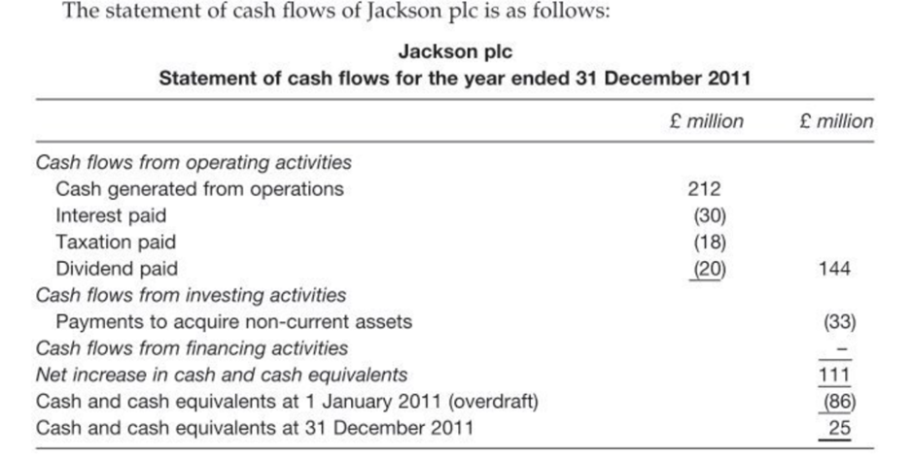

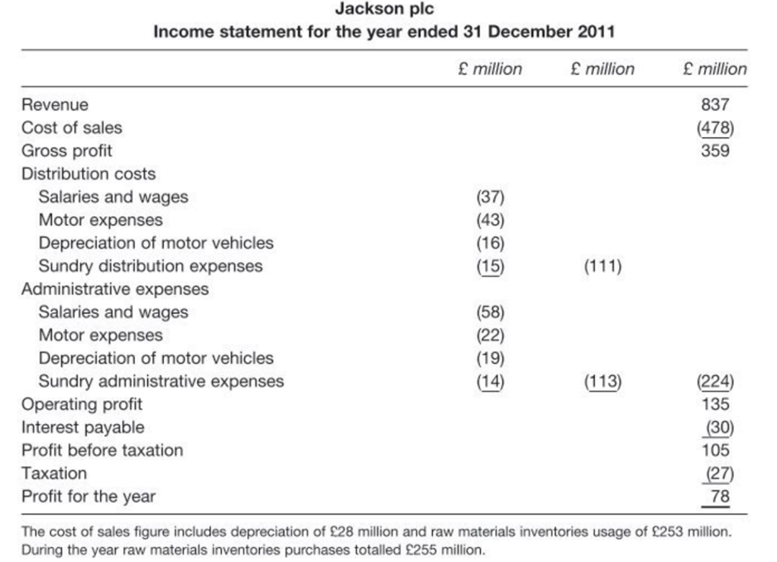

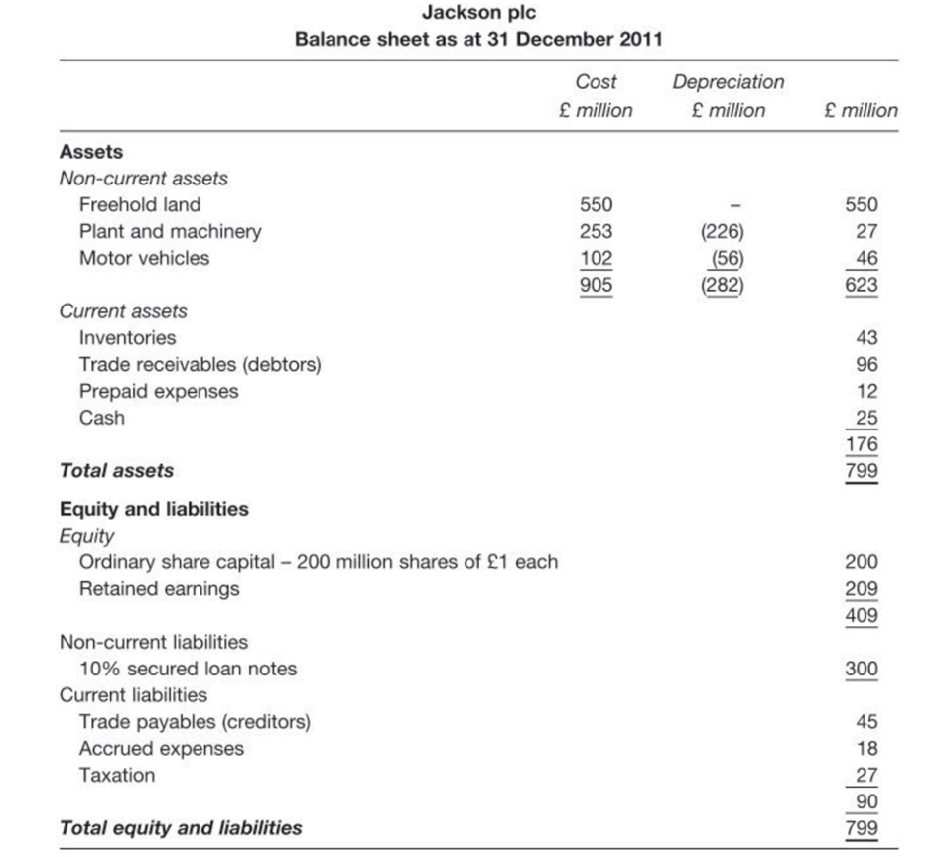

- Do the required calculations using different methods of Capital Budgeting Decisions.

The methods of evaluations are classified as follows:
(A) Traditional methods (or Non-discount methods) (i) Pay-back Period Methods (ii) Post Pay-back Methods (iii) Accounts Rate of Return

(B) Modern methods (or Discount methods) (i) Net Present Value Method (ii) Internal Rate of Return Method (iii) Profitability Index Method

Pay-back Period:

Pay-back period is the time required to recover the initial investment in a project.

Accept/Reject criteria
If the actual pay-back period is less than the predetermined pay-back period, the project would be accepted. If not, it would be rejected.

Exercise: 1

Project cost is GBP 30,000 and the cash inflows are 10,000 GBP, the life of the product is 5 years. Calculate the pay-back period.

Exercise: 2

A project costs 20,00,000 and yields annually a profit of GBP 3,00,000 after depreciation @12.5% but before tax at 50%. Calculate the pay-back period.

Profit after depreciation 3,00,000
Tax 50% 1,50,000 1,50,000
Add depreciation
20,00,000 1 12 %2 2,50,000
Cash in flow 4,00,000

Uneven cash Inflows:

Normally, the projects are not having uniform cash inflows. In those cases, the pay-back period is calculated, cumulative cash inflows will be calculated and then interpreted.

Exercise 3: Certain projects require an initial cash outflow of GBP 25,000. The cash inflows for 6 years are GBP 5000, 8000, 10,000, 12,000, 7000 and 3,000. Calculate the payback period.

Post Pay-back Profitability Method: One of the major limitations of pay-back period method is that it does not consider the cash inflows earned after pay-back period and if the real profitability of the project cannot be assessed. To improve over this method, it can be made considering the receivable after the pay-back period. These returns are called post pay-back profits.

Exercise 4: From the following particulars, compute:

Payback period
Post pay-back profitability and post pay-back profitability index.

- Cash outflow GBP 1,00,000
Annual Cash inflow GBP 25,000
(After tax before depreciation)
Estimated Life 6 years

- Cash outflow GBP 1,00,000
Annual Cash inflow
(After tax and depreciation)
First Five Years GBP 20,000
Next Five years GBP 8,000
Estimated Life 10 years
Salvage Value GBP 16,000

Accounting Rate of Return or Average Rate of Return:
Average Rate of Return means the average rate of return or profit taken for considering the project evaluation. This method is one of the traditional methods for evaluating the project proposals.

Exercise: 5 A company has two alternative proposals. The details are as follows:

 | Proposal 1 | Proposal 2
 | Automatic Machine | Ordinary Machine
Cost of the machine | GBP 2,20,000 | GBP 60,000
Estimated life | 5.5 Years | 8 Years
Estimated sales p.a. | GBP 1,50,000 | GBP 1,50,000
Costs: Material | GBP 50,000 | GBP 50,000
Labor | GBP 12,000 | GBP 60,000
Variable Overheads | GBP 24,000 | GBP 20,000
Compute the profitability of the proposals under the return-on-investment method

Net Present Value

Net present value method is one of the modern methods for evaluating the project proposals. In this method cash inflows are considered with the time value of the money. Net present value describes as the summation of the present value of cash inflow and present value of cash outflow. Net present value is the difference between the total present value of future cash inflows and the total present value of future cash outflows.

Accept/Reject criteria If the present value of cash inflows is more than the present value of cash outflows, it would be accepted. If not, it would be rejected.

Exercise 6 From the following information, calculate the net present value of the two project and suggest which of the two projects should be accepted a discount rate of the two.

 | Project X | Project Y
Initial Investment | GBP 20,000 | GBP 30,000
Estimated Life | 5 Years | 5 Years
Scrap Value | GBP 1,000 | GBP 2,000

The profits before depreciation and after taxation (cash flows) are as follows

 | Year 1 | Year 2 | Year 3 | Year 4 | Year 5
 | GBP | GBP | GBP | GBP | GBP
 | 5,000 | 10,000 | 10,000 | 3,000 | 2,000
 | 20,000 | 10,000 | 5,000 | 3,000 | 2,000

Note : The following are the present value factors @ 10% p.a.

Year | 1 | 2 | 3 | 4 | 5 | 6
Factor | 0.909 | 0.826 | 0.751 | 0.683 | 0.621 | 0.564

Exercise 7 The following are the cash inflows and outflows of a certain project.

Year | Outflows (GBP) | Inflows (GBP)
Year 0 | 175,000
Year 1 | 550,000 | 35,000
Year 2 |  | 45,000
Year 3 |  | 65,000
Year 4 |  | 85,000
Year 5 |  | 50,000

The salvage value at the end of 5 years is Rs. 50,000. Taking the cutoff rate as 10%, calculate net present value.

Year | 1 | 2 | 3 | 4 | 5 | 6
Factor | 0.909 | 0.826 | 0.751 | 0.683 | 0.621 | 0.564

Exercise 8 From the following information you can learn after tax and depreciation concept.

Initial Outlay | GBP 1,00,000
Estimated Life | 5 Years
Scrap Value | GBP 10,000
Profit after Tax
End of Year 1 | GBP 6,000
End of Year 2 | GBP 14,000
End of Year 3 | GBP 24,000
End of Year 4 | GBP 16,000
End of Year 5 | Nil

Internal Rate of Return

Internal Rate of Return Internal rate of return is time adjusted technique and covers the disadvantages of the traditional techniques. In other words it is a rate at which discount cash flows to zero.

Exercise 9: A company has to select one of the following two projects:

 | Project A (GBP) | Project B (GBP)
Cost | 22,000 | 20,000
Cash Inflows
Year 1 | 12,000 | 2,000
Year 2 | 4,000 | 2,000
Year 3 | 2,000 | 4,000
Year 4 | 10,000 | 20,000

Using the Internal Rate of Return (IRR) method, suggest which is preferrable.

Exercise 10 A project costs Rs. 16,000 and is expected to generate cash inflows of Rs. 4,000 each 5 years. Calculate the Interest Rate of Return.

Excess Present Value Index Excess present value is calculated on basis of net present value. It gives the results in percentage.

Exercise 11 The initial of an equipment is Rs. 10,000. Cash inflow for 5 years are estimated to be Rs. 3,500 per year. The management is desired minimum rate of excess present value index

Capital rationing:
In the rationing, the company has only limited investment, the projects are selected according to the profitability. The project has selected the combination of proposal that will yield the greatest profitability.

Exercise 12: Let us assume that a firm has only 2 million GBP to invest and funds cannot be provided. The various proposals along with the cost and profitability index are as follows.

Proposal | Pool of the project | Profitability Index
1 | 6,00,000 | 1.46
2 | 2,00,000 | .098
3 | 10,00,000 | 2.31
4 | 4,00,000 | 1.32
5 | 3,00,000 | 1.25

From the following information, calculate the net present value of the two projects and suggest which of the two projects should be accepted a discount rate of the two.
 | Project X (GBP) | Project Y (GBP)
Initial Investment | 20,000 | 30,000
Estimated Life | 5 years | 5 years
Scrap Value | 1000 | 2000

The profits before depreciation and after taxation (cash flows) are as follows:

 | Year 1 | Year 2 | Year 3 | Year 4 | Year 5
 | GBP | GBP | GBP | GBP | GBP
Project X | 5,000 | 10,000 | 10,000 | 3,000 | 2,000
Project Y | 20,000 | 10,000 | 5,000 | 3,000 | 2,000

Note: The following are the present value factors @ 10% per annum

Year | 1 | 2 | 3 | 4 | 5 | 6
Factor | 0.909 | 0.826 | 0.751 | 0.683 | 0.621 | 0.564

D. The following are the cash inflows and outflows of a certain project:

Year | Outflows | Inflows
0 | 1,75,000 | -
1 | 5,50,000 | 35,000
2 |  | 45,000
3 |  | 65,000
4 |  | 85,000
5 |  | 50,000

The salvage value at the end of 5 years is GBP 50,000. Taking the cutoff rate as 10%, calculate the net present value.

E. From the following information you can learn after tax and depreciation concept.

Initial Outlay | GBP 1,00,000
Estimated Life | 5 Years
Scrap Value | GBP 10,000
Profit after Tax
End of Year 1 | GBP 6,000
End of Year 2 | GBP 14,000
End of Year 3 | GBP 24,000
End of Year 4 | GBP 16,000
End of Year 5 | Nil

- Calculate Excess Present Value Index: The initial of an equipment is GBP 10,000. Cash inflow for 5 years is estimated to be GBP 3,500 per year. The management is desired minimum rate of excess present value index.
- Capital Rationing: In the rationing, company has only limited Let us assume that a firm has only 2 Million GBP to invest and funds cannot be provided.

- Risk and Uncertainty in Capital Budgeting:

- Risk-adjusted cutoff rate (or method of varying)

Exercise: The ABC Ltd. is considering the purchase of a new investment. Two alternative investments are available (X and Y) each costing GBP 15,0000. Cash inflows are expected to be as follows:

Year | Investment X (GBP) | Investment Y (GBP)
1 | 60,000 | 65,000
2 | 45,000 | 55,000
3 | 35,000 | 40,000
4 | 30,000 | 40,000
The company has a target return on capital of 10%. Risk premium rates are 2% and 8% respectively for investment X and Y. Which investment should be preferred?

B) Certainty equivalent method:
Exercise: There are two projects A and B. Each involves an investment of GBP 50,000. The expected cash inflows and the certainty co-efficient are as under:

Year | Project A |  | Project B
Year | Cash Inflows (GBP) | Certainty Co-efficient | Cash Inflows (GBP) | Certainty Co-efficient
1 | 35,000 | 0.8 | 25,000 | 0.9
2 | 30,000 | 0.7 | 35,000 | 0.8
3 | 20,000 | 0.9 | 20,000 | 0.7

Risk-free cutoff rate is 10%. Suggest which of the two projects should be preferred.

3. Sensitivity technique:
Exercise:
Mr. M is considering two mutually exclusive project X and Y. You are required to advise him about the acceptability of the two projects from the following information:

 | Project X (GBP) | Project Y (GBP)
Cost of the investment | 1,00,000 | 1,00,000
Forecast cash inflows per annum for 5 years
Optimistic | 60,000 | 55,000
Most Likely | 35,000 | 30,000
Pessimistic | 20,000 | 20,000
(The cut-off rate may be assumed to be 15%)

4. Probability technique:
Exercise: Two mutually exclusive investment proposals are being considered. The following information is available:

 | Project A (GBP) | Project B (GBP)
Cost | 10,000 | 10,000

Cash Inflows Year | GBP | Probability | GBP | Probability
1 | 10,000 | .2 | 12,000 | .2
2 | 18,000 | .6 | 16,000 | .6
3 | 8,000 | .2 | 14,000 | .2
Assuming cost of Capital at (or) advise the selection of the Project:

Which project should be accepted on the basis of probability technique?

5. Standard deviation method: Exercise: From the following information, ascertain which project should be selected on the basis of standard deviation.

Project X |  | Project Y
Cash Inflow | Probability | Cash Inflow | Probability
GBP |  | GBP
32,000 | .2 | 32,000 | .1
5,500 | .3 | 5,500 | .4
7,400 | .3 | 7,400 | .4
8,900 | .2 | 8,900 | .1

6. Co-efficient of Variation method:
Excerice: Using the figures of the previous example compute co-efficient of variation and suggest which proposal should be accepted:

7. Decision Tree analysis:

Accept/Reject criteria:

If the net present values are in positive the project may be accepted otherwise it is rejected.
Exercise: Mr. K is considering an investment proposal of GBP 40,000. The expected returns during the left of the investment are as under:

Year 1

Event | Cash Inflow | Probability
1 | 16,000 | .3
2 | 24,000 | .5
3 | 20,000 | .2

Year 2

Cash inflows in Year 1 are:
 | 16,000 |  | 24,000 |  | 20,000
 | Cash Inflow | Probability | Cash Inflow | Probability | Cash Inflow | Probability
1 | 30,000 | .2 | 40,000 | .1 | 5,000 | .2
2 | 40,000 | .6 | 60,000 | .8 | 8,000 | .5
3 | 50,000 | .2 | 80,000 | .1 | 12,000 | .3

Using 10% as the cost of capital, advise about the acceptability of the proposal.

- Working Capital Management issues:

Prepare an estimate of working capital requirement from the following scenarios:

Scenario 1: A proforma cost sheet of a company provides the following particulars:

Elements of cost and percentages

Material 35%
Direct Labours 25%
Overhead 20%

Further particulars are:

- It is proposed to maintain a level of activity of 2,50,000 units
- Selling price is £10 per unit
- Raw materials are to remain in stores for an average period of one month
- Finished foods are required to be in stock for an average period of one moth
- Credit allowed to debtors is 3 months
- Credit allowed by suppliers is 2 months

You are required to prepare a statement fo working capital requirements, a forecast of profit and loss account and balance sheet of the company assuring that

Share capital £12,00,000
10% Debentures £3,00,000
Fixed Assets £11,00, 000

Scenario: 2 From the information given below, Mr. X wants to commence a new trading business and givs the following information to you

The total estimated sales in a year will be £20,00,000
His expenses are estimated fixed expenses of £3,000 per month plus variable expenses equal to 10% of his turover.

He expects to fix a sales price for each product which will be 33 1/3% in excess of his cost of purchase
He expects to turover his stock 6 times in a year
The sales and purchase will be evenly spread throughout the year. All sales will be for cash, but he expects one month’s credit for purchases.

Calculate his estimated profit for the year.
His average working capital requirements.

Scenario 3: Cash Management
A company expects to have £37500 cash in hand on 1st of April, and requires you to prepare an estimate of cash position during the 3 months.
April, May and June – the following information is supplied to you:

Month | Sales | Purchases | Wages | Factory  Expenses | Office Expenses | Selling Expenses
Feb | 75,000 | 45,000 | 9,000 | 7,500 | 6,000 | 4,500
March | 84,000 | 48,000 | 9,750 | 8,250 | 6,000 | 4,500
April | 90,000 | 52,000 | 10,500 | 9,000 | 6,000 | 5,250
May | 1,20,000 | 60,000 | 13,500 | 11,250 | 6,000 | 6,570
June | 1,35,000 | 60,000 | 14,250 | 14,000 | 7,000 | 7,000

Other information:
Period of credit allowed to suppliers 2 moths
20% of sales for cash and period of credit allowed to customers for credit is one month
Delay in payment of all expenses: 1 month
Income tax of $57, 500 is due to be paid on June 15th.
The company is to pay dividend to shareholders and bonus to workers of £15,000 and £22,500 respectively in the month of April.
A plant has been ordered to be received and paid in May. It will cost £120,000

Following the general guidelines to complete the task is highly recommended (see below).

GUIDANCE FOR Students IN THE COMPLETION OF TASKS

NOTE: The guidance offered below is linked to the five generic assessment criteria overleaf.

- Engagement with Literature Skills
Your work must be informed and supported by scholarly material that is relevant to and focused on the task(s) set. You should provide evidence that you have accessed an appropriate range of sources, which may be academic, governmental, and industrial; these sources may include academic journal articles, textbooks, current news articles, organisational documents, and websites. You should consider the credibility of your sources; academic journals are normally highly credible sources while websites require careful consideration/selection and should be used sparingly. Any sources you use should be current and up-to-date, mostly published within the last five years or so, though seminal/important works in the field may be older. You must provide evidence of your research/own reading throughout your work, using a suitable referencing system, including in-text citations in the main body of your work and a reference list at the end of your work.

Guidance specific to this assessment: Evaluate the credibility, relevance, and quality of the literature sources you find. Prioritise peer-reviewed journals, reputable publishers, and authoritative authors in the field. Ensure that the selected sources contribute to the academic discourse on the topic. Engage critically with the literature by analysing and synthesising the information you gather. Identify common themes, contrasting viewpoints, or emerging trends in the literature. Compare and contrast different authors' perspectives and arguments to gain a deeper understanding of the topic. Ensure that you accurately cite and reference all the sources you have consulted in your assignment using the Harvard referencing style. Follow this citation style consistently throughout your work. This demonstrates your ability to engage ethically with the literature and give credit to the original authors.

- Knowledge and Understanding Skills
At level 4, you should be able to demonstrate knowledge of the underlying concepts and principles associated with your area(s) of study. Knowledge relates to the facts, information and skills you have acquired through your learning. You demonstrate your understanding by interpreting the meaning of the facts and information (knowledge). This means that you need to select and include in your work the concepts, techniques, models, theories, etc. appropriate to the task(s) set. You should be able to explain the theories, concepts, etc. to show your understanding. Your mark/grade will also depend upon the extent to which you demonstrate your knowledge and understanding.

Guidance specific to this assessment: Thoroughly understand the assignment requirements: Start by carefully reading and understanding the assignment brief. Identify the key concepts, theories, and topics that need to be addressed in your response. Provide clear explanations. Clearly explain the key concepts, theories, and principles relevant to the assignment.

- Cognitive and Intellectual Skills
You should be able to present, evaluate and interpret qualitative and quantitative data, in order to develop lines of argument and make sound judgements in accordance with basic theories and concepts of your subject(s) of study. You should be able to evaluate the appropriateness of different approaches to solving problems related to your area(s) of study and/or work. Your work must contain evidence of logical, analytical thinking. For example, to examine and break information down into parts, make inferences, compile, compare and contrast information. This means not just describing what! But also justifying: Why? How? When? Who? Where? At what cost? You should provide justification for your arguments and judgements using evidence that you have reflected upon the ideas of others within the subject area and that you are able to make sound judgements and arguments using data and concepts. Where relevant, alternative solutions and recommendations may be proposed.

Guidance specific to this assessment: Demonstrate your ability to think critically by presenting well-reasoned arguments and making logical connections between ideas. Apply problem-solving skills relevant to the assignment topic. Identify and define the problem, analyse its components, and develop solutions or recommendations based on logical reasoning and evidence. Show your ability to think creatively and propose innovative approaches when appropriate.

- Practical Skills
At level 5, you should be able to apply the basic underlying concepts and principles to evaluate and interpret these within the context of your area of study. You should be able to demonstrate how the subject-related concepts and ideas relate to real world situations and/or a particular context. How do they work in practice? You will deploy models, methods, techniques, and/or theories, in that context, to assess current situations, perhaps to formulate plans or solutions to solve problems, or to create artefacts. This is likely to involve, for instance, the use of real-world artefacts, examples and cases, the application of a model within an organisation and/or benchmarking one theory or organisation against others based on stated criteria.

Guidance specific to this assessment: Utilise organization management tools relevant to the assignment topic. Showcase your ability to apply these tools effectively to solve practical problems or analyse Financial Management for Projects. Explain the methodologies, assumptions, and limitations associated with the tools used.
Offer practical recommendations or solutions based on your analysis and understanding of the subject matter. Demonstrate your ability to propose feasible and effective Financial Management strategies, designs, or improvements to address specific challenges or problems.

- Transferable Skills for Life and Professional Practice
Your work must provide evidence of the qualities and transferable skills necessary for employment requiring the exercise of some personal responsibility. This includes demonstrating that you can communicate the results of your study/work accurately and reliably, and with structured and coherent arguments; that you can initiate and complete tasks and procedures, whether individually and/or collaboratively; fluency of expression; clarity and effectiveness in presentation and organisation. Work should be coherent and well-structured in presentation and organisation.

Guidance specific to this assessment: Clearly communicate your ideas, analysis, and recommendations in a manner that is easily understandable to both technical and non-technical audiences. Use appropriate Financial Management terminology, visual aids (such as diagrams or charts), and concise explanations to convey your ideas effectively. Demonstrate strong written communication skills throughout your assignment. Ensure clarity, coherence, and proper grammar and spelling.

Student FEEDBACK FORM

This section details the extent to which the assessment criteria are demonstrated by you, which in turn determines your mark. The marks available for each category of skill are shown. Lecturers will use the space provided to comment on the achievement of the task(s), including those areas in which you have performed well and areas that would benefit from development/improvement.

