Name: tika dhimal
Module: foreign languages and cultural awareness
The fourth assignment: caution sentences in mandarin and caution sentences in English
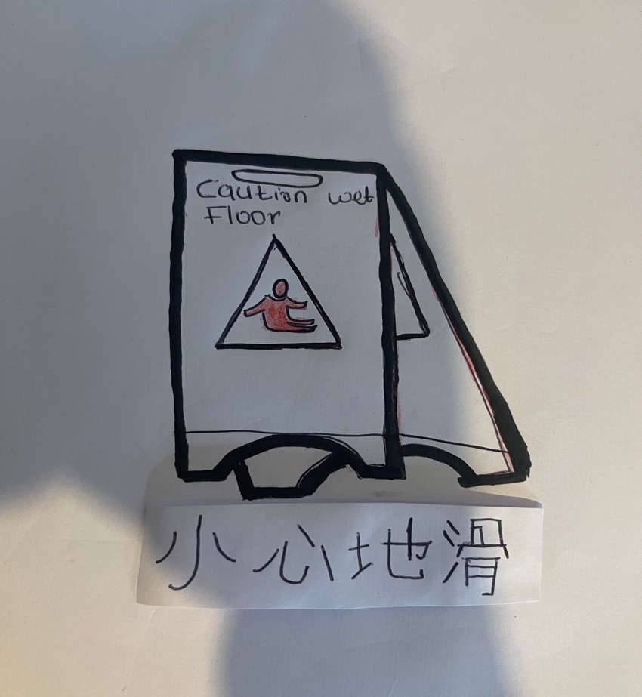
Lecture: jinping li

