

Presentation
Use Bamboo make money while you saving the planet
Waleed Sulaiman (2212596)

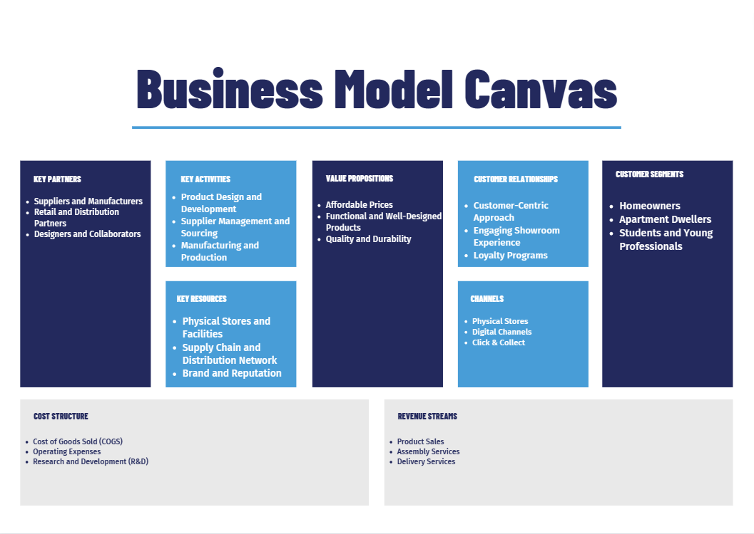

Key Partners
IKEA, as a global retail company, collaborates with various key partners to support its operations and provide a seamless experience to customers. Here are some key partners of IKEA:
- Suppliers and Manufacturers: IKEA partners with suppliers and manufacturers worldwide to source the products it sells. These partners provide a wide range of items, including furniture, home accessories, textiles, and more.

- Retail and Distribution Partners: In some regions, IKEA collaborates with retail and distribution partners to extend its reach and make its products available to customers. These partnerships enable IKEA to expand its presence in new markets or regions where it may not have a physical store.

- Designers and Collaborators: IKEA often collaborates with external designers, artists, and creative partners to develop new products, collections, and innovative solutions. These partnerships bring fresh perspectives, design expertise, and unique ideas to IKEA's product range.

Key activity
IKEA engages in several key activities to operate its business successfully and deliver value to its customers. These key activities include:
- Product Design and Development: IKEA invests in product design and development to create innovative, functional, and well-designed home furnishing products. It emphasizes simplicity, functionality, and affordability in its designs, ensuring that the products meet customer needs and preferences.

- Supplier Management and Sourcing: IKEA maintains relationships with a vast network of suppliers worldwide. It focuses on responsible sourcing, ensuring that suppliers meet ethical and sustainability standards. IKEA works closely with suppliers to secure the necessary materials, negotiate pricing, and maintain quality standards.

- Manufacturing and Production: IKEA engages in manufacturing and production processes to create its products. It utilizes efficient production methods and economies of scale to achieve cost-effective manufacturing while maintaining quality standards. IKEA's manufacturing activities involve coordination with suppliers, production facilities, and quality control processes.

Key Resources
IKEA, as a global retail company, relies on a variety of key resources to support its operations, deliver value to customers, and maintain its competitive position in the market. Here are some key resources of IKEA:
- Physical Stores and Facilities: IKEA operates a vast network of physical stores worldwide. These stores serve as the primary touchpoints for customers to browse, purchase, and experience IKEA's products. The stores are strategically designed and organized to showcase a wide range of furniture, home furnishings, and accessories.

- Supply Chain and Distribution Network: IKEA has a complex and efficient supply chain and distribution network. It works closely with suppliers and manufacturers worldwide to ensure a steady flow of products to its stores and distribution centers. The distribution network involves transportation, logistics, and warehousing operations to manage the movement and storage of goods.

- Brand and Reputation: IKEA has established a strong brand and reputation globally. It is known for its affordable, functional, and well-designed products. The brand image and reputation contribute to customer trust, loyalty, and recognition, allowing IKEA to attract and retain a large customer base.

Customer Segments
IKEA serves a diverse range of customer segments, targeting both individual consumers and businesses. Here are some key customer segments that IKEA caters to:
- Homeowners: One of IKEA's primary customer segments is homeowners who are looking for affordable and stylish home furnishing solutions. This includes individuals and families who are setting up new homes, renovating existing spaces, or seeking to update their furniture and decor.

- Apartment Dwellers: IKEA targets customers living in apartments or smaller living spaces. With a focus on space-saving solutions and multi-functional furniture, IKEA offers products that are well-suited for optimizing limited space while maintaining functionality and style.

- Students and Young Professionals: IKEA appeals to students and young professionals who are looking for affordable and practical furniture and home accessories. IKEA's offerings cater to the needs of this segment, providing options that are both functional and aesthetically pleasing.

Value Propositions
IKEA offers several value propositions that differentiate it from its competitors and attract customers. Here are some key value propositions for IKEA:
- Affordable Prices: IKEA is known for its affordable pricing strategy, offering well-designed and functional products at competitive prices. By utilizing efficient production methods, economies of scale, and cost-conscious design, IKEA makes stylish and quality home furnishings accessible to a wide range of customers.
- Functional and Well-Designed Products: IKEA focuses on creating products that are not only aesthetically pleasing but also functional and practical. Its designs emphasize simplicity, versatility, and space-saving solutions, catering to the needs of modern living and addressing common challenges in home furnishing.

- Quality and Durability: Despite its affordable prices, IKEA maintains a commitment to quality. It strives to provide products that are built to last, utilizing durable materials and rigorous testing to ensure longevity and customer satisfaction. IKEA also offers warranties and after-sales support to reinforce its commitment to quality.
Customer Relationship
IKEA focuses on building and maintaining strong customer relationships to enhance customer satisfaction and loyalty. The company employs various strategies to engage with customers and provide a positive experience throughout their journey. Here are some key aspects of IKEA's customer relationships:
- Customer-Centric Approach: IKEA places the customer at the center of its business operations. It aims to understand customer needs, preferences, and aspirations to provide relevant and personalized solutions. IKEA conducts market research, customer surveys, and feedback mechanisms to gather insights and improve its offerings.

- Engaging Showroom Experience: IKEA's physical stores offer an engaging and interactive showroom experience. Customers can explore various room settings, touch and feel products, and visualize how they might look in their own homes. The showroom experience helps customers make informed decisions and creates a connection with the brand.

- Loyalty Programs: IKEA offers loyalty programs in some regions to reward and incentivize repeat customers. These programs provide benefits such as exclusive discounts, special promotions, and early access to sales events. By acknowledging and rewarding customer loyalty, IKEA encourages ongoing engagement and repeat business.

Channels
IKEA utilizes multiple channels to reach and serve its customers. These channels are designed to provide convenience, accessibility, and a seamless shopping experience. Here are some key channels used by IKEA:
- Physical Stores: IKEA operates a vast network of physical stores globally. These stores serve as the primary channel for customers to browse and purchase IKEA's products. The stores are typically large and feature showroom sections where customers can explore different room settings and interact with the products. Customers can also visit the self-serve warehouse to collect their purchases.

- Digital Channels: In addition to its e-commerce platform, IKEA engages customers through various digital channels. Its website provides detailed product information, design ideas, and customer reviews. IKEA also maintains active social media presence on platforms like Facebook, Instagram, and YouTube, sharing content, updates, and engaging with customers.

- Click & Collect: IKEA offers a Click & Collect service where customers can place orders online and then pick them up at a designated area within the store. This service provides convenience for customers who prefer to collect their purchases themselves and reduces delivery costs.
Cost Structure
IKEA's cost structure is composed of various elements that contribute to its overall expenses. While specific cost details are not publicly disclosed by IKEA, the following are some key components that typically make up the cost structure of a retail company like IKEA:
- Cost of Goods Sold (COGS): This includes the direct costs associated with the production and procurement of products sold by IKEA. It comprises expenses such as raw materials, manufacturing costs, packaging, transportation, and logistics.

- Operating Expenses: These are the day-to-day expenses incurred in running IKEA's operations. Operating expenses include costs related to marketing and advertising, employee salaries and benefits, rent and utilities for stores and facilities, maintenance and repairs, administrative expenses, and technology infrastructure.

- Research and Development (R&D): IKEA invests in research and development activities to innovate and develop new products, improve existing products, and enhance sustainability practices. R&D costs cover product design, testing, prototyping, and other related expenses.
It's important to note that the specific breakdown and proportions of these cost elements may vary depending on factors such as geographic location, store format, business model, and market conditions. IKEA continuously evaluates and optimizes its cost structure to maintain its competitive position, deliver value to customers, and ensure profitability.
Revenue Streams
IKEA generates revenue through various streams that contribute to its overall financial performance. While specific revenue figures and details are not publicly disclosed by IKEA, the following are the primary revenue streams for the company:
- Product Sales: The main source of revenue for IKEA is the sale of its home furnishing products. This includes furniture, lighting, textiles, kitchenware, home accessories, and other related items. IKEA offers a wide range of products in different price ranges to cater to various customer segments and budgets.

- Assembly Services: IKEA offers assembly services for customers who prefer assistance with furniture assembly. These services involve additional charges and generate revenue for IKEA.

- Delivery Services: IKEA provides delivery services to customers who choose to have their purchases delivered to their homes. Delivery fees are charged, contributing to the company's revenue stream.

- Collaborations and Licensing: IKEA collaborates with other brands, designers, and artists to create limited-edition collections or licensed products. These collaborations generate revenue through product sales and licensing agreements.

Reference list:

Heath, O. (2020). IKEA on sustainability, furniture hacking, new trials and the Buy Back initiative. [online] House Beautiful. Available at: https://www.housebeautiful.com/uk/lifestyle/a34751862/ikea-sustainability-buy-back-circular/.
Heath, O. (2020). IKEA on sustainability, furniture hacking, new trials and the Buy Back initiative. [online] House Beautiful. Available at: IKEA on Sustainability, Buy Back, Hacking & Linear To Circular (housebeautiful.com)
Lehner, M., Mont, O., Mariani, G. and Mundaca, L. (2020). Circular Economy in Home Textiles: Motivations of IKEA Consumers in Sweden. Sustainability, 12(12), p.5030. Sustainability | Free Full-Text | Circular Economy in Home Textiles: Motivations of IKEA Consumers in Sweden (mdpi.com)
Stewart, R. and Niero, M. (2018). Circular economy in corporate sustainability strategies: A review of corporate sustainability reports in the fast-moving consumer goods sector. Business Strategy and the Environment, 27(7), pp.1005–1022. Circular economy in corporate sustainability strategies: A review of corporate sustainability reports in the fast‐moving consumer goods sector - Stewart - 2018 - Business Strategy and the Environment - Wiley Online Library.
Weetman, C. (2016). A Circular Economy Handbook for Business and Supply Chains: Repair, Remake, Redesign, Rethink. [online] Google Books. Kogan Page Publishers. Available at: A Circular Economy Handbook for Business and Supply Chains: Repair, Remake ... - Catherine Weetman - Google Books [Accessed 18 May 2023].
Weetman, C. (2020). A Circular Economy Handbook: How to Build a More Resilient, Competitive and Sustainable Business. [online] Google Books. Kogan Page Publishers. Available at: A Circular Economy Handbook: How to Build a More Resilient, Competitive and ... - Catherine Weetman - Google Books [Accessed 18 May 2023].

