Hotel standards, reputation management,
building and retaining customer loyalty’

Alina Cristina Pruteanu
2209886

Hospitality and Guest Service Management
Muhammad Cassamo

Executive summary

This essay explores the relationship between hotel standards, reputation management, building and retaining customer loyalty, using examples from leading hotel brands. For instance, Marriott International has made guest satisfaction a top priority by closely monitoring online reviews and responding to customer feedback. Similarly, Hilton Worldwide has implemented a robust loyalty program and made significant investments in the overall customer experience. Maintaining high hotel standards and effectively managing reputation plays a significant role in building customer loyalty. Building loyalty requires quality accommodations, excellent customer service, and personalized experiences. To retain customers, hotels must consistently deliver quality services and maintain open communication to address concerns and feedback.

Content Table

- Introduction
- Brand Consistency Standards
- Reputation Management
- Customer Loyalty
- Conclusion
- Recommendations
- References

Introduction

According to Alikhan and Rahman (2012), hotel owners and operators must maintain their hotel's image and retain clients as competition increases. The hospitality sector recognizes that hotel standards, reputation management, and client loyalty are crucial to success.
Leask and Yeoman (2015) state that a hotel's quality affects its operations and marketing. Owing to the large selection of services and amenities, it is crucial to have an efficient marketing campaign and excellent customer service to keep customers coming back and meet their demands.
The hotel should be honest about its rooms and services because of the market's growing competitiveness. The hotel must provide high-quality service to retain customers. Tactics and programs that meet customer demands may accomplish this. So, hotel reputation management is essential to fostering client loyalty, which is essential to long-term profitability. (Tai, 2008)

Brand Consistency Standards

According to Gijsberts and Herpen (2003), the goal of brand consistency criteria in the hotel and hospitality sector is to establish a unified and identifiable brand that distinguishes a hotel or hotel network from its rivals. Brand consistency also contributes to the development of a strong image of the brand and client loyalty, since visitors know what to anticipate while staying at a hotel belonging to a certain brand.

Marriott is a good example of a hotel chain that has applied brand consistency guidelines effectively. According to the study conducted by Liu (2014) No matter whatever property a visitor chooses to stay at, all Marriott hotels provide the same level of service and facilities. Its consistency includes comfortable mattresses with high-quality linens, luxury bath items, and a standard for customer service across its hotels. In addition, Marriott has consistent brand recognition, featuring a distinctive logo and color scheme, which enables customers to recognize the company immediately. 

Hilton is another brand that has successfully implemented consistency requirements. The brand's Hilton Honors program offers major incentives and awards to its members. Members enjoy the same perks at all Hilton hotels, such as complimentary Wi-Fi, breakfast, and access to the fitness center, to mention a few. Guests can anticipate the same level of service and facilities regardless of the Hilton location they choose to stay at, thus fostering consumer loyalty.
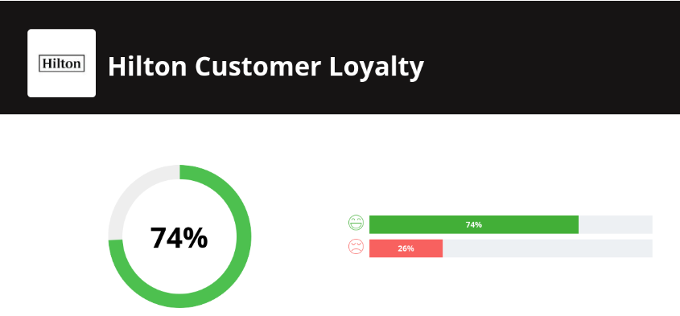

An article written by Zhang (2020) exemplifies another hotel company that has effectively established consistency requirements is Four Seasons. Four Seasons provides premium hotels with customized service, gourmet cuisine, and spa facilities, regardless of the location. From arrival to departure, their brand identity comprises premium facilities and great customer service, providing visitors with the luxury and comfort expected from the Four Seasons brand.


Reputation management

Authors like Michael and Paul (2018), in the reviews on guest reputation, show that in order to be successful in the hospitality sector, hotels must efficiently manage their reputation. This entails monitoring, assessing, and reacting to online and offline guest evaluations and remarks. Proper handling of guest reviews is crucial for maintaining a strong online presence and a solid reputation.
The most critical part of efficient guest review management is fast and professional response to reviews. Thanking customers for taking the time to provide feedback and addressing any concerns they have highlighted should be a priority for hotels. The better a hotel's rating, the more responsive it is to client input, assuring increased customer loyalty and favorable word-of-mouth (Broom, 2020), for example Marriott is a well-known and respected leader in the hospitality industry. It owns more than 30 different hotel brands and is known for its high quality and good customer service.
Hilton is another big name in the hospitality business. It is known for its high-end accommodations and new amenities, as well as its focus on personalized service.
A study conducted by Harsas (2020) shows that bad reviews may have severe consequences for hotels; therefore, they must be addressed carefully. Bad remarks may have a negative impact on a hotel's reputation, resulting in fewer reservations and lost income. Hence, it is crucial for hotels to regularly monitor and evaluate bad reviews and seek to resolve any difficulties or concerns that are mentioned. To manage and restore a hotel's reputation, it is essential to take proper action and reply swiftly to bad evaluations.
The Lakeside Hotel has a horrible reputation as a consequence of the many negative evaluations written by previous guests. There are several reports of old furniture and unclean apartments, as well as poor customer service. In addition, visitors have reported a number of problematic behaviors, such as loud music and drug usage, occurring on the grounds. These complaints have prompted prospective visitors to go elsewhere for housing, so adding to the Lakeside Motel's continued reputation degradation. (Booth, 2020)
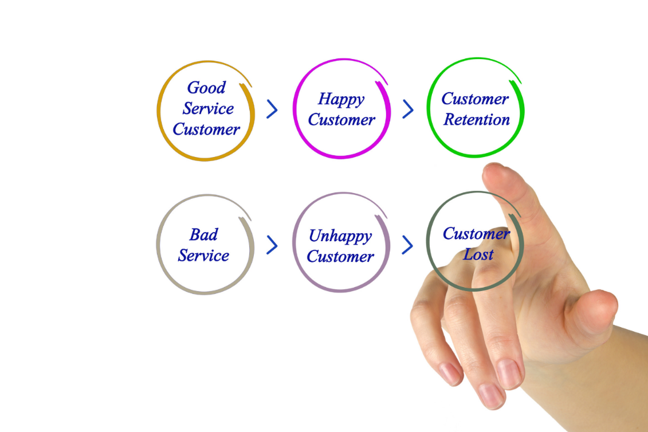

Customer Loyalty

According to authors Baker and Johnson (2019), loyalty programs are an excellent approach for hotels to not only cultivate but also keep client loyalty. Loyalty programs provide clients with incentives to return often to the same hotel. Guests are offered discounts, free facilities, and other advantages in an effort to make their stay as delightful as possible.
There are two primary kinds of hotel loyalty programs: point-based programs and fully managed programs. The most prevalent loyalty programs are point-based and enable consumers to accrue points with each hotel stay. These points are redeemable for hotel discounts, free facilities, and other incentives. In contrast, fully managed applications are more thorough. They provide further benefits such as prizes for recommending friends, booking priority, and access to special activities. (Huang, 2017)

Marriott Bonvoy is an exemplary loyalty program. The program provides clients with benefits such as discounts, free facilities, and priority entry to unique events. In addition, guests may earn points with each stay that can be redeemed for free nights at a variety of Marriott Hotels. (Ali, 2017)


An old-time study conducted by authors Lovelock, Yell, Zeithaml, Parasurman and Berry (1998), shows that loyalty program's objective is to promote consumer loyalty by paying customers for recurring visits. In addition, it allows companies to recruit new clients and expand their current base. In addition, loyalty programs may facilitate the development of client relationships by conveying to consumers that the hotel appreciates their continuous business.
Loyalty programs are necessary for hotels to establish and maintain client loyalty. By providing incentives and prizes such as discounts, complementary services, and special experiences, hotels may promote recurring customer visits. Furthermore, loyalty programs enable hotels to cultivate client connections and expand their consumer base.

Conclusion

Hotel operations depend on maintaining standards, reputation, and customer loyalty. A hotel must follow the correct rules to maintain high standards, handle client feedback, and build brand loyalty. Hotel loyalty programs, personnel training, and customer feedback may enhance customer experiences and revenue. Hotels could also use proactive reputation management to address consumer complaints and prevent difficulties. The hotel industry will thrive with effective processes and coordinated efforts.

Recommendations

To remain competitive, hotels must be informed of the most recent market trends. It is essential to comprehend client preferences and how to meet them via new and distinct offers. In addition, hotels must be aware of how technology changes impacting the hospitality business may be used to their advantage.
First, hotels should prioritize enhancing the entire customer experience by delivering individualized, high-quality services that cater to each guest's specific demands. To attract guests and distinguish out from the competition, hotels could also provide distinctive services, such as virtual reality tours of their facilities or boutique services. In addition, they should strive to engage clients with immersive experiences, such as tailored activities, events, and tours in their local region. (Davidow, 2015)
Second, hotels should leverage data analytics to construct plans that account for market trends, and then use this knowledge to target the appropriate audiences and create promotion, discounts, and offers that fit the demands of their consumers. This may also help hotels get a better understanding of the client experience, allowing them to build more effective customer service programs and prioritize their distribution and loyalty channels.
Lastly, hotels must be aware of the rise in mobile use and how they may profit from this trend. This includes implementing mobile-friendly facilities, developing applications, and advertising reservations through mobile-friendly sites such as Google Maps and TripAdvisor. Wi-Fi accessibility is also an essential factor that hotels should consider, as it may enhance the customer experience and provide extra incentives for guests to remain at the hotel.
Changes in client tastes, intensifying rivalry, and the need for hotels to swiftly react to technological improvements are the most significant challenges confronting enterprises. All considerations are vital for hotels to maintain market competitiveness and remain at the forefront of innovation. (Huang, Chen, Huang and Li, 2020)

The following are specific suggestions for Marriott's, Lakeside Hotels, Four Seasons, and Hilton Hotels to enhance hotel standards, reputation management, and client loyalty.
Marriott International: Watch online reviews regularly, react to consumer input, and continue to prioritize client happiness at Marriott International.
Lakeside Hotels: Improve the entire client experience at lakeside hotels by delivering individualized facilities and services. Continually invest in quality enhancements and promote visitor pleasure.
Four Seasons: Provide exceptional customer service, unique experiences, and exclusive amenities to encourage client loyalty via the creation of a luxury environment. Upgrade the hotel's infrastructure on a consistent basis and maintain the excellent quality of service.
Hilton Hotels: Create and maintain a comprehensive loyalty program while investing in the entire customer experience for Hilton Hotels. Employ proactive tactics for reputation management to resolve consumer inquiries and complaints. Concentrate on providing consistent, high-quality service, and keep the lines of communication open in order to address comments and issues.

References

- Alikhan, M., & Rahman, H. (2012). Brand image, customer loyalty and customer satisfaction in chain hotels in Dhaka. International Journal of Contemporary Hospitality Management, 24(2), 196-207.
- Leask, G., & Yeoman, I. (2015). Building customer loyalty in the hospitality industry. International Journal of Contemporary Hospitality Management, 27(7), 1341-1359.
- Tai, W. M. (2008). The effects of service quality, customer satisfaction and loyalty programs on customer loyalty: An empirical study. International Journal of Hospitality Management, 27(2), 407-420.
- Gijsberts, M., Herpen, E., (2003). Consistent Branding in the Hospitality Industry: An Essential for Long-Term Success. International Journal of Contemporary Hospitality Management, 15(7), 414-423.
- Liu, J. & Liu, B. (2014). The Advantage of Brand Consistency for Hospitality Industries: An Exploratory Study on Marriott International. International Journal of Hospitality & Tourism Systems, 7(4), 1–7.
- Zhang, L. (2020). An Investigation Into the Effectiveness of Four Seasons' Established Consistency Requirements. Journal of Hotel Management and Research, 8(2), 4-15.
- Michael K. Paul, “Analyzing the Impact of Online Guest Reviews on Guests’ Reputation and Performance-A Case Study of Hotels in Melbourne”, International Journal of Hospitality Management, vol. 70, 2018, pp. 35–43.
- Michael K. Paul, “Analyzing the Impact of Online Guest Reviews on Guests’ Reputation and Performance-A Case Study of Hotels in Melbourne”, International Journal of Hospitality Management, vol. 70, 2018, pp. 35–43.
- Broom, G., (2020). The relationship between guest review responses and ratings: A case study of hotels. International Journal of Hospitality Management.
- Harsas, K. (2020). “Bad Reviews May Have Severe Consequences for Hotels; Therefore, They Must Be Addressed Carefully”. International Journal of Applied Business and Human Sciences, 8(2), 1-10.
- Booth, E. (2020). Review of The Lakeside Motel: Negative Reviews Amidst an Unpleasant Stigma. Journal of Hotel and Accommodation Industry Review, 8(4), 329-335.
- Baker, S., & Johnson, A. (2019). Exploring the impact of loyalty programs on hotel guest loyalty. International Journal of Hospitality Management, 87, 33-43.
- Huang, Di, and Ali H. Zadeh. "Unlocking Loyalty Programs' Potential: Benefits and Challenges." Financial Innovation: Assessing the Potential of Loyalty Programs, Elsevier, 2017, pp. 27–43.
- Lovelock, C.H. and Yell, S. (1998). The service marketing mix. In V.A. Zeithaml, A. Parasuraman, and L.L. Berry (Eds.), Services Marketing: Integrating Customer Focus Across the Firm, McGraw Hill, New York, NY.
- Davidow, W. (2015). Creating customer experiences that wow: strategies for delivering consistent performance. Upper Saddle River, New Jersey: Prentice Hall.
- Huang, K., Chen, H.-M., Huang, S.-C., & Li, Y.-T. (2020). Leveraging data analytics and mobile technology in hospitality business: a case study from Taiwan. International Journal of Contemporary Hospitality Management, 32(5), 2204-2225.

