[1]

Security Vulnerabilities & Penetration Assessment

  - Security Documentation

Chris Hopkins BSc Hons, EWC | Mres Computer Networking | 26/10/2017

Contents
List of Figures 2
List of Acronyms 3
Introduction 4
Attacking Tool 5
Attacks 8
Injection Attack 8
Broken Authentication and Session Management 10
Cross-Site Scripting (XSS) 12
Broken Access Control 13
Security Misconfiguration 14
Sensitive Data Exposure 15
Insufficient Attack Protection 16
Cross-Site Request Forgery (CSRF) 17
Analysis 18
Contingency Planning 22
Conclusion 24
References 25
Appendices 29

List of Figures

Figure 1 OWASP ZAP example of XSS[3] 5
Figure 2 Help Bar 6
Figure 3 OWASP Password finding in script 7
Figure 4 SQL Injection[4] 8
Figure 5 Broken Authentication[8] 10
Figure 6 Cross Site Scripting[12] 12
Figure 7 Broken Access Control Example[9] 13
Figure 8 Security Misconfiguration[19] 14
Figure 9 Sensitive Data Exposure [20] 15
Figure 10 Insufficient attack protection[22] 16
Figure 11 Cross-Site Request Forgery[24] 17
Figure 12 OWASP ZAP Startup screen 19
Figure 13 Path Traversal attack 20
Figure 14 Snap shot of responses 21

List of Acronyms

OWASP – Open Web Application Security Project
SQL – Simple Query Language
HTML - Hypertext Markup Language
XSS - Cross site scripting
ESAPI - Encryption Services Application Programming Interface

Introduction

This is a security assessment reports on the vulnerabilities of the on the website http://www.cupstv.com. A number of methods have been used to infiltrate the site in a black box penetration testing scenario. The OWASP[2] (Open Web Application Security Project) list the top ten attacked that were be used to take down a website or gather information form the web sites. OWASP ZAP tool has been implemented for the penetration testing. A report on the most utilized attacks and a contingence plan to be implemented in response to a disaster physically and loss of data.

Attacking Tool
To perform the attacks on the website WWW.CUPTSTV.COM a penetration testing software was procured. The system was made by OWASP project. This tool in most popular free tool used worldwide according to OWASP. The OWASP ZAP platform is vigorously maintained by hundreds of volunteers. This application helps finds any security weaknesses in web applications and web pages.
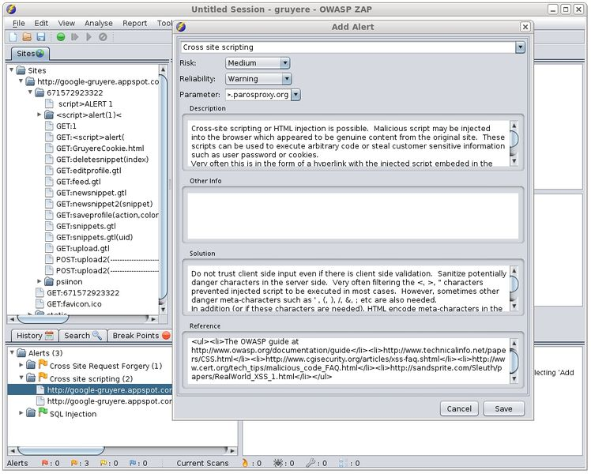
Figure 1 OWASP ZAP example of XSS[3]

Figure one shows the alert status of the Cross-Site Scripting and what risk this would be to a company’s Website /Web application. ZAP does this for all the top ten OWASP penetration attacks. The application is constantly being updated to adapt to new attacks.
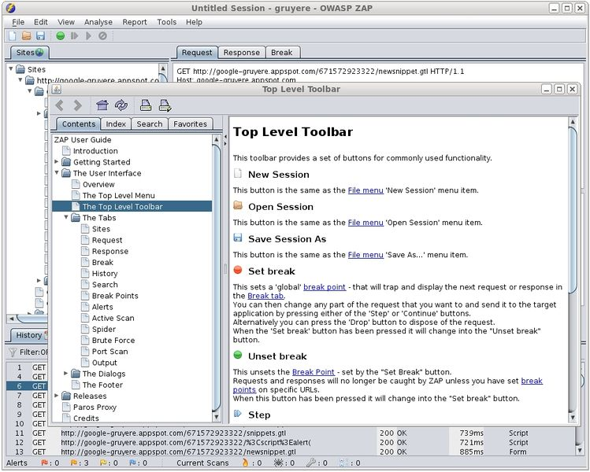
Figure 2 Help Bar

Figure two show how useful the help function is and how to use OWASP ZAP.

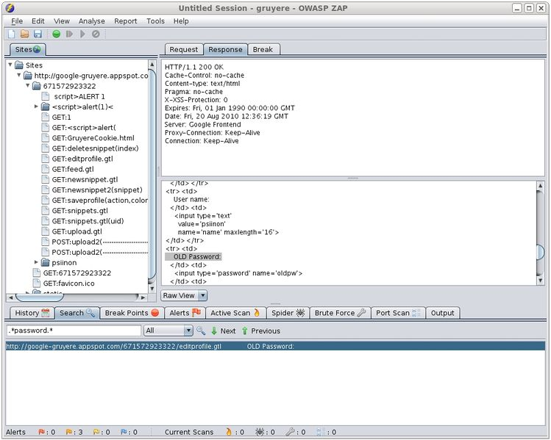
Figure 3 OWASP Password finding in script

OWASP ZAP has the ability to look for poor scripting. In figure four ZAP has found an old password that has been left in the scrip of a web page. This would now give you access to the web page.

Attacks

Injection Attack

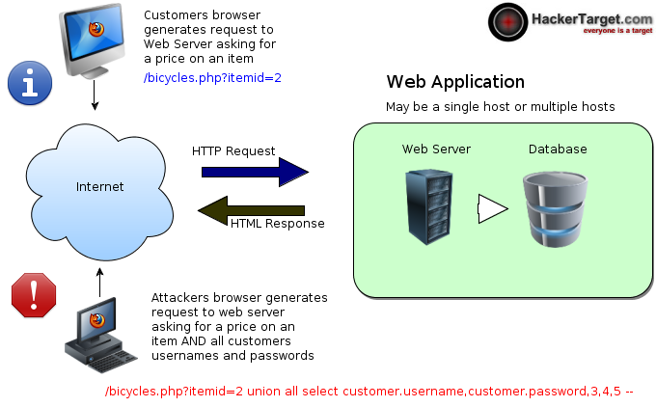
Figure 4 SQL Injection[4]
Injection flaws happen when an application directs untrusted data to a translator. The Injection attack is widespread, especially in legacy coding. The flaws can often be found in NoSQL queries, SQL, OS commands, XML parsers, SMTP Headers. Injection flaws can be easily discovered when examining the coding, although often hard to discern while testing. Scanners can be used to identify flaws for attackers to find injection points.[5] Injection attacks can result in corruption of data and or loss of data, or even denial of access. Injection attacks can possible lead to the host being taken over. [6]
Prevention of an injection attack. The easiest way to prevent an injection attack would be to keeping untrusted information isolated from queries and commands.[7]

Broken Authentication and Session Management

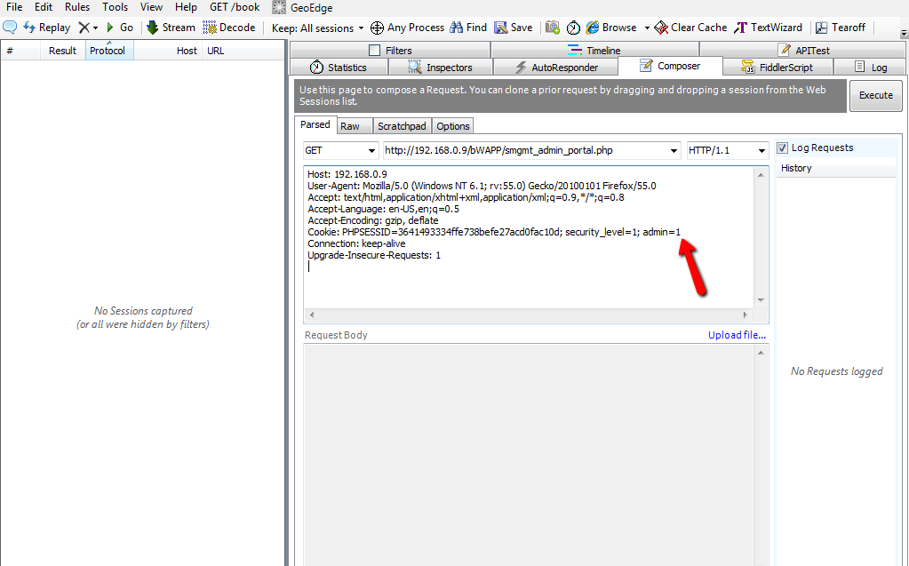
Figure 5 Broken Authentication[8]

Web application developers often make custom verification and session management systems; this can be difficult to be these correctly. This quiet often results these in the customized verification schemes being flawed in areas such as creating accounts, changing passwords, timeouts, etc... Discovering these flaws can be problematic, as each of the implementation is developer specific.[9]
Prevention of broken authentication and or session management should follow the following. A set of robust verification and session management procedures. These procedures should endeavor to meet all the authentication and session management necessities designed in the OWASP’s Verification standards. The application developers should also consider using ESAPI authentication. [8], [9]

Cross-Site Scripting (XSS)

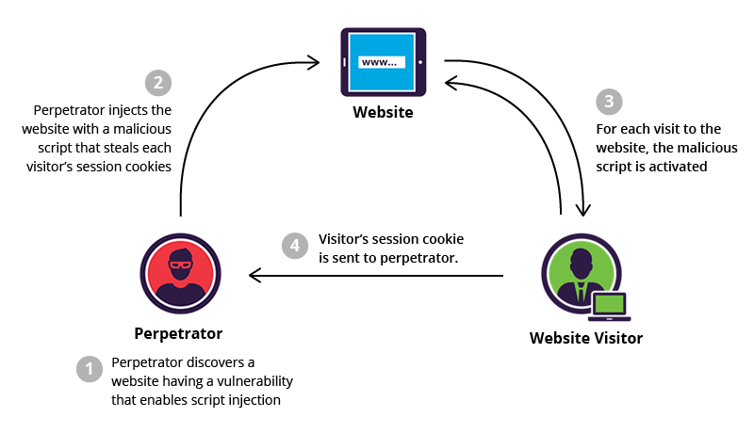
Figure 6 Cross Site Scripting[12]

A cross site scripting (XSS) is one of the most common attacks used to target websites. Alternatively, to an SQL injection, the end user of the web application is at risk from this attack as opposed to the application. Dependent on the attacker’s intentions and the severity of the attack, the user accounts could be compromised, Viruses, Trojan Horses programs could modify, deceive the end user into giving way private data.[13]–[15]
Preventing XSS, the most widely used option would be to appropriately escape untrusted databases on any of the HTML framework that the information will be stored in. Iha, Genta Doi, Hiroshi[16] postulates the use of binding mechanism for preventing XSS vulnerabilities.

Broken Access Control
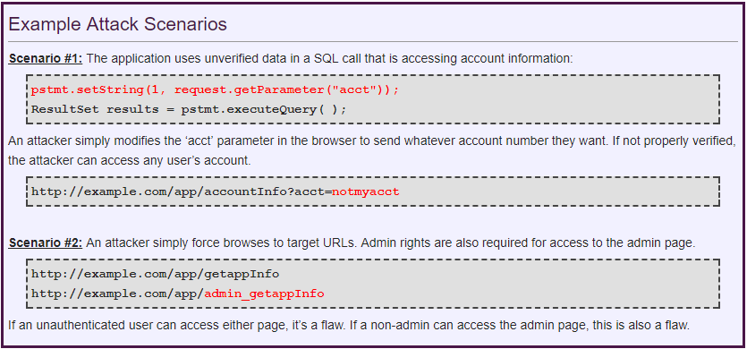
Figure 7 Broken Access Control Example[9]
Broken access control uses the fact that applications and API’s don’t regularly use authenticate for the user to gain access to the targeted resources. API’s and application quiet often use the frequently use the key and or name of the object when creating web pages. This can often result in flaws on your access control. [17]
Preventing broken access control can be done three different ways.
- Checking the access. Access control checks should be put in place to check untrusted sources to make sure the user is authorized to make this request.[9]
- Use a coding pattern avoid attackers from directly aiming at unapproved resources. An example of this, an alternative to using the database key, a list of six authorized resources for the user would have the choice of 1 to 6 to specify the value the user selects. [18]
- Automatic authentication. Control automation to confirm the appropriate authorization deployment.

Security Misconfiguration

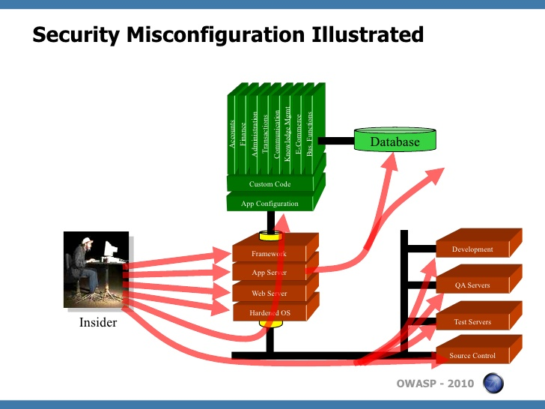
Figure 8 Security Misconfiguration[19]
Misconfiguration at the application levels are common and can happen in any part of application stack, this including the platform, web server, application server, database, frameworks, and custom code. Developers and system administrators need to work together to ensure that the entire stack is configured properly. Automated scanners are useful for detecting missing patches, misconfigurations, use of default accounts, unnecessary services, etc.

Sensitive Data Exposure
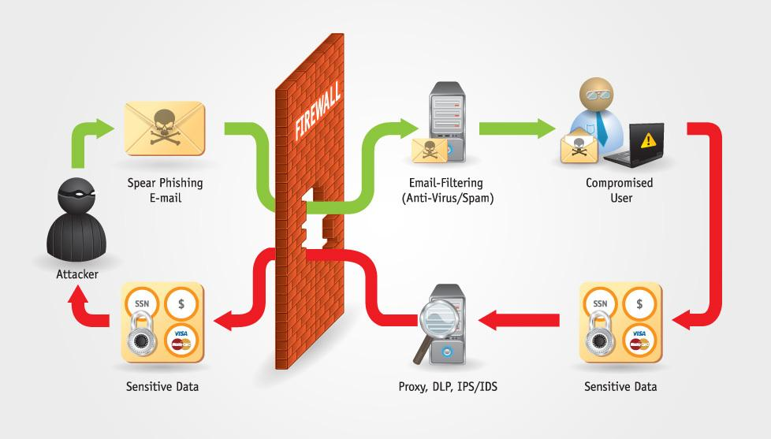
Figure 9 Sensitive Data Exposure [20]

One of the most common faults is that the sensitive data has not been encrypted. When the crypto virus is set about it targets key generation that has been set up with weak protocols or policies and management, or weak algorithm are implemented. The easiest to target is the weak password hashing methods. Weaknesses in the browser are easy to abuse but this becomes harder to exploit on larger scales. Attacks from external sources are more difficult to identify on the because of limited access making it harder to exploit. [21]

Insufficient Attack Protection
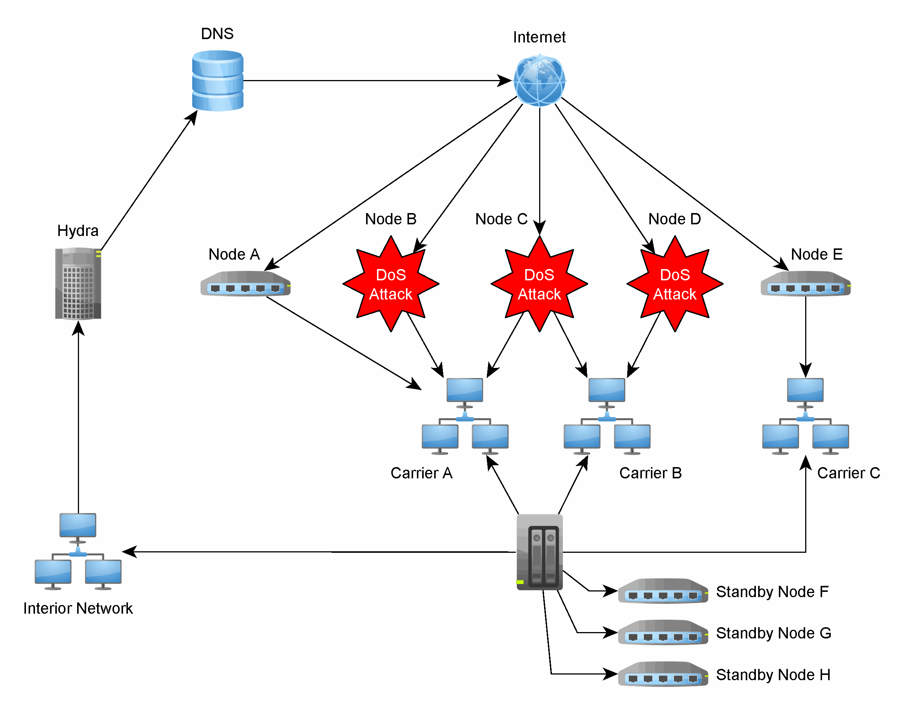
Figure 10 Insufficient attack protection[22]

Attacks on API’s and Applications are constantly happening. The Applications and API’s recognize these attacks and returns a null and void output which then becomes rejected, API’s or applications permit the attacks to continue repeatedly. These attacks show a malicious user or group of users searching to exploit vulnerabilities in the scripts. The best way of detecting and blocking these attacks is to increase the security. To stop these types of attacks you would need to evaluate how quickly critical patch can be implemented? [23]

Cross-Site Request Forgery (CSRF)
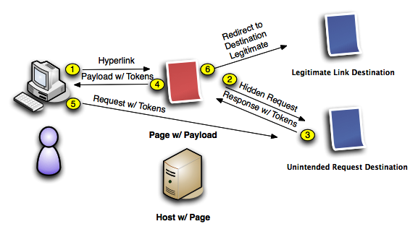
Figure 11 Cross-Site Request Forgery[24]

SCRF is an attack that uses the fact that a user is already authenticated on a web application and forces that end user to then execute forces undesirable actions. As the attacker does not get to see the response from the attack, this type of attack would only be useful in changing stats. When users are in a chatroom or using email, the attacker would trick the end user into executing a executing activities of the attacker's choosing. Depending on the access the user would have for example and normal end user might just loose funds from personal account but if this was and administrative user then the entire website would be compromised. The most common way to prevent CSRF is to use the challenge token that is linked with the user. This is found as a concealed value in every state changing form which is present on the web application.[25], [26]

Analysis
An attack was performed on WWW.CUPTV.COM on behalf of Network Security company based in Faculty of Architecture, Computing and Engineering (FACE) South building, Swansea. Many attacks were performed to test the site’s resilience and to see if any weaknesses could be found and exploited the results showed there to be two areas in which the website could be exploited.

Path Traversal
This method allows the attackers access to directories, files and commands that possibly reside outside the web document root directory. An aggressor may manipulate a URL in such a way that the web site will perform or expose the contents of arbitrary files anyplace on the web server. Any device that leaks an HTTP-based interface is theoretically helpless to Path Traversal attacks.
The majority of web sites limit user access to a specific share of the file-system, this is characteristically called the “CGI root"[27] or "web document root" [28] directory. These directories normally comprise of the files proposed for user access and the executable needed to drive the applications functions. For these files to be access or executable commands to be run on the file-system, Path Traversal attacks will use a sequences special-characters.
The most straightforward Path Traversal attack utilizes “../" special-character this can be used to modify the resource position requested in the URL. Even though the most popular web servers will have preventative measures put in place for these attacks the attacker my still have access to evade the security filters. “These technique variations include valid and invalid Unicode-encoding ("..%u2216" or "..%c0%af") of the forward slash character, backslash characters ("..\") on Windows-based servers, URL encoded characters "%2e%2e%2f"), and double URL encoding ("..%255c") of the backslash character.”[3]

Cross-Domain JavaScript Source File Inclusion

This attack shows that there is scripture included in the web site that has been has one or more scripts files from a third-party domain. This is a form of XSS.

Screen shots of the attacks.

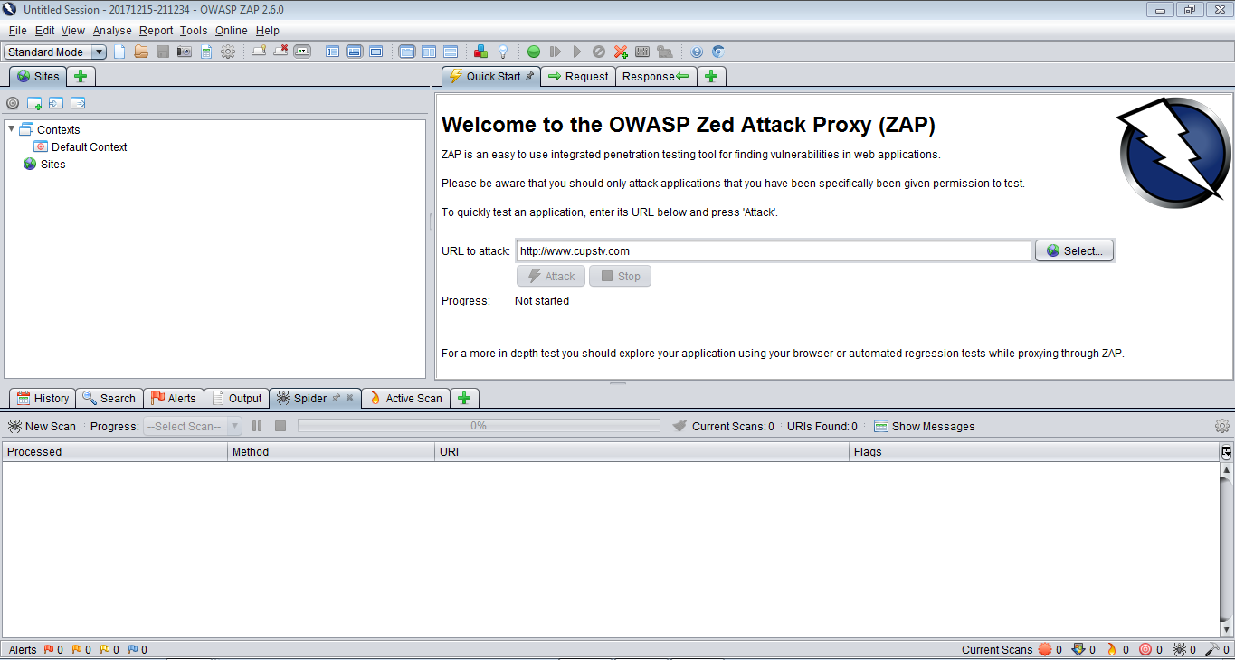
Figure 12 OWASP ZAP Startup screen

In figure twelve you are introduced to the welcome page. This where you would be expected to direct the application to the website to be attacked. You would also be expected to change the type of attack to performed, in this case a standard attack was performed but there are options for attack and prevention mode as well.

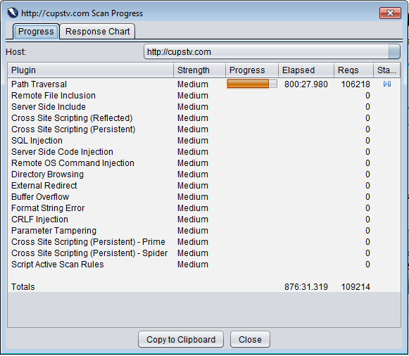
Figure 13 Path Traversal attack

Figure thirteen shows the attack being performed. In figure thirteen in total over 300000 requests were sent to the webpage numbering a number upwards of 3weeks of attacks on the cupstv website. In total 150000 requests were made just in conjunction with path traversal.

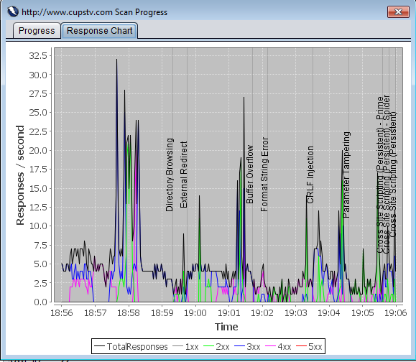
Figure 14 Snap shot of responses

Figure fourteen shows a snap shot of the attacks taking place over ten-minute scan. Each section named is the attack that was being implemented at that moment in time.

Contingency Planning

There are three main topics to keep in mind when creating a contingency plan.

Disaster Planning
Physical facilities: An alternate work areas in either same site or at a different company location, there are specific company’s set up that provided location for disaster recovery, please consider using employees’ homes or at a moveable work facility. Other considerations site security, staff access procedures, ID badges and the location of the alternate space relative to the primary site.[29], [30]
Technology: Consider access to equipment space that is correctly constructed for IT systems, with elevated floors.[29], [30]
This would also include appropriate heating, aeration and air conditioning (HVAC) for IT systems; adequate main electrical power; appropriate network infrastructure; accessibility to failover (to a backup system) and failback (return to normal operations) technologies to facilitate recovery; the distance of the alternate technology area from the primary site; provision for staffing at an alternate technology site; support for legacy systems; and physical and information security capabilities at the alternate site.[29], [30]
Data: Areas to look at include timely backup of critical data to a secure storage area in accordance with RTO/RPO requirements, method(s) of data storage (disk, tape, optical, etc), connectivity and bandwidth requirements to ensure all critical data can be backed up in accordance with RTO/RPO time scales, data protection capabilities at the alternate storage site, and availability of technical support from qualified third-party service providers.[29], [30]
Suppliers: You’ll need to identify and contract with primary and alternate suppliers for all critical systems and processes, and even the sourcing of people.[29], [30]
Key areas where alternate suppliers will be important include hardware (such as servers and racks), power (such as batteries, universal power supplies, and power protection), networks (voice and data network services), repair and replacement of components, and multiple delivery firms (such as FedEx and UPS).[29], [30]
Policies and procedures: Define policies for IT disaster recovery and have them approved by senior management. Then define step-by-step procedures to, for example, initiate data backup to secure alternate locations, relocate operations to an alternate space, recover systems and data at the alternate sites, and resume operations at either the original site or at a new location.[29], [30]

Conclusion
This paper has shown the vulnerabilities of the website www.cupstv.com. A number of vulnerabilities were found. The one that could cause problems would be the XSS. This leaves the website open to cross-script attacks. There are preventative measures that have been suggested in the report. A contingence plan has been created in the event of a major disaster for example earthquake to loss of data on a large scale. I have left access to the reports gained by using OWASP ZAP application in the appendices.

References

[1] “Penetration Testing | Pen Test Services | TCDI | Cleveland, Ohio.” [Online]. Available: https://www.tcdi.com/penetration-testing-pen-test/. [Accessed: 27-Oct-2017].
[2] “OWASP.” [Online]. Available: https://www.owasp.org/index.php/Main_Page. [Accessed: 27-Oct-2017].
[3] “The Web Application Security Consortium / Path Traversal.” [Online]. Available: http://projects.webappsec.org/w/page/13246952/Path Traversal. [Accessed: 15-Dec-2017].
[4] “SQL Injection Tutorial | HackerTarget.com.” [Online]. Available: https://hackertarget.com/sql-injection/. [Accessed: 02-Nov-2017].
[5] “주요 Top 10 제약기업 및 아시아-태평양 지역의 라이센싱 및 제휴 전략 트렌드,” 2011.
[6] K. Khanna, B. K. Panigrahi, and A. Joshi, “Bi-level modelling of false data injection attacks on security constrained optimal power flow,” IET Gener. Transm. Distrib., vol. 11, no. 14, pp. 3586–3593, 2017.
[7] S. Deng, X. Gao, Z. Lu, and X. Gao, “Packet Injection Attack and Its Defense in Software-Defined Networks,” IEEE Trans. Inf. Forensics Secur., vol. 6013, no. c, pp. 1–1, 2017.
[8] “Broken Authentication and Session Management – Part 1 - Cybrary.” [Online]. Available: https://www.cybrary.it/0p3n/broken-authentication-session-management-part-1/. [Accessed: 02-Nov-2017].
[9] “Top 10 2017-A2-Broken Authentication and Session Management - OWASP.” [Online]. Available: https://www.owasp.org/index.php/Top_10_2017-A2-Broken_Authentication_and_Session_Management. [Accessed: 02-Nov-2017].
[10] D. Huluka and O. Popov, “Root Cause Analysis of Session Management and Broken Authentication Vulnerabilities,” Internet Secur. (WorldCIS), 2012 World Congr., pp. 82–86, 2012.
[11] O. B. Al-Khurafi and M. A. Al-Ahmad, “Survey of Web Application Vulnerability Attacks,” Proc. - 2015 4th Int. Conf. Adv. Comput. Sci. Appl. Technol. ACSAT 2015, pp. 154–158, 2016.
[12] “What is XSS | Stored Cross Site Scripting Example | Incapsula.” [Online]. Available: https://www.incapsula.com/web-application-security/cross-site-scripting-xss-attacks.html. [Accessed: 02-Nov-2017].
[13] M. R. Zalbina, T. W. Septian, D. Stiawan, M. Y. Idris, A. Heryanto, and R. Budiarto, “Payload recognition and detection of Cross Site Scripting attack,” 2017 2nd Int. Conf. Anti-Cyber Crimes, ICACC 2017, pp. 172–176, 2017.
[14] M. Mohammadi, B. Chu, and H. R. Lipford, “Detecting cross-site scripting vulnerabilities through automated unit testing,” Proc. - 2017 IEEE Int. Conf. Softw. Qual. Reliab. Secur. QRS 2017, pp. 364–373, 2017.
[15] C. H. Wang and Y. S. Zhou, “A New Cross-Site Scripting Detection Mechanism Integrated with HTML5 and CORS Properties by Using Browser Extensions,” Proc. - 2016 Int. Comput. Symp. ICS 2016, pp. 264–269, 2017.
[16] G. Iha and H. Doi, “An implementation of the binding mechanism in the web browser for preventing XSS attacks: Introducing the bind-value headers,” Proc. - Int. Conf. Availability, Reliab. Secur. ARES 2009, pp. 966–971, 2009.
[17] “Ensuring proper ventilation,” pp. 2–2.
[18] “AccessController (ESAPI 2.1.0.1 API).” [Online]. Available: https://static.javadoc.io/org.owasp.esapi/esapi/2.1.0.1/org/owasp/esapi/AccessController.html. [Accessed: 02-Nov-2017].
[19] Mitchp, “OWASP Top 10 Web Security vulnerabilities,” DZone, pp. 6–8, 2010.
[20] “Sensitive Data Exposure- A CxO not just CSO nightmare | Venkatesh (Venky) Sundar | Pulse | LinkedIn.” [Online]. Available: https://www.linkedin.com/pulse/20140913122506-4298133-sensitive-data-exposure-a-cxo-not-just-cso-nightmare. [Accessed: 17-Nov-2017].
[21] “Top 10 2017-A3-Sensitive Data Exposure - OWASP.” [Online]. Available: https://www.owasp.org/index.php/Top_10_2017-A3-Sensitive_Data_Exposure. [Accessed: 15-Dec-2017].
[22] “RaccoonTech.com.” [Online]. Available: http://www.raccoontech.com/HydraRouting.php. [Accessed: 11-Dec-2017].
[23] “owasp - How is Insufficient Attack Protection a Definite Threat/Risk to an Organization? - Information Security Stack Exchange.” [Online]. Available: https://security.stackexchange.com/questions/157213/how-is-insufficient-attack-protection-a-definite-threat-risk-to-an-organization. [Accessed: 15-Dec-2017].
[24] “csrf.png (577×317).” [Online]. Available: http://4.bp.blogspot.com/-fJ-PMQTUlP4/UaBWj8iqfPI/AAAAAAAAEs8/ZZVTi9zE4TY/s720/csrf.png. [Accessed: 15-Dec-2017].
[25] “Cross-Site Request Forgery (CSRF) - OWASP,” 2016. [Online]. Available: https://www.owasp.org/index.php/Cross-Site_Request_Forgery_(CSRF). [Accessed: 15-Dec-2017].
[26] Acunetix, “Defending against CSRF Attacks, XSRF or Sea-Surf,” 2017. [Online]. Available: https://www.acunetix.com/websitesecurity/csrf-attacks/. [Accessed: 15-Dec-2017].
[27] “Apache Tutorial: Dynamic Content with CGI - Apache HTTP Server.” [Online]. Available: https://httpd.apache.org/docs/2.4/howto/cgi.html. [Accessed: 15-Dec-2017].
[28] “Mapping URLs to Filesystem Locations - Apache HTTP Server Version 2.4.” [Online]. Available: https://httpd.apache.org/docs/2.4/urlmapping.html. [Accessed: 15-Dec-2017].
[29] 11/10/2009, “Building a Disaster Recovery Plan for Your SaaS Vendors -.” [Online]. Available: https://go.druva.com/rs/307-ANG-704/images/White-Paper_Building-a-Disaster-Recovery-Plan-for-the-Cloud-Era_WEB_Q118-CON-10753.pdf. [Accessed: 15-Dec-2017].
[30] P. Kirvan, “How to write a disaster recovery plan and define disaster recovery strategies,” ComputerWeekly. [Online]. Available: http://www.computerweekly.com/feature/How-to-write-a-disaster-recovery-plan-and-define-disaster-recovery-strategies. [Accessed: 15-Dec-2017].

Appendices

ZAP Scanning Report
Summary of Alerts
Risk Level | Number of Alerts
High | 1
Medium | 0
Low | 3
Informational | 0
Alert Detail
High (Medium) | Path Traversal
Description | The Path Traversal attack technique allows an attacker access to files, directories, and commands that potentially reside outside the web document root directory. An attacker may manipulate a URL in such a way that the web site will execute or reveal the contents of arbitrary files anywhere on the web server. Any device that exposes an HTTP-based interface is potentially vulnerable to Path Traversal.  Most web sites restrict user access to a specific portion of the file-system, typically called the "web document root" or "CGI root" directory. These directories contain the files intended for user access and the executable necessary to drive web application functionality. To access files or execute commands anywhere on the file-system, Path Traversal attacks will utilize the ability of special-characters sequences.  The most basic Path Traversal attack uses the "../" special-character sequence to alter the resource location requested in the URL. Although most popular web servers will prevent this technique from escaping the web document root, alternate encodings of the "../" sequence may help bypass the security filters. These method variations include valid and invalid Unicode-encoding ("..%u2216" or "..%c0%af") of the forward slash character, backslash characters ("..\") on Windows-based servers, URL encoded characters "%2e%2e%2f"), and double URL encoding ("..%255c") of the backslash character.  Even if the web server properly restricts Path Traversal attempts in the URL path, a web application itself may still be vulnerable due to improper handling of user-supplied input. This is a common problem of web applications that use template mechanisms or load static text from files. In variations of the attack, the original URL parameter value is substituted with the file name of one of the web application's dynamic scripts. Consequently, the results can reveal source code because the file is interpreted as text instead of an executable script. These techniques often employ additional special characters such as the dot (".") to reveal the listing of the current working directory, or "%00" NULL characters in order to bypass rudimentary file extension checks.
URL | http://www.cupstv.com/comments/feed/?query=
Method | GET
Parameter | query
Instances | 1
Solution | Assume all input is malicious. Use an "accept known good" input validation strategy, i.e., use a whitelist of acceptable inputs that strictly conform to specifications. Reject any input that does not strictly conform to specifications, or transform it into something that does. Do not rely exclusively on looking for malicious or malformed inputs (i.e., do not rely on a blacklist). However, blacklists can be useful for detecting potential attacks or determining which inputs are so malformed that they should be rejected outright.  When performing input validation, consider all potentially relevant properties, including length, type of input, the full range of acceptable values, missing or extra inputs, syntax, consistency across related fields, and conformance to business rules. As an example of business rule logic, "boat" may be syntactically valid because it only contains alphanumeric characters, but it is not valid if you are expecting colors such as "red" or "blue."  For filenames, use stringent whitelists that limit the character set to be used. If feasible, only allow a single "." character in the filename to avoid weaknesses, and exclude directory separators such as "/". Use a whitelist of allowable file extensions.  Warning: if you attempt to cleanse your data, then do so that the end result is not in the form that can be dangerous. A sanitizing mechanism can remove characters such as '.' and ';' which may be required for some exploits. An attacker can try to fool the sanitizing mechanism into "cleaning" data into a dangerous form. Suppose the attacker injects a '.' inside a filename (e.g. "sensi.tiveFile") and the sanitizing mechanism removes the character resulting in the valid filename, "sensitiveFile". If the input data are now assumed to be safe, then the file may be compromised.  Inputs should be decoded and canonicalized to the application's current internal representation before being validated. Make sure that your application does not decode the same input twice. Such errors could be used to bypass whitelist schemes by introducing dangerous inputs after they have been checked.  Use a built-in path canonicalization function (such as realpath() in C) that produces the canonical version of the pathname, which effectively removes ".." sequences and symbolic links.  Run your code using the lowest privileges that are required to accomplish the necessary tasks. If possible, create isolated accounts with limited privileges that are only used for a single task. That way, a successful attack will not immediately give the attacker access to the rest of the software or its environment. For example, database applications rarely need to run as the database administrator, especially in day-to-day operations.  When the set of acceptable objects, such as filenames or URLs, is limited or known, create a mapping from a set of fixed input values (such as numeric IDs) to the actual filenames or URLs, and reject all other inputs.  Run your code in a "jail" or similar sandbox environment that enforces strict boundaries between the process and the operating system. This may effectively restrict which files can be accessed in a particular directory or which commands can be executed by your software.  OS-level examples include the Unix chroot jail, AppArmor, and SELinux. In general, managed code may provide some protection. For example, java.io.FilePermission in the Java SecurityManager allows you to specify restrictions on file operations.  This may not be a feasible solution, and it only limits the impact to the operating system; the rest of your application may still be subject to compromise.
Reference | http://projects.webappsec.org/Path-Traversal  http://cwe.mitre.org/data/definitions/22.html
CWE Id | 22
WASC Id | 33
Source ID | 1

Low (Medium) | Cross-Domain JavaScript Source File Inclusion
Description | The page includes one or more script files from a third-party domain.
URL | http://www.cupstv.com
Method | GET
Parameter | http://cupstv.com/wp-content/themes/sahifa/js/tie-scripts.js
Evidence | <script type='text/javascript' src='http://cupstv.com/wp-content/themes/sahifa/js/tie-scripts.js'></script>
URL | http://www.cupstv.com
Method | GET
Parameter | http://cupstv.com/wp-content/plugins/wunderground/assets/js/widget.min.js
Evidence | <script type='text/javascript' src='http://cupstv.com/wp-content/plugins/wunderground/assets/js/widget.min.js'></script>
URL | http://www.cupstv.com/wp-register.php
Method | GET
Parameter | http://cupstv.com/wp-content/themes/sahifa/js/tie-scripts.js
Evidence | <script type='text/javascript' src='http://cupstv.com/wp-content/themes/sahifa/js/tie-scripts.js'></script>
URL | http://www.cupstv.com
Method | GET
Parameter | http://cupstv.com/wp-includes/js/jquery/ui/menu.min.js
Evidence | <script type='text/javascript' src='http://cupstv.com/wp-includes/js/jquery/ui/menu.min.js'></script>
URL | http://www.cupstv.com/wp-register.php
Method | GET
Parameter | http://cupstv.com/wp-includes/js/wp-embed.min.js
Evidence | <script type='text/javascript' src='http://cupstv.com/wp-includes/js/wp-embed.min.js'></script>
URL | http://www.cupstv.com/wp-login.php
Method | GET
Parameter | http://cupstv.com/wp-includes/js/jquery/ui/position.min.js
Evidence | <script type='text/javascript' src='http://cupstv.com/wp-includes/js/jquery/ui/position.min.js'></script>
URL | http://www.cupstv.com
Method | GET
Parameter | http://cupstv.com/wp-includes/js/wp-embed.min.js
Evidence | <script type='text/javascript' src='http://cupstv.com/wp-includes/js/wp-embed.min.js'></script>
URL | http://www.cupstv.com
Method | GET
Parameter | http://cupstv.com/wp-includes/js/jquery/ui/autocomplete.min.js
Evidence | <script type='text/javascript' src='http://cupstv.com/wp-includes/js/jquery/ui/autocomplete.min.js'></script>
URL | http://www.cupstv.com/wp-register.php
Method | GET
Parameter | http://cupstv.com/wp-includes/js/jquery/ui/position.min.js
Evidence | <script type='text/javascript' src='http://cupstv.com/wp-includes/js/jquery/ui/position.min.js'></script>
URL | http://www.cupstv.com/wp-register.php
Method | GET
Parameter | http://cupstv.com/wp-includes/js/jquery/jquery.js
Evidence | <script type='text/javascript' src='http://cupstv.com/wp-includes/js/jquery/jquery.js'></script>
URL | http://www.cupstv.com
Method | GET
Parameter | http://cupstv.com/wp-content/themes/sahifa/js/ilightbox.packed.js
Evidence | <script type='text/javascript' src='http://cupstv.com/wp-content/themes/sahifa/js/ilightbox.packed.js'></script>
URL | http://www.cupstv.com/wp-login.php
Method | GET
Parameter | http://cupstv.com/wp-includes/js/jquery/ui/core.min.js
Evidence | <script type='text/javascript' src='http://cupstv.com/wp-includes/js/jquery/ui/core.min.js'></script>
URL | http://www.cupstv.com/wp-login.php
Method | GET
Parameter | http://cupstv.com/wp-includes/js/jquery/ui/widget.min.js
Evidence | <script type='text/javascript' src='http://cupstv.com/wp-includes/js/jquery/ui/widget.min.js'></script>
URL | http://www.cupstv.com/wp-login.php
Method | GET
Parameter | http://cupstv.com/wp-content/plugins/wunderground/assets/js/widget.min.js
Evidence | <script type='text/javascript' src='http://cupstv.com/wp-content/plugins/wunderground/assets/js/widget.min.js'></script>
URL | http://www.cupstv.com/wp-login.php
Method | GET
Parameter | http://cupstv.com/wp-includes/js/wp-a11y.min.js
Evidence | <script type='text/javascript' src='http://cupstv.com/wp-includes/js/wp-a11y.min.js'></script>
URL | http://www.cupstv.com/wp-login.php
Method | GET
Parameter | http://cupstv.com/wp-includes/js/jquery/ui/autocomplete.min.js
Evidence | <script type='text/javascript' src='http://cupstv.com/wp-includes/js/jquery/ui/autocomplete.min.js'></script>
URL | http://www.cupstv.com/wp-login.php
Method | GET
Parameter | http://cupstv.com/wp-includes/js/wp-embed.min.js
Evidence | <script type='text/javascript' src='http://cupstv.com/wp-includes/js/wp-embed.min.js'></script>
URL | http://www.cupstv.com/wp-register.php
Method | GET
Parameter | http://cupstv.com/wp-content/themes/sahifa/js/ilightbox.packed.js
Evidence | <script type='text/javascript' src='http://cupstv.com/wp-content/themes/sahifa/js/ilightbox.packed.js'></script>
URL | http://www.cupstv.com/wp-login.php
Method | GET
Parameter | http://cupstv.com/wp-includes/js/jquery/ui/menu.min.js
Evidence | <script type='text/javascript' src='http://cupstv.com/wp-includes/js/jquery/ui/menu.min.js'></script>
URL | http://www.cupstv.com/wp-login.php
Method | GET
Parameter | http://cupstv.com/wp-includes/js/jquery/jquery-migrate.min.js
Evidence | <script type='text/javascript' src='http://cupstv.com/wp-includes/js/jquery/jquery-migrate.min.js'></script>
Instances | 37
Solution | Ensure JavaScript source files are loaded from only trusted sources, and the sources can't be controlled by end users of the application.
Reference
CWE Id | 829
WASC Id | 15
Source ID | 3

Low (Medium) | Web Browser XSS Protection Not Enabled
Description | Web Browser XSS Protection is not enabled, or is disabled by the configuration of the 'X-XSS-Protection' HTTP response header on the web server
URL | http://www.cupstv.com/wp-register.php
Method | GET
Parameter | X-XSS-Protection
URL | http://www.cupstv.com/wp-login.php
Method | GET
Parameter | X-XSS-Protection
URL | http://www.cupstv.com
Method | GET
Parameter | X-XSS-Protection
URL | http://www.cupstv.com/wp-content/uploads/
Method | GET
Parameter | X-XSS-Protection
URL | http://www.cupstv.com/wp-admin/admin-ajax.php
Method | GET
Parameter | X-XSS-Protection
URL | http://www.cupstv.com/wp-admin/
Method | GET
Parameter | X-XSS-Protection
Instances | 6
Solution | Ensure that the web browser's XSS filter is enabled, by setting the X-XSS-Protection HTTP response header to '1'.
Other information | The X-XSS-Protection HTTP response header allows the web server to enable or disable the web browser's XSS protection mechanism. The following values would attempt to enable it:  X-XSS-Protection: 1; mode=block  X-XSS-Protection: 1; report=http://www.example.com/xss  The following values would disable it:  X-XSS-Protection: 0  The X-XSS-Protection HTTP response header is currently supported on Internet Explorer, Chrome and Safari (WebKit).  Note that this alert is only raised if the response body could potentially contain an XSS payload (with a text-based content type, with a non-zero length).
Reference | https://www.owasp.org/index.php/XSS_(Cross_Site_Scripting)_Prevention_Cheat_Sheet  https://blog.veracode.com/2014/03/guidelines-for-setting-security-headers/
CWE Id | 933
WASC Id | 14
Source ID | 3

Low (Medium) | X-Content-Type-Options Header Missing
Description | The Anti-MIME-Sniffing header X-Content-Type-Options was not set to 'nosniff'. This allows older versions of Internet Explorer and Chrome to perform MIME-sniffing on the response body, potentially causing the response body to be interpreted and displayed as a content type other than the declared content type. Current (early 2014) and legacy versions of Firefox will use the declared content type (if one is set), rather than performing MIME-sniffing.
URL | http://www.cupstv.com/license.txt
Method | GET
Parameter | X-Content-Type-Options
URL | http://www.cupstv.com/robots.txt
Method | GET
Parameter | X-Content-Type-Options
URL | http://www.cupstv.com/wp-admin/admin-ajax.php
Method | GET
Parameter | X-Content-Type-Options
URL | http://www.cupstv.com
Method | GET
Parameter | X-Content-Type-Options
Instances | 4
Solution | Ensure that the application/web server sets the Content-Type header appropriately, and that it sets the X-Content-Type-Options header to 'nosniff' for all web pages.  If possible, ensure that the end user uses a standards-compliant and modern web browser that does not perform MIME-sniffing at all, or that can be directed by the web application/web server to not perform MIME-sniffing.
Other information | This issue still applies to error type pages (401, 403, 500, etc) as those pages are often still affected by injection issues, in which case there is still concern for browsers sniffing pages away from their actual content type.  At "High" threshold this scanner will not alert on client or server error responses.
Reference | http://msdn.microsoft.com/en-us/library/ie/gg622941%28v=vs.85%29.aspx  https://www.owasp.org/index.php/List_of_useful_HTTP_headers
CWE Id | 16
WASC Id | 15
Source ID | 3

