School of Sport, Health & Outdoor Education

Assessment Feedback Sheet

Student No./Name:1501106/Marley Winn
Module: Landscape and Sustainable Recreation
Module Code: (SHSS6082)

Personal Evaluation – to support your academic progress please complete the section below BEFORE submitting your work.
What do you consider to be the best aspects of this work? |  |  | Reflecting on the field work of Dinefwr Park
Which aspects do you consider could have been improved in this piece of work? |  |  | Providing sustainable approaches and discussing the landscape of Bwlch Nant Y Arian
What have you found most satisfying whilst undertaking this submission? |  |  | Learning the different approaches to sustainable and landscape between the National Trust and Natural Resources Wales
ASSESSMENT CRITERIA | Learning  Outcomes |  | GRADE
ASSESSMENT CRITERIA |  |  | Poor  < 20% | Weak  20-29% | Unsatisfactory  30-39% |  | Satisfactory  40 – 49% | Good  50 – 59% | Very Good  60 – 69% | Excellent  70 – 84% |  | Exceptional  85– 100% | %
Your discussion of the nature of landscape within the context of the fieldwork locations | 1 |  |  |  |  |  |  |  |  |  |  |  | 20%
Your critical evaluation of external and internal influences that affect the perception, interpretation and use of landscape at the fieldwork sites. | 2 |  |  |  |  |  |  |  |  |  |  |  | 20%
Your critical discussion of the relationship between landscape and recreation and your suggestion of sustainable approaches to the interpretation and use of landscape for recreation. | 3 |  |  |  |  |  |  |  |  |  |  |  | 40%
Your identification and use of relevant academic and other material to help inform and develop your argument | 1,2,3 |  |  |  |  |  |  |  |  |  |  |  | 20%
It is expected that students will present work that is proof read, correctly referenced and adheres to the Assessment Checklist. Therefore a range of 0 – 10 marks will be deducted for non-completion of any of the points on the checklist below.
TUTOR COMMENTS:

Submission date:  via Turnitin |  | Return date:  (at least within 4 weeks) |  |  |  | Tutor: |  |  |  |  | Mark:

Reflective Fieldwork Journal
Introduction
Research and fieldwork were gathered at two field work sites including notes on an additional fieldwork site. These fieldwork sites include the Dinefwr Park, Bwlch Nant Yr Arian and Pengelli Forest as notes. At each location notes and photographic evidence was collected about the landscape character, landscape quality, designations, use, access and future potential. Each area is maintained and run by an organisation or charity, Dinefwr Park is maintained and run by the Nation Trust while Bwlch Nant Yr Arian is run and maintained by Natural Resource Wales and Pengelli Forest is run and maintained by The South and West Wales Wildlife Trust. The National Trust is a charity which was founded in 1895 by Octavia Hill, Sir Robert Hunter and Hardwicke Rawnsley and has become one of the largest charities in the UK. The National Trust is funded by membership subscriptions, entrance fees, legacies, and revenue from gift shops and restaurants within its properties. The National Trust was given statutory powers, starting with the National Trust Act 1907 (The National Trust Acts 1907 - 1971). Currently the National Trust has been accused of “focusing too much on country estates, and in recent years, the trust has sought to broaden its activities by acquiring historic properties such as former mills, early factories, workhouses, and the childhood homes of Paul McCartney and John Lennon.” (National Trust, 2017). Natural Resource Wales is the “largest Welsh Government Sponsored Body - employing 1,900 staff across Wales with a budget of £180 million.” (Natural Resources Wales, 2019). Natural Resources Wales were formed in April 2013 taking over the functions of the Countryside Council for Wales, Forestry Commission Wales and the Environment Agency in Wales, as well as certain Welsh Government functions. (Natural Resources Wales, 2019). The roles and responsibilities of the Natural Resources Wales are adviser, regulator, designator, responder, statutory consultee, manager/operator, partner, educator, enabler, evidence gatherer and employer. National Resources Wales purpose is to "pursue sustainable management of natural resources” and “apply the principles of sustainable management of natural resources” as stated in the Environment (Wales) Act 2016 (Welsh Assembly Government, 2016). The Wildlife Trusts is a movement made up of 46 Wildlife Trusts: independent charities who all share a mission to create living landscapes and living seas and a society where nature matters. (Wildlifetrusts.org, 2019). Each Wildlife Trust is a member of the “Royal Society of Wildlife Trusts (RSWT) which is a registered charity in its own right, founded in 1912.” (Wildlifetrusts.org, 2019). There are thirty-seven Trusts in England, five in Wales, a Trust for Scotland and a Trust for Northern Ireland. There are also Trusts in Alderney and the Isle of Man. The central charity’s role is to ensure a strong voice for wildlife at a UK and England level and to lead the development of the movement. (Wildlifetrusts.org, 2019).
Fieldwork: Dinefwr Park
Dinefwr Park is an 800-acre estate national nature reserve, historic house, 18th century landscape park and medieval deer park located in Llandeilo in Carmarthenshire South West Wales. Dinefwr Park is run and maintained by the National Trust. The National Trust is a charity which was founded in 1895 by Octavia Hill, Sir Robert Hunter and Hardwicke Rawnsley and has become the largest charity in the UK. Dinefwr Park is a site of special scientific interest (SSSI) and the only parkland National Nature Reserve in Wales. In terms of landscape character Dinefwr park has a wide range of habitats and environment. Dinefwr Park is hilly which slopes down onto the floodplain near the tywi river. Furthermore, the landscape has a range of meadows to dense woodland, wide open spaces to bog woods and wet meadows, each area provides vital habitats for a range of species and plays a crucial role in the biodiversity of the UK. The wildlife within Dinefwr park has a range of native British wildlife such as otter, pole cat, voles, fallow deer and badgers as well as invasive species such as the grey squirrel. Furthermore, Dinefwr park also holds a hundred-acre medieval deer park with over one hundred Fellow deer. Dinefwr ancient woodland is home to some of the oldest trees in Britain which include over 300 oak trees which are stated as being over 400 years old. They state that when the trees die or fall to the ground, they do not remove them unless they cause a health and safety risk, but they do state that they stay where they fall to provide habitat for Dinefwr plant, wildlife and fungi species (See Appendices). In terms of use and access Dinefwr Park is open all year round and is free to enter during the winter. Dinefwr Park has a range of permissive footpaths around the park and estate which are suitable for all abilities. The National Trust focusses heavily on the conservation of historic buildings and heritage rather than the conservation of the environment and its wildlife as throughout their website it discusses and promotes the conservation of historic buildings and discusses about its history on many historic buildings than the nature reserves, they claim to support. The National Trust states that they “develop new, innovative ways of managing land on a large scale, which are good for farmers, the economy and the environment”. This further provided evidence that the National Trust aims are to control and manage the environment and provides very little details on how they manage the environment and promote wild areas. Furthermore, the tour guide mention how the fallow deer which they promote as their main tourist attraction and an invasive species that Sykes et al., (2006) states that that fallow deer was introduced into southern England in the first century AD. The tour guide states that the environment which they are within have little resources and that if there is an increase of fellow deer population the way to manage this is to shoot them. Which then clearly goes against their protection of wildlife and not being able to provide a suitable environment in which they claim to promote. The tour guide further states that the trees surrounding the estate and park get damaged from an invasive species known as the grey squirrel from North America which have a huge population within the UK and Ireland because of the lack of natural predators which the only predators in Europe are the European pine marten which are currently only in nature and wildlife reserves in the UK Sheehy and Lawton, (2014). The National Trust further states that when the trees fall over or the branches fall on the ground they are left to try and promote habitats for animals yet during the tour and walk the large majority of the trees where cut and that branches which have fallen have been put into piles than being left where there are except within the deer park which are left where they are (See Appendices). Some of the paths around the estate and park are not suitable for some abilities as the path during the tour was slippery and a lack of signpost to know where to go. However just recently the National Trust has announced to weather proof their trails. The reason for this and what was mentioned during the tour, the National Trust states that “Increasing visitor numbers and footfall on some of our more popular routes is bound to have an effect on the paths, especially in the wetter months.” (National Trust, 2019). They further state that on the trails they are seeing increased erosion of vegetation on there more popular paths which exposes the soil underneath which then results in these paths becoming muddy and very slippery. National Trust, (2019). The National Trust state that each year they spend “around £160,000 on the Dinefwr property just to maintain access and undertake day to day land management work on the estate.” (National Trust, 2019) this clearly shows the National Trust main priority is the maintenance and land access on the estate than conservation work however the National Trust states in the same article that “Over the next two years we will be investing a further £125,000 on our path network and conservation objectives to show our continued commitment and investment in ensuring our visitors continued enjoyment of the park and the protection of its flora and fauna.” (National Trust, 2019). Examples of the conservation work they will be doing are weather proofing their popular routes, installing new gateways, sign posts, hedge and boundary restoration, road repairs, tree maintenance, scrub clearance and temporary path diversions to aid ground cover to recover. However, there’s a lack of information available for Dinefwr Park and the National Trust especially the National Trust website which is difficult to navigate, and information is sparse. In terms of providing sustainable approaches to recreation development at Dinefwr Park is to improve the less popular routes by making the weather proof using sustainable methods, other such sustainable approaches are to provide wild flowers to encourage bees and butterflies while creating a walk around the wildflower area. Another suggestion is to provide a larger area for the Fallow deer to roam and allow more sustainable ways to improve the amount of food in the deer reserved to allow a larger population.
Bwlch Nant Yr Arian
The second fieldwork site which is Bwlch Nant Yr Arian which is run and maintained by Natural Resource Wales is situated in Mid-Wales on the A44 East of Aberystwyth. Bwlch Nant Yr Arian is famous for its red kites and mountain bike trails. As you can see from the image (Appendices) the majority of the landscape is mountainous, with large areas of managed woodland and lakes and reservoirs. In 1999 Bwlch Nant Yr Arian became a red kite feeding station as part of a programme to protect the small number of red kites in the areas before 1999. Use and access at Bwlch Nant Yr Arian is accessible for everyone. There is a wide range of trails for various activities and abilities, these trails include three waymarked walking trails, three mountain bike trails, mountain bike skills park, two running trails, four orienteering courses and a waymarked circular trail for horse riders all of which are managed by Natural Resource Wales. Before Nant Yr Arian became a red kite feeding area and the help from the RSPB (The Royal Society for the Protection of Birds), red kites were nearly extinct due to illegal poison baits set for foxes or crows, the rarity of the red kite made it a prime target for egg collectors and bounty hunters, who robbed up to a quarter of nests each year and that due to the low rate of chick production by the Welsh kites which was largely caused by the marginal habitat the birds live in, The RSPB, (2019). The red kites were saved from “national extinction by one of the world's longest-running protection programmes. It has now been successfully re-introduced to England and Scotland.” (The RSPB, 2019) Red kites are listed under Schedule 1 of The Wildlife and Countryside Act which Schedule 1 lists over forty species of birds that are protected by special penalties. GOV.UK, (1981). The majority of trees at Nant Yr Arian are cash crop namely Larch trees however there has been current issues particularly the Phytophthora Ramorum disease which effects Larch trees throughout Wales and that 6.7 million trees have been felled since 2016 (Whitchurch, 2016). The disease is transmitted by airborne fungal spores and infect the bark and needles of the trees which visitor have been told to clean there boots, mountain bikes and horses feet when they leave to reduce spreading the disease to other area and make sure that your boots, mountain bike and horses feet are clean when visiting Bwlch Nant Yr Arian to reduce spreading in the area. National Resources Wales “has already replanted around 12,000 native trees at Bwlch Nant Yr Arian since the last phase of major tree felling in 2013. The area will continue to be replanted with a mix of species including Douglas fir and Western red cedar.” (Natural Resources Wales, 2015). Nant Yr Arian uses a mix of land owned by Natural Resources Wales and open access land, open access land in Wales was established by the Countryside and Rights of Way Act (CRoW) in 2005 (GOV.UK, 2000). One fifth of Wales is mapped as ‘access land’ where the public have a right of access on foot. Open access land under the CRoW act consist of open land such as mountains, moorland, heathland and down land and consists of registered common land which consists of land that is recorded on the official registers held by the common registration authority. Open access land further includes dedicated land where owners for example Natural Resources Wales allow free access. (Natural Resources Wales, 2019). Mountain biking and walking both have an impact on vegetation at a location, Bwlch Nant Yr Arian is popular for its mountain bike routes and walking routes both get popular during the summer months. The mountain bike routes use an all-weather surface however erosion does occur however, the walking route are not all-weather proof apart from the walking route around the red kite feeding zone which uses gravel. A study was conducted looking at the impact of mountain biking and hiking on vegetation. What the study found was that there were “no signiﬁcant differences between hiking and mountain biking treatments” and that “when vulnerable plants are directly contacted by a weight-bearing surface they will be affected no matter what the weight-bearing surface is, once a certain weight threshold is met” (Thurston and Reader, 2001) this could be said with mountain bikers and horse rider which again Bwlch Nant Yr Arian has a horse riding routes. Natural Resources Wales have very little information on dealing with erosion at Bwlch Nant Yr Arian and way to reduce the popularity on certain popular trails and walking routes. However, they do have information on replanting native trees from the disease which has affected the larch trees. 12,000 native trees including sessile oak, rowan, birch, field maple, wild cherry, hawthorn and blackthorn have been replanted by Natural Resources Wales at Bwlch Nant Yr Arian. (Natural Resources Wales, 2014).

Words-2360
Appendices
Notes for Pengelli Forest
Pengelli Forest is run and maintained by the Wildlife Trust of South and West Wales which is a part of the Wildlife Trusts. Pengelli Forest is located South West Wales in North of Pembrokeshire with the Pembrokeshire Coast National Park. It is predominantly oak trees and other native trees. Pengelli Forest is part of the largest block of ancient Oak woodland in west Wales. The forest comprises a mixture of Birch, Ash and Alder with a wide range of hybrid Oaks. Over much of the forest there is a dense understorey of Bramble, Hazel, Honeysuckle, Hawthorn and Holly. This is the only known location for the Midland Hawthorn in Pemrokeshire and Aspen, Goat Willow, Wild Cherry, Wych Elm and Apple are also to be found. There is a range of wildlife at Pengelli Forest such as Badgers, Polecats, Woodmice, Bank Voles, Dormice, Barbastelle bat, Frogs and newts, Lizard and Slow Worms and include many beetles and butterflies. Same can be said for a range of birds such as Redstart, Wood Warbler, Buzzard, Chiffchaff, Tawny Owl, Sparrowhawk and Woodcock birds during the winter. The main body of Pengelli Forest has a gently undulating hilly topography and many small streams which run through the forest. Pengelli Forest has a range of walks around the forest currently no cycling or horse riding is allowed.
Photos of Pengelli Forest
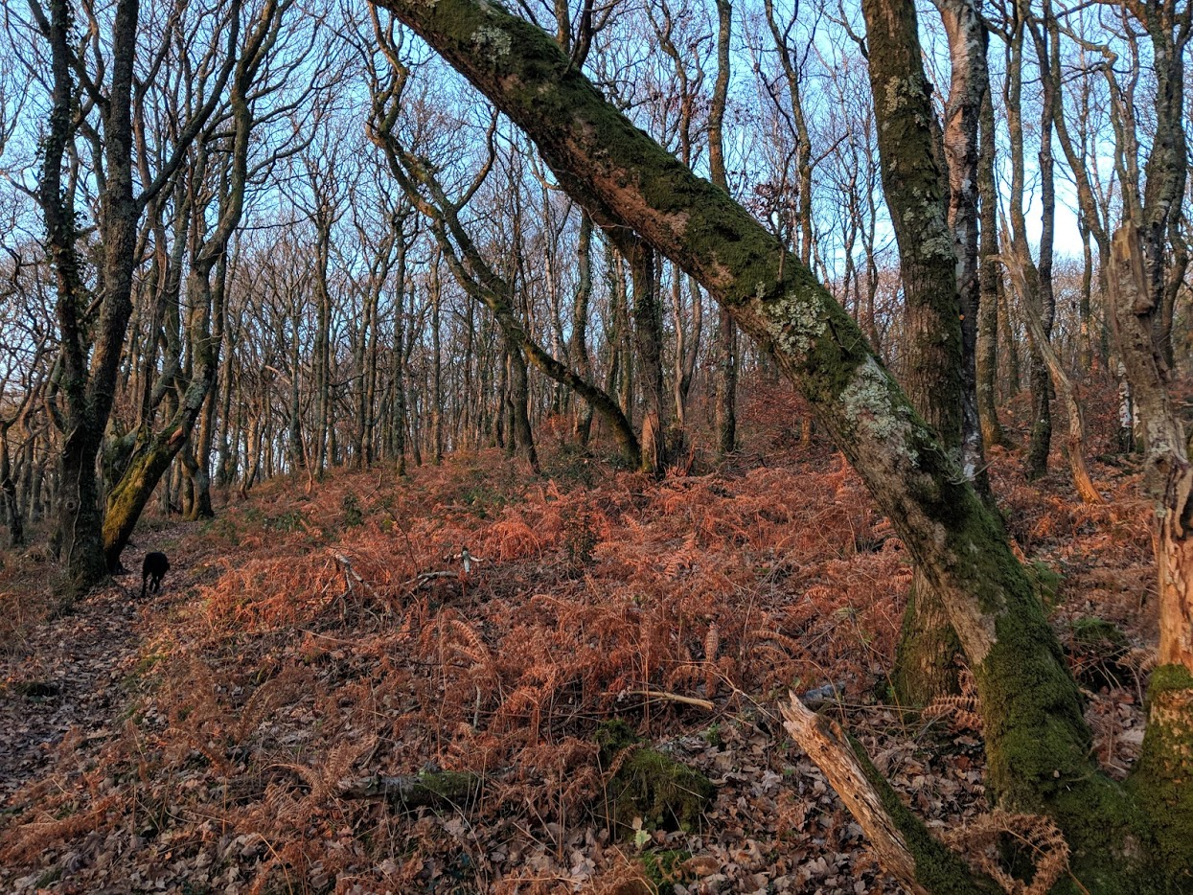
Figure 1 Pengelli Forest during the autumn season
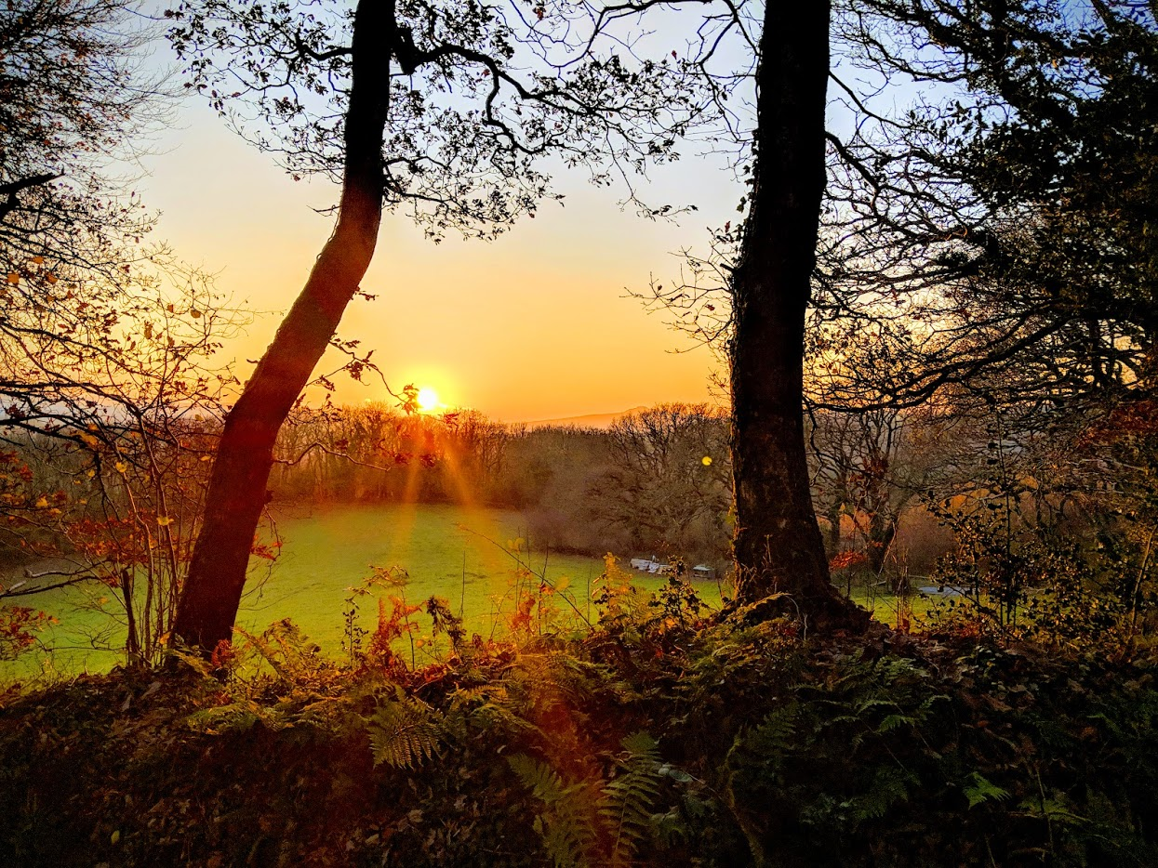
Figure 2 Pengelli terrain with the Preseli Hills in the background
Photos of Dinefwr Park
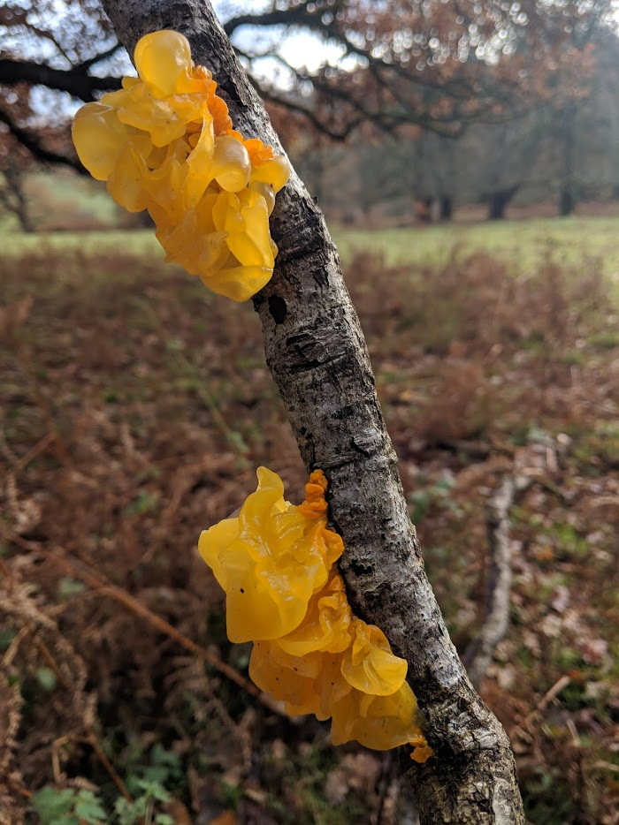
Figure 3 Witches Butter on some of the branch piles
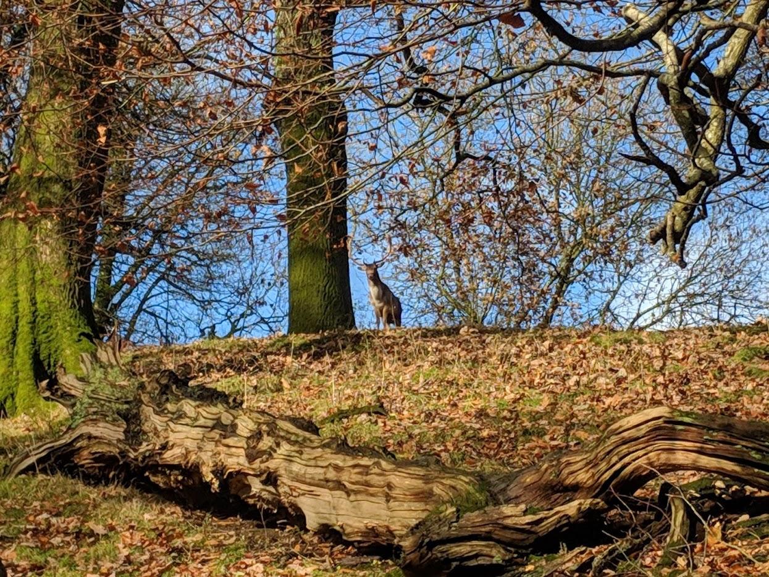
Figure 4 Fallow Deer at Dinefwr Park

Photos of Bwlch Nant Yr Arian
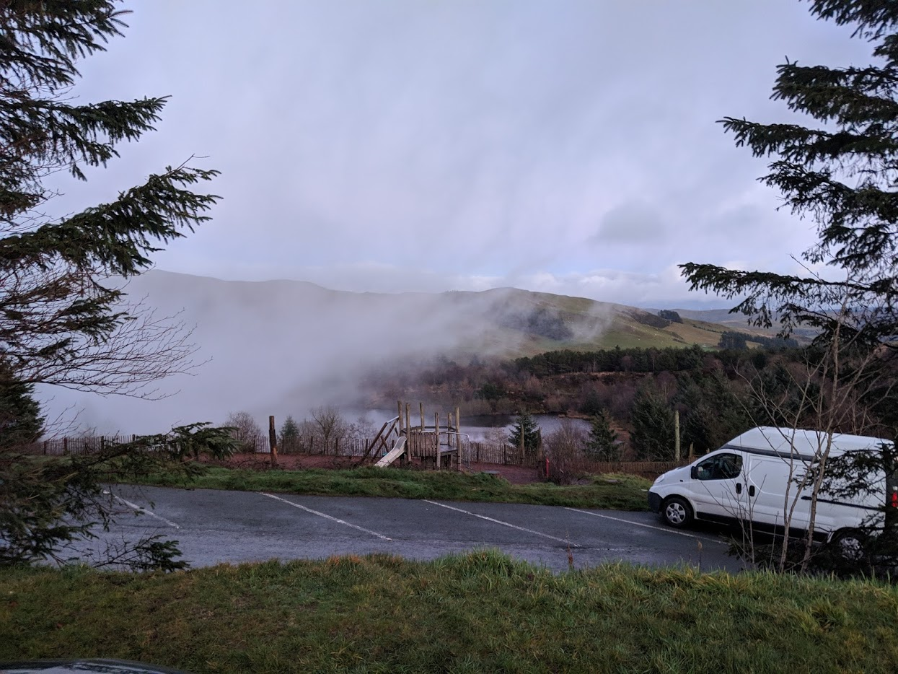
Figure 5 Mist coming in at Nant Yr Arian
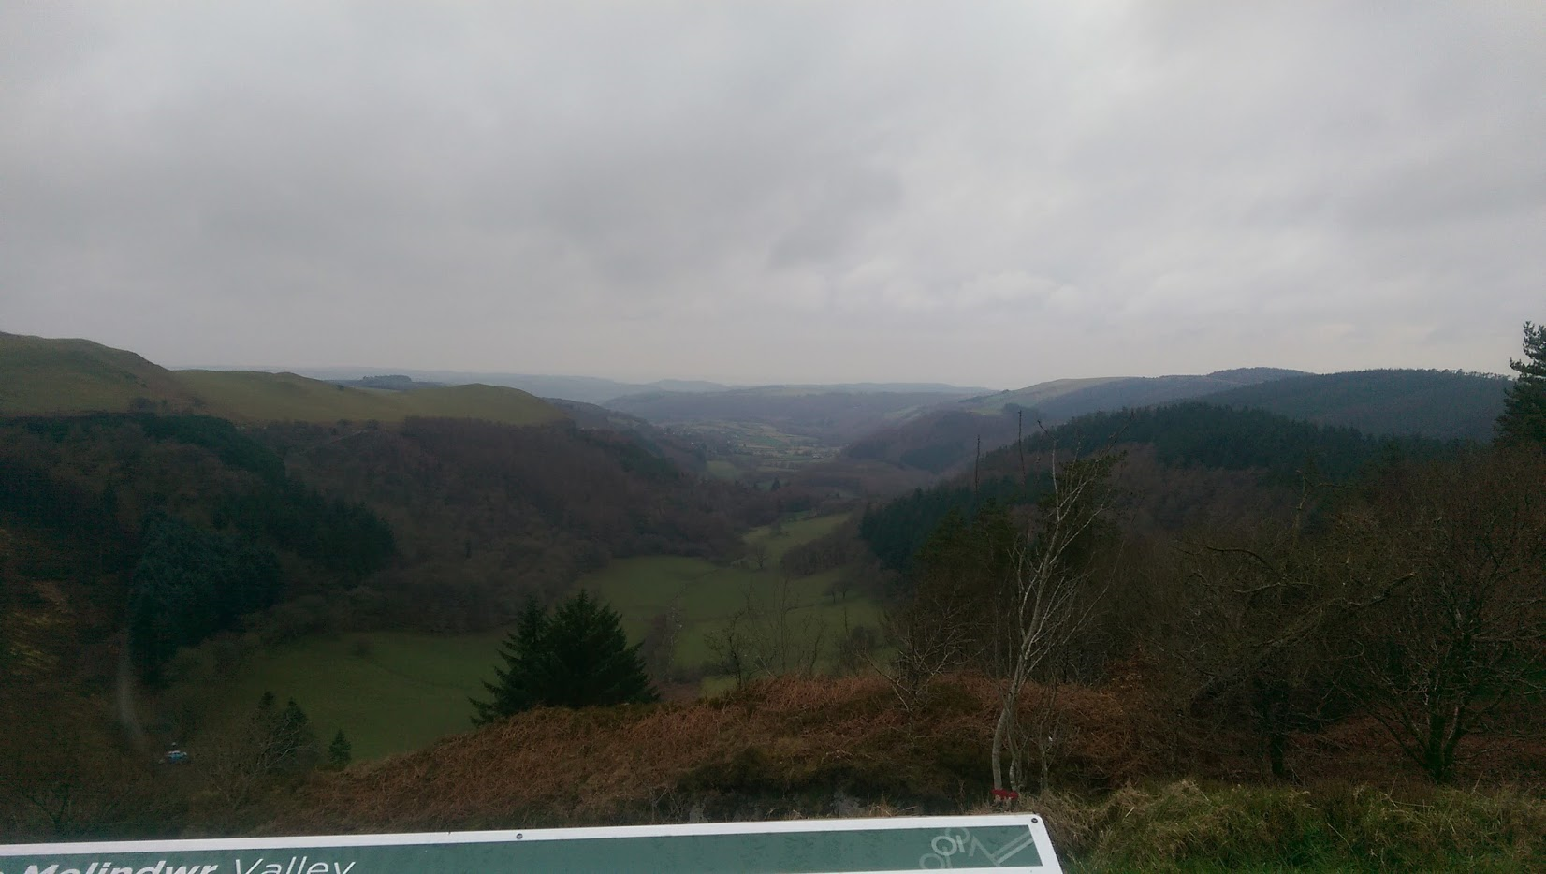
Figure 6 View from Nant Yr Arian with Aberystwyth in the background
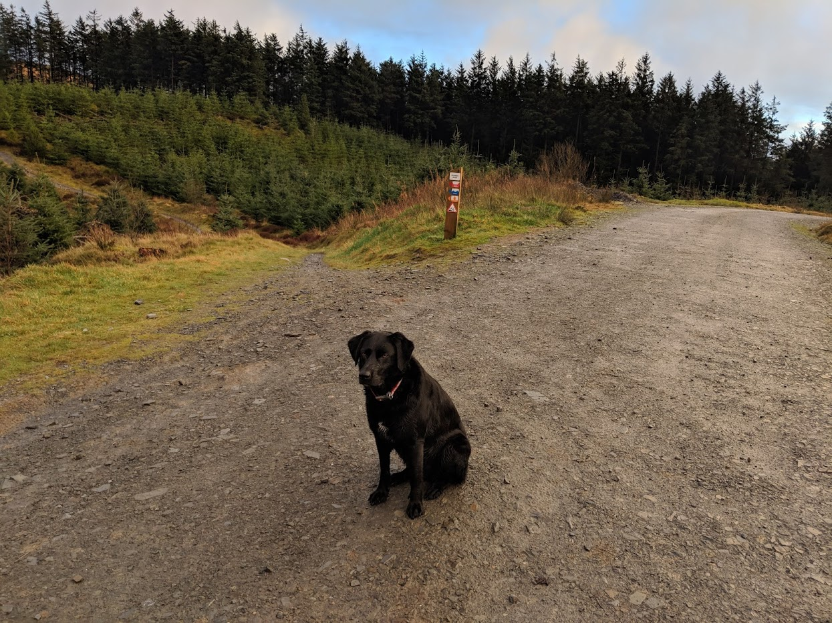
Figure 7 Shows the type of forest at Nant Yr Arian including the mountain bike trail

References
GOV.UK (1981). Wildlife and Countryside Act 1981. London: Legislation.gov.uk, p.69.
GOV.UK (2000). Countryside and Rights of Way Act 2000. London: GOV.UK, pp.1-104.
National Trust. (2017). Beatles Childhood Homes. [online] Available at: https://www.nationaltrust.org.uk/beatles-childhood-homes [Accessed 9 Jan. 2019].
National Trust. (2019). We're weather-proofing our trails. [online] Available at: https://www.nationaltrust.org.uk/dinefwr/features/walking-whatever-the-weather- [Accessed 8 Jan. 2019].
Natural Resources Wales. (2014). Natural Resources Wales / Visitors really rate award-winning forest centre. [online] Available at: https://naturalresources.wales/about-us/news-and-events/news/visitors-really-rate-award-winning-forest-centre/?lang=en [Accessed 9 Jan. 2019].
Natural Resources Wales. (2015). Natural Resources Wales / Tree felling to combat disease at Nant yr Arian. [online] Available at: https://naturalresources.wales/about-us/news-and-events/news/tree-felling-to-combat-disease-at-nant-yr-arian/?lang=en [Accessed 8 Jan. 2019].
Natural Resources Wales. (2019). Natural Resources Wales / Open Access Land. [online] Available at: https://naturalresources.wales/days-out/recreation-and-access-policy-advice-and-guidance/managing-access/open-access-land/?lang=en [Accessed 9 Jan. 2019].
Natural Resources Wales. (2019). Natural Resources Wales / Our roles and responsibilities. [online] Available at: https://naturalresources.wales/about-us/what-we-do/our-roles-and-responsibilities/?lang=en [Accessed 9 Jan. 2019].
Sheehy, E. and Lawton, C. (2014). Population crash in an invasive species following the recovery of a native predator: the case of the American grey squirrel and the European pine marten in Ireland. Biodiversity and Conservation, 23(3), pp.753-774.
Sykes, N., White, J., Hayes, T. and Palmer, M. (2006). Tracking animals using strontium isotopes in teeth: the role of fallow deer (Dama dama) in Roman Britain. Antiquity, 80(310), pp.948-959.
The National Trust Acts 1907 - 1971.
The RSPB. (2019). Red Kite Conservation - The RSPB. [online] Available at: https://www.rspb.org.uk/birds-and-wildlife/wildlife-guides/bird-a-z/red-kite/conservation/ [Accessed 8 Jan. 2019].
Thurston, E. and Reader, R. (2001). Impacts of Experimentally Applied Mountain Biking and Hiking on Vegetation and Soil of a Deciduous Forest. Environmental Management, 27(3), pp.397-409.
Welsh Assembly Government (2016). Environment (Wales) Act 2016. Cardiff: Welsh Assembly Government, pp.1-89.
Wildlifetrusts.org. (2019). How we are run | The Wildlife Trusts. [online] Available at: https://www.wildlifetrusts.org/about-us/how-we-are-run [Accessed 9 Jan. 2019].
Whitchurch, T. (2016). The complexities of tree felling at Bwlch Nant Yr Arian. [Blog] Natural Resources Wales. Available at: https://naturalresources.wales/about-us/news-and-events/blog/felling-in-bwlch-nant-yr-arian/?lang=en [Accessed 8 Jan. 2019].

