Kristian Cole (1810705)

Visualisation Of Data

Table of Contents
Login 2
Rainfall Data 2
Rainfall Graph 2
Rainfall Search 5
References 6

Login
The login page (login.php) utilizes the html form submission structure. A html form with a post command that transfers the username and password to the checklogin.php. The password input field has been assigned a ‘password’ type, this hides the password from the user and unauthorized users [1]. The field does not utilize a password minimum or maximum length because this indicates to unauthorized users a range for password brute force password attacks. The Check Login page (checklogin.php) checks the rainfall database users table for users and passwords. The entries provided by the user on the login page need to be cleaned up prior to the check. There is a chance that SQL injection can be attempted, in this case a str_replace [2] is applied to both input and password fields. Str_replace is a string replace function that replaces characters with characters of a users choice. The “’” is replaced in the login page to prevent SQL queries from being executed in the SQL query defined in the system [3]. An addition route has been coded so that if the password is incorrect the page automatically navigates back to the login.php to retry access. Each php page within the program utilizes the session object to check if a user is logged in. “if(@$_SESSION["uname"]!="")”, a check that simply denies a user, who is not logged in, access to any of the pages by direct link alone. If a user attempts to access any pages without logging into first they are directed back to the login page, header("location:login.php"). The logout.php clears the @$_session[”uname”] so it cannot be used without a user manually reentering the login details to access the system. Additionally the “$_SESSION["uname"]=""; session_destroy();” is implemented on every page that uses the php session, this provides an extra layer of security that sessions are cleared if any questionable access is attempted.

Rainfall Data
The Rainfall Data web page (rainfall.php) outputs a table of all the data onto the page. Each php form implements Bootstrap to manage the placement of all outputs on the page in the container and row grid system [4]. This php page collects the data from the three data text files, normalizes the data and inserts them into the mysql database Rainfall. The script first explodes the string data in the files and then allocates each split into columns for each of the expectant columns in the rainfall_data table in the database.
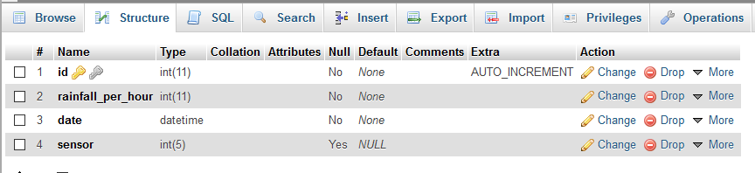

Rainfall Graph
The Rainfall Graph page (rainfall.php) simply outputs three png images created using the phpmygraph5.0:
- Yearly rainfall divides the table into available data from the past few years, 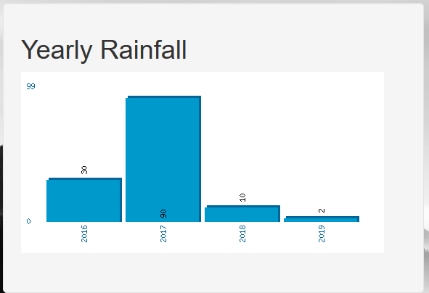
- Monthly rainfall graph divides the data into months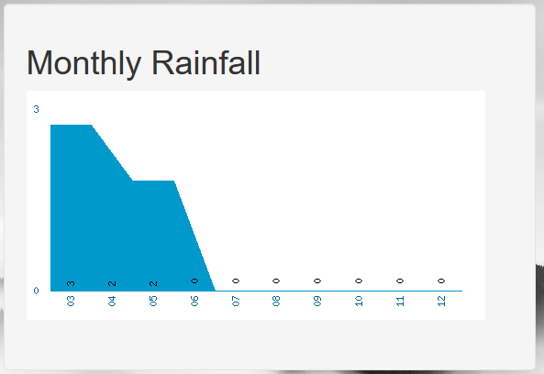
- Total rainfall by sensor graph divides the sensors.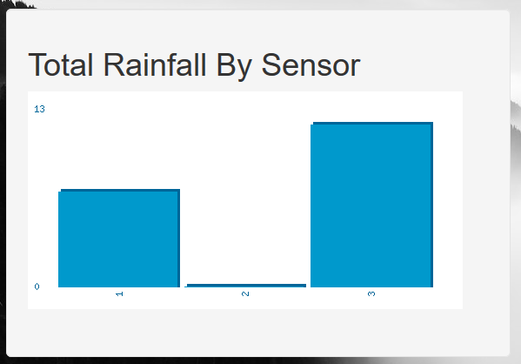
Each image relies on its own php page to request data from the database (rainfall_data), add that data to an array ($data) and pass it to the Myphpgraph5.0 [4].
Yearly Rainfall Graph (Yearlyrainfallgraph.php) – rainfall data grouped by year implementing the parseVerticalPolygonGraph function.
Monthly Rainfall Graph (Monthlyrainfallgraph.php) – rainfall data grouped by month year implementing the parseVerticalColumnGraph function.
Total Rainfall 2019 By Sensor (Totalrainfallgraph.php) – rainfall data grouped by sensor year implementing the parseVerticalColumnGraph function.
Each php file has a header line that returns the results as an image rather than php code. Connection information and the phpmygraph are included in the page to reference. The configuration of the graph is reference by the $cfg array that holds editable graph configuration
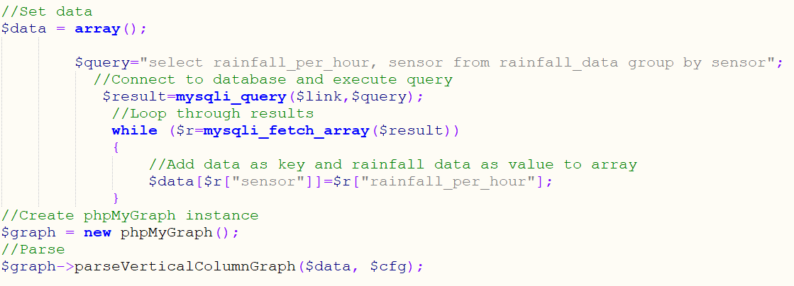
A data array is created marked $data, the query in this example is to return rainfall per hour and sensor information from the database and group the results by sensor. The result is created and populated with query result data, this is then looped through, added to the array in a key value pair. Phpmygraph is created as $graph, the $data and $cfg is passed to the parseVerticalColumnGraph to create the XY axis data needed for the graph png.
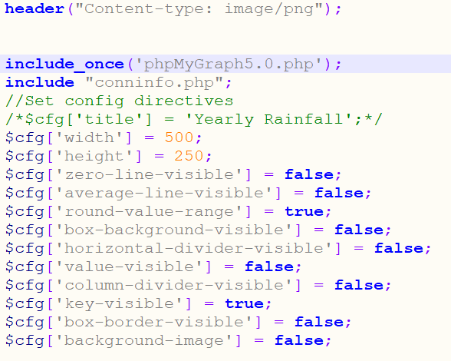
The $cfg variable is an array object that structures the look of the .png image that is created.

Rainfall Search
The Rainfall Search section (rainfallsearch.php) is built upon searching using a combinations of drop downs rather than an editable search field. The reason for this is that it denies the user the ability to search on anything other than what is displayed.
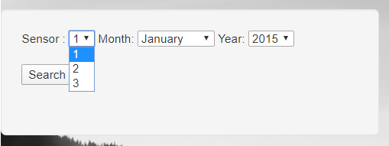
Three variables are passed to the Rainfall Search Results page (rainfallsearchresults.php), Sensors, Month and Year. These variables are then used in a prepared statement sql query:
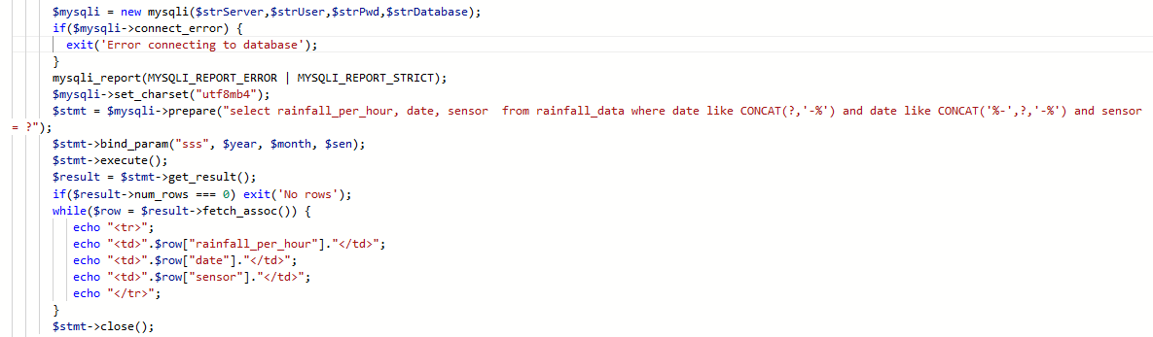
The sql prepared statement provides a level of security that can automatically convert special characters, such as “ ’ ” that could be used to create an sql injection attempt, into a safe executable sql query [5]. An $mysqli connection is created with connection information from the conninfo.php, the sql query is then encapsulated within a $stmt object that is parametrized with string variables specifically, bind_param(“sss”). The statement is then executed and the results are encapsulated within a $results object, iterated and displayed as a html table. The $stmt connection is then closed by applying the ->close() function.
This grants the user the ability to pick sensor one to three, a month and a year( within a certain timescale) and produce a table of results on the following page. There is a limitation to this structure. The sensor and year drop downs are not dynamic enough to cater for new sensors or future years. There would need to be further development to update the dropdowns.
Additional security is applied to the database connection in the prepared statement.

References

[1] | Mozilla, "<input type=password> Html hypertext markup language mdn," 2020. [Online]. Available: https://developer.mozilla.org/en-US/docs/Web/HTML/Element/input/password. [Accessed 17 02 2020].
[2] | T. P. Group, "str_replace - manual," PHP, 2020. [Online]. Available: https://www.php.net/manual/en/function.str-replace.php. [Accessed 17 02 2020].
[3] | G. Thomas, "SQL Injection," Swansea University, Swansea, 2020.
[4] | G. Thomas, "Visualisations With PhpMyGraph," Swansea University, Swansea, 2020.
[5] | G. Thomas, "Improving Security With Prepared Statements," Swansea University, Swansea, 2020.

