
Cross-platform Studies of How User-Generated Contents (UGC) Affect Customer Purchase Decisions on Personal Care Products
Jiaying HE

10 December 2023
university of wales trinity saint david

Table of Contents
Task 1 2
1.1 Introduction 2
1.2 Value 3
1.3 Research Approach 4
1.4 Data Collection 6
1.5 Sampling Method & Sample Size 7
Task 2 8
2.1 Primary Research 8
2.2 Secondary Research 12
Task 3 13
3.1 Elevator pitch 13
3.2 Feedback 13
Task 4 14
Appendix 15
References 21

Task 1
  - Introduction
With the rapid development of e-commerce, online shopping has become increasingly dominant in our daily purchase activities (Kasuma et al. 2020). Besides, because of the easier access to online interaction, consumers today have more control over media consumption than ever before, with interactive media helping to transform industries away from a traditional publisher-centric focus towards a new dynamic user-centric model (Eastin et al., 2011; Gamble et al., 2019). User-generated content (UGC) is exactly the product of user-centric era. Within this context, marketing research conducted by Hewett et al. (2016) has acknowledged that the link between e-platform and enterprise performance largely occurs through its effect on consumer attitudes and behavior. Thus, this paper was inspired to investigate the impact of UGC on customer behavior.
Through the observations of Internet UGC production and consuming habits, as well as related research on the cross-platform UGC (Jia et al., 2023), this paper decided to focus the research on two categories of platforms: shopping rating platforms (e.g. Amazon) and social media platforms (e.g. Instagram).
According to the survey conducted by PowerReviews (2023), a technology company analyzing UGC and product sales, nearly all (99.5%) of beauty shoppers read reviews at least sometimes when shopping online this year, which shows that beauty product purchase decisions are closely in relation with UGC, given the intimate experiencing contact with the product. Considering the larger feminine dominance of beauty products (Verbickaite, 2017), this paper chose to expand the research subjects on personal care products to accommodate some male respondents included in this study.

  - Value
The value of this study is mainly focused on providing support and advice for enterprise digital marketing through insights into consumer behavior.
- Market Insights: Help companies effectively gain valuable information including consumer needs and preferences from UGC for fine-tuning product design and market positioning.
- Content Marketing Strategy: Position the platforms and content types having the greatest impact on target audiences, and provide suggestions on utilizing UGC about what should be emphasized and de-emphasized, which helps to optimise digital marketing strategies and improve the effectiveness of advertising and publicity.

  - Research Approach
    - Investigate methods: Inductive Reasoning
This research will apply inductive reasoning to explore the possible impact that UGC exerts on purchase behavior. Inductive reasoning refers to the search for patterns from observation and the development of explanations, and theories will be formed at the end of the research as a result of observations (Bernard, 2011). Namrata and Aradhana (2022) presented that consumers will undertake an in-depth study of their purchase journey and triggers of buying personal care products, and Jia et al., (2023) recognised the UGC preferences on different platforms. Inspired and guided by these previous researches, this paper decided to explore consumers' focus and preferences for UGC and the impact of UGC on purchase decisions on different platforms, which will be realized by exploring the possible answers from a questionnaire including choice questions, open questions and ratings.
Inductive reasoning can be more efficient in identifying patterns and trends in data, and it recognises that conclusions are based on probability rather than certainty, making it a more realistic approach in many situations (Eisenhardt, Graebner and Sonenshein, 2016). However, inductive reasoning can be influenced by personal biases and preconceptions, which may lead to inaccurate generalizations. Thus, the researchers should be objective in the reasoning process to avoid too much subjective involvement.
    - Analysis methods: Mixed Method
This research not only involves qualitative analysis of the influence of UGC and opinions but also includes horizontal data calculation and comparison between platforms, so a mixed method was chosen to explore this topic more comprehensively.
- Qualitative
  - Survey: summarizing sample answers and drawing related conclusions about influencing factors by doing questionnaire surveys.
  - Case study: synthesizing and providing suggestions by doing further case studies on benchmark enterprise’s UGC strategy.
- Quantitative
  - Data analysis: The ratings in different dimensions will be conducted within the questionnaire based on relevant indicators (see below) for different kinds of platforms, investigating the key features that users focus on for UGC. Comparative studies for variables will be visualized in the form of data analysis.
Mixed method combines quantitative and qualitative data to provide a more comprehensive, multi-angle view of the findings (Haq, 2015). However, we also face the challenges of complexity and correlation. How to effectively integrate data and synthesize conclusions needs to be considered in the process of research.

  - Data collection
- Primary resources
  - Questionnaire answers: After browsing the relevant literature, five aspects of questions were summarised including demographic questions, UGC browsing habits, UGC preferences indicators (Owusu et al., 2016), platforms comparison and sellers' UGC feedback behavior (Rieg et al., 2018), as the focus of the survey, for summarizing sample characteristics.
- Secondary resources
  - Literature review: The overall theoretical framework of this study is based on six pinpointing UGC features defined by Owusu et al. (2016), which are Relevance, Usefulness, Indicativeness, Credibility, Ease-of-use and Up-to-dateness. Other literature on UGC, purchase decisions, e-commerce and other aspects will also provide support for the research. (See Task 2.2)
  - Case study: In order to further provide constructive advice for personal care enterprises, the research will also include specific case studies. As a benchmark beauty company in the FMCG industry, surveys on L 'Oreal from Bazaarvoice (2023) and Sykes (2023) are investigated as examples of UGC strategy utilization. Famous Japanese beauty brand Shiseido is also taken as a typical case in result analysis.
Secondary resources provide framework support and existing case examples for the research, while primary resources can present the most direct and authentic evidence to obtain verification or refutation of secondary resources. Compared with secondary resources, primary resources are more accurate and reliable but lack the accessibility and diversity features of secondary resources, so it is necessary to combine the advantages and disadvantages of the two to support research.

  - Sampling Method & Sample Size
- Sampling method
Due to time and resource constraints, this paper chose convenience sampling for the investigation. Convenience sampling is a kind of non-random sampling where the target research participants are easily accessible to the researcher (Etikan, Musa and Alkassim, 2016). The questionnaire collection will be carried out online within the class, through the Smart survey platform. By selecting the most easily obtained groups as samples, the results become simple and easy to access. However, due to the similarity of groups' majors and ages, the samples may be homogenized and not representative enough.
- Sample size
Considering the research scale, time and resource limits and authorization, the sample size will be concentrated at 10 people. Given the group's knowledge of related fields and proficient use of the Internet, the samples are believed to be relatively persuasive. However, due to the risk of error and insignificance caused by a small sample size, evaluation and analysis of the error are necessary based on secondary resources.

Task 2
  - Primary research
As the main part of the research, the questionnaire survey has been carefully designed to explore the possible patterns of UGC impacts.

The first part is demographic questions to collect basic information about the participants. This section is naturally designed as a single choice, including age and gender, where age is divided into groups and gender options are given ‘Other’ choice for respecting different gender recognitions.
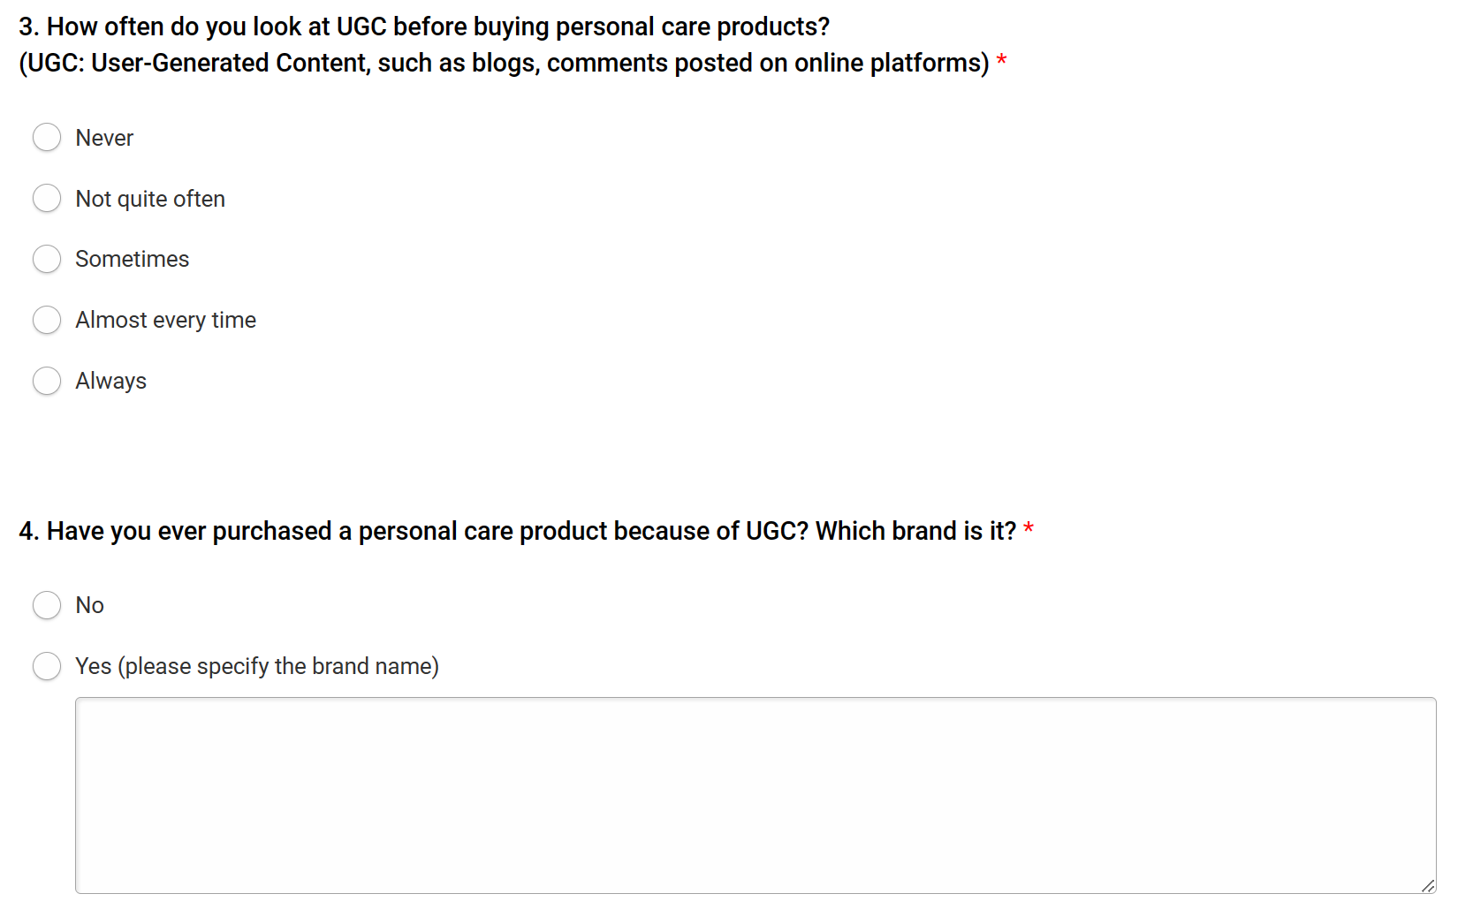
The second part is designed to investigate the UGC browsing habits of the participants, including the frequency of viewing UGC and the past experience of referring to UGC, which helps understand the role of UGC in the population and is the basis for follow-up investigations. Question 4 is designed as a half-open question, requiring participants who choose “Yes” to specify their experience and brand name, providing more persuasive examples for research.
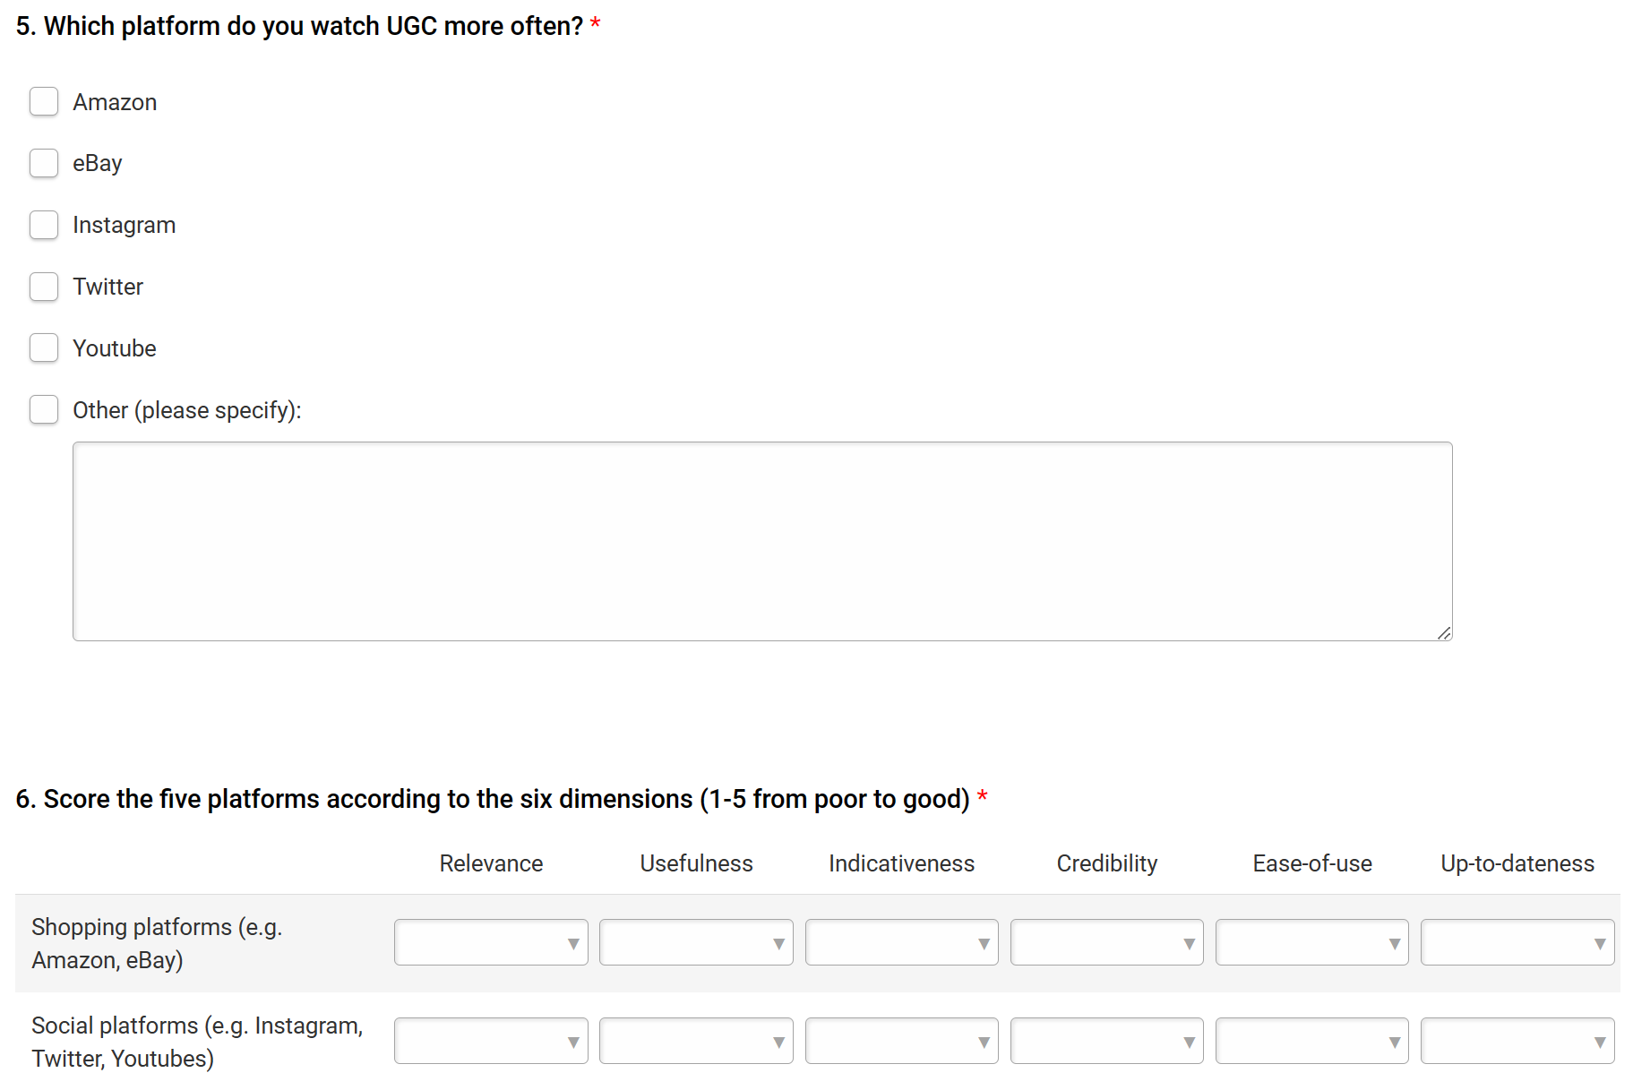
The third part referred six indicators of UGC quality ratings designed by Owusu et al., (2016), which is also an important part of the survey. Assisted by Question 5, the scale is applied to compare two kinds of platforms by grading them in Question 6. The data will be quantitatively analyzed to draw related conclusions about platform variance between them.
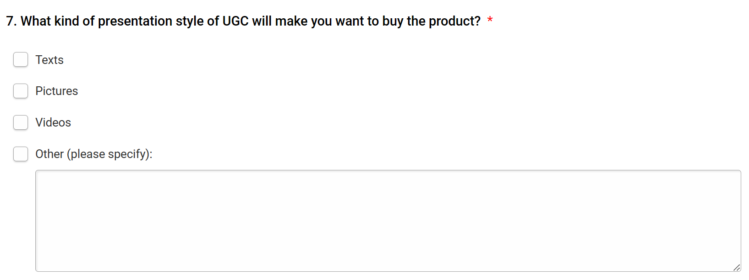
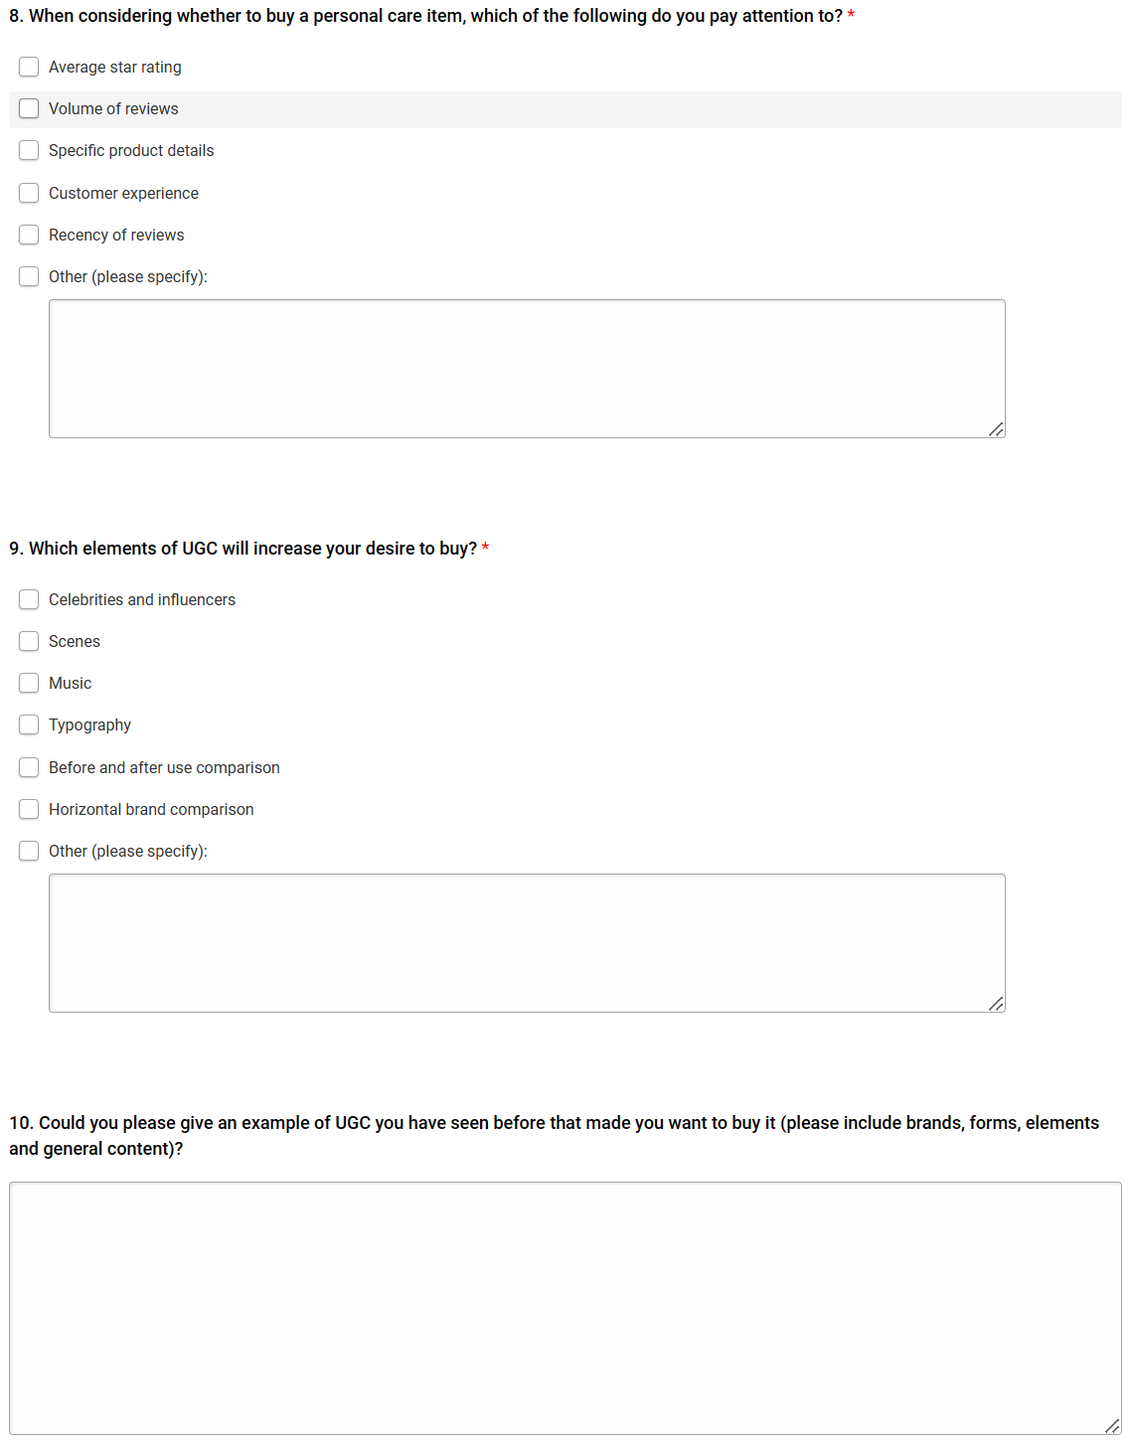
Questions 7-10 are around the UGC preferences analysis including preferred forms, elements, factors and an open question. The selection of these features by consumers will be combined with previous questions to determine whether they are consistent with the characteristics of the platform, so as to further verify the different impacts of UGC on different platforms.
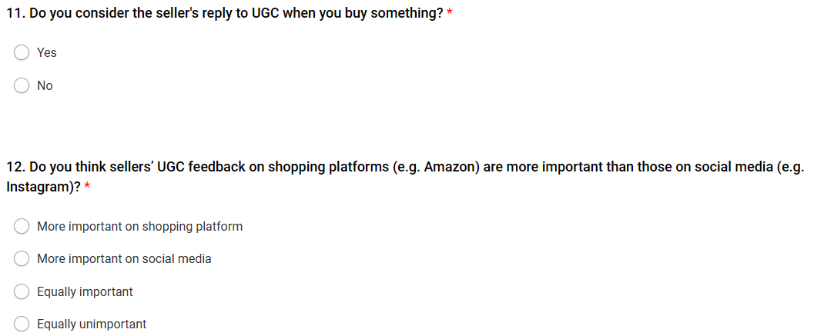
The last part will focus on sellers about will their responses to UGC influence consumers' purchasing decisions about personal care products. This can be regarded as expanding the scope of the topic from another perspective, so as to obtain more abundant information and inspiration on UGC utilization strategies.

  - Secondary research
In the process of survey design and investigation, secondary research including diachronic and dialectical theoretical summaries has been extensively implemented from different perspectives, and the basic literature review is summarized as follows.
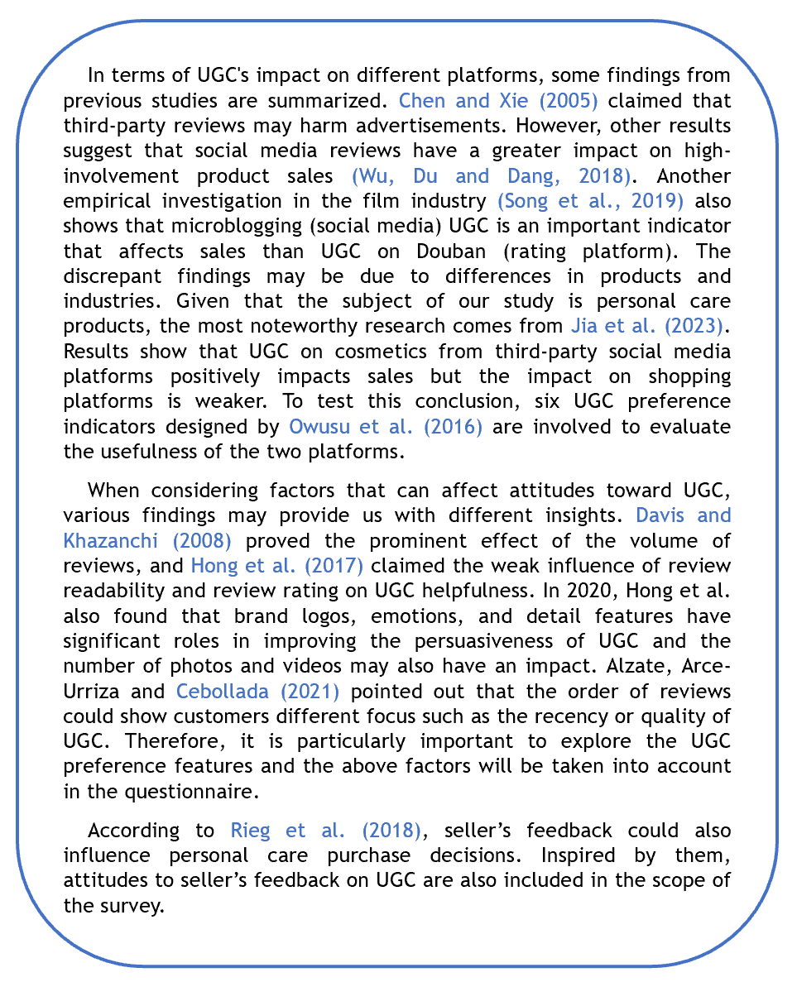

Task 3
  - Elevator pitch
Please Click this link to view the video elevator pitch:

https://youtu.be/L74M6_Xq2XY

  - Feedback
Due to the lack of feedback from online comments, I interviewed several stakeholders to get direct feedback after watching the speech.
The elevator pitch is evaluated as well-structured and informative and covers the key aspects of the study. Besides, some suggestions and feedback to help improvement are also provided for reflection.
In the introduction, one of the stakeholders suggested adding a brief attention-grabbing statement or a relevant statistic to engage the audience from the start. The speech raised a self-answering question to lead to the concept of UGC and arranged the statistical data in the middle part, but this suggestion can indeed be considered as an alternative introduction mode. Kadian (2023) also claimed an eye-catching statement at the beginning can attract the audience and make the message spread more effectively.
The speech is said to be logically organized. However, more transition sentences are needed between different sections to guide the audience smoothly through the presentation. Besides, more details on the research methodology should be presented, though this is the inevitable inadequacy due to time constraints.
The example of L'Oréal is thought to be excellent and helpful, but the relevance of the research topic and how other companies could learn from it should be elaborated more.

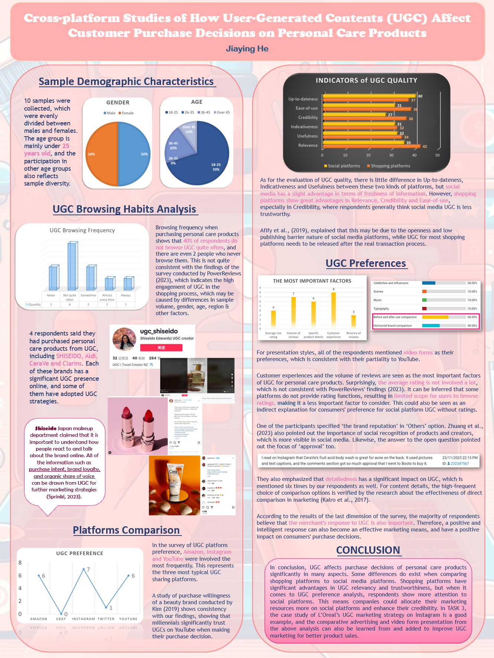
Task 4

Appendix
      - Please Click this link to view the survey questions: https://www.smartsurvey.co.uk/s/WFXX80/
      - Survey Results
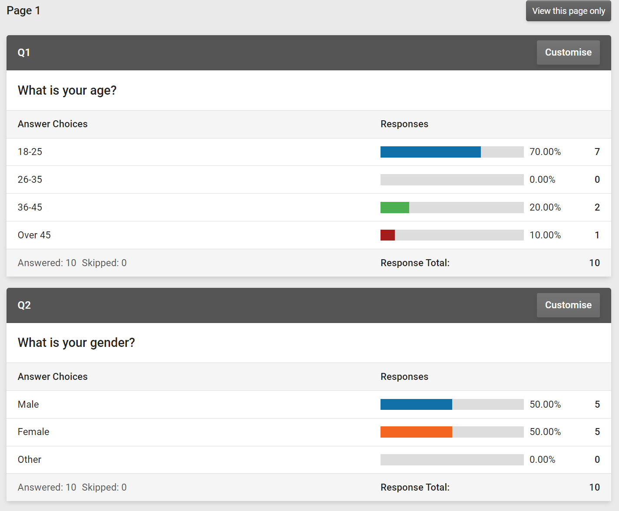
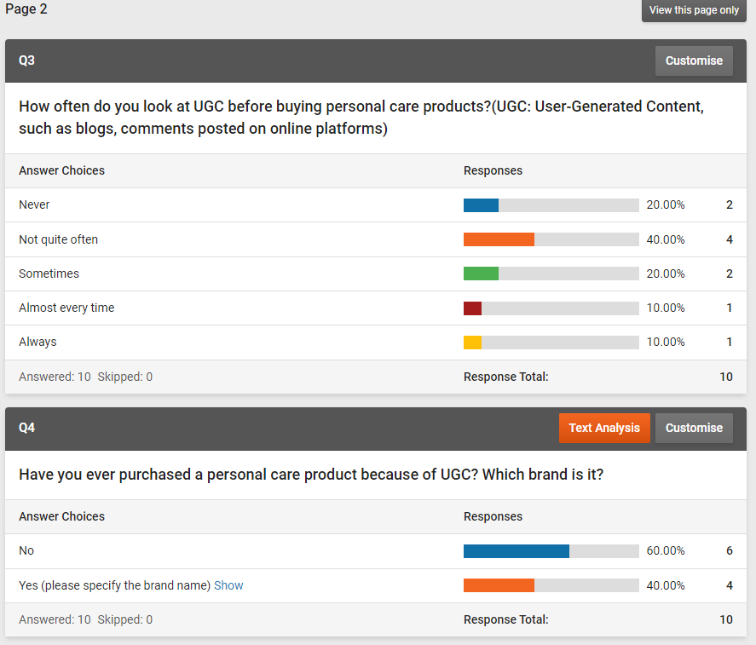
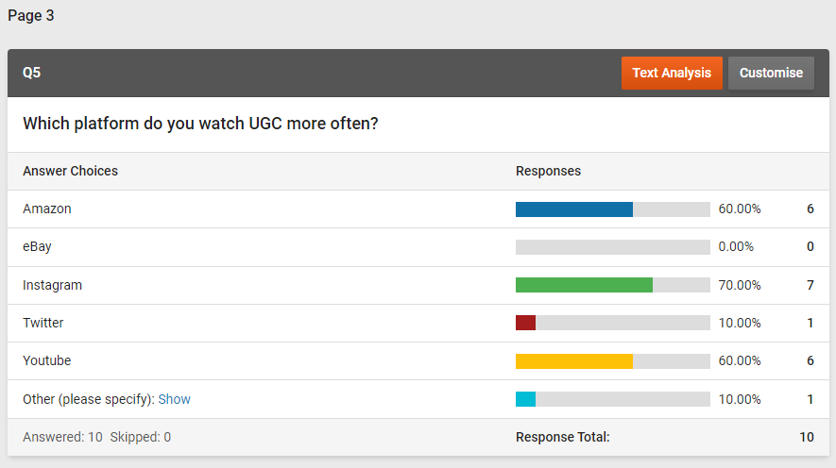
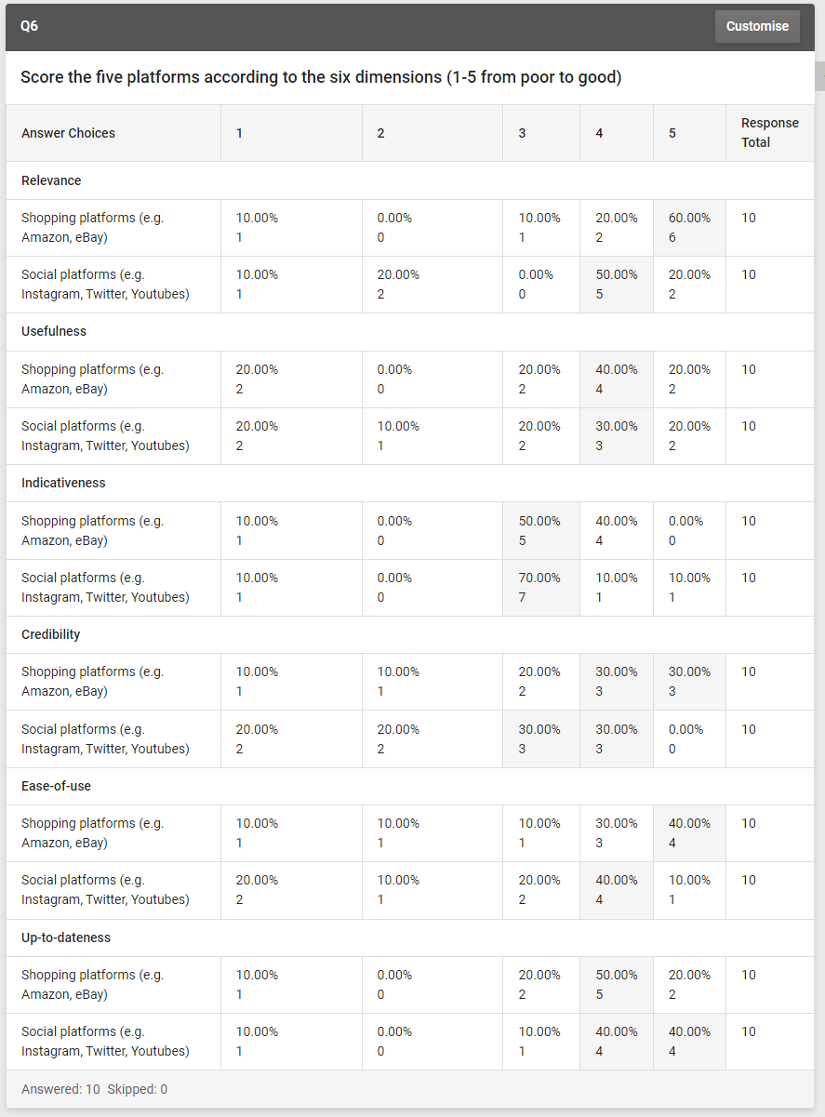
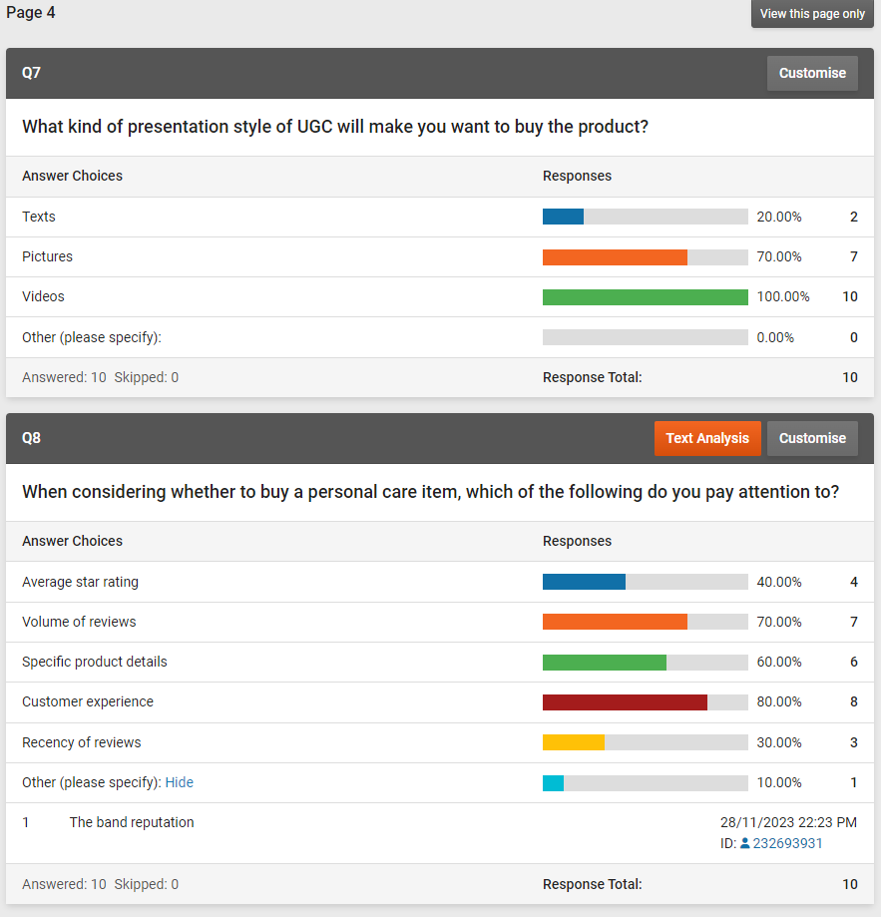
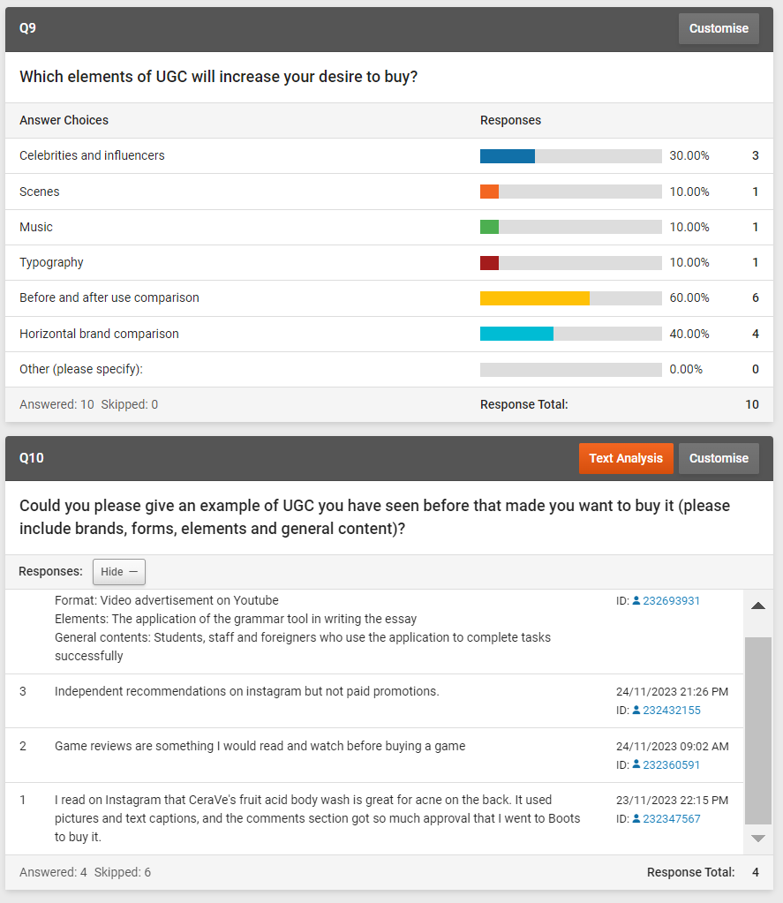
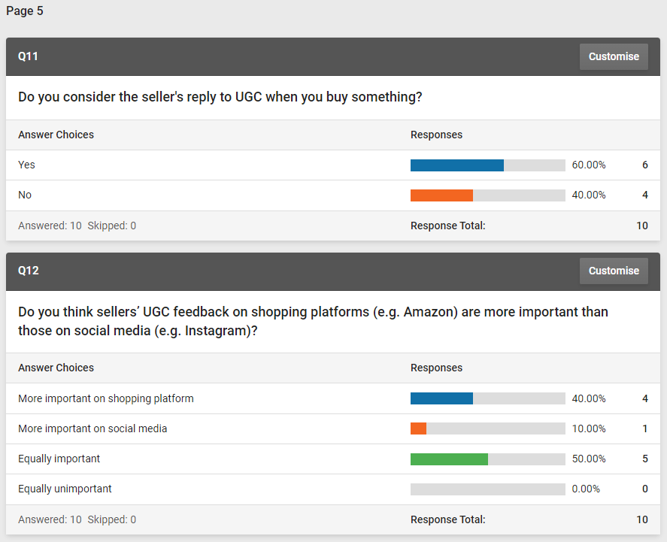

References
Afify, E. et al. (2019). ‘User-generated content (UGC) credibility on social media using sentiment classification’, Egyptian Journals, (1)1, pp. 19-1.
Alzate, M., Arce-Urriza, M., and Cebollada, J. (2021). ‘Online reviews and product sales: the role of review visibility’. Journal of Theoretical and Applied Electronic Commerce Research, 16(4), pp. 638-669.
Bernard, H.R. (2011) “Research Methods in Anthropology” 5th edition, AltaMira Press, p.7
Chen, Y., and Xie, J. (2005). ‘Third-party product review and firm marketing strategy’. Marketing science, 24(2), pp. 218-240.
Davis, A., and Khazanchi, D. (2008). ‘An empirical study of online word of mouth as a predictor for multi‐product category e‐commerce sales’. Electronic markets, 18(2), pp.130-141.
Eastin, M.S., Daugherty, T. and Burns, N.M. (2010).‘Expectancy-Value: Identifying Relationships Associated with Consuming User-Generated Content’, in Handbook of Research on Digital Media and Advertising: User Generated Content Consumption. IGI Global, pp. 146–160. Available at: https://doi.org/10.4018/978-1-60566-792-8.ch007.
Eisenhardt, K. M., Graebner, M. E., and Sonenshein, S. (2016). Grand challenges and inductive methods: Rigor without rigor mortis. Academy of management journal, 59(4), pp. 1113-1123.
Etikan, I., Musa, S. A., and Alkassim, R. S. (2016). ‘Comparison of convenience sampling and purposive sampling’. American journal of theoretical and applied statistics, 5(1), pp. 1-4.
Gamble, J. R., McAdam, R., and Brennan, M. (2019). ‘How user‐centric innovation is affecting stakeholder marketing strategies: Exploratory findings from the music industry’. European Management Review, 16(4), pp. 1175-1193.
Haq, M. (2015). A Comparative Analysis of Qualitative and Quantitative Research Methods and a Justification for Adopting Mixed Methods in Social Research.
Hewett, K. et al. (2016). ‘Brand Buzz in the Echoverse’, Journal of marketing, 80(3), pp. 1–24. Available at: https://doi.org/10.1509/jm.15.0033.
Hong, H., Xu, D., Wang, G. A., and Fan, W. (2017). ‘Understanding the determinants of online review helpfulness: A meta-analytic investigation’. Decision Support Systems, 102, pp. 1-11.
Hong, W., Yu, Z., Wu, L., and Pu, X. (2020). ‘Influencing factors of the persuasiveness of online reviews considering persuasion methods’. Electronic Commerce Research and Applications, 39, 100912.
Jia, Y. et al. (2023). ‘“Customer Reviews or Vlogger Reviews?” The Impact of Cross-Platform UGC on the Sales of Experiential Products on E-Commerce Platforms’, Journal of theoretical and applied electronic commerce research, 18(3), pp. 1257–1282. Available at: https://doi.org/10.3390/jtaer18030064.
c. ‘Attention-Grabbing Tactics on Social Media’ (Doctoral dissertation, University of South Florida).
Kalro, A. D., Sivakumaran, B., and Marathe, R. R. (2017). The ad format-strategy effect on comparative advertising effectiveness. European Journal of Marketing, 51(1), pp. 99-122.
Kasuma, J. et al. (2020). ‘Factors influencing customers intention for online shopping’. International Journal of Modern Trends in Business Research, 3(11), pp. 31-41.
Kim, S. (2019). An User-Generated Content Strategy on Brand Equity and Customer Satisfaction toward Purchase Intention among South Korean Millennials: A Case Study of Innisfree.
L’Oréal Australia. (2023). Bazaarvoice. Available at: https://www.bazaarvoice.com/success-stories/loreal-australia/ (Accessed: 23 October 2023).
Namrata, S., and Aradhana, G. (2022). Analysis of the Consumer Purchase Behavior of Personal Care Products in a Developing Country. Cardiometry, 23, pp. 718–727.
Owusu, R. A., Mutshinda, C. M., Antai, I., Dadzie, K. Q., and Winston, E. M. (2016). Which UGC features drive web purchase intent? A spike-and-slab Bayesian Variable Selection Approach. Internet Research, 26(1), pp. 22-37.
PowerReviews. (2023).‘Beauty Shoppers’ dependence on UGC’, PowerReviews. Available at: https://www.powerreviews.com/research/health-beauty-shopping-trends-2023/dependence-on-ugc/ (Accessed: 23 October 2023).
Rieg, D.L. et al. (2018) ‘The Influence of the Seller’s Performance on the Consumer Purchase of Clothes and Personal Care, Toiletries and Cosmetics Products’, Independent Journal of Management & Production, 9(2), pp. 507–525. Available at: https://doi.org/10.14807/ijmp.v9i2.713.
Song, T., Huang, J., Tan, Y., and Yu, Y. (2019). ‘Using user-and marketer-generated content for box office revenue prediction: Differences between microblogging and third-party platforms’. Information Systems Research, 30(1), pp. 191-203.
Sprinklr. (2023) ‘Shiseido Japan boosts social engagement 244%’, Sprinklr. Available at: https://sprinklr.com/stories/shiseido-japan/ (Accessed: 04 December 2023).
Surana, N. and Gandhi, A. (2022) ‘Analysis of the Consumer Purchase Behavior of Personal Care Products in a Developing Country’, Cardiometry, (23), pp. 718–727. Available at: https://doi.org/10.18137/cardiometry.2022.23718727.
Verbickaite, G. (2017). What is the Impact of the Cosmetic Industry in the West on Caucasian Female Consumer Wellbeing?, Metropolia Ammattikorkeakoulu.
Wu, J., Du, L., and Dang, Y. (2018). ‘Research on the impact of consumer review sentiments from different websites on product sales’. In 2018 IEEE International Conference on Software Quality, Reliability and Security Companion (QRS-C) (pp. 332-338). IEEE.
Zhuang, W., Zeng, Q., Zhang, Y., Liu, C., and Fan, W. (2023). What makes user-generated content more helpful on social media platforms? Insights from creator interactivity perspective. Information processing & management, 60(2), pp. 103-201.

