Student Name: Olinda Raposo
Module Name: Developing Workplace critical thinking
Code: BMSK5003

Table of contents
Contents
Introduction 3
Values in a workplace at (British American Tobacco) BAT: 3
Management Theory – Workplace in the context of British American Tobacco (BAT) 5
Use of Logic to Establish Causal Relationships: 9
Skills in Presenting Rational Arguments and Debating Points of View: 9
Value and Purpose of Reflection in Supporting Learning: 9
How emotions, values, and beliefs affect rational discourse like British American Tobacco (BAT) 10
Methods for comparing and assessing other propositions critically 11
The inductive and deductive reasoning 11
Significance of beliefs 13
The relation among beliefs, values, attitudes and culture and norms: 14
Conclusion 15
References 16

Introduction
British American Tobacco Plc (B A T) is one of the largest and famous tobacco companies which are on U K Based (Kerin, & Peterson, 2007). The company has been operating business in more than 180 countries and even the company is on top chart in more than 50 countries in fact. The company is British stock exchange listed. In last year they make 20 billion dollars as profit. There is lot of positive things behind the success of the company and to maintain discipline and strong management system are mentionable. The authority of the company and the decision makers always give priority to the opinion of the employees from top to bottom and they try to give proper respect and value to every employee without any misery. Recently the company has bagged an award as there are most of the workers engaged for couple of years. to be success the company focuses on some exact element like innovative idea, creativity, open minded thinking, open market survey, products quality developing etc. Beside in some cases a manager of the organization is mostly liable for some cases to make the organization on right track and that’s why the manager should introduce about critical thinking about the market policy and how to help the top position in the list of successful marketing company. To keep similarity with the choice of customers the company should make the company policy and enter in the market with the product successfully. Critical thinking can be a best way to find out the best plan from the employees where they can share a good policy for the development of the company strategy indeed. The manager of BAT can apply some creative and perfect theory which can help the company to run with more success and can earn the company goal beside they can make a comfortable workplace where the employees can give their proper effort to stand the company.

Values in a workplace at (British American Tobacco) BAT:
Value is an element of internal and external evaluation of ethics and working supplementation. Ina the work place the employees deserve adequate values the coworkers should give them in every prospector in work place. her are different ways to evaluate values and its identity like mutual understanding, sharing thoughts and ideas, presenting actual responsibilities, caring about company policies and making the co-curricular activities in the workplace (Marchington & Wilkinson, 2008). The employees should give the full effort to make the company successful and the human resource department should show the best values to the workers from top to bottom and encourages them to think about the organization of their own. BAT is always concern about the fact and they are open to make the employees as the nucleus of the organization in every spare of working.
Dimension to understand values:
There are various types of dimensional part to understand the values in a company which are given
Prosaically dimension: The British American Tobacco Plc Company thinks about the customers and clients not about finance in every time so there are values towards the consumers of the company
Marketplace dimension: BAT sells their products in the dimensional market place where there are different kinds of products in various point in this way the company can hold the different market of different countries
Financial dimension: In this stage the financial statement can be described in the in the way where the company deals with the economical complication with the financial dimensions.
Achievement dimension: BAT is very much concern about the achievement of the company and the there are many ways to enter in this case in fact.
Importance of Attitudes in British American Tobacco (BAT):
Attitude is an element where there is the behavioral reflection of a group in an organization. Attitude in the workplace plays an important role to bring success from the organization itself (Milkovich & Newman, 2008). The workers of the organization should be very positive and determined towards the organization where they work. The employees’ attitude mostly leads the company into the glory and success as they are the main key to run an organization. In most of the cases the attitude over the activities of the organization is the main element which can hold the company in right position where the company can operate the business in the global market. As a result attitude may be best option to be considered as the best way to enter into the successful marketing policy of BAT Plc

Importance of Beliefs in the workplace:
Belief is an element which can create the understanding and working ability among the employees of the organization. Especially in the BAT the belief and faith among the employees are in that limitation where they are very much respected and closely related with the developing activities in the organization (Marchington & Wilkinson, 2008). The workers from top to bottom give priority to the others and respect to their thoughts and emotion which can be more effective in different point of view for the organization. Beliefs are the common key of to make the company meaningful and strong to carry the market in different countries as BAT is a universal and well known company which is well established and profitable company in U k so the employees of the organization should be cooperative and keep belief with each other in all the sectors of working activities.

Management Theory – Workplace in the context of British American Tobacco (BAT)
Maslow's need theory
Maslow’s theory is very common and well recognized theory where the person deals about the five essential needs of human beings. British American Tobacco Company is very much common with the theory where there are all the ways to meet the needs.

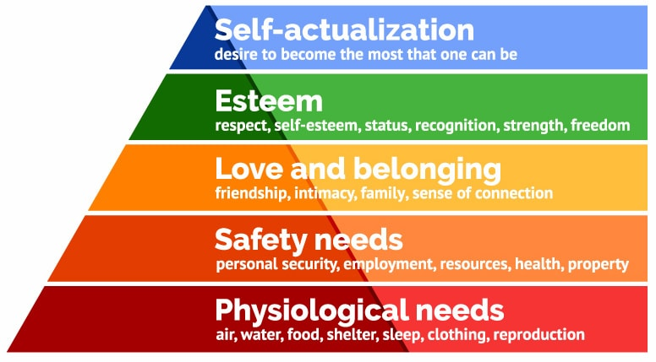
Figure: Maslow's need theory
Source: (Hamtag, 2008)
Psychological Needs:
In this type of needs all the basic and genital needs are added like food, shelter, dresses and other basic need which are the main element to make a person alive In this point of view the psychological needs are the main element which are related to life(Milkovich & Newman, 2008),. A person can meet the needs when he is able to get a handsome salary in deed so BAT is concern to pay a handsome salary to the employees so that they can meet all the psychological needs without any difficulty.
Security Needs: Security needs is also important as every person should need security of his or her won so the persons who work in BAT should get the security and safety from the organization so that they can work in the organization without any fear and hesitation. The authority of BAT is always careful and concern to give the best security of the working employees
Belongingness Needs: This type of needs come when the Psychological Needs and Security Needs are met in the best ways (Fortin, 2015). The employees of any organization need cooperation, beliefs and love from the other. BAT is always conscious about the facts as the human resource department always tries to focus on that fact so that the employees do not face any lonely situation.
Esteem Needs: Esteem needs is
The wants where every individual wants gain more honor, credit, designation and personal evaluation in any workplace. So to gain all every individual should be skilled and experts personally in different ways. The company should make platform for them to prove themselves and make scope to gain all the wants a person feels so that the person can earn all the requirements which can help to make them success. A person can be involved with a specific work in any organization but the person may wish to prove him or her in different characteristics which he or she able to show. BAT Company realizes the reality and offers the employees to make them skilled in different ways and offer them the right things which they want.
Self-Actualization needs:
This stage where the employees can meet all the wishes he or she desire and make them skilled by learning many thing from the work place. BAT offers the employees different opportunities to prove themselves so that they can invent themselves in new way and can be asset for the organization
Theory X and Theory Y
Theory X and theory Y are two ways which are for human beings who work in an organization according to a well design and planned direction. These two are helpful for the workers which are very effective to make the works in the workplace with more concentration

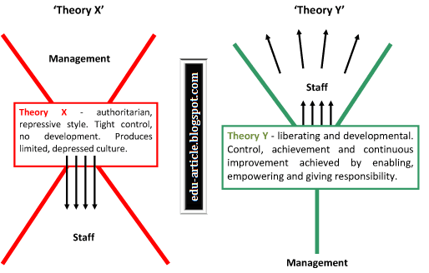 Figure: McGregor’s Theory X & Y
Source: (Pettinger, 2007)
Theory X
Theory X leads the employees of the organization by the management. The managerial body of any organization should lead the lower employees and the workers and create the ways where the staffs can cut a good figure for the organization to make it success in different ways (Fortin, 2015).. In this theory the management of BAT always supervises the employees so that they can evaluated properly and can be the best asset for the company beside the management should be ready to offer any necessary things in the time of necessity. If it is happening, then the employees can be more updated and motivated to work hard.
Theory Y
In this theory the staffs of different section of a company always cooperate the management in different ways and try to bring the company together (Caddle & Turner, 2015). If the employees get the space, they can contribute in various ways to develop the companies as their responsibilities. The staffs from top to bottom can be part of the production and implantation of the company so if the management thinks they can import the thought and idea from the staffs and they can utilize the ideas then the company can make some new strategy from the organization to bring innovation in the market.
PESTEL Theory in the context of British American Tobacco (BAT):
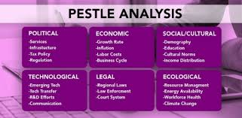
Figure: PESTEL Theory
Political: politics is an important feature which can stop the journey of a company if the political condition is not favor of business in any organization. Political stability is the pre-condition to continue any business in a country. If the politician does not help the business organization they cannot product the goods, transport the goods from one place to another and other related activities
Economical: There are some issues which are related to finance of an organization. Like revenue, interest rate, vat, tax etc which all are financial terms which are very essential and closely related to the business organization
Social: No organization is out of society so there are some social issues which are much related to the business organization. The people of the society and their religion, culture, tradition and other customs and beliefs all the social things which are necessary for every organization to follow
Technological: Technology is an important element now days to run a company with more success and in easy and fast ways. Different machine makes the work easy than before and the man power can take help from the technology if they want which helps the organization to make more production
Legal: Every government of a country makes some rules and regulation fro the business organization which is must to follow and keep the legal papers to continue the business. As BAT is a multinational company so the operation of the company is in different countries as a result the management of the company should follow the rules of that country strictly
Environmental: Environment is an important element which helps the company to run its activities where the environment in favor of the company as the ecological condition is not equal in everywhere so the management should about the facts before run any business on that area

Use of Logic to Establish Causal Relationships:
There are different concepts and ideas in an organization as there are different person to work in the workplace abut all are not strong on the basis of logic The HRM department and the management department should select the best one among the other which one is more reliable and logical to use for the strategy for the company. And this type of idea can lead the company in worldwide as there is more competition in the global market. BAT Company and the managerial body is always alert to find out the best thoughts and concepts among the other to use it for the organization.

Skills in Presenting Rational Arguments and Debating Points of View:
The skills and presentation policy are more effective for rational and logical concepts in the work place in a company. The employees of the organization should have more power of rational concepts and they should show more professionalism in presenting any arguments for the development of the organization. Even if it is needed the management of the organization select the best one if there is more debate in the subject of choosing the best things among the all concepts and arguments in the organization.

Value and Purpose of Reflection in Supporting Learning:
Reflective value and purpose are the two significant thins which are much needed to increase the ability and capability of the employees in the organization beside reflective knowledge helps the organization to earn the most meaningful ideas from the other employees
According to the J. Amulya claims “Reflection is a vigorous procedure of observing one’s individual involvement so as to take a quicker appearance at it, occasionally to direct care to it temporarily, nonetheless frequently to discover it in better complexity.
Reflective value and purpose are the main learning element which is also effective to work together in an organization of all the employees. A n employee can gather knowledge and use it in the workplace indeed
It is also effective for both information providers and receivers who are the part and parcel of the company as they are behind the real scenario that makes the proper information and data for the organization

How emotions, values, and beliefs affect rational discourse like British American Tobacco (BAT)
Though emotions, feelings and belief all are necessary and presented element in organizations of the common employees in the workplace but in some case all the above elements can cause the rational discourse in very often and at that case the manager of the organization has give priority over the rational concepts more than the rest others. Though it’s tough o over look all the other things of the employees but for the biggest profit the authority has to select the rational and perpetual prospect for the betterment of the company. BAT is also not out of this rules, the responsible figure of the organization has to give priority over rational proposal for the organization
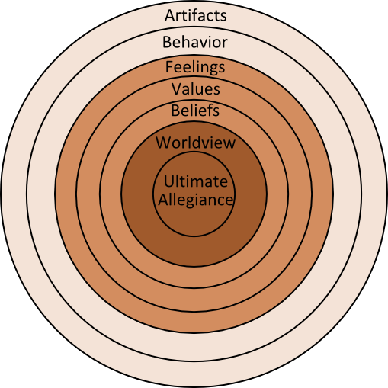
Figure: emotions, values, and beliefs in the shape of an onion
Source: (Jensen, 2017)

Methods for comparing and assessing other propositions critically

In All the organization of any type of business, to make any decision from the development of the organization is very much essential. The decision makers should make some alternative plan as the main tricks sometimes may fail then the other can be used as the back up to make the company profitable. The company of different goods in global market are stand on the strategy which can make very organization different and individual from each other. They used to think about the business policy, production quantity, environmental condition etc.

The inductive and deductive reasoning
There are only two kinds of reasoning like the inductive reasoning and the deductive reasoning, the discussion about the two is given below
Inductive reasoning
There is an assumption with inductive cognitive. The inductive reasoning can be changed in different place in the organization like if the college students will be sick in one third of number then the concluding reasoning should be one third of the students fall in sick
An example at the British American Tobacco (BAT):
Inductive reasoning is also affect the BAT Company in different purposes. The manager of the company lists as they office staffs are in absent then the person lists them as the non-appear in the organization in fact. Thus the inductive reasoning can be used for the inclusion in the organization
Deductive reasoning
Deductive reasoning, also deductive logic, rational assumption is the procedure of cognitive from one or more declarations to the extent a rationally convinced deduction. Deductive reasoning is also similar in some cases where the rest stands can be deducted by the manager of the company.
An example at the British American Tobacco (BAT):
BAT offers hair oil to convince those women who has little time to use it abut to catch the concentration of that type of women the company offer the products to hold the market and increase the customers.
Human Relations
Human relation is a term which has introduced 1920 in the organization. Human relations help the organization to catch the customer’s concentration with the product of the organization. If the management of any organization can develop human relations department and can follow specific strategy to win the heart of the human beings, then the company can be benefitted and can create more customers for the organization

Scientific Management
Science has made the business sector more reliable and fast to run the business in some sectors (Hammer & Champy, 2008). The scientific usage in the work place in different department like production, accounts and human resource management the scientific usage can make the policy fresh and more believable. If an organization wants to product more goods with in short time, then it has to take help from technology and scientific production. Human beings can be benefitted by taking help from scientific aim in different sector of life
Contingency Theory
Contingency theory indicates that there is no chance to keep just one way as the strategy as there should be more ideas where the company can be more helped by the alternative thinking’s there is a lot of competition in the international market so to survive in this tough market the company should make more plan how to sell the product more in number (Belch & Belch, 2014). If one tricks fail, then the next one should be applied for the development of the marketing policy
Systems Theory
System theory indicates the systematic process in the organization as all the individual organization should have some specific and individual organization which is the main keys to develop the frame of the organization (Ahlstrom & Bruton, 2015). British American Tobacco Company has also some systems theory and the employees of the organization are forced to follow those. The system is considered as the principles of the organization which has to be followed strictly
Bureaucratic Management
As the appearance of bureaucracy is in everywhere it’s not out of the organization (Pettinger, 2007). The bureaucrat is not selected persons always they are sometimes none selected and they work for domination and creating the frontline to run the activities of the organization. The bureaucrats are from the following place like

- Environmental Protection Agency
- Social Security Administration, and
- Public universities.
In the private sector the maximum biggest organization has bureaucratic farms of their own like The British American Tobacco Organization has IBM, GM, and the Union Pacific Railroad.

Significance of beliefs

Belief is an important element of human behaviour where the employees in an organization can believe them personally and their work in the workplace even they are unknown with each other. The employees of an organization are not relative or well-known but in profession they are closely related so they should believe the colleagues in different aspects in the workplace beside they should show the respects and sympathy with each other mostly (Homeburg & Kuester, 2008). If the employees can make belief with the other employees, then the organization can get more feedback from the customers as the workers can work together for the development of the organization
Attitudes and value systems in shaping human behaviour:
To shape human behaviour there is no other better ways more than the attitudes and value system in the organization (Kerin, & Peterson, 2007). Attitude and values can make the employees more professional and polite which can be reflected in the workplace when the employees work together in the company. When aperson can get more value in the workplace even he or she is in a small rank then the workers can think him or herself as important assets for the organization and then he or she can work with more strength.
Consumer Buying Behaviour: Customers buying behaviour shows the customers demand, choice and other expected element which are important for the management to know about the demand of the customers. And the company then arranges all the products according to their demand and desire
Price preferences: Price preferences in the market of any goods of a company reveals the buying capacity for the customers and then the organization can fix the prices according to the price capacity of the local customers. SO the management should closely observe the price preference in the market.
Quality preferences: The customer’s first search about the quality preference of the products if the quality and standard of the goods is above expectation then the customers will be interred to buy it so the company should keep the quality and standard of any product according to the satisfaction of the customers

The relation among beliefs, values, attitudes and culture and norms:
The entire social; elements which are mentioned in the above line are not separated from each other (Homeburg & Kuester, 2008). All the elements are necessary from the human beings in any society and the business organization of any kinds of products should thinks about the features and should introduce those types of products which are not conflicted with the elements then the people can take the products without any blind belief.
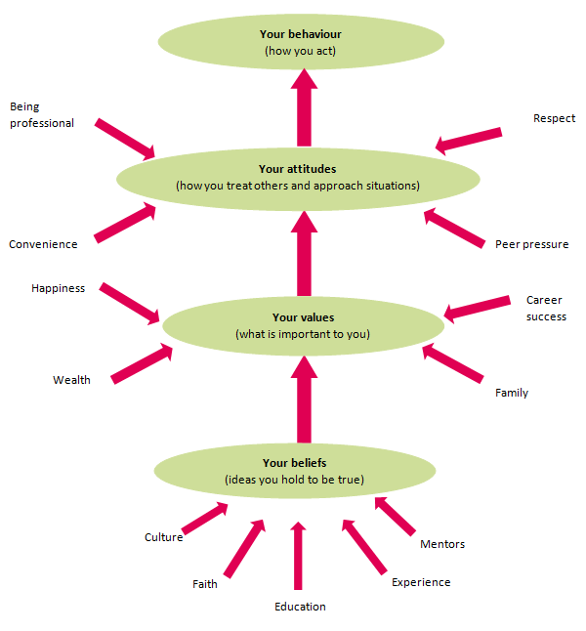
Figure: Relation n among beliefs, values, attitudes and culture and norms
Source: (Hill and Hill, 2011)
Values, beliefs, culture and attitudes all are related with each other so all the elements should be kept tied for the organization to show the elements importance in the society (Kaufman, 2013). The business organization should show respects towards the elements so that the persons can be more respected and reliable with the organization. When t5he customers can understand that the specific company run the business with great respects about the element of the society they can be convinced to go to the company

Conclusion
In the concluding lines it can be said that to develop the working place there are different strategies and policies which typical importance but effective to run the company are according to its personal strategies (Hill & Hill, 2011). The management should sometimes give priority over the logic and rationality more than emotion and passion of the employees in the organization. If the management can select the best logical concepts, then the company can be benefitted for a long run a and the organization can earn more benefit from the global market by fighting with other companies of different countries

References
- Hill, A and Hill, T. (2011) Essential Operations Management. London: Palgrave.
- Homeburg, C., Kuester, S., & Krohmer, H. (2008) Marketing Management: a Contemporary Perspective, 1st Edition, McGraw-Hill: New York.
- Kerin, R. & Peterson, R., (2007). Strategic marketing problems. New Jersey: Pearson Prentice Hall.
- Marchington, M. and Wilkinson, A. (2008), Human Resource Management at Work People Management and Development, 4th ed., London: CIPD
- Milkovich, G. and Newman, J. (2008), Compensation, McGraw-Hill/Irwin
- Pettinger, R. (2007) Introduction to Management. 4th Ed. London: Palgrave Macmillan.
- Ahlstrom, D. and Bruton, G. (2015) International management. Australia: South-Western Cengage Learning, pp. 131-136.
- Belch, E.G. & Belch, A.M. (2014) Advertising and Promotion: An Integrated Sales Communication Perspective, 6th Edition, The McGraw-Hill: New York.
- Fortin, D. (2015). Global Sales for the Digital Age20002Bill Bishop. Global Sales for the Digital Age. Illinois: Lincolnwood 1999. 270pp. $34.95. Journal of Consumer Sales, 17(4), pp.358-372.
- Caddle, J., Paul, D., & Turner, P. (2015) Business Analysis Techniques: 72 Essential Tools for Success, BCS: Swindon, UK.
- Hammer, J.Champy, 2012. Reengineering the Corporation: A Manifesto for Business Revolution, Harper Business 1993
- Kaufman, B. (2013) The Origins and Evolution of the Field of Industrial Relations. New York : ILR Press
- Hammer, J.Champy, 2003. Reengineering the Corporation: A Manifesto for Business Revolution, Harper Business 1993

