How Do Animation Graduates Find Work In The Animation Industry?
on OCTOBER 11, 2016 with NO COMMENTS

From an article by Alex Williams published in Skwigly

Jobs in the entertainment industry have always been competitive. Below are the 12 key rules that I believe are vital for success.

Rule No. 1 – Get really good at what you do
Your first and most important task sounds obvious, but you’d be surprised how many people focus on the end result of working in the animation industry rather than getting really good at animating! To get the top jobs you have to be on top of your craft. This takes time; but that’s what those three years are for at university. Use them to study hard, practice, and to learn from your tutors.
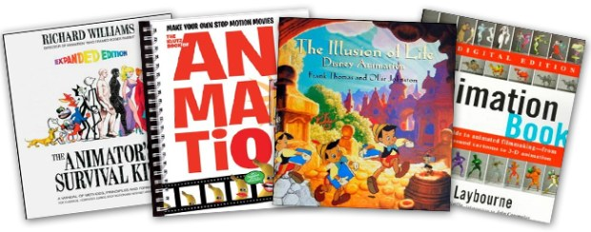

Rule No. 2 – Build a great demo reel
A great demo reel is the best way to showcase your skills (Read: How To Create A Great Animation Show Reel). The most important thing that any student will have on graduation is their demo reel, so make sure that yours is completely free of mistakes. Studios get piles of unsolicited reels, and if there are errors in your work, they will notice! When they do, they’ll assume that you saw the mistake but were unable to fix it, or worse, that you missed it completely. Dedicate time to editing and re-editing, to make sure that your demo reel is perfect.

Rule No. 3 – Make your work easy to find
Get yourself a blog or website. Employers won’t wait for you to send them a reel. They want to be able to click on your work and view it easily. The internet is a great tool for helping yourself get noticed.

Rule No. 4 – Polish your CV
You need an up-to-date, short and easily readable CV. Make it clear, and set out the skills that you are hoping to be hired for.

Rule No. 5 – Find out who is hiring
There are hundreds of animation, games and visual effects companies in the UK alone! Create a spreadsheet so that you can track where you have applied, and when. There is always a company somewhere looking to hire fresh talent.

Rule No. 6 – Sign up for job alerts
The jobs page at AWN (the Animation World Network) is a great resource. My first 3D animation job on Robots with Blue Sky Studios in New York came from here, so don’t underestimate the power of job sites.
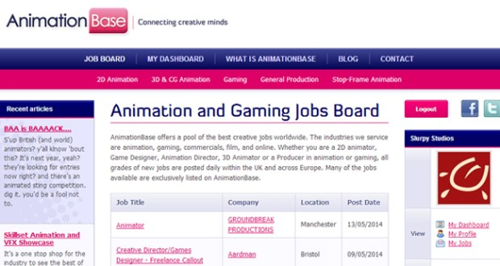
Animation Base is one of many job posting websites you should be checking out

Rule No. 7 – Start applying for jobs
Once you’ve got your demo reel edited to perfection, your CV polished, and job alerts arriving in your inbox, it’s time to start applying! Draft a good cover letter to send to each company that you are applying to, and personalise it to make it stand out.

Rule No. 8 – Consider working as a runner or intern
It’s an unfortunate fact of life, but finding internships is easier than finding a job. A successful internship brings experience, contacts, and a direct understanding of what is needed to get a job within the company, or the industry as a whole.

Rule No. 9 – Get ready for interview
Companies want to know that you are enthusiastic and motivated for the industry and the job role you are applying for. Research the company and find out what your potential job is likely to involve, matching your skills to the company’s requirements.

Rule No. 10 – Build connections
Personal connections count. If you know people who work in the creative industries, ask them about internships. Employers want to be comfortable with the person they are hiring, and if someone within their company can vouch for the applicant, then so much the better. Make a list of people you know in the business; ex-students from your uni are a good place to start. Sending down the ladder to help give an opportunity to a newbie isn’t as rare as you might think.

One of the best ways to build relationships is through networking. Festivus, in London, is a regular event where animators get together to drink, chat and swap cards

Rule No. 11 – Keep your ears open!
Keep in touch with your fellow graduates; you can keep each other informed about who is hiring and who needs extra bodies in a hurry.

Rule No. 12 – Don’t give up
Be persistent. Keep at it, and you will be rewarded

For more useful animation links and resources click here

