RESEARCH METHODS / TOOLS

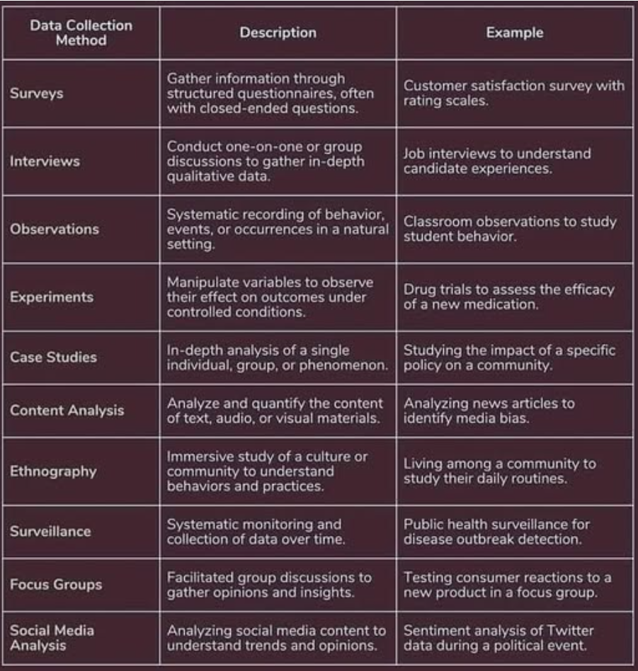

Data Collection Methods – Links

Differences Between Research Methods and Research Methodology
https://youtu.be/RSUfNkJFWeU

Differences Between Questionnaires and Interviews
https://youtu.be/OuFAofE3To0

Differences Between Survey and Questionnaire
https://youtu.be/YQlMU6ro2AA

Differences B/W Ordinary Least Square & Generalized Least Square
https://youtu.be/oLtApsX6Rwc

Linear Regression vs Logistic Regression
https://youtu.be/JevvnnWETsA

Differences B/W Simple & Multiple Linear Regression Model
https://youtu.be/NU8OIwEnEk4

Differences Between Robust Regression and Linear Regression
https://youtu.be/s0ocXFm-7pc

Differences Between Random Effect Model and Fixed Effect Model
https://youtu.be/BbPN-MMUG2U

Differences Between Meta Analysis and Meta Synthesis
https://youtu.be/uy_U2KuQ7QQ

Differences Between Factor Analysis and Principal Component Analysis
https://youtu.be/8vH0WH7p39M

Differences Between Meta Analysis and Systematic Review
https://youtu.be/UiFjh1Mvosw

Differences Between Content Analysis and Thematic Analysis
https://youtu.be/BPxD1pDlZwk

Differences Between SWOT Analysis and TOWS Analysis
https://youtu.be/elht9Ywk_IE

Differences Between Regression and Causation
https://youtu.be/XIwVnaCqhfw

Differences Between Regression and Correlation
https://youtu.be/sjypH4v00e4

Differences Between Correlation and Covariance
https://youtu.be/7q6n6dFlO5E

Differences Between Correlation and Causation
https://youtu.be/DFfKR2LycYo

Differences Between R Squared and Adjusted R Squared
https://youtu.be/TzXbdNtEANE

Differences Between R, R Squared and Adjusted R Squared
https://youtu.be/AJ5mZkfS-ag

Differences Between Durbin Watson Test & Wooldridge Serial Correlation Test
https://youtu.be/a0TRo_5MtGs

Types of Research Methodologies
https://youtu.be/sq5jjoNFoVQ

STATISTICAL TESTS

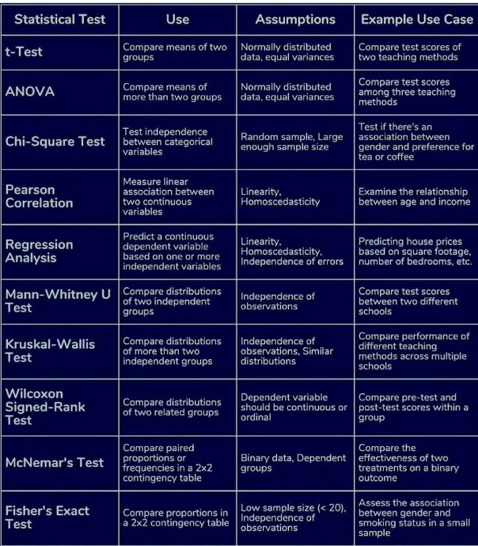

Statistical Tests - Links

Differences Between Descriptive Statistics and Inferential Statistics
https://youtu.be/mwoXa0qsG8M

Differences Between Grouped Data and Ungrouped Data
https://youtu.be/dGyMU5PUrLs

Types of Graphs | Grouped Data and Ungrouped Data
https://youtu.be/Ek-K1sjE6Tg

Differences Between Bar Graph and Histogram
https://youtu.be/TlmI2eXjveE

Differences Between Central Tendency and Dispersion
https://youtu.be/eyBqon-ljBc

Differences Between Skewness and Kurtosis
https://youtu.be/wRt9pmMPM9w

Differences Between Dispersion and Skewness
https://youtu.be/KAw8aRlY-JE

Types of Data: Nominal, Ordinal, Interval, Ratio Scale | Scales of Measurement
https://youtu.be/0rwn50CWu98

Differences Between Unit of Analysis and Unit of Observation
https://youtu.be/XQJ7lIYEL2g

Panel Data Techniques | Chow Test, Breusch-Pagan Lagrange Multiplier LM Test and Hausman Test
https://youtu.be/FXcOSGRW01U

Differences Between Probability and P-Value
https://youtu.be/4EzY7dsnDT4

Differences Between Intercept and Slope
https://youtu.be/fkwybYdWohk

Differences Between Beta and Standard Deviation
https://youtu.be/DEUc_7Ah8Mk

Differences Between R Squared and Adjusted R Squared
https://youtu.be/TzXbdNtEANE

Differences Between R, R Squared and Adjusted R Squared
https://youtu.be/AJ5mZkfS-ag

Differences Between Descriptive Analysis and Correlation Analysis
https://youtu.be/4erbW5uyL_8

Differences Between Correlation and Causation
https://youtu.be/DFfKR2LycYo

Differences Between Correlation and Covariance
https://youtu.be/7q6n6dFlO5E

Differences Between Regression and Correlation
https://youtu.be/sjypH4v00e4

Differences Between Regression and Causation
https://youtu.be/XIwVnaCqhfw

Regression Analysis With Scientific Calculator
https://youtu.be/NHYLthpxQnw

Differences Between ANOVA and ANCOVA
https://youtu.be/Wkjqtrl6uUU

Differences Between Dependent Variable and Independent Variable
https://youtu.be/ZRRYd5v8X9I

Differences Between Moderator and Mediator
https://youtu.be/gwKbE_-2DfA

Differences Between Parametric Tests and Non-Parametric Tests
https://youtu.be/6FQT-NtLM6g

Differences Between z test and t test
https://youtu.be/fugOdf7vc_w

Differences Between t-test and P-Value
https://youtu.be/csZY8Sbu3E8

How to Select an Appropriate Statistical Test
https://youtu.be/Dxnh3SMTk-Q

Differences Between Hypothesis Formulation and Hypothesis Development
https://youtu.be/VH87BtOnlNE

Differences Between Null Hypothesis and Alternative Hypothesis
https://youtu.be/Nk_39ko1nWw

P-Value and Hypothesis Testing
https://youtu.be/Izy9oGmFzzo

Differences Between Simple Linear Regression Model and Multiple Linear Regression Model
https://youtu.be/NU8OIwEnEk4

Differences Between Random Effect Model and Fixed Effect Model
https://youtu.be/BbPN-MMUG2U

Logit and Probit Model
https://youtu.be/hwcFdeWEVgc

ARCH and GARCH Models
https://youtu.be/faPVyXOsQac

Differences Between Durbin Watson Test and Wooldridge Serial Correlation Test
https://youtu.be/a0TRo_5MtGs

How to Determine Sample Size | Cochran's Formula
https://youtu.be/n9EcxClr2vk

Differences Between Robust Regression and Linear Regression
https://youtu.be/s0ocXFm-7pc

