STRATEGIC REPORT
- McDonalds
Darren Emanuel
Student No. 1402731
Strategic Management -BMMB7013

Table of Contents
2. List of Figures - 3 -
3. List of Acronyms - 4 -
4. Executive summary - 5 -
4.1 Further information : - 5 -
5. Introduction - 6 -
5.1 Define Topic / Challenge - 6 -
5.2 Organisational introduction - 6 -
6. Strategy Definitions & Strategic Management models - 8 -
6.1 Exploring Strategy Framework - 8 -
6.2 Peter Drucker Theory of the business - 8 -
6.3 Mintzberg’s 5Ps of strategy - 9 -
6.4 Michael Porter definition - 10 -
6.5 Charles Handy Model of Organisational culture - 10 -
6.6 Strategic management definition - 11 -
7. Analysis of the Micro & Macro Environment - 12 -
7.1 SWOT - 12 -
7.1.1 McDonalds SWAT Matrix - 13 -
7.1.2 McDonalds SWOT summary - 13 -
7.2 PESTEL - 16 -
7.2.1 PESTEL Analysis - 17 -
7.2.2 PESTEL Summary - 17 -
7.3 Porter’s 5 forces - 20 -
7.3.1 Porter’s 5 forces analysis - 20 -
7.3.2 Porter’s 5 forces summary - 21 -
7.4 Organisational culture analysis - 23 -
8. Conclusion - 25 -
9. Recommendations - 27 -
10. References - 28 -

List of Figures

Figure 1 : McDonalds Logo. Source : (McDonalds Restraurants Limited, 2022) - 6 -
Figure 2 : Ray Kroc 3-legged stool. Source : (Olavarria, 2013) - 6 -
Figure 3 : Market Drayton store showing the scale of a typical store and the size of land acquired at each store. Source : (Chadwick, 2021) - 7 -
Figure 4 : illustration identifying 3 levels of strategy proposed by Johnson et al 2017. Source : Author (Darren Emanuel) - 8 -
Figure 5 : Mintzberg's 5 Ps. Source : Author (Darren Emanuel) - 9 -
Figure 6 : 2 Levels of Strategy proposed by Michael Porter. Source : (Porter, 2008) - 10 -
Figure 7 : Charles Handy model of Organisational Culture. Source : Author (Darren Emanuel) - 10 -
Figure 8 : The Exploring Strategy Framework. Source : (Johnson, et al., 2017) - 11 -
Figure 9 : SWOT matrix. Source: (Business indicator, 2022) - 12 -
Figure 10 : SWOT matrix analysis. Source : Author (Darren Emanuel) - 13 -
Figure 11 : A brief competitor analysis. Source : Author (Darren Emanuel) - 15 -
Figure 12 : PESTEL Analysis. Source : Author (Darren Emanuel) - 17 -
Figure 13 : Porters 5 forces. Source : Author (Darren Emanuel) - 20 -
Figure 14 : McDonalds 5 forces analysis. Source : Author (Darren Emanuel) - 20 -
Figure 15 : Cultural analysis of McDonalds. Source : Author (Darren Emanuel) - 24 -

List of Acronyms
AI – Artificial Intelligence
CEO – Chief Executive Officer
CPI – Consumer Price Index
CSR – Corporate Social Responsibility
ETPS – Economic, Technological, Political and Social
EU – European Union
EUIPO – European Union Intellectual Property Office
FSR – Financial Stability Report
HRMC – Her Majesty Revenue & Customs
IBM – International Business Machines
IP – Intellectual property
KFC – Kentucky Fried Chicken
PESTEL – Political, Economic, Social, Technological, Environmental and Legal
PR – Public Relations
R&D – Research & Development
SBU – Strategic Business Unit
SME – Subject Matter Experts
SWOT – Strengths, weaknesses, opportunities and threats
TBL – Triple Bottom Line
UK – United Kingdom
WFH – Work from home

Executive summary
An investigative report of McDonald’s identifying the current micro and macro environments to redirect their strategies to reflect emerging trends, improve consumer care, combat negative media narrative and improve public opinion.

An introduction into McDonald’s identifying methods used to facilitate their rise to dominating the fast-food restaurant sector. The work of several proven theorists was considered to identify the best theorist models to apply, in an attempt to identify key considerations that are currently impacting McDonald’s on a micro and macro level.

A range of analytical tools were then utilised by the author to undertake an environmental scan to understand McDonalds current positioning in the highly competitive hospitality sector post-pandemic.

The author concludes that McDonalds sits in a red ocean strategy environment due to the marketplace saturation and recognises the high level of threats particularly the emerging online delivery model combined with high staff turnover, increasing mandatory requirements and greater consumer demand are posing a greater challenge than ever.

After careful consideration of available resources, several recommendations have been written to inform the proposed strategy redirection going forward. Which in turn, will address negative media narrative, introduce personalised customer car, improve public opinion and capitalise on emerging trends.

Further information :
Total word count: 7077
Applicable word count: 5064
Pages: 33

Introduction

Define Topic / Challenge
This report has been written in an effort to redirect McDonalds organisational strategy direction by undertaking a thorough strategic analysis on a micro and macro scale to address the quickly changing desires of the primary customers. This report will focus on improving customer care, building resilience and attempting to create sustainable competitive advantage.

This presence of negative media narrative of how businesses have reacted to the Coronavirus global pandemic is the catalyst for the Author to analyse the current McDonalds strategies and identify areas for improvement.


Organisational introduction
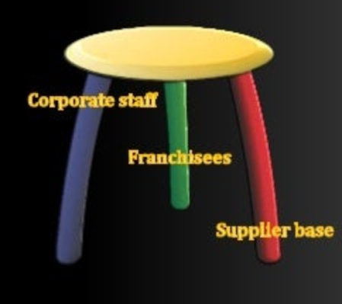
On the 15th May 1940, Richard and Maurice McDonald opened the first McDonalds store in California which was a restaurant with a limited menu consisting of only burgers, fries and beverages on an assembly line method. This allowed the brothers to concentrate on providing a quality product and delivering that product at pace, resulting in a highly efficient business model. (McDonalds Restraurants Limited, 2022)
Figure 1 : McDonalds Logo. Source : (McDonalds Restraurants Limited, 2022)

In 1954, A salesman by the name of Ray Kroc visited the restaurant and was impressed by effectiveness of the McDonalds brother’s operation and in 1961, purchased the exclusive rights to the McDonalds name and efficient operating system. Ray Kroc went on to franchise the McDonalds name and fast service model with a simple 3-legged stool analogy, the first leg was the McDonalds Franchisees, second was the McDonalds suppliers and the third was McDonalds employees. (McDonalds (USA) LLC, 2022).
Figure 2 : Ray Kroc 3-legged stool. Source : (Olavarria, 2013)

Ray Kroc continued to franchise the business model with over 40,000 stores worldwide in 2022, although its first store in the United Kingdom (UK) opened in 1974 in Woolwich, South-East London and as of 2022, there are 1,374 UK restaurants employing over 120,000 staff throughout the UK.

Throughout this investigation into McDonalds operating model, the Author has identified that the franchise opportunity offers the temporary rights to operate the fast-food business model and utilise the McDonalds brand but there is a considerable rental fee to utilise the location and storefront. Corporate McDonalds purchases the land, constructs the restaurant and subsequently leases the building to the franchisee for 25 years for a variable but profit linked rent. Therefore, whilst the business model franchised is that of a restaurant chain, corporate McDonalds themselves operate in the property and land business sector “as World’s largest owner of retail real estate” (Love, 1986)
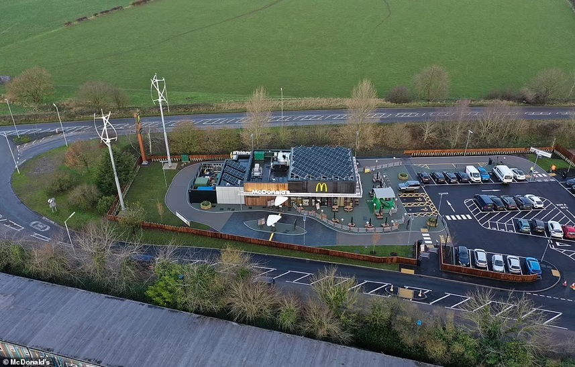
Harrold ( Harry) J Sonneborn was McDonalds president and Chief Executive Officer (CEO) in 1959 and proposed the initial strategy of McDonalds becoming a real estate business which is now the source of 90% of McDonalds Profits (Love, 1986). This model was confirmed by Sonneborn himself who was famously quoted saying “We are not technically in the food business. We are in the real estate business. The only reason we sell fifteen-cent hamburgers is because they are the greatest producer of revenue, from which our tenants can pay us our rent.” (Wall Street Survivor , 2022).
Figure 3 : Market Drayton store showing the scale of a typical store and the size of land acquired at each store. Source : (Chadwick, 2021)

Strategy Definitions & Strategic Management models
Before we can undertake an environmental scan or analysis of McDonalds as an organisation, we must first look at the definitions of strategy and definitions of strategic management and determine if there’s an existing strategic management framework which will allow us to undertake a comprehensive analysis.

Exploring Strategy Framework
Johnson, Whittington, Scholes et al in their 2017 book ‘Exploring Strategy’ define strategy “as the direction and scope of an organisation over the long term, which achieves advantage in a changing environment through its configuration of resources and competences with the aim of fulfilling stakeholder expectations” (Johnson, et al., 2017)
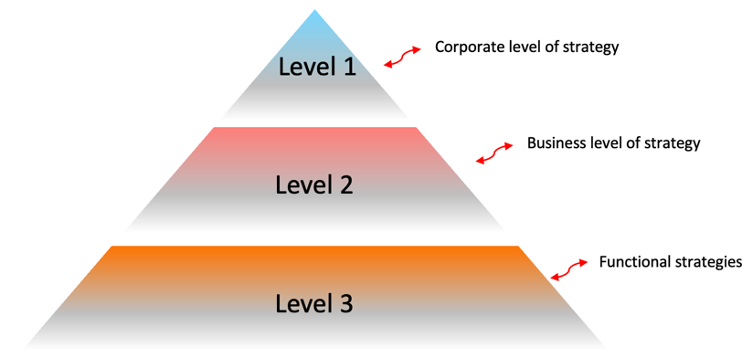
Figure 4 : illustration identifying 3 levels of strategy proposed by Johnson et al 2017. Source : Author (Darren Emanuel)
(Johnson, et al., 2017) continued to propose that there are 3 level of strategy, corporate level which includes the most senior people in the business, Business level which involves the strategic business unit (SBU) and Functional level which includes the departmental managers is the approach adopted by the wider strategic management industry but this is opposed by Michael porter who proposes only two levels of strategy (Porter, 2008).

Peter Drucker Theory of the business
Peter Drucker defined strategy as ‘a theory on how to gain a competitive advantage’ (Drucker, 1994) and further defined strategy as "analytical thinking and commitment of resources to action." (Drucker, 1986). In the 1986 book Management Tasks, Responsibilities, Practices, Drucker went on to describe strategy as unintelligent and foolish to attempt to predict the future. Instead, to Drucker, strategy is “purposeful action” with “meaningful results” (Drucker, 1994).

Mintzberg’s 5Ps of strategy
In 1987, Henry Mintzberg wrote the seminal report named ‘The Strategy Concept 1 : Five Ps for Strategy’ and stated that “Strategic management cannot afford to rely on a single definition of strategy” (Mintzberg, 1987) and instead offered 5 approaches to strategy known as the 5Ps.
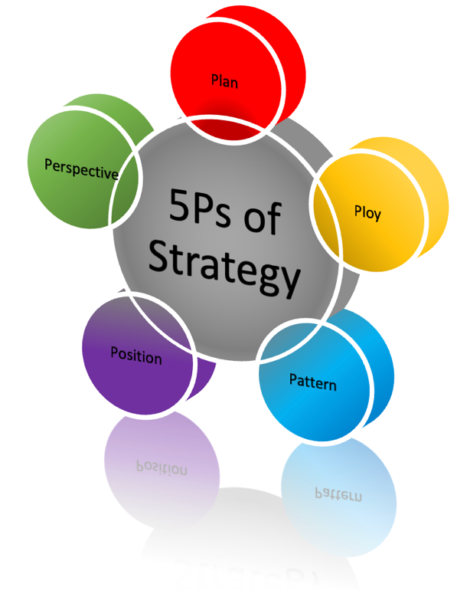
These are as follows :
- Plan – Mintzberg defines that “Strategy is a plan – some sort of consciously intended course of action a guideline (or set of guidelines) to deal with a situation. (Mintzberg, 1987)
- Ploy – Mintzberg states that “ a strategy can be a ploy, too, really just a specific manoeuvre intended to outwit an opponent or competitor” (Mintzberg, 1987)
- Pattern - This is defined as “Strategy is a pattern – specifically, a pattern in a stream of actions” (Mintzberg, 1987)
Figure 5 : Mintzberg's 5 Ps. Source : Author (Darren Emanuel)
- Position – This is defined as “Strategy is a position – specifically, a means of locating an organization in what an organization theorists like to call an “environment”. (Mintzberg, 1987)
- Perspective – Mintzberg defines this as “Strategy is a perspective – its content consisting not just of a chosen position, but of an ingrained way of perceiving the world” (Mintzberg, 1987)

Michael Porter and Henry Mintzberg are two of the most well-known strategy theorists in the academia environment and their theories are regularly contrasted to identify the weaknesses of their strategies. Porter’s strategies are regarded as traditional and deliberate, whereas, Mintzbergs strategies are regarded as modern and wider thinking with particular focus on emergent strategy. (Forbes, 2011).

Michael Porter definition
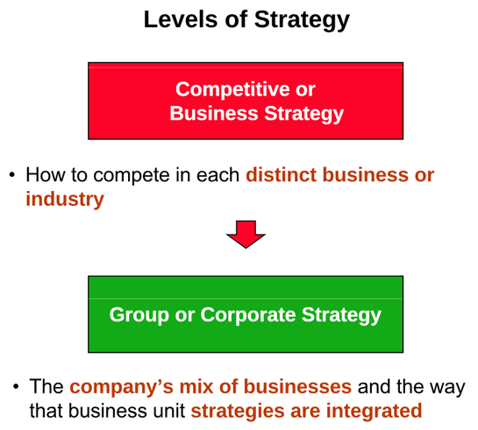
Michael Porter defined strategy as identifying “what not to do” and a tailored series of activities that “reinforce each other” to offer a “unique value proposition” (Porter, 2008). Porter continues to identify that there are two levels of strategy, “competitive or business strategy” and “Group or Corporate Strategy” (Porter, 2008). This differs to the three levels of strategy proposed by Johnson, Whittington, Scholes, Angwin et al in “Exploring Strategy” (Johnson, et al., 2017)
Figure 6 : 2 Levels of Strategy proposed by Michael Porter. Source : (Porter, 2008)

Charles Handy Model of Organisational culture
Charles Handy, in 1978, presented a model identifying 4 culture types which are present within organisations (Handy, 1995), which the author believes are an important consideration that many strategic management analysis tools fail to recognise. Handy stated “if you can find the right culture or style for your situation, you will thrive, and if not, you will struggle” (Handy, 1995).
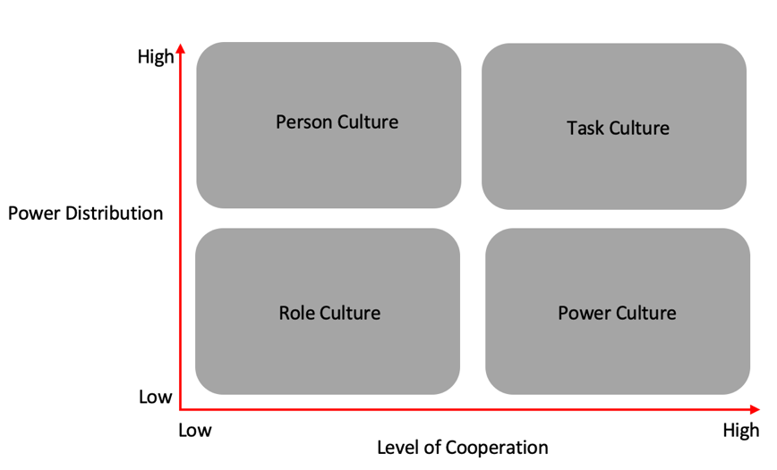
Forbes reported that “people are what matter most in business” (Forbes, 2014) and it is clear that people make the difference in business and are the primary cause of success or failure. Whilst most business focus on policy or procedure, it is time that organisations put culture first as Forbes further reported “When leaders realize that people are what matter most in business, everything else falls in line”. (Forbes, 2014).
Figure 7 : Charles Handy model of Organisational Culture. Source : Author (Darren Emanuel)
All definitions discussed above from leading theorists are correct in their own ways, each of the definitions and models have shortcoming’s. It would be reasonable to identify Mintzberg’s theories and definitions the most applicable to the modern-day environment with focus on emergent strategies. Use of Mintzberg’s theory combined with Charles Handy’s organisational culture consideration would provide an organisation with a good understanding of the challenges faced and required direction of the organisation.

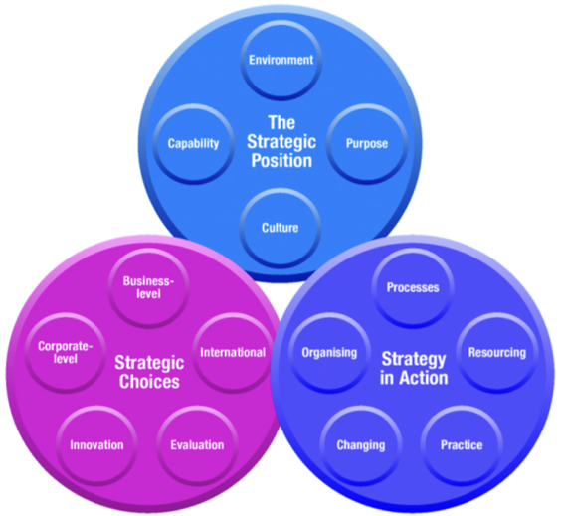
Strategic management definition
Johnson, Scholes and Whittington describe strategic management in their book ‘Exploring Strategy’ define strategy as “the long-term direction of an organisation” and progress further into creating ‘the exploring strategy framework’ separating strategy into 3 distinct stages. Stage one is the “Strategic Position”, Stage 2 is the “Strategic Choices” and the final stage is “Strategy in Action” (Johnson, et al., 2017).
Figure 8 : The Exploring Strategy Framework. Source : (Johnson, et al., 2017)

These 3 stages can also be simplified as shown by the questions below :
- Strategic Position – Where is the organisation now ?
- Strategic Choices – What options do we have to change or improve ?
- Strategy in Action – How do we implement a new strategy ?

Michael porter defines strategic management as “an explicit process of formulating strategy, to insure that at least the policies (if not the actions) of functional departments are coordinated and directed at some common set of goals” (Porter, 1998). Henry Mintzberg defines strategic management as “Leaders at the centre of an authority formulate their intentions as precisely as possible and then strive for their implementation – their translation into collective action – with minimum of distortion”. (Mintzberg, 1985).

Analysis of the Micro & Macro Environment
Now that the definitions from leading theorists have been covered, this section will look to analyse McDonalds using a range of theorist’s frameworks and analysis tools to analyse the micro & macro environment that McDonalds is currently impacted by. All analysis tools and frameworks contain their own limitations and therefore, to form an accurate strategy in an attempt to gain a competitive advantage going forward, many analysis tools must be used.
The author will apply the SWOT, PESTEL and Porters 5 Forces tools.

SWOT
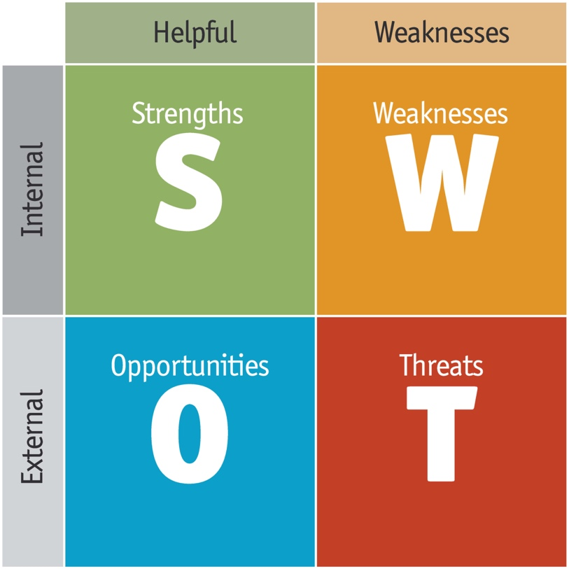
A Strengths, Weaknesses, Opportunities and threats (SWOT) analysis is a stand-alone business strategy tool credited for its “flexibility” and the fact it was “quick and dirty” (CIPD, 2021). Originally concepted by Albert Humphrey for Stanford University in the 1960’s, although the matrix format that is best known today, originated from Heinz Weihrich initially presented in the article ‘The TOWS Matrix a tool for situational analysis’ within the ‘Long Range Planning’ journal in 1982 and its purpose is “for matching the environmental threats and opportunities with the company’s weaknesses and especially its strengths” (Weihrich, 1982) Weihrich reported that use of this matrix will allow a business to “gain greater prominence in the future” (Weihrich, 1982).
Figure 9 : SWOT matrix. Source: (Business indicator, 2022)

McDonalds SWAT Matrix
A SWOT analysis has been undertaken on McDonalds as can be seen below. 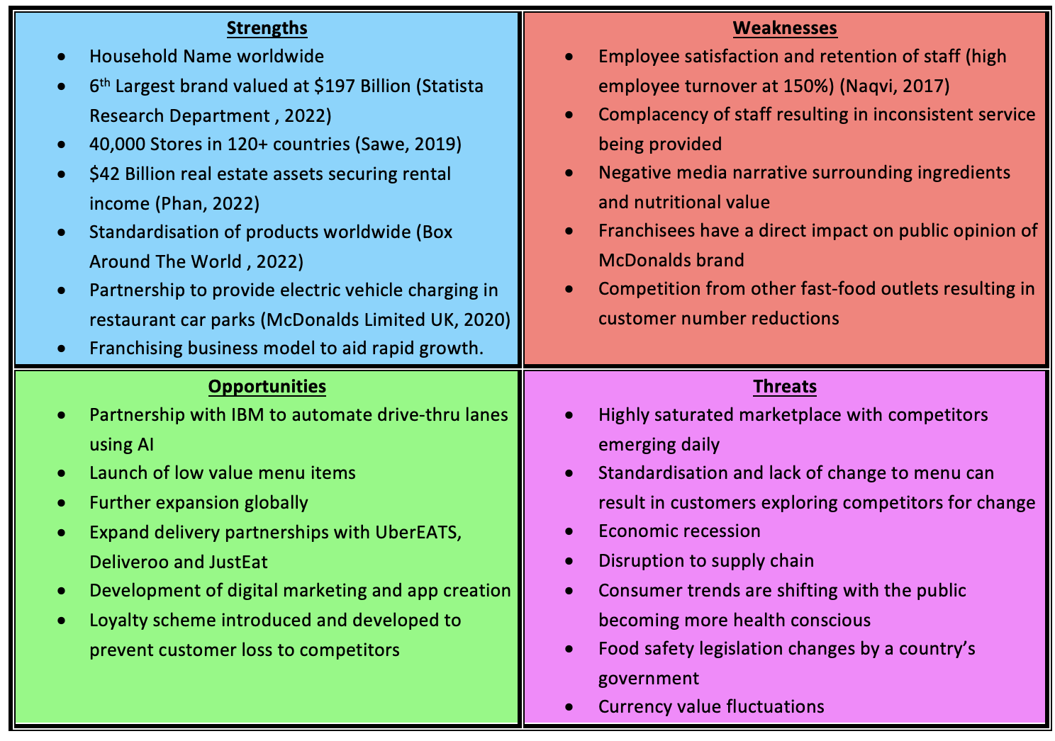
Figure 10 : SWOT matrix analysis. Source : Author (Darren Emanuel)

McDonalds SWOT summary
Strengths
McDonalds is a global household name and one of the largest brands worldwide placing sixth with a value of $197 billion (Statista Research Department , 2022) and has 40,000+ stores in 120+ countries (Sawe, 2019) negating any impacts from changes to local economies or currency fluctuations. $42-billion of McDonalds assets are land and property (Phan, 2022) which builds resilience into the business as income is guaranteed irrespective of food trends.

McDonalds has successfully standardised a range of core menu products worldwide (Box Around The World , 2022) resulting in economies of scale and a simplified menu which provides ease of ordering for customers anywhere in the world and a standard instruction manual for staff when training.

McDonalds Limited UK has partnered with Instavolt (McDonalds Limited UK, 2020)providing a solution to a new problem. Electric vehicle charging Whilst assisting McDonalds corporate agenda to achieve net zero carbon. The convenient charging time of an electric vehicle is between 20-30 mins which combined with the efficient service of McDonalds will further accelerate restaurant turnover and value of the business. (McDonalds Limited UK, 2020)

With the IBM partnership being announced (Lucas, 2021), McDonalds will be directing themselves into a blue ocean strategy as the only fast-food chain with electric vehicle charging and as the world’s largest retail owner (McDonalds Limited UK, 2020), they will diversify and become the largest owner of electric vehicle charging ports, a title currently held by Tesla. (Love, 1986)

Weaknesses
McDonalds have a high staff turnover rate of “150% which made existing employees lose Morale“ (Naqvi, 2017) with Wall Street Zen reporting that “1 in every 8 workers in the US has been employed by McDonalds at one point. (Wall Street Zen , 2012).

Negative public opinion and media narrative around the nutritional value of McDonalds and their lack of defence is a weakness for McDonalds. The documentary film ‘Supersize Me’ directed by Morgan Spurlock was a public relations (PR) disaster (IBDP Business Management , 2004) which really placed the hypothetical spotlight onto McDonalds business ethics and in particular their corporate social responsibilities (CSR) or lack thereof. This has resulted in several legal cases being launched against McDonalds by “obese people who claim its products supported by lavish marketing” contributed to their obesity (The Guardian , 2004) which brings McDonalds morals and ethics into question.

McDonalds are operating a red ocean strategy due to the market saturation with a long list of direct and indirect competitors (David, 2020).
These companies are listed below in the non-exhaustive competitor analysis list :
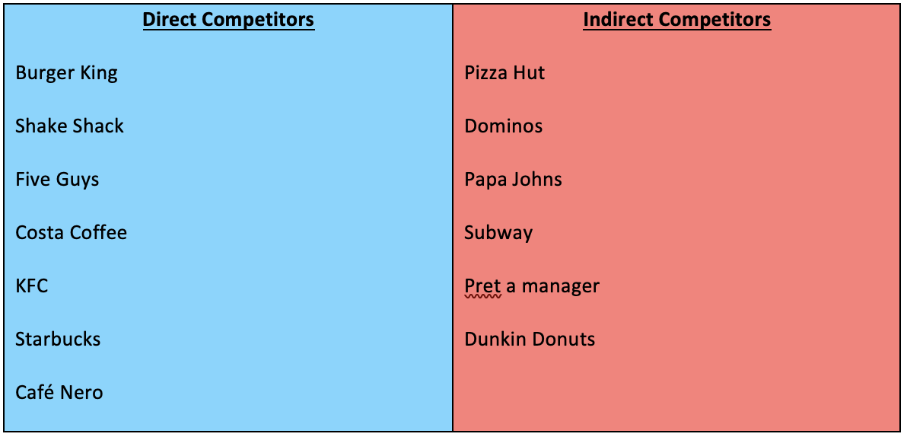
Figure 11 : A brief competitor analysis. Source : Author (Darren Emanuel)
Opportunities
McDonalds has recently entered into a strategic partnership with IBM which will see IBM acquire McD Tech Labs with the objective of automating McDonalds drive-thru lanes using the development of artificial intelligence (Lucas, 2021). This technology could be rolled out to all ordering systems whether drive-thru lanes or in-restaurant ordering which will reduce human error, staff numbers and salary costs whilst providing a reliable and consistent service to customers.

A further opportunity in the technology advancement field would be for McDonalds to create its own application to allow consumers to order food before arriving at the restaurant or to request delivery. McDonalds could integrate a loyalty scheme within this application whereby consumers are rewarded for their brand loyalty which will increase the returning customer base. This loyalty scheme would provide McDonalds with a wealth of knowledge on their customer base and could also be a platform for customer engagement and digital marketing.

McDonalds are also faced with the opportunity to further develop delivery partnerships with UberEATS, Deliveroo and JustEat to improve delivery times, priority collection and delivery services and to geographically extend the delivery distances capturing a wider audience, particularly within rural areas. Most rural areas fall outside delivery distances although when compared with city centre locations, it can often be quicker and more fuel efficient delivering to rural areas due to traffic density.

Threats
Michael Porter states that competition is always a threat in his 1979 journal article ‘How Competitive Forces Shape Strategy’ (Porter, 1979). McDonalds dominated the fast-food sector from its inception although the current day is the most challenging time for McDonalds with such a high saturation of competitors and new businesses opening daily.

Food consumer trends are continually shifting with the last two years of “trends being influenced by pandemic-related shifts in consumer behaviour” (National Geographic , 2022), although national geographic predict trend changes in 2022/2023 with consumers moving away from traditional fast food. National geographic predict that people will consume less burgers, chicken or fries and will consume more seafood, kelp and Udon noodles. (National Geographic , 2022)

The British government has introduced a pilot scheme which will see environmental impact scores being shown on food products (Independant, 2021), which will fuel the increase of environmentally conscious consumers which combined with health-conscious consumers is a great threat to McDonalds.

PESTEL
The creation of the PESTEL analysis analogy is credited to Francis Aguilar who is thought to have introduced the framework albeit using a different analogy in his 1967 book ‘Scanning the business environment’ (Mind Tools, 2022). Aguilar initially described a macro analysis tool to assist in environmental scanning which was initially known as ETPS (Economic, Technological, Political and Social) (Aguilar, 1967) which was later changed to PEST and further developed into PESTEL.
Whilst credited for its simplicity (CIPD, 2021), simplicity is also its main downfall as the model only assess the macro environment (Oxford College of Marketing , 2022) and not that of the micro environment which is critical in conceptualising a new strategy.

PESTEL Analysis
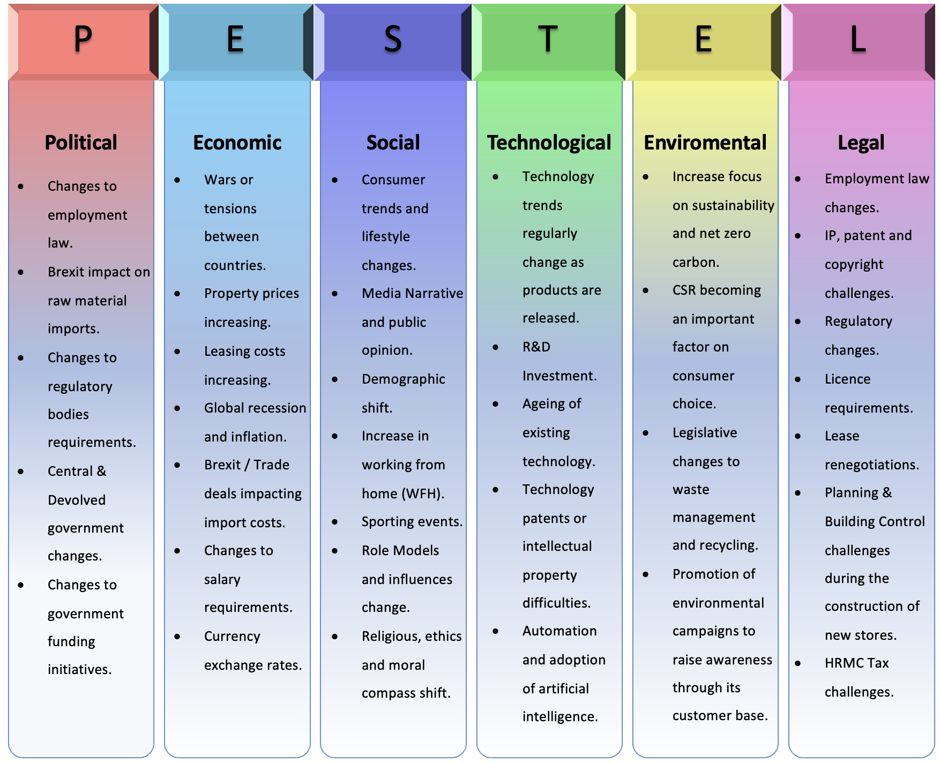
A full PESTEL analysis has been undertaken which can be viewed below.
Figure 12 : PESTEL Analysis. Source : Author (Darren Emanuel)

PESTEL Summary
Political
The London Economic reported that McDonalds was suffering supply chain issues post-Brexit (The London Economic, 2021) whereby McDonalds experienced a period where the fast-food chain had no stock of bottled drinks or milkshakes across it 1,250 stores. (The London Economic, 2021). Due to the lack of clarity around trade agreements with the European Union (EU), McDonalds will have been cautious in their UK investments.
Economic
In 2020, The World Bank predicted that “Covid-19 to plunge global economy into worst recession since World War 2” (The World Bank, 2020) which will inevitably result in significantly less expendable income to purchase the luxury of dining out. McDonalds reported that only 75% of their worldwide restaurants were operational and only on a drive-thru focused service resulting in a 22.2% drop in sales in March 2020. (Hargreaves Lansdown , 2020)
Social
McKinsey & Company released a report in 2020 identifying “hyperpersonalized care and care of one” (Amar, et al., 2020) as an emerging trend whereby consumers are requiring a personalised service combined with “empathy and connection and addressing “individual needs” (Amar, et al., 2020). Fortunately, McDonalds have learnt of this trend and taken action by creating a “new customer experience team” (Forbes, 2021) based on an article released by Meritas in 2019 stating that “customers identified “experience” as a more important attribute than price and product. Further, a PwC report found that 73% of consumers point to experience as a key factor in their purchasing decisions.” (Meritas, 2019)
Technological
Forbes reported in 2020 that customer numbers visiting McDonalds stores is decreasing year-on-year although the amount spent by customers is increasing, masking the issue to investors (Forbes, 2020). Forbes further reports that they believe the cause to be the advancement in technology at drive-thru lanes with the introduction of digital kiosks and digital menus that “scroll too fast” (Forbes, 2020). Whilst technology is a faced paced and volatile environment, it is clear to see that consumers do not develop at the same pace.

Environmental
The Paris Agreement was ratified on 4th November 2016 which is a legally binding treaty marking the “shift to a net-zero carbon emissions world” (United Nations, 2021). Fast-forward to 2021 and McDonalds has committed “to cut greenhouse gas emissions to net zero by 2050” (Reuters, 2021) and by December 2021, McDonalds has already opened its first UK net-zero carbon restaurant in Market Drayton, Shropshire, England “which will act as the blueprint for future restaurants” (McDonalds Limited UK, 2021).
Legal
McDonalds regularly apply for copyright and IP rights on some of its logo trademarks that form a large part of their marketing campaigns and materials. In 2019, “the cancellation Division of the European Union Intellectual Property Office (“EUIPO”) rendered a surprising decision that revoked in its entirety the McDonald’s Company’s BIG MAC trademark registration, which had been registered in the EU since December 1998”. (Foley Hoag LLP, 2019).

However, evidence opposing McDonalds losing this case was reported by BBC in 2019, “EUIPO upheld McDonalds right to own the ‘Mc’ trademark on chicken nuggets and some of its sandwich products”. (BBC, 2019). We can see from these two cases that McDonalds is regularly challenged on their copyright’s and it is a costly and timely process to fight these challenges.

We can see from our PESTEL analysis that McDonalds have subscribed to the triple bottom line (TBL) model proposed by John Elkington in 1994 by focusing on “Profit, People and Planet” (Elkington, 2008) and are therefore, fully aware of the full costs of the business and are well informed for proposing future strategy.

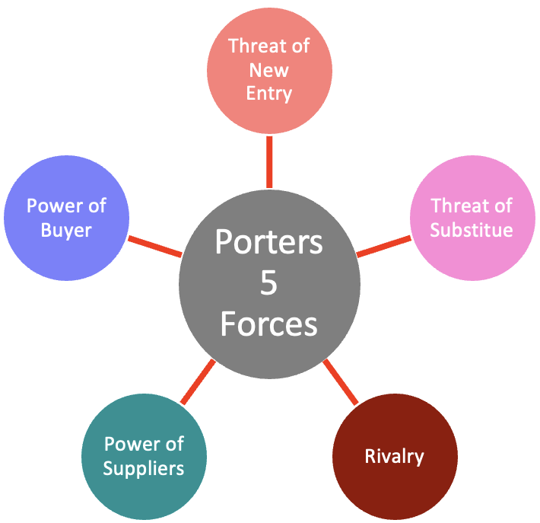
Porter’s 5 forces
Michael Porter developed the ‘five forces of competitive position analysis’ in 1979 whilst working at ‘Harvard Business School’ to allow individuals and businesses to evaluate a sector or industry and analyse the competitive forces within the sector.

Porters 5 forces analysis “tells you immediately how the industry works” (Magretta, 2012) and “does not require any specialised or technical skills” (Garcia, 2019) and integrates “with other analytical frameworks” (Garcia, 2019)
Figure 13 : Porters 5 forces. Source : Author (Darren Emanuel)

Porter’s 5 forces analysis
A 5 forces analysis has been undertaken which can be viewed below.
Figure 14 : McDonalds 5 forces analysis. Source : Author (Darren Emanuel)
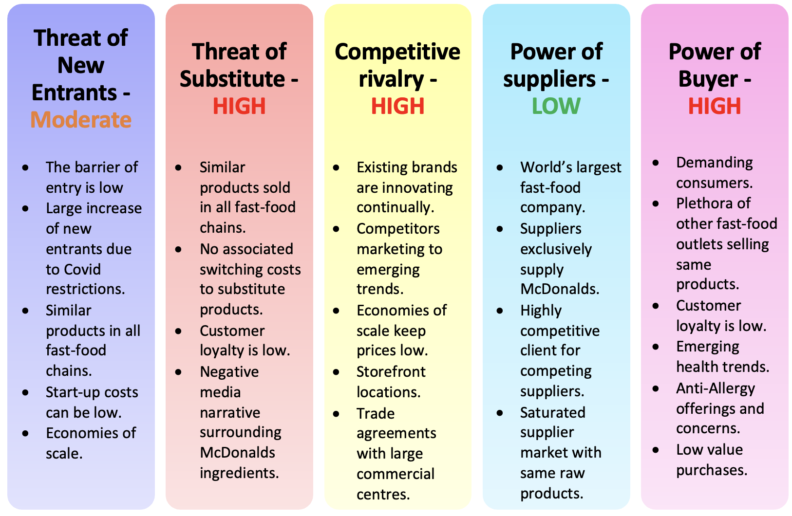

Porter’s 5 forces summary
Threat of New Entry
Barrier of entry is high when applied to competing with physical stores with drive-thru model, however, barrier of entry is low if following an online delivery model which has become popular since covid. The Guardian reported that online delivery orders soared by 76% during Covid restrictions, a model that McDonalds did not subscribe to until recently. (The Guardian , 2021)

Whilst new entrants’ forces innovation, McDonalds current competitive advantage due to economies of scale is diminishing as consumer trends are changing with the introduction and surge in the online delivery space whereby new entrants are not subject to overheads of running a physical retail space. This model is attracting a younger demographic (Moteria, 2020) and addressing the appetite for convivence which has surged due to covid with “online food delivery is set to become a $200 billion industry by 2025” (The Conversation, 2021).
Threat of Substitute
The threat of substitute products is high as the core menu of most fast-food outlets is similar which combined with low consumers loyalty is a high threat to McDonalds. In a recent survey of over 5000 people, “McDonalds customer loyalty ranked last” (FOX 13, 2022).

Furthermore, with McDonalds departure from Russia after 30 years, Russian consumers have switched to replacement ‘Tasty & that’s it’ with equal satisfaction, providing up-to date evidence of low brand loyalty and the high threat of substitute (Marrow, 2022).
Competitive Rivalry
Existing rivalry is already strong as this is a saturated marketplace and all businesses will be adopting a red ocean strategy. Burger King is McDonalds biggest direct competitor seeing $20 billion revenue for 2020 financial year compared with McDonalds $19.2 Billion (Downie, 2021).

Competitive rivalry is particularly intense as Burger King is privately owned and has the freedom to act quickly to emerging trends and the freedom to adjust strategies quickly as opposed to McDonalds which is a publicly traded company which comes with convoluted board approvals process and the necessity to appease investors (Downie, 2021).
A sustainable differentiation would benefit McDonalds in addressing rivalry.
Power of Suppliers
Whilst the fast-food market is highly competitive and saturated, most restaurants use the same raw initial product from the same supplier (Tyson Foods, 2022) and add their own recipe of seasonings or different use of cooking oils to secure a sustainable differentiation in taste or to address certain trends or allergies. An example of this can be seen when analyzing ‘Tyson Foods’ who are one of the largest international wholesale food suppliers with presence in 113 different countries worldwide and clients include Wal-Mart, McDonalds, KFC and Burger king (Tyson Foods, 2022).

The wholesale food suppliers are part of the McDonalds 3-legged stool and whilst McDonalds recognise the importance of a sustainable supply chain, they supply 1% of the global population with food on a daily basis (Market Realist , 2020). Therefore, McDonalds have great power to negotiate economies of scale and to demand certain business requirements. ‘Market Realist’ reports that McDonalds requires its supply chain to focus “on its 3 E’s : Ethics, Environment and Economics” (Market Realist , 2020)
Power of Buyers
Consumers are generally demanding, however, given ‘The Bank of England’ financial stability report (FSR) disconsolate prognosis of the economy based on consumer price index (CPI) (Bank of England , 2022) which combined with the ‘cost of living crisis’ due to inflation rising to 10.1% (Institute for Government, 2022) , consumers are likely to become more demanding with higher expectations of customer care, higher quality for lower cost which will apply pressures to McDonalds profitability.

Organisational culture analysis
As mentioned earlier in this report, the author finds that an organisational culture analysis and important part of identifying the current position of a business as many of the strategic management analysis tools fail to recognise this important factor.

Charles Handy identifies 4 culture types as listed below :
- Role Culture : Has low cooperation levels and low distribution of power in the organisation. As the name suggests, this type of culture focuses on policy and procedure where there is a typical pyramid hierarchy and there is focus on clear role remits providing a stable and predictable environment. This is known to be a rigid culture type and is where McDonalds will be placed. (Toolshero, 2022).

- Power Culture : Has high cooperation levels and low distribution of power in the organisation. This type of culture is best when describing start-up businesses where there is a very horizontal hierarchy usually consisting of the founder and team of employees. There are usually great relationships amongst the organisation and a high degree of loyalty to the founder. This is known to be a flexible culture. (Toolshero, 2022)

- Person Culture : Has low levels of co-operation and high distribution of power throughout the business. This culture is usually found in professional organisations where highly educated professionals are the subject matter experts (SME’s) in their chosen field. Consultancies and academic research organisations usually adopt this culture type and is usually flexible. (Toolshero, 2022)

- Task Culture : High levels of cooperation and high distribution of power throughout the business. As the name suggests, this culture type focuses on results as opposed to policy and procedure and is usually found in team working environments where the task has a deadline or limited timescale similar to project management teams. (Toolshero, 2022).


The author suggests that McDonalds would sit within the role culture category with a traditional pyramid hierarchy and a rigid structure.
Figure 15 : Cultural analysis of McDonalds. Source : Author (Darren Emanuel)

Conclusion
After completing a comprehensive analysis of McDonalds by applying 3 theoretical strategy models, we can see that McDonalds is an incredibly successful organisation with good forward-thinking strategies for its time. However, since the Coronavirus pandemic, the hospitality sector is more volatile than ever before with the faced paced advancement in technology and consumer trends shifting forcing strategies to require reviewing at such a quick pace to address these changes.

McDonalds strategies over the last 20 years have been well planned and well executed, albeit when the hospitality sector was more predictable. The analysis has shown that consumer trends have changed resulting in greater demand for personalised service as identified by McKinsey & Companies June 2020 report ‘Hyperpersonalization of customer care’ and new entrants operating online delivery models have shifted the demographic of the McDonalds consumer base.

From the analysis, we can see that McDonalds is aware of emerging trends and have adopted the triple bottom line (TBL) approach to their business as concepted by John Elkington in 1994 by focusing on “Profit, People and Planet” (Elkington, 2008) and are therefore, fully aware of the full costs of the business and are well informed for proposing future strategy.
People, planet, profit – be more sustainable.

It is clear from the analysis above that McDonalds has adopted the red ocean strategy as it sits within a highly competitive and saturated market where many direct competitors are competing for the largest market share. McDonalds are attempting to become more sustainable via their net-zero carbon restaurants and by procuring more sustainable suppliers to follow government mandates and which will also help appeal to the environmentally conscious consumers.

As we can see from the analysis above, McDonalds are at the forefront of emerging trends whether that be ‘hyperpersonalization of customer care’ or that of achieving net-zero carbon to satisfy several countries obligations through the ‘Paris Agreement’ McDonalds position can be described as innovative and ambitious with the desire to pioneer the future of fast-food.

McDonalds have a role focused organisation culture which whilst causes stability, is rigid and doesn’t promote high levels of morale as the workforce has fixed remits and do not have the option to improve the business or be motivated to go above and beyond to create a personalised customer care experience.

Recommendations
The aim of these recommendations is to redirect McDonalds strategy in an attempt to modernise their approach and consider emerging trends and shortfalls within the business. The recommendations will also aim to address the negative media narrative and improve customer care for consumers further attempting to improve brand loyalty.

The author believes these recommendations to be achievable after careful consideration of resources available and any challenges facing their implementation. However, there are risks associated with any strategy redirections.

Recommendations

- Improve personalised customer care experience via an improved loyalty scheme rewarding consumer

- Introduce an online delivery model via the McDonalds website and mobile application which will build resilience into the model in the event of future pandemics

- Adopt AI to improve and standardise consumer ordering experience through drive thru, instore and through online ordering which will reduce wait times.

- Build sustainable differentiation to address rivalry by introducing a personalised customer experience and limited-edition meals using existing raw materials.

- Innovating new products to Increase vegan, vegetarian offerings and those products that satisfy a wider range of dietary needs addressing allergies improving the demographic reach of consumers worldwide

- Look to improve staff morale by adding value through improving organisational culture by empowering employees, introducing staff development, encouraging creativity and welcoming challenge which will improve retention rates.

- Introduce renewable energy sources to restaurants which will reduce overheads, assist in net-zero carbon strategy and target the environmentally conscious demographic.

- Adopt CSR into the forefront of their business model and Improve marketing to address negative media narrative and poor public opinion.

- Explore collaboration with direct or indirect competitors to increase consumer demographic

References
- Aguilar, F. J., 1967. Scanning the business enviroment. 1 ed. New York: Macmillan.
- Amar, J. et al., 2020. The vision for 2025: Hyperpersonalized care and ‘care of one’. [Online]
Available at: https://www.mckinsey.com/capabilities/operations/our-insights/the-vision-for-2025-hyperpersonalized-care-and-care-of-one
[Accessed 14 December 2022].
- Bank of England , 2022. Financial Stability Report - December 2022. [Online]
Available at: https://www.bankofengland.co.uk/financial-stability-report/2022/december-2022
[Accessed 16 December 2022].
- BBC, 2019. McDonald's loses second 'Mc' trademark case against Supermac's. [Online]
Available at: https://www.bbc.co.uk/news/world-europe-49254551
[Accessed 14 December 2022].
- Box Around The World , 2022. McDonald’s Supply Chain Management is The Secret to Their Success!. [Online]
Available at: https://boxaroundtheworld.com/mcdonalds-supply-chain-management/
[Accessed 13 December 2022].
- Business indicator, 2022. SWOT Matrix. [Online]
Available at: https://businessindicator.com/wp-content/uploads/2021/04/SWOT_Matrix-scaled.jpg
[Accessed 16 December 2022].
- Chadwick, J., 2021. Inside the UK's first net zero McDonald's. [Online]
Available at: https://www.dailymail.co.uk/sciencetech/article-10293217/Inside-UKs-net-zero-emissions-McDonalds.html
[Accessed 12 December 2022].
- CIPD, 2021. PESTLE analysis. [Online]
Available at: https://www.cipd.co.uk/knowledge/strategy/organisational-development/pestle-analysis-factsheet#7992
[Accessed 14 December 2022].
- CIPD, 2021. SWOT Analysis. [Online]
Available at: https://www.cipd.co.uk/knowledge/strategy/organisational-development/swot-analysis-factsheet
[Accessed 13 December 2022].
- David, J., 2020. Competitors of McDonald’s (Competitor analysis of McDonald’s). [Online]
Available at: https://howandwhat.net/competitors-mcdonalds-competitor-analysis-mcdonalds/
[Accessed 13 December 2022].
- Downie, R., 2021. Who Are McDonald’s Main Competitors?. [Online]
Available at: https://www.investopedia.com/articles/markets/102815/who-are-mcdonalds-main-competitors.asp
[Accessed 16 December 2022].
- Drucker, P. F., 1986. Management Tasks and Responsabilities. First ed. New York: Truman Talley Books.
- Drucker, P. F., 1994. The Theory of Business. Harvard Business Review , Issue September - October 1994, pp. 94-104.
- Elkington, J., 2008. People, Planet, Profit. [Online]
Available at: https://johnelkington.com/2008/06/people-planet-profit/
[Accessed 16 December 2022].
- Foley Hoag LLP, 2019. BIG MAC Trademark Not That Big in the EU: How McDonald’s Failed to Prove Genuine Use of its EU Trademark. [Online]
Available at: https://www.trademarkandcopyrightlawblog.com/2019/02/big-mac-trademark-not-that-big-in-the-eu-how-mcdonalds-failed-to-prove-genuine-use-of-its-eu-trademark/
[Accessed 14 December 2022].
- Forbes, 2011. Porter or Mintzberg: Whose View of Strategy Is the Most Relevant Today?. [Online]
Available at: https://www.forbes.com/sites/karlmoore/2011/03/28/porter-or-mintzberg-whose-view-of-strategy-is-the-most-relevant-today/
[Accessed 15 December 2022].
- Forbes, 2014. People Are What Matter Most In Business. [Online]
Available at: https://www.forbes.com/sites/brucekasanoff/2014/07/21/people-are-what-matter-most-in-business/
[Accessed 16 December 2022].
- Forbes, 2020. McDonald’s Declining Customer Traffic Is A Death March To The Future. [Online]
Available at: https://www.forbes.com/sites/larrylight/2020/02/10/mcdonalds-declining-customer-traffic-is-a-death-march-to-the-future/
[Accessed 14 December 2022].
- Forbes, 2021. McDonald’s Has Created A New Team To Focus On Customer Experiences. [Online]
Available at: https://www.forbes.com/sites/aliciakelso/2021/07/26/mcdonalds-has-created-a-new-team-to-focus-on-customer-experiences/
[Accessed 14 December 2022].
- FOX 13, 2022. McDonald's ranks last in new survey of customer loyalty. [Online]
Available at: https://www.q13fox.com/news/mcdonalds-ranks-last-2022-customer-loyalty-index-survey
[Accessed 15 December 2022].
- Garcia, C., 2019. Porters Five Forces Model. [Online]
Available at: https://www.konsyse.com/articles/porters-five-forces-analysis-benefits-and-applications/
[Accessed 15 December 2022].
- Handy, C. B., 1995. Gods of Management : The changing work of organisations. 3rd ed. London: Arrow.
- Hargreaves Lansdown , 2020. McDonalds - COVID-19 having a significant impact. [Online]
Available at: https://www.hl.co.uk/shares/share-research/202004/mcdonalds-covid-19-having-a-significant-impact
[Accessed 14 December 2022].
- IBDP Business Management , 2004. McDonalds - Supersize Me. [Online]
Available at: https://www.thinkib.net/businessmanagement/page/21954/mcdonalds-supersize-me
[Accessed 13 December 2022].
- Independant, 2021. Food and drink labels to show ‘eco scores’ traffic light system under UK pilot scheme. [Online]
Available at: https://www.independent.co.uk/climate-change/news/eco-impact-label-food-drink-b1873633.html
[Accessed 14 December 2022].
- Institute for Government, 2022. Cost of living crisis. [Online]
Available at: https://www.instituteforgovernment.org.uk/explainers/cost-living-crisis
[Accessed 16 December 2022].
- Johnson, G. et al., 2017. Exploring Strategy. 11 ed. London: Pearson.
- Love, J. F., 1986. McDonalds : Behind The Arches. 1 ed. New York: Bantam Books.
- Lucas, A., 2021. McDonald’s enters strategic partnership with IBM to automate drive-thru lanes. [Online]
Available at: https://www.cnbc.com/2021/10/27/mcdonalds-enters-strategic-partnership-with-ibm-to-automate-drive-thru-lanes.html
[Accessed 13 December 2022].
- Magretta, J., 2012. Understanding Michael Porter. In: The essential guide to competition and strategy. massachusetts: Harvard Business Review Press, pp. 35-62.
- Market Realist , 2020. McDonald’s Supply Chain: A Must-Know for Investors. [Online]
Available at: https://marketrealist.com/2019/11/must-know-mcdonalds-supply-chain-2/
[Accessed 16 December 2022].
- Marrow, A., 2022. Russia’s McDonald’s successor replacing Big Mac with 'Big Hit'. [Online]
Available at: https://www.yahoo.com/news/russia-mcdonald-successor-replacing-big-120328819.html
[Accessed 15 December 2022].
- McDonalds (USA) LLC, 2022. McDonalds History. [Online]
Available at: https://www.mcdonalds.com/us/en-us/about-us/our-history.html
[Accessed 12 December 2022].
- McDonalds Limited UK, 2020. McDonald’s Partners with InstaVolt to Create Electric Vehicle Charging Network as UK Prepares for Green Recovery. [Online]
Available at: https://www.mcdonalds.com/gb/en-gb/newsroom/article/ev_rollout.html
[Accessed 13 December 2022].
- McDonalds Limited UK, 2021. MCDONALD’S OPENS FIRST UK NET ZERO CARBON RESTAURANT. [Online]
Available at: https://www.mcdonalds.com/gb/en-gb/newsroom/article/uk_net_zero_carbon.html
[Accessed 14 December 2022].
- McDonalds Restraurants Limited, 2022. McDonalds Newsroom History. [Online]
Available at: https://www.mcdonalds.com/gb/en-gb/newsroom/history.html
[Accessed 12 December 2022].
- Meritas, 2019. The Rise of the Chief Experience Officer. [Online]
Available at: https://www.meritas.co/the-rise-of-the-chief-experience-officer/
[Accessed 14 December 2022].
- Mind Tools, 2022. PEST Analysis. [Online]
Available at: https://www.mindtools.com/aqa3q37/pest-analysis
[Accessed 14 December 2022].
- Mintzberg, H., 1985. Of Strategies, Deliberate and Emergent. Strategic Management Journal, 6(3), pp. 257-272.
- Mintzberg, H., 1987. The Strategy Concept I: Five Ps for Strategy. Carlifonia Management Review, 30(Fall 1987), pp. 11-24.
- Moteria, D., 2020. Online Delivery To Takeaways – Food Industry Sees Growth Amid Pandemic. [Online]
Available at: https://guestpostblogging.com/online-delivery-to-takeaways-food-industry-sees-growth-amid-pandemic/
[Accessed 15 Decmber 2022].
- Naqvi, D. F., 2017. McDonald's UK: Staffing & Retention Issues. International Journal of Economic Research , 14(17), pp. 529-537.
- National Geographic , 2022. The 12 biggest global food trends for 2022. [Online]
Available at: https://www.nationalgeographic.co.uk/travel/2022/03/the-12-biggest-global-food-trends-for-2022-from-kelp-to-yakitori
[Accessed 14 December 2022].
- Olavarria, J., 2013. McDonalds Presentation. [Online]
Available at: https://www.slideshare.net/jeffolavarria/mcd-donalds-presentation
[Accessed 12 December 2022].
- Oxford College of Marketing , 2022. What is a PESTEL Analysis. [Online]
Available at: https://blog.oxfordcollegeofmarketing.com/2016/06/30/pestel-analysis/
[Accessed 14 December 2022].
- Phan, T., 2022. MCDONALD’S $42B REAL ESTATE EMPIRE. [Online]
Available at: https://workweek.com/2022/06/25/mcdonalds-42b-real-estate-empire-explained/
[Accessed 13 December 2022].
- Porter, M., 2008. What is Strategy. Boston, Massachusetts: Harvard Business School .
- Porter, M. E., 1979. How Competitive Forces Shape Strategy. Harvard Business Review, 57(2 (March - April 1979)), pp. 137-145.
- Porter, M. E., 1998. COMPETITIVE STRATEGY Techniques for Analyzing Industries and Competitors. Second ed. New York: The Free Press.
- Reuters, 2021. McDonald's targets net zero emissions by 2050, from meat to energy. [Online]
Available at: https://www.reuters.com/business/sustainable-business/mcdonalds-targets-net-zero-emissions-by-2050-meat-energy-2021-10-04/
[Accessed 14 December 2022].
- Sawe, B. E., 2019. How Many McDonalds Locations Are There In The World?. [Online]
Available at: https://www.worldatlas.com/articles/countries-with-the-most-mcdonald-s-restaurant.html
[Accessed 13 December 2022].
- Statista Research Department , 2022. McDonald's: brand value 2006-2022. [Online]
Available at: https://www.statista.com/statistics/326059/mcdonalds-brand-value/
[Accessed 13 December 2022].
- The Conversation, 2021. Shutterstock Appetite for convenience: how the surge in online food delivery could be harming our health. [Online]
Available at: https://theconversation.com/appetite-for-convenience-how-the-surge-in-online-food-delivery-could-be-harming-our-health-163348
[Accessed 15 December 2022].
- The Guardian , 2004. McDonald's fights back against hit film. [Online]
Available at: https://www.theguardian.com/media/2004/aug/20/advertising.edinburghfilmfestival2004
[Accessed 13 December 2022].
- The Guardian , 2021. This article is more than 1 year old Just Eat Takeaway orders soar 76% during six months of Covid restrictions. [Online]
Available at: https://www.theguardian.com/business/2021/aug/17/just-eat-takeaway-orders-soar-76-during-six-months-of-covid-restrictions
[Accessed 15 December 2022].
- The London Economic, 2021. Full list of companies facing post-Brexit supply chain issues. [Online]
Available at: https://www.thelondoneconomic.com/business-economics/full-list-of-companies-facing-post-brexit-supply-chain-issues-288822/
[Accessed 14 December 2022].
- The World Bank, 2020. COVID-19 to Plunge Global Economy into Worst Recession since World War II. [Online]
Available at: https://www.worldbank.org/en/news/press-release/2020/06/08/covid-19-to-plunge-global-economy-into-worst-recession-since-world-war-ii
[Accessed 29 June 2022].
- Toolshero, 2022. Handy Model of Organisational Culture. [Online]
Available at: https://www.toolshero.com/management/handy-model/
[Accessed 16 Decmber 2022].
- Tyson Foods, 2022. Tyson Foods - What we do. [Online]
Available at: https://www.tysonfoods.com/who-we-are/our-story/what-we-do
[Accessed 16 December 2022].
- United Nations, 2021. The Paris Agreement. [Online]
Available at: https://www.un.org/en/climatechange/paris-agreement
[Accessed 14 December 2022].
- Wall Street Survivor , 2022. Mcdonald’s Real Estate: How They Really Make Their Money. [Online]
Available at: https://www.wallstreetsurvivor.com/mcdonalds-beyond-the-burger/
[Accessed 12 December 2022].
- Wall Street Zen , 2012. Mcdonalds Corp Statistics & Facts. [Online]
Available at: https://www.wallstreetzen.com/stocks/us/nyse/mcd/statistics
[Accessed 13 December 2022].
- Weihrich, H., 1982. The TOWS Matrix - A tool for situational analysis. Long Range Planning , 15(2), pp. 54-66.

