Jacob Quinn
University Of wales trinity saint david
using GIs as a tool within the conservation of palaeontological sites – Analysis of Distribution and Quality

Contents
1.0 Introduction 2
2.0 Literature Review 2
2.1 Geoconservation 2
2.2 Dissertation background – Palaeontological Value Index 2
3.0 Locations 0
3.1 Kings Dyke Nature reserve – Whittlesey, Cambridgeshire 0
3.2 Yaxely pit – Yaxely, Cambridgeshire 0
3.3 Tidmoor Point, The Fleet – Weymouth, Dorset 1
4.0 Methodology 1
5.0 Process of Creating a Map 1
5.1 Plotting Data Points 8
5.2 Distribution 9
5.3 Quality 11
6.0 Conclusion 14
References 15

Table 1: Palaeontological Value Index. 0
Table 2: Location and survey dates. 1

Figure 1: Map of study locations - produced in MapInfo Pro using Infuse 2011 regional boundary data, the central coordinates of each site and the label tool. 0
Figure 2: Example of 1:10000 scale geology data downloaded from EDINA digimaps. 2
Figure 3: Geology data uploaded to MapInfo Pro with Bing aerial map as a base layer. 2
Figure 4: Creating a Thematic Map - Choosing template. 3
Figure 5: Creating a Thematic Map - Choosing data source. 3
Figure 6: Creating a Thematic Map - Confirming selections 4
Figure 7: Issues with creating a thematic map using 1:10000 geology data. 5
Figure 8: Using 1:50000 geology data – Weymouth, Dorset. 5
Figure 9: Using 1:50000 geology data - Cambridgeshire sites. 6
Figure 10: Creating a Legend - choosing layers. 7
Figure 11: Creating a Legend - Frame Properties. 7
Figure 12: Data used to create points. 8
Figure 13: Creating points. 8
Figure 14: Plotted data after creating data points - Cambridgeshire sites. 9
Figure 15: Distribution of fossils at Kings Dyke Nature Reserve - Whittlesey, Cambridgeshire. 9
Figure 16: Distribution of fossils at Tidmoor Point, The Fleet - Weymouth, Dorset. 10
Figure 17: Distribution of fossils at Yaxely pit - Yaxely, Cambridgeshire. 10
Figure 18: SQL select. 11
Figure 19: Fossils with a 'very high' quality (5) as marked by a size 14 font purple star - Kings Dyke Nature Reserve. 12
Figure 20: Example of fossils recorded during surveying: Fossils from the Stewartby Member (middle/upper) of the Oxford Clay at Tidmoor Point, The Fleet – Weymouth, Dorset..13

1.0 Introduction
Geographical Information systems (GIS) have been used as a method of visualising data since as early as 1781, at the battle of Yorktown (Waters, 2017). GIS is becoming ever-increasingly popular for its use as a tool within management and analysis of the environment.
GIS’ are a type of information system designed to capture and store data that can be queried for analysis. It will have a geospatial element, this is spatial data that relates to the earth surface such as latitude and longitude (Worboys & Duckham, 2004); in GIS, spatial data is typically always linked to attribute data, this data tells us about the spatial data points (Dempsey, 2013). Longley et al (2011) identified that data delineated for GIS plays a role in the decision-making process at differing levels (e.g. public, private, governmental etc.). It has shown to be used for a range of tasks such as:

- Location of a feature and relationships to other features
- Mapping quantities of features
- Mapping densities of features
- Mapping activities within proximity to the area of study – e.g. buffer tool
- Mapping change over time
Though beneficial for environmental management, Larsen (1999) states that environmental GIS works often do not have the added skills to develop further GIS application, subjecting workers to work within predefined software parameters.

2.0 Literature Review

2.1 Geoconservation
Geological conservation geoconservation is defined as the measures taken to conserve/enhance geological and geomorphological features, as well as the recording and rescue of specimens that may be threatened or subject to damage from a range of activities at a site (Prosser, et al., 2013). Within the UK, geoconservation is product of the 1940’s governments attempt to conserve the natural environment (Burek & Prosser, 2008). Statutory provisions to conserve geological features were first provided in the ‘National Parks and Access to the Countryside Act 1949’ – this allowed for areas to be designated as Sites of Special Scientific Interest (SSSI’s) and National Nature Reserves (NNR’s) (Brown, et al., 2018; Burek & Prosser, 2008). There have been considerable developments within the geoconservation designations since the 1949 act such as the Geological Conservation Review (GCR) – the primary geoconservation designation within UK, as well as non-statutory conservation designations such as Regionally Important Geological Sites (RIGS) and UNESCO heritage sites e.g. Dorset’s Jurassic Coast. At present there is no quantitative measure to determine a geological sites conservation value.

2.2 Dissertation background – Palaeontological Value Index
The proposed methodology to used assess a geological formations palaeontological value is the Palaeontological Value Index (PVI). The PVI is an innovative adaption of several peer-review methodologies such as the Coastal Vulnerability Index (CVI) and Ratcliffe’s ‘A Nature Conservation Review’ (1977). The PVI is a set of six multi-dimensional variables, each variable is quantified, set on a 1-5 scale (Quinn, 2019). Unlike CVI, which has variables chosen to highlight areas of vulnerability to coastal processes, the PVI variables were chosen on a basis they would highlight areas of palaeontological value (Table 1). The variables are as follows: Biota diversity; Rarity; Erosion; Quality; Access; Anthropogenic activity. The quantified variables are to be combined using an equation,
forming a single-index figure. GIS is essential to PVI assessment as a method of visualising data for further analysis.

Table 1: Palaeontological Value Index.
Rank | Very-Low | Low | Moderate | High | Very-High
Variable | 1 | 2 | 3 | 4 | 5
Biota Diversity | <5 species observed. | 6-10 species observed. | 11-15 species observed. | 16-20 species observed. | >20 species observed.
Rarity | 0-20 | 21-40 | 41-60 | 61-80 | >80
Erosion (m/yr) | 0-0.25  Minimal erosion – Shallow gullying; raindrop impact; etc. | 0.26-0.50  Low erosion –  Deeper gullying; evidence of mass movement; etc. | 0.51-0.75  Moderate erosion – Localised mass movement; gullying; angular material; etc. | 0.76-1.00  High erosion – Large scale mass movement; steep facies; etc. | ≥1.01  Very-high erosion- Erosion dominant force; landslides; angular/coarse material; etc.
Quality (Avg.) | 0-1 | 1.01-2 | 2.01-3 | 3.01-4 | 4.01-5
Access | Limited to no access – private property; working quarry; geographical limitations; etc. | Low access – private property; working quarry – access with organisations; etc. | Moderate access – timed access; membership; etc. | High access – publicly accessible; considerations such as tide times; etc. | Very-high access – no access limitations or considerations
Anthropogenic Activity | Very-high impact by human activity – extensive heavy machinery use; land re- development; etc. | High impact by human activity – extensive digging of material/bedrock; undifferentiation of bedrock layers; etc. | Moderate impact by human activity – digging of material/bedrock; etc. | Low impact by human activity – limited evidence of human activity; etc. | Very-low impact by human activity – limited to no evidence of human activity; material in relative abundance; etc.

3.0 Locations
The Oxford Clay Formation was chosen as the geological formation for the test application of the PVI index, allowing for comparability between sites. The Oxford Clay is a series Callovian to lower Oxfordian age marine deposits, rich in fossiliferous materials (Martill & Hudson, 1991). The formation spans from the Dorset coast to the North Yorkshire coast, with a range of inland exposure sites that have different economic and social uses (Cox & Sumbler, 2002; Cox, et al., 1992; Martill & Hudson, 1991). Three locations were chosen that expressed a range of usages, different types of exposures, as well as different conservation designations.
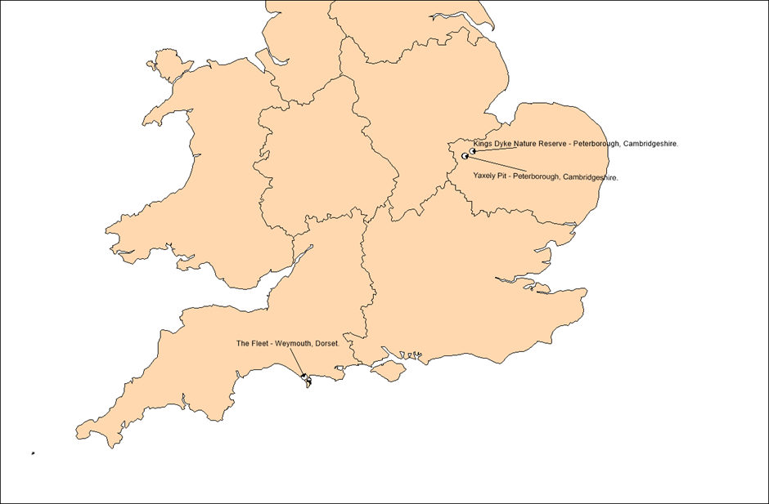
Figure 1: Map of study locations - produced in MapInfo Pro using Infuse 2011 regional boundary data, the central coordinates of each site and the label tool.

3.1 Kings Dyke Nature reserve – Whittlesey, Cambridgeshire
Kings Dyke is a former working brick pit, that has since been restored (1995) to a multi-use wildlife conservation area (Kings Dyke Nature Reserve , 2019). The site is an exposure of Lower Oxford Clay, with the fossil hunting area designated as RIGS for its historical heritage and its scientific value (Kings Dyke Nature Reserve , 2012). Most of material found on site is stockpiled clay from beds 1-13, imported from the active brick pit – Must Farm (Hudson & Martill, 1994; Reserve Manager, pers. comm., 2019).

3.2 Yaxely pit – Yaxely, Cambridgeshire
Yaxely pit is a former working brick pit that is now disused (Martill, 1986), areas of the pit have been lost to development while other areas have been left as areas for nature. The pit is an exposure of Lower Oxford Clay, excavated down to bed 10 (Martill, 1985), though the main pit is now infilled with water. Fossils at Yaxely pit can be discovered by surveying the rim of the pit, where the greatest amount of erosion occurs; surveying the edge of the pit is better suited to summer conditions when the water levels within the pit drop.

3.3 Tidmoor Point, The Fleet – Weymouth, Dorset
Arkell (1947: 30) once described Tidmoor Point as “one of the most celebrated fossil locations in England”. Tidmoor Point is a coastal exposure of the Middle Oxford Clay of the Stewartby Member (Duff, 1978; Martill & Hudson, 1991). The site has gained SSSI status for its stratigraphy, as well as forming part of the basis of the UNESCO World Heritage Site of the Jurassic Coast (Natural England, 1986; Jurassic Coast Trust, 2019).

4.0 Methodology
Data was collected using the following pieces of equipment: Geological prospecting hammer; Cold chisel; Garmin handheld GPS.
Due to the diverse variety of the fauna and the differing types of preservation within the Oxford Clay Formation, multiple collecting strategies were required according to the type of fossil sought and dependent on the location of study (Martill & Hudson, 1991). Sites were surveyed during winter of 2018 and 2019:
Table 2: Location and survey dates.
Location | Date of Survey
Kings Dyke Nature Reserve – Whittlesey, Cambridgeshire | 28th of December 2018
Yaxely Pit – Yaxely, Cambridgeshire | 3rd of January 2019
Tidmoor Point, The Fleet – Weymouth, Dorset | 6th of January 2019

During a survey of each site, visible specimens were collected and recorded on the GPS, though it should be noted that some of the more common fossils were left for others, but still recorded. Most specimens were identified on site, though some required minor in-lab preparation to remove debris before they could be identified. Within the Lower Oxford Clay of the Peterborough Member, concretionary carbonate horizons and organic-rich, fissile shales are persistent (Martill & Hudson, 1991; Hudson & Martill, 1994). Fossil bearing concretions were split using a hammer, revealing Kosmoceras jason ammonites; shale was split and separated using the both the hammer and chisel to reveal specimens, although fossils found within the shale suffer from significant compaction making them somewhat fragile (Martill & Hudson, 1991).
Each of the fossils were assessed on their quality using the Palaeontological Value Index (PVI) (see Appendix). Quality is the semi-quantitative measure of the condition of the preservation of palaeontological specimens found during surveying, it is set on a 1-5 scale of ‘very-low’ to ‘very-high’ (Quinn, 2019). For each site, quality is averaged.

5.0 Process of Creating a Map
Gentilli (1997) has shown GIS Maps to be effective tools for the presentation of data, as well as further analysis of such data. The process of producing a map has been done using MapInfo Pro GIS software. To create a base layer, an aerial map was opened up within MapInfo Pro; Geology data was to be used as a secondary to show the geological source of the fossils recorded during . Geology data maps were downloaded from Edina Digi Maps at 1:10000 scale as a Shapefile and uploaded directly to MapInfo - this data is thematic data (vector); a selection of grid squares in and around the sites were chosen to build a greater understanding into the geology of the wider area (Figure 3).
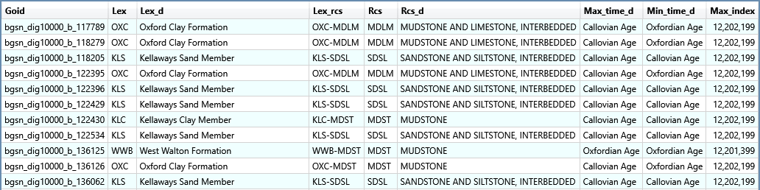
Figure 2: Example of 1:10000 scale geology data downloaded from EDINA digimaps.
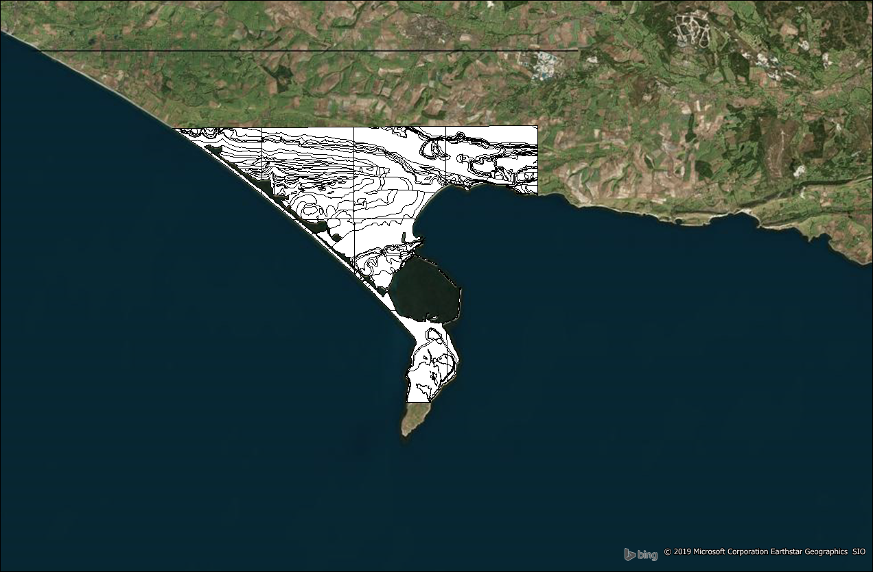
Figure 3: Geology data uploaded to MapInfo Pro with Bing aerial map as a base layer.
At present all of the geological data is appearing as white on the thematic map, meaning it is uncertain as to what each formation is. There is the option to ‘Add Theme’ that can be found under the Map tab within MapInfo. Clicking this enables you to create the thematic map; there are a large variety of formations present (qualitative data) within each grid square, so under step 1 the option ‘Region IndValue Qualitative Pastel’ was chosen as the best option of displaying these.
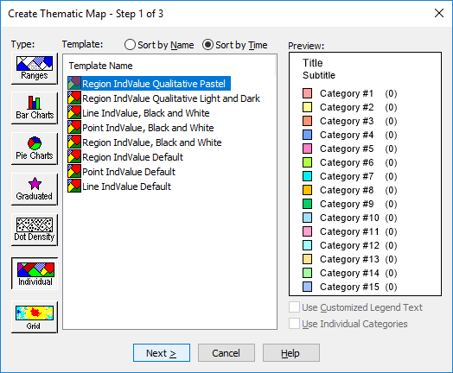
Figure 4: Creating a Thematic Map - Choosing template.
Step 2 ensures the correct selection of data to ensure the thematic map is precise, one of 1:10000 scale geology grid is selected as the table option and ‘Lex_d’ is always to be used as the column, displaying the lexicon of named rock units within each selected table/grid square.
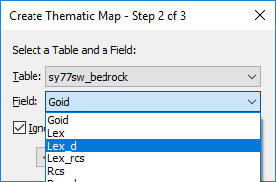
Figure 5: Creating a Thematic Map - Choosing data source.
After this in Step 3 of 3, selecting ‘OK’ is done to confirm prior selection of the theme and selected data sources. This process must be repeated for every 1:10000 scale geology grid that is downloaded and is somewhat timely.
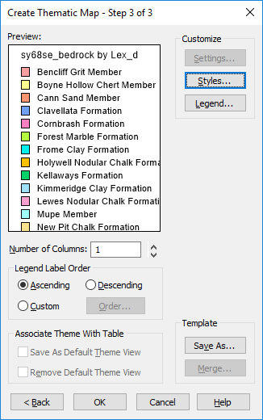
Figure 6: Creating a Thematic Map - Confirming selections
After the process was repeated for all tables/grid squares, it was evident there were several discrepancies to adress in the form of the theme colours. The theme colours were not consistant across all grid squares, displaying the same formation as multiple colours (Figure 7) or even multiple formations as the same colour. This process also created multiple legends, with the same formations mentioned multliple times across multiple legends.
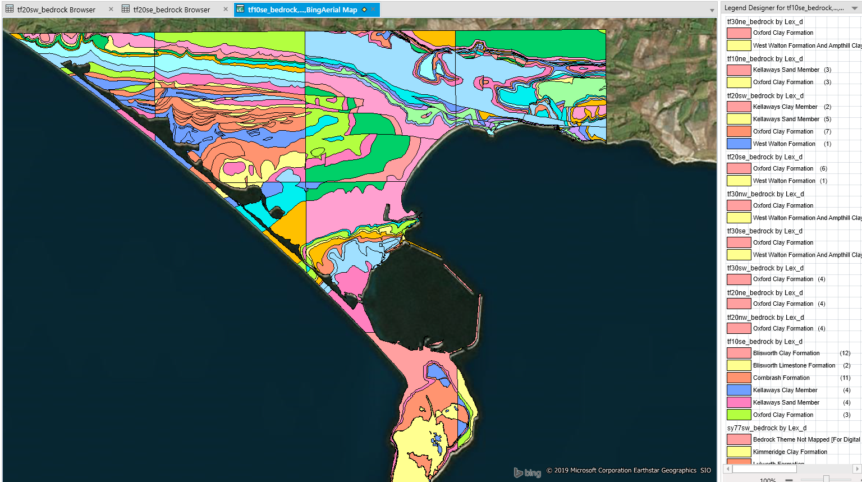
Figure 7: Issues with creating a thematic map using 1:10000 geology data.
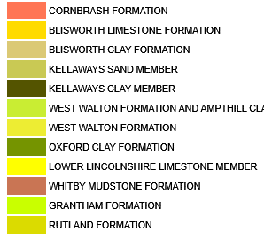
As an alternate option, the geology data was redownloaded from Edina Digi Maps for all of the study sites and their surrounding areas, however it was downloaded at 1:50000. The same as previously, the data was downloaded as a Shapefile and uploaded directly to MapInfo, though this time the colour of each formation was already displayed and the same across each area.
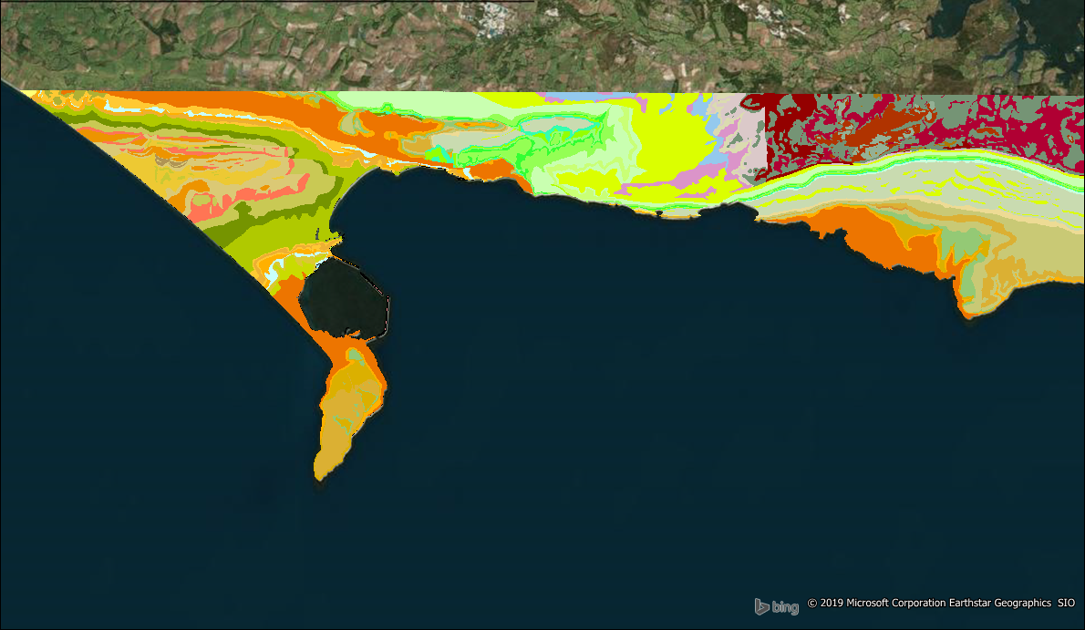
Figure 8: Using 1:50000 geology data – Weymouth, Dorset.
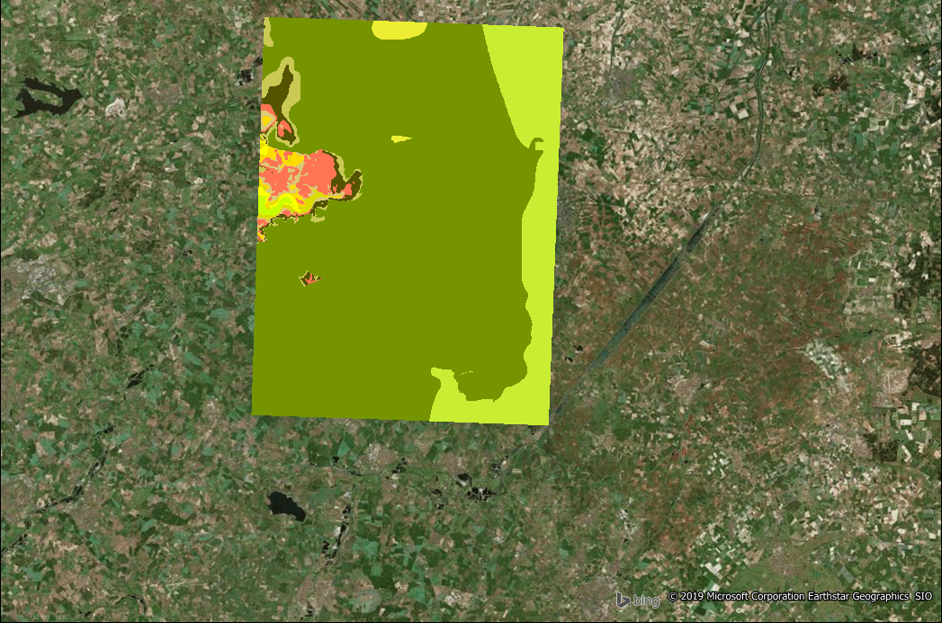
This is substanially better than the previous option and considerably quicker in regard to time constraints, though not all of the data is relevant; Figure 8 shows that the downloaded geology data extends far into east Dorset, despite the olive green Oxford Clay Formation to the east being the only area of concern. However, upon invesigation the geological map tells us very limited information about the nature of the sites (other than their geology) as it is just a continous series of block colours; satalite imagery is deemed as the most suitable way of displaying data, and may give greater insights for further anaysis.
Figure 9: Using 1:50000 geology data - Cambridgeshire sites.
In regard to geological maps, a legend is essential for our understanding of the map (Figure 9). Under the map heading there is the option to ‘Create Legend’. After selecting this option, the layers on the map are to be selected (Figure 10) and added to the legend frames. After selecting next, it will take you to ‘Legend Default Properties’, this can be bypassed by selecting next again.
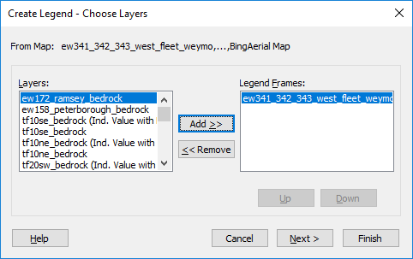
Figure 10: Creating a Legend - choosing layers.
When faced with ‘Frame Properties’, ‘LEX_D’ is selected as the lable style, assigning each named lexicon of rock units a colour theme in the legend as seen in Figure 11.
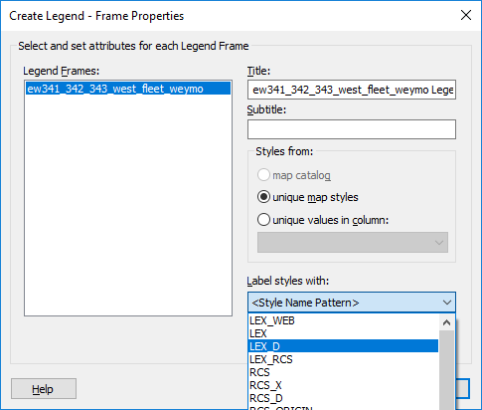
Figure 11: Creating a Legend - Frame Properties.

5.1 Plotting Data Points
Gathered data was uploaded directly from the GPS to ‘Microsoft Excel’ via USB. Files saved as an ‘Microsoft Excel 97-2003 Worksheet’ can be opened up directly in MapInfo Pro as a table.
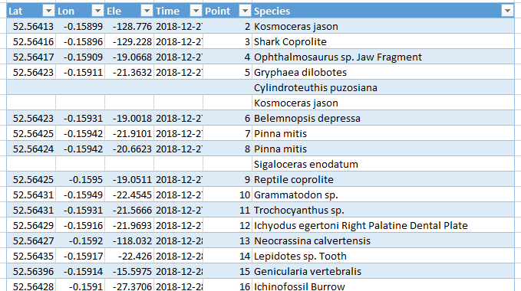
Figure 12: Data used to create points.
Under the ‘Spatial’ tab in MapInfo there is the option to ‘Create Points’. Selecting this option allows for data to be selected from the correct table – ‘dec27_kd’, latitude and longitude are the X & Y coordinates. It is essential to have the projection as the British National Grid, though this is automatic. This will be created as table.
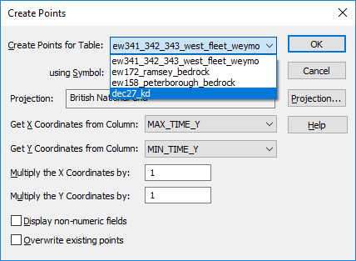
Figure 13: Creating points.
After creating the points, the locations of each of the recorded fossils could be added as a layer by adding the table to the map (Figure 14).
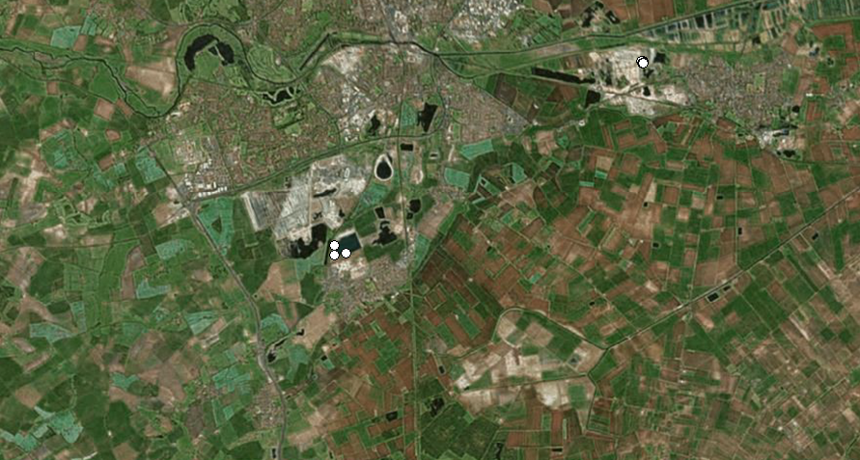
Figure 14: Plotted data after creating data points - Cambridgeshire sites.
Fossil locations are marked on the map as a blank symbol. Symbols may be altered by selecting the symbol within the ‘Map’ column and conducting a ‘Style Override’, preforming this presents you with Figure 18. This allows you to alter all aspects of the symbol so that data can be shown clearly; a gold star has been chosen as it has a high contrast against the relatively dark satellite imagery.

5.2 Distribution
GIS has been used to in this instance to better visualise the distribution of the fossils recorded for greater analysis.
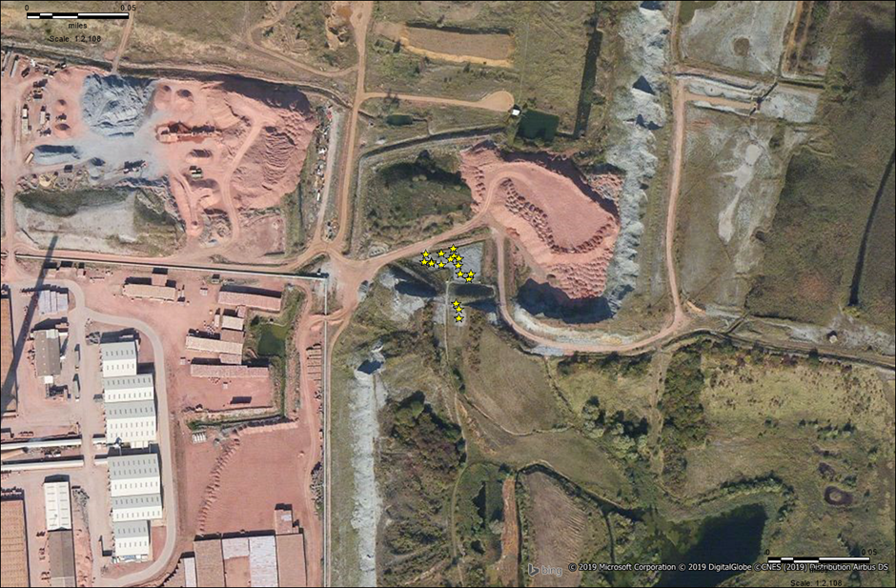
Figure 15: Distribution of fossils at Kings Dyke Nature Reserve - Whittlesey, Cambridgeshire.
The distribution of recorded fossils at Kings Dyke and Tidmoor Point is relatively densely packed. Using the ruler tool on MapInfo to measure the distance between finds has shown that the smallest distance between fossils at Kings Dyke is approximately 0.3 meters and 4.6 meters at Tidmoor Point – 175% greater.
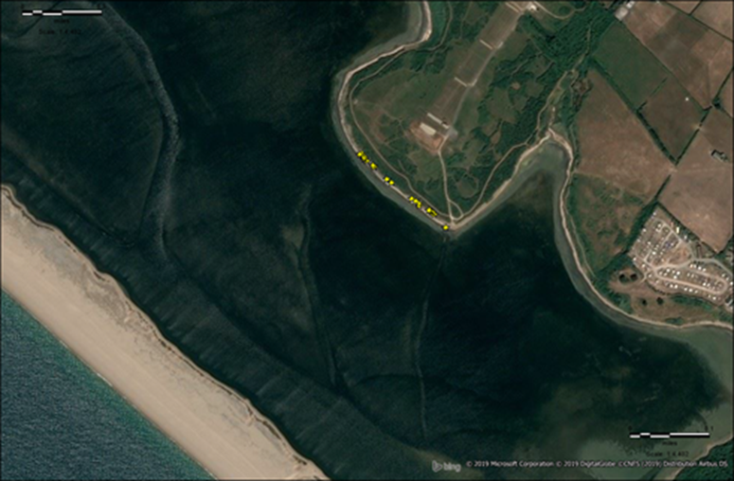
Figure 16: Distribution of fossils at Tidmoor Point, The Fleet - Weymouth, Dorset.
The distribution of recorded fossils at Yaxely pit is sporadic, with an approximate distance of 360m meters between each of the fossils. All of the fossils were recorded directly around the rim of the now water filled pit, this is presumably due to the time of year the study was undertaken; as previously stated within the location descriptions, this locality is better suited to summer or periods of limited precipitation when the high water levels drop and the fossiliferous layers of clay are exposed – GIS analysis shows water levels are significantly higher (as marked by fossil locations) than the aerial map portraits.
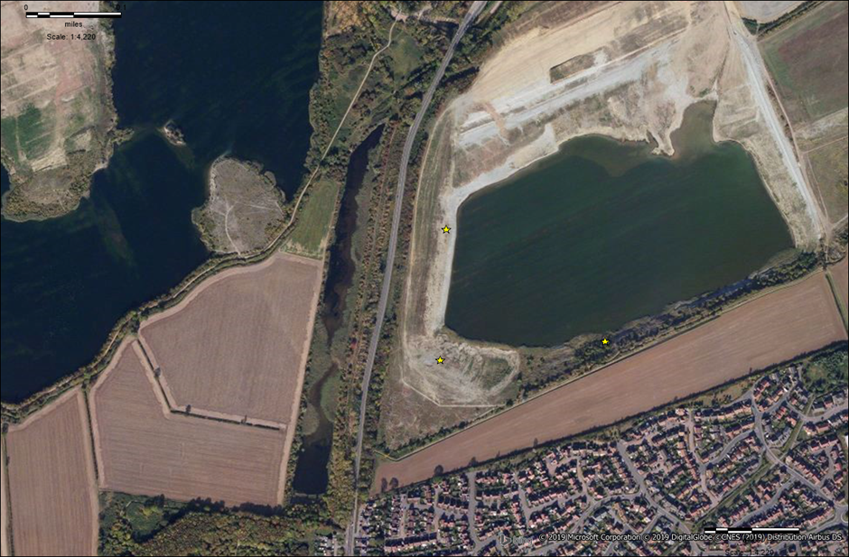
Figure 17: Distribution of fossils at Yaxely pit - Yaxely, Cambridgeshire.

5.3 Quality
Within the Spatial tab there is the option to preform an ‘SQL Select’, this tool uses existing information found within table uploaded to MapInfo to derive new information (Daniel, et al., 2001). Within the SQL Select, just 3 of the parameters are needed - ‘from Tables’, ‘Select Columns’ and ‘where Condition’ – this allows for querying of the data by filtering the conditions. For this study, the data was derived from the table ‘dec27_kd’, with the column of interest being quality. The query seen in Figure is to find all recorded fossils with a quality of 5 - “very-high”. By selecting ‘OK’, the query can be processed and produced into a table, this table may be added as a layer to the current workspace using the Explorers column.
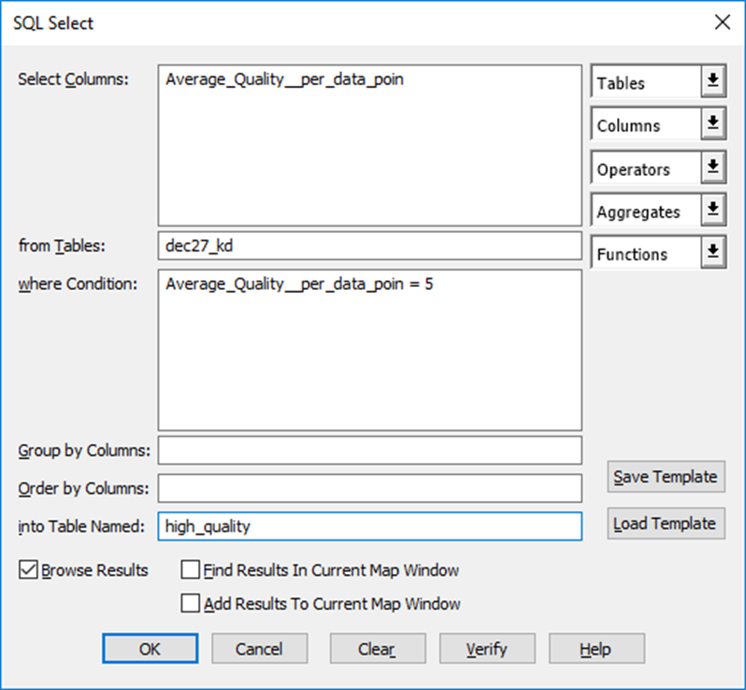
Figure 18: SQL select.
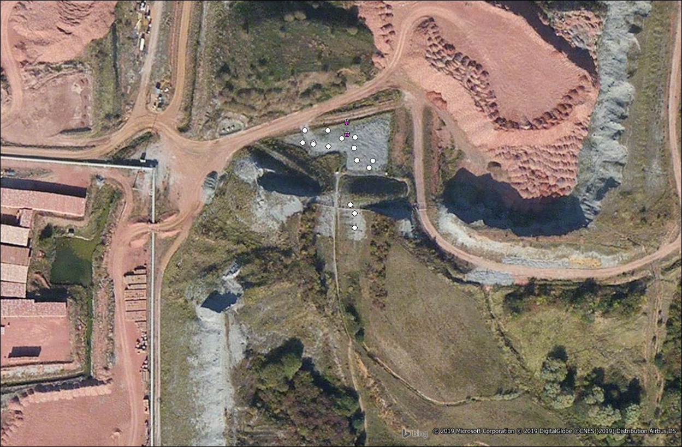
Figure 19: Fossils with a 'very high' quality (5) as marked by a size 14 font purple star - Kings Dyke Nature Reserve.
The average quality is akin to one another across all sites, at a moderate quality (2.01-3). However, this query has found just two fossils to be of a ‘very-high’ quality, both are from the Kings Dyke site and were vertebrate remains (Ischyodus egertoni & Lepidotes sp.); The Lower Oxford Clay of the Peterborough Member is famed for its well-preserved vertebrate remains (Martill & Hudson, 1991; Andrews, 1910). Vertebrate remains across both Cambridgeshire sites were typically considered well preserved with bone textures still visible, though the majority were isolated fragments, thus considered to be of low quality. As the sediments at both sites are undifferentiated (ex-situ) (Natural England, 2012), the vertebrate material is likely to have come from basal Lower Oxford Clay (beds 1-13) and have been brought to the surface by prior economic activity - damaged in the process (Hudson & Martill, 1994; Martill, 1986; Martill & Hudson, 1991)
The quality of the recorded fossils from Tidmoor Point is typically affected as a result of pyrite (FeS₂). Sulphate naturally occurs in water found in the ocean/sea, though when buried by reducing muds on the sea floor it is reduced to sulphide by micro-organisms such as bacteria. The sulphides combine with iron to form pyrite (FeS₂) (Martill & Hudson, 1991; U.S. EPA, 2016); fossils at this site are primarily preserved as pyritic internal moulds (Duff, 1978). When fossil preserved in pyrite are exposed to air and water (such as the conditions at Tidmoor Point), the pyrite beings to react, oxidising and decaying, this signified by the ‘rust’ colouration. Pyritic decay of fossils may be prevented or cured, though it is a costly process and requires a high level of chemical expertise (Larkin, 2011).
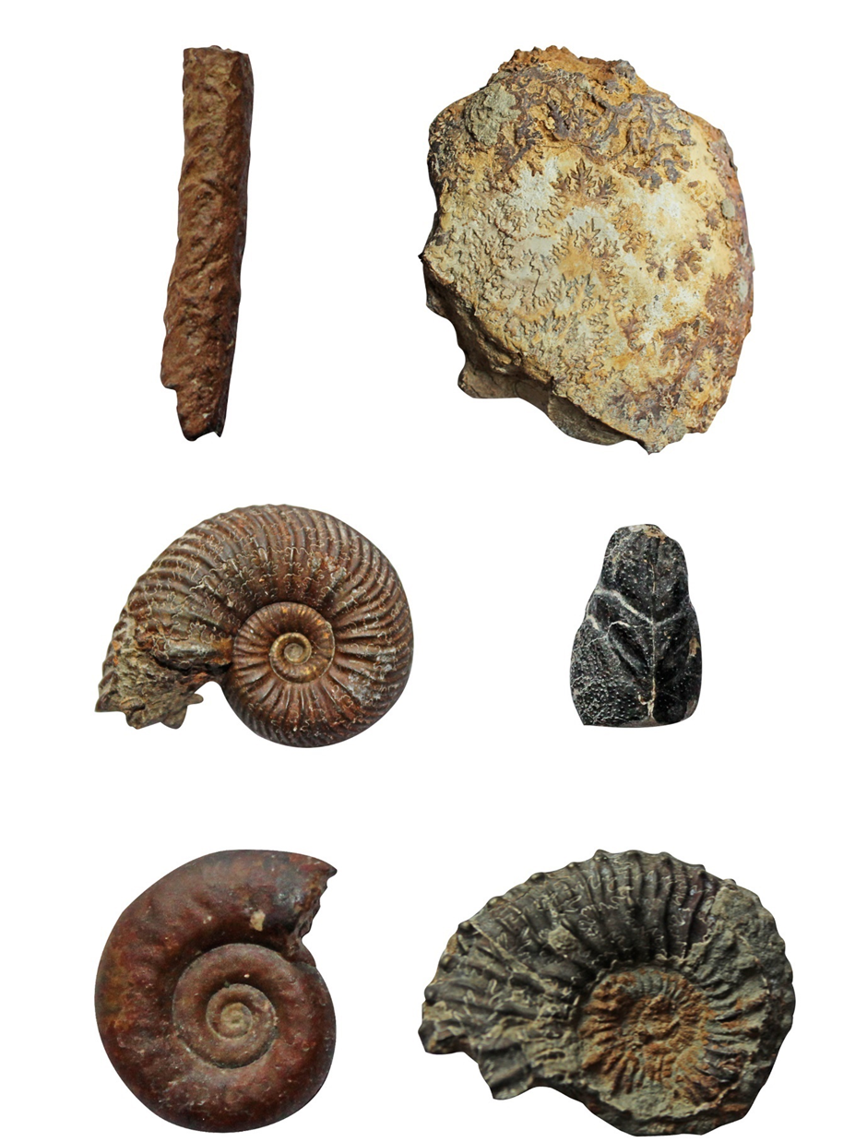
E F
C D
A B
Figure 20: Example of fossils recorded during surveying: Fossils from the Stewartby Member (middle/upper) of the Oxford Clay at Tidmoor Point, The Fleet – Weymouth, Dorset. Fossils are not to scale, nor are they all figuratively represented. Serpula sulcata ichinofossil (A); Section of a large Hecticoceratid ammonite (B); Quenstedtoceras lamberti IJ.Sowerby) (C); ?Eryma crustacean carapace (D); Hecticoceras (Putealiceras) bonarelli de Loriol (E); Kosmoceras spinosum (J. de C. Sowerby) (F).

6.0 Conclusion
In an ever growing need to conserve the environment, Geographical Information Systems can play a vital role within management and analysis of conservation aspects of the environment, such as its usage within the proposed Palaeontological Value Index. The process of creating a map has shown to be beneficial in analysing the distribution of fossils found during surveying. Discrepancies within secondary data such the lack of colour on the downloaded geology data mean that producing a map has been somewhat trail-and-error based, with the most information delineated from aerial maps. Though environmental works do not often have the ability to develop software, future research could see further interlinked usage of GIS and PVI, with potential for the development of new software.

References
Andrews, C. W., 1910. A Descriptive Catalogue of the Marine Reptiles of the Oxford Clay Part 1. 1st ed. London: The British Museum (Natural History) .
Arkell, W., 1947. Geology of the Country Around Weymouth, Swanage, Corfe and Lulworth. London: Her Majesty's Stationary Office .
Brown, E., Evans, D.H., Larwood, J.G., Prosser, C.D. & Townley, H.C., 2018. Geoconservation and geoscience in England: a mutually beneficial relationship. Proceedings of the Geologists' Association , Volume 129, pp. 492-504.
Burek, C. & Prosser, C., 2008. The History of Geoconservation: an Introduction. In: C. Burek & C. Prosser, eds. The History of Geoconservation . London : The Geological Society of London, Special Publications, pp. 1-5.
Cox, B., Hudson, J. & Martill, D., 1992. Lithostratigraphic nomenclature of the Oxford Clay (Jurassic).. Proceedings of the Geologists' Association, Volume 103, pp. 343-345.
Cox, B. & Sumbler, M., 2002. British Middle Jurassic Stratigraphy, Geological Conservation Review Series, No. 26. Peterborough : Joint Nature Conservation Committee.
Daniel, L., Loree, P. & Whitener, A., 2001. Inside MapInfo Professional. 3rd ed. New York: Onword Press.
Dempsey, C., 2013. Attribute Data Types for GIS. [Online]
Available at: https://www.gislounge.com/attribute-data-types-gis/
[Accessed 29 January 2019].
Duff, K., 1978. Bivalvia from the English Lower Oxford Clay (Middle Jurassic). London: Palaeontographical Society Monographs.
Duff, K., 1991. The Dogsthorpe Pliosaur. Peterborough : Peterborough City Museum & Art Gallery Publications .
EDINA Digimaps, 2019. Geology Data Download. [Online]
Available at: https://digimap.edina.ac.uk/roam/download/geology
[Accessed 11 Jaurary 2019].
Gentilli, J., 1997. The use of thematic maps to aid research. Cartography , 26(1), pp. 41-56.
Hudson, J. & Martill, D., 1994. The Peterborough Member (Callovian, Middle Jurassic) of the Oxford Clay Formation at Peterborough, UK. Journal of the Geological Society , Volume 151, pp. 113-124.
Jurassic Coast Trust, 2019. Where is the Jurassic Coast?. [Online]
Available at: https://jurassiccoast.org/about/world-heritage/where-is-the-jurassic-coast/
[Accessed 16 April 2019].
Kings Dyke Nature Reserve , 2012. RIGS viewing board-welcome notice. [Online]
Available at: https://www.kingsdykenaturereserve.com/wp-content/uploads/2012/11/RIGS-viewing-board-Welcome-notice-2012.pdf
[Accessed 11 April 2019].
Kings Dyke Nature Reserve , 2019. Kings Dyke Nature Reserve. [Online]
Available at: https://www.kingsdykenaturereserve.com/
[Accessed 11 April 2019].
Larkin, N., 2011. Pyrite Decay: cause and effect, prevention and cure.. NatSCA News, Volume 21, pp. 35-43.
Larsen, L., 1999. GIS in environmental monitoring and assessment. In: Geographical Information Systems 2. s.l.:s.n., pp. 999-1007.
Lomax, D. & Tamura, N., 2014. The Oxford Clay Formation (Middle Callovian to Early Oxfordian). In: Dinosauts of the British Isles. Manchester: Siri Scientific Press, pp. 184-204.
Longley, P., Goodchild, M., Maguire, D. & Rhind, D., 2011. Geographic Infomation Systems & Science. 3rd ed. Hoboken : Hohn Wiley & Sons .
Martill, D., 1985. Studies on the Vertebrate Palaeontology of the Oxford Clay (Jurassic) of England, Leicester : PhD thesis submitted to: University of Leicester .
Martill, D., 1986. The stratigraphic distribution and preservation of fossil vertebrates in the Oxford Clay of England. Mercian Geologist , 10(3), pp. 161-186.
Martill, D. & Hudson, J. eds., 1991. Fossils of the Oxford Clay. In: Palaeontological Association Field Guide to Fossils 4: . London: The Palaeontological Association , pp. 1-286.
Martill, D. & Hudson, J., 1991. Fossils of the Oxford Clay. London: The Palaeontological Association.
Natural England, 1986. Chesil & The Fleet SSSI. [Online]
Available at: https://designatedsites.naturalengland.org.uk/PDFsForWeb/Citation/1002654.pdf
[Accessed 04 12 2019].
Prosser, C., Brown, E., Larwood, J. & Bridgland, D., 2013. Geoconservation for science and society – an agenda for the future. Proceedings of the Geologists' Association , 124(2), pp. 561-567.
Prosser, C. & King, A., 1998. Regionally Important Geological and Geomorphological Sites: the origin and a forward view. In: P. Oliver, ed. Proceedings of the first UK RIGS conference. Worcester: Herefordshire and Worcestershire RIGS Group , pp. 1-8.
Quinn, J., 2019. Proposing Objective Means to Determine the Conservation Value of Palaeontological Sites - Palaeontological Value Index , Swansea : Undergraduate Disseration Submitted to University of Wales Trinity Saint David .
U.S. Environmental Protection Agency (U.S. EPA), 2016. What is acid mine drainage?. [Online]
Available at: http://www.sosbluewaters.org/epa-what-is-acid-mine-drainage%5B1%5D.pdf
[Accessed 6 March 2019].
UK Data Service , 2011. Boundary Data Selector - InFuse Regions. [Online]
Available at: https://borders.ukdataservice.ac.uk/bds.html
[Accessed 11 January 2019].
Waters, N., 1998. Geographic Information Systems. Encyclopedia of Library and Information Science, 63(1), pp. 98-125.
Waters, N., 2017. GIS history. In: D. Richardson, et al. eds. International Encyclopedia of Geography: People, the Earth, Environment and technology. Hoboken: John Wiley & Sons, pp. 2-12.
Worboys, M. & Duckham, M., 2004. GIS - A Computing Persepctive. 2nd ed. Boca Raton : CRC Press LLC.

