
5/9/2019
Academic and Employability skills
By Maya Velinova
Maya Velinova (1810400)
uNIVERSITY OF WALES TRINITY SAINT DAVID shao Yuen 09.05.2019
Table of Content

Introduction………………………………………………………………………………………………………………………………2
Mindset ……………………………………………………………………………………………………………………………………2
Personal Development Plane…………………………………………………………………………………………………….3
Employability skills…………………………………………………………………………………………………………………….3
Time management…………………………………………………………………………………………………………………….4
Academic skills………………………………………………………………………………………………………………………….5
Conclusion………………………………………………………………………………………………………………………………..6
References………………………………………………………………………………………………………………………………..7

Introduction
Academic and employability skills are adopted by students during the process of education. For a student to improve their writing and communication skills, as well as to be able to analyses articles and research, they will need to be equipped with the necessary academic knowledge. Employability skills can also be handy skills which are needed by an individual to make them eye catching to an employee. Some of the skills that a student must develop for a successful career and studying feature are: time management, personal development, self -motivations, writing skills etc. Our personal work experience will demonstrate what skills we have. Further, the associate and enhancement of those skills will enable students to gain valuable employability skills and benefit both the students and prospective employers. In this assignment there will be analysis of some of those skills.
Mindset
At first this appeared to be the right course to take, it is believed building more knowledge will settle the struggle, but when more information was provided, started to question if this was the right course to do. Procrastination was the way to avoid these difficulties in the beginning. It was a new challenge and involves a lot of effort. My personal experience will be explained using this learning cycle.

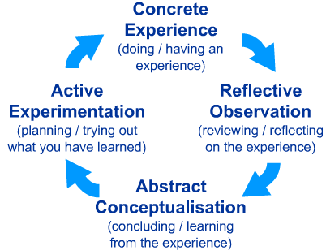
Figure: Kolb’s learning cycle (1984)
(Source: McLeod, S. A, 2017)

Learning that we can change our mindset was the first step for learning new skills and improving the ability to succeed in different areas of the life. Changing your mindset will help mounting, evolving and overcoming challenges. Learning new skills is a challenging experience but having the right mindset can help you reach your goals develop new skills and knowledge. According to Dweck (2017) there are two type of mindsets, fixed and growth. At the beginning of the course it was noticed that my mindset was fixed and realizing that there was an uncomfortable feeling when failure is an option, that would stop me to develop and improve new employability and academic skills. Deciding to view challenges as opportunities, knowing that the opportunity to try again is available even if failure is an option, trying different learning tactics and stretching myself are different methods that was used and helped bring me closer to my goals. The desire to mature and adopt new

knowledge and skills aided me to improve and grow my mindset. Thus, from this research we can conclude that changing your mindset is the first step for your personal development.

Personal development plane
Learning about and investing in the personal development plane was the step to identifying what can be achieved, and what skills are needed to develop to complete the course successfully and accrued new employability skills.
The plan can examine the skills that employers are looking for, or skills you need for a successful study at the university. Failing to develop negative consequences for your academic success will be if you fail to develop your learning skills, and failure to develop the skills you need in the workplace will have consequences for your career (Morgan, 2017)
Personal development plane helped to invest in myself, to overcome procrastination and increased my productivity and allow me to be more focused, and ambitious. Instead of waiting for something to naturally happen within time, putting effort in to achieve this goal quicker and live a more appreciative and rewarding life. The Personal development plane was the first step in helping to identify my weaknesses and strengths in the learning process, as well as the skills that can be improved.
According to Tracy (2017) It was realized that tracing your goals and adding them to your life can help you stop overloading yourself with things that is not important for you, and they are not worthy of your life. Locating specific goals to yourself and following them properly will decrease the workload and improve the quality of everything you do and life you live.
The skills that must to be develop in the future to be able to gain credibility in search of employment opportunity are time management, and academic writhing. This skill will help to overcome the struggle to gain new knowledge an develop new employability skills.
Employability skills
The willingness to learn new things and improve my personal development was the reason to start this course. The opportunity to improve the current skills to a high standard and improve new ones was driving me to continue. As an individual with a strong personality, and the wish to build a career in the management, my goals are to develop and improve the new professional skills and competencies. It is believed that to succeed in the business industry you need to improve yourself every day by gardening and reassuring for new information tactics and develop new skills.
Self -motivation is another skill that drives me to continue with education, to accomplish the task and gain my personal development. The self-motivation helped to look forward and not give up when the task became challenging.
Self -discipline can help individuals to succeed and achieve their goals in the long term and is the key skills that distinguish the followers and the leaders. Self- Discipline has been an important part of my educational

process and personal life and drive me to attend this course on a regular basis and helped to understand and apply what was learned during the course in the right way and overcome many problems and achieve success.
The ability to listen effectively helped to interact and communicate with other individuals openly and honestly. Paying attention, respecting people, motivating and reproach them benefits me to build strong personal and professional relationship. The good listening skills are important for the effectiveness of the learning process, on the other hand individuals who have this skill can be very resilient for any business and organization as well.
Time management
The ability to use your time in an industrious and operative way is a useful skill in any area of your life. Managing the amount of time, you spend on specific activities can increase your productivity and reduce the stress. According to Covey (1989) effective self-management is the capability to make decisions and to act in agreement to them. Prioritizing my time become very important, and necessary to develop and change bad habits and create new better habits. Prioritizing the important task will enable me to control my emotions, set my values and goals. When you are motivated, egotistic and disciplined you can accomplish your goals even if there are obstacles on your way to achieving them. I’ve learned how to priorities my time using this guardant.

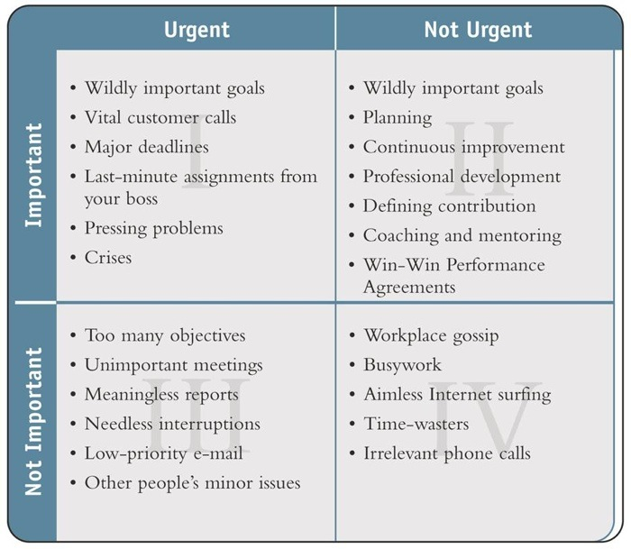

Picture of guardant Covey (1989)

The skill that requires you to be able to use your time effectively, plan and manage what you do is called time management, time is also something that can be managed or controlled. Furthermore, to improve the new skills that had been learnt in this course, and to overcome the difficulties, prioritizing my time was necessary. The time is equal for everybody, but the difference between successful and unsuccessful people is the understanding of time management, and the control you have over how and what you waste your time on. The daily habits, setting goals, prioritizing and planning are key parts of this process.
Procrastination is a popular phenomenon which necessitate negative results regarding performance and subjective well-being (Klinqsieck,2013) To avoid procrastination, setting clear and specific goals for myself and using that as a daily checklist has become a part of my daily lifestyle and routine.
The thought of being able to improve and develop time management skills seemed impossible at the beginning. The main obstacle in my way which lead to more stress was putting off a task which has a higher priority and procrastinated them in a favor of task that is not significant. Many individuals try to find the balance between their personal and professional life, but in many cases are ineffective as one overtakes the other. Understanding that we can achieve everything, but not in the same time is helpful in prioritizing the most important things in a personal and professional life.
In many cases you must make sacrifices to reach professional development. For example, spending a few hours with friends when you have an important project to finish or assignment deadline, can waste a lot of your time and can prevent you to finish the task on time .Spending hours on the phone for no particular reason can waste a lot of your time and can also decrease your productivity.
To help avoid procrastination you need to adapt to good habits of managing your time effectively, an example of a good habit is planning how to deal with the most difficult task first. The satisfaction from finishing that task first as you insisted on, will raise your self-esteem and productivity. Giving time on some activities sometimes is not enough, you can spend time, and still not make any progress, on the hand when we focus our energy better, can accomplish better results.
Multitasking is another way of wasting time, and can reduce productivity, and your energy. To prevent multitasking take a certain amount on time for just one task. Planning a day ahead and preparing the daily activities in advance is a useful skill for any student or individual with a busy life. Acquiring these skills will help to create quality life in any area of your life.
Academic skills
To improve and develop these skills, a positive and mental attitude needs to be persistent throughout the course and during your life. These skills involve lots of effort, research skills and decent time management skills. The academic writing is the skill that I struggle with the most in this course. Facing problems with the correct structure of the sentence, grammar paraphrasing and referencing created a feeling of insecurity and failure. According to Greasley (2016) the ability to learn from your mistake and getting advice from people with experience is the way to successful academic writing. Deciding to act through putting all my effort to develop this skill has motivated me to work harder, and even join writing classes. To improve these skills, you can adopt different learning methods and organizing skills.

Organized, sorting the lecture notes in folders helped to find them easy and prepare for the task on time. Reading different books and researching around the subject area to develop more knowledge, asking for help and feedback when it is required. Researching different information to improve the paraphrasing and how to apply the reference. Writing and rehearsal on daily basis to improve the grammar problems. Learning to write a good report is another advantage for the students. Good reporting can help the future employers, business or organization to identify problems and find other opportunities.
Conclusion
In conclusion we can say that developing and improving new skills can be difficult and long process. Mounting the academic skills can encourage students to become more efficient learners and improve or develop their current employability skill on acquired new ones. From the above discussion and with the help of the mentioned skills the performance of the students can be improved. This skill, which including time management, willingness to learn, planning, note-taking, are also exceedingly convenient, and therefore vital for succession any career.

References

Covey, S., 1989. 7 Habbits of Highly Effective People . New York: Simon & Shuster.
Dweck, D. C. S., 2017. Mindset. London: Robinson
Greasley, P., 2016. Doing Essays and Assignments (2nd edition). London: Sage
Klinqsieck, B.K., 2013.European Psychologist, 18, pp. 24-34
https://econtent.hogrefe.com/doi/abs/10.1027/1016-9040/a000138?journalCode=epp
McLeod, S. A. (2017, Oct 24). Kolb-learning style
https://www.simplypsychology.org/learning-kolb.html
Morgan, P., 2017. The Student's Quide to Study and Employability. London: Robinson
Tracy, B., 2017. Eat that frog. London: Yellow Kite

