SOFTWARE DEVELOPMENT

University of Walls Trinity Saint David
Cloud computing Level 4

Tsvetelina Tsoneva - Duz
Student ID 1914026

Lecturer : Mr Paul Jenkins

TABLE OF CONTENTS
1 INTRODUCTION 3
2 PART A – UNDERSTANDING 3
2.1 THE DIFFERENCE BETWEEN SETTING A VARIABLE TO A CONSTANT NUMBER AND USING THE KEYWORD CONST TO DEFINE A CONSTANT IN C#. 3
2.2 DATA TYPES AND WHY THEY ARE NECESSARY 5
2.3 DIFFERENT TYPES OF CONTROL STRUCTURES IN PROGRAMMING 6
3 PART B-INTERPRETATION 9
3.1 DESRIPTION OF HOW THE APPLICATION WORKS 9
3.2 HOW THE CODE FOR THIS APPLICATION HAS BEEN IMPLEMENTED. 10
4 PART C – IMPLEMENTATION 11
4.1 EXERCISE 1: A PROGRAM TO CALCULATE AVERAGE MARKS FOR A STUDENT ON A COURSE 11
4.2 EXERCISE 2: A PROGRAM TO ALLOW THE USER TO ENTER THE RADII TO CALCULATE THE SHADED AREA 13
4.3 EXERCISE 3: A PROGRAM TO ENTER A LIST OF NAMES OF PUPILS IN A CLASS AND THEIR CORRESPONDING MARKS FOR COURSEWORK AND EXAMINATION 15
5 CONCLUSION 18
6 REFERENCES 18

1. INTRODUCTION
Being an object oriented programming language, C# requires knowledge of such concepts as changing of variables to constants, different data types and control structures among others. This report will look at the difference that exists between use of the keyword const and the setting of a variable to a constant, different data types and their important in programming. The report will further look at the control structures that can be utilised in code execution control together with different forms of looping in C#. The report will also undertake interpretation of the given code in terms of workability with a stepwise guide on how the application can be used. In addition, it will provide a line by line explanation of the application’s code. The report also contains the code developed to solve different tasks together with the corresponding outputs.

2. PART A – UNDERSTANDING

2.1 THE DIFFERENCE BETWEEN SETTING A VARIABLE TO A CONSTANT NUMBER AND USING THE KEYWORD CONST TO DEFINE A CONSTANT IN C#.
Keyword const
In C# the keyword const is used in declaring constant fields as well as constant local. When declared, the value of the constant field will remain the same throughout the programme. Therefore, once a variable has been changed to constant using the keyword const it cannot be changed throughout the programmes. In C# the constant fields and locals are not regarded as variables, however, a constant is a number, a string, a Boolean or a null reference.
Example;
// C# program to illustrate the use of const keyword
using System;

class Windows10Pro
{

// Constant field
public const int price = 399;

// Main method
public static void Main()
{

// Display the value of Constant fields
Console.WriteLine("The price of Windows 10 Pro: {0}", price);
}
}
Output
The value of Windows 10 Pro: 399
In this code, the value of “price” will remain as 399 throughout with no possibility of changing it.
In C#, the keyword readonly can also be used to declare a variable into a constant. Through this keyword, a variable can be assigned only when declaring a variable or a constructor of the same class in which it is declared hence the variable declared does not remain the same throughout the whole code (..).
// C# program to illustrate the use of the readonly keyword
using System;

class PhonePrices
{

// readonly variables
public readonly int Samsung;
public readonly int Iphone;

// Values of the readonly variables are assigned using constructor
public PhonePrices( )
{

int Samsung = 199;
int Iphone = 599;
Console.WriteLine("Display value of Samsung S9 {0}, " +
"and iphone X {1}", Samsung, Iphone); //the code returns 199 and 599 as phone prices for Samsung and Iphone respectively

}

public PhonePrices(int v1, int v2)
{
}

// Main method
public static void Main()
{
PhonePrices Samsung = new PhonePrices(186, 596); // this code returns 186 and 596 as phone prices for Samsung and Iphone respectively

}
}

Output
Display value of Samsung S9 186, and iPhone X 596
Note that even though the readonly had been declared for the prices of phones, to 199 and 599 for Samsung S9 and iPhone X respectively, the output displayed 186 and 596 which are the new prices which has been changed.
The table below shows the comparison between use of keyword const and keyword readonly
Readonly keyword | Const keyword
Fields can be created using readonly keyword | Fields can be created using the keyword const
It is a runtime constant | It is a compile time constant
The values can be changed | The values remain same throughout the programme
Cannot be declared in the method | Can be declared in the method
Values can be assigned in declaration as well as constructor | Values can only be assigned in declaration
Allows use with static modifiers | Cannot be used with static modifiers

2.2 DATA TYPES AND WHY THEY ARE NECESSARY
A data type is a classification which specifies the type of value a variable has together with the type of mathematical logical operation that can be applied to it without resulting into an error. C# contains two major categories of built in data types, value types and reference types which are defined by keywords and classes respectively. Value types can be categorised as integral types which include bit, short, integer and long; non integral types which include single, double and decimal or float; character data types which hold char and string; boolean data types which holds true or false and nullable types (Clark, 2013).
Data types are important in C# because the language is strongly typed meaning all operations need to be type-checked by the compiler for compatibility of the data type. This means that illegal operations will not be compiles thus preventing errors and enhancing reliability of the programme. This is ensured through strong type checking where all variables, expressions and values have their specific data types (Schildt, 2010). For example, C# will not compile a wrong data type such as float 10; and double 2; since they are int data types.
As mentioned earlier, C# is a typed language and hence, the type of variable must match the value both in the compiler and in the runtime. As such, there is in most cases a need for conversion of one type of data into another type, for instance, converting a string data (10) into an int32 in order to perform an arithmetic operation (Asad and Ali, 2017). This conversion can be done in two ways, implicitly or explicitly.
Implicit conversion.
This type of conversion happens automatically by the compiler with not special casting syntax needed and also there is no data that is lost during this form of conversion.
Example;
int i = 10;
double d = i;
This will give an output; d = 10 indicating that there is no data lost during the process of conversion.
Explicit conversion
This conversion requires special casting or syntax and happens when data cannot be automatically converted into other data types. During the casting, data might be lost (Asad and Ali, 2017).
Example;
double d = 3.1417;
int i = (int)d;
The output will be i =3 showing how data has been lost through truncation of the decimal part of the 3.1417.

2.3 DIFFERENT TYPES OF CONTROL STRUCTURES IN PROGRAMMING
Control structures are responsible for controlling the flow of the programme through analysing and choosing which direction the programme should take based on the conditions specified. There are three types of control structures that can be used in programme control. These include sequential, selection or conditional and iteration flows.
Sequential flow
This type of flow follows a sequence which depends on a series of instructions that are given to the computer. The programme follows this instruction sequence until different instructions are given by invoking or calling other methods which makes the control to transfer to that method inside which statements are again executed through linear flow. Upon reaching the end of the method, control returns to the place in the calling segment from where the call was initiated (Doyel, 2016).
Selection/conditional flow
This is used for decision making allowing the programme statements to deviate from the sequential path and undertake different statements based on the value of an expression (Doyel, 2016). Conditional structures are of three kinds - single, double and nested.
Single alternative
If (condition) then:
[Module A]
[End of If structure]
Double alternative
If (Condition), then:
[Module A]
Else:
[Module B]
[End if structure
Nested
If (condition A), then:
[Module A]
Else if (condition B), then:
[Module B]
..
..
Else if (condition N), then:
[Module N]
[End If structure]

Iteration flow
This is also known as looping and it enables writing of instructions that can be repeated over and over. C# has rich looping structures which enable identification and blocking together of one or more statements to be repeated based on a predetermined condition. For C#, the looping uses while, do…while and for statements (Doyel, 2016).
WHILE STATEMENT
while (condition expression)
Statement;
The condition expression must return a Boolean result of true or false. The while statement is a pre-test loop meaning that the conditional expression is first tested before any other statement in the loop body. If the expression evaluates to false, the statement in the loop body is never performed. However, if evaluated to true, the statements are performed and then the control transfers back to the conditional expression which is re-evaluated and the cycle continues.
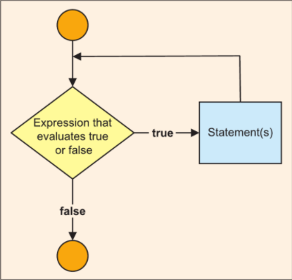
While loop (Doyel, 2016)
DO…WHILE STATEMENT
This is similar to while loop but instead checks the condition after each execution of its loop body hence referred to as post-test loop.
do
{
executable code;
} while (condition);
In this loop, the loop body is executed initially then the condition is checked and if it returns true, the loop is repeated over and over until it returns false and then ends. However, if the loop condition is constantly true, then the loop will never end (Nakov and Kolev, 2013).
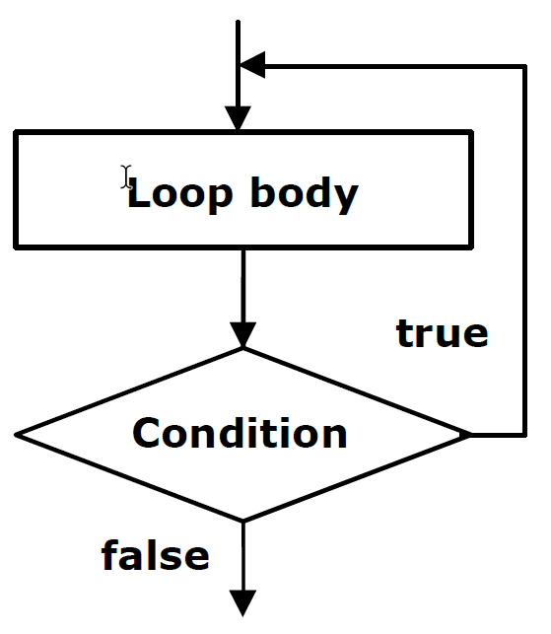
Do..while loop (Nakov and Kolev, 2013).

FOR LOOP
This is the most common loop in C# which is a basic structure as shown below
for (assignment; condition; increment/decrement)
{
statement block;
}
For example,
static void Main(string[] args)
{

for (int i = 1; i <= 10; i++)
{
{
if (i > 5)
{
break;
}
Console.WriteLine("The value of i is {0}" i);
}

}

3. PART B-INTERPRETATION
3.1 DESRIPTION OF HOW THE APPLICATION WORKS
The user is prompted to enter a value for the width of the window between 0.5 and 5. Upon entering the values and presses enter key, the program performs checks to ascertain if the values are within specified limits. If the width is not between the range the user is prompted to enter width again until the correct value within the range is entered due to the do while loop.

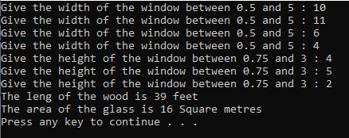

Flowchart :
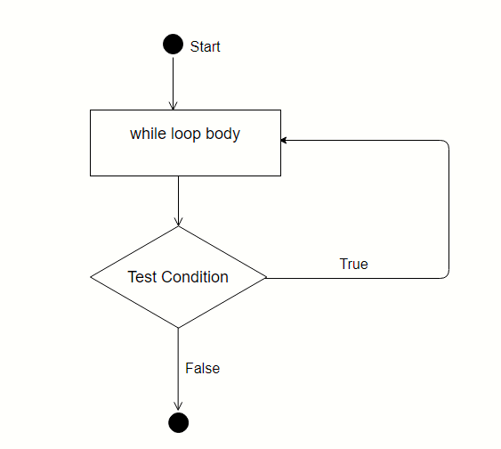

3.2 HOW THE CODE FOR THIS APPLICATION HAS BEEN IMPLEMENTED.
using System
This allows access to the classes defined in namespace which is an internal namespace of the System namespace
namespace
In C#, this is a logical collection of related classes bundled together in order not to allow same class names to be used in the programme thus preventing conflicts (Rasheed, 2006).
The curly braces {}
This shows where the code block starts and ends.
class
These contains data or fields together with the functions or methods that can be performed on this data in order to achieve a solution to a problem.
static void Main(string [] args) method.
This is the main entry point of the program., that is, C# starts its execution from the first line of this method and terminated when the Main method terminates. It is designated as static for it to be called by Common Language Runtime (CLR) without making any object of the code block. It is also declared as void since it does not return anything. Main is the standard name for the method while (string [] args) denotes the parameter list which can be passed to the main during programme execution from the command line (Rasheed, 2006).
Variable declaration and initialization.
This is where declaration of variables and assigning of values to some of these variables is done. The variables which already have assigned values have been declared through use of const keyword hence cannot be changed during program execution.
Do while loop.
This loop starts by executing the code then evaluates the conditions given for true or false and if the condition is true the loop repeats execution sequentially until the condition evaluate to false then terminates.
6.Calculation.
woodLength = 2 * (width + height) * 3.25. Is a mathematical calculation containing multiplication and addition aimed at solving the programme problem.
Console.WriteLine().
This a function for outputting the results in the console before adding a line break at the end.

4. PART C – IMPLEMENTATION

4.1 EXERCISE 1: A PROGRAM TO CALCULATE AVERAGE MARKS FOR A STUDENT ON A COURSE

Code :
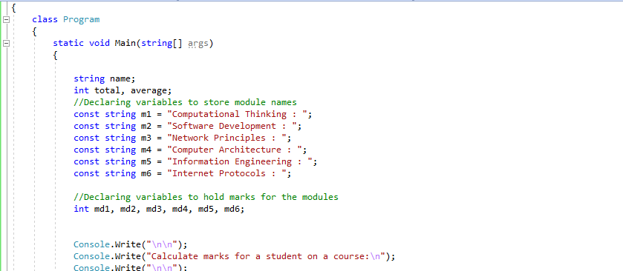
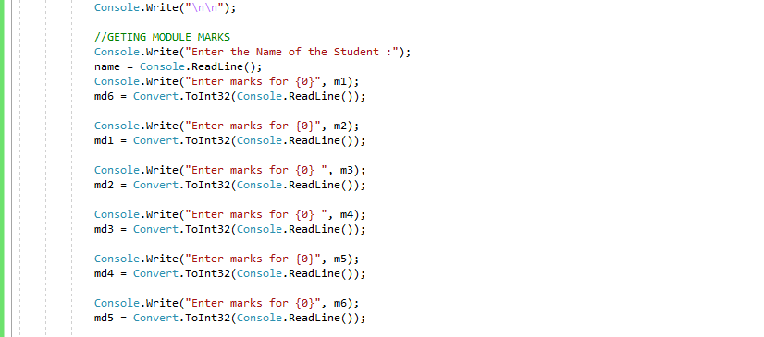
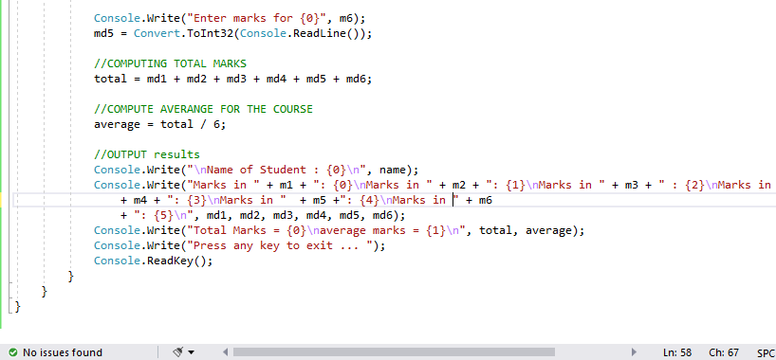
Output :
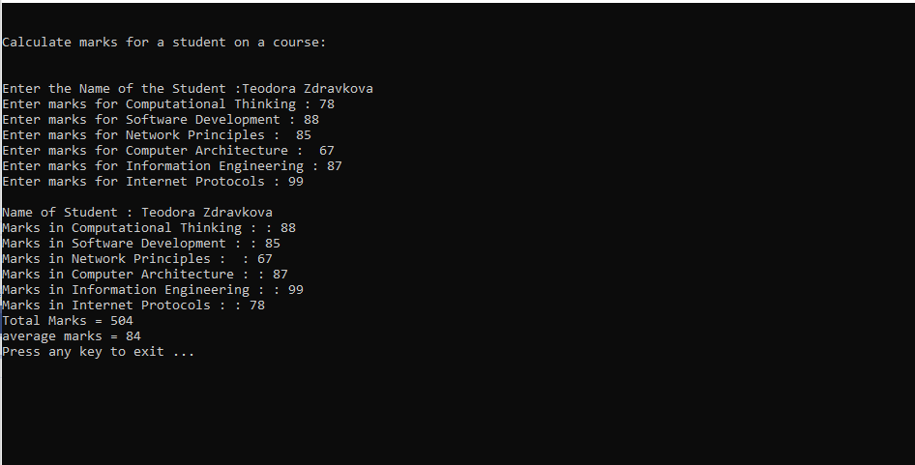

4.2 EXERCISE 2: A PROGRAM TO ALLOW THE USER TO ENTER THE RADIUS TO CALCULATE THE SHADED AREA

Code :
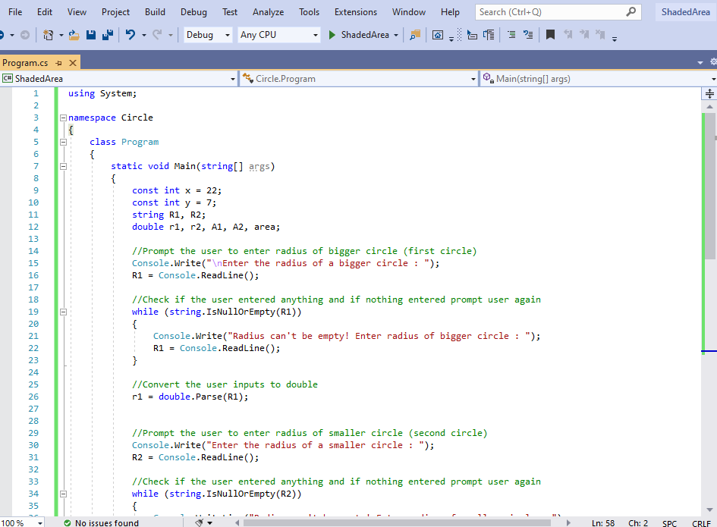
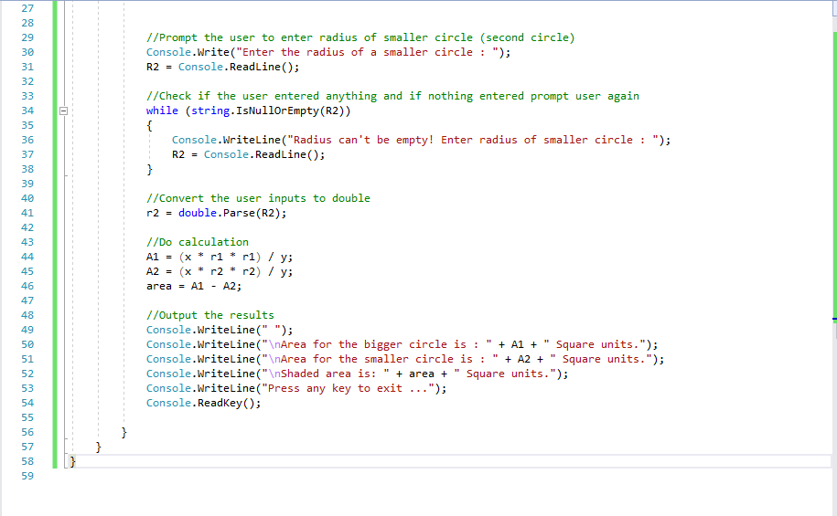
Output :
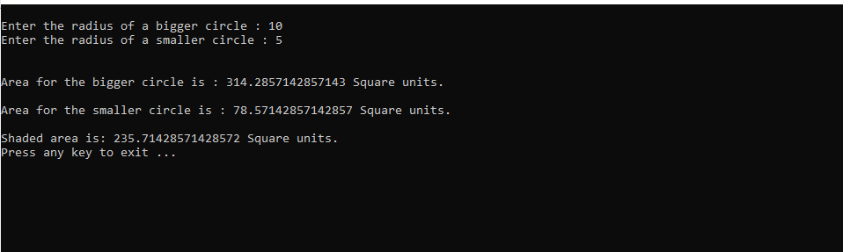

4.3 EXERCISE 3: A PROGRAM TO ENTER A LIST OF NAMES OF PUPILS IN A CLASS AND THEIR CORRESPONDING MARKS FOR COURSEWORK AND EXAMINATION

Code :
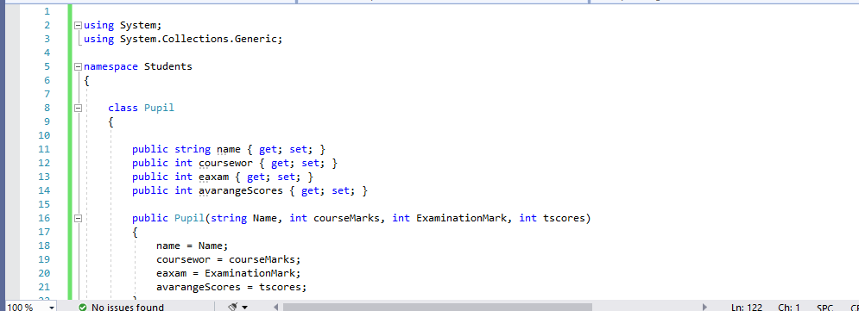
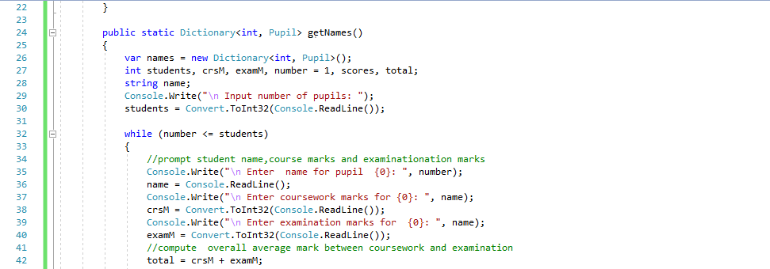
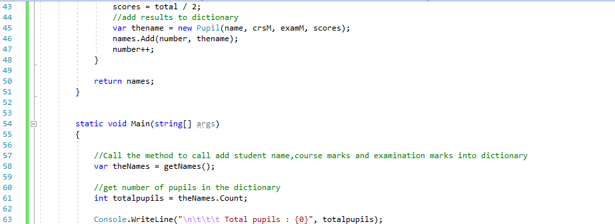
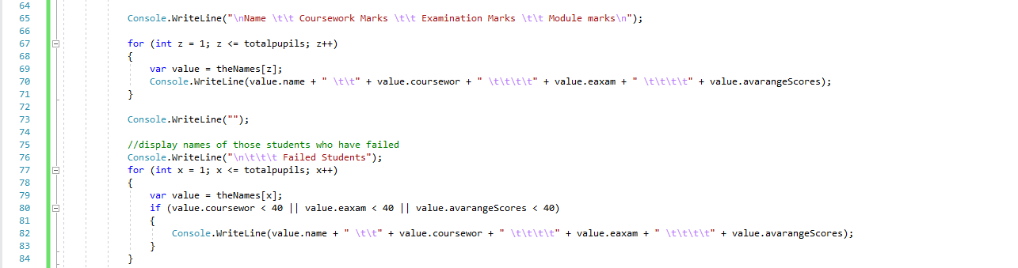
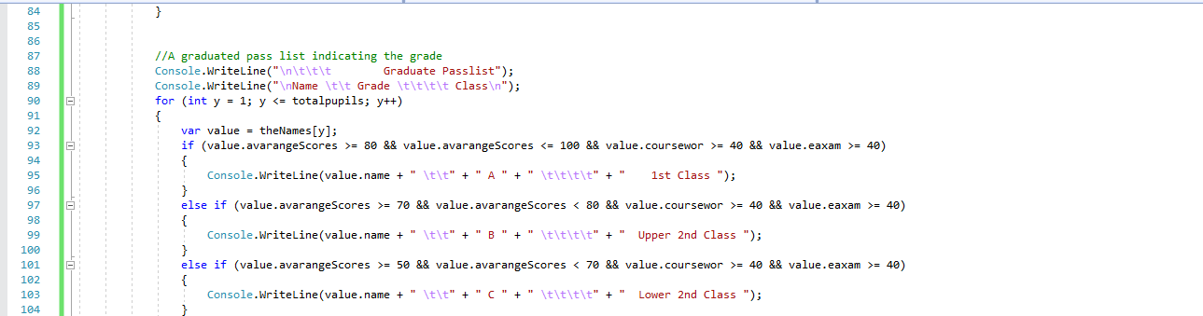
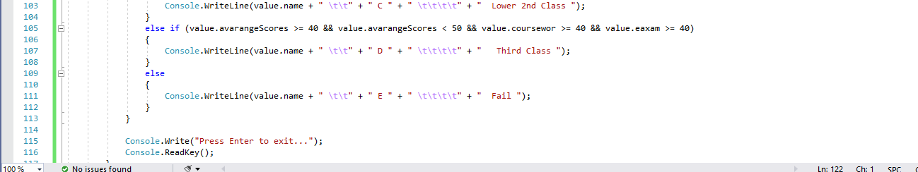

Output :
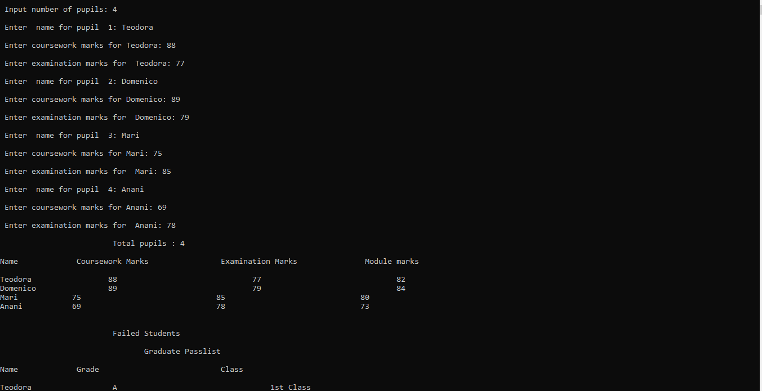


5. CONCLUSION
Programming is C# requires knowledge of basic concepts such as variables and constants and how to change variables into constants using keywords const and readonly together with different data types and how to convert from one data type to another. This plays an important role in ensuring that constants and variables can be used in a manner that will avoid errors in the programme. In addition, C# presents various control structures which need to be understood for one to be able to give required direction to the programme.

6. REFERENCES
Asad, A. and Ali, H. (2017). The C# Programmer’s Study Guide (MCSD): Exam: 70-483. Apress.
Clark, D. (2013). Beginning C# Object-Oriented Programming. New York: Springer Science.
Doyel, B. (2016). C# Programming: From Problem Analysis to Program Design, 5th ed. Boston, MA: Cengage Learning.
Nakov, S. and Kolev, V. (2013). Fundamentals of Computer Programming with C#. Faber Publishing.
Schildt, H. (2010). C# 4.0: the complete reference. New York: Tata McGraw-Hill Education.
Shaheed, F. (2006). Programmer’s Heaven. Fuengirola, Synchron Data S.L.

