

Health Industry Internships

(M5X00562)

Lecturer: Tania Davies
Student: Saba Rejaee (1705223)
Talking about my own employment goals, is hard for me because I did not work as an employment in nursing career in the UK, but this module gave me an opportunity to think about my nursing career goals. My employment career goals in nursing in future, depend on my personality and my situation. Some nurses aim to work in child nursing, while others want to work with adult. Some nurses prefer to do traveling nurse, and others may choose working on their way up at the local hospital.
Employment goals for nurses depend on what kind of nurses are. In the future, I will be a novice nurse that I am looking for a job, and it is the beginner of my way, while is going to be different for other nurses who has worked years and years in other types of nursing like:
- Registered nurse (RN)
- Licensed practical nurse (LPN)
- Travel nurse
- Nurse practitioner (NP)
- Intensive care unit (ICU) registered nurse
- Medical-surgical nurse
- Emergency room nurse
- Operating room (OR) nurse (Clement, 2018)

I want to be an adult nurse and work in local hospital in Swansea, (Castledine, 2009) mentioned: Nursing has traditionally provided compassionate services to patients and the nursing goal is to put the patient in to the best condition

Possible routes for this progression for me is that come out of my comfort zone, try to communicate with people that I don’t know and have more social relationship, do more research, and I have to ask for what I want.

Mentoring and coaching in Health- background and origin.

HISTORY DISCLOSURE website 2016 mentioned: Word ‘mentor’ comes from the ancient Greek language. The name is derived from a character found in Homer’s Odyssey named Mentor (in Greek ΜΕΝΤΩΡ). Meaning someone who teaches or gives help and advice to a less experienced and maybe younger person.
Mentor was the trusted friend of Odysseus. During the Trojan War, Mentor stayed behind in Ithaca to watch over the upbringing of Telemachus; the son of Odysseus. Mentor advised Telemachus with the objective of preparing him to take responsibility over family responsibilities during his father´s absence.
Telemachus received advice from the goddess of wisdom Athena unknowingly. Athena took the form of Mentor. These cases were when Tilemachus travelled to Pylos; during the killing of his mother’s suitors and lastly during the revolt of the supporters of Eupithis.
In 18th century author Fenelos used the term ‘mentor’ derived from the Odyssey to deal with the subject of education who should be both a guide and educator and mentoring a relationship between teacher and student.

Over the years, mentor developed in education system and also in recent years, the word ‘coach’ used in education field as well, and now mentoring and coaching both are using in schools and universities for performance, management and continuing professional development in education.

First of all in this report we going to know, who is a mentor? (Fagenson, 1989: Page: 312)
A mentor is a person in the position of power, comes to you to advise you and their educational achievements will be available for you to using as a better guide.
Also Seibert, 1999, Page: 493 defined mentor as a: Mentor is someone, who will provides you their technical or career advice, can coaching you, or give their information on an informal way to you.
Haggard et al (2010) are all agree that mentoring is a one to one relationship between a person who is more experienced and senior person (Mentor) and a new entrant or less experienced person (Person who learning). The Mentor need not be the supervisor or department head and not necessarily from the same department. A mentor can generally be defined as an influential individual in work environment who has advanced work experience and knowledge and who is committed to providing upward mobility and support to your career.

The royal college of nursing (RCN) 2015 said: the aim of mentor is to enable the RCN students to make better results of their practice for nurses and provide feedback for future work to support nursing education in the practice field and experiences.

Mentoring has many uses in health nurse education, such as: supporting the career development of minority groups, and encouraging the development of teams that are stuck in terms of their relationships or interventions with service users. (NHS EDUCATION FOR SCOTLAND, 2016)

Mentoring explained by Kinnell and Hughes (2010) as the transferring of knowledge, experiences, educations, skills and attitudes from health professionals to the students that they are working on this fields.

Chandan and Watts 2012, both are agree that there is no international definition of mentorship and the mentorship can be change with supervising, preceptoring or facilitating.

The nursing and Midwifery Council code of practice (NMC) (2008) said: that the registered nurse should share their skills and experiences to others and they have duty to improve students and others to develop their skills and improve their qualities.

History of mentoring in the UK and Wales:
In 1992 nurse training prefer joint with Higher Education Institutes rather than hospital based nursing schools. University affiliation and academic status were seen as strengthening the claim that nursing needed to become a ‘profession’ as well as a job. The new project 2000 curriculum had a common eighteen month foundation programme after which students would choose general nursing, children’s nursing mental health or learning disabilities training to complete their three years programme. In 1999 a commissioned report by Sir Leonard Peach entitled ‘Fitness for Practice’ had recommendations including a need to focus attention on the accountability and credibility of mentors’ decision making. (Mentor - NHS Wale)
The introduction of mentorship in Wales, started with mentors in the Common Foundation Programme (CFP) of Project 2000 (UKCC 1986) in Wales. It was commissioned by the Department of Health Research and Development Division on behalf of the Welsh Office Nursing Division.
(Nursing Standard, 1996)

Clip model: background and origin
Collaborative Learning in Practice (CLiP) model, is a coaching model, where students are encouraged to take the lead in their practice, caring for their own patient group and supporting the learning through identified daily learning outcomes. The student themselves are coached by registered staff with additional mentor support.
Learning in practice is very important part of all health professional education. It is through learning in practice that students develop many of the experiences, attitudes and values as well as the skills of person centred caring. The organisation of learning in practice found out on strong partnerships between health and care providers and Higher Education Institutions (HEIs) and, in the UK, with Health Education England and the professional regulatory bodies. From the of students experiences, each practice placement is designed to support learning and achievement at a particular point in the programme. All members of the practice area need to be aware not only of the significant increase in the number of students to be placed but also of the change in philosophy of learning. This is very important if the aim is also to influence, incorporate and embed coaching as a culture of the learning environment. Preparation involves ensuring all levels of the organisation are aware of the proposed changes as well as the multi-disciplinary teams working in the practice area. This practice preparation is part of the project plan.
(Lobo et al, 2014)
The CLiP model started to work in Amsterdam and was brought to the UK by Senior Lecturer Charlene Lobo, from the University of East Anglia (UEA). It has been running for three years now in Norfolk and Great Yarmouth Hospitals. Their pilot was a huge success and the project has now extended to most of their practice placements. Lord Willis, and members of the Royal College of Nursing and the Nursing and Midwifery Council have all visited these hospitals to see the project for themselves, and have advocated this as best practice to increase capacity, aid retention of students and enhance mentor, student satisfaction. (NHS Health Education England, 2015)

The aim of CLiP model is that the students from different years who can support and learn from each other, although they are supervised by a number of staff and be coached by any registered professional for the duration of the shift. (NHS Foundation Trust)
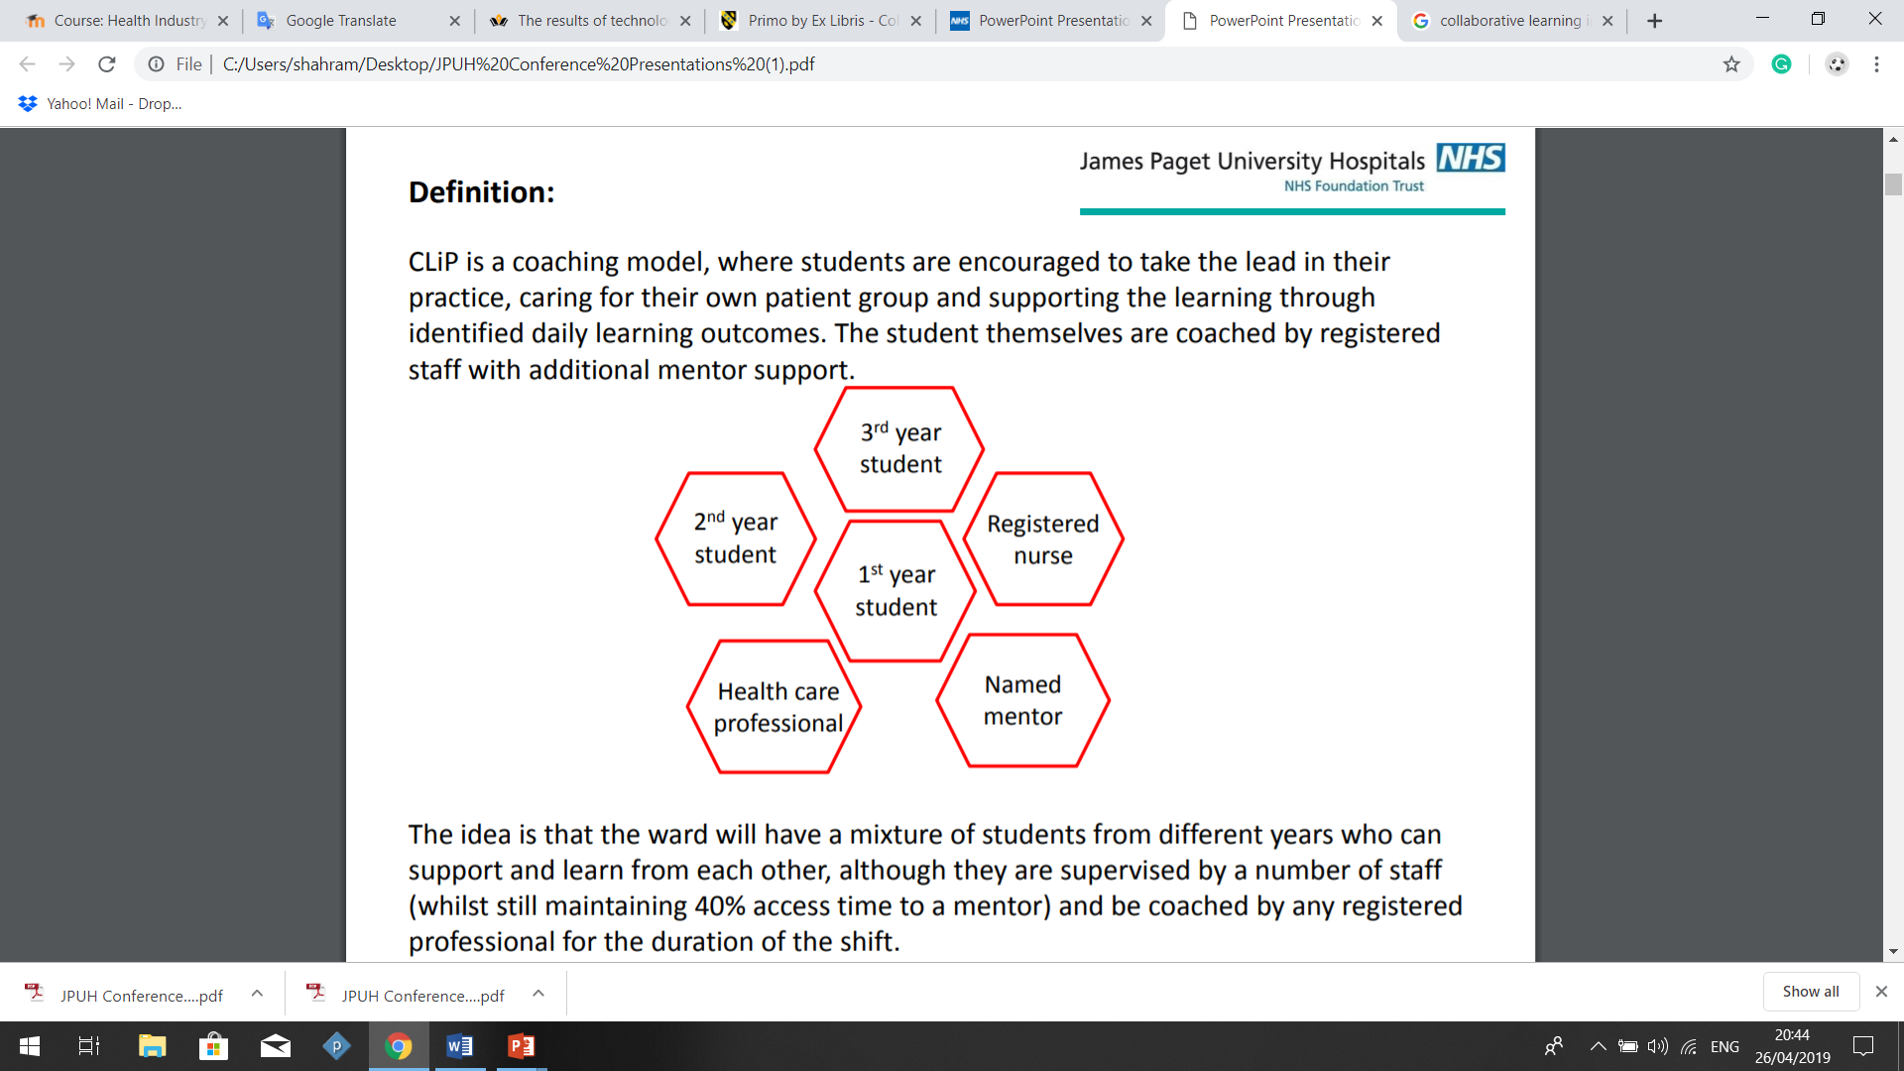

CLiP model has some aims, such as:
- Provide an enhanced and different placement experience for Mentors and
Students.
- To demonstrate how placement capacity could be increased.
- To promote a quality learning environment.
- To improve student placement satisfaction.
- Will support an important part towards the retention of students by helping to eliminate their concerns.
- To provide excellent care delivery to patients.
- To prepare you for continuing study in nursing.
- To bring awareness of new training before anyone else.
- To make you more attractive prospective student.
- To ensure you can rely on and provide support to peers.
- To help you become the best healthcare provider you can be.
- To increase mentor experience. (NHS Health Education England, 2015)

Clip model: research, successes, results and issues

In Abertawe Bro Morgannwg University Health Board (ABMU HB) in Wales, the practice education facilitator team has recently re-examined the role of CLiP model and developed this into a lead mentor role. Lead mentors as the fundamental building block for quality care, professional standards and the best possible health outcomes for patients. This requires strong nursing leadership at all levels and would also require practice-based education to have a vibrant presence at board level and be central to quality outcome measures.
CLiP model is circle of new way of nursing mentoring, doing coaching rather than traditional mentoring, will supporting coaches to support students and students to support studies within Nurse Training in Wales and England.
The CLiP model worked in NHS and worked successfully in the UK, did many projects to enable mentors to fulfil their role, did more on questioning and ‘stepping back’ to allow the student to step forward and become critical thinker.
Coaching provided by the whole team so released mentors to complete documentation in work time.
In practical terms, nursing students usually will facilitate all hygiene, nutritional and mobility assessment, document care activity and participate.

Collaborative Learning in Practice, had few disadvantages and difficulties included: preparing of implementing the project, lack of awareness, obtaining financial support for coaching sessions, needs more staff to develop needs, some students were anxious about the commencement of the project.

Cameron, Roxburgh, Taylor and Lauder (2011) all are agree that: In the UK, the National Student Survey (Higher Education Funding Council for England, results for nursing indicated that 86% of students ‘received appropriate supervision on Collaborative Learning in Practice, but there is still room for improvement and evidence indicates that placement dissatisfaction is an issue throughout the UK, such as: unmet expectations, difficulties with mentors, travel, and ill-defined support.

In the other hand, Collaborative Learning in Practice has some main positive effects such as: Capacity of using this model will be increased by 133%, the government suggests this will create 10,000 more student places with Health Education Institutions (HEIs) in England alone and provided a workforce for the future, placement providers will need to increase placement capacity an increased staff retention and preparation for registrant practice.

Clip model: Describe your own experience

For describing my own experience in mentoring, I used Johns' model for structured reflection which is based on five cue questions that will enable me to break down my experience and reflect on the process and outcomes.
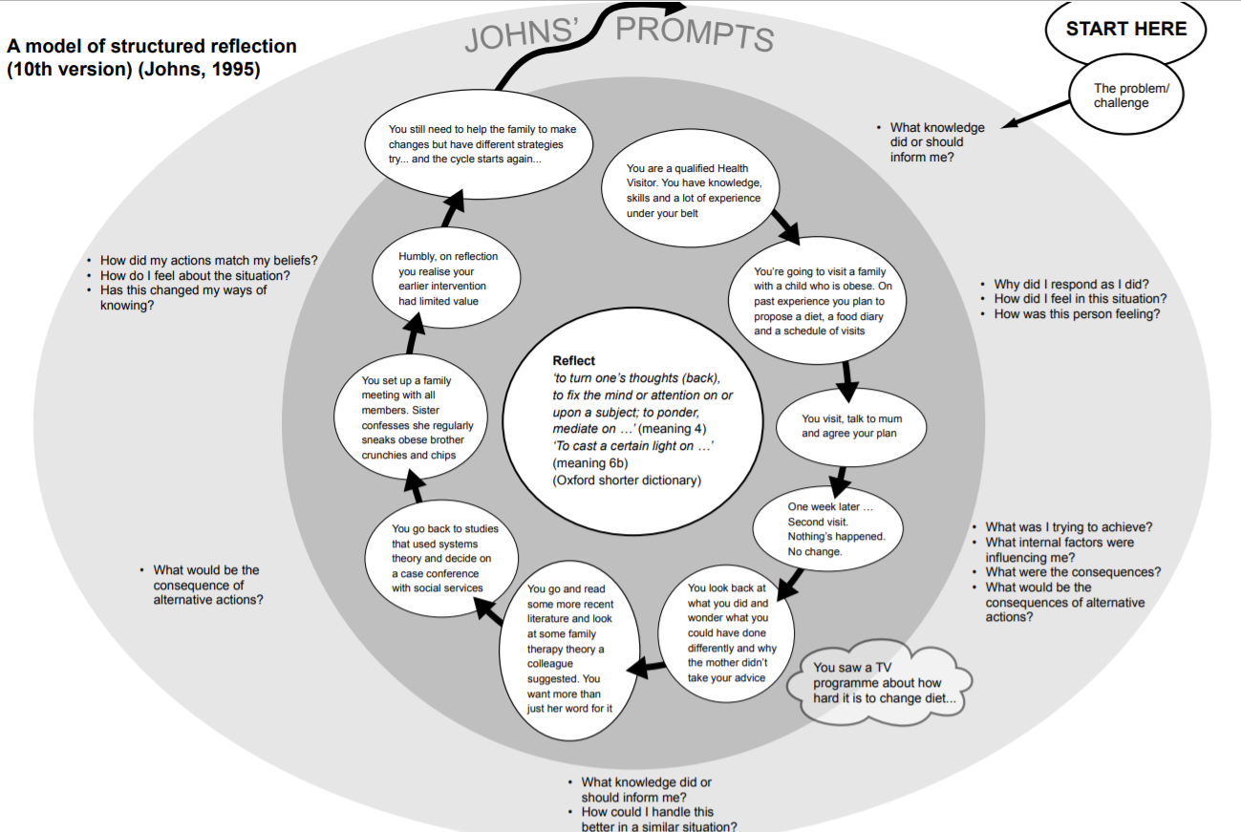
(Johns, 1995)
According to John’s reflection I have to ask myself: What knowledge did or should inform me?
First of all I have to say: I never heard about words ‘Mentoring’ and ‘Coaching’ in English Language, and did not know anything about it in Nursing education as the nursing system in the UK is pretty different with Nursing education in my back home country.
First time that I heard about it, was in Level 5 Nursing Placement, Health Industry Internships, Nursing Studies. In this module asked second year student nurses to mentor first year students and support them order to utilise and become familiar with this model.
Through doing this module, I have developed knowledge and critical awareness of mentorship in health care practice. I really encouraged to being confidence to look at my own experiences, and enabling me to support students with Collaborative Learning in Practice (CLiP) model and encouraged me to do research and learn about it and to know how does it work and what is the boundaries. I gain much valuable understanding of the mentoring and teaching. I now feel more organise into the futures practice. This will enable me to be mentor with more knowledge and confidence.
According to NMC (2008) guidelines, I understood that I can act as a role model to support learning in practice in order to fulfil my role as a mentor for students. Mentoring allowed me to learn a lot about my individual development as a mentor. It has also helped me out to achieve the ability to challenge, motivate and reflect.
Our lecturer explained: This will take the form of one to one matches, group meetings and or pastoral support and this practice will prepare you for peer to peer support within your nursing future and makes you a far more attractive prospective applicant, nurse and practitioner.
Second year students received their coaching list and started to do the work. I had four first year students to be their mentor and did not have any idea how does it work, then I started to read about it in CLiP Model reading which our lecturer put in our module, and some other useful journal articles.
And then I understood this practice will prepare me for continuing study in nursing, to bring awareness of new training, make me more attractive student, gave this confidence that I can rely on my knowledge and provide supports for first year students and will help me to become the best healthcare provider as I can.
Then I completed my research about: how can I be an effective mentee?
What kind of things can I offer to students?
I searched and found out a Mentoring Guidelines which was provided by Manchester University, provided by: (Watkin et al 2016-2017) it was very helpful to give me some tips about mentee’s skills, such as:
- Listening skills.
- Asking questions to help develop my understanding of their problems.
- Provide my information about my own experiences and advice on career development.
- And encouraging the students.

I completed my research and after that I decided to send them an email with my student email address (not personal email). In email I introduced myself and explained how the process will work and at the end I asked them to meet in the University of Wales Trinity Saint David’s library if the time that I offer them is convenient for them.
I was wait for a week and checked my email address regularly, but I did not receive any replying emails from the students. However on the meeting day, I went to the library and waited for students. I felt so much stress and uncomfortable because I did not have enough confidence and I thought how a second year student from another background can be a mentor for students who are probably native and they are from the UK. Before the meeting I repeated with myself that I am a qualified health student, I have knowledge, skills and a lot of experiences and I am going to visit first year students to talk about daily life educations and not more.
Then I felt more relax and comfortable to visit students. I was waiting for students half an hour, and unfortunately nobody come. They did not making contact, and it could be that they feel intimidated or worried.
I did not heard anything from students and I was concerned that the relationship is not continue.
On this situation I found out one of the big challenge about my mentoring is: not being able to engage students as my mentees.

I asked myself: How can I handle this problem in this situation? It was a poor communication that effects on professional relationships, negative experiences for me but negative mentoring experiences can have more effects than positive ones and I was worried that maybe same problem will happen in future.
Challenges faced with mentoring and the solutions, included:
- Failing meeting as Scheduled, which was not work for my mentoring plan and this will cause to quickly erode the foundation of mentoring relationship.
- Unrealistic Expectations: In this case mentor needs to set the goals.
- Overdependence on the Mentor: Mentor needs to remind themselves that the relationship is about the mentoring. (Management mentors, 2018)

Evaluate what lessons could NHS learn from Clip model experiences and ideas?

Willis, 2012 tried to argued to bringing closer partnerships between higher education and Collaborative Learning in Practice, to make sure that students who studding nursing, support during their placement learning and their educations and be able to receive the best preparation.
In 2015 the NMC announced plans to regulate staff with preparation programmes other than degrees, using the term ‘nursing associates’, and these roles would typically operate as a subsidiary to the ‘qualified nurses’ already on the NMC register.

The RCN (2016) and NMC (2017) both are agree that students who have supports and using Collaborative Learning in Practice model (CLiP), are broadly speaking, about their real life learning.
Implementing a Collaborative Learning in Practice (CLiP) model, is becoming increasingly popular in the UK, and somewhat dispenses with one-to-one mentors in favour of a ‘team’ approach. This allows nursing students to be facilitated or ‘coached’ by registered health care professionals incorporating peer and tiered mentoring where senior students coach junior students in a ward-based environment. (Lobo et al, 2014)
As I had negative experience in Collaborative Learning in Practice, but allows me to be facilitated and organised with health care professionals peer and tried to be a mentor. CLiP allows me to have greater input into my own learning in future through working with other students to help run their academic education.
Also CLiP model has been shown that students has improve in learning and placement, with positive benefits for mentors and patients. (Huggins, 2016)

There are other professions where coaching and mentoring works well in health, for example, CLiP model have previously been used successfully in medical training, and have been reported to provide a major contribution to junior doctors' development of their own personal and professional identity.

Irwin, Blissb and Poole (2018) said: If the CLiP model being more widely for nurse education, students may be able to enjoy a more holistic learning experience in NHS, accruing greater confidence from the additional control over their learning and also increasing their knowledge for working with patients.

There is evidence of the benefits of implementing CLiP and coaching models in practice; however, in order for the model to become successful and well-established, a sound research evidence-base will be required to evaluate and substantiate claims for improvements, and to inform wider national and international implementation. (Clarke et al, 2018).

Through my experience as a mentor in CLiP model, I believe that NHS, should include more skills for their mentors like: communication, motivation, decision making, try to encourage and engage students and conflict resolution. I believe my current skills are not enough in communication and motivation but in my role as a mentor in future, I will need to use more personal skills to engaging students to mentoring plan and influence other students to gain their goals. NHS can learn from my own experiences that some mentors and students may have strengths and weaknesses and requires a multidisciplinary team worker, to considering the organisational skill and resources. Team members need to have an understanding of what is expected of them, and to know how their individual contributions will be effective to the whole project.
NHS need to develop nursing education skills in applying quality care frameworks in practice to improve mentoring quality.

Recommendations
As my experience, if mentee fails to respond to communications with their mentor, and mentor is aware that they have not responded within a timeframe that offered, it is better to follow up with a polite email, professionally worded, perhaps asking if they got the mail and for a short response without the pressure of a full detailed response.
This will then allow the mentor to have a chance to offer brief feedback if they are busy with other priorities but not feeling they have to give a full response at this time. This should then help in opening up brief dialogue on extending a timeframe for communication or assessing if there needs to be a pause to proceedings.
If there is still no response then inform them that you will be contacting the lecturer.

Conclusion
In conclusion this assignment talked about my personal employment goals, and how helped me to do some useful research about CLiP model in mentoring and coaching. Tried to found out that there are many types of nursing job with different duties and role, such as: registered nurse, licensed practical nurse, travel nurse, nurse practitioner, intensive care unit, medical-surgical nurse, emergency room nurse and operating room nurse.

I explained my dream job and where I want to work in future. And I talked about what is the possible routes for me?
We discussed about Mentoring and coaching in Health, mentoring background and origin and found out where these words came from and how first time developed in education system in UK nursing education.

In this report we found out and did some research to know, who is a mentor? And found out the aim of mentor is to enable the RCN students to make better sense of their practice for nurses and provide feedback for future work to support nursing education in the practice setting and experiences.

As we discussed mentoring has many uses in health nurse education, included: will support the career development of minority groups, and encouraging the development of teams that have become stuck in terms of their relationships or interventions with service users.
The main point of this report was to break down the Collaborative Learning in Practice background and origin which is a coaching model, where students are encouraged to take the lead in their practice, caring for their own patient group and supporting the learning through identified daily learning outcomes. Then students themselves are coached by registered staff with additional mentor support and the aim of CLiP model is that the students from different years who can support and learn from each other, although they are supervised by a number of staff and be coached by any registered professional for the duration of the shift.

Johns' model for structured reflection used in this report and as we know had five main steps to follow, such as:
- Description of the experience
- Describe the experience and what were the significant factors?
- What was I trying to achieve and what are the consequences?
- How has this experience changed my ways of knowing.

At the end of report, evaluated the lessons that NHS can learn from this Clip model experiences and ideas, and we understood that NHS, must include more skills for their mentors to gain better results, such as: communication, motivation, decision making and conflict resolution. I knew that my current skills are not enough in communication with other students and needs to improve it and being more motivation.

References
- Cameron, J. Roxburgh, M. Taylor, J. Lauder, W. (2011). An integrative literature review of student retention in programmes of nursing and midwifery education: why do students stay? Volume20, Issue9‐10. Pages 1372-1382.

- Castledine, G. (2009). Oxford handbook of adult nursing. Publisher: Oxford University Press. [Accessed online to University of Wales Trinity Saint David library]

- Chandon, M. Watts, C. (2012). Mentoring and Preregistration Nurse Education. Available at: http://www.dphu.org/uploads/attachements/books/books_5513_0.pdf. [Accessed online 25th April 2019]

- Clarke, D. Williamson, G. Kane, A. (2018). Could students’ experiences of clinical placements be enhanced by implementing a Collaborative Learning in Practice (CliP) model?

- Clement, A. (2018). Different Types and Roles of Nurses. Available at: https://www.dropbox.com/home/Yahoo!%20Mail. [Accessed online 25th April 2019]

- Fagenson, E. A. (1989). The mentor advantage: Perceived career/job experiences of protégés versus non-protégés. Journal of Organizational Behavior, 10: (Pages: 312), 309-320.

- Haggard, D, L. Dougherty,T, W. Turban, D, B. Wilbanks, J, E. (2010). Who Is a Mentor? A Review of Evolving Definitions and Implications for Research. Volume: 37 issue: 1. (Pages: 280-304)

- HISTORY DISCLOSURE website. (2016). Available at: http://www.historydisclosure.com/word-mentor-originates-homer/. [Accessed online 25th April 2019]

- Huggins, D. (2016). Enhancing nursing students’ education by coaching mentors. 23 (1), 30–32.

- Irwin, C. Blissb, J. Poole, K. (2018). Does Preceptorship improve confidence and competence in Newly Qualified Nurses: a systematic literature review? Nurse Education Today. 60 (1), 35–46.

- Johns, C. (1995). About Johns’ model of structured reflection. Available at: https://www.brookes.ac.uk/students/upgrade/study-skills/reflective-writing-johns/. [Accessed online 28th April 2019]

- Kinnell, D. Hughes, P. (2010). Mentoring nursing and healthcare students. Vol. 34, Iss. 2. Published by SAGE Publications Ltd.

- Lobo, C. Arthur, A. Lattimer, A. (2014). Collaborative Learning in Practice (CLiP) for pre-registration nursing students.

- Management mentors. (2018). Business Mentoring Matters, 7 Common Challenges in Mentoring Relationships. Available at: https://www.management-mentors.com/about/corporate-mentoring-matters-blog/7-common-challenges-in-mentoring-relationships. [Accessed Online: 3rd May 2019]

- Mentor - NHS Wale. Available at: http://www.wales.nhs.uk/sitesplus/863/opendoc/166418. [Accessed online 25th April 2019]

- NHS EDUCATION FOR SCOTLAND. (2016). Available at: https://eoeleadership.hee.nhs.uk/coaching_and_mentoring. [Accessed online 25th April 2019]

- NHS Foundation Trust. The Journey of Collaborative Learning In Practice (CLiP) Available at: https://www.hee.nhs.uk/sites/default/files/documents/JPUH%20Conference%20Presentations.pdf. [Accessed online 25th April 2019]

- NHS Health Education England. (2015). Case Study: Implementing Collaborative Learning in Practice - a new way of learning for Nursing Students. Available at: UWTSD, Health Industry Internship (M5X00562). [Accessed online 26th April 2019]

- Nursing Standard. (1996). Available at: https://journals.rcni.com/nursing-standard/the-introduction-of-mentorship-to-project-2000-in-wales-ns.10.25.37.s43. [Accessed online 25th April 2019]

- NMC. (2008). Standards to Support Learning and Assessment in Practice: NMC Standards for Mentors, Practice Teachers and Teachers. London. NMC.

- Seibert, S. E. (1999). The effectiveness of facilitated mentoring: A longitudinal quasi-experiment. Journal of Vocational Behavior, 54: (Pages: 483-502)

- The nursing and Midwifery Council code of practice (NMC). (2008). Available at: https://www.nmc.org.uk/globalassets/sitedocuments/nmc-publications/nmc-code.pdf. [Accessed online 25th April 2019]

- The royal college of nursing (RCN). (2015). RCN Mentorship Project. Available at: https://www.rcn.org.uk/-/media/royal-college-of-nursing/documents/publications/2016/february/005455.pdf. [Accessed online 25th April 2019]

- Watkin, N, Zimmer, A. (2016-2917). Mentor Handbook. The Manchester Gold Team at the Careers Service. Available at: https://your.manchester.ac.uk/wp-content/uploads/2016/09/manchester-gold-mentor-handbook-2016-17.pdf. [Accessed online 11th April]

- Willis Commission. (2012). Quality with Compassion: the Future of Nursing Education. Report of the Willis Commission on Nursing Education, Royal College of Nursing, London. Available at: https://www.macmillan.org.uk/documents/newsletter/willis-commission-report-macmail-dec2012.pdf. [Accessed online 28th April 2019]

