

Elizabeth line project: a success or a failure?

Module Name: Project Management
Module Code: LCBB5005
Student Name: Alina Mutoi
Student Number: 2028702

Lecturer: Dr. Molly Jack
Submitted date: 25th of December 2022

Table of Contents

1. Elizabeth line history 3
2.1 A succes or a failure? 5
2.2 Lessons to be taken 5
3. Conclusion 6
References 7

- Elizabeth line history
Elizabeth line is a new train line in London, United Kingdom, opened in May 2022. The line, built by Crossrail Ltd, runs through 41 stations – 10 new – from Reading and Heathrow in the west to Shenfield and Abbey Wood in the east.
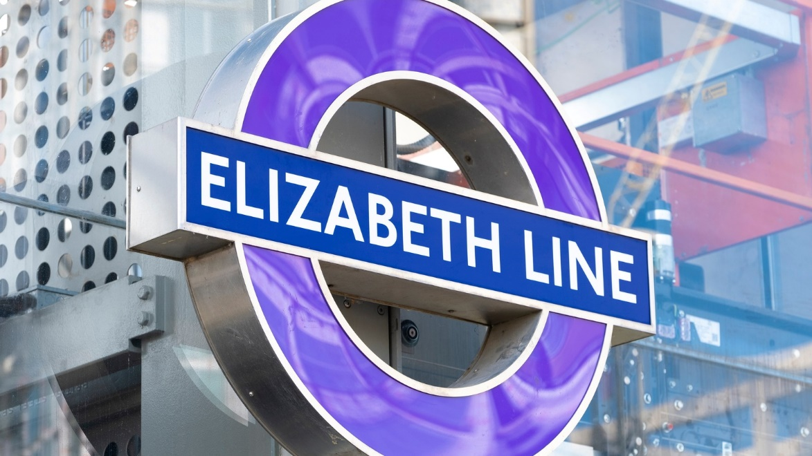
(Source of the image – The List, 2022)
The history of Elizabeth line project, called as Crossrail at the beginning, has started in 1990, when Parliament rejected the idea of new network rail construction. The next scheme was presented in 2005, being finally approved three years later, in 2008. Works on the new rail network started in 2011, the main phase of station building having place between 2016 and 2021.
In February 2016, the train line was renamed to Elizabeth line by the mayor of London, Boris Johnson, in honour of Queen Elizabeth II. The main colour of the train line is purple, used as a pattern and logo. (London Transport Museum, 2022)

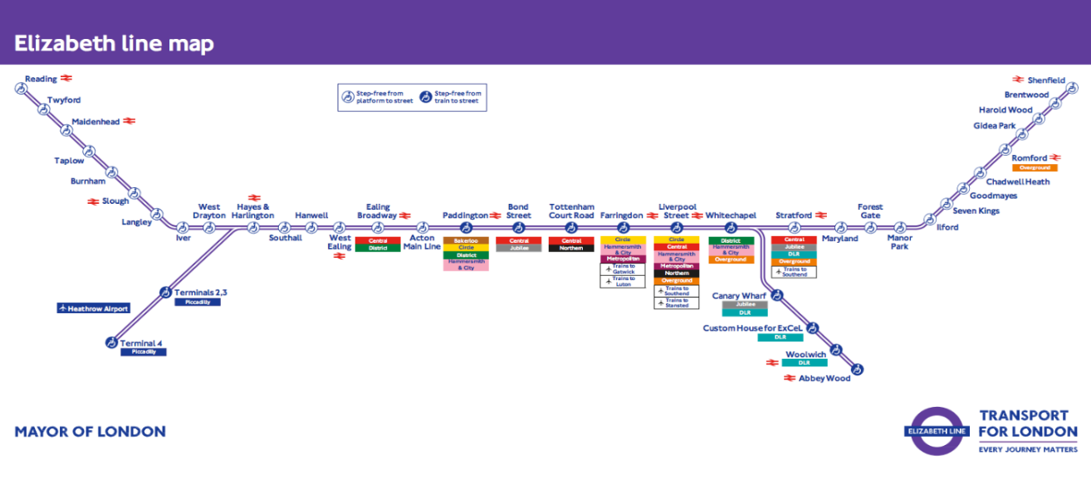

(Source of the image: Transport for London web site, 2022)

The Elizabeth trains were built in Derby, UK, at Bombardier Transportation’s, company owned by Alstom. There is a fleet of 70 specially-designed Class 345 trains, with 1500 passengers spaces, free Wi-Fi, air conditioning and temperature control carriages. TFL also promises 4G access on trains and platforms soon.
Elizabeth line connects East, West and Central London, making easier traveling into and through central part of the city without need to change more lines at Liverpool Street or Paddington stations. Stations are easy to navigate and accessible for people, having distinct features, as: platform edge screens (safety barrier that helps to keep the platform cool and provides lightning, signs, speakers and CCTV), information about departing services, signs to direct people, easily legible and using accessible language, newly-designed seats. Areas outside stations are wide, large spaces for pedestrians.
There were new stations built for Elizabeth train line, but also many of the existing stations were just refurbished. Travelers can walk through brighter and more spacious ticket halls and waiting areas, with step-free access at every station, new lifts and footbridges. Toilets and waiting rooms were also refurbished. (Transport for London, 2022)

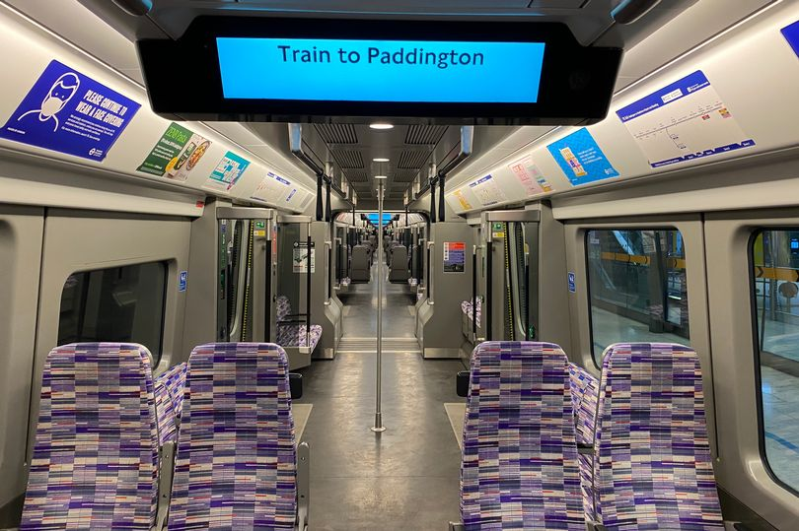
(Source of the image – Transport for London, 2022)

2.1 A success or a failure?
The new train line was supposed to boost UK’s economy, generating a potential yearly income of 42 billion pounds. Also, it was planned to enlarge capacity of the network rail services, serving up to 200 million travelers yearly. It comes as an improving and expanding solution for existing train lines, with the possibility to avoid overcrowding. The line is seeing positive performance indicators, with a 100% reliability three times within the first month after opening. In July 2022, there was registered 5 million journeys made on Paddington-Abbey Wood route, with 40% full capacity on trains. (My London, 2022)
The opening of Elizabeth line has created 55 000 full-time jobs for the duration of construction and provided more than 1000 apprenticeships with about 44 000 young people involved. Also, the project has closely monitored environmental outcomes by meeting CEEQUAL and BREEAM international sustainability standards. According to a study done by Transport of London, the announcement of crossrail network opening had a positive impact of 3% growing office rent values close to the line stations areas. Also, the house prices in area (0-500 m away) has grown by 2% after announcement and number of jobs within 1 km of all Elizabeth line stations grew by 15 percents. It means that the opening of the train line had a good impact on UK’s economy growth and population development. (Transport for London, 2022)
According to the mayor of London, Sadiq Khan, the Elizabeth Line is planned to boost rail capacity in central London by 10%, being the largest increase in the las 70 years. (Rail Technology Magazine, 2022)
With Elizabeth line train opening, London has gained an extra clean, safe and modern transport system line. It drives growth and encourage tourists and investors to visit the city, increases the footfall, especially in the West End, which now is more accessible and easier to get to. It supports businesses and cultural organisations by getting more visitors and buyers. (Rail Advent, 2022)
Despite many advantages of opening the new train line, there were some issues of planning and managing the project. First of all, it has costed Government 23 billion pounds, even though the initial estimated plan was 18.8 billion. The rail network was opened with huge delays of three and a half years than it was planned. According to different sources, there were certain reason for it, as Covid-19 pandemic and issues with safety testing and signaling systems. Also, there were delays because of work splitting in too many packages and failure to manage the job contractors.
The government was promising to open Elizabeth line in December 2018, but since then the deadline was postponed for more than 6 times. Each time of cancelling the project costs were going up extra 1 billion pounds or even 2 billion. (Reuters, 2022)

2.2 Lessons to be taken
A good planning and management are important keys for a project to be done successfully and on time. Steps and phases as planning, initiation, quality and budget monitoring and control, time management, closure etc. need to be followed to get the best results, to respect the planned time and budget and to boost the performance of the project.
Depending on unplanned circumstances or on a wrong and inefficient planning, the project can suffer delays or overruns in implementing, as it has happened to Elizabeth Line. Analysing and identifying the made mistake during a project can help to have a better planning and managing for future programs.
A report of The Institution of Civil Engineers (ICE), that presents the assessment of Elizabeth Line project, has analysed a few problems and lesson to be taken by the government after putting in work this major project:
- Importance of agility. Some projects can suffer challenges or changes and the structure can be slow at reaction. The changes and their results must be understood and action should be taken within hours, not weeks. Major projects need flexibility, adaptability and reallocation of resources, if it is needed; The Elizabeth Line project has alternated more than 30 major contractors with no sufficient capability and authority to assess and manage it;
- Digital projection as a catalyst should be adopted. This ensures that program leaders are chosen by the best performance proven, ability to deeply get into the project and to figure out and sort out the root cause of occured issues;
- Resistance the urge of overlying on detailed planning and stability. There is a risk that the focus and control of detailed and rigid plans can get a failure of the outset, when uncontrollable situations happen;
- The projects need to be set up in a way that the intended outcomes continually drive decisions. Emphasising the need to deliver the right outcomes and not just the right plans. A flexible outlook is necessary to always identify the occurring problems or changes and plan it in advance;
- It is needed regular reviews of structures, governance and skills of executive and board members of the project. These should be optimized and completely aligned in order to achieve the planned outcome. Also, different approaches work differently for certain phase, so a project cannot be achieved by using the same methods from another earlier project that had good results. (Deloitte, 2022)

3. Conclusion
The start of a project involves positive impacts and benefits for the society, but also there it can come with a lot of challenges during the implementation of it. Even if the initiation and planning are at their best, over time delays, loses of money or other range of difficulties can occur. It is a need to efficiently manage it and to be prepared that the project can go in a different way that it was initially planned. Managers and members of the program have to get adaptability and flexibility skills to easily react at every step of project challenges.
Even though sometimes the negative changes and different than desired results cannot be avoided, certain lessons for improvements can be taken out for future projects.

References
- Business Insider, 2022. London’s 25 billion railway, which took 23 years to build, was opened by Queen Elizabeth II. One station is big enough to fit the city’s skyscraper inside https://www.businessinsider.com/london-railway-elizabeth-line-train-years-build-uk-crossrail-station-2022-3?r=US&IR=T (Accessed on 24th of December 2022)
- Construction News, 2019. Crossrail: A history of missed deadlines and cost overruns https://www.constructionnews.co.uk/civils/crossrails-history-missed-deadlines-cost-overruns-12-11-2019/ (Accessed on 7th of December, 2022)
- Crossrail Learning Legacy, 2022. https://learninglegacy.crossrail.co.uk/ (Accessed on 6th of December, 2022)
- Deloitte, 2022. Lessons from Crossrail. A next-generation approach for delivering complex programs https://www2.deloitte.com/uk/en/pages/public-sector/articles/lessons-from-crossrail.html (Accessed on 23th of December, 2022)
- Lock, D., 2013. Project management (10th Edition). Gower
- London Transport Museum, 2022. https://www.ltmuseum.co.uk/collections/stories/transport/elizabeth-line (Accessed on 29th of November, 2022)
- My London, 2022. Elizabeth line: 5m journeys made in a month and trains around 40% full on new Paddington-Abbey Wood route https://www.mylondon.news/news/zone-1-news/elizabeth-line-5m-journeys-made-24434421 (Accessed on 23th of December, 2022)
- Rail Advent, 2022. Businesses celebrate six months of success since Elizabeth Line opened https://www.railadvent.co.uk/2022/11/businesses-celebrate-six-months-of-success-since-elizabeth-line-opened.html (Accessed on 24th of December, 2022)
- Rail Technology Magazine, 2022. Elizabeth Line proves to be roaring success https://www.railtechnologymagazine.com/articles/elizabeth-line-proves-be-roaring-success (Accessed on 24th of December, 2022)
- Reuters, 2022. London’s 24 billion Crossrail finally opens https://www.reuters.com/world/uk/londons-24-billion-crossrail-finally-opens-2022-05-23/ (Accessed on 1st of December, 2022)
- Transport for London, 2022. https://tfl.gov.uk/travel-information/improvements-and-projects/elizabeth-line (Accessed on 20th of December, 2022)
- Transport for London, 2022. Crossrail baseline study and pre-opening evaluation https://content.tfl.gov.uk/crossrail-baseline-evaluation-summary-report-acc.pdf (Accessed on 24th of December, 2022)

