‘Is Feminist Art Still Relevant Today?’

The purpose of this essay is to show that feminism is very much still relevant in the world and how female artists show their experiences through their art and the extremities they go through to display the issues in which women experience daily. An example of this is in 2016 the Guerilla Girls were invited to do an exhibition at MFC-Michele Didier, and they created a poster about the gallery itself titled ‘How many women had one-person exhibitions at MFC-Michele Didier’ this poster had shown the statistics of how many women had an exhibition over five years from 2011 to 2015 and there was only one woman every other year in between those five. This essay will be looking at the following artists as research to support this essay; Guerilla Girls, Regina Jose Galindo, Santiago Sierra and Florence Given.
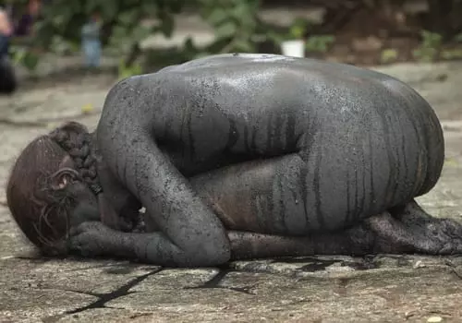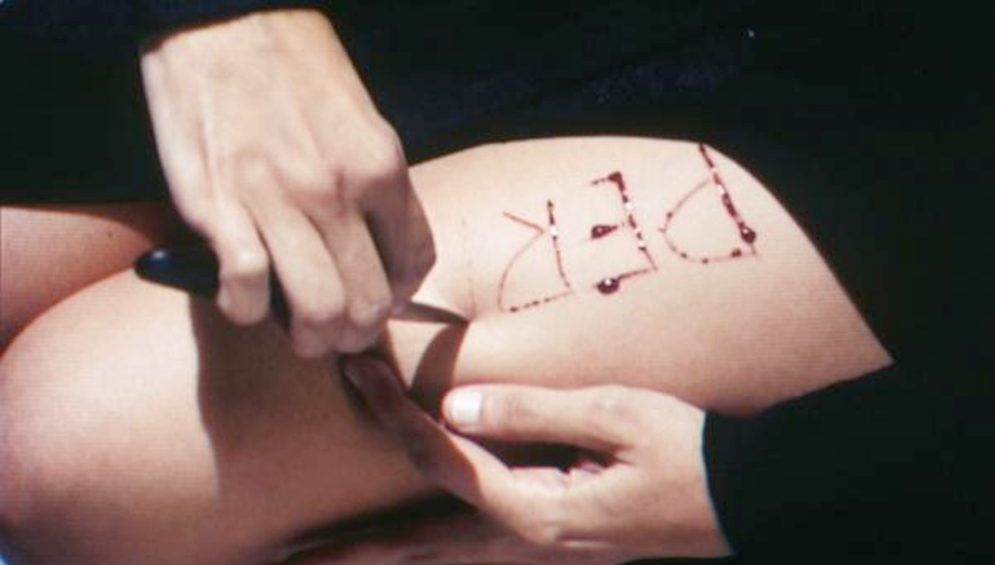
Regina Jose Galindo, ‘Piedra’ [Rock], 2013. Regina Jose Galindo, Bitch, 2005.
An example of a female artist taking her art to the extreme in order to show the inequalities of society is Regina Jose Galindo, a performance artist who uses her own body as the protagonist of her art. In her piece ‘Piedra’ in 2013 she had taken on the role of a rock, painting herself in black and curling up into a ball as members of the audience were ‘invited’ to urinate on her, this piece was a way of protesting abuse and unequal power relations. In 2013 she had shot a 9mm bullet at her own shadow as a way of expressing the Spanish metaphor ‘to be afraid even of one’s shadow’ she said, ‘As a woman in Guatemala, one is permanently exposed to the danger of attacks such as rape or other forms of humiliation. I want to find an image which recounts this everyday conduct as well as the fears it provokes.’ (Waldmann, n.d.) These pieces are shocking but successfully sends the message across and brings awareness to what women in certain countries experience. Another one of her pieces that is quite extreme is ‘Bitch’ in 2005 she had carved the word bitch in Spanish on her thigh in reference to the series of murders in which the killer had carved ‘Death to the Bitches’ into the corpses. She had done this thinking at the time, “I inflicted this pain onto myself, now you can’t hurt me”. (Waldmann, n.d.)

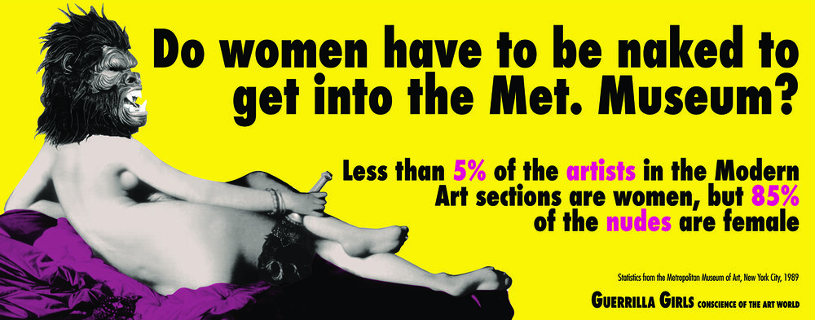
Guerilla Girls, ‘Do women have to be naked to get into the Met. Museum?’, 1989.
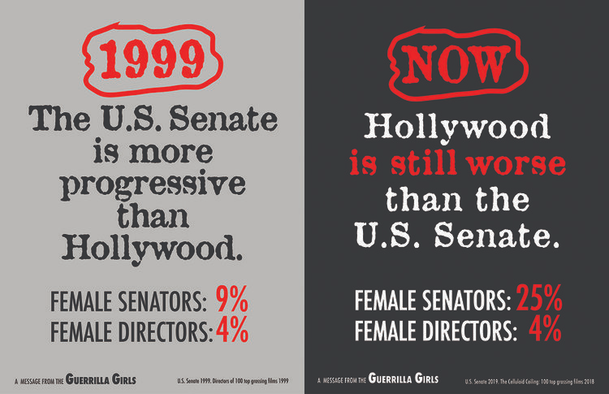
Guerilla Girls, 'The U.S Senate is more progressive than Hollywood, update', 2019.
The Guerrilla Girls are a group of anonymous feminist artists who take on a less extreme route with their art and use a straight to the point method of using statistics in their work in which everyone understands instantly and incorporates humour to bring more attention to it. They are less shocking and extreme in comparison to Regina Jose Galindo but there is still an eye-opening factor with the statistics shown and it is very effective due to the bold and colourful way that they have presented it. In their ‘Do women have to be naked to get into the Met. Museum’ piece they used imagery for the first time since starting the anonymous group by replacing the head of Jean-Augustus-Dominique Ingress’s La Grande Odalisque with a Gorilla head. This poster was made again in 2012 with another counting of the representation of women artists in the Metropolitan and was used again but tweaked in 2014 into ‘Do women have to be naked to get into a music video?’ (Girls, n.d.) Comparing the Guerrilla Girls and Regina Jose Galindo, even though the style of art is vastly different they both have similar goals and they not only focus on feminism they also speak out on racism and politics etc.
During the research of this essay, there was one thought which was if there were any male feminist artists and what were their views on gender inequality and come to find out that there were not many male feminists however one that stood out was Wolfgang Klaus Maria Friedrich who was the first male artist to have exhibited his work at the Women’s Museum in Bonn.
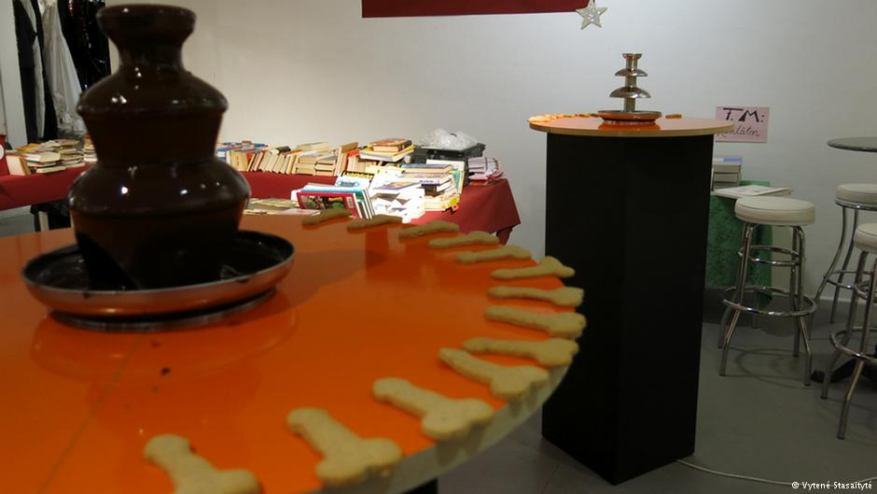
Wolfgang Klaus Maria Friedrich, 'On everyone's lips.' 2013
The piece exhibited was a chocolate fountain which contained dark, bittersweet chocolate whilst surrounded by cookies in the shape of penises. This piece is about trying to put an end to child abuse as ‘Bitter-sweet’ is the name of an organisation in Cologne to combat child abuse. Friedrich said he felt ostracized by other male artists because he believes that in their eyes, he has taken a female position however he said ‘But I’m really a man and I do it out of conviction. When I see inequality, then I have to address it. That’s my main job as an artist. One must always fight back. I do it with great pleasure every single day.’ (Stasaityte, 2013) His views on the gender issues he said, ‘I love women, and I’m a determined feminist, but I’m a man, I would like all rights to be shared 50/50.’ (Stasaityte, 2013)

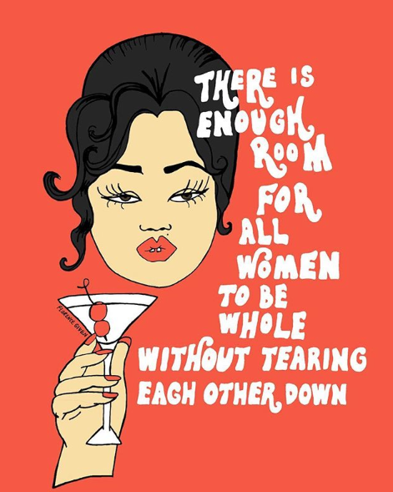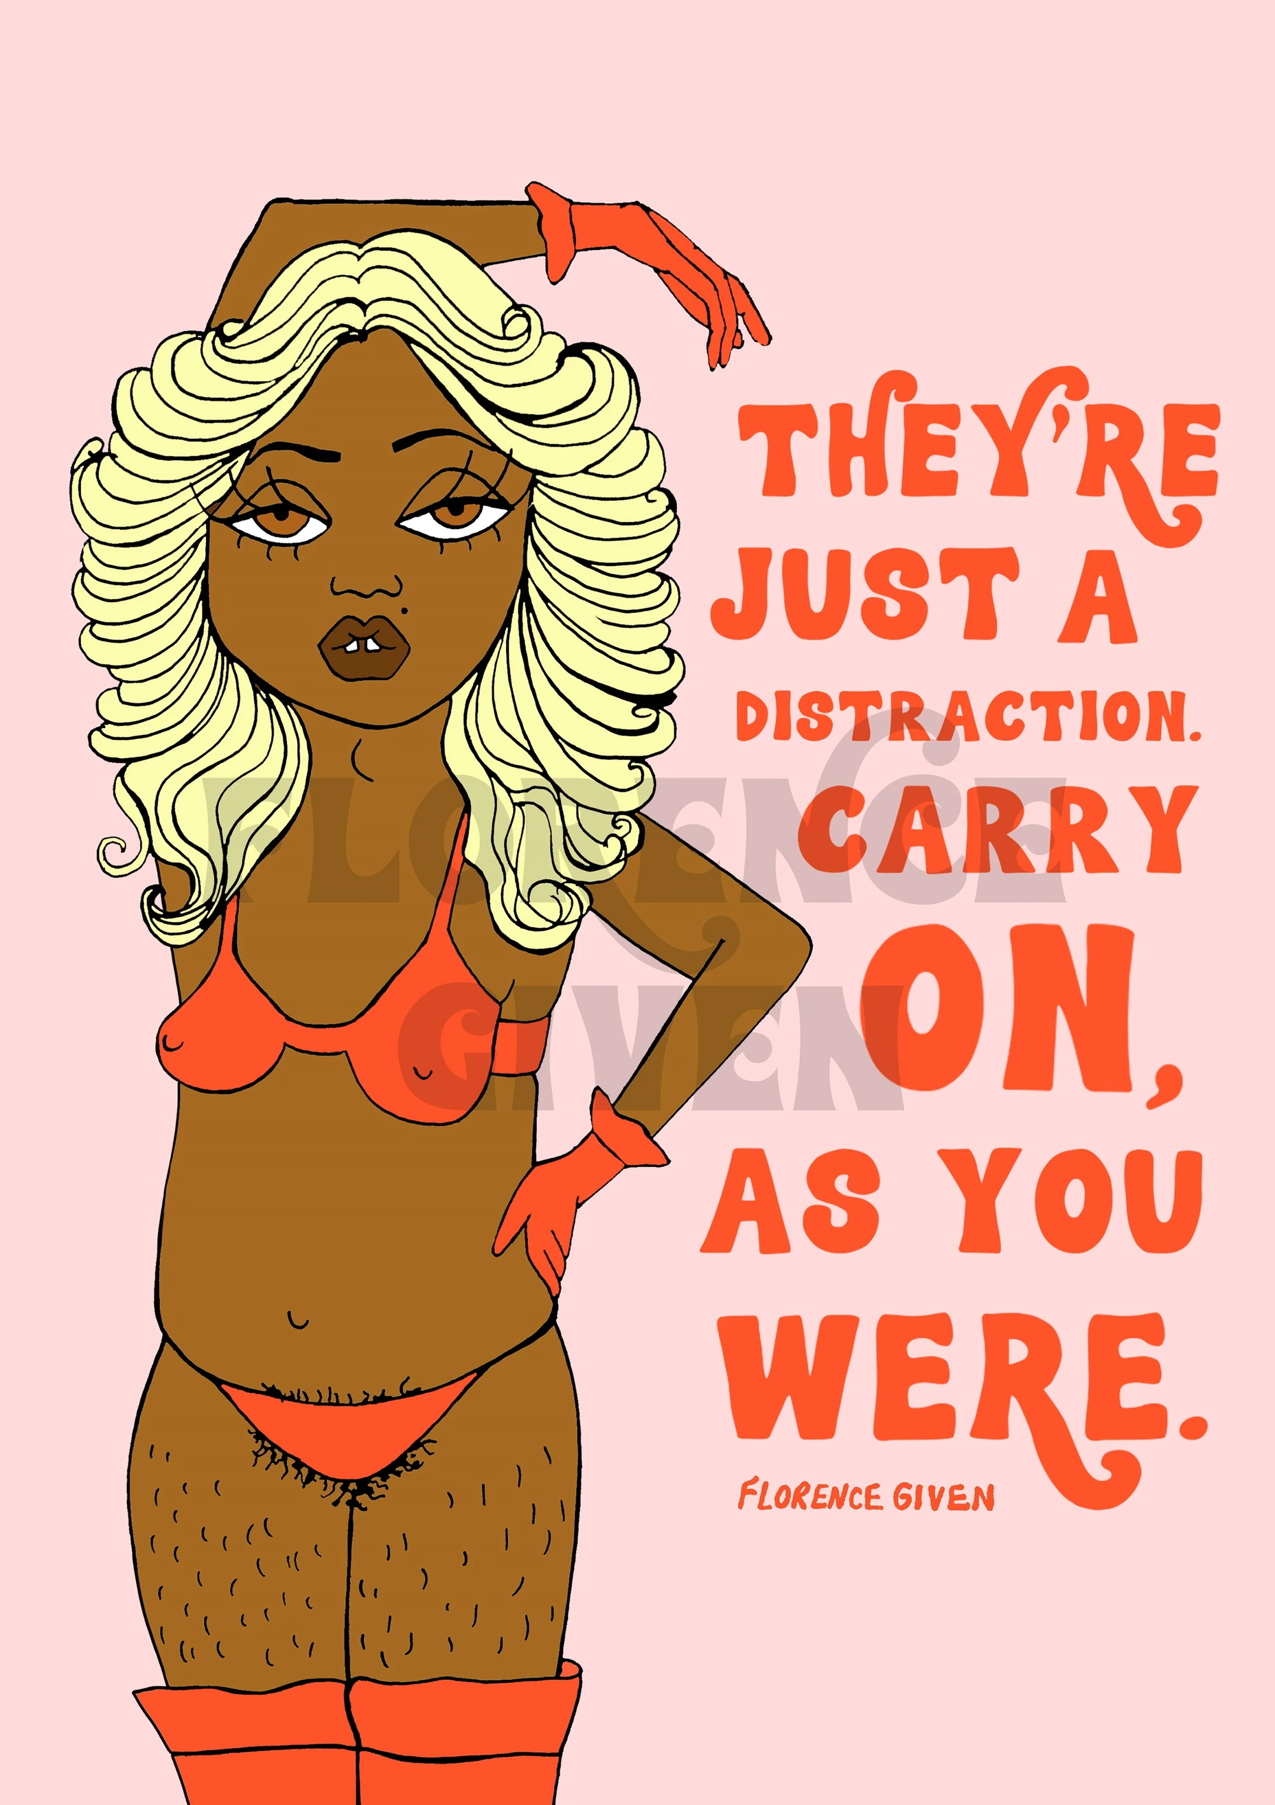
Florence Given, Enough Room Florence Given, Carry On
Florence Given is a British illustrator and writer. She is different to the other artists mentioned in this essay as she uses a less extreme approach but because she also draws women with diversity, it is somewhat surprising to see. She is not afraid to draw women as they are and not the version society portrays and praises. ‘We live in a patriarchal society which prioritizes our desirability above anything and everything else. Which means that…Life is easier when we dress up. Life is easier when we shave. Life is easier when we wear make-up to work. Life is easier when we have made a visible “effort” with our appearance. Life is easier when we reflect society’s idea of beauty. Full stop.’ (Given, 2020)
Given’s piece, ‘Enough Room’ touches on internalized misogyny and how some women often bring other women down in order to grab the attention of a man because they want to fit the trope of ‘not like other girls’ where they don’t fit into the stereotype of the thin, blonde beauty but that they are different, which is shown in most movies which are directed towards women or young teens. Another theme of internalized misogyny is slut-shaming, again it fits into the trope of ‘not like other girls’ because they are portrayed as innocent and having virginity being almost a personality trait and so for them to see these other girls being sexually active, they slut shame them for it as do the men but when the men are doing the exact same, they are praised for it. For her ‘Carry On’ piece she illustrated a woman of colour wearing a bikini and embracing body hair and it is clear to see the message she puts out that women and their bodies are constantly shamed because they do not shave or that their body type does not fit into the ridiculous standards that are placed upon women.

After comparing the artists and their work, no matter what scale of extremism their art might be on, there is a constant battle for gender inequality and though their art receives a lot of attention there is only limited change being done in these past few years and it should be a lot more but considering that the top 10 richest painters in 2021 are male and not only that, 8 out of the 10 are white men, it is clear to see that there is still a divide. (Shelddon, 2021) Another fact to support my statement is that while researching the Guerrilla Girls’ ‘Do women have to be naked to get into the Met. Museum’ trilogy, as the years went by the statistics had worsened and only slightly increased however it still being worse than the first piece. As social media is accessible to people, they and artists are getting involved by posting or sharing their own art which receives a lot of attention considering they are seen worldwide and that may be a benefiting factor for feminist art whereas art shown in galleries are more limited to the specific area that they are being held and that most galleries contain more male artwork than female. So to answer my question, is feminism still relevant my answer is yes but not as relevant as it was.
The main recurring factor in the artists researched in this essay is that they are not only raising awareness in gender inequality they are also raising awareness on other major issues going on around the world examples being the Guerrilla Girls advocating against racism, Friedrich supporting organizations that are fighting against child abuse and Galindo, again with discrimination relating to race and Florence Given with her advocating for body image and race.

Bibliography
Girls, G., n.d. Guerrilla Girls. [Online]
Available at: https://www.guerrillagirls.com/work
[Accessed 2 March 2021].
Given, F., 2020. 'Women Don't Owe You Pretty'. In: London: Andrews McMeel Publishing, p. P.32..
Shelddon, S., 2021. Top 10 Richest Painters Net Worth 2021. [Online]
Available at: https://mashtos.com/richest-painters-net-worth/
[Accessed 17 March 2021].
Stasaityte, V., 2013. Feminist Male artist shakes up gender norms. [Online]
Available at: https://www.dw.com/en/feminist-male-artist-shakes-up-gender-norms/a-16506066
[Accessed 14 March 2021].
Stasaityte, V., 2013. Feminist male artist shakes up gender norms.2. [Online]
Available at: https://www.dw.com/en/feminist-male-artist-shakes-up-gender-norms/a-16506066
[Accessed 14 March 2021].
Waldmann, J., n.d. Regina Jose Galindo: "I am not a vulnerable woman". [Online]
Available at: http://amlatina.contemporaryand.com/editorial/regina-jose-galindo/
[Accessed 1 March 2021].
Waldmann, J., n.d. Regina Jose Galindo: "I am not a vulnerable woman2. [Online]
Available at: http://amlatina.contemporaryand.com/editorial/regina-jose-galindo/
[Accessed 1 March 2021].

