
Managing Enterprise in the 21st Century
Tudor Plescan
2127270
4/6/2023

April 6, 2023

Website login details :
Email: sitenoupariuri@gmail.com
Password: Site123123
Student ID: 2127270
Tutor: Christian Felices

Contents
1. Introduction 4
- Importance of market research for a business: 4
2. Analysis of the questionnaire data including graphs/snippets and how the findings can impact/influence your business idea. 6
3. Website design and rationale 9
4. Discussion around the importance of SEO and how the primary research informs the SEO strategy 11
5. Reference list 12

Introduction

Marketing and research are very important for any business that want to be successful. Without proper research, we will never be able to find out what we will have to do to make our business successful.
Marketing in another hand it is not done properly, it will be very hard to make the business run and make it successful.
Marketing research is the function that links the consumer customer, and the public to the marketer through information---- information used to identify and define opportunities and problems, generate, refine, and evaluate actions; monitor performance; and improve understanding of it as a process (American Marketing Association, 2017)

Importance of market research for a business:

Market research is a technique that is used to collect data on any aspect that you want to know to be later able to interpret it and, in the end, make use of it for correct decision-making.

Businesses need to conduct proper market research from the very beginning. By doing the research properly we will be able to gather data and use it to make our business stable and create opportunities for us to grow.
Using marketing research we can raise our brand awareness. This is important because it gets people acquainted with your brand and the products or services you provide. It also makes you memorable to customers who can begin to trust your brand, become loyal clients, and tell their network about you. (Cyberclick, 2021)

As I mentioned before, it is very important how we conduct the research. Using the 4 Ps of marketing we can develop easier. The four key considerations must be thoughtfully considered and wisely implemented to successfully market a product or service. They are product, price, place, and promotion. (Twin, 2022)
Using this theory properly, we can have a better start to the business. Looking around to see what our competitors offer we can set ourselves some limits but also create some guidance which will help us in the future because it will be easier for us to know how to do things and when to do them.
Primary research is also very important because we can conduct surveys, in-depth interviews, focus groups, and observations. In my opinion, observation is one of the most reliable methods. Observation involves watching or video-recording how consumers interact with a product or service in a natural setting. Although a time-consuming method, it has the advantage of providing unbiased research. This is because customers are not under any pressure and will behave naturally. (Markus, 2016)

Analysis of the questionnaire data including graphs/snippets and how the findings can impact/influence your business idea.

A questionnaire is a research tool featuring a series of questions used to collect useful information from respondents These instruments include either written or oral questions and comprise an interview-style format (Cint, 2022)

Looking at the questionnaire data is a bit hard for me because my clients are easier to convince over the phone or in face-to-face meetings. As a Healthcare Agency, people who run businesses that I can help, with won’t be looking to find agencies online because usually they get approached by people like me who can help them out during emergencies.

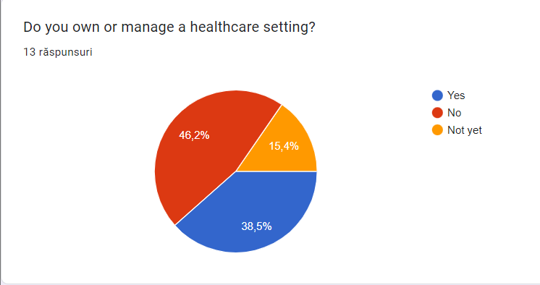

As we can see, my first question in my questionnaire was if you own or manage a healthcare setting. I know I was meant to do this with my colleagues from the course but that would be irrelevant to my questionnaire because I knew that none of my colleagues have any ties to the healthcare sector.
Using some people whom I know are active in the healthcare sector, I manage to pull a few answers from their managers, owners, or people who are just working in the sector.
Looking at the questionnaire, we can see that only 38.5% are owners or they are managing a healthcare setting. Usually, people in these positions have a saying when it comes to what agency they will be using and that will be based on how fast the agency can cover the shifts, the hourly rate and how well the staff is trained.
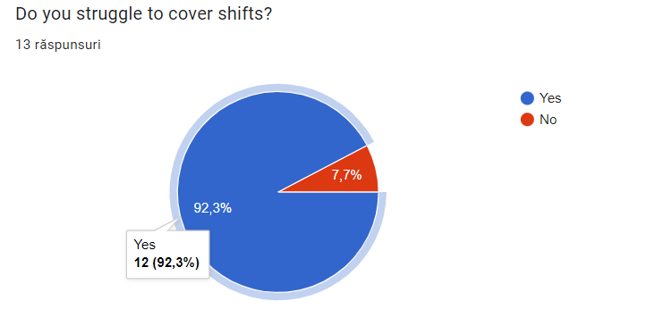
As a second question, I asked if people are struggling to cover their shifts and 92.3% answered with “yes” which means it a lot of demand for this kind a business which encourages me even more now to go ahead with my idea of business and make it active as soon as possible.
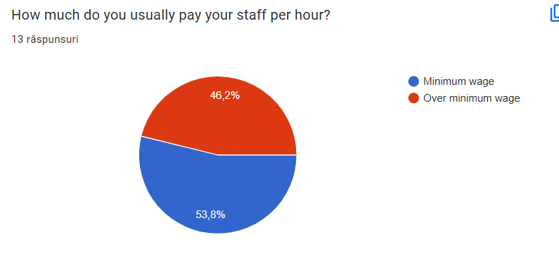
The third question was more to find out how much are the workers paid because if a lot of healthcare assistants are on minimum wage, they will be tempted to join my agency for better pay. As an agency healthcare assistant, you could earn up to £20 per hour on the weekend witch it’s nearly double of minimum wage.
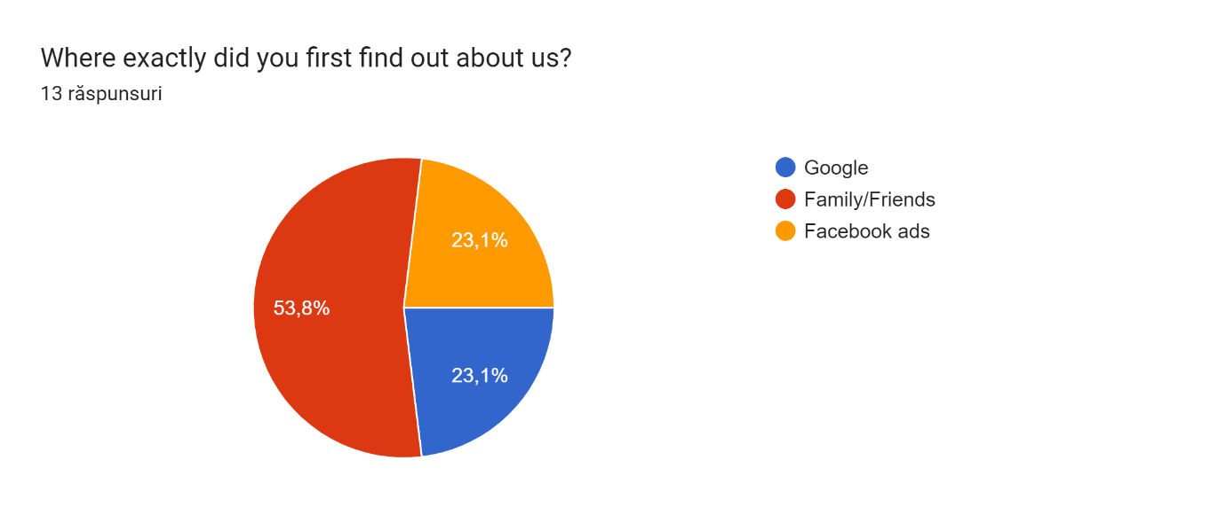
In the question above, I wanted to find out more about how people find new services and it seems that talking to each other still working. It is very important that you engage with your local community because now these days most people know someone who works in a healthcare setting and that could lead you to get more customers for your business. I always believed that if you are polite and nice to people they will be the same to you and as an owner of a business a believe that even more.
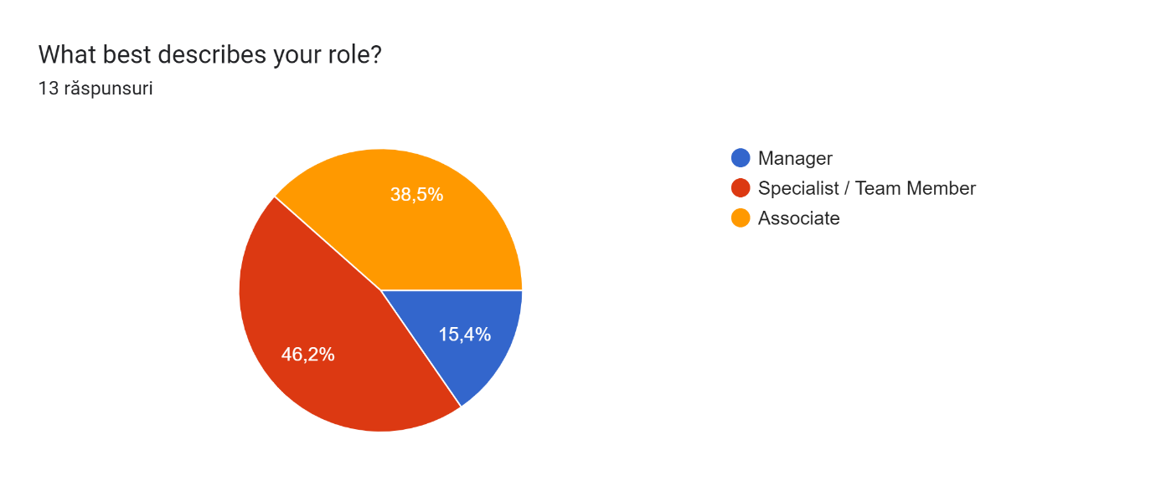
As we can see above, only 15.4% are managers which means this questionnaire didn’t get to the right people.

Website design and rationale

While I was creating the website, I realized that the website will come in handy only after some time I open the company just because the best way to promote the business at the start will be flyers and emails.
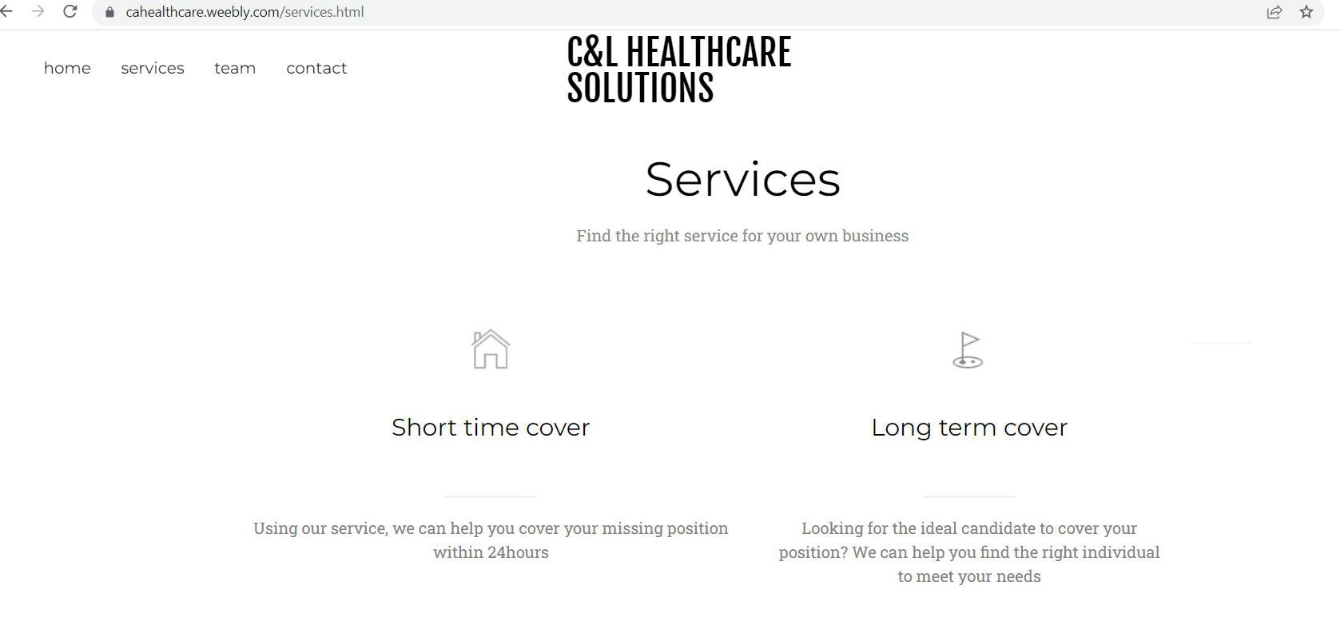

As we can see, when I created the website I only created a small template for what I will be able to offer through my business.
Colour theory is both the science and art of using colour. It explains how colours to mix, match, or contrast with each other. The colour theory also involves the messages colours communicate; and the methods used to replicate colour. (Decker, 2017)
Colours mean a lot when you create an website because if you use the right colours you can transmite to the brain different signals To unleash the power of colour, you first have to start by understanding colour theory, the colour wheel, how to use complementary colours to create an impactful colour scheme, and the psychological effects of those colours. (Anas, 2020)

Also on the website, I did put down the team because I do believe it is important for your customers to know who you are.
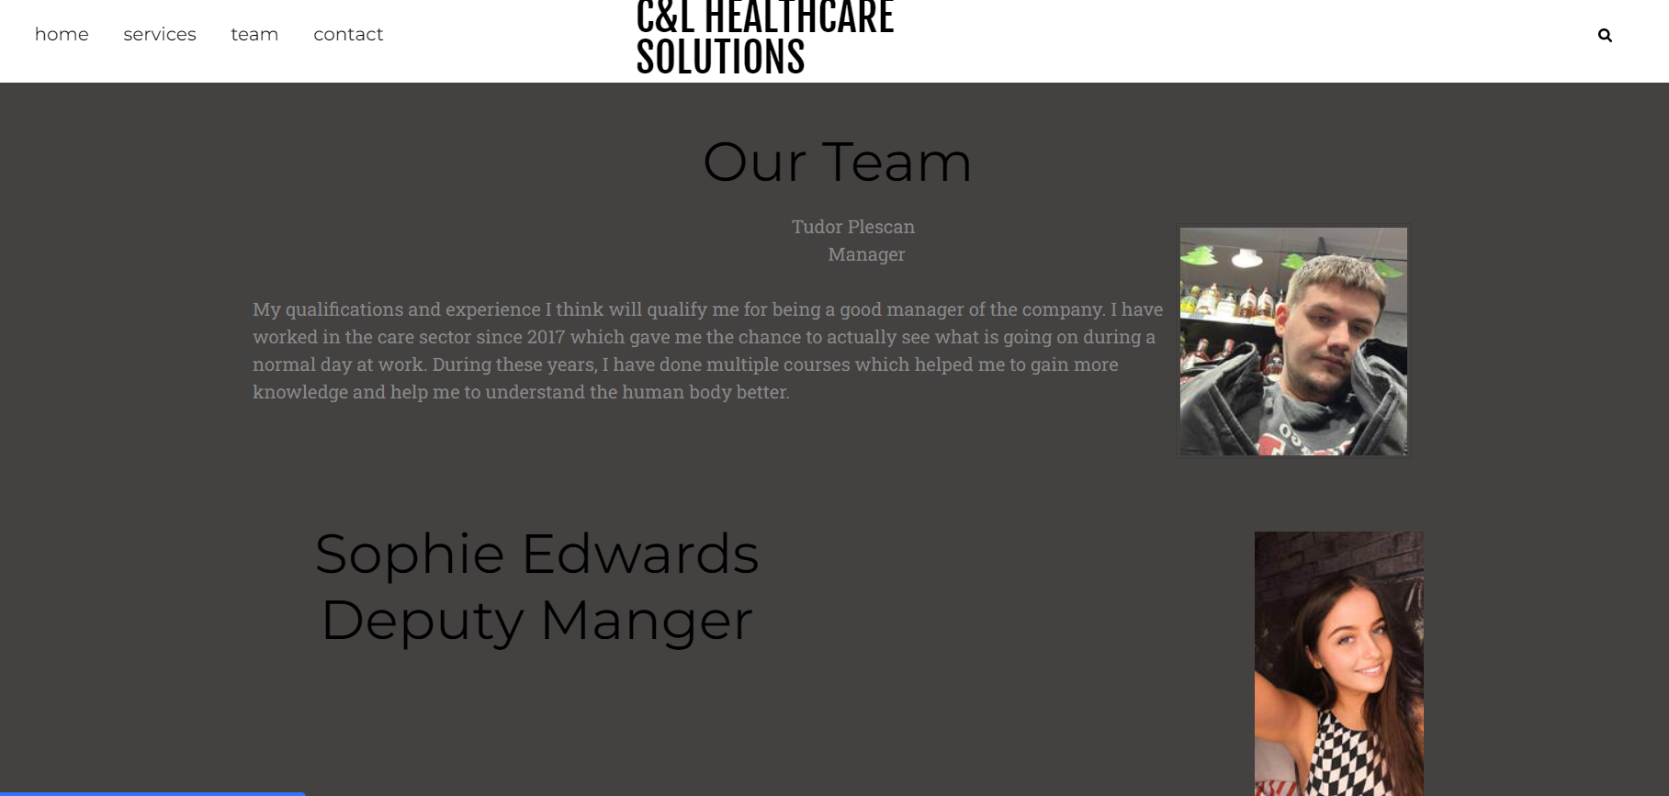
Also, on the website, we will be able to find my home address because, at this very moment, I don’t have an office I do believe that the office will come when I have most of the things ready for the business.

Discussion around the importance of SEO and how the primary research informs the SEO strategy

SEO stands for “search engine optimization”. In simple terms, SEO means the process of improving your website to increase its visibility in Google, Microsoft Bing, and other search engines whenever people
search for it. Primary keywords and Secondary keywords are terms used by webmasters and content creators to target specific search queries to help rank their content higher in search results. (Wilson, 2022)
Using the right words while you describe your services or product can help you a lot to promote your business. Looking back a couple of years social media came out with the # phenomenon (EX: #cookwithme, #London) and it seems that everybody got familiar with this and now this it’s a new way to promote your business. (Search Engine Land, n.d.)
Primary research it is important because it can help you develop your SEO strategy.
Google offers the largest free online market research tool, AdWords. It provides crucial data about your market, product, and competition. The goal of gathering market research is this manner – or by obtaining the quality reports available at MarketReasearch.com. (Ricketts, 2019)
We do live in a world where the internet plays a major role and it is very important to make sure you can handle the whole process if you can’t do it, you need to find the right individual who will be able to get your business online and all your business is well promoted online.

Reference list
American Marketing Association (2017). Definitions of Marketing. [online] American Marketing Association. Available at: https://www.ama.org/the-definition-of-marketing-what-is-marketing/.
Anas, B. (2020). Understanding color theory: the color wheel and finding complementary colors. [online] www.invisionapp.com. Available at: https://www.invisionapp.com/inside-design/understanding-color-theory-the-color-wheel-and-finding-complementary-colors/.
Cint (2022). What Is a Questionnaire | Types of Questionnaires in Research. [online] CintTM. Available at: https://www.cint.com/blog/what-is-a-questionnaire-and-how-is-it-used-in-research.
Cyberclick (2021). What is Marketing? Definition and how it works · Cyberclick. [online] www.cyberclick.net. Available at: https://www.cyberclick.net/marketing.
Decker, K. (2017). The fundamentals of understanding color theory. [online] 99designs. Available at: https://99designs.com/blog/tips/the-7-step-guide-to-understanding-color-theory/.
Markus, J. (2016). Market Research. [online] Oberlo. Available at: https://www.oberlo.com/ecommerce-wiki/market-research.
Ricketts, P. (2019). Conducting comprehensive market research for an SEO campaign. [online] Smart Insights. Available at: https://www.smartinsights.com/digital-marketing-strategy/conducting-comprehensive-market-research-for-an-seo-campaign/.
Search Engine Land. (n.d.). What Is SEO - Search Engine Optimization? [online] Available at: https://searchengineland.com/guide/what-is-seo#why-is-seo-important.
Twin, A. (2022). Four Ps of Marketing: Know What They Are. [online] Investopedia. Available at: https://www.investopedia.com/terms/f/four-ps.asp.
Wilson, S.J. (2022). What are Primary Keywords and Secondary Keywords in SEO? [online] Steven J. Wilson. Available at: https://stevenjwilson.com/primary-keywords-secondary-keywords-seo/?utm_content=cmp-true [Accessed 6 Apr. 2023].

