

Module Name: Skills for Personal and Professional Growth
Module Code: BMSW4008
Assignment Name: Evidence of Learning (E-Portfolio)

Student Name:Ramona Petica
Student Number:2324280
Lecturer:Philippa Fitzgerald
Deadline: Friday 20thJune 2025 23.59pm

Wordcount:
AI Acknowledgement
Examples of statements If you have not used AI
I confirm that I have not presented any AI generated materials as my own work.
I confirm that I have copies of my drafts, notes, and other resources I used, which I may be asked to provide in evidence.
Examples of AI statements if you have used AI
Example 1:
I acknowledge the use of Grammarly (https://www.grammarly.com/) on Date to check my work using the prompt(s):
1. Please check the following text for readability, grammar and syntax.
I confirm that I have not presented any AI generated text as my own work. I confirm that I have copies of my drafts, notes, and other resources I used before, and after the use of AI tools which I may be asked to provide in evidence.
Example 2:
I acknowledge the use of SciSpace (https://typeset.io/) on 7 March 2024 to support my research using the prompt(s):
1. Please provide me with materials on the biology of the liver.
2. Please provide me with materials on liver cells.
I confirm that I have not presented any AI generated text as my own work. I confirm that I have copies of my drafts, notes, and other resources I used before, and after the use of AI tools which I may be asked to provide in evidence.
Example 3:
I acknowledge the use of ChatGPT (https://chatgpt.com/) on 13 April 2024 to write my notes into submission format using the prompt(s):
1. Please write up these bullet points as an essay paragraph at university level.
I confirm that I have not presented any AI generated text as my own work. I confirm that I have copies of my drafts, notes, and other resources I used before, and after the use of AI tools which I may be asked to provide in evidence.
Example 4 -acknowledgement of the use of multiple AI tools:
I acknowledge the use of SciSpace (https://typeset.io/) on 28 June 2024 to support my research using the prompt(s):
1. Please provide me with materials on the American Civil War.
2. Please provide me with materials on the reception of Gone with the Wind.
I confirm that I have not presented any AI generated text as my own work. I confirm that I have copies of my drafts, notes, and other resources I used before, and after the use of AI tools which I may be asked to provide in evidence.
I acknowledge the use of Adobe Express (https://www.adobe.com/express/) on 24 June 2024 to edit photographic material:
1. Remove background from Figure 1.
I confirm that I have not presented any AI generated materials as my own work. I confirm that I have copies of my drafts, notes, and other resources I used before and after the use of AI tools which I may be asked to provide in evidence.


Certificate of Higher Education in Employability Skills LEVEL 4
Module Name: – BMSW4008– Digital Skills for Personal and Professional Growth
Module Lead: Philippa Fitzgerald
Student Name: Ramona Petica (2324280)

TASK 1: MARKET RESEARCH AND WEBSITE DEVELOPMENT PROJECT
Introduction
The beauty business is booming, but customers are usually unable to find a salon that has a mix of talented professionals, friendly atmosphere, and services that are value-oriented, convenient, and offered in a comfortable setting. It is uniquely positioned and with this knowledge we have fashioned The Nail & Beauty Lounge to fill this gap in providing a modern affordable yet accessible beauty experience to adults that have a taste of quality, reliability and affordability(Gabriel et al., 2023). The purpose of our business is to provide high-quality gel nails and other necessary beauty treatments to a community of mature clients in an environment where these people feel nurtured, supported, and empowered to feel and look their most beautiful(Gupta, Agarwal and Singh, 2020). In the presented business plan, the importance of primary market research in defining every detail of The Nail & Beauty Lounge is described, including the offered services and branding, the design of their online presence and electronic marketing.

Questionnaire Creation and Data Collection
Google forms were utilised to develop a survey of 14 questions to examine the needs, expectations and behaviours of prospective beauty salon consumers(Kim and Jin, 2022). The questions that were answered were:
- What is your age range?
- How often do you visit a beauty salon?
- How far are you willing to travel for beauty services?
- How important is the availability of parking when choosing a beauty salon?
- How do you prefer booking appointments?
- What services do you usually seek when visiting a beauty salon?
- How much do you typically spend per visit to a beauty salon?
- How do you typically pay for your beauty salon services?
- What factors influence your choice of a beauty salon?
- Do you feel that regular beauty treatments are a necessity or a luxury?
- Do you follow beauty salons or professionals on social media?
- Which social media platforms do you use most to discover beauty trends or salons?
- What would encourage you to engage more with our content on social media?
The design used both open-ended and multiple choice questions to seek quantitative and qualitative data. The survey was distributed among the very classmates and the local community members, and this has brought 26 full responses, which is sufficient in order to make meaningful analysis.

Data Analysis and Key Findings and Trends
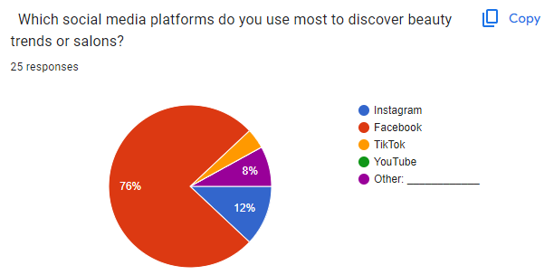
Figure 1: Which social media platforms do you use most to discover beauty trends or salons?
Interpretation: An examination of the responses reveals the most amazing figure is that an overwhelming 76 percent of clients rely on Facebook to seek beauty trends or salons on Facebook, 12 percent on Instagram, and a paltry 8 percent on YouTube. The presence of TikTok and other platforms has almost zero presence in this segment.
This indicates that Facebook should be a heavy concentration area of digital marketing activities performed by the salon. It is best to introduce Facebook follow buttons to the website and to share all of the promotions, giveaways, and announcements of a new service via this platform(Park and Lee, 2022). Instagram is a potential secondary source of presenting visuals, and client engagement and client acquisition will be most prevalent on Facebook.
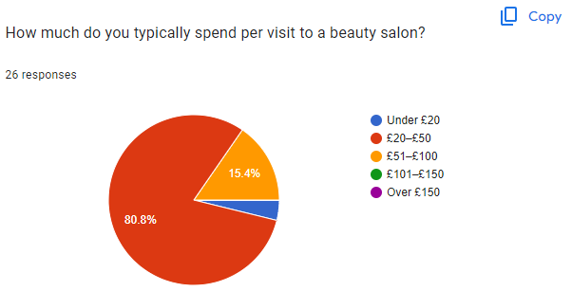
Figure 2: How much do you typically spend per visit to a beauty salon?
Interpretation: According to the survey data, 80.8 percent of respondents spend the range of 20-50 pounds during each visit, and only 15.4 percent spend the range of 51-100 pounds. Almost no customers make higher than one hundred pounds.
The salon does not have to be tagged as an expensive, luxury or premium service, but rather as an affordable, high value giver(Yang and Jin, 2023). To lure and sustain the high percentage of price-conscious customers, merits, loyalty deals, and competitive rates should be mentioned in websites, menu cards, advertisements.
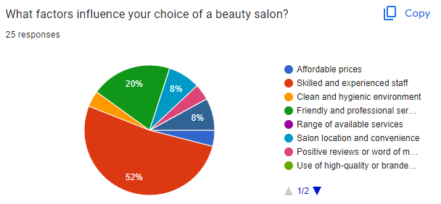
Figure 3: What factors influence your choice of a beauty salon?
Interpretation: First is to have competent and seasoned employees (52%), and then comes a pleasant and attentive service (20%). The other aspects including affordability, cleanliness, and location are secondary.
Both the web content and social media marketing messages as well as testimonials and visual content need to focus on staff expertise, continuous training, and customer care(Ros et al., 2023). Staff bio pages, testimonials by clients, and meet the team pages can create trust and establish the salon as a quality and professional place (Rosário and Raimundo, 2021).

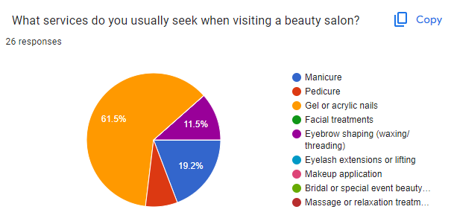
Figure interpretation: The service stated as the most desired is the gel or acrylic nails with 61.5 percent, thereafter manicure with 19.2 percent and lastly eyebrow shaping with 11.5 percent. The other services are relatively in demand.
All the essential services should be based on the gel /acrylic nail services and products such as gel /acrylic nail decoration, etc. These services should be on the center stage on the homepage of the site, on the booking CTA and in all marketing images(Park, Yun and Chon, 2021). More services to be offered can be nail art, shaping eyebrows, and basic manicure packages.

Business Strategy, Website, and Marketing
The Nail & Beauty Lounge’s business strategy focuses on affordability and quality, targeting price-conscious adults seeking gel nail services, as 80.8% spend £20-£50 per visit (Q7). A two-page website was created on Weebly, comprising a Homepage and Services Page, reflecting survey preferences. The Homepage highlights affordable gel nails, skilled staff (52% priority, Q9), and a phone booking CTA (61.5% preference, Q5). The Services Page lists gel nails (£25), manicures (£20), and eyebrow shaping (£15), aligning with top services (Q6) and budget constraints. SEO strategies include keywords like “affordable gel nails” in meta tags, enhancing search visibility for the target audience: adults aged 25-44 seeking budget-friendly beauty treatments (Wuisan and Handra, 2023). Marketing materials were designed on CANVA, including a poster and flyer, emphasizing gel nail promotions and staff expertise, with a pink aesthetic matching the website. Both feature a Facebook link (76% usage, Q12) for engagement through exclusive promotions (Q13). Screenshots of the website pages and CANVA materials are included in the portfolio, demonstrating how survey insights shaped the design and marketing approach, ensuring a cohesive strategy that resonates with the audience’s needs and preferences (Olson et al., 2021).

Figure 5 Flyer

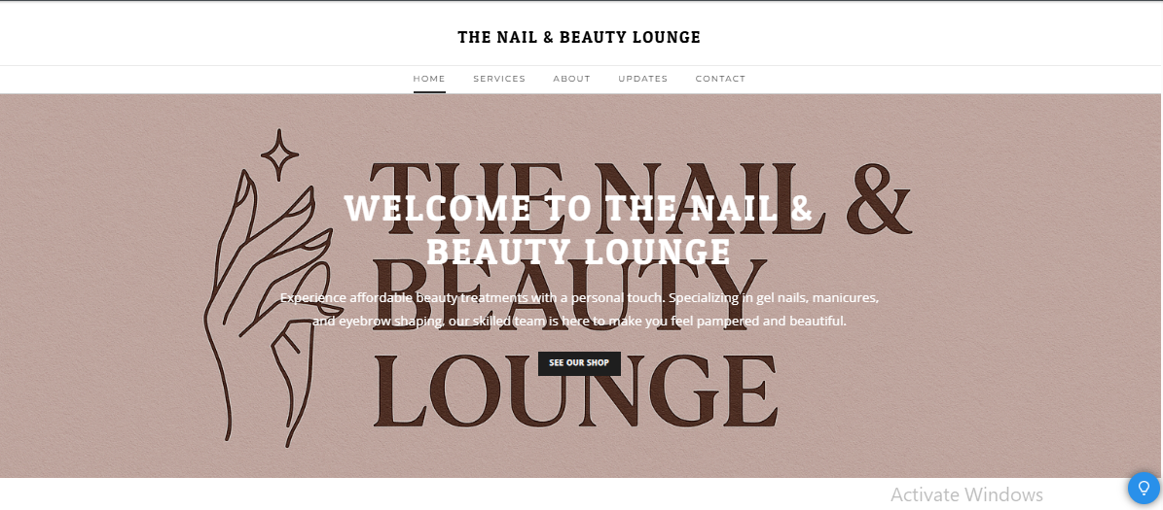
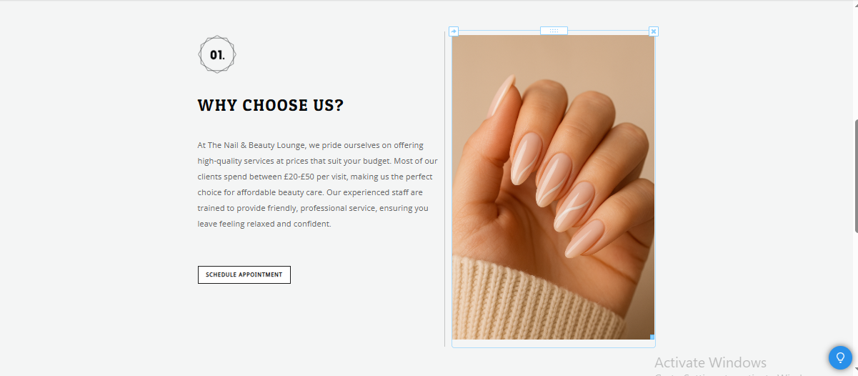
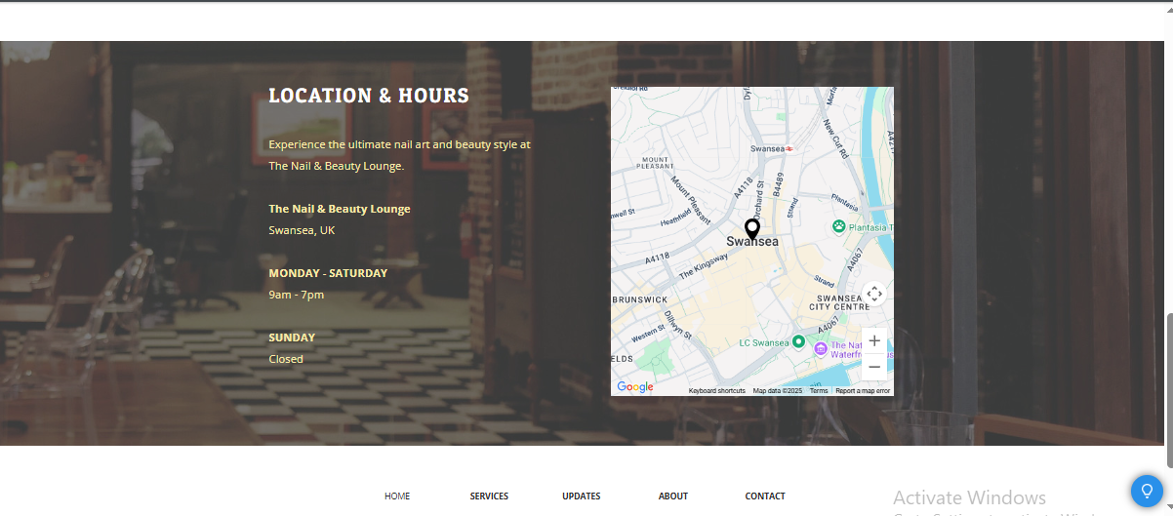

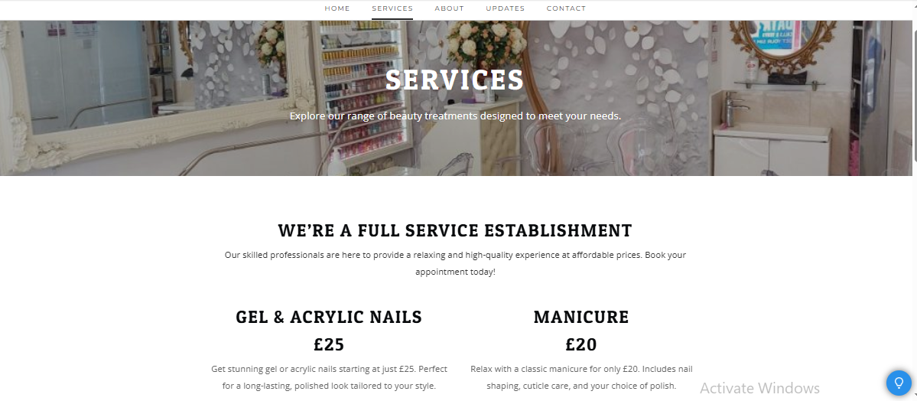

The Importance of Excel in the Digital Era: Application in Beauty Salon
In the Digital Age, success in small business is becoming more and more reliant on the capacity to collect, understand, and act on right information(Abang, 2021). This is because Microsoft Excel is quite flexible, accessible and robust in analytical capabilities making it central to digital business management. In the case of a beauty salon, Excel is not a software program, but a program that completes the important roles of healthy business planning, financial control, and excellence in operations.

Projected Financials
Jan
Feb
Mar
Apr
May
Jun
Jul
Aug
Sep
Oct
Nov
Dec
Annual Total
INCOME
Gel/Acrylic Services
2,000
2,100
2,300
2,500
2,400
2,600
2,700
2,600
2,300
2,200
2,400
2,940
29,040
Other Services
550
560
570
590
600
610
630
620
580
570
590
700
7,170
Product Sales
110
120
120
130
140
140
150
140
130
120
140
200
1,640
Total Income
2,660
2,780
2,990
3,220
3,140
3,350
3,480
3,360
3,010
2,890
3,130
3,840
37,850
EXPENSES
Rent
600
600
600
600
600
600
600
600
600
600
600
600
7,200
Staff Wages
900
900
950
1,000
1,000
1,100
1,150
1,100
1,000
950
1,000
1,200
12,250
Utilities
160
150
150
150
150
140
140
140
150
160
170
180
1,840
Supplies/Products
300
320
340
350
350
370
390
370
350
330
350
420
4,240
Marketing
110
120
150
160
150
140
130
130
120
120
150
200
1,680
Miscellaneous
70
70
80
90
70
70
90
80
70
70
90
120
970
Total Expenses
2,140
2,160
2,270
2,350
2,320
2,420
2,500
2,420
2,290
2,230
2,360
2,720
28,180
Profit/Loss
520
620
720
870
820
930
980
940
720
660
770
1,120
9,670
Strategic Financial Planning with Excel
The financial forecast is one of the major components of any business plan. A beauty salon is an example where the owner can use Excel to coordinate monthly expenses of the business and revenues in detail. As an example, the annual projection of the salon indicates the total income increasing over time, having £2,660 in January, and a highest level of £3,840 in December, as a result of both the market research and seasonal fluctuation. Breakdown contains significant revenue contributing items namely Gel/Acrylic Services (beginning at 2000 in January, and rising to 2940 at the end of the year), Other Services (between 550 and 700), Product Sales (commencing at 110 in January and 200 at the end of the year).
The salon can automatically update any of the totals by entering a variable when any input number changes; e.g. =SUM (B3:B5) formula would have monthly income and =SUM (B8:B13) formula would have total expenses. This real-time calculation implies that the company can determine the effect of adding a new service, altering the prices, or conducting seasonal offers almost immediately(Agustian et al., 2023). Excel can then be a very lively financial planning tool, unlike paper-based traditional methods that are not dynamic in any way.

In a service based business such as a beauty salon, expense management is important. Fixed costs like Rent (600 per month) and the variable costs such as Staff Wages (increasing to 1200 in December) are clearly written and added in the spreadsheet(Tanvir Mustafy and Ur, 2024). The same goes to utilities, supplies, marketing and the miscellaneous expenses in that, it is easy to know how much has been spent and there are no surprises at the end of the month. As an example, the overall costs go up, 2,140 in January to 2,720 in December when the demand is higher, more employees, and supplies are needed.
The ability in Excel to use formulas to calculate Profit/Loss (e.g. =B6-B14) means that the business can immediately see which months were profitable and when there was a risk. In this salon, profit is positive all the year round and it reaches 1120 in December(Areej ElSayary, 2023). Such financial transparency can make proactively decision-making possible, e.g. reserve building in months where the profits are high to cover the slack months.
Excel contributes to a wider variety of business functions in addition to accounting. The salon deploys the use of spreadsheets to roster employees, to account inventory, and also to take up bookings of clients(Salmela et al., 2022). The business will get a chance to detect peaks in terms of service and adjust staffing needs based on monthly data provided through the analysis. An example is that when the income and footfall are high in July and December, Excel can assist in the provision of sufficient staff and stock.
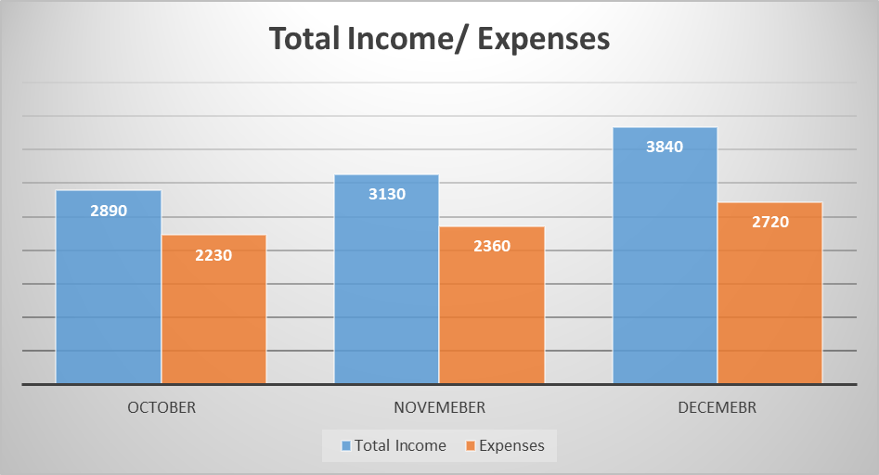
According to the bar chart, a total amount of income and expenditure increases between the months of October to December, with the highest increase being in the month of December. Revenues are always bigger than expenses which is a sign of permanent profitability, and signifying increased demand and expenses during the holiday season by the beauty salon(Diana, Azani and Mahmudulhassan M, 2024). This will enable the salon to be able to plan on promotional offers at off-profit months and the staffing schedule according to the forecasted demands/demands at a certain point in real-time financial transparency.

Beauty industry is dynamic and it relates to trend, customer demand and seasonal events. Excel allows flexibility and the business owner can make quick modifications in the forecasts, test new service provision and immediately view the anticipated results(Kumar, 2023). Such flexibility becomes essential in order to stay competitive and in the process capture emerging opportunities.

REFERENCES
Abang Yusof, D.A. (2021). Reading Habits Among Students in the Digital Era. Journal of Academic Library Management (AcLiM), 1(1), pp.43-54. doi:https:doi.org/10.24191/aclim.v1i1.5.
Agustian, K., Mubarok, E.S., Zen, A., Wiwin, W. and Malik, A.J. (2023). The Impact of Digital Transformation on Business Models and Competitive Advantage. Technology and Society Perspectives (TACIT), [online] 1(2), pp.79–93. Available at: https://journal.literasisainsnusantara.com/index.php/tacit/article/view/55.
Areej ElSayary (2023). An investigation of teachers’ perceptions of using ChatGPT as a supporting tool for teaching and learning in the digital era. Journal of Computer Assisted Learning. doi:https://doi.org/10.1111/jcal.12926.
Diana, A., Azani, M.Z. and Mahmudul Hassan M (2024). THE CONCEPT AND CONTEXT OF ISLAMIC EDUCATION LEARNING IN THE DIGITAL ERA: RELEVANCE AND INTEGRATIVE STUDIES. Profetika Jurnal Studi Islam, 25(01), pp.33–44. doi:https://doi.org/10.23917/profetika.v25i01.4239.
Gabriel, A., Ajriya, A.D., Zahra, C. and Handayani, P.W. (2023). The influence of augmented reality on E-commerce: A case study on fashion and beauty products. Cogent Business & Management, [online] 10(2). doi:https://doi.org/10.1080/23311975.2023.2208716.
Gupta, Y., Agarwal, S. and Singh, P.B. (2020). To Study the Impact of Instafamous Celebrities on Consumer Buying Behavior. Academy of Marketing Studies journal, 24(2).
Kim, N.-R. and Jin, Y.-M. (2022). Effect of Hair Salon Selection Criteria on Consumer Behavior and Satisfaction. Journal of the Korean Society of Cosmetology, 28(1), pp.1–9. doi:https://doi.org/10.52660/jksc.2022.28.1.1.
Kumar, D.M.D. (2023). A Study On Importance of Microsoft Excel Data Analysis Statistical Tools in Research Works. Journal of Management & Educational Research Innovation, [online] 1(3), pp.25–33. doi:https://doi.org/10.5281/zenodo.10449150.
Olson, E. M., Olson, K. M., Czaplewski, A. J., and Key, T. M. (2021). Business strategy and the management of digital marketing. Business horizons, 64(2), 285-293. https://doi.org/10.1016/j.bushor.2020.12.004
Park, H.-A. and Lee, I.-H. (2022). The Effect of Clean Beauty Cosmetics on Consumer’s Engagement on Consumer Norms and Consumption Behavior. Journal of the Korean Society of Cosmetology, 28(1), pp.153–164. doi:https://doi.org/10.52660/jksc.2022.28.1.153.
Park, Y.-R., Yun, Y.-D. and Chon, H.-J. (2021). The Effect of the Convenience of Beauty Service on the Value Consumption, Customer Satisfaction, and Behavioral Intention of Users of Nail Beauty Service. Journal of the Korean Society of Cosmetology, 27(3), pp.667–674. doi:https://doi.org/10.52660/jksc.2021.27.3.667.
Ros, Rahman, A., Haque, R. and Isa (2023). Marketing Mix Influence on Consumer Buying Behavior: A Case Study on the Cosmetics Industry. International Journal of Professional Business Review: Int. J. Prof.Bus. Rev., [online] 8(5), p.39. doi:https://dialnet.unirioja.es/descarga/articulo/8956967.pdf.
Rosário, A., & Raimundo, R. (2021). Consumer marketing strategy and E-commerce in the last decade: a literature review. Journal of theoretical and applied electronic commerce research, 16(7), 3003-3024. https://doi.org/10.3390/jtaer16070164
Salmela, H., Baiyere, A., Tapanainen, T. and Galliers, R.D. (2022). Digital Agility: Conceptualizing Agility for the Digital Era. Journal of the Association for Information Systems, [online] 23(5), pp.1080–1101. doi:https://doi.org/10.17705/1jais.00767.
Tanvir Mustafy and Ur, T. (2024). Statistics and Data Analysis for Engineers and Scientists. Transactions on computer systems and networks. Springer Nature. doi:https://doi.org/10.1007/978-981-99-4661-7.
Wuisan, D. S., & Handra, T. (2023). Maximizing online marketing strategy with digital advertising. Startupreneur Business Digital (SABDA Journal), 2(1), 22-30. https://doi.org/10.33050/sabda.v2i1.275
Yang, S.-Y. and Jin, Y.-M. (2023). The Effect of Convenience and Value Consumption of Beauty Service on Satisfaction and Revisit. Journal of the Korean Society of Cosmetology, [online] 29(2), pp.430–439. doi:https://doi.org/10.52660/JKSC.2023.29.2.430.

