

Corporate social responsibility focuses on social media

JUNQIAN DAI
2005928

Abstract

As more and more attention are paid to the social responsibility of enterprises in today's world, the activities of enterprises must be beneficial to society, so as to help the business growth of enterprises (Heyward, 2020). CSR is an organisation's obligation to consider the interests of its customers, employees, shareholders, communities, and the social and environmental consequences of its operations (Cipd.co.uk., 2021). This paper aims to analyse the social responsibility of social media. The authors chose three large social media companies (Twitter, Tiktak, and Facebook) for analysis. Through content analysis, this paper will evaluate the implementation of corporate social responsibility on social media and get enlightenment on the problems and give relevant suggestions.

Keywords: social media; corporate social responsibility

Contents

Introduction 4
Section 1 6
Theoretical basis 8
Institutional theory 11
Legitimacy theory 12
Resource dependence theory 13
Section 2 17
Section 3 26
References 29

Figure1………………………………………………………………………………...6
Figure2………………………………………………………………………………...9
Figure3……………………………………………………………………………….10
Figure4……………………………………………………………………………….21

Introduction
With the development of society, modern commercial society believes that enterprises can shoulder more social responsibilities （CHRIS, 2022）. CSR is a model established by companies to help them be accountable to the market, themselves and their stakeholders (Rachel, 2021). For example, sustainable development, environmental protection, human rights, gender equality. Taking on these responsibilities can give companies more exposure and visibility, which can grow their business (Camilleri, 2017). People are being urged to stay at home because of the coronavirus outbreak. In the absence of any outdoor entertainment, the use of social media has exploded (Pandya, and Lodha, 2021). However, false news, user privacy theft and other problems exist in social media all the time (LibertiesEU, 2021). But there are few accountabilities demands on social media platforms. Therefore, this paper hopes to critically think about their possible ethical problems and predict their short-, medium- and long-term impacts on society by studying the social responsibility of three social media companies that have existed for more than 10 years.As corporate social responsibility is valued by the public, more and more enterprises begin to focus on their own CSR (Kim, Milliman and Lucas, 2021). Corporate social responsibility is to encourage enterprises or organizations to assume more responsibilities through some excellent business practices or activities (Saridakis, Angelidou and Woodside, 2020). Due to the progress of technology, more and more enterprises will release relevant CSR reports on various social media platforms (Heyward, 2020). However, I did not find any CSR reports on social media platform companies. The author finally obtained the CSR reports of three social media companies through Internet search. Therefore, analysis can only be carried out through existing CSR reports. However, through a large number of searches and research, the author found that social media platforms are profitable institutions. Non-profit social media platforms do not exist today. Most of the research on CSR focus on for-profit organisations, while few research on non-profit organisations (Latapí et al, 2019). According to the overall survey on social media platforms, if CSR is studied only from social media platforms, it can be explained why there are few CSR reports from non-profit organisations. Therefore, this paper will focus on the CSR of Twitter, Tiktak and Facebook, three social media platforms. The paper is divided into three parts. The first part is a review of CSR related research and theoretical elaboration. The second part analyses the CSR of these three companies through Content analysis and gives relevant suggestions. The third part is the overall reflection on the second part and suggestions for future development.

Section 1
Corporate social responsibility (CSR) has become a priority for business leaders (Melo and Galan 2011).
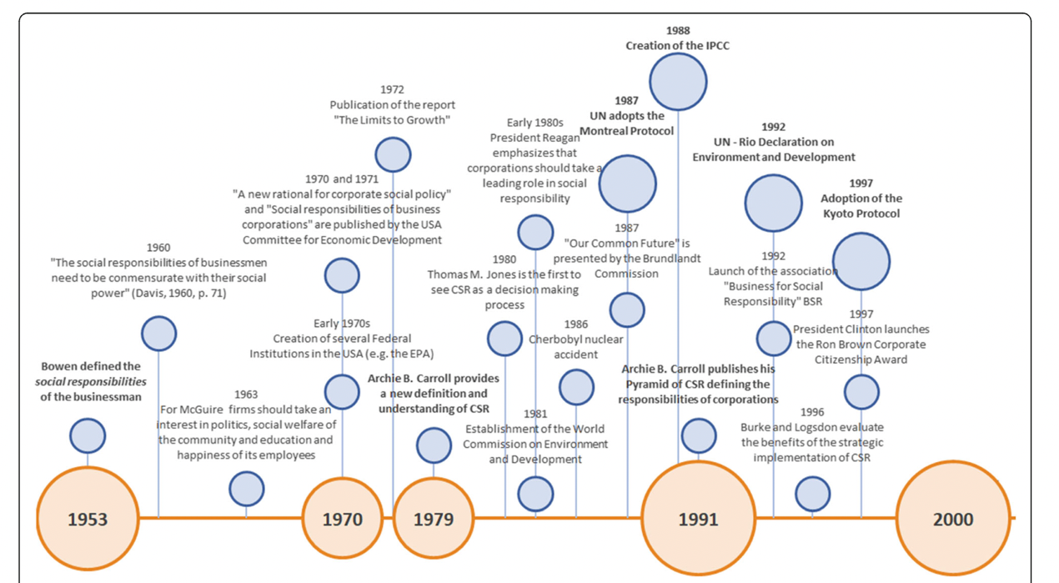
Figure 1(Latapí et al., 2019)

Figure 1 shows the overall development process of CSR. In 1953, Bowen first proposed the concept of a set of specific principles for enterprises to fulfill social responsibility (Latapí et al., 2019). He believes that the decisions and actions of businessmen not only affect their stakeholders, employees and customers, but also have a direct impact on the quality of life of society as a whole (Bowen, 1953). Bowen defined CSR as "the obligation of businessmen to pursue these policies, to make these decisions, or to follow a course of action that is desirable to the goals and values of society" (Bowen 1953, p. 6). Since the 1960s, scholars have regarded CSR as a response to modern social problems (Latapí et al., 2019). It is mainly due to the social, economic and political changes that make businessmen re-examine their role in society and the pressure to assume social responsibilities (Davis, 1960). Davis argues that businessmen have obligations to society in terms of economic and human values (Davis, 1960). He acknowledges that, to a certain extent, social responsibility can be linked to the economic returns of the firm (Carroll 1999; Davis 1960). As a result, modern business environments increasingly encourage the application or implementation of CSR concepts (Barauskaite and Streimikiene, 2021). This will encourage companies to operate professionally and focus on sustainability and protecting the planet while pursuing profits. (Eckert, 2017). According to the research, the implementation of the corporate social responsibility concept can help enhance the competitive advantage of enterprises, improve their reputation, ensure the stability of customers and the friendliness of investors. It can bring new economic benefits (Nibusinessinfo.co.uk. 2022). This means that corporate social responsibility can positively affect the corporate financial status and market value. With the demand of the market and society, CSR is becoming a part of business strategy (Barauskaite and Streimikiene, 2021). Companies represented by shareholders believe that their sole responsibility is to make shareholders profitable. However, nowadays, many scholars and entrepreneurs find that the social responsibility of a company goes beyond profit (Mele, 2008). Moreover, when enterprises focus on charity, moral and social issues, they actively spread their CSR achievements, which can significantly enhance their reputation and financial performance (Tang, Gallagher, and Bie 2015). For example, in July last year, heavy floods broke out in Henan Province of China. Among them, HongXing Erke Group Donated 50 million yuan in supplies, but its annual revenue is at a loss. After the customers learned the real situation, they went to hongxing Erke's shop for consumption, which brought new growth to the enterprise's finance (Kejie Yi. 2021). In 2001, the European Commission defined corporate social responsibility (CSR) as "enterprises integrate social and environmental issues into their business activities and interact with stakeholders on a voluntary basis" (Green Paper, 2001). The commission stresses that corporate social responsibility is not just to comply with local laws, but to undertake more obligations. Rather than reporting on corporate social responsibility, companies invest in their own future with the expectation that their voluntary commitments will help improve profitability directly or indirectly (Audrey and Romiena 2009). Lantos (2001) believes that fulfilling social responsibility is a necessary behaviour. Quazi and O’Brien (2000) believe that solving social problems should consider economic benefits. Porter and Kramer (2006) both show that companies have an obligation to do the right thing. However, at present, the governments of many countries have issued relevant laws and regulations requiring enterprises to issue social responsibility reports (Lin, 2020). The government believes that such enforcement will help companies better fulfill their social responsibilities (Gov, 2014). In the UK, for example, regulations require all listed companies to show ethical, social and environmental risks in their annual reports （Lin, 2022.）. As a result, most corporate social responsibility reports include environment, sustainability, employee welfare and so on in order to inform stakeholders of the relevant content and activities. Firstly, through CSR report, stakeholders outside the enterprise can understand how the enterprise is responsible for social problems (R and Heather, 2018). This means that the corporate social responsibility is open, through the report to inform the public of their plans and how to implement the steps (Business Insights Blog, 2019). Secondly, they can understand that some unacceptable behaviours will bring substantial financial risks to the enterprise (Frc, 2014.). The shareholders of a business value the growth of the business because it means how much money it directly brings to them. Finally, from a strategic point of view, corporate social responsibility can promote significant social progress because companies use resources and expertise in activities that benefit society (JASON, 2022).

Theoretical basis
Incorporate social responsibility, in addition to the relevant social issues, the company's stakeholders are the next concern. Because the interests of the company will directly affect them. Stakeholders are groups affected by the company's interest behaviour, and they usually have a particular influence on the enterprise (Du et al., 2010). Figure 2 is the stakeholders proposed by Edward Freeman, who divides them into external and internal. In his opinion, external stakeholders include suppliers, governments customers shareholders, society and stakeholders. Internal stakeholders include employees, manager and owners (Tang, Gallagher, and Bie 2015).
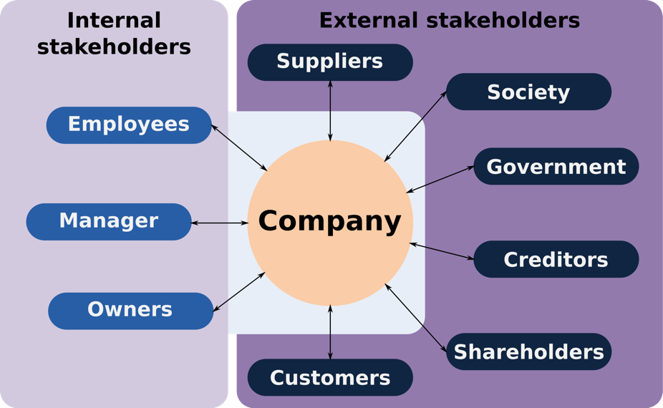
Figure2 (Laplume, 2008)

Edward Freeman argues that stakeholder groups need to be identified before a decision can be made that takes them into account. Therefore, the Edward’s stakeholder theory needs to determine all stakeholder groups when considering or deciding a business decision (Heath, and Norman, 2004). In addition to being responsible for its own stakeholders, the enterprise also needs to be responsible for external stakeholders. Often these external stakeholders can influence the development of an enterprise (Waddock, 2000). For example, whether the policies of the local government are favorable to the business (e.g., tax exemption policy) (Luo, Xue, and Han, 2010). The case of Hongxing Erke Group mentioned above can well prove that the purchasing power of consumers will directly affect the finance of enterprises.

Most companies consider CSR as a form of investment (McWilliams and Siegel, 2001). They believe that they can maximise profits while meeting stakeholders' needs for CSR (Werther, and Chandler, 2005). However, in fact, when enterprises undertake social responsibility, their return is far greater than the input (Du et al., 2010). No more than that, CSR has different goals and priorities in different industries. Carroll once proposed that corporate social responsibility has four specific responsibilities: economic, legal, moral and charitable (Carroll,1979). These four representatives have specific responsibilities; however, they depend on each other (Pineda, 2018). In different situations, corporate social responsibility is also different. For example, the social responsibility of non-profit organizations is mainly to improve social welfare (Melo and Galan, 2011). And business priorities are different in developed and developing countries. Social responsibility in developing countries mainly relates to national socio-economic development issues such as education, health, child Labour and human rights (Muhammad and Craig, 2008). For example, in China, people are very concerned about the education of young people. It is common for Chinese parents to focus on their children's education, which leads to too much competition for their children. In order to reduce the physical and mental health of children under the age of 16, the government has issued a "double reduction policy" to reduce the pressure on children (Li, et al., 2021). However, as a populous country, China is bound to choose the best because of demographic factors. Therefore, enterprises still have a great responsibility in the social responsibility of education in developing countries. In developed countries, CSR mainly includes climate change, environment, sustainable development, gender equality, work-life balance, etc. (Kvasničkova et al. 2020). Through these data, it can be found that corporate social responsibility is different in different situations. As a result, there is still no consensus on the most appropriate theoretical classification for CSR research. However, based on the review of previous CSR theoretical perspectives and through the conceptual framework of Mellahi et al. (2016), a new approach can be developed (Figure 3).
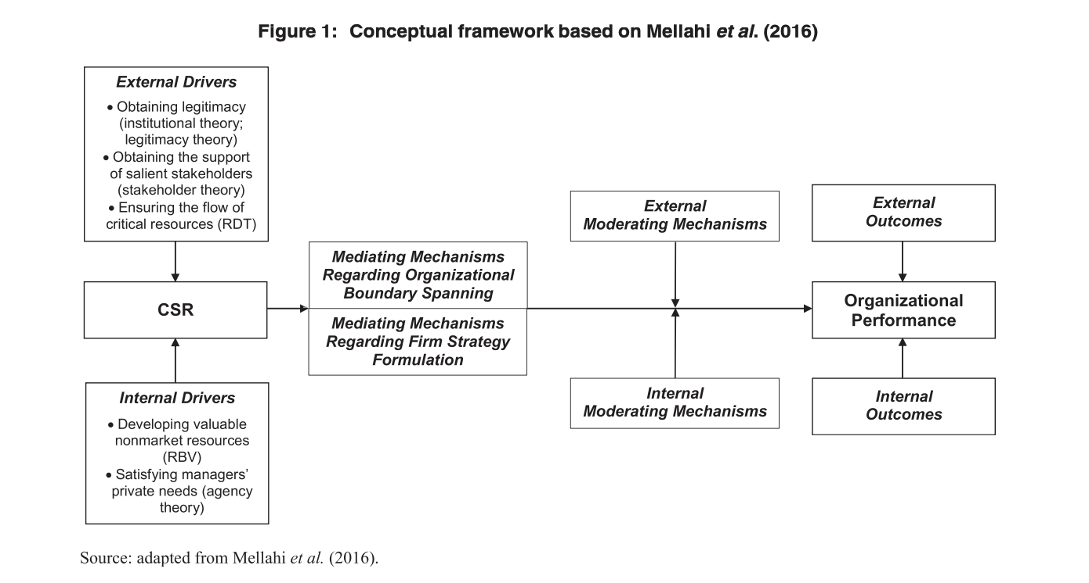
Figure 3 (Frynas and Yamahaki, 2016)

Figure 3 shows that Mellahi et al. (2016) emphasize that theoretical perspectives are interdependent and that problems are diverse in non-market environments (e.g., political, social). Therefore, at least one theory related to external drives and one theory related to internal drives should be applied in the multi-theory perspective (Frynas and Yamahaki, 2016). Figure 3 shows that externally driven theories include stakeholder theory, institutional theory and resource dependency theory (Hessels, and Terjesen, 2010). These external driving theories are more suitable for focusing on the relationship between enterprises and society. Because these theories emphasise the relationship with external actors or emphasize the role of external actors in conveying relevant management practices to the enterprise (Geels, 2011). Internal driving theory focuses on processes within organisations (Frynas and Yamahaki, 2016). Therefore, internal drive theory is more suitable for analysing social and environmental problems. Because these questions are more focused on understanding management within the organisation and individual social values (Camilleri, 2017). Moreover, they believe that there is at least one external driver theory or internal driver theory for social, environmental or market problems. Such an idea is very similar to the classification of previous scholars (Frynas and Stephens, 2015).

These theories all indicate that managers need to make positive choices about CSR practice in different ways. All of these theories require managers to consider whether CSR is related to the economic value creation of enterprises or to the personal beliefs and interests of individual decision-makers when making decisions (Mei, 2016).

Institutional theory
The institutional theory holds that firms conform to social norms in a given business environment (Henrich and Linda, 2015). Companies often listen not to external actors but to conventions. For example, a particular way of doing things for a long time or as it should be done (Kauppi and Hannibal, 2017). Generally, it can be divided into three ways: 1) Economic methods, which mainly regulate the essential supporting role of economic activities. 2) Sociological methods, mainly to determine the legitimacy of the system. 3) Comparative institutional methods are mainly used to define capitalist economies and shape the differences between economic organisations and enterprise competitiveness systems (Hotho and Pedersen, 2012). Studies show that environmental management and social institutions are the factors that influence corporate social responsibility behaviour (Zelazna, Bojar, and Bojar, 2020). When firms in the same industry face institutional pressures, their strategies and practices become very much the same in a stable environment (no war, economic stability, policy is convenient) (Fransen, 2013). A significant advantage of institutional theory over other theories is that it allows CSR to be studied as a social institution and as a governance model in society and economy (Brammer et al., 2012). Treating CSR as an institution within a broader governance system can broaden the scope of CSR research, integrate it into other social science disciplines and further develop the overall scientific theory.

Legitimacy theory
Legitimacy theory is defined as "a general perception or assumption that an entity's behaviour is desirable, appropriate, or appropriate within some socially constructed system of norms, values, beliefs, and definitions.” (Suchman, 1995, p. 574). The premise of legitimacy theory is that enterprises operate on the basis of a contract with society. Society needs to recognise or give legitimacy to enterprises to avoid the negation of social goals. Companies get certain rewards from society and can survive. According to the theory of legitimacy, enterprises and society are closely linked. There is no unique high or low power between them, only to the extent that society gives them legitimacy. Therefore, corporate activities must be legalised in order to maintain consistency between social goals and corporate goals (Deegan, 2002). Academically, legitimacy is studied in two ways: strategic and institutional. The strategy has a certain degree of management control over the legalisation process. Legitimacy is the inspiration of stakeholders to resource dependency theory. This theory emphasises the importance of resources and the need for management to pay attention to relevant stakeholders (Milne and Patten,2002). As a result, legitimacy is considered a resource that stakeholders outside the firm grant. The strategic approach of legitimacy theory has been widely used in various studies (Craig, 2019). It is mainly to solve how to narrow the gap between social expectation and business practice after enterprises' social responsibility is announced (Magness, 2006). Legitimacy theory research shows that companies use various means to bridge such gaps, such as philanthropy (Lanis and Richardson 2013). In an institutional way, legitimacy is obtained through the joint construction of enterprises and the social environment (Tracey, Phillips, and Jarvis, 2011). It can be seen from these two approaches that different challenges to legitimacy require different strategies.

Resource dependence theory
The theory suggests that firms are dependent on their environment to ensure their survival. Therefore, enterprises must pay attention to the needs of those in their environment, which provide the resources for their own survival（Mitchell, Agle, and Wood, 1997). However, the theory was developed initially to understand the relationships between and within firms (Carpenter, Pollock, and Leary, 2003). However, people find that the Resource dependence theory can be easily applied to the relationship between enterprises and different types of institutions (Julian et al., 2008). The dependence theory emphasises the role of the board of directors as the essential Resource to ensure the operation of the company (Mallin et al., 2013). As enterprises need to exchange resources with other related industries, relevant studies have found that the exchange of resources with important external groups can effectively improve the performance of enterprises (Ramanathan et al., 2014).

Resource dependence theory is about the study of the external drive. In the resource-based view of internal drive, the theory is that enterprises can have a sustainable competitive advantage under specific resources. It is mainly because enterprises obtain equivalent exchange through valuable and unique resources (Kraaijenbrink et al., 2010). CSR can be thought of as an investment in a company's capabilities (Bhardwaj et al., 2018). This is to make the company stand out from its competitors and improve its status. The resource-based view can help enterprises develop and utilise social and environmental problems to obtain corresponding economic benefits (Hart, and Dowell, 2011). However, some studies have shown that CSR-related capabilities (such as innovation or sustainable development) can bring new competitive advantages to enterprises (Lourenco et al., 2014).

Another internal driving factor theory is Agency theory. The theory is mainly concerned with the relationship between "principal" and "agent". Agency theory is often applied to extensive, open relationships between owners and managers. For example, employers and employees, suppliers and buyers (Frynas and Yamahaki, 2016). Agency theory can solve the related "agency problem". For example, an exciting subject and a principal cannot effectively monitor their agent's behaviour. Friedman (1962) believes that Agency theory is the self-interested behaviour of corporate social responsibility (CSR) on behalf of managers (agents), whose main purpose is to pursue ultra-low profits without considering social and environmental issues, and ultimately to harm shareholders (principals). However, the agency theory has a significant disadvantage in that it can only provide a partial explanation of corporate social responsibility. As a result, the agency theory needs to be combined with other related theories in later development.

This paper mainly studies the CSR of social media platform enterprises. Since all social media are for-profit organisations, the author selected Facebook, Bytedance (TikTok) and Twitter after multiple checks. The three social media companies were studied.

Due to the emergence of social media services in recent years, the relevant social responsibility theory is not very perfect. Uses and Gratifications Theory (UGT) are used to support social media services (Chen et al., 2021). UGT believes that audiences can find information to meet their own needs through the media. This theory holds that audiences restrict the process of media communication through their active use of media and points out that the use of media is entirely based on individual needs and desires (Kaur et al., 2020). Uses and Gratifications Theory was originally an analysis of traditional media. As social media is a part of media, the application of this theory in social media is also possible. The main reason is that the Uses and Gratifications Theory can explain and predict personal behaviours in social media (Leung, 2013). After a lot of studies, it is confirmed that the Uses and Gratifications Theory is applicable to social media, and it can meet people's requirements on social media (Lee & Ma, 2012; Leung, 2013). Therefore, Uses and Gratifications Theory can be applied to the relationship between social media and audiences (Chen et al., 2021).

There are also controversies about ethics related to social responsibility in social media enterprises, mainly whether philosophical "ethics" can standardise and criticise social media. However, Plato divided the moral impact of social media services into three categories: 1) the direct impact of social network activities themselves; 2) It is that enterprises support some potential destructive business behaviours for the purpose of marketing and other activities, leading to its related stakeholders indirectly affected; 3) social media is a new society, whether there are some unfair behaviours, it is easy to have some structural impact (Plato, 2012). Some researchers argue that online social media tends to create a culture. In such cultures, deprivation of personal beliefs and behaviours can have permanent consequences, which can disconnect virtual people from their social identities in the real world (JANNA AND LEE, 2018). As a result, Dreyfus (2002) argues that there can be no real commitment or fulfilment of responsibility in a virtual world. For example, since the outbreak of the COVID-19 pandemic in 2020, various types of misinformation online have seriously affected the public's perception of the danger and transmissibility of the virus (Royal Society Open Science, 2020). Moreover, prevention efforts have been overshadowed by online conspiracy theories, which have greatly hampered public health efforts (Marie and Frederick, 2021). However, with the development of science and technology, social media continued to move forward and promoted a series of new philosophical studies in the field of social epistemology and ethics (Plato, 2012). Regina Rini(2017) argues that the issue of false online information, personal morality and cognitive responsibility, and the responsibility of social media platforms themselves cannot be considered from the perspective of individual cognition but must be regarded as "the tragedy of the cognitive Commons", which requires practical solutions. The age of social media has ushered in a new ethic. In virtual worlds, individuals and communities are built, executed and managed (Parsell 2008).

Section 2
Content analysis is a qualitative research tool, mainly to analyse and determine some unique words, themes, or concepts in the text (Schreier, 2012). Use content analysis to quantify and analyse the relationships between particular words, topics, concepts, etc. The data source for content analysis can be any communicative language (like books, news, reports, media) (Publichealth.columbia.edu, 2022). When using Content Analysis, it is necessary to determine the intention of the research subject (Bengtsson, 2016). Have a deep understanding of the research subject; Cultural differences should be taken into account in the content of research. The content analysis itself comes in two types: conceptual and relational (Bizhan, 2020). Concept analysis is the frequency with which a particular concept appears or exists in a particular article (Furner, 2004). The relational analysis is a further development of the relationship between researchers through conceptual analysis (Publichealth.columbia.edu, 2022). Concept analysis will use specific dimensions to analyse CSR.

In order to convert the data observed in the content analysis into valid data and make the results more intuitive. Kao et al. (2018) divided CSR into 12 categories based on the internal and external drivers of CSR: “Corporate Governance and ethical value; The Employee Growth; Environmental Management and Protection; Energy Saving and Reduction; Sustainable Development; The Product Quality Control; Protection of Consumer Equity; Supply Chain Partnership; Promotion technological Development; Tax Contribution. Scientific Responsibility Management System; Sound Corporate Image”. This paper will learn from and develop these 12 categories to adapt to the CSR research of these three social media platform companies. Due to the global scope and nature of social networks, stakeholders are diverse. The analysis of these three enterprises is carried out through the stakeholder theory in the Literature review above. Among them, drivers selected are obtained according to the nature of social media and relevant data shown in CSR reports of the three companies: Users, governance, Employee, environment and Age of organisation (The length of time can be used to determine the influence of the enterprise in society) and Mission which includes CSR statements. Relevant data have been sorted out in the following table, and the CSR content of the three enterprises can be found in the appendix.

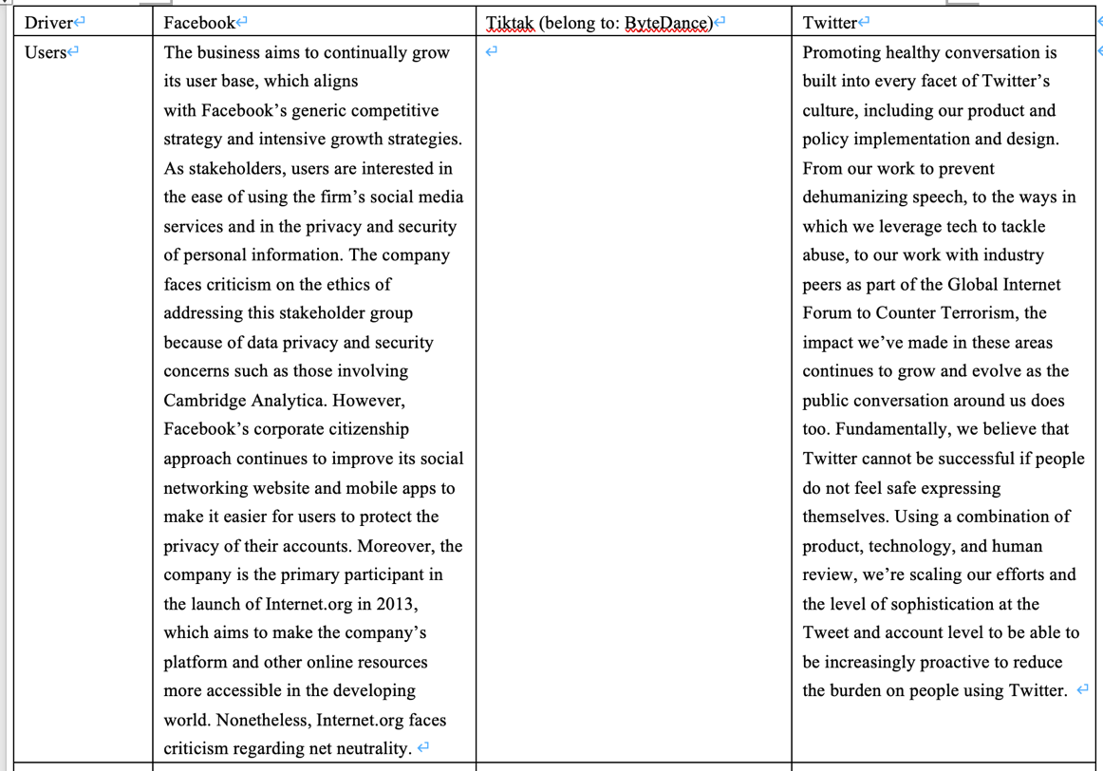
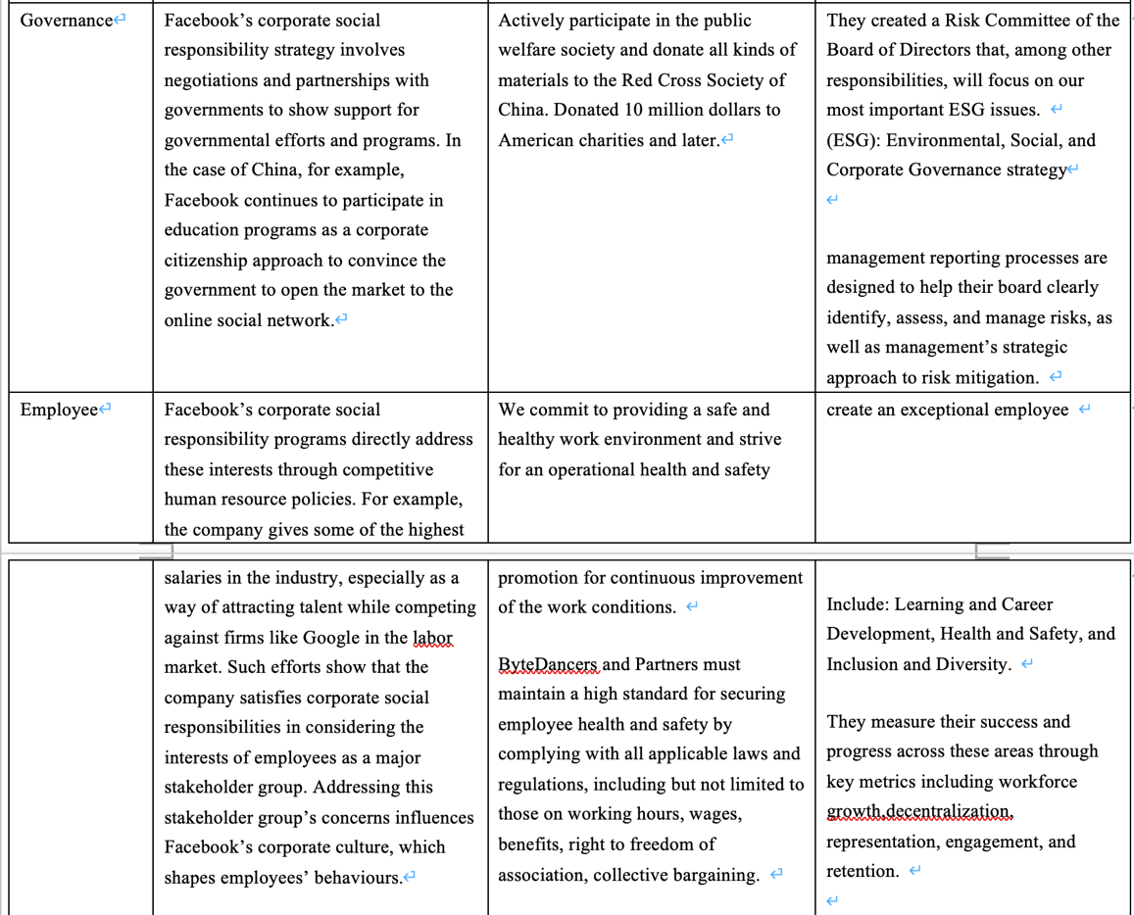
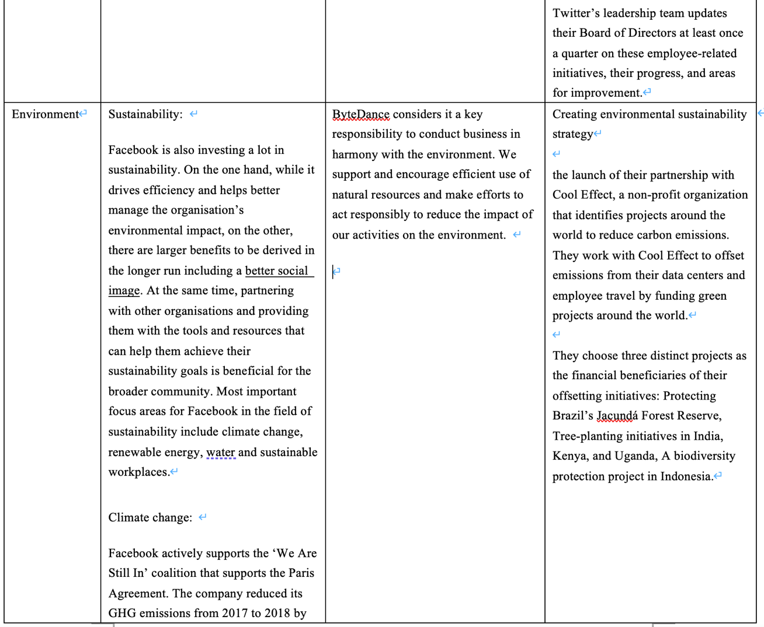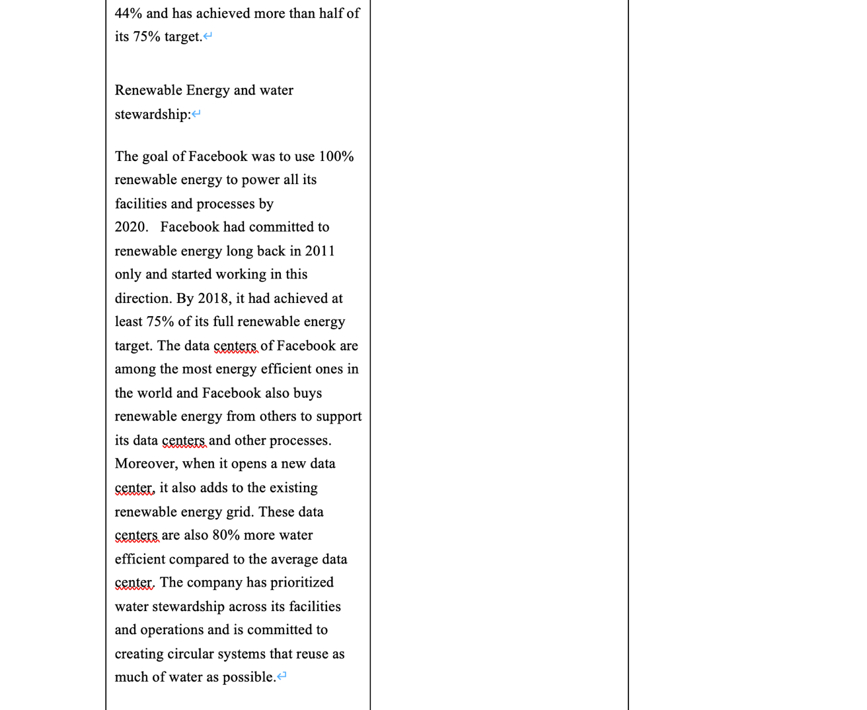
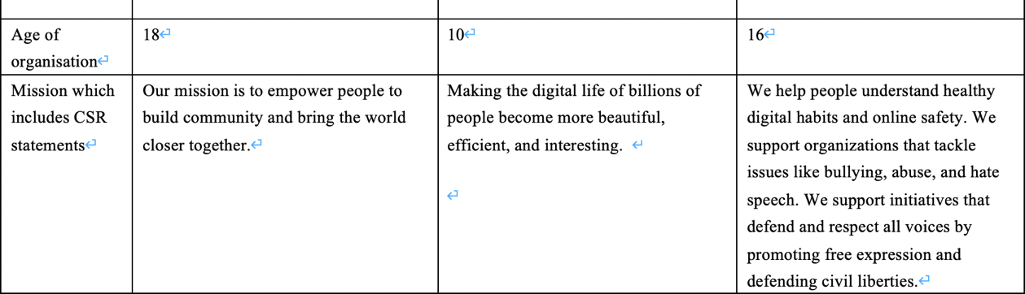

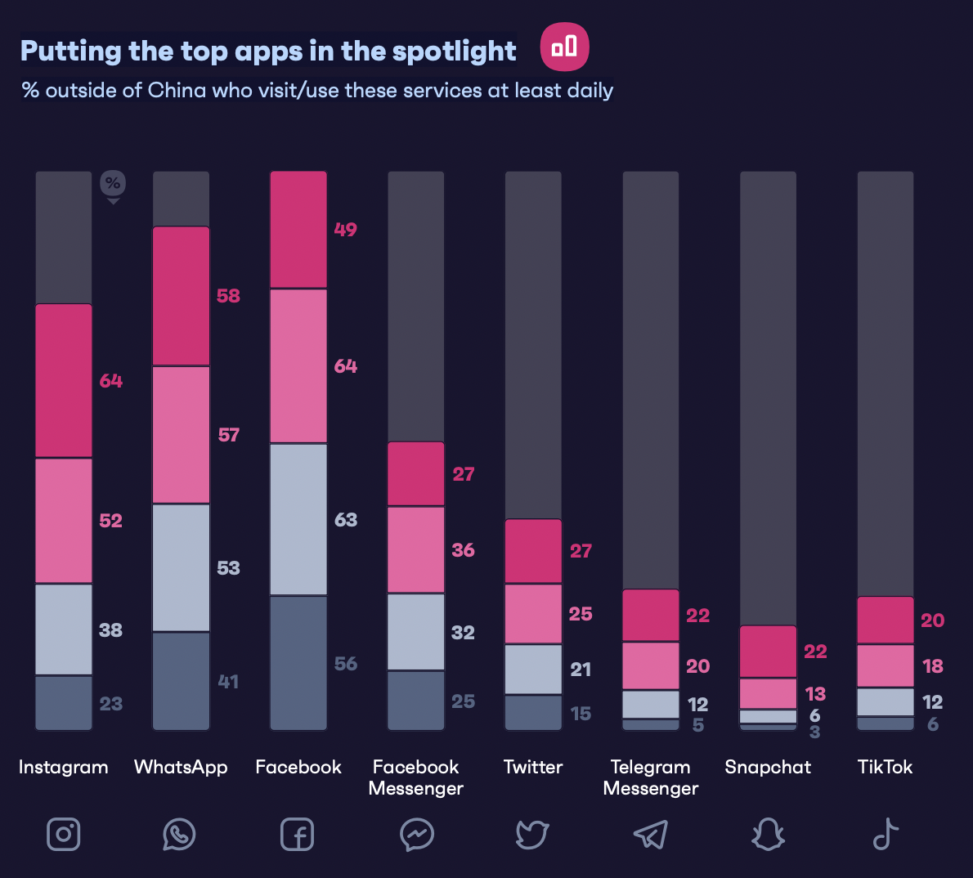
Figure 4 (GWI. 2022)

According to GMI data, Facebook is the most used site. Instagram, which shares pictures and text, has the most users. Tiktok was chosen because it is currently the only social app on the market for sharing short videos (Gwi.com. 2022). Facebook and Twitter are American companies, while ByteDance, TikTok's parent company, is Chinese. Since CSR has not been developed for a long time in China, the relevant information is not perfect. However, according to Yiming, ByteDance's global CEO, ByteDance has established the CSR department, which he personally manages, with the primary purpose of leading and developing ByteDance's global strategy. To support the company's tremendous global growth, as well as corporate social responsibility efforts and new businesses such as education (Bytedance.com. 2020).

Through table content and correlation analysis, the author integrates and further analyses the 12 dimensions mentioned above, as follows:

Corporate Governance and ethical value
With the development of technology, using social media platforms is the choice of more and more people. This also means that the values and morals of the society in the virtual network are constantly being challenged. Furthermore, that's a new responsibility for companies on social media platforms. They must act according to corresponding moral values. This is a necessary part of corporate strategy (Carroll, 2008).

Facebook
As shown in the table, Facebook's CSR for the government includes cooperation and negotiation to show the company's support for the local government. In this report, only the communication with the government is shown. However, the improvement of social morality is not shown (Milton, 2019). For example, how to prevent people from "addiction". Internet companies are lacking in moral values (Plato, 2012). Therefore, managers need to strengthen their thinking in this aspect so as to help enterprises win recognition and respect from users in terms of values (Houssem, Nadia and Kaouther，2020).

ByteDance
According to the table, ByteDance spends 10 million dollars on charity. There has been little other co-operation with the government (Bytedance.com. 2020). The number of TikTok users has exceeded hundreds of millions around the world (Business of Apps. 2022). There is no moral constraint with such a vast user base, and many people's videos will have some moral problems. This requires ByteDance to actively cooperate with the government, introduce relevant policies, and contribute to jointly maintaining a harmonious and beautiful network environment. Because, as the platform used by users, from its own point of view, it needs to bring corresponding services to users and assume relevant responsibilities (von Hippel, 2001).

Twitter
On the table, Twitter said it had created a Risk Committee of the Board of Directors, which sets strategy on environmental, social and corporate governance issues. Compared with the previous two companies, Twitter seems to be relatively well-developed in terms of moral values and direct cooperation with the government. Through communication with the government through specialised departments within the company, some problems can be solved well. Under the policy and moral values, enterprises need to improve the transparency of stakeholders and let stakeholders know their plans so as to improve better the value of enterprises (Colleoni, 2013). Users expect CSR to make changes and contributions not only for corporate interests but also for society and the environment (Matute-Vallejo, Bravo, and Pina, 2011). Therefore, there is a greater need to understand how the enterprise develops its strategic plans in accordance with the needs of society (Suarez-Rico; Gomez - Villegas; Garcia-benau, 2018).

Employee
Facebook
Pratap says Facebook uses competitive hr policies to grow its employees and as a way to attract talent (Pratap, 2021). However, if pure competition may lead to some bad behaviour does not appear, for example, corruption. Therefore, in addition to the necessary competition, it is also necessary to strengthen the welfare of employees and improve their satisfaction in the company.

ByteDance
ByteDance has some relatively good practices in employee welfare. For example, to provide a safe and healthy working environment and continuously improve staff's working conditions. This is very pleasing for the employees. Because a comfortable office environment will make everyone happy, and it will improve work efficiency (Bytedance.com. 2020).

Twitter
As you can see from the table, Twitter's employee growth is positive. This shows that fewer people are leaving and that employees are satisfied with the company. That's because Twitter helps employees grow and advance in all aspects of their career path. They even have a team that reports quarterly to the CEO to help employees get promoted faster.

Sustainable Development
Facebook
Facebook has invested heavily in Sustainable Development (facebook CSR report 2019). This kind of behaviour is mainly to improve Facebook's public image. Although the cost is too high, it is appropriate for corporate image and social responsibility. So, it is desirable for Facebook to put in more than it produces.

ByteDance
In terms of sustainable development, Bytedance chose to set up a corresponding department to improve this direction and consider it an important responsibility (Bytedance.com. 2020). They are trying to take action. However, there is currently no information posted on the Internet about Bytedance.

Twitter
Twitter has an advantage when it comes to Sustainable Development. They chose to work with a nonprofit organisation called Cool Effect. They chose projects to reduce carbon emissions around the world to offset the carbon emissions generated by their data centres and employees. Although this may seem like a bit of an overkill, it would be more effective for employees to cut down on office paper (double-sided printing) and turn off the lights when they leave work. However, projects to mitigate carbon emissions still make sense.

Technological Development
With the rapid development of technology, Facebook came up with the concept of the Metaverse (Nover, 2022); Bytedance has chosen to enhance AI usage further (Jason, 2019). However, there are still big questions about user privacy.

In 2018, There was a scandal at Facebook about a massive leak of user data. Facebook has even granted certain companies the right to gain access to users' privacy in return for compensation and benefits. Despite what Facebook Later said, this behaviour is meant to make it easier for users to access it on other platforms. However, that does not help users' distrust of Facebook and fear of privacy violations (ERIC Jhonsa., 2018). Another way is about Internet addiction, which makes it difficult for people to leave quickly after they open Facebook (Busalim, A.H., Masrom, and Binti 2019). To avoid the above problems, Facebook needs to further develop its technology, such as a better system on user privacy to reduce unnecessary related links. In terms of Internet addiction, it is necessary to limit login time and reduce people's dependence behaviour (Wolniczak et al., 2013).

Summary
A business needs to be accountable to its stakeholders and society. Because the growth of enterprises cannot do without these factors, some studies show that after enterprises undertake social responsibility, different stakeholders will pay attention to it. Their attention can change the overall evaluation and value of the company (Jesús et al., 2016). However, there are still other motivations for enterprises to implement social responsibility, such as brand value enhancement, relationship building, preferential policies and resource increase, which play an essential role in promoting enterprises' economic activities in the future (Zhang et al., 2019). As a result, enterprises need to pay more attention to CSR related activities. In terms of the environment, further energy conservation and emission reduction are needed to protect the environment; In terms of employee growth, excellent promotion conditions should be provided for them in order to retain better and cultivate talents; For Internet enterprises, the most important thing is about users' privacy rights and interests. At the same time, they were improving various technologies to protect users' privacy and prevent them from being harassed by hackers. These are all things that enterprises need to consider when formulating strategies.

Section 3
Conclusion
Through the research on the corporate social responsibility reports of the three social media companies selected above, it is found that they have taken corresponding measures for the environment, employees, sustainability and the government. For example, there are corresponding schemes for carbon emissions, climate change, deforestation, and waste of available water resources in environmental issues.

All enterprises express that they will set up social responsibility departments to develop their social responsibility strategies. In practice, managers find that special departments are needed to deal with problems related to employment policies, human rights, users and equality. Otherwise, it will have a significant impact. However, the influence of external stakeholders such as the government will significantly increase the uncertainty of enterprises. Therefore, special departments are needed for communication and coordination (Quarshie and Leuschner, 2016).

While social media platforms have changed in many ways, the impact of these changes on the broader public interest remains unclear. The legalisation of personal information on its platform is still a controversial topic (She and Michelon, 2019). Through the information spread on social media, its stakeholders may gain more power, and the expression of information to the broader public will have adverse effects (Napoli, 2015).

Recommendation
Legislation
The government needs to strengthen the accountability system of social media platforms (Kemper & Kolkman, 2018). When problems such as user privacy leakage, cyber violence, hacking attacks and human rights occur on the platforms, it can be judged as the poor supervision of the platforms. In the future, the government will need to punish these misdeeds jointly. The government, as a policymaker, should attach importance to draft bills and conduct regular research on the needs of relevant enterprises so as to regulate corporate social responsibility (Amlys et al., 2021).

The enterprise itself must comply with all applicable laws and regulations, such as the laws and regulations concerning employee human rights, employee welfare, users' right to know, and responsibilities to be performed by the enterprise.

Research shows that social media is still essentially one-way communication. There is a lack of honest communication between enterprises and stakeholders, so the inquiries and criticisms of stakeholders are often ignored (Colleoni, 2013). In this case, enterprises need to improve the feedback system so that the communication between stakeholders and enterprises can go smoothly.

Industry regulation
There must be leading enterprises in a big industry, which need to set up committees to regulate the whole industry in addition to self-regulation. The Committee needs to actively cooperate with the government to do an excellent job in industry supervision and strive to further the development of the industry under the leadership of the Committee.

Different from other industries, the particularity of the social media industry lies in the fact that the entire industry is in the virtual world, which means that many things are not authentic and lack evidence. As a result, there will be a lot of unethical things, such as hackers attacking computers, platforms accessing users' personal privacy, and even the government accessing citizens' information (Legal.thomsonreuters.com. 2022. Electronic Frontier Foundation. 2022). Many users report feeling they are being monitored. Therefore, whether relevant agencies or governments can access users' privacy needs a further ethical argument.

Between enterprises and users
For social media platforms, their customers are the users who use their products. Although these users are free to use, they bring a lot of wealth to the enterprises (Monfort, Villagra, and López, 2019). For example, advertisers serve ads (if there are no users, advertisers will not want to serve ads on the platform). As a result, under such circumstances, enterprises are required to improve the transparency of their social responsibility, especially when the social responsibility includes some information about values and moral commitment (Du et al., 2010). In addition, social media platforms need to provide users with direct channels to communicate with them (DiStaso et al., 2011). In fact, most social media are willing to communicate with stakeholders or provide some enterprise content through the platform (Dellarocas, 2003). In this way, user viscosity can be improved, and the interaction between enterprises and stakeholders can enhance the credibility of enterprises and increase their competitive advantages (Bilic, 2010).

Companies should consider some information when issuing CSR reports. For example: operating status of the company, corporate finance, local social activities, next development plan, participating public welfare projects. These can increase user interest, increase the company's appeal, and strengthen the relationship between the company and its stakeholders (Menon and Kahn, 2003).

References
Audrey T. and Romiena D. (2009) Corporate Social Responsibility (CSR) reporting: How are targets transformed into actions? [online] Available at: https://libstore.ugent.be/fulltxt/RUG01/001/392/330/RUG01-001392330_2010_0001_AC.pdf [Accessed 17 January 2022].

Amlys Syahputra Silalahi, Doli Muhammad Jafar Dalimunthe and Aryanti Sariartha Sianipar. (2021) Content Analysis of Corporate Social Responsibility (CSR) Activities of Companies Listed in Indonesia Stock Exchange. [online] Available at: https://www.scitepress.org/Papers/2019/92013/92013.pdf [Accessed 23 January 2022].

Aguinis, H. and Glavas, A. (2012) ‘What we know and don’t know about corporate social responsibility: a review and research agenda’. Journal of Manage- ment, 38(4), pp. 932–968.

Barauskaite, G. and Streimikiene, D. (2021) ‘Corporate social responsibility and financial performance of companies: The puzzle of concepts, definitions and assessment methods’, Corporate social-responsibility and environmental management, 28(1), pp. 278–287. doi:10.1002/csr.2048.

Barnett, M.L. (2014) ‘Why stakeholders ignore firm mis- conduct: a cognitive view’. Journal of Management, 40(3), pp. 676–702.

Barbosa, M.W. and de Oliveira, V.M. (2021) ‘The Corporate Social Responsibility professional: A content analysis of job advertisements’, Journal of cleaner production, 279, p. 123665–. doi:10.1016/j.jclepro.2020.123665.

Baskentli, S. et al. (2019) ‘Consumer reactions to corporate social responsibility: The role of CSR domains’, Journal of business research, 95, pp. 502–513. doi:10.1016/j.jbusres.2018.07.046.

Bowen, H. R. (1953) Social Responsibilities of the Businessman. [online] Available at: https://www.google.co.uk/books/edition/Social_Responsibilities_of_the_Businessm/ALIPAwAAQBAJ?hl=en&gbpv=1&dq=Bowen,+H.+R.+(1953).+Social+responsibilities+of+the+businessman.+University+of+Iowa+Press.&pg=PT5&printsec=frontcover [Accessed 14 March 2022].

Bilic, I. (2010) “Development of web corporate communications function by official web sites and value added ranking: Case of Croatia”. The business review, [online] Available at: https://bib.irb.hr/datoteka/479324.Paper_Bilic_Ivana_Feb._3_10_New_Yohttps://bib.irb.hr/datoteka/479324.Paper_Bilic_Ivana_Feb._3_10_New_York_10_May_Formated.doc rk_10_May_Formated.doc [Accessed 28 January 2022].

Busalim, A.H., Masrom, M. and Binti Wan Zakaria, W.N. (2019) ‘The impact of Facebook Addiction and self-esteem on students’ academic performance: A multi-group analysis’, Computers and education, 142, p. 103651–. doi:10.1016/j.compedu.2019.103651.

Business of Apps. 2022. TikTok Revenue and Usage Statistics. (2022) [online] Available at: https://www.businessofapps.com/data/tik-tok-statistics/ [Accessed 25 January 2022].

Brammer, S., Jackson, G. and Matten, D. (2012) ‘Cor- porate social responsibility and institutional theory: new perspectives on private governance’. Socio-Eco- nomic Review, 10(1), pp. 3–28.

Bytedance.com. (2020) Kelly Zhang and Lidong Zhang to lead ByteDance Business in China. [online] Available at: https://www.bytedance.com/en/news/5e6f3017679cb801f7524d8e [Accessed 24 January 2022].

Business Insights Blog. (2019) 5 Examples of Corporate Social Responsibility | HBS Online. [online] Available at: https://online.hbs.edu/blog/post/corporate-social-responsibility-examples [Accessed 16 March 2022].

Bengtsson, M. (2016) ‘How to plan and perform a qualitative study using content analysis’, NursingPlus Open, 2, p. 8–. doi: 10.1016/j.npls.2016.01.001.

Bizhan Romani. (2020) What Is Content Analysis? | Scientific Editing. [online] Available at: https://www.scientific-editing.info/blog/what-is-content-analysis/#:~:text=There%20are%20two%20types%20of,in%20a%20piece%20of%20content. [Accessed 20 March 2022].

Bhardwaj, P. et al. (2018) ‘When and how is corporate social responsibility profitable?’, Journal of business research, 84, pp. 206–219. doi: 10.1016/j.jbusres.2017.11.026.

Carroll, A. B. (2008) (PDF) A History of Corporate Social Responsibility: Concepts and Practices. [online] Available at: https://www.researchgate.net/publication/282746355_A_History_of_Corporate_Social_Responsibility_Concepts_and_Practices [Accessed 20 January 2022].

Camilleri, M. (2017) Corporate sustainability and responsibility: creating value for business, society and the environment. [online] Available at: https://ajssr.springeropen.com/articles/10.1186/s41180-017-0016-5 [Accessed 20 January 2022].

Carroll, A. B. (1979) ‘A Three-Dimensional Conceptual Model of Corporate Performance’, Academy of Management Review 4(4), 497–505.

Carroll, A.B. (1999) ‘Corporate Social Responsibility: Evolution of a Definitional Construct’, Business & society, 38(3), pp. 268–295. doi:10.1177/000765039903800303.

Carroll, A.B. (2016) ‘Carroll’s pyramid of CSR: taking another look’, International journal of corporate social responsibility, 1(1), pp. 1–8. doi:10.1186/s40991-016-0004-6.

Colleoni, E. (2013) ‘CSR communication strategies for organisational legitimacy in social media’, Corporate communications, 18(2), pp. 228–248. doi:10.1108/13563281311319508.

Chen, X. et al. (2021) ‘Research on Social Media Content Marketing: An Empirical Analysis Based on China’s 10 Metropolis for Korean Brands’, SAGE open, 11(4), p. 215824402110529–. doi:10.1177/21582440211052951.

CHRIS B. MURPHY. (2022) Why Is Social Responsibility Important to Some Businesses?. [online] Available at: https://www.investopedia.com/ask/answers/041015/why-social-responsibility-important-business.asp [Accessed 9 March 2022].

Cipd.co.uk. (2021) [online] Available at: https://www.cipd.co.uk/Export/ToPdf?path=%252fknowledge%252fstrategy%252fcorporate-responsibility%252ffactsheet [Accessed 8 March 2022].

Carpenter, M.A., Pollock, T.G. and Leary, M.M. (2003) ‘Testing a model of reasoned risk-taking: governance, the experience of principals and agents, and global strategy in high-technology IPO firms’, Strategic management journal, 24(9), pp. 803–820. doi:10.1002/smj.338.

Craig Michael Deegan (2019) ‘Legitimacy theory: Despite its enduring popularity and contribution, time is right for a necessary makeover’, Accounting, auditing & accountability journal, 32(8), pp. 2307–2329. doi:10.1108/AAAJ-08-2018-3638.

Da Silva Junior, A. et al. (2019) ‘Sustainability and corporate social responsibility in the opinion of undergraduate students in management programs: Between the concrete and the abstract’, Journal of cleaner production, 207, pp. 600–617. doi:10.1016/j.jclepro.2018.10.011.

Davis, K. (1960) ‘Can Business Afford To Ignore Social Responsibilities?’, California management review, 2(3), pp. 70–76. doi:10.2307/41166246.

Darnall, N., Henriques, I. and Sadorsky, P. (2010) ‘Adopting proactive environmental strategy: the influence of stakeholders and firm size’. Journal of Management Studies, 47(6), pp. 1072–1094.

Deegan, C. (2002) ‘Introduction – The legitimising effect of social and environmental disclosures – a theoreti- cal foundation’. Accounting, Auditing & Accountabil- ity Journal, 15(3), pp. 282–311.

Dellarocas, C. (2003) ‘The Digitization of Word of Mouth: Promise and Challenges of Online Feedback Mechanisms’, Management science, 49(10), pp. 1407–1424. doi:10.1287/mnsc.49.10.1407.17308.

Du, S., Bhattacharya, C.. and Sen, S. (2010) ‘Maximizing Business Returns to Corporate Social Responsibility (CSR): The Role of CSR Communication’, International journal of management reviews : IJMR, 12(1), pp. 8–19. doi:10.1111/j.1468-2370.2009.00276.x.

DiStaso, M.W., McCorkindale, T. and Wright, D.K. (2011) ‘How public relations executives perceive and measure the impact of social media in their organisations’, Public relations review, 37(3), pp. 325–328. doi:10.1016/j.pubrev.2011.06.005.

Dreyfus, H.L. (2002) ‘Anonymity versus commitment: the dangers of education on the Internet. [This paper is an earlier version of Dreyfus, Hubert. “Nihilism on the Information Highway: Anonymity vs Commitment in the Present Age”; in Dreyfus, Hubert. On the Internet (2001).]’, Educational philosophy and theory, 34(4), pp. 369–378. doi:10.1080/0013185022000011763.

Donaldson, T. and Preston, L.E. (1995) ‘THE STAKEHOLDER THEORY OF THE CORPORATION: CONCEPTS, EVIDENCE, AND IMPLICATIONS’, The Academy of Management review, 20(1), pp. 65–91. doi:10.5465/AMR.1995.9503271992.

Eckert, C. (2017) Corporate reputation and reputation risk: Definition and measurement from a (risk) management perspective. Journal of Risk Finance, 18(2), 145–158. https://doi.org/10.1108/JRF-06-2016-0075

Electronic Frontier Foundation. (2022) Government Hacking and Subversion of Digital Security. [online] Available at: https://www.eff.org/issues/government-hacking-digital-security [Accessed 28 January 2022].

ERIC JHONSA. (2018) The real impact of the constant stream of negative news about Facebook. [online] Available at: https://www.thestreet.com/opinion/facebook-negative-news-impact-14817872 [Accessed 24 January 2022].

Frynas, J.G. and Yamahaki, C. (2016) ‘Corporate social responsibility: review and roadmap of theoretical perspectives’, Business ethics (Oxford, England), 25(3), pp. 258–285. doi:10.1111/beer.12115.

Frynas, J.G. and Stephens, S. (2015) ‘Political corporate social responsibility: reviewing theories and setting new agendas’. International Journal of Management Reviews, 17(4), pp. 483–509.

Frc.org.uk. (2014) [online] Available at: https://www.frc.org.uk/getattachment/d672c107-b1fb-4051-84b0-f5b83a1b93f6/Guidance-on-Risk-Management-Internal-Control-and-Related-Reporting.pdf [Accessed 15 March 2022].

Friedman, M. (1962) Capitalism and Freedom. Chicago, IL: University of Chicago Press.

Furner, J. (2004) ‘Conceptual Analysis: A Method for Understanding Information as Evidence, and Evidence as Information’, Archival Science, 4(3), pp. 233–265. doi:10.1007/s10502-005-2594-8.

Gwi.com. (2022) About us - Our Story, What We Do and Who We Are - GWI. [online] Available at: https://www.gwi.com/about-us [Accessed 21 March 2022].

Geels, F.W. (2011) ‘The multi-level perspective on sustainability transitions: Responses to seven criticisms’, Environmental innovation and societal transitions, 1(1), pp. 24–40. doi:10.1016/j.eist.2011.02.002.

Gov.uk. (2014) [online] Available at: https://assets.publishing.service.gov.uk/government/uploads/system/uploads/attachment_data/file/300265/bis-14-651-good-for-business-and-society-government-response-to-call-for-views-on-corporate-responsibility.pdf [Accessed 16 March 2022].

Green Paper, (2001) “Promoting a European framework for Corporate Social Responsibility”, Commission of the European Communities, COM (2001), 366 final.

Hart, S.L. and Dowell, G. (2011) ‘Invited Editorial: A Natural-Resource-Based View of the Firm: Fifteen Years After’, Journal of management, 37(5), pp. 1464–1479. doi:10.1177/0149206310390219.

Houssem Edine Nasr, Nadia Eleuch Mhiri and Kaouther Saied Benrached (2020) ‘FACEBOOK AND CSR: IS THERE A CONCORDANCE?’, International journal of entrepreneurship, 24(5), pp. 1–3.

Henrich R. Greve, Linda Argote, (2015) Welcome. [online] Available at: https://www.sciencedirect.com/topics/social-sciences/institutional-theory/pdf [Accessed 17 March 2022].

Heyward, C., (2020) Council Post: The Growing Importance Of Social Responsibility In Business. [online] Forbes. Available at: https://www.forbes.com/sites/forbesbusinesscouncil/2020/11/18/the-growing-importance-of-social-responsibility-in-business/?sh=5ed1f5452283 [Accessed 8 March 2022].

Heyward, C. (2020) Council Post: The Growing Importance Of Social Responsibility In Business. [online] Forbes. Available at: https://www.forbes.com/sites/forbesbusinesscouncil/2020/11/18/the-growing-importance-of-social-responsibility-in-business/?sh=1686bbc42283 [Accessed 9 March 2022].

Heath, J. and Norman, W. (2004) ‘Stakeholder Theory, Corporate Governance and Public Management: What Can the History of State-Run Enterprises Teach Us in the Post-Enron Era?’, Journal of business ethics, 53(3), pp. 247–265. doi:10.1023/B:BUSI.0000039418.75103.ed.

Hessels, J. and Terjesen, S. (2010) ‘Resource Dependency and Institutional Theory Perspectives on Direct and Indirect Export Choices’, Small business economics, 34(2), pp. 203–220. doi:10.1007/s11187-008-9156-4.

JANNA ANDERSON AND LEE RAINIE, (2018) Stories From Experts About the Impact of Digital Life. [online] Available at: https://www.pewresearch.org/internet/2018/07/03/the-negatives-of-digital-life/ [Accessed 22 January 2022].

Jason Davis. (2019) The TikTok Strategy: Using AI Platforms to Take Over the World. [online] Available at: https://knowledge.insead.edu/entrepreneurship/the-tiktok-strategy-using-ai-platforms-to-take-over-the-world-11776 [Accessed 26 March 2022].

JASON FERNANDO. (2022) Corporate Social Responsibility (CSR) Definition. [online] Available at: https://www.investopedia.com/terms/c/corp-social-responsibility.asp [Accessed 16 March 2022].

Julian, S.D., Ofori-Dankwa, J.C. and Justis, R.T. (2008) ‘Understanding strategic responses to interest group pressures’. Strategic Management Journal, 29(9), pp. 963–984.

Jesús Barrena Martínez, Macarena López Fernández and Pedro Miguel Romero Fernández (2016) ‘Corporate social responsibility: Evolution through institutional and stakeholder perspectives’, European journal of management and business economics, 25(1), p. 8–. doi:10.1016/j.redee.2015.11.002.

Kauppi, K. and Hannibal, C. (2017) ‘Institutional pressures and sustainability assessment in supply chains’, Supply chain management, 22(5), pp. 458–472. doi:10.1108/SCM-01-2017-0004.

Kaur, P. et al. (2020) ‘Why do people purchase virtual goods? A uses and gratification (U&G) theory perspective’, Telematics and informatics, 53, p. 101376–. doi: 10.1016/j.tele. 2020.101376.

Kao, E. H. et al. (2018) ‘The relationship between CSR and performance: Evidence in China’, Pacific Basin Finance Journal, 51(June 2016), pp. 155–170. doi: 10.1016/j.pacfin.2018.04.006.

Kuo, L., Yeh, C. C. and Yu, H. C. (2012) ‘Disclosure of Corporate Social Responsibility and Environmental Management: Evidence from China’, Corporate Social Responsibility and Environmental Management, 19(5), pp. 273–287. doi: 10.1002/csr.274.

Kvasničková Stanislavská, L. et al. (2020) ‘Corporate Social Responsibility and social media: Comparison between Developing and Developed Countries’, Sustainability (Basel, Switzerland), 12(13), p. 5255–. doi:10.3390/su12135255.

Kraaijenbrink, J., Spender, J. C. and Groen, A.J. (2010) ‘The resource-based view: a review and assessment of its critiques’. Journal of Management, 36(1), pp. 349–372.

Kemper, J., & Kolkman, D (2018) Transparent to whom? No algorithmic accountability without a critical audience. [online] Available at: https://www.tandfonline.com/doi/full/10.1080/1369118X.2018.1477967 [Accessed 28 January 2022].

Kejie Y. (2021) Hong Xing Erke Sees Surge in Popularity After Henan Flood Donation. [online] Available at: https://chinamktginsights.com/chinese-sports-brand-hong-xing-erke-sees-surge-in-popularity-after-its-donation-to-henan-flood-relief/ [Accessed 15 March 2022].

Kim, J. and Ha, J. (2021) ‘Taken for granted? The impact of stakeholder orientation on CSR and CEO’s wealth and prominence’, in Academy of Management Proceedings, p. 14204–. doi: 10.5465/AMBPP.2021.14204abstract.

Lantos, G.P. (2001) The boundaries of strategic corpo- rate social responsibility. Journal of Consumer Mar- keting 18(7). pp. 595–630.

Laplume, A.O., Sonpar, K. and Litz, R.A. (2008) ‘Stakeholder Theory: Reviewing a Theory That Moves Us’, Journal of Management, 34(6), pp. 1152–1189. doi:10.1177/0149206308324322.

Lanis, R. and Richardson, G. (2013) ‘Corporate social responsibility and tax aggressiveness: a test of legitimacy theory’. Accounting, Auditing & Accountability Journal, 26(1), pp. 75–100.

Latapí Agudelo, M., Jóhannsdóttir, L. and Davídsdóttir, B. (2019) A literature review of the history and evolution of corporate social responsibility. [online] Available at: https://jcsr.springeropen.com/articles/10.1186/s40991-018-0039-y [Accessed 28 January 2022].

Leung, L. (2013) ‘Generational differences in content generation in social media: The roles of the gratifications sought and of narcissism’, Computers in human behavior, 29(3), pp. 997–1006. doi:10.1016/j.chb.2012.12.028.

Lee, C.S. and Ma, L. (2012) ‘News sharing in social media: The effect of gratifications and prior experience’, Computers in human behavior, 28(2), pp. 331–339. doi:10.1016/j.chb.2011.10.002.

Legal.thomsonreuters.com. (2022) Internet Privacy Laws Revealed - How Your Personal Information is Protected Online. [online] Available at: https://legal.thomsonreuters.com/en/insights/articles/how-your-personal-information-is-protected-online [Accessed 28 January 2022].

Lin, L., (2020) Mandatory Corporate Social Responsibility Legislation around the World: Emergent Varieties and National Experiences. [online] Papers.ssrn.com. Available at: https://papers.ssrn.com/sol3/papers.cfm?abstract_id=3678786 [Accessed 21 January 2022].

LibertiesEU, (2021) Why Is Social Media Toxic? How to Deal With It the Right Way?. [online] Liberties.eu. Available at: https://www.liberties.eu/en/stories/social-media-is-toxic/43494?utm_medium=advert&utm_source=google&utm_campaign=privacy&utm_content=ag-mxcl-exp-sp-en-id43494-v3&kwd=social%20media%20privacy&campaignid=13441344132&adgroupid=122076748974&keyword=social%20media%20privacy&device=c&gclid=CjwKCAjwxOCRBhA8EiwA0X8hi0S4UCqPOm8-UKWTveiM7vStuVTZ4QxncgNfGQ4LBSfDkLyRgLjacBoCJ1QQAvD_BwE [Accessed 9 March 2022].

Lourenc ̧o, I.C. Callen, J.L., Branco, M.C. and Curto, J.D. (2014) ‘The value relevance of reputation for sus- tainability leadership’. Journal of Business Ethics, 119(1), pp. 17–28.

Luo, Y., Xue, Q. and Han, B. (2010) ‘How emerging market governments promote outward FDI: Experience from China’, Journal of world business : JWB, 45(1), pp. 68–79. doi:10.1016/j.jwb.2009.04.003.

Li, J., Li, X., Shi, A. and Yang, Q. (2021) The Impact of the Double Reduction Policy. Available at:
https://www.atlantis-press.com/article/125969941.pdf [Accessed 19 March 2022]

Magness, V. (2006) ‘Strategic posture, financial per- formance and environmental disclosure: an empiri- cal test of legitimacy theory’. Accounting, Auditing & Accountability Journal, 19(4), pp. 540–563.

McWilliams, A. and Siegel, D.S. (2001) Corporate social responsibility: A theory of the firm perspective. Academy of Management Review 26(1). pp. 117–127.

Mele, D. (2008) Corporate social responsibility theories, The Oxford handbook of corporate social responsibility, pp. 46-82.

Melo, T. and Galan, J.I. (2011) ‘Effects of corporate social responsibility on brand value’, The journal of brand management, 18(6), pp. 423–437. doi:10.1057/bm.2010.54.

Mellahi, K., Frynas, J.G., Sun, P. and Siegel, D. (2016) ‘A review of the nonmarket strategy literature: towards a multi-theoretical integration’. Journal of Management, 42(1), pp. 143–173.

Menon, S. and Kahn, B.E. (2003) ‘Corporate Sponsorships of Philanthropic Activities: When Do They Impact Perception of Sponsor Brand?’, Journal of consumer psychology, 13(3), pp. 316–327. doi:10.1207/S15327663JCP1303_12.

Mellahi, K. et al. (2016) ‘A Review of the Nonmarket Strategy Literature: Toward a Multi-Theoretical Integration’, Journal of management, 42(1), pp. 143–173. doi:10.1177/0149206315617241.

Mei Peng Low, (2016) Corporate Social Responsibility and the Evolution of
Internal Corporate Social Responsibility in 21st Century. [online] Available at: https://www.researchgate.net/profile/Mei-Peng-Low-2/post/Corporate_Social_Responsibility-how_important_it_is_and_what_attention_do_organisations_pay/attachment/5a66f1184cde266d58858806/AS%3A585878938345472%401516695832116/download/538-1160-2-PB.pdf [Accessed 20 March 2022].

Monfort, A., Villagra, N. and López-Vázquez, B. (2019) ‘Exploring stakeholders’ dialogue and corporate social responsibility (CSR) on Twitter’, El profesional de la informacion, 28(5). doi:10.3145/epi.2019.sep.13.

Mitchell, R.K., Agle, B.R. and Wood, D.J. (1997) ‘Toward a Theory of Stakeholder Identification and Salience: Defining the Principle of Who and What Really Counts’, The Academy of Management review, 22(4), pp. 853–886. doi:10.2307/259247.

Milne, M.J. and Patten, D.M. (2002) ‘Securing organi- sational legitimacy: an experimental decision case examining the impact of environmental disclosures’. Accounting, Auditing & Accountability Journal, 15(3), pp. 372–405.

Muhammad Azizul Islam and Craig Deegan (2008) ‘Motivations for an organisation within a developing country to report social responsibility information: Evidence from Bangladesh’, Accounting, auditing & accountability journal, 21(6), p. 850–. doi:10.1108/09513570810893272.

Marie-Jeanne Leonard and Frederick L. Philippe, (2021)
Conspiracy Theories: A Public Health Concern and How to Address It. [online] Available at: https://www.frontiersin.org/articles/10.3389/fpsyg.2021.682931/full [Accessed 20 March 2022].

Matute-Vallejo, J., Bravo, R. and Pina, J.M. (2011) ‘The influence of corporate social responsibility and price fairness on customer behaviour: evidence from the financial sector’, Corporate Social Responsibility and Environmental Management, 8(4), pp. 317–331. doi:10.1002/csr.247.

Milton Mueller. (2019) [online] Available at: <https://www.cato.org/policy-analysis/challenging-social-media-moral-panic-preserving-free-expression-under> [Accessed 21 March 2022].

Napoli, P.M. (2015) ‘Social media and the public interest: Governance of news platforms in the realm of individual and algorithmic gatekeepers’, Telecommunications policy, 39(9), pp. 751–760. doi:10.1016/j.telpol.2014.12.003.

Nibusinessinfo.co.uk. (2022) Business benefits of corporate social responsibility | nibusinessinfo.co.uk. [online] Available at: https://www.nibusinessinfo.co.uk/content/business-benefits-corporate-social-responsibility [Accessed 21 January 2022].

Nover, S., (2022) Facebook was on the defensive for years—until the metaverse came along. [online] Quartz. Available at: https://qz.com/2122686/facebook-was-on-the-defensive-until-the-metaverse-came-along/#:~:text=Facebook's%20transformation%20into%20Meta%20reflects,Neal%20Stephenson%20novel%20Snow%20Crash. [Accessed 24 March 2022].

Parsell, M. (2008) ‘Pernicious virtual communities: Identity, polarisation and the Web 2.0’, Ethics and information technology, 10(1), pp. 41–56. doi:10.1007/s10676-008-9153-y.

Pandya, A. and Lodha, P. (2021) Social Connectedness, Excessive Screen Time During COVID-19 and Mental Health: A Review of Current Evidence. Available at: https://www.frontiersin.org/articles/10.3389/fhumd.2021.684137/full [Accessed 09 March 2022].

Pineda, M., (2018) Theories of Corporate Social Responsibility - Profolus. [online] Profolus. Available at: https://www.profolus.com/topics/theories-of-corporate-social-responsibility/ [Accessed 21 January 2022].

Porter, M.E. and Kramer, M.R. (2006) The link between competitive advantage and corporate social responsibility. Harvard Business Review 85(12) pp. 78–92.

Publichealth.columbia.edu. 2022. Content Analysis Method and Examples | Columbia Public Health. [online] Available at: https://www.publichealth.columbia.edu/research/population-health-methods/content-analysis [Accessed 23 January 2022].

Plato.stanford.edu. (2012) Social Networking and Ethics (Stanford Encyclopedia of Philosophy). [online] Available at: https://plato.stanford.edu/entries/ethics-social-networking/ [Accessed 23 January 2022].

Pratap, A., (2021) CSR and Sustainability at Facebook | notesmatic. [online] notesmatic –. Available at: https://notesmatic.com/csr-and-sustainability-at-facebook/ [Accessed 25 January 2022].

Quazi, A.M. and O’Brien, D. (2000) An empirical test of a cross-national model of corporate social responsibility. Journal of Business Ethics 25(1) pp.33–51.

Quarshie, A.M., Salmi, A. and Leuschner, R. (2016) ‘Sustainability and corporate social responsibility in supply chains: The state of research in supply chain management and business ethics journals’, Journal of purchasing and supply management, 22(2), pp. 82–97. doi:10.1016/j.pursup.2015.11.001.

Ramanathan, R., Poomkaew, B. and Nath, P. (2014) ‘The impact of organisational pressures on environ- mental performance of firms’. Business Ethics: A European Review, 23(2), pp.169–182.

Rachel J. (2021) Corporate Social Responsibility - A Simple Guide | TheGivingMachine. Available at: https://www.thegivingmachine.co.uk/blog/posts/corporate-social-responsibility-a-simple-guide/?gclid=CjwKCAjwxOCRBhA8EiwA0X8hi4nId91k1oLHLeAm3WBxa3i0v07GeHfz8RTcoY8yke6Ie94GjTbLnhoCJYQQAvD_BwE [Accessed 9 March 2022].

Regina Rini. (2017) Fake News and Partisan Epistemology - Kennedy Institute of Ethics Journal. [online] Available at: https://kiej.georgetown.edu/fake-news-partisan-epistemology/ [Accessed 22 January 2022].

R Edward Freeman and Heather Elms (2018) The Social Responsibility of Business Is to Create Value for Stakeholders, MIT Sloan Blogs. Cambridge: Massachusetts Institute of Technology, Cambridge, MA.

Royal Society Open Science. (2020) Susceptibility to misinformation about COVID-19 around the world | Royal Society Open Science. [online] Available at: https://royalsocietypublishing.org/doi/10.1098/rsos.201199 [Accessed 20 March 2022].

Saridakis, C., Angelidou, S. and Woodside, A.G. (2020) What Type of CSR Engagement Suits My Firm best? Evidence from an abductively-derived Typology. Journal of Business Research, 108, pp.174–187.

Schaefer, S.D., Terlutter, R. and Diehl, S. (2019) ‘Is my company really doing good? Factors influencing employees’ evaluation of the authenticity of their company’s corporate social responsibility engagement’, Journal of business research, 101, pp. 128–143. doi: 10.1016/j.jbusres.2019.03.030.

Schreier, M. (2012) Qualitative content analysis in practice. London: SAGE.

Schreck, P., van Aaken, D. and Donaldson, T. (2013) ‘Positive economics and the normativistic fallacy: bridging the two sides of CSR’. Business Ethics Quar- terly, 23:2, 297–329.

Schuler, D.A. and Cording, M. (2006) ‘A corporate social performance–corporate financial performance behavioral model for consumers. Academy of Man- agement Review, 31(3), pp. 540–558.

Suchman, M. (1995) Managing legitimacy: Strategic and institutional approaches. Academy of Management Review, 20(3), pp. 57l–610.

Suárez-Rico, Y., Gómez-Villegas, M. and García-Benau, M. (2018) ‘Exploring Twitter for CSR Disclosure: Influence of CEO and Firm Characteristics in Latin American Companies’, Sustainability (Basel, Switzerland), 10(8), p. 2617–. doi:10.3390/su10082617.

She, C. and Michelon, G. (2019) ‘Managing stakeholder perceptions: Organised hypocrisy in CSR disclosures on Facebook’, Critical perspectives on accounting, 61, pp. 54–76. doi: 10.1016/j.cpa.2018.09.004.

Tang, L., Gallagher, C.C. and Bie, B. (2015) ‘Corporate Social Responsibility Communication Through Corporate Websites: A Comparison of Leading Corporations in the United States and China’, International journal of business communication (Thousand Oaks, Calif.), 52(2), pp. 205–227. doi:10.1177/2329488414525443.

Townsend and Wallace. (2018) Social Media Research: A Guide to Ethics [online] Available at: https://ahrecs.com/resources/social-media-research-a-guide-to-ethics-by-townsend-and-wallace-guidance-dr-leanne-townsend-prof-claire-wallace-2016/ [Accessed 23 January 2022].

Tracey, P., Phillips, N. and Jarvis, O. (2011) ‘Bridging Institutional Entrepreneurship and the Creation of New Organizational Forms: A Multilevel Model’, Organization science (Providence, R.I.), 22(1), pp. 60–80. doi:10.1287/orsc.1090.0522.

von Hippel, E. (2001) ‘PERSPECTIVE: User toolkits for innovation’, The Journal of product innovation management, 18(4), pp. 247–257. doi:10.1016/S0737-6782(01)00090-X.

Wolniczak, I. et al. (2013) ‘Association between Facebook dependence and poor sleep quality: a study in a sample of undergraduate students in Peru’, PloS one, 8(3), pp. e59087–e59087. doi: 10.1371/journal.pone.0059087.

Waddock, S. (2000) ‘The Multiple Bottom Lines of Corporate Citizenship: Social Investing, Reputation, and Responsibility Audits’, Business and society review (1974), 105(3), pp. 323–345. doi:10.1111/0045-3609.00085.

Werther, W.B. and Chandler, D. (2005) ‘Strategic corporate social responsibility as global brand insurance’, Business horizons, 48(4), pp. 317–324. doi: 10.1016/j.bushor.2004.11.009.

Zhang, Q., Oo, B.L. and Lim, B.T.H. (2019) ‘Drivers, motivations, and barriers to the implementation of corporate social responsibility practices by construction enterprises： A review’, Journal of cleaner production, 210, pp. 563–584. doi: 10.1016/j.jclepro.2018.11.050.

Zelazna, A., Bojar, M. and Bojar, E. (2020) ‘Corporate Social Responsibility towards the Environment in Lublin Region, Poland: A Comparative Study of 2009 and 2019’, Sustainability (Basel, Switzerland), 12(11), p. 4463–. doi:10.3390/su12114463.

Appendix

Facebook
http://panmore.com/facebook-inc-stakeholders-corporate-social-responsibilities

https://notesmatic.com/csr-and-sustainability-at-facebook/

ByteDance (tiktalk)
https://www.chinanewsweb.com/index.php/2021/03/26/bytedance-2020-corporate-social-responsibility-report-fighting-epidemic-poverty-alleviation-and-promoting-employment/

https://www.bytedance.com/en/news/5e6f3017679cb801f7524d8e

https://sf16-sg.tiktokcdn.com/obj/eden-sg/upsnuhpevbn/bytedance_official/code_of_conduct.pdf

Twitter
https://about.twitter.com/content/dam/about-twitter/en/company/global-impact-2020.pdf

This table is compiled through CSR reports disclosed by these three social media platform companies, and relevant data are collected through online public information.

