Introduction

For this module , I have selected 4 piece of digital work: a formated word document , an Exel spreadsheet, an microsoft , and a Powerpoint presentation. I chose these fourth because they cover the main tools we learned , and they show my journey from not knowing how to use them at all, to being able to create slides by my self and complete work with more confidence.

WHAT My Portfolio shows
My portfolio shows that I have mastered the basics of fourth essential of those digital tools: word, Excel , microsoft , and PowerPoint it shows I can choose the right tool for different jobs, follow the best practices to make work clear and organised, and that I have made real progress from the start of the course till now .

IN week 4th I learn how to use: WORD

Skills I used:

•Word: Typing and formatting texts , using headlines, bullet points , page numbers and consistent style to make documents easy to read add screenshots and pictures.
In my work I used practical skills like:
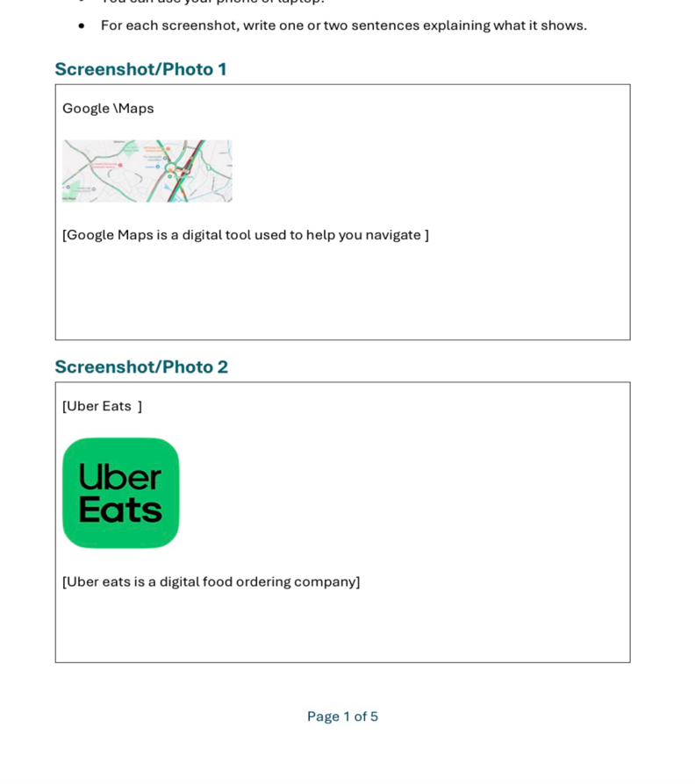
IN week 7th I learn how to use: PowerPoint

Skills I used:

•PowerPoint: Adding clear text , images and notes , arranging slides logically, and keeping content simple and easy to follow.

In my work I used practical skills like:

IN week 9th I learn how to use Excel

Skills I used:

•Excel: Entering data into tables ,using basic formulas like sum to calculate totals,, sorting information and making simpler charts, using basic formulas to calculate totals. make margins.

In my work I used practical tools like:

Training Area | Number of Requests
Health and safety | 22
Customer communication | 18
Digital Systems | 15
Data protection | 9
Time management | 7

In week 5th I learn how to use Microsoft

Skills I used:

•Microsoft: General skills Like Saving, naming , and organising files so I can find them easier later .

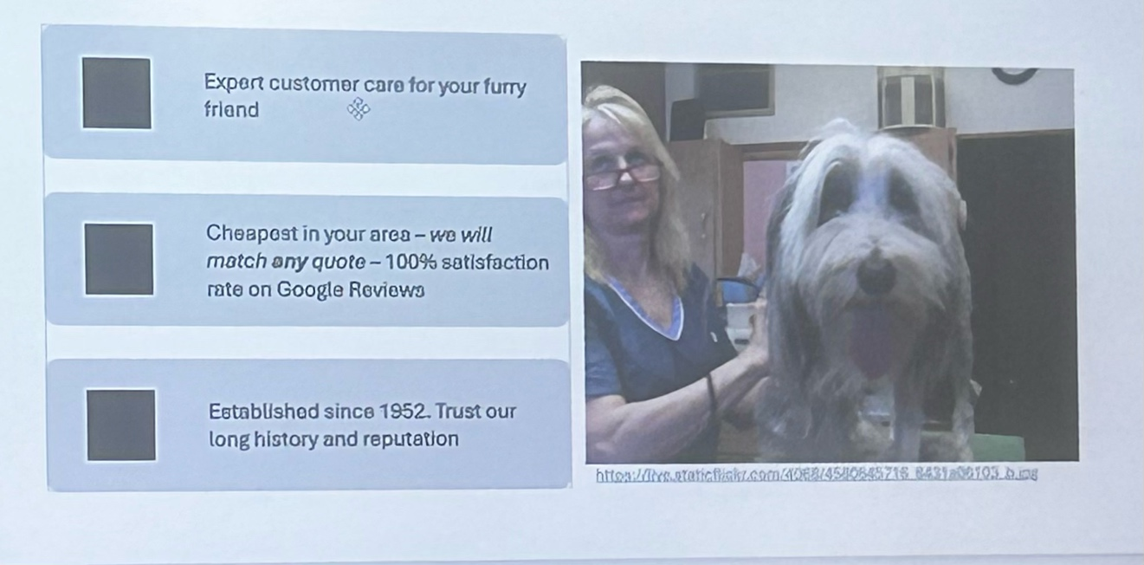

At the beginning of the module, I found digital tools difficult because I was not familiar with all their functions. I sometimes needed help understanding where to find tools and how to format my work. I also needed time to understand how to organise information professionally.

How i improve:

- I practised using the tools.
- I followed instructions from class.
- I corrected mistakes
- I learned from feedback.
- I became more confident using PowerPoint, Word and Excel.

What I don’t can do independently now

I can now create and format documents, organise information, create presentations and design professional-looking digital content with less support.

Reflection

- I learned that digital skills improve with practice.
- I became more confident.
- I learned how to solve problems independently.
- I understand better how digital tools can be used for university and work.

Hello, my name is Ileana Chiciu . In this presentation I will talk about my digital portfolio and reflect on the skills I developed during this module.

My portfolio contains four examples of digital work. I selected these examples because they show different skills and also demonstrate my progress.

My first example is the FreshBite Meals digital menu, which I created using Microsoft PowerPoint. The purpose of this task was to create a clear and professional digital menu. I learned how to organise information, use headings, choose suitable layouts and present prices clearly. PowerPoint was useful because it allowed me to organise the information visually.

My second example is a spreadsheet. This helped me develop my skills in organising information and working with data. At first, I found spreadsheets difficult because I was not completely confident using cells, tables and formulas. After practising, I became more comfortable and understood how spreadsheets can be useful for organising information.

My third example is a Word document. This work helped me improve my formatting skills. I learned how to use headings, paragraphs, spacing and a clear structure. I also learned that presentation is important because information needs to be easy for another person to read and understand.

My fourth example is a PowerPoint presentation. This developed my ability to communicate information visually. I learned that slides should not contain too much information. Instead, important points should be organised clearly so that the audience can understand them.

At the beginning of the module, some of these tasks were difficult for me. I was not confident with all the digital tools and sometimes needed help understanding what I had to do. However, I improved by practising, following the instructions and correcting my mistakes.

One important improvement for me was becoming more independent. I can now use PowerPoint to create and organise slides, Word to create structured documents and Excel to organise information. I feel more confident because I do not need the same level of support that I needed at the beginning.

The main thing I learned is that digital skills improve through practice. Making mistakes was part of my learning process. Instead of giving up when something was difficult, I learned to try again and find a solution.

These skills will help me with my university studies because I can create better documents and presentations and organise information more effectively. They will also help me in future employment because digital skills are important in many workplaces.

To conclude, my portfolio shows my progress from being less confident with digital tools to becoming more comfortable and independent. I still have more to learn, but I now have a stronger foundation and more confidence in using digital technology. Thank you for listening.

A small addition, Hello, I apologize for being late with my work. Some minor difficulties occurred and I was no longer able to submit my work and voice recording. At least I tried to submit it now rather than never.

