Encyclopedia Entry – Sachsenhausen Concentration Camp

Introduction
In this encyclopedia entry I will be looking at the Sachsenhausen Concentration Camp located in Germany. The primary focus of this encyclopedia entry is to look at the historical aspects of the camp, as well as focusing on the different religious groups which were held there. Its main focus will be on the period in which the camp was controlled by the Nazi regime (1936 – 1945). This encyclopedia entry would be able to assist those who are researching or have an interest in how the Jews and other groups were captured and persecuted in Germany under the Nazi dictatorship. The first section the entry will cover will be the origins of the camp.
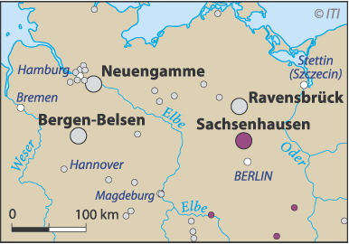
Origins
With Hitler’s rise to power in Germany there were many major changes made to treatment of those who had different beliefs or rival political views to those in power. When Adolf Hitler was appointed as the Chancellor of Germany in 1933 after the Nazi party had become the largest political party in the German government, many of his rivals were captured and imprisoned in a number of camps.
Figure 1: Map of Germany showing Sachsenhausen.
One of the earliest concentration camps was the Oranienburg camp located 35km north of the capital of Berlin in which the Nazi led government was located. A local group belonging to the Sturmabteilung (This was the paramilitary organization of the Nazi Party) converted a factory building located in the center of the town into the concentration camp. Although the camp was only active between the years 1933 – 1934 it managed to imprison 3000 people who opposed the Nazi party in its early stages of power. These prisoners would contain members belonging to the rival German Communist party (also known as the KPD) as well as even imprisoning some of their own members who would speak out against the direction of where the party was heading.
After the Nazi party took full control over the German government on April the 26th 1933 they formed the Gestapo (also known as the SS or the Nazi secret police). The Gestapo were responsible for the closing down of the Oranienburg concentration camp in 1934 and later for the construction of the Sachsenhausen camp which was located on the outskirts of the town.
The man responsible for the construction of the Sachsenhausen concentration camp was Heinrich Himmler (1900 – 1945). He was appointed as the Reichsfuhrer SS (This was the rank of the head of the Nazi police force) in the year 1936. His plan for Sachsenhausen was for it to become the perfect example of what the concentration camps would be like under the Nazi regime for all of their enemies.
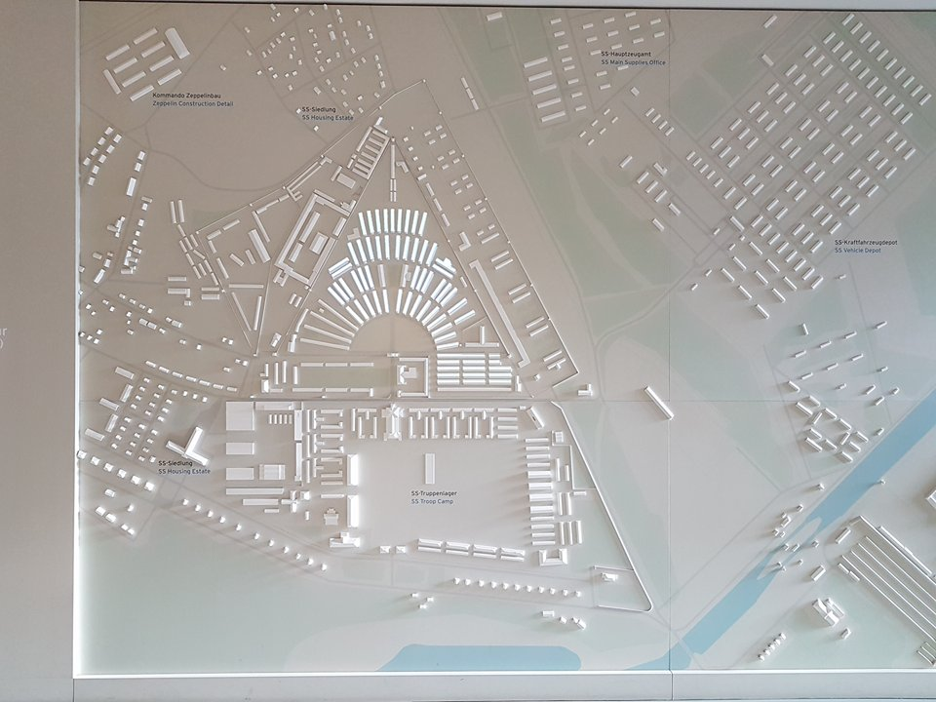
Design
With the SS now in charge of the construction and design of the new concentration camps throughout the German held territories, they were tasked with modernizing the design in which they were built. To do this the architects built the layout of the camp in the shape of a triangle. To have the Sachsenhausen camp built the SS made plans to transfer groups of prisoners located from other smaller work camps located across Germany and use them as manual laborers. For the SS the use of political prisoners was an effective means for them to build their work and death camps as they did not have to pay any wages or take proper care of the safety of these workers.
Figure 2: Model of the Sachsenhausen Concentration Camp
As well as being designed to be used as one of the primary concentration camps located in Germany as it was close in location to the capital, it also became home to the SS. They built many new facilities surrounding the camp such as having an administration office, troop/vehicle depots as well as a training facility for Gestapo officers and other high ranking Nazi officials. One of the most famous members of the SS who was trained at the Sachsenhausen facility was a man called Rudolf Höss (1901- 1947). He was a lieutenant colonel in the SS and was the commandant who served the longest at the Auschwitz concentration camp located in Poland.
As we can see in figure 2 it shows the entire layout of the Sachsenhausen facility. The concentration camp which would house all of the prisoners is located inside of the triangular shaped complex in the center of the image. As the SS had control of the surrounding areas of the camp it allowed them to have complete privacy from the locals and others who they would rather not know of what took place there. Because of the vehicle depot located outside the camp and the use of a rail network which ran through Oranienburg, it allowed for the easy transportation of prisoners to and from the concentration camp.

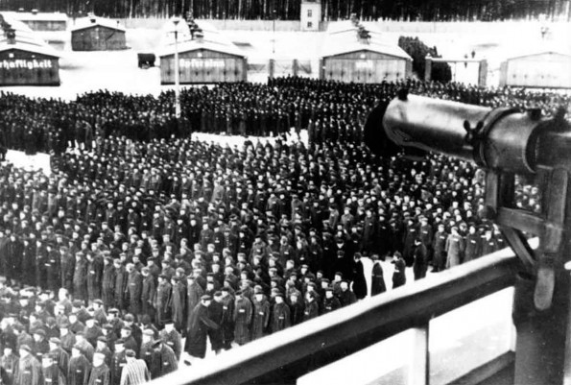
The Prisoners
From the years that the Sachsenhausen concentration camp was active under the Nazi regime (1936 – 1945) there were over 200,000 prisoners which had been kept there. Instead of focusing solely on confining Jews and other groups which they saw as a threat to their goal of having an Aryan society, they also imprisoned a number of POW’s belonging to the Red Army and the western powers.
Figure 3: Prisoners lining up at Sachsenhausen Concentration Camp

Prior to the beginning of the Second World War a high percentage of the inmates which were kept at the camp were just political rivals and others who the SS found as threats to the new Nazi leadership. However after Hitler rose to power and became the Fuhrer his anti-Semitic views on the Jewish people became popular throughout Germany and new laws were legislated to restrict their rights as citizens.
On November the 9th 1938 one of the first major demonstrations against the Jewish people took place in Germany called the Kristallnacht (also called the night of the Broken Glass). During this period many acts of violence were taken against the Jews and other minorities which didn’t categorize as part of the ‘Aryan race’. This would include thousands of synagogues being burned to the ground and being looted of all of their valuable possessions, many other important parts of the Jewish communities such as the businesses and schools were also pillaged and destroyed. The German police force was instructed by high Nazi officials to make mass arrests to the Jewish populations even though they were the victims of the crimes which took place during Kristallnacht. Because of the large amount of arrests of the Jewish people they had to be transferred to concentration camps such as Sachsenhausen.

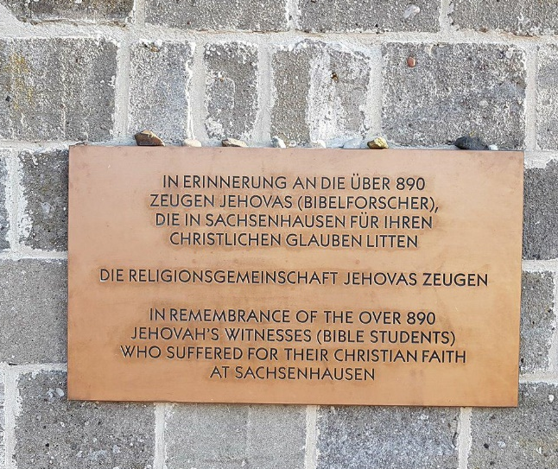
Not only were the Jewish people imprisoned and executed for their religious beliefs at Sachenhausen. There were also a number of different religious groups such as the Jehovah’s Witnesses who unfortunately perished at the camp. They were persecuted and imprisoned because they disagreed with the political views of the Nazi German government and they also refused to conscript or have any part in the Second World War. Unlike the Jews who were targeted to be attacked and removed from the beginning of the Nazi regime, the Jehovah’s Witnesses were not originally targeted by the SS or the Nazi government for their religious beliefs.
Figure 4: Memorial to Jehovah’s Witnesses at Sachsenhausen
As you can see in the image of figure 4, there is a memorial located within the walls of the Sachsenhausen concentration camp solely dedicated to the 890 Jehovah’s witnesses who sadly perished for their religious views. This is a prime example on how the Nazi government executed millions of people regardless of what political or religious faith that they had. Now in the 21st century there have been more memorials in honour of those who died for their religious beliefs at this camp. In 2014 there was a memorial held for the Jehovah’s Witness August Dickmann who was murdered at the camp on the 15th of September 1939. He was seen as the first conscientious objector of the German military during this time and in turn was executed in front of the rest of the prisoners at this camp.
As the war continued the Nazi party were creating plans to finally remove and exterminate the Jews and their other prisoners to help finalise their ‘Aryan’ only society. The original plan of the Nazi’s was to deport all of the Jews and other minorities to the east near Russia, this would allow Europe to have more free space for the German people without the need of Ghettos in the cities. Due to the unsuccessful attempt at trying to invade Russia and being pushed back by the Red Army, Hitler and other high members of the Nazi party had to come up with a new solution to their Jew problem.
During the latter part of 1941 the Nazi government decided that they would use mass shootings to try and exterminate the Jews across Europe. However the soldiers which were ordered to perform these executions were suffering from mental issues because of this, so they had to devise a new method to commit their mass genocide. They devised a new process of extermination by adding gas chambers to many of the concentration and death camps all across the German occupied land. A gas chamber was later built at the Sachsenhausen facility to exterminate many of the prisoners which were kept there.

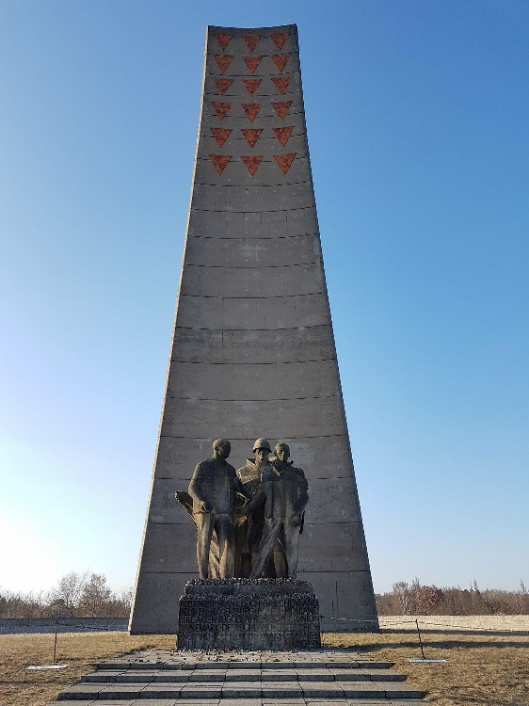
The Liberation of Sachsenhausen
Towards the end of the Second World War in 1945 the Red Army was marching towards Berlin to bring an end to the Nazi regime and to end the war. The SS at Sachsenhausen realized this so they made a plan for a quick evacuation of the camp and its prisoners at the beginning few months of 1945. The Commandant of the camp Anton Kaindl (1902 – 1948) ordered his men to escort the remaining 33,000 prisoners to the east so they could try and evade the oncoming enemy forces. However many of the prisoners perished due to exhaustion from the conditions and the marching, the illness due to the freezing temperatures or were murdered by the SS soldiers.
On the 22nd of April 1945 the Red Army and a number of Polish forces entered the Sachsenhausen concentration camp to find that the SS had left over 3000 prisoners behind. Although the camp was finally liberated by the Allied forces at the end of the war, it was later used by the Soviet Union to imprison those who were involved with the Nazi party as well as those who opposed them. Prior to the camp finally being closed and not used for further use of imprisonment, the Soviet Union moved all of their prisoners to other labour camps and Gulags to the eastern Soviet controlled lands.
Figure 5: Memorial of the Liberation of the Camp
The Sachsenhausen Memorial
After its use as a Soviet prisoner camp in 1950 it was later reopened as a memorial for those who wished to come and view the camp. A large amount of the camp was still being used by Soviet Military assets until the early 1990’s when the Berlin Wall was destroyed and the unification of Germany took place. One of the key issues with the Soviet controlled memorial was that it did not give an accurate telling of what actually occurred at the camp. Because it was being used during the Cold War it portrayed the West in a negative light.
After the museum was reopened in 1993 by a unified Germany it was redesigned so that visitors were able to visit many of the still standing original buildings of the camp. Instead of containing Soviet propaganda and misinformation, the memorial now provides accurate information and showcases many of the clothing and equipment which was used at the camp during its active years. To modernize the camp they have added such things as audio guides to give visitors key information about each part of the camp.

Bibliography
References
BBC. 2017. The Nazi Racial State. [ONLINE] Available at: http://www.bbc.co.uk/history/worldwars/genocide/racial_state_01.shtml. [Accessed 23 March 2018].
Britannica; Kristallnacht. [ONLINE] Available at: https://www.britannica.com/event/Kristallnacht. [Accessed 23 March 2018].
JW.org; 2014. Sachsenhausen Memorial to Honor One of Jehovah’s Witnesses Executed by Nazis. [ONLINE] Available at: https://www.jw.org/en/news/releases/by-region/germany/sachsenhausen-memorial-honors-witness. [Accessed 23 March 2018].
Stiftung-bg.de. Memorial and Museum Sachsenhausen. [ONLINE] Available at: http://www.stiftung-bg.de/gums/en/. [Accessed 25 March 2018].
Stiftung-bg.de; Oranienburg. [ONLINE] Available at: http://www.stiftung-bg.de/gums/en/geschichte/kzsachs/oranienburg/oranien05.htm. [Accessed 23 March 2018].
Images
Figure 1 - Sachsenhausen [ONLINE]. Available at: https://www.holocaust.cz/en/history/concentration-camps-and-ghettos/sachsenhausen-3/ [Accessed 25 March 2018].
Figure 2 – Phillips, M. 2018. Taken at Sachsenhausen Memorial and Museum. Taken on the 1st of March 2018.
Figure 3 - Roll-Call-At-Sachsenhausen [ONLINE]. Available at: http://ww2today.com/13-december-1944-sachsenhausen-concentration-camp-new-arrivals [Accessed 23 March 2018].
Figure 4 – Phillips, M. 2018. Taken at Sachsenhausen Memorial and Museum. Taken on the 1st of March 2018.
Figure 5 – Phillips, M. 2018. Taken at Sachsenhausen Memorial and Museum. Taken on the 1st of March 2018

http://www.stiftung-bg.de/gums/en/geschichte/kzsachs/oranienburg/oranien05.htm
https://www.britannica.com/event/Kristallnacht
https://www.jw.org/en/news/releases/by-region/germany/sachsenhausen-memorial-honors-witness/
http://www.bbc.co.uk/history/worldwars/genocide/racial_state_01.shtml
http://www.stiftung-bg.de/gums/en/
http://www.stiftung-bg.de/gums/en/
http://www.stiftung-bg.de/gums/en/

