
AWD Torque Vectoring

Combined Advance Vehicle Dynamics

ACHA6003/6011

Lecturer: Mark Sandford

BEng Automotive Engineering

Duke Asamoah

1706143

Contents
1 Table of figures 3
Abstract 4
2 Introduction 5
3 Investigation 5
3.1 Base Vehicle data 5
3.1.1 Background research 5
3.1.2 Mass distribution 7
3.1.3 Drive line layout 7
3.1.4 Control strategy 8
3.2 Torque Vectoring Systems 8
3.3 Lumped mass of the vehicle 9
3.4 Longitudinal Centre of Gravity 10
3.5 Vehicle’s rotational inertia 11
3.6 Inertia conjugate 12
3.7 Dynamic Index 13
3.8 Vehicle specifications 14
3.9 Front wheels mechanical torque path 15
3.10 Finding the clutch pack axial force 16
3.11 Potential longitudinal acceleration on different surfaces 17
4 Conclusions and summary 17
5 References 17

Table of figures
Figure 1 The Ferrari FF driving on sand with ease (Ireson, 2011) 5
Figure 2 Ferrari FF layout (Glucker, 2011) 7
Figure 3 longitudinal force and slip ratio connections under various wheel slip angles, lateral force and slip ratio relationships under various slip angles (Li, 2009) 8
Figure 4 Longitudinal force vs slip ratio (Wang et al., 2021) 9
Figure 5 Calculation in excel to achieve the moment of inertia 11
Figure 6 Spreadsheet showing the dynamic index received 13
Figure 7 Ferrari FF AWD vehicle (Edmunds, 2020) 16

Abstract
This report analysis the key feature of the Ferrari FF, this includes research about its important feature, torque vectoring. To better understand how the torque vectoring front wheel drive system affects vehicle dynamics and possible management options.

Introduction
Ferrari released their first all-wheel drive vehicle in March 2011; this vehicle is known as the Ferrari FF. The purpose of this report is to analyse the FF in a way to the methods used by a rival car manufacturer (to gain a competitive edge). To achieve this, aim several areas of investigation including theoretical research and calculation based of vehicle data must be carried out. The key points of focus will be:
- Base Vehicle data
- Torque Vectoring Systems
- Lumped mass model
- Longitudinal Centre of Gravity position
- Vehicle moment of inertia
- Position conjugate
- Dynamic Index
- Vehicle specifications
- Front wheels mechanical torque path
- Clutch pack torques
- Potential longitudinal acceleration on different surfaces
- Yaw rates increase relative to hand wheel position
- Controller sensors required and potential vehicle dynamic improvements
The report will end with a summary of the findings and any further recommendations for future development.

Investigation
As mentioned in the introduction above, this section will be divided into multiple sub sections.

Base Vehicle data

Background research
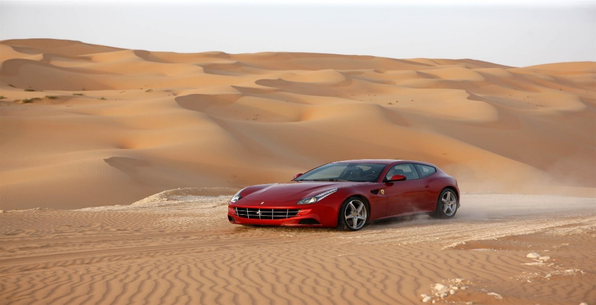
When Ferrari unveiled their all-wheel drive shooting brake vehicle, the automotive community divided into three camps: those who loved it, those who despised it, and those who were ambivalent. However, fresh facts on FF's All wheel drive (AWD) system may not alter that reality, but it's guaranteed to excite all parties and cause unending discussion, especially among Lamborghini Aventador enthusiasts. Despite the existence of seven forward speeds in the main gearbox, it only has all-wheel drive in first through fourth ratios. For the first four gears of the main box, the forward transmission is powered by a conical gear located at the front of the engine. As a result of gear multiplication/reduction, in fifth through seventh gears, the rear wheels can handle the torque. There are two primary purposes for the system: improving the vehicle's performance on poor road surfaces such as mud, snow, gravel, ice, and sand which reducing the vehicle's speed on these types of terrain. Starting from a standstill and scrabbling out of low-speed bends, in these situations, help from the front wheels will offer both more acceleration and traction, easing some of the weight from the rear tyres (Ireson, 2011).
Figure 1 The Ferrari FF driving on sand with ease (Ireson, 2011)
The following section down below will discuss all-wheel drive in more detail and the advantages and disadvantages that come with it.
AWD is a relatively new type of vehicle drive system that distributes power to the wheels with the best grip. Through three 'differentials': central, front, and rear, power can be distributed between the front and rear wheel axles or between individual wheels. A differential is a mix of the AWD gearbox and advanced engineering that transfers power from the transmission to the correct axles of an automobile. AWD is available in two configurations: mechanical and electronic. Mechanical AWD employs the differential-based method described above, but SUVs from 2015 and 2016 also feature digitalised 'electronic' AWD. Each wheel of the car is equipped with sensors that accurately monitor traction, wheel speed, and more. An ECU (Electrical Computer Unit) uses this data to determine which wheel has the most grip. Electronic AWD is frequently referred to as 'torque vectoring’ (which will later be elaborated on). (Sandicliffe, 2016).
All-Wheel Drive (AWD) is indeed a difficult system, but that is a very important advancement in current automobiles that may significantly increase road safety and driving skills.
Key advantages for an All-wheel drive vehicle:
- Increased traction in icy or wet conditions - All-wheel drive systems distribute traction swiftly and skilfully to the proper wheels when the road is wet, ice, or otherwise treacherous. This aids with the stability of your vehicle when driving in inclement weather.
- Enhances all-round manoeuvrability - Intelligent torque vectoring is used in the newest AWD systems, from ordinary crossovers to supercars. It is simpler to drive on uneven roads because to the ECU's ability to adjust the grip and speed within each wheel.
- AWD is always activated - In contrast to All-Wheel Drive, which kicks in automatically when the engine starts, traditional 4-Wheel Drive must be engaged by the driver, however, modern systems are automated.
- Improves the control and grip of a variety of vehicles - The SUV's handling and other areas of sports car performance can be improved with all-wheel drive (AWD). For dynamic everyday driving, several popular cars have updated from 4x4 to AWD (Hartman, 2022).
The disadvantages of AWD must also be considered:
- Pricing - Although the resale value may be better than a two-wheel drive, the original purchase price is more. Different systems might cost as much as $5,000 for the same car. The complexity of AWD means that it costs more to maintain than conventional two-wheel drive vehicles. If there is an issue with the vehicle, buyers who are thinking about buying a used automobile without a guarantee may be surprised at a repair or maintenance cost.
- Low fuel economy - Apart from the additional expense of the car, these AWD systems have a much worse fuel economy. Due to the increased weight of AWD cars and the engine's requirement to supply power to all wheels, vehicles consume four to ten percent more fuel than two-wheel-drive vehicles.
- Preconceived choices - When purchasing a new car, most customers pick AWD over two-wheel drive without hesitation, believing they will have an advantage on icy conditions. What people do not realise is that AWD systems boost traction to aid acceleration; it has no influence on the car's braking or handling in treacherous circumstances. The braking and handling characteristics are identical to that of a two-wheel drive.
- Advanced technology for 2-wheel drive - While new and improved technology has not yet (Wan, 2017)achieved the performance of an AWD car in a two-wheel drive vehicle, it is near. Many two-wheel-drive vehicles now have traction and stability control, which allows the driver to direct more power to one wheel while decreasing power to another.
If required, the driver can even entirely remove power to one wheel to avoid the car spinning out of control. On the other hand, ABS improves a vehicle's stopping ability and is not restricted to AWD cars (Pande, 2020).

Mass distribution
The all-wheel drive system is 50% lighter in mass than a conventional four-wheel drive arrangement in comparison. Weight-to-power ratio and performance of the FF are considerably enhanced as a result. This configuration allows for the preservation of a low centre of gravity as well as the preservation of Ferrari's performance car weight distribution, with more than 50% of the car's weight distributed over the rear axle since it is a front engine vehicle (Edmunds, 2020; Ferrari, 2011).
The FF's front-mid-mounted engine and rear-mounted transmission result in an ideal front-to-rear weight distribution of 47:53 (Wan, 2017).

Drive line layout
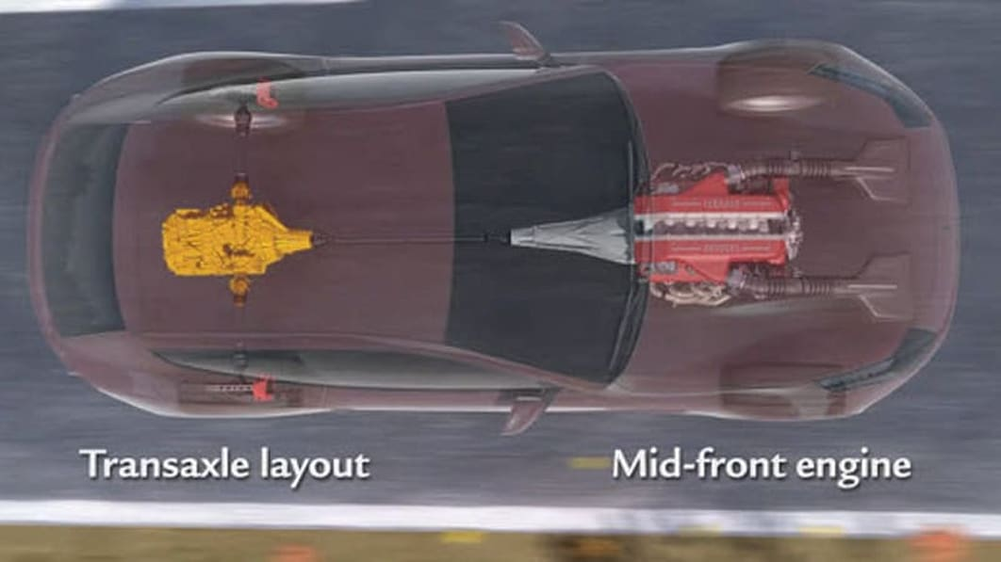
With a seven-speed dual clutch gearbox (automatic), or a six-speed dual clutch gearbox (manual) in the back between the rear wheels, this automobile features a mid-front positioned engine with a driveshaft that connects directly to its engine's rear end (Whyhighend? ,2010).
Figure 2 Ferrari FF layout (Glucker, 2011)

Control strategy
The first precaution is a panic response that may be triggered by the driver using the steering wheel. The Ferrari FF has systems in place to deal with understeer. In addition, it is best that the driver must softly push the brake to avoid ABS from stepping in and the Ferrari FF transforms a severe understeer into an oversteer. As the Ferrari FF slides, the driver must exert a fair amount of effort in order to get it back on track (Davis, 2022).

Torque Vectoring Systems
Torque vectoring mechanisms primarily intend to increase a vehicle's traction, particularly while travelling in wet, muddy or icy conditions. Torque vectoring is a computer-controlled technology that regulates the amount of power sent to each wheel by the car's engine or motors. By more efficiently managing power, a vehicle equipped with torque vectoring will have even more traction on treacherous terrain and will accelerate more swiftly. In order to disperse such power, an electronic torque vectoring system is used. By controlling how much torque is transmitted to each wheel and how much slack is permitted, the differential uses many clutches to do this. This will depend on how much traction the wheels have and what the driver wants them to do (Hirons, 2022).
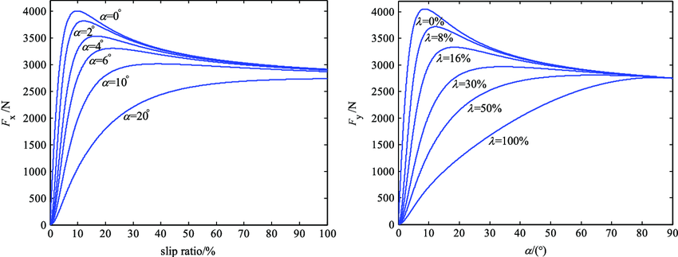
While cornering, a vehicle with a rear-wheel independent-drive (RWID) system may benefit from a torque vectoring control method. Initial differential torque is then computed to reduce the total tyre slippage energy dissipation of the vehicles involved. An acceleration slip regulation (ASR) is inserted into overall control plan before differential torque is provided to the two driving wheels to prevent approaching the tyre adhesion saturation area and causing excessive slip. The torque vectoring control method and tyre longitudinal linear stiffness are tested in a variety of manoeuvre scenarios to ensure the accuracy of the estimates. It has been shown that a 17 percent decrease in slip power consumption may be achieved by using the suggested torque vectoring control (Wang et al., 2021).
Figure 3 longitudinal force and slip ratio connections under various wheel slip angles, lateral force and slip ratio relationships under various slip angles (Li, 2009)

During cornering, the lateral transfer of normal force from one side of the wheels to the other during vehicle body roll causes the slip of the outer-wheel to result in a lower slip of the inner-wheel. Therefore, if the driving torque is evenly split between the two wheels, the outer-wheel cannot fully use the sticky state, even if it still has adhesion margin, and the inner-wheel may also easily slide owing to the comparative large traction force need (Wang et al., 2021).
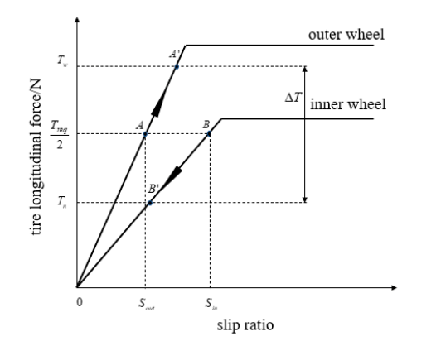
Figure 4 Longitudinal force vs slip ratio (Wang et al., 2021)

Lumped mass of the vehicle
In a lumped mass model, all the components are treated as if they were one big mass in space (Lobontiu, 2018).
The mass components for the Ferrari FF that will be investigated are:
- Gearbox
- Engine (V12)
- Driver
- Vehicle front chassis
- Vehicle rear chassis
The masses of these parts will be split into 5 individual masses: the engine at the front being mass 1 (m1), the driver at the centre being mass 2 (m2), the gearbox at the rear being mass 3 (m3), mass 4 (m4) and mass 5 (m5) represent the remaining weight of the vehicle to the front and the rear chassis, respectively.
The front gearbox which will be included with mass 1 being the engine. The front gearbox will weigh 60kg and the engine will weigh 340kg, this will make m1 a total of 400kg.
The Driver of the Ferrari FF would weigh 100kg. This mass will be considered as mass 2.
The rear gearbox at the back of the vehicle weighs 100kg. this mass will be considered mass 3.
In addition to the previously discussed components the investigator must also consider both the minor components of the vehicle and the weight of the chassis when considering the lumped mass. To ascertain this, the investigator must consider the centre of gravity of the vehicle (47% front and 53% rear). This gives the investigator the values of mass 4 (vehicle front) to be 648.6kg and mass 5 (vehicle rear) to 731.4kg. Mass 1, 2 and 3 were found through research, while mass 5 and 6 were found by removing mass 1,2 and 3 from the kerb mass bring it to 1380kg. With this mass remaining it was multiplied by the front weight distribution (47%) giving the value for 648.6kg and multiplied by the rear weight distribution (53%) giving it a value of 731.4kg.

This is a spreadsheet made in excel to show the values discussed above:
 | Length (m) | Mass (Kg)
Mass 1 (Engine) |  | 400
Mass 2 (Driver) |  | 100
Mass 3 (Gearbox) |  | 100
Mass 4 (Vehicle Front) |  | 648.6
Mass 5 (Vehicle Rear) |  | 731.4

It can be observed that the total of the lump masses sums up to the kerb weight of the vehicle which indicates that the simulation in excel is using correct mathematics.

Longitudinal Centre of Gravity
The centre of gravity, also known as the centre of mass, is the place where a system or entity acts as if its whole mass were centred there. Through which the weight and all accelerating forces of acceleration, braking, and cornering operate.
Location of the centre of gravity could well be defined as:
- The location where an applied force will result in a 100% literal translation.
- The point of equilibrium of the object.
- The point where the body, when hung, will maintain equilibrium.
- The fulcrum around which the opposing forces of gravity are balanced.
Load distribution between the front and back is established by the height of the vehicle's centre of gravity in relation to the wheelbase. Because momentum occurs at the vehicle's centre of gravity, it may cause the vehicle to lean forward or backward during braking or acceleration. The impact on over/under steer is counter to that of a true shift in the centre of mass since only the downward force is altered (TheCarTech, 2022).
By using the longitudinal centre of gravity (which would be the wheelbase length given of 2.99m) this was used to find the values for wheelbase front and rear by multiplying the overall wheelbase length with the weight distributions.
In the excel sheet, the wheelbase front is labelled as A, and the wheelbase rear is label as B (as seen below)
A (Wheelbase front) | 1.5847m
B (Wheelbase rear) | 1.4053m

Vehicle’s rotational inertia
The moment in this concept is dictated by the centre of gravity's front-to-rear placement. During cornering, the automobile rotates (changes direction) around its centre of gravity, and the farther apart the centres of weight concentration are from the centre of gravity (which serves as their common centre), the greater the moment (Webmaster, 2009).
To find the moment of inertia, the following formula was used:
I = (M1 x R1²) + (M4 x R4²) + (M3 x R3²) + (M5 x R5²)
In the formula above the following variables are used:
- I: this is the moment of inertia
- M1: mass 1
- M2: mass 2
- M3: mass 3
- M4: mass 4
- M5: mass 5
- R1: distance from the CoG to the engine
- R4: distance from the CoG to the rear gearbox
- R3: distance from the CoG to behind the front wheel
- R5: distance from the Cog to in front of the rear wheel
This formula can be calculated in Microsoft Excel as seen below
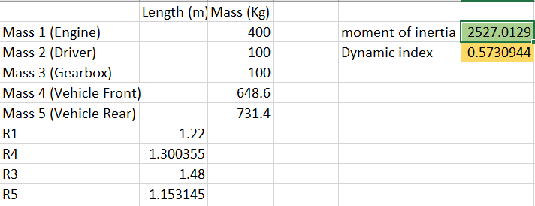
Figure 5 Calculation in excel to achieve the moment of inertia
The moment inertia was calculated by taking the total mass of the vehicle (however, excluding the driver as their distance from the centre of gravity is 0) and multiplying them by the distances connected to the centre of gravity (r). The value received as shown above is 2527kgm².

Inertia conjugate
An inertial conjugate is a position where no translation occurs when a free entity with finite mass and inertia qualities is loaded at an angle that does not pass through its centre of gravity. While loading, no translation takes place, regardless of whether it is a percussion-based load or not. The concept of the inertia conjugate can be applied to an automobile. The application of force is at the front wheels, which resolves to the force and moment at the centre of gravity. The mass, moment of inertia, and distance from the centre of gravity to the front and rear axles all contribute to the lateral acceleration, lateral force, direction, and magnitude at the rear wheels. (Blundell & Harty, 2004).
On the Ferrari FF vehicle, somewhere between the centre of gravity and the rear axle is the inertia conjugate. If the inertia conjugate is in front of the rear axle, the dynamic index is less than 1. However, if the inertia conjugate is on the rear axle, the dynamic index is greater than 1.
The dynamic index is a ratio of the distances between the rear axle and the centre of gravity set against the distance between the inertia conjugate and the centre of gravity.

Dynamic Index
The dynamics of the real vehicle are significantly impacted by the whole vehicle's yaw moment of inertia, which is dominated by the body and accompanying masses. An often-debated metric is the ratio k²/ab, also referred to as the 'Dynamic Index,' where k denotes the radius of gyration associated with Izz and a and b denote the longitudinal location of the vehicle mass centre relative to the front and rear axles, respectively (Blundell & Harty, 2004).
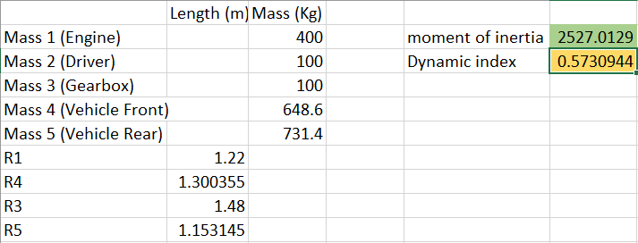
Most sports cars will have an inertia conjugate in front of the rear axle. Since the Ferrari FF is a sports car, the inertia conjugate is in front of the rear axle. In the case of the inertia conjugate being in front of the axle, the dynamic index will be less the 1. Counter wise, in the event of it being behind the rear axle, it will be greater than 1. If the vehicle were to turn a left corner, the rear of the vehicle would turn right slightly, and the front of the car will turn left slightly. This means at the response that vehicle will turn in the corner more quickly. This can be beneficial at low speeds but can cause instability at high speeds. When the dynamic index is too low, at high speeds the vehicle becomes difficult to control when cornering at high speed. In figure 6, the rotational inertia was used instead of the inertia conjugate to calculate the dynamic index.
Figure 6 Spreadsheet showing the dynamic index received
In order to find the dynamic index, the following formula was used:
$$D.I=\frac{I_{zz}}{M.A.B}$$
In the formula above, the following variables were used:
- D.I: Dynamic index
- Izz: Rotational inertia
- M: Kerb mass
- A: Wheelbase front length
- B: Wheelbase rear length
The investigation shows the dynamic index to be 0.6 as can be seen in the spreadsheet above. However, the author deems that even though this indicates that the inertia conjugate is in front of the rear axle (which is correct for this class of vehicle) the value is somewhat too low. This means the inertia on the Ferrari FF is too low.

Vehicle specifications
Here is the Ferrari ff specifications:
Powertrain
- Engine 6.3 engine (V12)
- Power 651 horsepower at 8000rpm
- Torque 683Nm at 6000rpm
- Transmission 7 speed automatic
- Drive train all-wheel drive
Vehicle Type
- Category sports car
Steering/Suspension/brakes/tires
- Steering Rack and pinion with assist
- Front suspension independent (double wishbones)
- Rear suspension independent multilink
- Front brakes disc
- Rear brakes disc
- Front tires 245/35ZR20
- Rear tires 295/35/ZR20
Dimensions and weight
- Length 4907mm
- Width 1953mm
- Height 1379mm
- Wheelbase 2990mm
- Front track 1676mm
- Rear track 1661 mm
- Weight 1884kg (The Car Guide, 2022)

Front wheels mechanical torque path
The Ferrari FF is very different to other vehicles, some of the drive is derived from the front of the engine for the front wheels. However, most of the drive is given from the back of the engine and is provide to the gearbox and rear wheels via the prop shaft (Much like in a traditional rear wheel drive vehicle).
In the Ferrari FF, there is a 6-speed gearbox located to the rear (7 in the automatic model), but in addition to this there are 2 gears located at the front of the engine (referred to as gear A and gear B) which function to the front left wheel and front right wheel via clutches.
When explaining about the mechanical torque path system, using the maximum torque of 683Nm, the literature reveals that 20% of the maximum torque is distributed towards the front wheels. This means that about 137Nm of torque is transferred between the front wheels. This leaves 546.4Nm of torque that must be allocated between the internal machinery and the rear wheels (Edmunds,2020).
The two ratios in the front gearbox function as follows: when first or second gear is chosen in the main gearbox, the first ratio is used. When the transmission is in third or fourth gear, the second front cog is selected.
Since the automobile is not traction-limited in such high ratios, no power is sent to the front wheels of the FF in fifth, sixth, or seventh. The front gearbox ratio must always be higher than the comparable ratio engaged in the rear gearbox due to the nature of gearing and the need to vector torque to the front wheels in different ways. it has been stated that "In 5th gear, all the torque that our engine is able to give us we can transmit only on the rear axle. In all conditions. Also, in snow when the surface is 0.3, 0.2 mu. we only need the rear axle to transmit all the torque." (Edmunds,2020).
Gear A distributes 6% torque to the 1st and 2nd gears to the rear, this means 6% of torque is sent from the front. Maximum front torque at the front of the engine is 20% from the over all maximum torque of 683Nm. This means the torque at the front engine is 137Nm.
Here are the gear ratios for the Ferrari FF from 1 to 6 (Car and Driver, 2016):
- First Gear Ratio: 3.40
- Second Gear Ratio: 2.19
- Third Gear Ratio: 1.63
- Fourth Gear Ratio: 1.29
- Fifth Gear Ratio: 1.03
- Sixth Gear Ratio: 0.84
- Final Drive Ratio: 4.38
The second gear ratio was multiplied by the final drive ratio to give the 2nd overall ratio. This calculation uses the 2 values from the list above to give: 2.19 x 4.38 = 9.59.
To get the Ratio A gear the values used are: 9.59 divided by 1.06 (the 6% difference) which a total of 9.05. This value will be multiplied by the front engine torque to find the front axle turning force. The calculation is as follows: 137 x 9.05 = 1240Nm. This value can be used to calculate the torque at each clutch pack by dividing by the number of wheels at the front axle which is 2. So, the calculation is as follows: 1240 / 2 = 620Nm. This value will be used as the clutch pack torque capacity to find the axial force of the clutch pack.

Finding the clutch pack axial force
In most situations, the FF will act like a regular rear-wheel drive vehicle. When there is plenty of traction available, the front clutches will be open, sending zero torque to the front wheels. To vector torque to the front wheels, the ECU may shut the clutches based on data from the throttle, steering angle, yaw, and wheel speed sensors. The carbon fibre-lined clutch packs may last longer with this "on-demand" method than if they were allowed to slide all the time. However, it is claimed that the system can handle heavy loads since the clutch packs are cooled by their own fluid system.
Like standard Front Engine-Rear wheel drive vehicles (FR), power is sent to the back wheels. The front-wheel drive system is what sets it apart. The front wheels are supplied with power by a Power Transfer Unit (PTU) installed in front of the engine. The crankshaft thus has two outputs, one of which is connected to the rear transaxle and the other to the front power take-off. PTU components include a gear set and two wet multi-plate clutches. Each clutch oversees powering a separate front wheel. PTU can control the amount of torque sent to each of the vehicle's front wheels by providing hydraulic pressure to the clutches in question. What this means is that not only is 4-wheel drive achieved, but torque vectoring as well! (Edmunds, 2020)
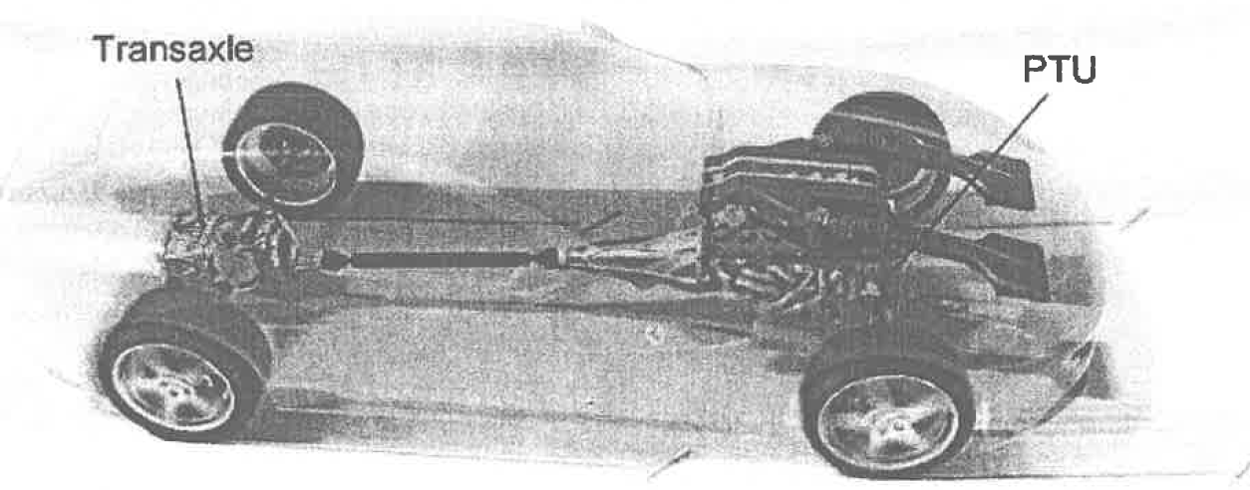
To find the Axial Force (W), this formula was used:
Figure 7 Ferrari FF AWD vehicle (Edmunds, 2020)
$$W=\frac{T2}{μ(r2+r1)}$$
In addition, as the clutch pack has 5 discs, the number of surfaces would be 10. The Axial Force (W) must then be divided by these surfaces. This calculation is as follows:
$$W=\frac{2*620}{0.1\left(0.1+0.05\right)}=82,667N$$
As mentioned above, this value must be divided by the number of surfaces (10) on the clutch pack. The calculation for this is as follows 82667/10 = 8,266.7N. This value is the true Axial Force that pushes against each surface in the clutch pack.

Potential longitudinal acceleration on different surfaces
The Ferrari FF has weight on the front axle and rear axle. If mu (µ) is 0.3 for a snowy road surface, this value could be used to calculate the Drive forces of F_{F} and F_{R}. However, other values are needed to find these drive forces such as the force acting on the axles which are W_{R} and W_{F} that need to be discovered. To find W_{F} and W_{R}, the axial force must be multiplied by the weight distributions. This means that 8266.7N x 0.47 = 3885.3N for W_{F} and 8266.7N x 0.53 = 4381.3 for W_{R}. Now that the figures have been established it is possible to find the drive forces. F_{F} = 3885.7N x 0.3 = 1164.71N and to find F_{R,} F_{R} = 4381.3N x 0.3 = 1314.38N. For rear wheel acceleration, this formula is used: F_{R}/Mass. The calculation is 1314.38N/1980 = 0.66 m/s² (this calculation has been performed with the assumption that the vehicle has a driver, but no passenger and no luggage). For all-wheel drive acceleration, the calculation is (F_{R} + F_{F})/Mass. (2479.39)/1980 = 1.25 m/s².

Conclusions and summary
This report finds that the Ferrari FF all-wheel drive vehicle is superior to most 4-wheel drive and its better in extreme road conditions than 2-wheel drive vehicle. When driving an All-wheel drive vehicle more control is intelligently given to the vehicle and as such gives the driver a much more enjoyable driving experience and prevents potential hazards over undesirable road surfaces.

References
Blundell, M., & Harty, D. (2004). The Mutlibody systems approach to vehicle dynamics.
Car and Driver. (2016). Ferrari FF Features and Specs. https://www.caranddriver.com/ferrari/ff/specs
Davis, J. (2022). Ferrari FF in the driving report: 660 PS four-wheel drive on test drive | CAR ENGINE AND SPORT. https://topgear-autoguide.com/category/sports-car/ferrari-ff-in-the-driving-report-660-hp-all-wheel-drive-on-test-drive1607335326
Edmunds, D. (2020). Ferrari FF info scan 2020.pdf.
Ferrari, S. p. A. (2011). Ferrari_int FF_2011.pdf.
Glucker, J. (2011). Video: Ferrari FF 4RM drivetrain explained. https://www.autoblog.com/2011/03/08/video-ferrari-ff-4rm-drivetrain-explained/
Hartman, D. (2022). What are the Benefits of All Wheel Drive? https://itstillruns.com/benefits-wheel-drive-5463557.html
Hirons, R. (2022). Torque vectoring explained | carwow. https://www.carwow.co.uk/guides/glossary/what-is-torque-vectoring#gref
Ireson, N. (2011). Yet More Details On Ferrari’s FF All-Wheel Drive System. https://www.motorauthority.com/news/1056494_yet-more-details-on-ferraris-ff-all-wheel-drive-system
Li, L. (2009). The relationships of the longitudinal force and the slip ratio under... | Download Scientific Diagram. https://www.researchgate.net/figure/The-relationships-of-the-longitudinal-force-and-the-slip-ratio-under-different-wheel-slip_fig2_245391030
Lobontiu, N. (2018). Mechanical Systems. System Dynamics for Engineering Students, 77–148. https://doi.org/10.1016/B978-0-12-804559-6.00003-8
Pande, S. (2020). 8 Advantages and Disadvantages of All-Wheel Drive. https://honestproscons.com/advantages-and-disadvantages-of-all-wheel-drive/
Sandicliffe. (2016). All You Need To Know About All-Wheel Drive (AWD). https://www.sandicliffe.co.uk/blog/all-you-need-to-know-about-all-wheel-drive-awd
The Car Guide. (2022). 2016 Ferrari FF Base Specifications - The Car Guide. https://www.guideautoweb.com/en/makes/ferrari/ff/2016/specifications/base/
TheCarTech. (2022). Finding the Car Centre of Gravity/Mass. http://www.thecartech.com/subjects/auto_eng/Center_of_Gravity.htm
Wan, M. (2017). Ferrari FF. https://www.autozine.org/Archive/Ferrari/old/FF.html
Wang, J., Lv, S., Sun, N., Gao, S., Sun, W., & Zhou, Z. (2021). Torque vectoring control of rwid electric vehicle for reducing driving-wheel slippage energy dissipation in cornering. Energies, 14(23). https://doi.org/10.3390/en14238143
Webmaster. (2009). VEHICLE DYNAMICS. https://ritzel.siu.edu/courses/302s/vehicle/vehicledynamics.htm
Whyhighend? (2010). Ferrari 4RM or 4 Ruote Motrici explained - Why High End. http://www.whyhighend.com/ferrari-4rm.html

