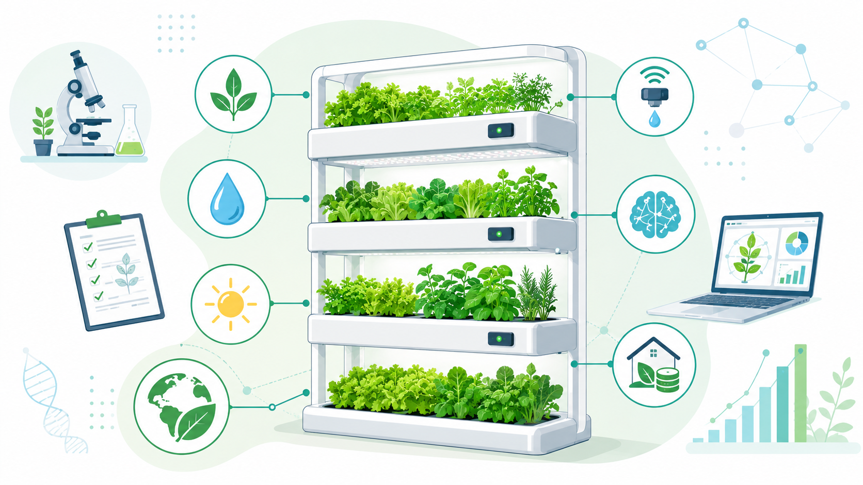  Research Proposal |   Module: Research Methods and Professional Development  Module code: ACFA7004  Lecturer: Mohamed Ben Farah  Student name: Alexei Nica  Student ID number: 2232919  Submission deadline: 14 July 2026

Table of Contents

1. Introduction 2
1.1 Context and Background 2
1.2 Research Problem 3
1.3 Research Aim and Objectives 4
1.4 Significance of the Research 4
2. Literature Review 5
2.1 Introduction to the Literature Review 5
2.2 Thematic Review of Current Research 5
2.2.1 Vertical Farming and Urban Food Production 5
2.2.2 Artificial Intelligence in Vertical Farming 6
2.2.3 Decision Support Systems in Agriculture 7
2.2.4 Home Vertical Farming and User Needs 8
2.3 Key Contributions and Research Gaps 9
2.4 Theoretical and Technical Frameworks 10
2.5 Relation to the Current Study 11
2.6 Literature Review Summary 12
3. Research Design and Methodology 12
3.1 Research Design 12
3.2 Research Methods and Materials 13
3.2.1 Research Method and Strategy 13
3.2.2 Search Strategy and Study Selection 13
3.2.3 Data Extraction, Analysis and Evaluation 16
3.2.4 Research Materials and Resources 17
3.2.5 Ethical Considerations and Methodological Limitations 18
4. Expected Outcome 19
4.1 Anticipated Results 19
4.2 Implications 19
4.3 Limitations 19
5. Timeline 21
References 22

Introduction

1.1 Context and Background

Food security, urbanisation, and environmental sustainability have become major global concerns. Growing urban populations are increasing the demand for fresh food, while agricultural land, water, and other natural resources are under increasing pressure. Climate change and supply-chain disruption have further encouraged interest in food production systems that can operate closer to consumers and within urban environments [1].
Vertical farming is one such approach. It involves growing crops in vertically stacked layers under controlled conditions, often using hydroponics, aeroponics, artificial lighting, and environmental monitoring technologies [2].These systems can reduce land use, improve water efficiency, and support year-round production by limiting dependence on outdoor weather conditions [3]. Because of this, many researchers now see vertical farming as a practical option for sustainable food production in cities [4].
Recent developments in sensors, Internet of Things technologies, automation, and data analytics have increased the level of control available within vertical farming systems [5]. Artificial Intelligence is now being used to analyse environmental data, predict crop performance, optimise resources, and support operational decisions [6]. Decision Support Systems turn these data into recommendations that help growers manage complex production conditions [7]. Recent studies have demonstrated the potential of AI-driven decision support systems to improve productivity, resource efficiency, and operational control within controlled environment agriculture and commercial vertical farming facilities [8]. In addition, Digital Twins extend this capability by allowing conditions and management choices to be tested within virtual representations of the farming environment [9].
Despite these developments, much of the existing research focuses on large-scale commercial farms, research facilities, and highly specialised agricultural environments [10]. Comparatively less attention has been given to home vertical farming, where users often have limited technical knowledge, restricted resources, and different decision-making requirements. This difference raises an important question about whether existing AI-driven decision support approaches can be transferred effectively to small residential systems. [11].

1.2 Research Problem

The central problem is that most AI-driven Decision Support Systems in vertical farming are designed around the needs and resources of commercial growers. These solutions commonly depend on specialised sensors, large datasets, automated infrastructure, and technical expertise that may not be available in-home environments [12], [13].
Home vertical farming presents a different set of requirements and challenges. Individuals who operate small-scale systems are often beginners with limited horticultural knowledge and little experience in managing environmental conditions, crop selection, irrigation schedules, or resource allocation [14]. Research on home vertical gardens indicates that interest in home food production is often accompanied by concerns about cost, technical complexity, and the effort required to maintain the system[13], [15].
Another challenge is the limited availability of decision support solutions specifically designed for home users. Existing AI research largely prioritises production optimisation, prediction accuracy, and commercial efficiency. Less attention is given to whether recommendations are understandable, accessible, and useful for people without specialist knowledge [16], [17].
The main barriers affecting the adoption and practical use of home vertical farming are summarised in Figure 1 These barriers show that technical performance alone is insufficient. Home systems must also be affordable, understandable, maintainable, and suitable for users with limited growing experience.
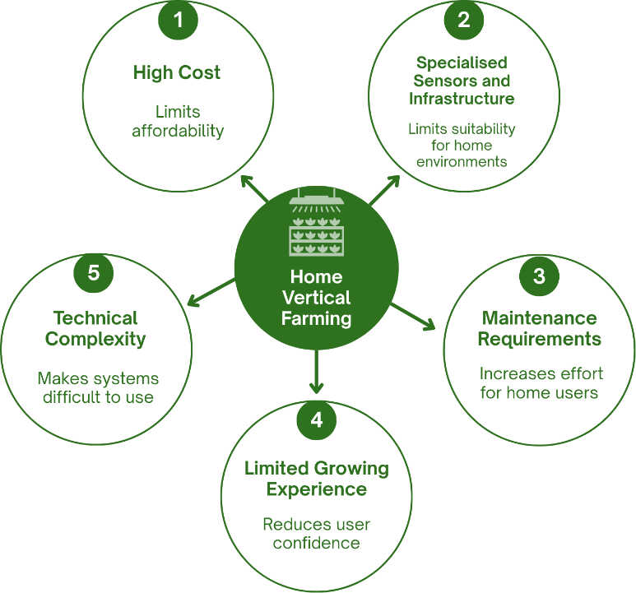

Figure 1. Main Barriers to Home Vertical Farming
This creates a clear gap in the current literature. There is limited understanding of which AI-driven decision support approaches are suitable for home vertical farming, how existing solutions address the needs of non-expert users, and what future research is required to make such support more accessible and practical.

1.3 Research Aim and Objectives

Aim
This study aims to systematically examine current AI-driven decision support approaches in vertical farming and assess their potential relevance to home growers, particularly users with limited agricultural or technical experience.

Objectives
- To review recent research on Artificial Intelligence, Decision Support Systems, and home vertical farming.
- To identify the AI approaches and input variables used for crop recommendation, growth prediction, and resource or cost estimation in vertical farming
- To evaluate the benefits and limitations reported for existing approaches.
- To assess the extent to which current research addresses home users and individuals with limited growing experience.
- To identify gaps in current knowledge and propose directions for future research on accessible home vertical farming support.

1.4 Significance of the Research

This research has academic value because it brings together evidence from areas that are often studied separately, including Artificial Intelligence, Decision Support Systems, controlled environment agriculture, and residential food production. By examining these areas through the needs of home users, the study can clarify where existing knowledge is strong and where important gaps remain. It may also provide a clearer foundation for future research on Human-Centred AI and explainable decision support in small growing environments [16].
The study also has practical and societal relevance. Home growers may benefit from decision support that simplifies crop selection, environmental management, resource use, and system maintenance. Although this research does not develop a new application, its findings can inform the future design of tools that are easier to understand and use without advanced technical knowledge. More accessible support could reduce the barriers identified in residential vertical farming and contribute to more efficient and sustainable home food production [15], [18].

2. Literature Review

2.1 Introduction to the Literature Review

This literature review examines recent research on Artificial Intelligence, Decision Support Systems, and vertical farming, with particular attention to their relevance to home growing environments. It covers studies published between 2023 and 2026 and is organised thematically around vertical farming, AI applications, agricultural decision support, and residential user needs. The review compares the main contributions and limitations of existing work, identifies the technical frameworks currently used, and establishes how the present study addresses a gap between commercial farming technologies and the needs of non-expert home growers.

2.2 Thematic Review of Current Research

2.2.1 Vertical Farming and Urban Food Production

Vertical farming has been widely discussed as a possible response to urbanisation, pressure on agricultural land, and the need for more local food production [1]. Controlled conditions can support year-round growing and more precise use of water, lighting, and nutrients [2].
Erekath et al. provide a broad account of recent vertical farming technologies, while Huang et al. show through crop modelling how controlled conditions can improve the predictability of leafy vegetable production [1], [3]. These studies demonstrate the technical potential of vertical farming, although their focus is production performance rather than the experience of users.
Small-scale urban agriculture can also contribute to local food availability, community activity, and environmental sustainability [4]. Yet these wider benefits are limited by energy consumption, equipment costs, environmental control requirements, and ongoing maintenance [2]. The same technologies that improve commercial production may therefore create barriers in smaller residential systems.
Studies focused on housing show that home users have different priorities. Residential acceptance depends on cost, practical design, ease of operation, and maintenance rather than technical capability alone [13], [15]. Research on building-integrated vertical farming also shows that successful adoption involves architectural and social factors alongside agricultural performance [18].

2.2.2 Artificial Intelligence in Vertical Farming

AI is increasingly used to analyse data from sensors and environmental monitoring systems. Predictive models can examine temperature, humidity, lighting, carbon dioxide, nutrients, and crop-growth data to support earlier and more informed decisions [19].
Rathor et al. link AI with IoT and automation, showing how these technologies improve real-time monitoring and environmental control in vertical farms [5]. Ali et al. reach similar conclusions across agriculture, where AI supports forecasting, resource optimisation, and operational planning [6]. These reviews establish the breadth of AI use, but their wide scope provides limited evidence about suitability for small home systems.
More focused research demonstrates practical applications. Predictive modelling and computer vision can support crop monitoring and resource management [11]. Digital Twins allow farming conditions to be represented virtually and tested before changes are made in the physical environment [9]. Alves et al. applied this approach to lighting optimisation, showing that AI can reduce resource use while maintaining suitable crop conditions [12].
As shown in Figure 2, these technologies support different stages of decision-making, including crop-growth prediction, condition monitoring, simulation, recommendation generation and explanation of results.

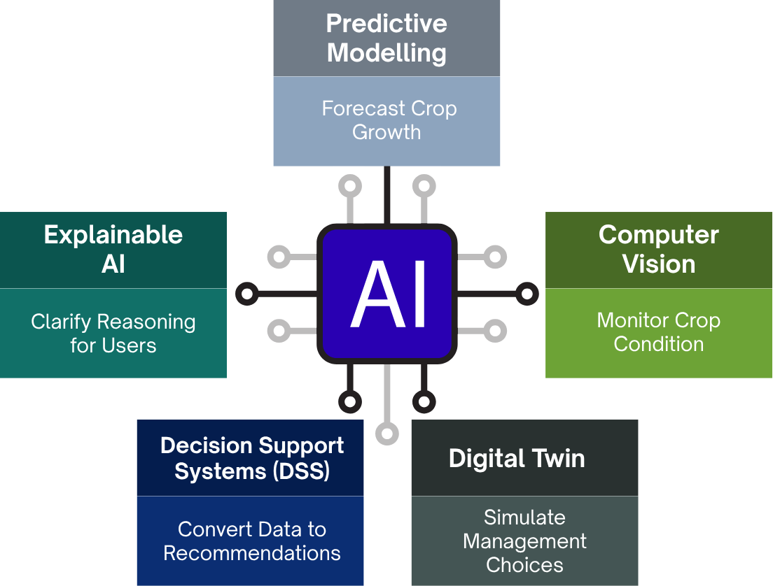

Figure 2. Key AI Technologies Used in Vertical Farming

These approaches remain dependent on reliable data, sensors, and technical infrastructure. Such requirements are realistic in commercial facilities but may be difficult to reproduce at home. Another concern is transparency. A model may produce an accurate recommendation without explaining why the action is needed. Explainable AI can address this issue by making crop recommendations easier for users to understand [16]. For beginners, clarity may be as important as predictive accuracy.

2.2.3 Decision Support Systems in Agriculture

Decision Support Systems turn data and analytical outputs into recommendations that can guide practical action. Agricultural DSS are used for planning, monitoring, irrigation, nutrient management, environmental control, and resource allocation [7].
Sridevy and Djanaguiraman describe the main functions of agricultural DSS, while Yi et al. emphasise their role as a bridge between data collection and decisions made by growers [7], [8]. This distinction is important because collecting environmental data provides little value unless users receive advice that they can apply.
In controlled environment agriculture, DSS can support decisions related to lighting, irrigation, nutrient delivery, and crop health. Producer-focused research also suggests that successful digital tools must fit users’ working practices rather than simply offer advanced technical functions [10], [11].
A limitation is that many current systems assume continuous sensor data, stable infrastructure, and experienced users. These assumptions may not reflect home environments. Home growers may require simpler recommendations, fewer technical outputs, and systems that remain useful with limited equipment and data.

2.2.4 Home Vertical Farming and User Needs

Research focused directly on home vertical farming remains limited. Existing studies mostly examine building integration, resident perceptions, or automation of individual tasks.
Balevic et al. demonstrate that automatic irrigation can be implemented within an at-home vertical farm [14]. This confirms technical feasibility but does not show whether beginners can understand the wider system, respond to faults, or make decisions about crops, lighting, and nutrients.
Residential studies identify a broader set of needs. Waseef et al. highlight practical implementation, maintenance, and stakeholder expectations and Tafahomi et al. identify cost and technical complexity as concerns that may discourage adoption [13], [15]. These findings show that a functional system is not automatically suitable for home users.
There is therefore a difference between automating one task and providing complete decision support. Home growers may need help across several stages of the growing process, but current residential research rarely examines integrated AI support designed for people with limited experience.

The main themes identified in the reviewed literature are summarised in Table 1. The table compares the contribution of the key studies and highlights the main limitations relevant to home vertical farming.

Theme | Key Studies | Main Contribution | Limitations / Focus
Vertical Farming and Urban Food Production | Erekath et al. (2024); Huang et al. (2024); Dona et al. (2024) | Demonstrate technical potential and resource efficiency in controlled environments | Focused on production performance; limited attention to user experience
Artificial Intelligence in Vertical Farming | Rathor et al. (2024); Ali et al. (2025); Alves et al. (2025); Shasteen & Kacira (2023) | Show how AI supports monitoring, prediction, and optimisation | Depend on large datasets and infrastructure; limited evidence for home systems
Decision Support Systems in Agriculture | Sridevy & Djanaguiraman (2023); Yi et al. (2024); Lindow et al. (2026) | Explain DSS as bridge between data collection and grower decisions | Assume continuous sensor data and experienced users; limited adaptation for beginners
Home Vertical Farming and User Needs | Balevic et al. (2024); Waseef et al. (2025); Tafahomi et al. (2024) | Identify cost, maintenance, and complexity as barriers to adoption | Focus on automation or perception; lack integrated AI decision support for home users
Table 1. Summary of the Main Literature Review Themes

2.3 Key Contributions and Research Gaps

Existing research has established that controlled environments can improve resource management and production consistency [1], [3]. AI studies have shown that predictive modelling, computer vision, and Digital Twins can support monitoring and optimisation [9], [11], [12], [20]. DSS research has demonstrated how these outputs can be converted into practical recommendations [7], [8], [17]. Residential studies have added evidence about cost, maintenance, design, and ease of use [13]-[15].
The main weakness is that these areas are usually studied separately. Technical research prioritises accuracy, productivity, and efficiency, while residential research focuses on acceptance and practical barriers.
Three gaps remain. Most AI systems are designed for commercial farms and rely on infrastructure that may not be realistic at home. Limited research explains how AI recommendations should be presented to non-expert users. Home studies also tend to focus on individual automated tasks rather than integrated decision support.
The problem is not the absence of AI technologies, but the lack of evidence showing how they can be adapted into understandable and practical support for home growers.

2.4 Theoretical and Technical Frameworks

The study is based on the principle that Decision Support Systems assist rather than replace human judgement [7], [8]. The system processes data and provides recommendations, but the user remains involved in the final decision.
Explainable AI extends this principle by helping users understand why a recommendation has been produced [16]. This is important in-home vertical farming, where beginners may need clear reasons before changing lighting, irrigation, or nutrient conditions.
Table 2 compares the main technical approaches identified in the reviewed literature. This framework allows existing approaches to be assessed through both technical performance and suitability for users with limited equipment, data, and experience.

Approach | Main purpose | Key contribution | Limitation for home users
Predictive modelling | Forecast crop growth | Earlier operational decisions | Needs reliable data
Computer vision | Monitor crop condition | Non-contact assessment | Camera and setup cost
Digital Twin | Simulate management choices | Tests changes before implementation | Complex infrastructure
Explainable AI | Explain recommendations | Supports understanding and trust | Limited home-farming evidence
Human-Centred AI | Keep users involved | Accessible and user-aware decisions | Mainly conceptual evidence
Table 2. Comparison of AI Approaches Relevant to Home Vertical Farming

2.5 Relation to the Current Study

The present study connects three areas that are often examined separately: AI in vertical farming, agricultural Decision Support Systems, and the needs of residential users.
More specifically, the findings will inform the later development of an AI model trained using data for approximately ten plant types. The model is expected to use environmental, spatial, resource, and cost-related parameters to recommend suitable crops for a home setting and estimate their likely growing expenses.
Based on the approaches identified in the literature, the future home vertical farming system could follow the decision-support process presented in Figure 3.

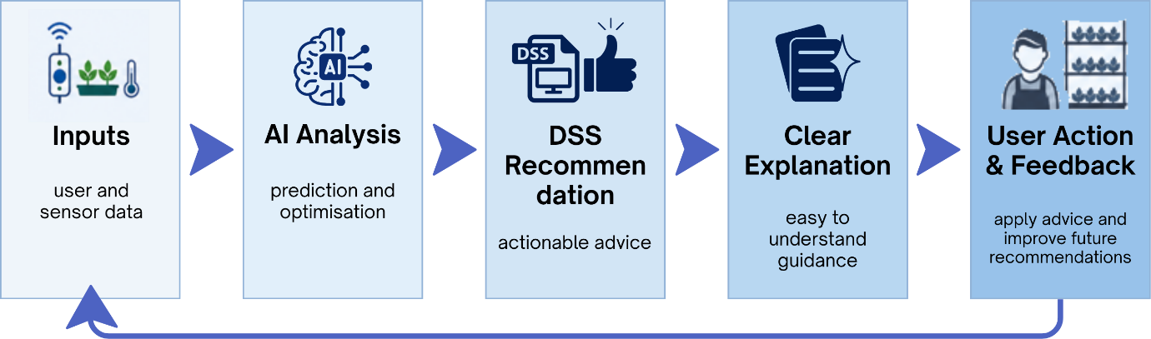
Figure 3. Proposed AI-Driven Decision Support Process for Home Vertical Farming

This stage does not develop the AI model itself. Instead, it identifies the approaches, variables, limitations, and design requirements that can guide its later development. Instead, it systematically assesses current approaches according to their purpose, data requirements, infrastructure, reported benefits, limitations, explainability, and relevance to non-expert home growers.
Its contribution is to move the discussion from what AI can achieve in commercial vertical farming to what would be required for the same approaches to provide accessible support within a home environment.

2.6 Literature Review Summary

Current research shows that AI, predictive models, computer vision, Digital Twins, and DSS can improve monitoring and decision-making in vertical farming. Most evidence, however, comes from commercial facilities with advanced infrastructure and experienced users.
Residential research identifies cost, maintenance, complexity, and ease of use as important barriers. Limited evidence currently connects these user needs with integrated AI-driven decision support. This gap provides the basis for the present systematic investigation.

3. Research Design and Methodology

3.1 Research Design

The research was designed as a systematic literature review rather than an experiment, survey, or software development project. This choice matched the purpose of the study, which was to examine how AI-driven decision support is currently used in vertical farming, assess the value and limitations of existing approaches, and identify whether these approaches respond to the needs of home growers.
A systematic review was more suitable than a traditional narrative review because the topic crosses several connected fields, including Artificial Intelligence, Decision Support Systems, controlled environment agriculture, Human-Centred AI, and home vertical farming. Evidence from these fields is spread across computing, engineering, and agricultural research. A structured search and screening process was therefore needed to reduce selective use of literature and provide a clear record of how the final studies were chosen [20].
The review followed the PRISMA reporting structure. PRISMA was used to record the movement of studies through identification, duplicate removal, title and abstract screening, full-text assessment, and final inclusion. This made the selection process easier to inspect and reduced the risk of presenting a final group of papers without explaining how it had been formed [21], [22].
The review also provides the evidence base for the later development of a home vertical farming AI model focused on crop recommendation and cost estimation.

3.2 Research Methods and Materials

3.2.1 Research Method and Strategy

The study used a qualitative research method based on systematic analysis of secondary academic evidence. A systematic approach was selected because it provides a transparent and reproducible process for identifying, evaluating, and synthesising existing research while reducing the risk of selective interpretation [23]. This method allowed findings from technically different studies to be compared without treating them as if they had used identical datasets or evaluation measures [24].
Qualitative evidence synthesis is suitable when the purpose is to bring together varied research, compare its meaning across contexts, and identify themes that are not visible when studies are considered separately [25].

3.2.2 Search Strategy and Study Selection

The literature search was carried out across three academic databases: IEEE Xplore, ACM Digital Library, and ScienceDirect. These databases were selected because together they cover computing, Artificial Intelligence, engineering, Decision Support Systems, and agricultural technology. Using three databases also reduced the likelihood that relevant work would be missed because it was indexed in one subject area but not another.
The search strategy was applied across IEEE Xplore, ACM Digital Library, and ScienceDirect. Examples of the searches and filters used are presented in Figure 4.
The search terms were adapted to each database, while the same publication period and eligibility requirements were maintained.
Search strings combined terms such as:
“artificial intelligence”, “machine learning”, “explainable AI”, “digital twin”, “decision support system”, “vertical farming”, “controlled environment agriculture”, and “home vertical farming”. The main Boolean search structure was adapted to the requirements of each database:
(“artificial intelligence” OR “machine learning” OR “explainable AI” OR “digital twin”) AND (“decision support system” OR recommendation OR prediction) AND (“vertical farming” OR “controlled environment agriculture” OR “home vertical farming”).





Figure 4. Examples of Database Searches Used in the Systematic Literature Review

The review focused on peer-reviewed journal articles and conference papers published from 2023 to 2026. Duplicate records, non-English publications, opinion pieces, commercial webpages, studies published before 2023, and papers with no clear connection to the research objectives were excluded. Papers that discussed agriculture in general without examining AI, DSS, user decision-making, or controlled growing environments were also removed.
The records were imported into Rayyan (Figure 5). Duplicate checking was completed before the titles and abstracts were screened. Each paper was marked as included, excluded, or uncertain, with full-text checking used to resolve uncertain cases (Figure 6). Rayyan was used as an organisational and screening tool rather than as a replacement for researcher judgement. This was important because automated screening can improve efficiency, but relevant studies may still be missed when decisions depend too heavily on automated recommendations [26].

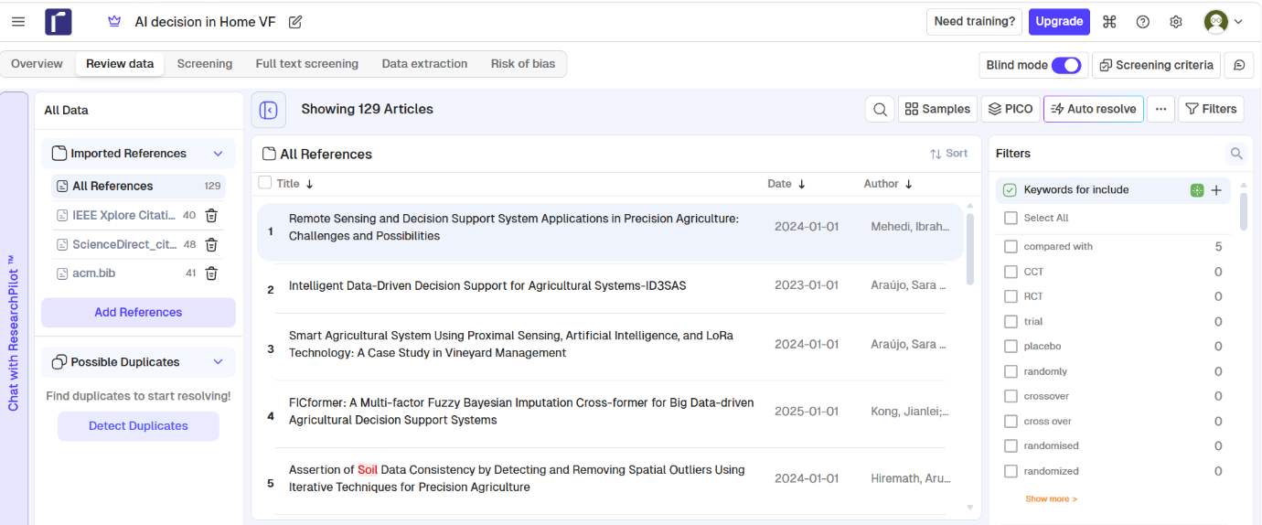
Figure 5. References Imported into Rayyan

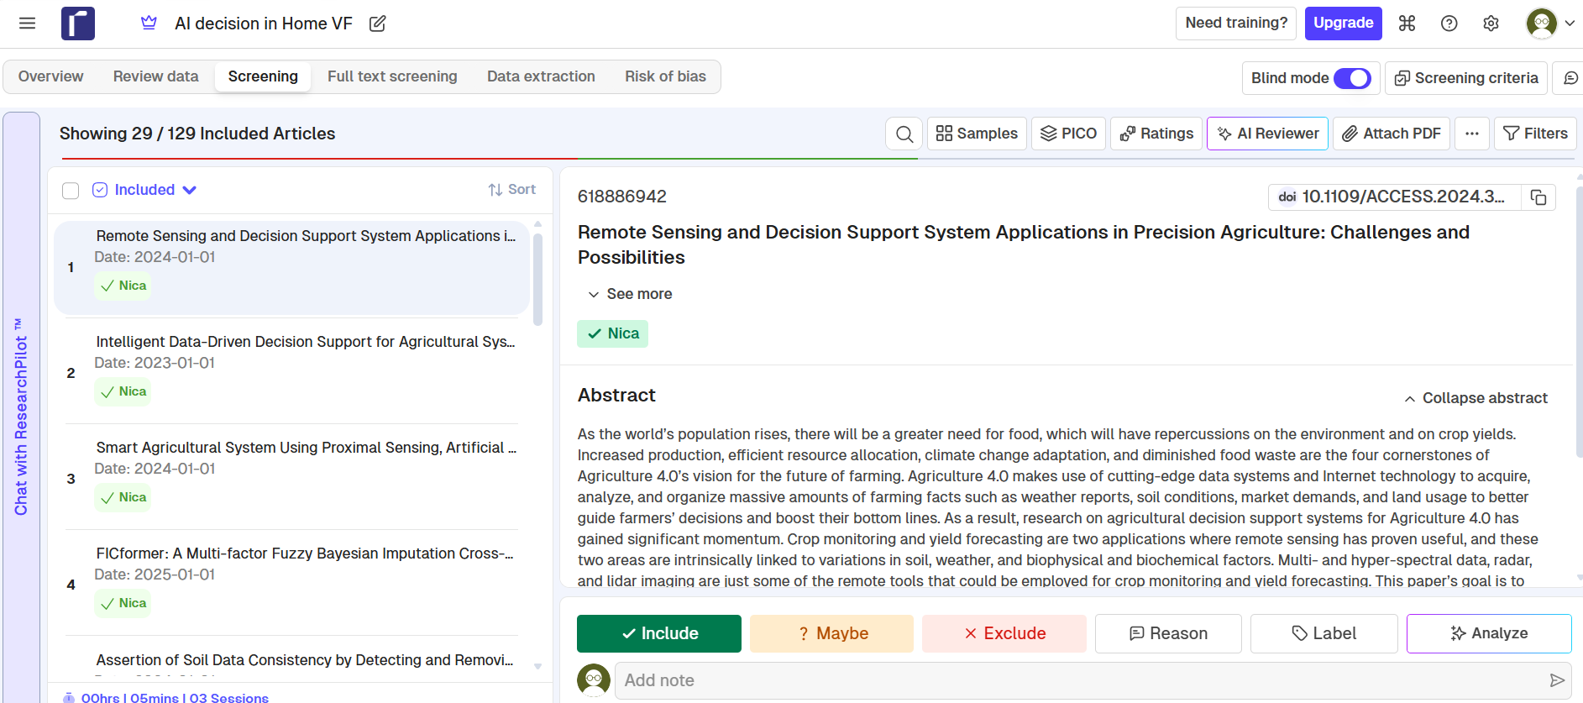

Figure 6. Title and Abstract Screening in Rayyan

The PRISMA flow diagram reports the number of records identified in each database, duplicates removed, records screened, full texts assessed, exclusion reasons, and studies included in the final review (Figure 7).
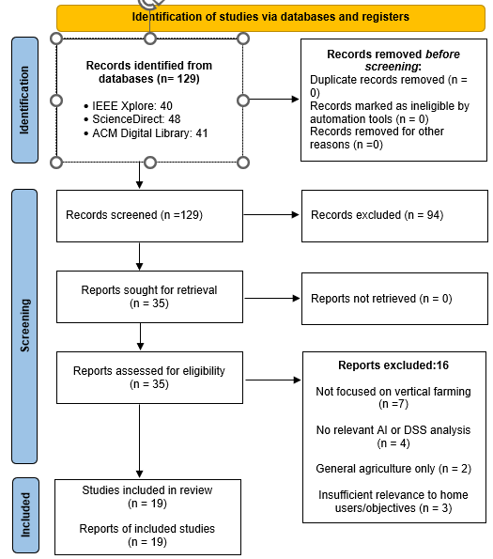
Figure 7. PRISMA 2020 Flow Diagram of the Study Selection Process

3.2.3 Data Extraction, Analysis and Evaluation

A structured extraction table was created in Microsoft Excel to organise the selected studies consistently. It recorded information relevant to the research objectives, including the research context, AI or decision-support approach, main findings, reported limitations, and relevance to home vertical farming.
Simple descriptive counts were used to identify patterns, such as the number of studies focused on commercial farming, home environments, particular AI approaches, or user-centred concerns. These counts were used only to map the evidence. No inferential statistical tests were applied because the studies used different research designs, datasets, and evaluation methods.
Each study was assessed against five criteria: a clear research aim, an appropriate data source, a transparent methodology, a reported evaluation process, and acknowledgement of limitations. Studies with stronger methodological detail were used to support the main arguments, while weaker evidence was interpreted cautiously.
Table 3 shows how extracted data were organised and evaluated according to approach, findings, limitations, and relevance to home vertical farming.

Study | AI / DSS Approach | Main Findings | Reported Limitations | Relevance to Home Vertical Farming
Rathor  et al. (2024) | IoT + AI for environmental control | Improved monitoring and automation in vertical farms | Requires advanced sensors and infrastructure | Limited applicability for home systems
Alves  et al. (2025) | Digital Twin + AI optimisation | Reduced energy use while maintaining crop conditions | Complex setup and high cost | Not feasible for small-scale users
Shasteen & Kacira (2023) | Predictive modelling + computer vision | Enhanced resource efficiency and crop monitoring | Needs large datasets and technical expertise | Could inform simplified home models
Waseef  et al. (2025) | Residential integration study | Identified cost and maintenance barriers | Focused on architecture, not AI support | Highlights user-centred design needs
Table 3. Comparison of Selected Studies Relevant to Home Vertical Farming

3.2.4 Research Materials and Resources

The research data consisted of published academic articles retrieved from IEEE Xplore, ACM Digital Library, and ScienceDirect. Rayyan was used for duplicate management and screening, Microsoft Excel was used for data extraction and thematic organisation, and Microsoft Word was used to write and format the report.
The main tools and resources used during the systematic literature review are summarised in Table 4.
Tool / Resource | Purpose | Justification
IEEE Xplore, ACM Digital Library, ScienceDirect | Literature databases | Cover computing, AI, DSS, and agricultural technology domains
Rayyan | Screening and duplicate management | Enables transparent inclusion/exclusion tracking
Microsoft Excel | Data extraction and thematic organisation | Allows structured comparison of studies
Microsoft Word | Report writing and formatting | Suitable for academic documentation
Standard computer with internet access | Hardware platform | Sufficient for literature-based research; no GPU or cloud required
Table 4. Research Tools and Resources
No programming language, machine-learning library, specialist data-analysis package, or system architecture was required because the study did not build or test an AI application. No GPU, server, cloud platform, or specialist hardware was needed. A standard computer with internet access and access to the university’s academic databases was sufficient.

3.2.5 Ethical Considerations and Methodological Limitations

The study used published academic literature and did not collect personal, confidential, or identifiable data. It presented no direct risk to participants and did not require informed consent. Ethical responsibility remained important through accurate representation of authors’ findings, transparent reporting of the selection process, and correct use of IEEE referencing.
The search was limited to English-language studies published between 2023 and 2026 and available through IEEE Xplore, ACM Digital Library, and ScienceDirect. This kept the review focused and current, but relevant research indexed elsewhere may not have been identified.
The analysis was also limited by the level of detail reported in the selected papers. Studies with unclear methods or limited evaluation could not be assessed as confidently as well-documented research. Evidence from commercial farming was used cautiously when considering its relevance to home environments.

4. Expected Outcome

4.1 Anticipated Results

The review is expected to show which AI-driven approaches are most useful for supporting decisions in vertical farming and which of them could realistically be adapted for home use. Attention will be given to crop recommendation, growth prediction, resource planning, and cost-related decisions.
Based on the current literature, the strongest solutions are likely to come from commercial and controlled farming environments, where reliable sensors, larger datasets, and specialist equipment are available [5], [10]. Residential studies suggest that home users face a different set of concerns, especially cost, maintenance, limited space, and technical complexity [13], [15]. The review may also confirm that clear explanations are important when AI recommendations are aimed at people with little growing experience [16].

4.2 Implications

The findings will provide a practical starting point for the later development of an AI model for home vertical farming. The planned model will use data from around ten plant types and consider environmental conditions, available space, resource needs, and likely expenses before recommending suitable crops.
The value of the study is not limited to identifying technologies. It should also help define what a useful home system needs to do, what information it should ask from the user, and how recommendations should be presented in a simple way. This can reduce the gap between technically strong agricultural AI and tools that beginners can understand and use.

4.3 Limitations

The expected outcome cannot confirm that the future AI model will work effectively in practice because this study does not build or test a prototype. Its role is to identify suitable approaches and provide a foundation for the later implementation.
The future model will also depend on the quality and availability of data for the selected plant types. Beginning with approximately ten plants will keep the project realistic, but its recommendations will not apply to every crop.
Cost estimates may change according to energy prices, equipment, location, crop cycle, and household conditions. The model could therefore provide useful guidance, but not one fixed estimate that would be accurate for every home grower.

5. Timeline

The proposed project schedule is presented in Figure 7. It shows the main stages of the future implementation, from research and AI design to data preparation, development, system integration, testing, and final submission. The schedule follows a phased approach, with clear milestones used to monitor progress. The research stage is completed first, while the remaining activities cover the planned development and evaluation of the AI-supported home vertical farming system.
Figure 8. Proposed Gantt Chart for the Future AI Implementation Project

References
[1] S. Erekath, H. Seidlitz, M. Schreiner and C. Dreyer, "Food for future: Exploring cutting-edge technology and practices in vertical farm," vol. 106, pp.105357, 2024,
[2] M. S. N. Kabir et al., , "Technological trends and engineering issues on vertical farms: a review," vol. 9, no. 11, pp.1229, 2023,
[3] J. J. Huang, C. X. Tan and W. Zhou, "Universal modeling for optimizing leafy vegetable production in an environment-controlled vertical farm," Comput.Electron.Agric., vol. 219, pp.108715, 2024,
[4] C. G. W. Dona, G. Mohan and K. Fukushi, "Multifunctionality benefits of small-scale urban agriculture," vol. 19, no. 3, pp.967–987, 2024,
[5] A. S. Rathor, S. Choudhury, A. Sharma, P. Nautiyal and G. Shah, "Empowering vertical farming through IoT and AI-Driven technologies: A comprehensive review," vol. 10, no. 15, 2024,
[6] Z. Ali, A. Muhammad, N. Lee, M. Waqar and S. W. Lee, "Artificial intelligence for sustainable agriculture: A comprehensive review of AI-driven technologies in crop production," vol. 17, no. 5, pp.2281, 2025,
[7] S. Sridevy and M. Djanaguiraman, "A Glance at agricultural decision support systems," vol. 12, no. 5, pp.755–757, 2023,
[8] D. Yi et al., , "Transforming agriculture: An insight into decision support systems in precision farming," vol. 5, no. 4, pp.1614–1624, 2024,
[9] J. Monteiro, J. Barata, M. Veloso, L. Veloso and J. Nunes, "A scalable digital twin for vertical farming," vol. 14, no. 10, pp.13981–13996, 2023,
[10] L. Lindow, C. Campbell, C. Longwater, Y. Zhang, A. Martin-Ryals and Z. Boz, "Decision-making in controlled environment agriculture: Producer perspectives on digital decision-support tools in the US," 2026,
[11] K. C. Shasteen and M. Kacira, "Predictive modeling and computer vision-based decision support to optimize resource use in vertical farms," vol. 15, no. 10, pp.7812, 2023,
[12] R. G. Alves, F. Lima, Í M. R. Guedes and S. P. Gimenez, "Dynamic light optimization in vertical farming using an IoT-driven digital twin framework and artificial intelligence," vol. 174, pp.112985, 2025,
[13] A. A. E. Waseef, M. Shahda, H. S. El Samaty and S. Nosier, "Integrating Vertical Farming into Residential Buildings in Egypt: A Stakeholder Perspectives-Based Approach," vol. 15, no. 16, pp.2917, 2025,
[14] E. G. Balevic, A. H. Farha, A. J. Hoess and E. A. Groll, "At-Home Vertical Farm and Automatic Irrigation System Implementation," 2024,
[15] R. Tafahomi, D. Nkurunziza, G. G. Benineza, R. Nadi and R. Dusingizumuremyi, "The Assessment of Residents’ Perception of Possible Benefits and Challenges of Home Vertical Gardens in Kigali, Rwanda," vol. 16, no. 9, pp.3849, 2024,
[16] M. Y. Shams, S. A. Gamel and F. M. Talaat, "Enhancing crop recommendation systems with explainable artificial intelligence: a study on agricultural decision-making," vol. 36, no. 11, pp.5695–5714, 2024,
[17] E. Elbasi, N. Mostafa, C. Zaki, Z. AlArnaout, A. E. Topcu and L. Saker, "Optimizing agricultural data analysis techniques through AI-powered decision-making processes," vol. 14, no. 17, pp.8018, 2024,
[18] X. Shi et al., , "A review of research Progress in vertical farming on façades: design, technology, and benefits," vol. 17, no. 3, pp.921, 2025,
[19] G. Jung, H. Choe and M. Lee, "Analysis of AI-Based Predictive Models Using Vertical Farming Environmental Factors and Crop Growth Data," vol. 16, no. 5, pp.575, 2026,
[20] M. Gusenbauer and S. P. Gauster, "How to search for literature in systematic reviews and meta-analyses: A comprehensive step-by-step guide," vol. 212, pp.123833, 2025,
[21] M. M. Albhirat et al., , "The PRISMA statement in enviropreneurship study: a systematic literature and a research agenda," vol. 18, pp.100721, 2024,
[22] V. Mishra and M. P. Mishra, "PRISMA for review of management literature–method, merits, and limitations–an academic review," 2023,
[23] M. Azarian, H. Yu, A. T. Shiferaw and T. K. Stevik, "Do we perform systematic literature review right? A scientific mapping and methodological assessment," vol. 7, no. 4, pp.89, 2023,
[24] P. C. Sauer and S. Seuring, "How to conduct systematic literature reviews in management research: a guide in 6 steps and 14 decisions," vol. 17, no. 5, pp.1899–1933, 2023,
[25] A. Moser and I. Korstjens, "Series: Practical guidance to qualitative research. Part 7: Qualitative evidence synthesis for emerging themes in primary care research: Scoping review, meta-ethnography and rapid realist review," vol. 29, no. 1, pp.2274467, 2023,
[26] J. Ng, N. Szydlowski, M. Gill, N. Fusco and K. Ruiz, "MSR72 an evaluation of the Rayyan artificial intelligence tool for systematic literature review screening," vol. 27, no. 6, pp.S273, 2024,

