Design, Simulate and Evaluation of a potential real-life Communication System

Jordan Phillips
MSc Computer Networks and Cybersecurity
University of Wales, Trinity Saint David
jphillips.147607@student.uwtsd.ac.uk
Table of Contents
I Introduction 2
II Modulation Techniques 3
A. Amplitude Shift Keying 3
B. Phase Shift Keying 4
C. Quadrature Amplitude Modulation 4
III Modulation Technique Experiment 5
A. ASK Modulation 5
B. PSK Modulation 7
C. QAM Modulation 8
IV Monitoring System Design 10
V Conclusion 13
References 14

Table of Figures
Figure 1: 16QAM Constellation Diagram 5
Figure 2: ASK Modulation Design 6
Figure 3: ASK Scope with 10 SNR 6
Figure 4: ASK Display with 10 SNR 6
Figure 5: ASK Scope with -10 SNR 6
Figure 6: ASK Display with -10 SNR 6
Figure 7: ASK Scope with -25 SNR 7
Figure 8: ASK Display with -25 SNR 7
Figure 9: PSK Modulation Design 7
Figure 10: PSK Scope with 10 SNR 7
Figure 11: PSK Display with 10 SNR 7
Figure 12: PSK Scope with -10 SNR 8
Figure 13: PSK Display with -10 SNR 8
Figure 14: PSK Scope with -25 SNR 8
Figure 15: PSK Display with -25 SNR 8
Figure 16: QAM Modulation Design 8
Figure 17: QAM Constellation 9
Figure 18: QAM Constellation with 10 SNR 9
Figure 19: QAM Display with 10 SNR 9
Figure 20: QAM Constellation with -10 SNR 9
Figure 21: QAM Display with -10 SNR 9
Figure 22: QAM Constellation with -25 SNR 10
Figure 23: QAM Display with -25 SNR 10
Figure 24: NetSim Network Design 11
Figure 25: NetSim Network Communication 11
Figure 26: NetSim 802.11 Modulations 11
Figure 27: Simulation Link Properties 12
Figure 28: Standard NetSim Simulation Results 12
Figure 29: 802.11ac NetSim Simulation Results 12
Figure 30: Farm Server to Police Server Throughput 13
Figure 31: Farm Server to Police Server Throughput with 802.11ac 13

Abstract – Wireless Networks (WN) are continuously evolving, with more modulation techniques being developed to support and enhance WN efficiency and speed. These include Amplitude Shift Keying (ASK), Phase Shift Keying (PSK) and Quadrative Amplitude Modulation (QAM). They possess several strengths such as ASK’s low power consumption, structural simplicity and easy method of modulation; PSK’s efficiency and error resistance; or QAM’s ability to transmit higher amounts of data across a carrier wave. However, Simulation results identified QAM’s extreme vulnerability to atmospheric noise, resulting in 74% error rate at -10 SNR noise level, which means it is undesirable for certain areas due to error rate. Both ASK and PSK also possess a vulnerability to noise, but far less severe in comparison, with PSK possessing the most resilience to atmospheric noise. Subsequently, to solve a scenario based on crime levels in the Caribbean, a WN was created which utilised modulation techniques. This network was created using NetSim simulation software in order to test network performance and required information to be gathered and transmitted to police authorities should a problem arise. Despite some limitations using NetSim’s IoT software, such as inability to select which modulation technique is utilised, a network was successfully designed and tested with a dB value of 5 to represent atmospheric sound. Packet loss using modulation technique was between 10-15%, which led to the hypothesis that PSK was utilised during network simulations.
Keywords – Wireless Networks, Modulation Techniques, ASK, PSK, QAM

I Introduction
As wireless networks (WN) continue to evolve, it requires network technicians to continually improve their knowledge of new and emerging technologies. To achieve this, research into different techniques is advised in order to understand how they interact with existing network infrastructures. Examples of networks which utilise wireless technology are wireless sensor networks (WSN) [1] [2]. These networks consist of devices called sensors that detect changes within their environment, based on type of sensor in question [1] [2]. Typically, sensor devices are autonomous and utilise wireless communication protocols in order to relay data to a central gateway or base station [1] [2]. Examples of WSNs in use would be within smart homes or smart cities, which utilise Internet of Things (IoT) concepts [3], and environmental monitoring [4]. IoT is a concept that utilises smart devices, or “things”, which can communicate over the internet [3]. Environmental monitoring involves the use of WSNs to monitor changes within remote regions that can be difficult to access [4]. Examples of WSNs in use here are within rivers, watersheds and agricultural applications [4].
Common concepts shared by WNs are that they utilise communication protocols and modulation techniques to relay information [5]. As a result, this report will research various digital modulation techniques used within communication systems and compare their performance. From there, a WN will be designed in order to test the performance of these modulation techniques using NetSim simulation software.

II Modulation Techniques
Modulation are methods used to transmit digital data over carrier waveforms from one point to another [6] [7]. These methods of data transfer are used to improve efficiency of data transmission and reception within the same bandwidth [6] [7]. This allows simultaneous transmission of multiple signals over a single channel by using different frequency ranges [6] [8].
Modulation comes in two methods: analog and digital [7]. Analog modulation is typically preferable when transmitting certain signals, such as voice, whereas digital is typically more resistant to noise [7]. However, since digital modulation requires both an analog to digital converter and digital to analog converter, at source and destination respectively, it is less ideal for voice traffic [7]. Digital methods also possess simpler reconfiguration and repeatability compared to analog solutions [7].
Bandpass filters are another component within modulation used mainly in wireless transmitter and receiver devices [6] [8]. These have different roles within transmitters and receivers but both function in order to ensure signal transmission from one point to another [6] [8]. Transmitters use these to limit bandwidth of the output signal in order to match the minimum bandwidth required to transmit data at desired speeds and forms [6] [8]. Receivers utilise bandpass filters to allow signals within a pre-selected range to be detected or demodulated, while also preventing un-associated signals from entering the receiver [6] [8].
Once receivers acquire the signal, demodulation is done in order to extract the original signal from the modulated carrier wave [6] [9]. This process varies based on the modulation technique utilised in sending signals [9].
The three main modulation techniques this report will analyse are Amplitude Shift Keying (ASK) [10], Phase Shift Keying (PSK) [11] and Quadrature Amplitude Modulation (QAM) [12].

A. Amplitude Shift Keying
ASK modulation technique, also known as On Off Keying (OOK), uses binary functions to determine what information is sent across the carrier wave [10] [13]. This typically leads to a digital input of 1 allowing data through the carrier wave, while a digital input of 0 prevents any information [10]. An example of ASK modulation can be found in Radio Frequency Identification (RFID) systems [13]. RFID utilises tags, which are attached to items and used as an identifier [13] [14]. This identifier possesses a unique ID for that item, used to identify the item or person through an RFID reader [13] [14].
ASK has several advantages regarding wireless communication systems, such as:
- Low power consumption [14].
- Structural simplicity [14].
- Easy to use method of modulation [13].
- Cost efficient. Both modulation and demodulation are simply to design and cheap to implement [13].
- Requires little bandwidth compared to some other modulation techniques, such as Frequency Shift Keying (FSK) [13]
However, ASK also possess several disadvantages which should be considered. These include:
- Sensitive to atmospheric noise and distortion [13] [15].
- Has poor bandwidth efficiency and therefore, possesses low power efficiency [13] [15].

B. Phase Shift Keying
PSK is a digital modulation technique which transmits data by altering the phase of the carrier wave [11] [15] [16]. This is done by changing the sine and cosine inputs at specific moments [15] [16]. Two main forms of PSK are Binary Phase Shift Keying (BPSK) and Quadrature Phase Shift Keying (QPSK) [15]. BPSK is the simplest form of PSK, where only two-phase states are represented with use of binary inputs [15] [16]. QPSK is another extension of the PSK modulation technique but utilises 4 phase states [15]. An increase in number of phases utilised requires further modifications in receiver design [15]. Failing to accommodate for an increased number of phases can result in errors and failure in signal detection [15]. Despite this added complexity, QPSK is considered a highly bandwidth efficient modulation technique [15]. However, the aim of this paper will focus more on the standard PSK two-phase method.
PSK advantages include:
- Able to carry data over carrier signals more efficiently compared to other modulation techniques, such as ASK and FSK [15] [16].
- Less susceptible to errors compared to ASK, while also occupying the same bandwidth [15].
- Higher transmission rate can be obtained through higher levels of modulation, such as QPSK and QAM [15].
PSK designs also possess several disadvantages, such as:
- Complex receiver designs to accommodate for phase states of the signals [15].
- Low bandwidth efficiency [15].
- Higher levels of PSK are more sensitive to phase variations, i.e. QPSK and QAM [15].

C. Quadrature Amplitude Modulation
QAM is a modulation technique which utilises both amplitude and phase components to transmit data across a carrier waveform [12] [17]. This method functions by combining two carrier waves with a 90-degree phase difference [12] [17] [18]. Typically, one of these signals is known as “in-phase”, while the second is the quadrature signal [12] [17] [18]. QAM is one of the more popular modulation techniques as it allows for efficient use of power and bandwidth [18]. This is due to the nature of QAM combining two modulated signals into one carrier channel [18]. QAM is widely used in several wireless technologies, such as IEEE 802.11 WiFi, IEEE 802.16 WiMAX and 3G [18].
This modulation technique can carry a higher quantity of data compared to other amplitude and phase modulation techniques [18]. Unlike other modulation techniques with a binary signal of 0 or 1, QAM possesses many different points with pre-defined values of amplitude and phase [18]. This is known as constellation diagram [18]. From these defined values, QAM can transfer a higher amount of data in comparison to other techniques [18]. Constellation diagrams arrange each data point into a grid, with the number of points being n², i.e. 16QAM, 64QAM and 256QAM [18] [19]. 16QAM possesses 4 bits per carrier, 64QAM possesses 6 bits per carrier and 256QAM possesses 8 bits per carrier [18] [19].
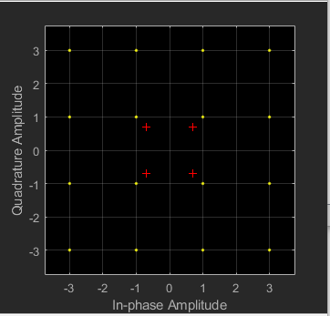
Figure 1: 16QAM Constellation Diagram
Figure 1 shows this layout as outputted from Matlabs built in simulation software called Simulink, which was used for the experiment later in the report.
The more points from higher modulation formats allow for more bits to be transferred [18]. However, this comes at the cost of the signal becoming more susceptible to atmospheric noise [18]. Therefore, higher versions of QAM are typically used when there is a high enough signal to noise ratio [18].
Like other modulation techniques, QAM possesses several advantages and disadvantages. Advantages of QAM include:
- The largest benefit of QAM is the increased capacity of data transfer thanks to the higher number of bits per carrier [18]
- QAM is efficient regarding bandwidth consumption, once again due to the increased number of bits per carrier [18] [19].
However, disadvantages of QAM include:
- More susceptible to background noise [18].
- Requires more complex receivers compared to other modulation techniques [18].
- QAM requires more power due to the nature of the amplitude component of the signal [18] [19].

III Modulation Technique Experiment
In order to examine how each modulation technique performs under certain noise levels, various simulations were conducted using Matlab’s Simulink software. A simulation was created for ASK, PSK and QAM modulation techniques in order to examine their performance. Each modulation technique was tested to a signal to noise ratio (SNR) of 10, -10 and -25. A higher SNR simulates a low amount of noise, while a lower SNR indicates a high concentration of noise. This allows for each modulation technique to be tested in order to determine their resistance to atmospheric noise. The results will be compared to the research in order to determine if the information discovered was accurate. Following this, a comparison between modulation techniques to determine how each functioned under these SNR values, and which are more ideal for high noise levels.

A. ASK Modulation
The first technique tested was the ASK modulation. Figure 2 below shows the ASK design created using Simulink.
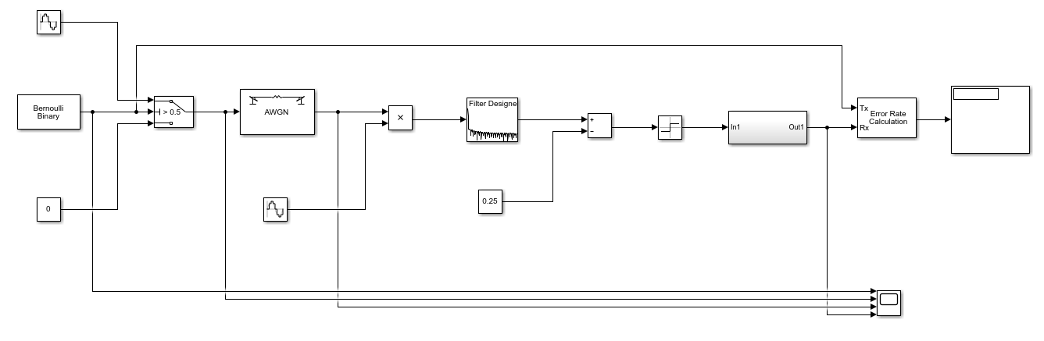
Figure 2: ASK Modulation Design
The design would create a digital wave and using ASK modulation, would convert the wave in order to be sent across an Additive White Gaussian Noise (AWGN) section. This section would be used to create background noise in order to test each modulation technique. Once the wave passed through this channel, it would need to be filtered and demodulated for the original data to be retrieved. The SNR value within AWGN channel was first set to 10 for the first test, the results of which can be seen in Figures 3 and 4 below.
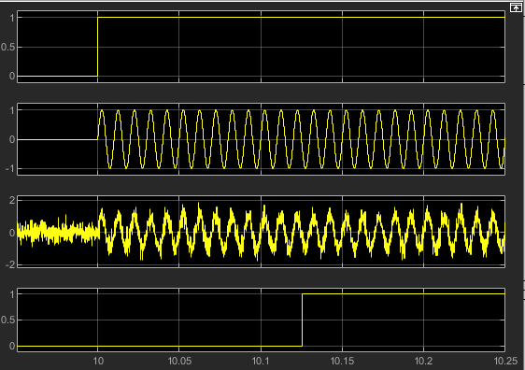
Figure 3: ASK Scope with 10 SNR
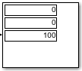
Figure 4: ASK Display with 10 SNR
Figure 3 shows the waveform at 4 stages within the simulation. The first display shows the original digital signal. Second and third displays show the modulated wave before and after entering the AWGN channel. Finally, the fourth display shows the retrieved signal. As shown, there is some distortion within the signal after it has passed through the noise channel. However, the original digital signal was retrieved with a slight delay between 0.1 and 0.15 seconds.
The display seen in Figure 4 shows the error percentage, number of bits lost, and number of bits sent from top to bottom. As seen, no data was corrupted by the noise generated from the AWGN channel. A SNR of 10 does not generate a lot of noise, therefore, this result is expected and supports the image shown in Figure 3.
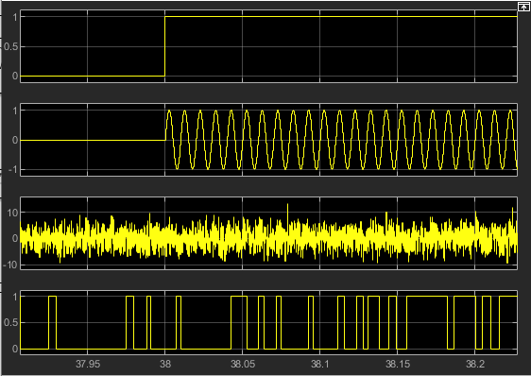
Figure 5: ASK Scope with -10 SNR
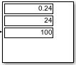
Figure 6: ASK Display with -10 SNR
Figures 5 and 6 show the results of a simulation with -10 SNR. This causes a larger amount of noise to be generated. As seen in Figure 5, this noise has influenced the waveform. Comparing results of Figure 5 to Figure 3, it is possible to see the wave has lost all form after passing through the AWGN channel. The final digital signal is also nothing like the original.
Despite this, Figure 6 shows only a 24% error rate. This means that despite the noise influence, some data was still retrieved. However, such error rate would not be ideal for certain communication methods, such as voice. This also supports the research of ASK being susceptible to noise.
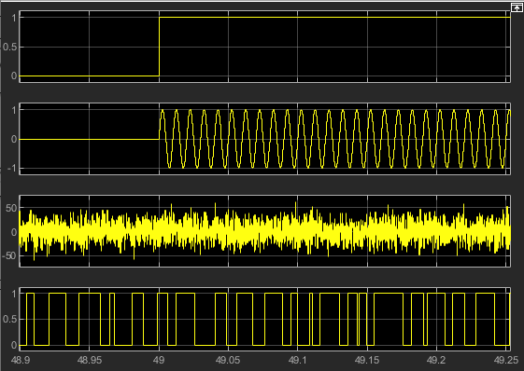
Figure 7: ASK Scope with -25 SNR
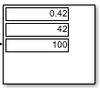
Figure 8: ASK Display with -25 SNR
The final simulation used an SNR of -25. Figure 7 shows results like Figure 5. However, the noise has had a much greater impact on the signal. The waveform after entering the AWGN channel is completely unrecognisable and the final digital signal has no similarities to the original.
Figure 8 further confirms the effect noise has had on this ASK simulation, showing a massive 42% error rate. This supports the conclusion identified from the -10 SNR simulation and previous research, i.e. ASK modulation is heavily affected by noise.

B. PSK Modulation
PSK was the next modulation method to be tested. A simulation model of PSK can be seen in Figure 9 below.
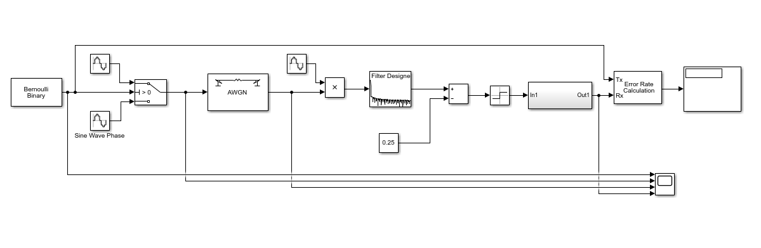
Figure 9: PSK Modulation Design
Like the simulations conducted for ASK, PSK will run 4 tests with the same SNR values previously used to analyse the effects and compare these results to ASK results.
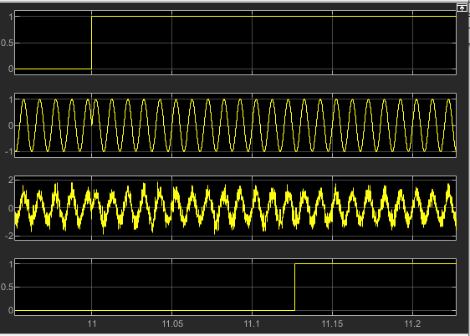
Figure 10: PSK Scope with 10 SNR
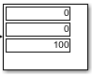
Figure 11: PSK Display with 10 SNR
Figures 10 and 11 show the results of a simulation run with 10 SNR. Like the results found for ASK, an SNR of 10 has hardly any effect on the overall signal. Despite slight distortion, it still holds form after the AWGN channel. There is still a slight delay in the final digital signal, like ASK. The display also shows no error rate.
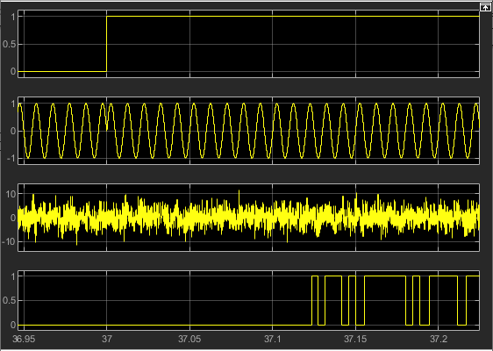
Figure 12: PSK Scope with -10 SNR
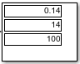
Figure 13: PSK Display with -10 SNR
A simulation with an SNR of -10 has had some effect on the wave, as seen in Figure 12. The wave has become more erratic and the final digital signal has some deviation from the original. However, despite this, Figure 13 shows only a 14% error rate. From this it can be concluded that PSK has slightly more resistance to low noise in comparison to ASK, which had a 24% error rate with -10 SNR.
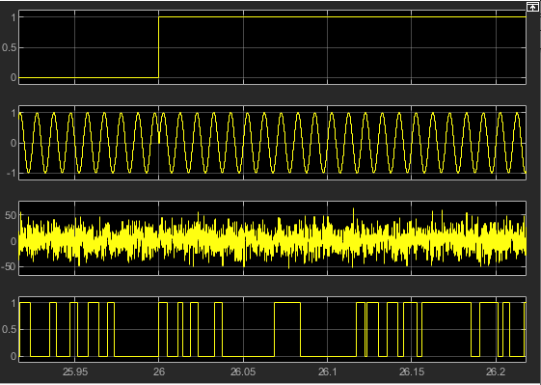
Figure 14: PSK Scope with -25 SNR
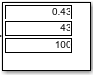
Figure 15: PSK Display with -25 SNR
Finally, a simulation was run with an SNR of -25, with results shown in Figures 14 and 15. Much like the simulation with ASK, -25 SNR has had a major impact on the signal. Both the waveform after the AWGN channel and the final digital signal bare no resemblance prior to entering the channel. Figure 15 further reinforces this as the simulation had a 43% error rate. The conclusion gathered from this is that PSK is susceptible to high noise levels but can be slightly resilient to low to medium noise when compared with ASK modulation. This is also supported within the research conducted.

C. QAM Modulation
Finally, simulations were conducted using QAM modulation. The design can be seen below in Figure 16.
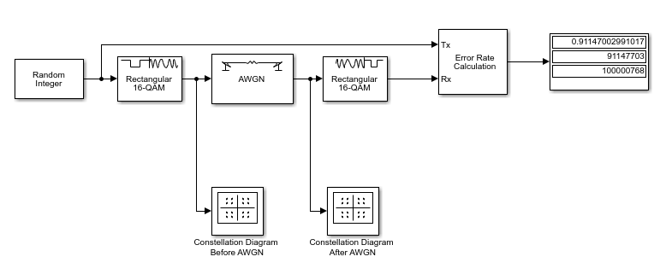
Figure 16: QAM Modulation Design
In creating QAM modulation, a few things were noted. Namely, the design is more complicated when compared to ASK and PSK designs, which was also noted during research. As such, Simulinks built in blocks were utilised in place of manual design blocks used in both ASK and PSK modulations. Furthermore, in order to accurately measure bits transferred via QAM, constellation charts must be used in place of scopes utilised by other modulation methods. However, the same AWGN block was utilised and as such, the same SNR numbers were utilised in these tests. Namely 10, -10 and -25.
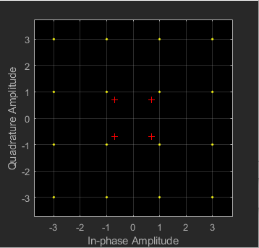
Figure 17: QAM Constellation
Figure 17 shows the layout of data utilised by QAM prior to entering the AWGN noise channel. This is identical in all tests, as the only variation occurs after passing through noise channel. As noted in the research section, each bit is specific to a certain data section.
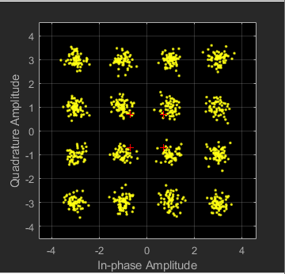
Figure 18: QAM Constellation with 10 SNR
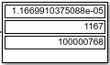
Figure 19: QAM Display with 10 SNR
Figures 18 and 19 show the results from a simulation with an SNR value of 10. Firstly, it should be noted that QAM sends far more data when compared to ASK and PSK, i.e. 100000768 bits compared to the 100 utilised by other modulation methods. This supports the previously noted mark that QAM can carry far more data compared to other modulation methods. Figure 18 shows the constellation with small amounts of noise. As noted, the data bits scatter far more compared to Figure 17. This shows the impact noise has on the transmission. As the scatter remain roughly within the original area, QAM receivers can reassemble the data with certain accuracy. However, as noted in Figure 19, error rates still occur. It should be noted that QAM has had more error rate at 10 SNR compared to other modulation methods. This is a downside of its ability to transmit massive amounts of information simultaneously.
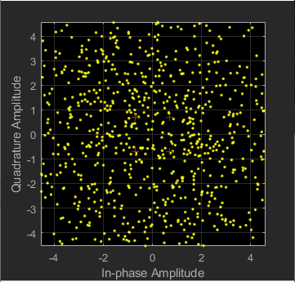
Figure 20: QAM Constellation with -10 SNR
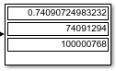
Figure 21: QAM Display with -10 SNR
Figures 20 and 21 show the results of a Simulink simulation with -10 SNR. As seen in Figure 20, the added noise has scattered the data bits to a far greater degree than before. This supports the fact that QAM is highly susceptible to atmospheric noise. Figure 21 further supports this, showing a large error rate of 74%. This type of error rate signifies that this method cannot function under certain noise levels.
To further note the effects of noise, a simulation was run with an SNR of -25. Results of this can be seen in Figures 22 and 23 below.
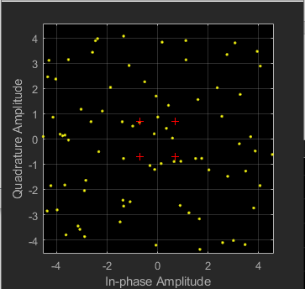
Figure 22: QAM Constellation with -25 SNR
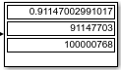
Figure 23: QAM Display with -25 SNR
Figure 22 shows far fewer markers compared to Figure 20. This indicates that the noise has scattered the original markers to such a degree that they no longer appear within the measured parameters. As such, a massive amount of data loss will occur, which can be viewed in Figure 23, showing an error rate of 91%. With such an error rate, this modulation method cannot function under high amounts of atmospheric noise.
Based on the results found during the testing of all three modulation methods, it is noted that QAM is by far the most susceptible to noise pollution, while base PSK shows some degree of resistance to slight noise levels. Despite this, all 3 methods function poorly at -25 SNR, with QAM becoming exceptional for data transfer rate at low noise levels.

IV Monitoring System Design
A scenario was put forth where several farmers and cities have become targets for theft and robbery. As a result, a wireless monitoring system is required in order to detect these crimes and submit a report to nearby police stations. To accomplish this, NetSim simulation software was used to create and test wireless network communications between remote farm areas and key city areas, such as public transport depots, to police stations located within the city.
Wireless communication systems considered while designing the Wireless Network (WN) were standards such as LoRa, satellite and cellular, as well as certain IoT technology, specifically WSN. LoRaWAN is a low-power wide-area communications technology [20] [21]. It is relatively new but has been increasing in popularity and use, overtaking other communication protocols such as ZigBee [20] [21]. LoRa networks consist of a front and back end part [20]. Front end parts consist of gateways and end devices, such as wireless sensors [20]. Back end parts consist of network servers and store information obtained via end devices [20].
These are key aspects to consider when designing a WAN for the mentioned scenario, as wireless sensors will be utilised in a manner like IoT in order to monitor remote areas, such as farms, for unusual activity. Likewise, LoRa is an ideal protocol to base a design on as this scenario requires constant updates from remote areas (farms and public transport systems) to police station servers so that officers can respond to emergencies.
Figure 24 and 25 below show the network design and communication channels, respectively, using NetSim software.
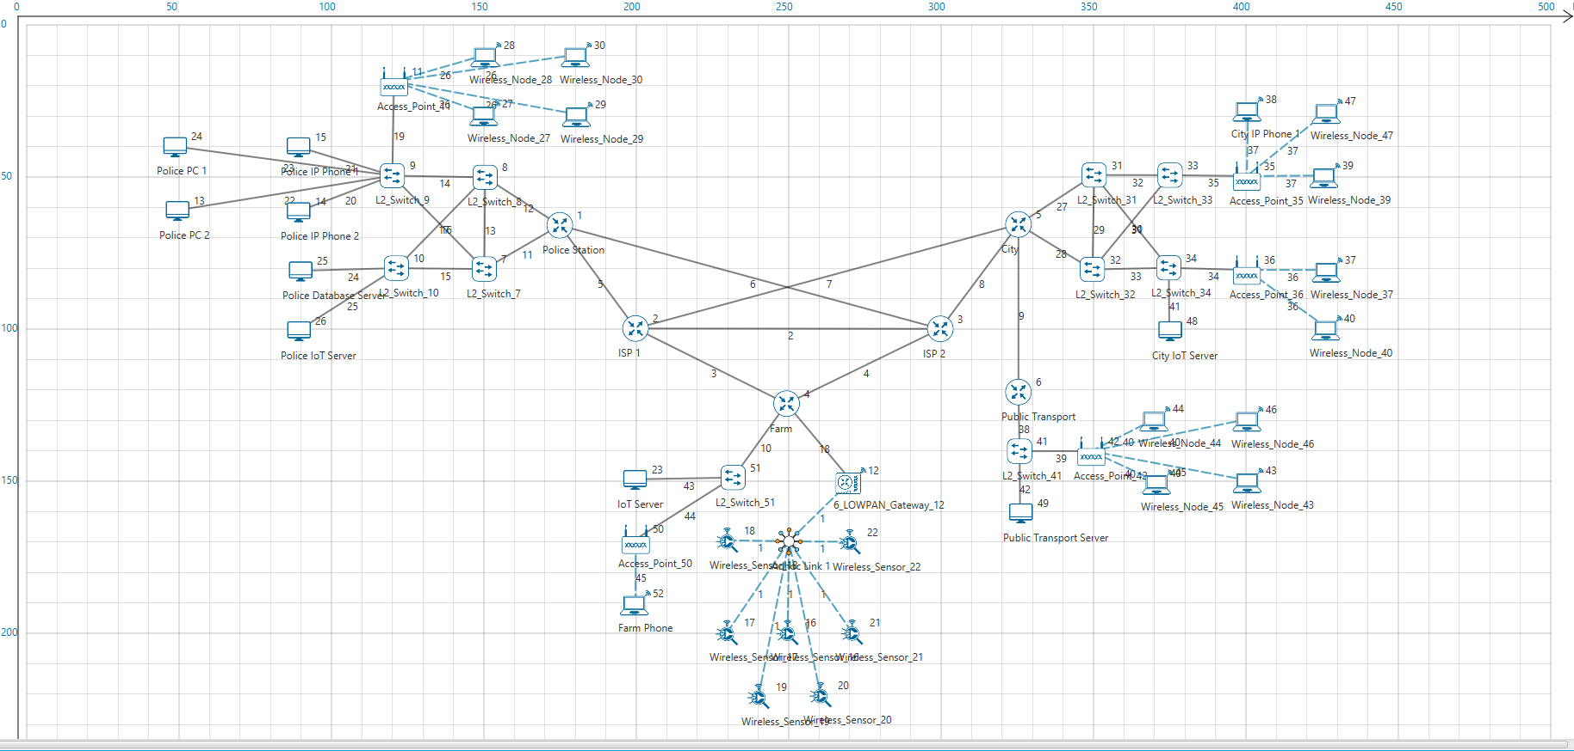
Figure 24: NetSim Network Design
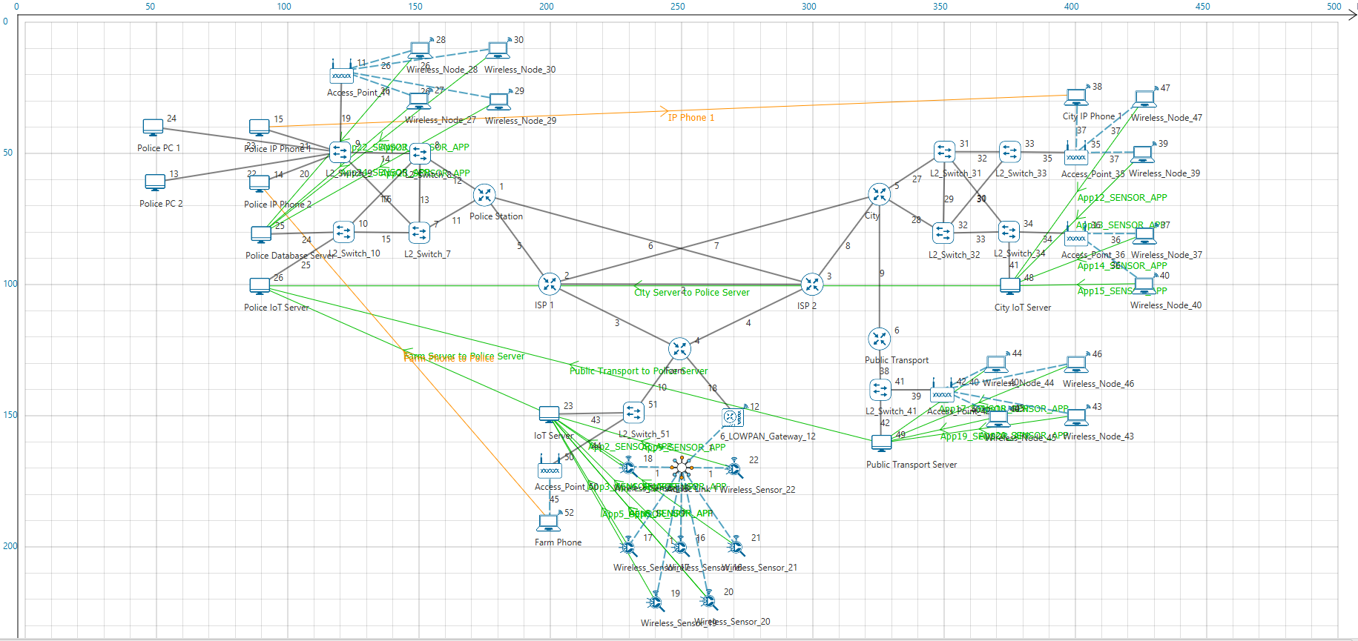
Figure 25: NetSim Network Communication
The network design is split into 3 sections for simplicity but can be extended to include extra farms or public transportation as required.
Firstly, certain limitations should be noted while using the IoT section within NetSim. One limitation is that there can be only one Adhoc link in the entire network, despite requiring this to simulate wireless sensor devices. Therefore, wireless nodes were used as substitutes within police station and city areas. These operate in the same manner and can also be configured for noise levels, negating this issue for simulation purposes.
Another issue is that the wireless protocol is set to ZigBee and cannot be changed to LoRa. Again, the work around used was to place devices in a closer proximity in order to counteract this. ZigBee is a low-power low-range protocol, opposed to LoRas low-power high-range qualities [21] [22]. Therefore, ZigBee will perform to satisfactory standards for this simulation, and its use was widespread within WSN previously [21] [22].
Finally, for testing QAM vs PSK / ASK, it is not possible to select a single modulation technique, shown in Figure 26 below.
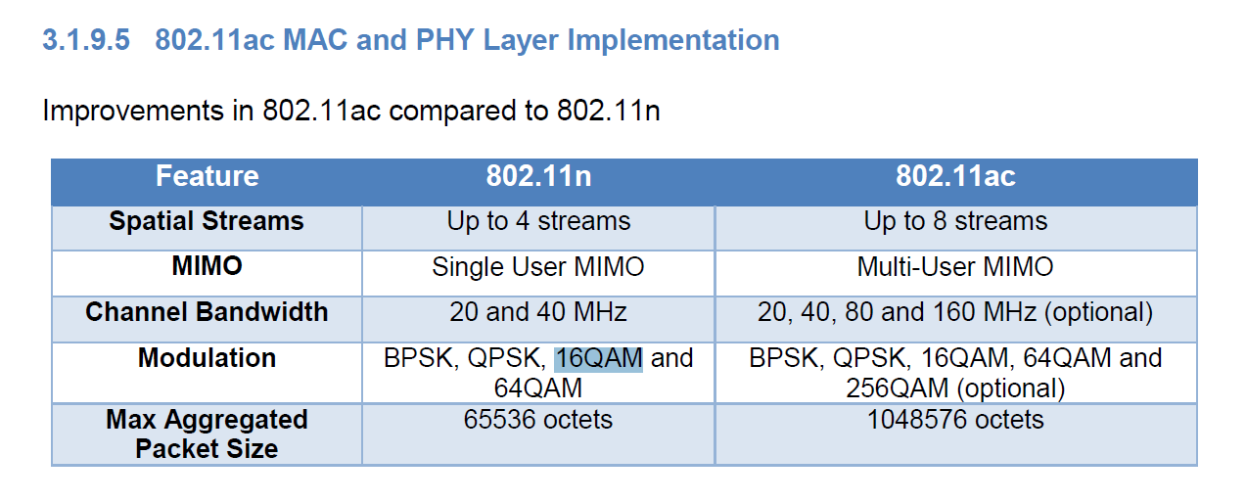
Figure 26: NetSim 802.11 Modulations
Figure 26 shows that modulations used can be either BPSK, QPSK or QAM. Overall this does not impact the concept much, as it is possible to judge the quality of both modulation techniques using results from other sections of this paper. However, it is not possible to test ASK as NetSim does not appear to utilise this modulation technique.
The design has several wireless sensor devices such as motion sensors, cameras, RFID readers and trip wires. These devices allow for coverage of an area, such as around a farm, in order to detect for intruders. RFID [23] [24] technology will be utilised to gain access to main farm buildings, public transport depots and police stations. This technology allows for automatic identification by utilising RFID readers and cards [23] [24]. Therefore, utilising this method with ID cards for police stations and farm workers, or within tickets for public transport access will control access to these areas. Motion sensors and sirens allow for proximity and intruder detection. Other devices such as metal detectors located at police stations and public transport depots would reduce the number of individuals accessing these areas with concealed weapons. All devices would transmit data to a server, which would be connected to the police server in order to communicate information from network devices.
Two simulations were done using NetSim. One consisted of using standard wireless communication protocols, while the second used 802.11ac features to test PSK or QAM.
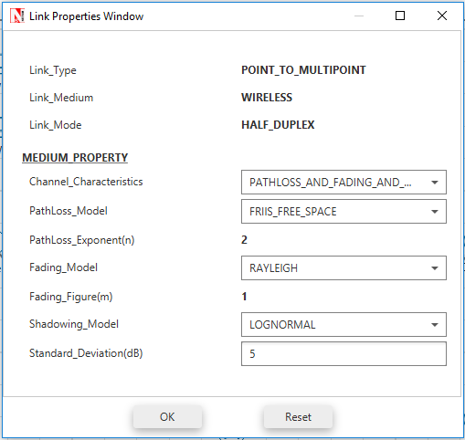
Figure 27: Simulation Link Properties
Figure 27 shows link properties used within these simulations. Noticeable pathloss_and_fading_and_shadowing was selected, with a fading model of Rayleigh. Noise levels were set to 5, which would equal 10 to -10 SNR used in the modulation simulations.
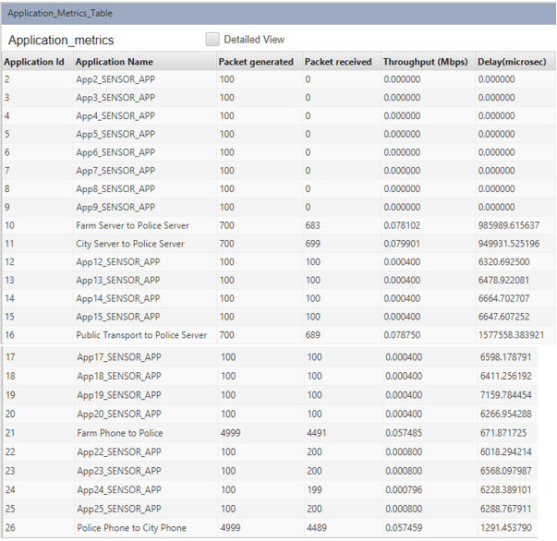
Figure 28: Standard NetSim Simulation Results
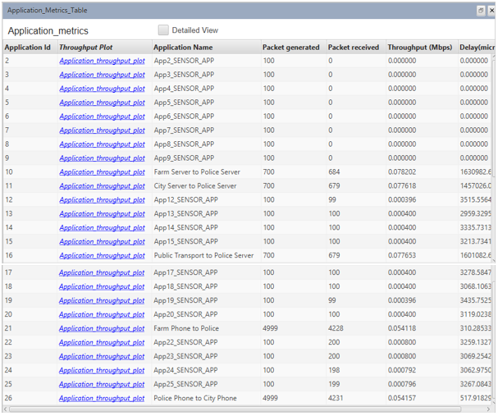
Figure 29: 802.11ac NetSim Simulation Results
Figures 28 and 29 show the results of both simulations conducted. The main results observed are between remote site servers to the police station server. This connection is vital to ensure that all information gathered by sensor devices located at the farm and public transport depot can be accessed by police staff. Figure 28 shows 700 packets generated between servers and between 680-690 of these being received. Throughput of these connections is between 0.078 and 0.08 Mbps. In order to properly measure these results, a sample was shown as a graph seen in Figure 30 below.
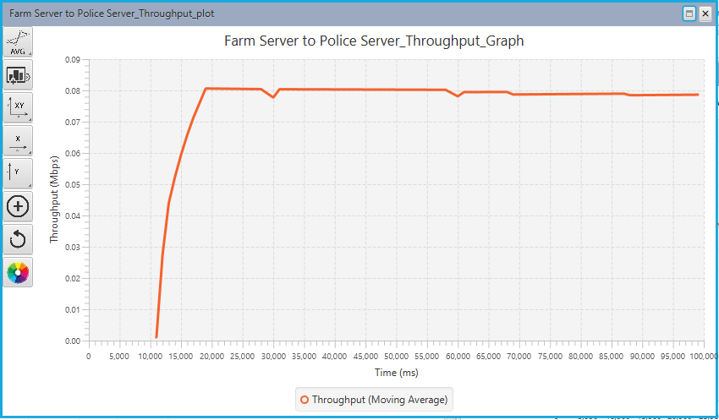
Figure 30: Farm Server to Police Server Throughput
As seen in Figure 30, the throughput remains consistent throughout the packet lifespan, with only slight drops.
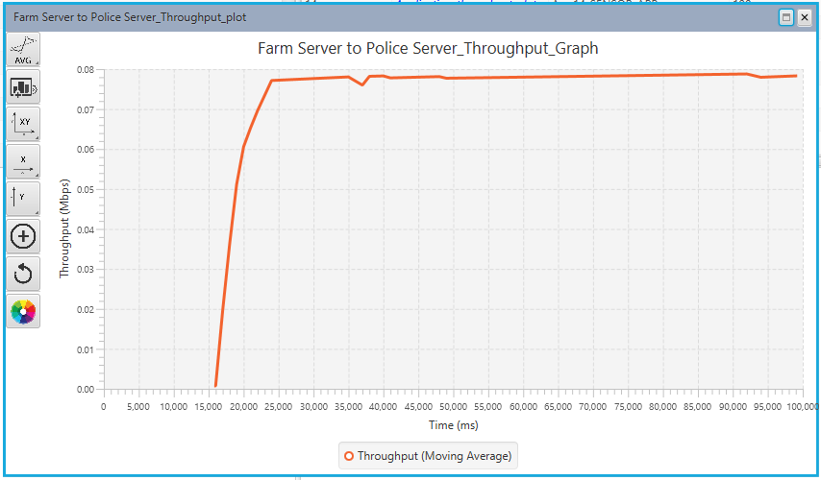
Figure 31: Farm Server to Police Server Throughput with 802.11ac
Figure 31 also shows a consistent throughput when using 802.11ac protocols. However, one slight deviation is in time before packets began transmitting. This could be due to modulation timings required in order to operate PSK and QAM. Returning to Figure 29, this supports the observation of similar throughput between both simulations. However, there is a lower number of packets received at the destination. This number is low enough that it can simply be ignored as it would have little impact on network performance.
One final observation regarding packets sent and received regarding phone systems is that the packets received is slightly lower for 802.11ac modulation compared to standard for voice traffic. This can be significant as voice traffic requires best connection possible to ensure quality of service. Therefore, should a simulation be run with higher noise, the expected outcome would be for 802.11ac operations to decline in output, as both QAM and PSK share the same issue with noise, i.e. susceptible to atmospheric noise which leads to data loss. However, the level of data loss leads to the hypothesis that PSK is the modulation technique utilised.

V Conclusion
Three simulations were created using Matlab’s Simulink software in order to create and test three modulation techniques, i.e. ASK, PSK and QAM. These simulations were all run with a SNR of 10, -10 and -25 in order to simulate atmospheric noise. Scope and Display tools were used to observe the effects of noise on these modulation techniques, which allowed for a comparison to each other, and to the research conducted. It was discovered, through both research and simulation, that QAM can carry far more data over a carrier wave in comparison to ASK and PSK.
However, out of the three, it is the most vulnerable to atmospheric noise, with a staggering 74% error rate at -10 SNR. In comparison, ASK and PSK had 24% and 14% error rate, respectively, at -10 SNR. Therefore, a conclusion was met that in scenarios with limited atmospheric noise, QAM would be the ideal choice as it has faster data transfer speeds, whereas standard PSK, or BPSK, would outperform QAM in higher noise levels, simply due to not losing as much data sections as noise levels increase.
From here, a scenario was given regarding an increase in crime in Caribbean islands. This scenario required a WAN to be created using wireless protocols, including modulation techniques. The goal was to create a network that could be utilised in informing police personnel of active crime and identifying individuals with concealed weapons, such as knives. To achieve this, a network design was created and tested using NetSim simulation software. Unfortunately, several limitations were identified, but ultimately did not hinder the creation or testing of the network to any large degree.
Several devices were chosen, such as motion sensors, RFID readers, metal detectors and trip wire technology, in order to detect intrusion within farming areas and to detect concealed weapons at key locations, such as police stations and public transport depots, i.e. bus or train stations.
Following this, simulations were run to determine the network performance regarding its resilience to atmospheric noise. Due to limitations, a modulation technique was not able to be selected manually. However, the simulation did run either QAM or PSK modulation techniques. Based on packets delivered and resilience to noise, PSK was identified as the modulation technique utilised. Connection between remote farming areas and public transport depots to police stations was successfully done with minimal loss in packets and throughput.
To improve on this design, future works would also include further testing with various sound levels. As of point of testing, only one sound level was chosen to represent the modulation simulation level of sound between 10 and -10 SNRs. More testing at higher sound levels would help to perfect network design. Other improvements include more specialised traffic. Only voice and wireless sensor signals were utilised. An addition of extra packet types would help test for priority traffic across the network.

References
[1] H. He, J. Mo, Q. Wen and Z. Meng, "Node information in WSN from the business perspective," 2012 IEEE 2nd International Conference on Cloud Computing and Intelligence Systems, Hangzhou, 2012, pp. 1028-1031.
[2] D. Baghyalakshmi, J. Ebenezer and S. A. V. Satyamurty, "WSN based temperature monitoring for High Performance Computing cluster," 2011 International Conference on Recent Trends in Information Technology (ICRTIT), Chennai, Tamil Nadu, 2011, pp. 1105-1110.
[3] A. R. Biswas and R. Giaffreda, "IoT and cloud convergence: Opportunities and challenges," 2014 IEEE World Forum on Internet of Things (WF-IoT), Seoul, 2014, pp. 375-376.
[4] P. Chen and Z. Lu, "A Web-Based Indoor Environment Monitoring System Using Wireless Sensor Networks," 2013 International Conference on Computational and Information Sciences, Shiyang, 2013, pp. 2007-2010.
[5] R. Correia and N. B. Carvalho, "Design of high order modulation backscatter wireless sensor for passive IoT solutions," 2016 IEEE Wireless Power Transfer Conference (WPTC), Aveiro, 2016, pp. 1-3.
[6] X. Huang, "Research on variable rate PCM/FM telemetry modulation and demodulation technology," 2016 IEEE International Conference on Ubiquitous Wireless Broadband (ICUWB), Nanjing, 2016, pp. 1-5.
[7] Umesharaddy and B. K. Sujatha, "Performance improvement of QPSK modem implemented in FPGA," 2015 International Conference on Smart Sensors and Systems (IC-SSS), Bangalore, 2015, pp. 1-6.
[8] Z. Chen, L. Wu and P. Chen, "Efficient modulation and demodulation methods for multi-carrier communication," in IET Communications, vol. 10, no. 5, pp. 567-576, 24 3 2016.
[9] M. Zhang and S. Kim, "Universal soft demodulation schemes for M-ary phase shift keying and quadrature amplitude modulation," in IET Communications, vol. 10, no. 3, pp. 316-326, 11 2 2016.
[10] W. Rao, L. Zhang, Z. Liu and Z. Wu, "Efficient Amplitude Shift Keying-Aided Orthogonal Chaotic Vector Position Shift Keying Scheme With QoS Considerations," in IEEE Access, vol. 5, pp. 14706-14715, 2017.
[11] Y. Gao, Y. Dai, C. Shu and S. He, "Wavelength Interchange of Phase-Shift-Keying Signal," in IEEE Photonics Technology Letters, vol. 22, no. 11, pp. 838-840, June1, 2010.
[12] G. Lu, "Flexible high-order quadrature amplitude modulation transmitter for elastic optical networks," 2015 Optoelectronics Global Conference (OGC), Shenzhen, 2015, pp. 1-2.
[13] A. G. Dimitriou, A. Bletsas and J. N. Sahalos, "On the design of passive RFID tags for ASK modulation," Proceedings of the 5th European Conference on Antennas and Propagation (EUCAP), Rome, 2011, pp. 2823-2827.
[14] Choi Myoeng-Jae and Jin Sung-Eon, "Design of low power ASK CMOS demodulator circuit for RFID tag: Design of All-MOSFET low power ASK demodulator," 2010 IEEE International Conference of Electron Devices and Solid-State Circuits (EDSSC), Hong Kong, 2010, pp. 1-4.
[15] D. K. Sharma, A. Mishra and R. Saxena, “ANALOG & DIGITAL MODULATION TECHNIQUES: AN OVERVIEW” in TECHNIA International Journal of Computing Science and Communication Technologies, Vol. 3, pp. 551 – 561, Jul. 2010.
[16] PSK at “https://www.tutorialspoint.com/digital_communication/digital_communication_phase_shift_keying.htm”, Date Accessed Apr. 4, 2019.
[17] B. Zheng, L. Deng, M. Sawahashi and N. Kamiya, "High-order circular QAM constellation with high LDPC coding rate for phase noise channels," 2017 20th International Symposium on Wireless Personal Multimedia Communications (WPMC), Bali, 2017, pp. 196-201.
[18] R. Mohamad, R. Mahmud and R. A. Awang, "Prototype of Quadrature Amplitude Modulation (QAM) baseband modem for a digital baseband signal processor," 2011 IEEE International RF & Microwave Conference, Seremban, Negeri Sembilan, 2011, pp. 407-411.
[19] QAM at “https://www.electronics-notes.com/articles/radio/modulation/quadrature-amplitude-modulation-what-is-qam-basics.php”, Date Accessed Apr. 4, 2019.
[20] A. Lavric and V. Popa, "Internet of Things and LoRa™ Low-Power Wide-Area Networks: A survey," 2017 International Symposium on Signals, Circuits and Systems (ISSCS), Iasi, 2017, pp. 1-5.
[21] L. H. Trinh, V. X. Bui, F. Ferrero, T. Q. K. Nguyen and M. H. Le, "Signal propagation of LoRa technology using for smart building applications," 2017 IEEE Conference on Antenna Measurements & Applications (CAMA), Tsukuba, 2017, pp. 381-384.
[22] Li Xiaoman and Lu Xia, "Design of a ZigBee wireless sensor network node for aquaculture monitoring," 2016 2nd IEEE International Conference on Computer and Communications (ICCC), Chengdu, 2016, pp. 2179-2182.
[23] M. I. Bin Idris, M. Bin Ibne Reaz and M. A. S. Bhuiyan, "A low voltage VGA for RFID receivers," 2013 IEEE International Conference on RFID-Technologies and Applications (RFID-TA), Johor Bahru, 2013, pp. 1-4.
[24] S. Genovesi, F. Costa, M. Borgese, F. A. Dicandia, A. Monorchio and G. Manara, "Chipless RFID sensor for rotation monitoring," 2017 IEEE International Conference on RFID Technology & Application (RFID-TA), Warsaw, 2017, pp. 233-236.

marking criteria and Student FEEDBACK

This section details the assessment criteria. The extent to which these are demonstrated by you determines your mark. The marks available for each criterion are shown. Lecturers will use the space provided to comment on the achievement of the task(s), including those areas in which you have performed well and areas that would benefit from development/improvement.

Common Assessment Criteria Applied (Assignment 1) | Marks available | Marks  awarded
1. Research-informed Literature
Extent of research and/or own reading, selection of credible sources, application of appropriate referencing conventions.
Key concepts discussed from diverse credible sources. (Grade mark: 100.00%) | 10 | 10
2. Knowledge and Understanding of Subject
Extent of knowledge and understanding of concepts and underlying principles associated with the discipline.
You have demonstrated excellent understanding of the depth and strength of the research for this level. Structure and quality is excellently done. (Grade mark: 100.00%) | 10 | 10
3. Analysis
Analysis, evaluation and synthesis; logic, argument and judgement; analytical reflection; organisation of ideas and evidence
Part 1 results were written and discussed excellently with inter-relating the experiment results with the literature review. Part 2 excellently done with the quality of and level of detailed for the design documentation. The result discussions inter-relate to some aspect of the case study but issues highlighted with the simulation tool/software. It’s a pity it would be good for the entire case problem to inter-relate to the simulation results. In saying this, more graphical results could be derived from the simulations output to discuss and inter-relate more to part 2 problems rather than so much on how the modulation technique will affect the wireless network data transmission. Your conclusion include recommendation for the future; very good. (Grade mark: 94.29%) | 35 | 33
4. Practical Application and Deployment
Deployment of methods, materials, tools and techniques; application of concepts; formulation of innovative and creative solutions to solve problems.
An outstanding application of techniques applicable to own research. Shows originality in application of knowledge and techniques. Documentation of the design done with justification of parameters used; a design diagram would be good. The actual simulation design selection & justification of relevant topologies and protocols used were demonstrated (Simulinx and Netsim) from evidence of running the simulation and screenshots of results in the report. Simulations worked, excellent application skills. (Grade mark: 94.29% ) | 35 | 33
5. Skills for Professional Practice
Attributes in professional practice: individual and collaborative working; deployment of appropriate media; presentation and organisation.
Professionally done, written and flow excellently. (Grade mark: 100.00%) | 10 | 10

Assignment Mark (Assessment marks are subject to ratification at the Exam Board. These comments and marks are to give feedback on module work and are for guidance only until they are confirmed. ) | Late Submission Penalties (tick if appropriate) |  | 96%
 | Up to four weeks late |  | 96%
 | First Attempt? |  | 96%

